Title
SymExtPoly.dll

Author
Dominique ‘Nikki’ Galvez

Brief Description
This DLL defines a User-Defined surface designed to replicate the Extended Polynomial surface, but support symmetry in x, y, or x & y.

Overview
This DLL creates a surface identical to the Extended Polynomial surface, but it allows the user to specify if symmetry should be enforced upon the surface, specifically in the x direction, y direction, x & y direction, or no symmetry (identical to the typical Extended Polynomial surface).

Plugin Type
User-Defined Surface

Language
DLL

Updates
Date | Version | OpticStudio version | Comment
2024/08/15 | 1.0 | 24.2 | Creation

Instructions

Installation
Place the DLL in the {Zemax}\DLL\Surfaces folder before starting OpticStudio

How to use
Under the Surface Type column in the Lens Data Editor of OpticStudio, select ‘User Defined’ as the surface type. From the Data File Popup menu, select ‘SymExtPoly.dll’. If it is not offered as an option, check that SymExtPoly.dll is in the ‘{Zemax}\DLL\Surfaces’ folder.
The Surface Type and DLL can also be changed in the Surface Properties drop-down menu of the LDE.
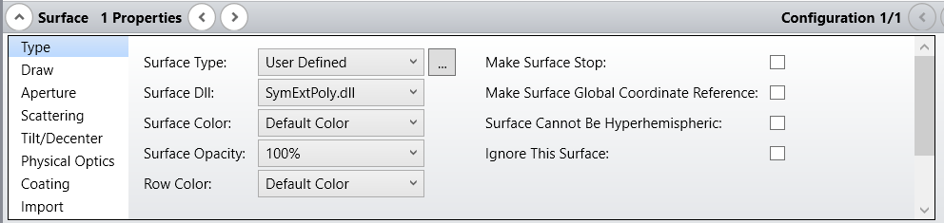
SymExtPoly.dll takes in 3 parameters from the user: Maximum term #, Normalization Radius, and Symmetry.
Maximum Term #: Defines the number of polynomial terms that will be used, and the amount of data columns that will appear. SymExtPoly.dll currently supports up to 230 polynomial terms.
Normalization Radius: Scales the polynomial terms to the desired normalization radius
Symmetry: Allows the user to set symmetry types. If the user enters any number other than [1-3], then it will default to standard extended polynomial behavior (no enforced symmetry).
1: x symmetry
2: y symmetry
3: x & y symmetry
The Symmetric Extended Polynomial follows the same Extended Polynomial sag equation as given in the Help Files, except with the absolute values of the x, y, or x & y coordinates used during the appropriate symmetry cases.

