Title
API_Extension_CS_Sequential_Solid_Gaussian_Beam_Envelope

Author
Sandrine Auriol - ZEMAX

Brief Description
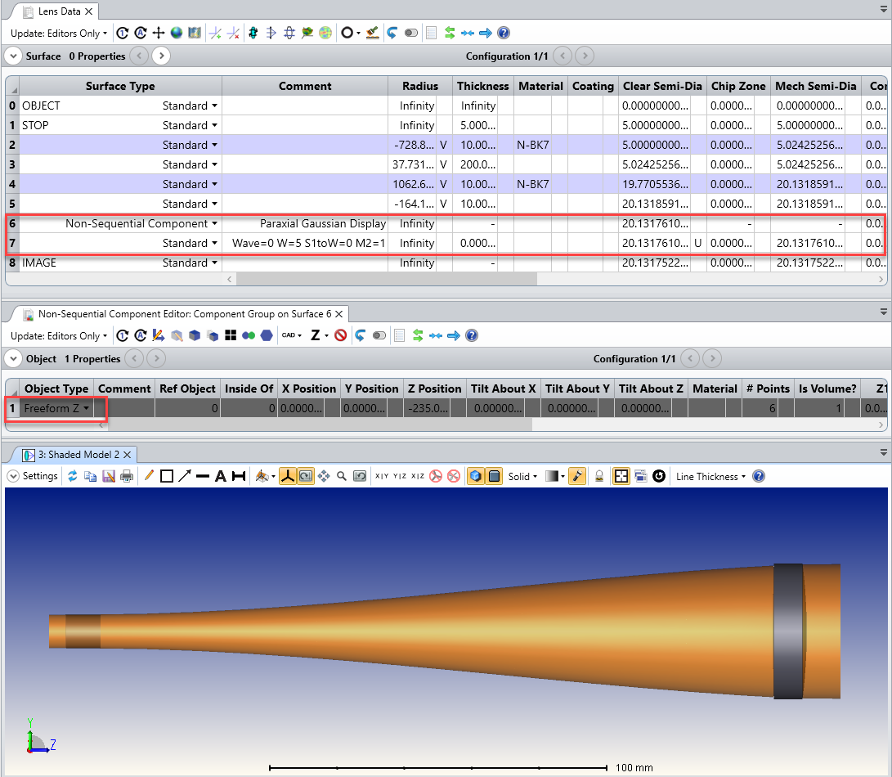

Overview
This Zemax User-Extension displays the envelope of a Gaussian Beam. The Gaussian Beam characteristics are calculated by the Paraxial Gaussian Beam calculator. The extension adds a Non-Sequential Component at the bottom of the sequential editor. A Freeform Z object is added to the Non-Sequential Component Editor. It is formed with the different sizes of the beam calculated by the Paraxial Gaussian Beam

Plugin Type
API Extension

Language
CS

Updates
Date | Version | OpticStudio version | Comment
24/03/2020 | 1.0 | 20.1.1 | Creation

Instructions

Installation
To install the Zemax User Plugin, copy the files called GaussianBeamDisplay.pdb, GaussianBeamDisplay.exe.config and GaussianBeamDisplay.exe under {Zemax}\ZOS-API\Extensions.
OpticStudio will have to be restarted to be able to view the newly installed Zemax User Plugin.

How to use
To use the Zemax User plugin, open a sequential file.
Go to Programming Tab…User Analyses and select the Zemax Plugin.
First select the settings:
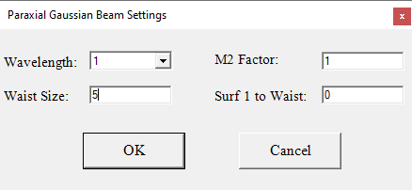

Once you press OK, the software will calculate the size of the Paraxial Gaussian Beam at every surface. It will then create a Freeform Z object that models the envelope of the Paraxial Gaussian Beam.

