Title
CodeExchange_API Analysis_C#_Sequential_Ghost Analysis Summary

Brief Description
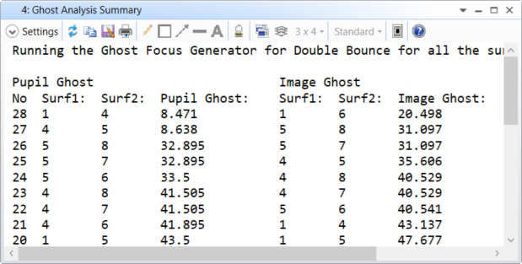

Overview
This User Analysis runs the Ghost Focus Generator in Double Bounce and sorts the combination of surfaces that contribute to the worst Pupil and Image Ghosts.

Plugin Type
API Analysis

Language
C#

Updates
Date | Version | OpticStudio version | Comment
20191127 | 1.0 | 19.8 | Creation
20220330 | 2.0 | 22.1.2 | Change the iteration of surfaces as some combinations where missed.  All combinations are now checked and if pupil ghost or image ghost = 0 the data is removed.

Instructions

Installation
To install the Zemax User Plugin, copy the .exe file under {Zemax}\ZOS-API\User Analysis.
OpticStudio will have to be restarted to be able to view the newly installed Zemax User Plugin.

How to use
To use the Zemax User plugin, open a sequential file.
Go to Programming Tab…User Analyses and select the Zemax Plugin.
The following analysis will be displayed. The Analysis calls the Ghost Focus Generator under Analyze…Straylight. It then sorts the results to display the combination of surfaces that creates the worst Pupil Ghost and the worst Image Ghost.
No settings are available.

