Title
An introduction to interfacing to OpticStudio from Mathematica written as a standalone application.

Author
David Keith

Brief Description
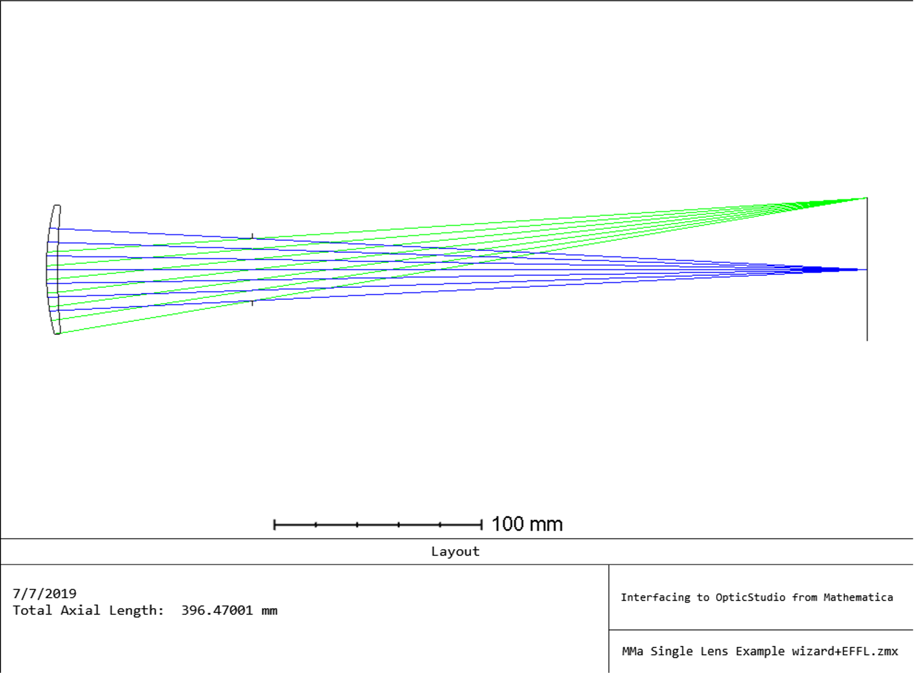

Overview
This notebook is intended as an introduction to using ZOS-API to interface to OpticStudio from Mathematica. It is written as a Mathematica version of a knowledgebase article titled: "How to build and optimize a singlet using ZOS-API with Python,” written by Thomas Aumeyr. (Thank you, Thomas!) It follows that work step by step, and in fact copies much of the text explanations directly. This has been done so that an immediate comparison can be made between the ZOS-API syntax of Mathematica and Python.

Plugin Type
API Standalone

Language Mathematica
Choose an item.

Updates
Date | Version | OpticStudio version | Comment
22/06/2022 | 1.1 | 22.2 | Creation

Instructions

Installation
Save the Mathematica notebook in a convenient directory.

How to use
To use the notebook open it in Mathematica. Execute the notebook and note that it creates a sequential lens and saves it in your Zemax samples directory. It can help to evaluate the notebook one cell at a time and confirm that the evaluation of each cell produces the expected result

