Title
ZPL_Macro_Sequential_Image_Simulation_Cross_Section

Author
First Name Last Name - Company

Brief Description
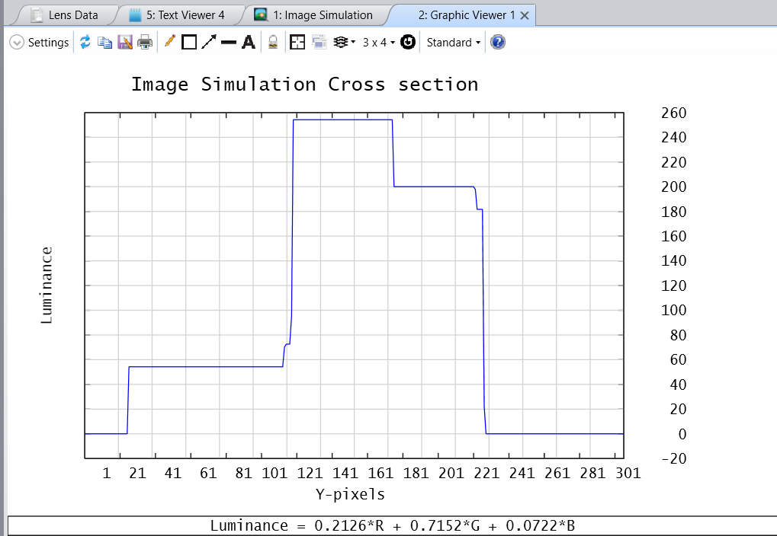

Overview
This macro reads the text output of the image simulation. The text output contains the RGB values of the image for each pixel. It then creates a cross section of the image simulation in X or Y for a defined X or Y pixel. In the Image Simulation window, click on Save first before running it.

Plugin Type
ZPL Analysis

Language
ZPL

Updates
Date | Version | OpticStudio version | Comment
2021-12-09 | 1.0 | - | Creation

Instructions

Installation
To run the macro, copy the .zpl file under {Zemax}\Macros.
The macro can then be run from:
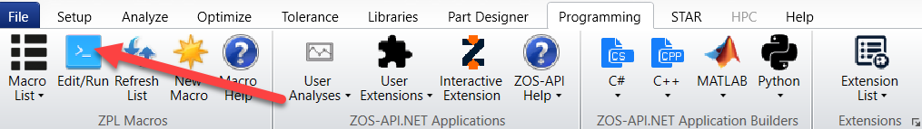

How to use
The macro will run the image simulation and reads the RGB values.
It will then display a cross section: 4 plots are displayed.
- One for the R values
- One for the G values
- One for the B values
- One for the luminance values calculated from the RGB values.
The Luminance formula used here is:
Luminance = 0.2126 * R + 0.7152 * G + 0.0722 * B
It comes from the following sources:
- https://en.wikipedia.org/wiki/Luma_(video)
- https://stackoverflow.com/questions/596216/formula-to-determine-perceived-brightness-of-rgb-color
- https://www.itu.int/rec/R-REC-BT.709

