Title
ZPL_Plotting_Entrance_Pupil

Author
Michael Cheng - Zemax

Brief Description
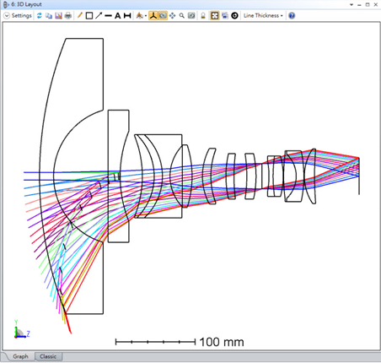

Overview
For wide angle system, it can be interesting to visualize the position and the size of a real entrance pupil in different field angles. This macro will compute with real ray tracing real entrance pupil information for different field angles. It then adds the entrance pupil as a dummy surface and each “field” entrance pupil is defined into a configuration. The macro assumes axial-symmetric, only y field and the field angle in object is positive. Ray-Aiming should be turned on to correctly run this macro. It may only work with field type Angle and Object Height. How to use: Just run the macro, and open 3D Layout with showing central field and all configs.

Plugin Type
ZPL Macro

Language
ZPL

Updates
Date | Version | OpticStudio version | Comment
- | - | - | Creation

Instructions

Installation
To install the ZPL operand, copy the ZT_ENP.ZPL file under {Zemax}\Macros.
It is ready to be used.

How to use
To use the macro, open a file that contains a doublet. For example "{Zemax}\Samples\Sequential\Objectives\Wide angle lens 210 degree field.zos"

Run the macro:
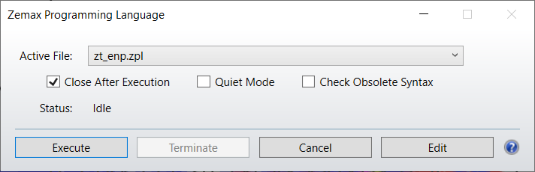

Open a new 3D layout and show all configurations:
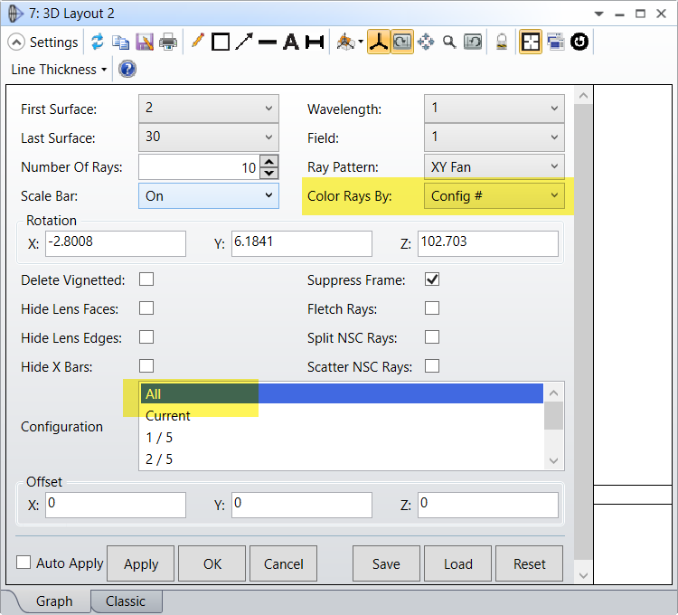

Select surface 2:
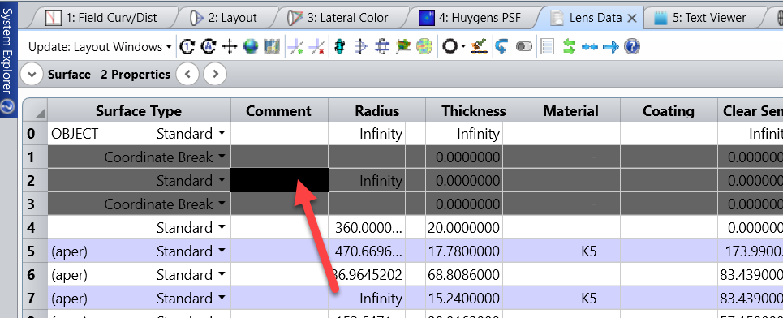

It will show the real entrance pupil per field on the 3D layout:
