Title
DLL_Surface_Cpp_Sequential_Gradient2_Tilted

Picture
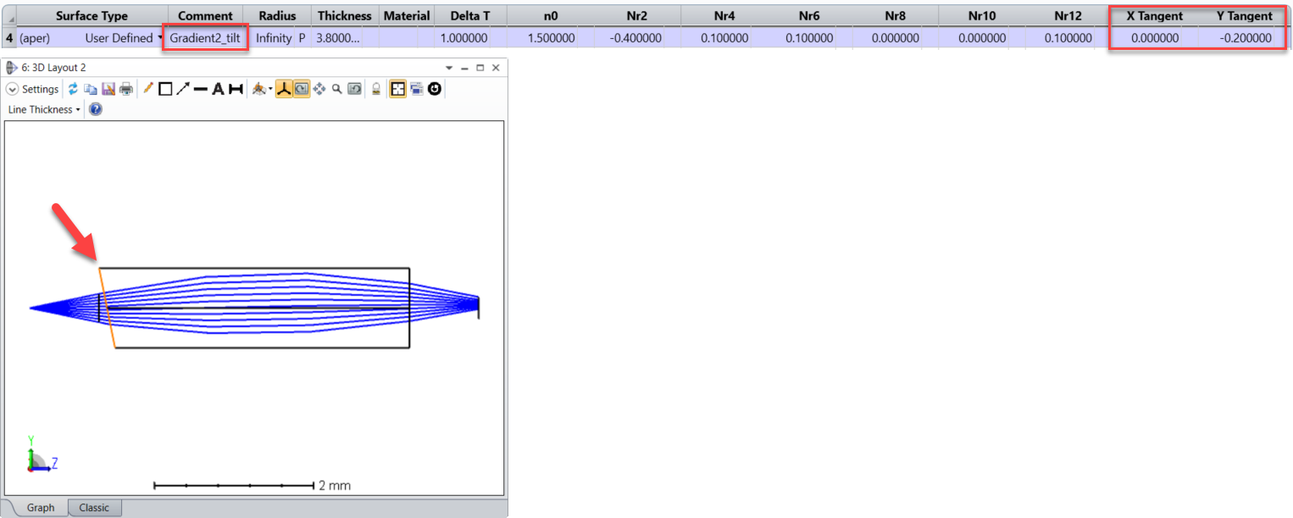

Overview
This user-defined surface can be used to model a tilted gradient 2 surface like a cleaved multi-mode fiber. Compared to the gradient 2 surface, this surface contains 2 additional parameters for the tilt.

Code Exchange Type
DLL_Surface

Language
C++

Author
Sandrine Auriol - Zemax

Updates
Date | Version | OpticStudio version | Comment
9/Dec/2021 | 1.0 | - | Creation

Instructions

Installation
Just open the attached ZAR file and the required DLL will be automatically extracted to the following folder:
\Zemax\DLL\Surfaces\

How to use
This is a gradient 2 surface with 2 additional parameters for the tilt. The derivatives of the index have been calculated with Mathematica.

