Title
ZPL_Macro_Create_GGD_file

Author
Michael Cheng

Brief Description
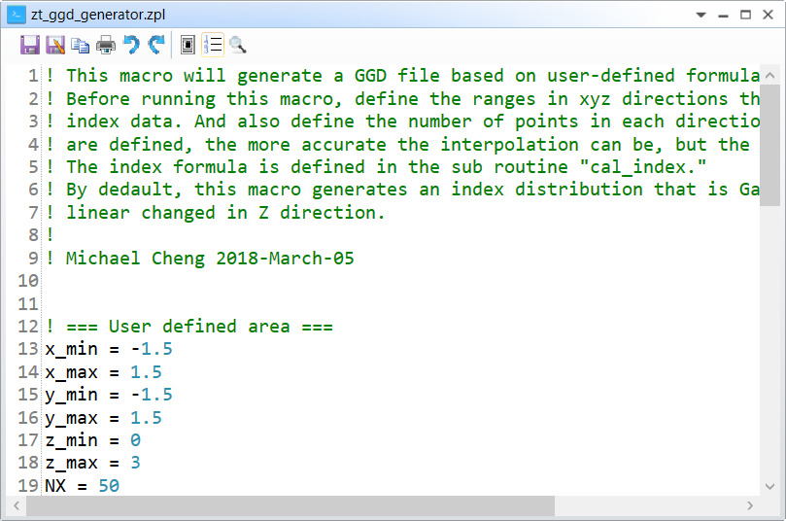

Overview
This macro will generate a GGD file based on user-defined formula. Before running this macro, define the ranges in xyz directions that you want to generate index data. And also define the number of points in each directions. The more the points are defined, the more accurate the interpolation can be, but the slow the simulation is. The index formula is defined in the sub routine "cal_index.". By default, this macro generates an index distribution that is Gaussian in XY-plane and linear changed in Z direction.

Plugin Type
ZPL Macro

Language
ZPL

Updates
Date | Version | OpticStudio version | Comment
2018-03-05 | 1.0 | - | Creation

Instructions

Installation
To install the macro, copy the .zpl file under {Zemax}\Macros\.

How to use

