Title
CodeExchange_API Standalone_Python_Sequential_LoadFEADataWithCLI

Author
Allen Cheng - Ansys Zemax

Brief Description
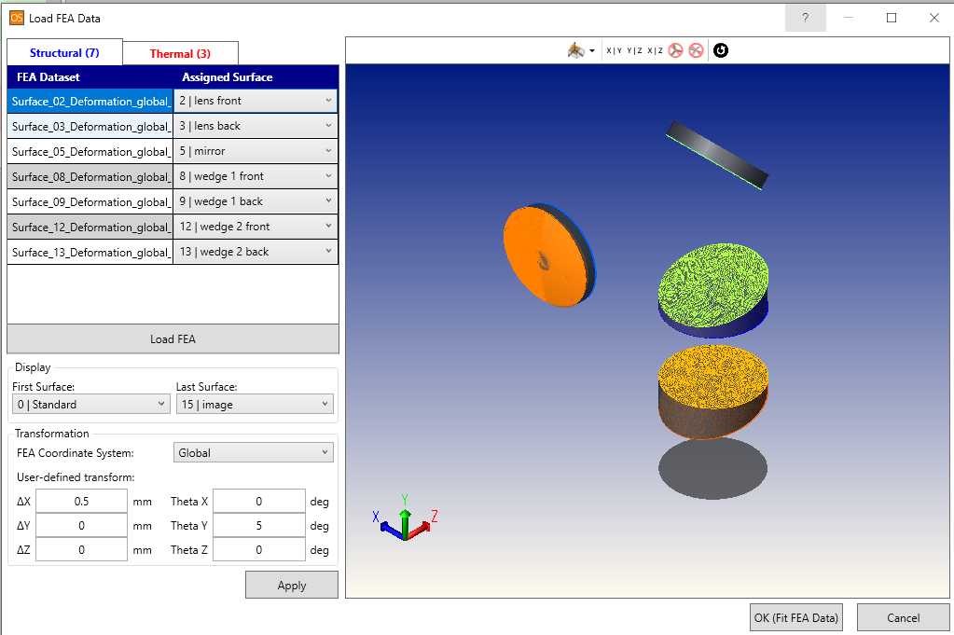

Overview
This tool can help you load and apply the FEA data to each surface. The feature is almost the same as the “Load FEA Data” tool in the STAR module. The difference is that this tool cannot help you check whether the FEA data is in the right place. However, it might be able to help you finish some routine work. If the script is not convenient enough to let you finish your work easier and you want to build your own tool, I think you can reference the functions “load_fea_deformation_with_transform” and “load_fea_temperature_with_transform”. I believe that they will give you some help.

Plugin Type
API Standalone

Language
Python

Updates
Date | Version | OpticStudio version | Comment
15/11/2022 | 1.0 | 22.3 | Creation

Instructions

Installation
You can place the code where you want. However, it is a command-line tool. Therefore, you will need to use your terminal to operate the program. The program is tested in the git-bash environment. To make the tool much more convenient, I recommend you set the alias in your environment configuration file, like .bashrc or .bash_profile.

How to use
To use this tool, you must put the configuration file and the FEA data in the same folder. The configuration file is a JSON file with the name “fea_config.json” The structure is as follows.
{
"surface_2":{
"deformation":
{
"fea_file":"Surface_02_Deformation_global_coordinates_surface_2.txt",
"fea_coordinate_system": "global",
"user-defined_transform_decenter": [0.5, 0, 0],
"user-defined_transform_rotation": [0, 5, 0]
},
"temperature":
{
"fea_file":"Surface_02_Temperature_global_coordinates_surface_2.txt",
"fea_coordinate_system": "global",
"user-defined_transform_decenter": [0, 0.1, 0],
"user-defined_transform_rotation": [0, 0.2, 0]
}
},
"surface_3":{
"deformation":
{
"fea_file":"Surface_03_Deformation_global_coordinates_surface_2.txt",
"fea_coordinate_system": "global",
"user-defined_transform_decenter": [0, 0, 0.2],
"user-defined_transform_rotation": [0, 0, 0.3]
}
},

At the top level, the keys’ names should include the prefix “surface_”. The number after the prefix is the surface’s ID. At the “Type” level, the key’s name is “deformation” or “temperature”. If you use another name, it will be skipped.
The value of “fea_file” should exist. You should delete the corresponding information if there is no FEA file in the folder. For instance, no FEA file will be applied to surface 4, so there is no “surface_4” term. And no temperature data will be applied to surface 3, so the “temperature” term is deleted.
There are only two types of “fea_coordiate_system”. They are “global” and “local”. If you give the wrong value, the program will raise a ValueError.
After finishing the configuration, go back to the command line and use the following command.
python main_cli.py lens_file fea_folder ouput_lens_file
In our example, it is as follows
python main_cli.py SteeringPrismSystem_SEQ_v04.zmx FEAData/ final.zmx
Open the output file. All the FEA data have been applied to the surfaces with the transform defined in the configuration file.

If you forget how to use this tool, go back to your command line and type “python main_cli.py -h”
