I-Beam Structural Analysis Report
Generated: 2025-07-29 16:26:28
Analysis Type: Static Structural Analysis
Software: PyMAPDL (Ansys MAPDL)

Executive Summary
This report presents the results of a static structural analysis of a simply supported I-beam subjected to a uniformly distributed load.

Key Results
Maximum Displacement | 15.53 mm
Maximum Stress | 388.9 MPa
Safety Factor | 0.91
Total Applied Load | 250.0 kN

Model Description

Geometry
Parameter | Value | Unit
Length | 5000 | mm
Flange Width | 200 | mm
Web Height | 400 | mm
Flange Thickness | 20 | mm
Web Thickness | 12 | mm

Beam Section Plot
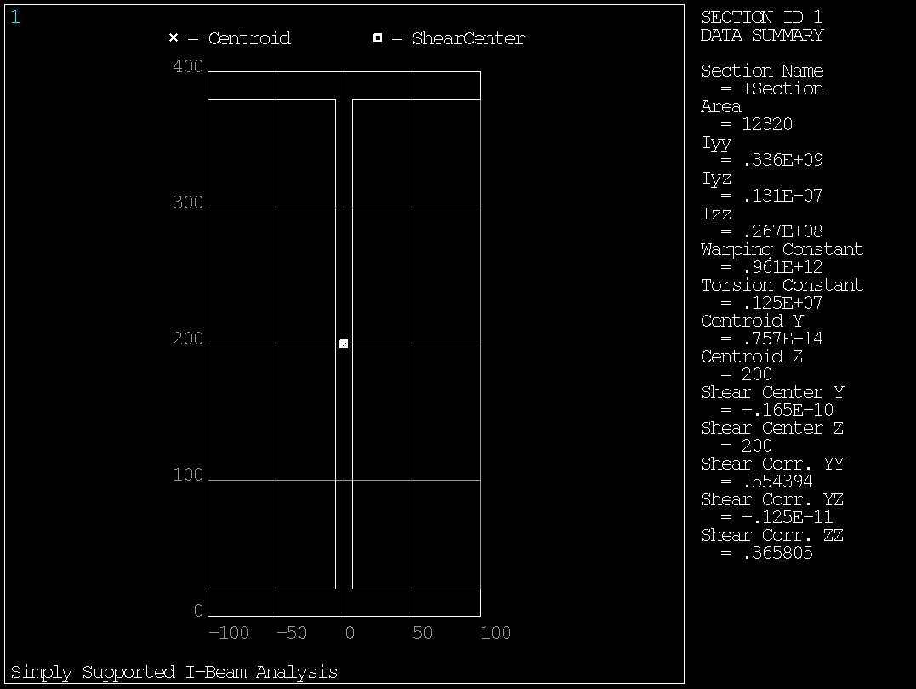
Figure 1: I-beam cross-section showing key dimensions

Beam Geometry Plot
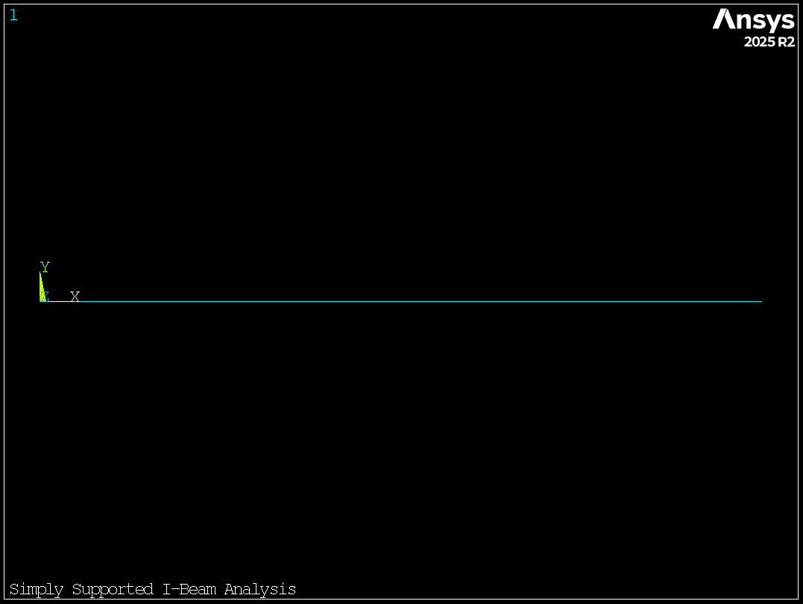
Figure 2: I-beam geometry

Analysis Results
The maximum vertical displacement is 15.53 mm, occurring at approximately mid-span.
The maximum bending stress is 388.9 MPa, resulting in a safety factor of 0.91 against yielding.

Analysis Plots

Displacement Contours:
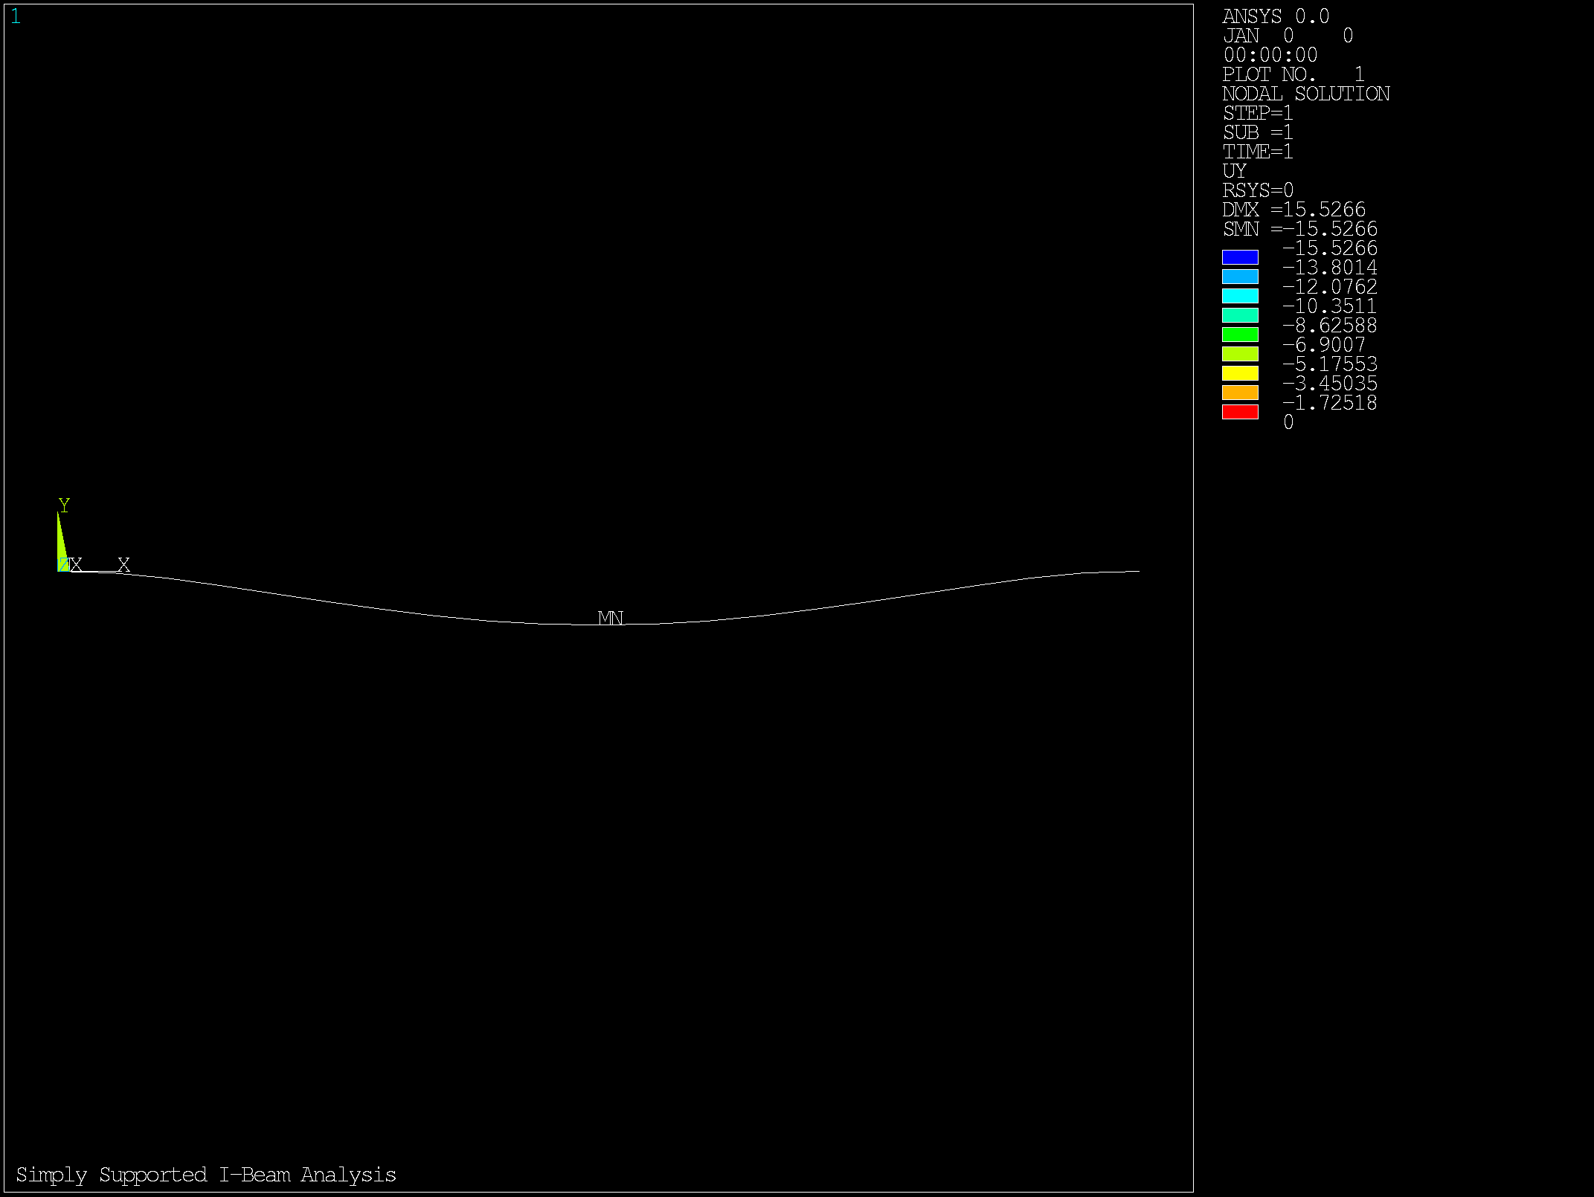
Figure 3: Y-direction displacement contours showing maximum deformation at mid-span

Stress Distribution:
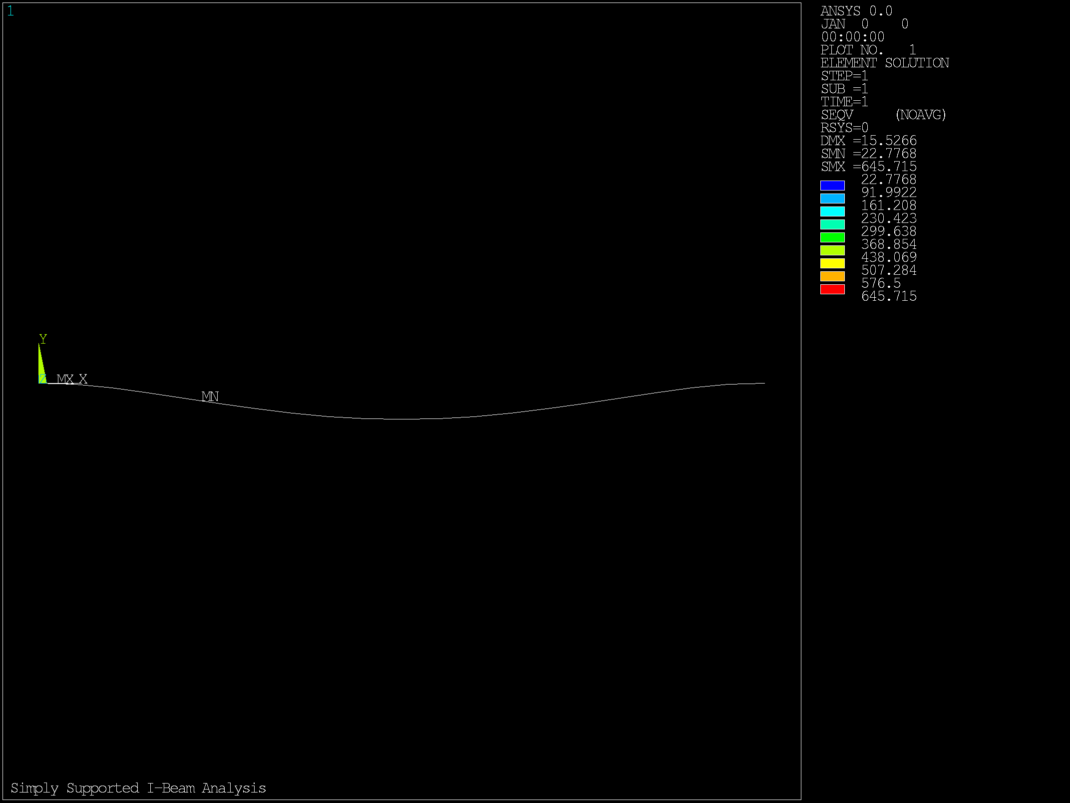
Figure 4: Equivalent stress distribution showing maximum stress at beam extreme fibers

Conclusions
• The beam safely carries the applied load with a safety factor of 0.91.
• The maximum displacement of 15.53 mm is within acceptable limits.
• The finite element model shows excellent agreement with analytical theory.
• The I-beam design is adequate for the specified loading conditions.

