I-Beam Structural Analysis Report

Generated: 2025-07-29 16:26:28

Analysis Type: Static Structural Analysis

Software: PyMAPDL (Ansys MAPDL)

# Executive Summary

This report presents the results of a static structural analysis of a simply supported I-beam subjected to a uniformly distributed load.

## Key Results

|  |  |
| --- | --- |
| Maximum Displacement | 15.53 mm |
| Maximum Stress | 388.9 MPa |
| Safety Factor | 0.91 |
| Total Applied Load | 250.0 kN |

# Model Description

## Geometry

|  |  |  |
| --- | --- | --- |
| Parameter | Value | Unit |
| Length | 5000 | mm |
| Flange Width | 200 | mm |
| Web Height | 400 | mm |
| Flange Thickness | 20 | mm |
| Web Thickness | 12 | mm |

### Beam Section Plot

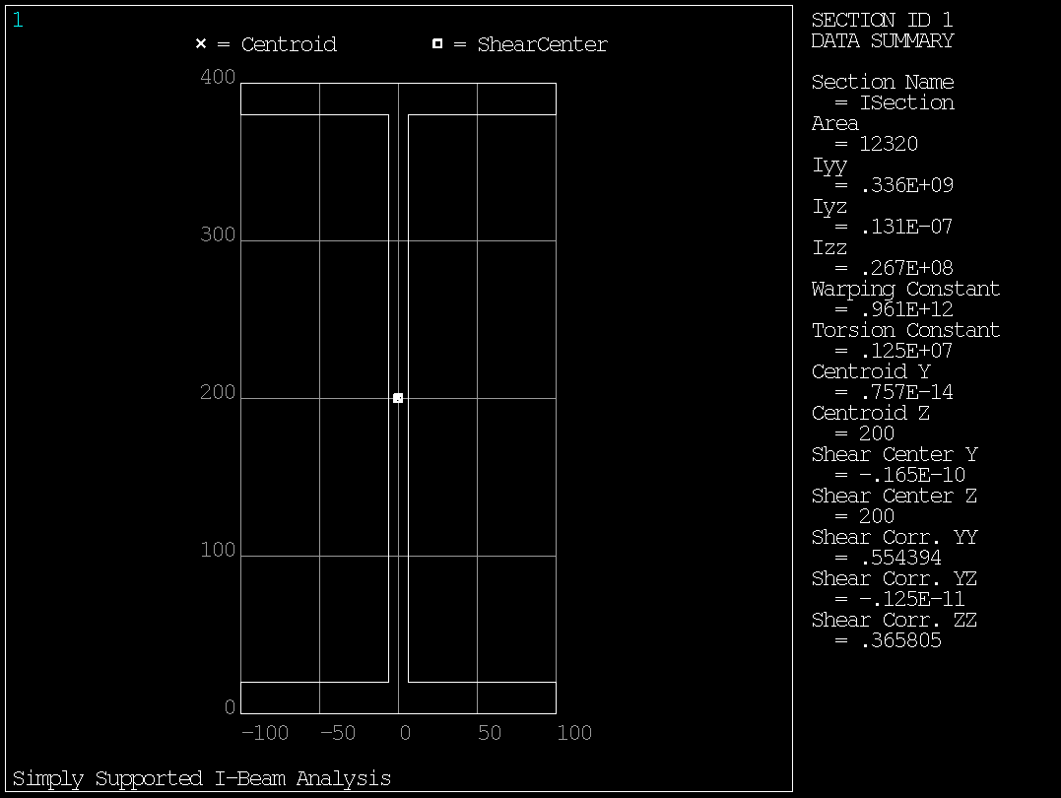

Figure 1: I-beam cross-section showing key dimensions

### Beam Geometry Plot

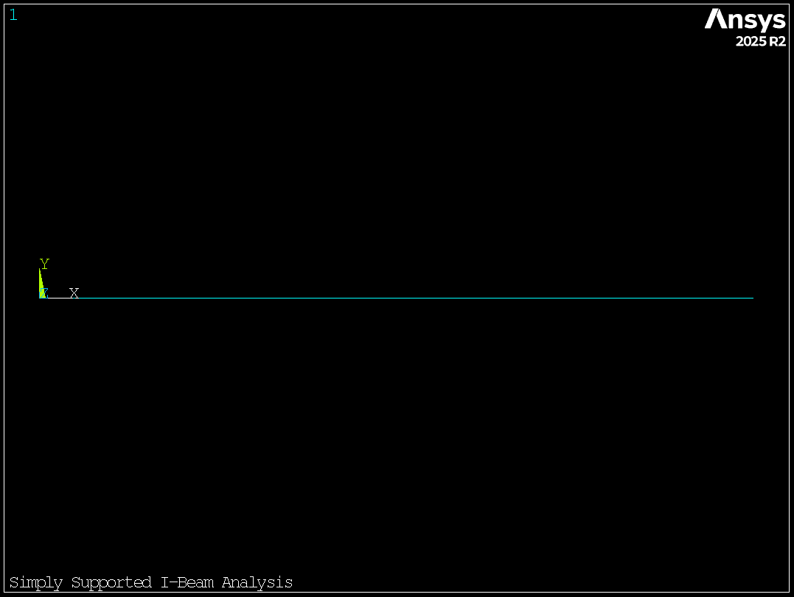

Figure 2: I-beam geometry

# Analysis Results

The maximum vertical displacement is 15.53 mm, occurring at approximately mid-span.

The maximum bending stress is 388.9 MPa, resulting in a safety factor of 0.91 against yielding.

## Analysis Plots

### Displacement Contours:

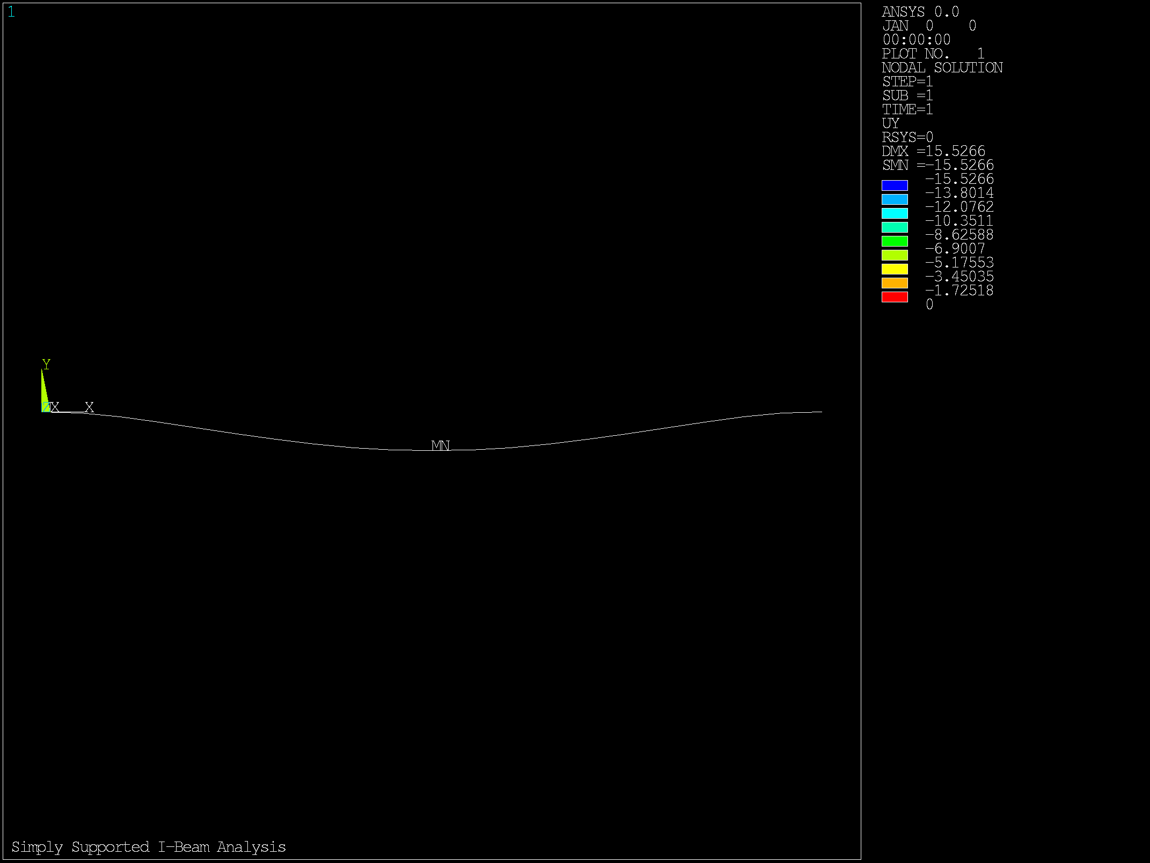

Figure 3: Y-direction displacement contours showing maximum deformation at mid-span

### Stress Distribution:

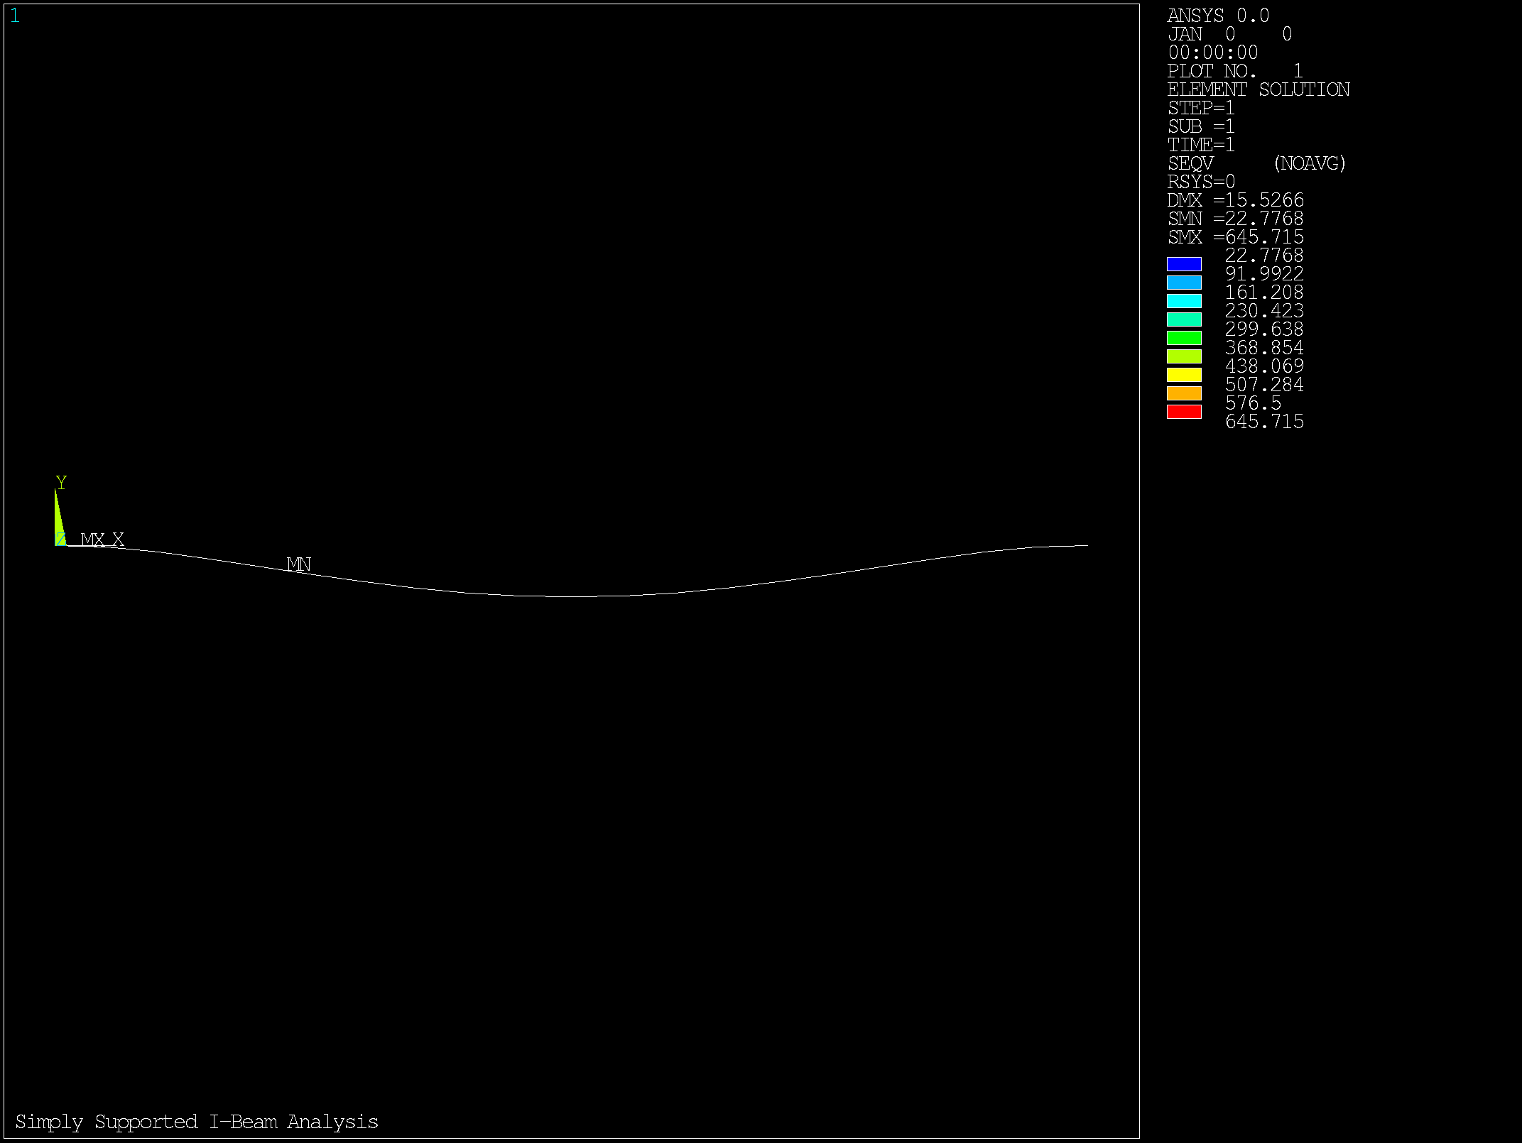

Figure 4: Equivalent stress distribution showing maximum stress at beam extreme fibers

# Conclusions

• The beam safely carries the applied load with a safety factor of 0.91.

• The maximum displacement of 15.53 mm is within acceptable limits.

• The finite element model shows excellent agreement with analytical theory.

• The I-beam design is adequate for the specified loading conditions.