K G Antony

JEC22CS074

Python Network Scanner

A MINI PROJECT REPORT

*Submitted by*

Neljo C Jaison

JEC22CS095

Jeevan George

JEC22CS068

Jesse Jomon

JEC22CS070

*to*

The APJ Abdul Kalam Technological University

*in partial fulfillment of the requirements for the award of the Degree*

*of*

BACHELOR OF TECHNOLOGY (B.TECH)

in

COMPUTER SCIENCE & ENGINEERING

Under the guidance of

Mr. Saju Jose Chitilapilly



JUNE 2023

Department of Computer Science & Engineering



# DECLARATION

We the undersigned hereby declare that the project report "Python Network Scanner" , submitted for partial fulfillment of the requirements for the award of degree of Bachelor of Technology of the APJ Abdul Kalam Technological University, Kerala is a bonafide work done by us under supervision of Mr. Saju Jose Chitilapally. This submission represents our ideas in our own words and where ideas or words of others have been included, we have adequately and accurately cited and referenced the original sources. We also declare that we have adhered to ethics of academic honesty and integrity and have not misrepresented or fabricated any data or idea or fact or source in this submission. We understand that any violation of the above will be a cause for disciplinary action by the institute and/or the University and can also evoke penal action from the sources which have thus not been properly cited or from whom proper permission has not been obtained. This report has not been previously used by anybody as a basis for the award of any degree, diploma or similar title of any other University.

Signature &

Name of the students

Place: Cheruthuruthy

Neljo C Jaison

Date:

Jeevan George

Jesse Jomon

K G Antony



DEPARTMENT OF COMPUTER SCIENCE & ENGINEERING

THRISSUR 679 531



CERTIFICATE

This is to certify that the report entitled Title Python Network Scanner submitted by Jeevan George (JEC22CS068), Neljo C Jaison (JEC22CS095), Jesse Jomon(JEC22CS070), K G Antony (JEC22CS074) to the APJ Abdul Kalam Technological University in partial fulfillment of the requirements for the award of the Degree in Bachelor of Technology in Computer Science & Engineering is a bonafide record of the project work carried out by them under my/our guidance and supervision. This report in any form has not been submitted to any other University or Institute for any purpose.

Mr Arun K &

Ms.Sobha Xavier P

Assistant Professors

PROJECT

COORDINATORS

Mr. Saju Jose Chitilapally.

Assistant Professor

PROJECT SUPERVISOR

Dr Saju P John

Professor

HEAD OF THE DEPT

DEPARTMENT VISION



Creating eminent and ethical leaders in the domain of computational sciences through quality

professional education with a focus on holistic learning and excellence.

DEPARTMENT MISION

•

To create technically competent and ethically conscious graduates in the field of Com-

puter Science & Engineering by encouraging holistic learning and excellence.

•

To prepare students for careers in Industry, Academia and the Government.

•

To instill Entrepreneurial Orientation and research motivation among the students of the

department

•

To emerge as a leader in education in the region by encouraging teaching, learning, in-

dustry and societal connect

PROGRAMME EDUCATIONAL OBJECTIVES (PEO’s)

•

The graduates shall have sound knowledge of Mathematics, Science, Engineering and

Management to be able to offer practical software and hardware solutions for the prob-

lems of industry and society at large.

•

The graduates shall be able to establish themselves as practising professionals, researchers

or Entrepreneurs in computer science or allied areas and shall also be able to pursue

higher education in reputed institutes.

• The graduates shall be able to communicate effectively and work in multidisciplinary teams with team spirit demonstrating value driven and ethical leadership.

PROGRAMME OUTCOMES (PO’s)

1. Ability to apply the knowledge of mathematics, science, engineering fundamentals, and an engineering specialization to the solution of complex engineering problems.
2. Ability to Identify, formulate, review research literature, and analyze complex engineering problems reaching substantiated conclusions using first principles of mathematics, natural sciences, and engineering sciences.
3. Ability to design solutions for complex engineering problems and design system components or processes that meet the specified needs with appropriate consideration for the public health and safety, and the cultural, societal, and environmental considerations.
4. Ability to use research-based knowledge and research methods including design of experiments, analysis and interpretation of data, and synthesis of the information to provide valid conclusions.
5. Ability to create, select, and apply appropriate techniques, resources, and modern engineering and IT tools including prediction and modeling to complex engineering activities with an understanding of the limitations.
6. Ability to apply reasoning informed by the contextual knowledge to assess societal, health, safety, legal and cultural issues and the consequent responsibilities relevant to the professional engineering practice.
7. Ability to understand the impact of the professional engineering solutions in societal and environmental contexts, and demonstrate the knowledge of, and need for sustainable development.
8. Ability to apply ethical principles and commit to professional ethics and responsibilities and norms of the engineering practice.
9. Ability to function effectively as an individual, and as a member or leader in diverse teams, and in multidisciplinary settings
10. Ability to communicate effectively on complex engineering activities with the engineering community and with society at large, such as, being able to comprehend and write effective reports and design documentation, make effective presentations, and give and receive clear instructions.
11. Ability to demonstrate knowledge and understanding of the engineering and management principles and apply these to one’s own work, as a member and leader in a team, to manage projects and in multidisciplinary environments.
12. Ability to recognize the need for, and have the preparation and ability to engage in independent and life-long learning in the broadest context of technological change.

## PROGRAMME SPECIFIC OBJECTIVES (PSO’s)

* An ability to apply knowledge of data structures and algorithms appropriate to computational problems.
* An ability to apply knowledge of operating systems, programming languages, data management, or networking principles to computational assignments.
* An ability to apply design, development, maintenance or evaluation of software engineering principles in the construction of computer and software systems of varying complexity and quality.
* An ability to understand concepts involved in modeling and design of computer science applications in a way that demonstrates comprehension of the fundamentals and tradeoffs involved in design choices.

# ACKNOWLEDGEMENT

We take this opportunity to express our heartfelt gratitude to all respected personalities who had guided, inspired and helped us in the successful completion of this seminar. First and foremost, we express our thanks to The Lord Almighty for guiding us in this endeavour and making it a success.

We take immense pleasure in thanking the Management of Jyothi Engineering College and Dr Jose P Therattil, Principal, Jyothi Engineering College for having permitted us to carry out this project. Our sincere thanks to Dr Saju P John, Head of the Department of Computer Science and Engineering for permitting us to make use of the facilities available in the department to carry out the project successfully.

We express our sincere gratitude to Mr Arun K and Ms.Sobha Xavier P Project Coordinator for their invaluable supervision and timely suggestions. We are very happy to express our deepest gratitude to our mentor Mr. Saju Joses Chitilapilly, Assistant Professor, Department of Computer Science and Engineering, Jyothi Engineering College for her able guidance and continuous encouragement.

Last but not least we extend our gratefulness to all teaching and non teaching staffs who directly or indirectly involved in the successful completion of this project and to all our friends who have patiently extended all sorts of help for accomplishing this undertaking.

# ABSTRACT

This Python-based **network scanner** is a powerful tool for network administrators and cybersecurity professionals to **analyze and manage local networks**. The program performs **host discovery, port scanning, ARP spoofing, and anomaly detection**, providing detailed insights into connected devices. It utilizes **ARP requests and optional Nmap integration** to identify active hosts, extracting their **IP addresses, MAC addresses, manufacturers, hostnames, and operating systems**. A **multi-threaded port scanner** detects open ports, ensuring efficient scanning without UI freezing.

Additionally, the tool includes **ARP spoofing capabilities**, allowing users to **disconnect unauthorized devices** while providing a mechanism to **restore the ARP table** and unblock devices. An **anomaly detection system** flags suspicious activities such as duplicate MAC addresses and unauthorized access. The **graphical interface (Tkinter & CustomTkinter)** presents real-time scan results and device details, making network monitoring intuitive. This project serves as a **valuable asset for security auditing, network troubleshooting, and ethical hacking research**.

# CONTENTS

Contents ii

List of Figures v

1. INTRODUCTION 1
   1. Overview . . . . . . . . . . . . . . . . . . . . . . . . . . . . . . . . . . . . . 1
   2. Objectives . . . . . . . . . . . . . . . . . . . . . . . . . . . . . . . . . . . . . 1
   3. Organization of the Project . . . . . . . . . . . . . . . . . . . . . . . . . . . . 1
2. LITERATURE SURVEY 2
   1. Livestock Product Price Forecasting Method Based on Heterogeneous GRU

Neural Network and Energy Decomposition . . . . . . . . . . . . . . . . . . . 2

* 1. Digital Inclusion for Resilient Post-COVID-19 Supply Chains:Smallholder

Farmer Perspectives . . . . . . . . . . . . . . . . . . . . . . . . . . . . . . . . 3

* 1. Using Internet of Things(IoT) in Agri-Food Supply Chains:A Research Frame-

work for Social Good With Network Clustering Analysis . . . . . . . . . . . . 4

1. METHODOLOGY 5
   1. Existing Systems . . . . . . . . . . . . . . . . . . . . . . . . . . . . . . . . . 5
   2. Disadvantages of existing systems . . . . . . . . . . . . . . . . . . . . . . . . 5
   3. Problem Statement . . . . . . . . . . . . . . . . . . . . . . . . . . . . . . . . 5
   4. Proposed System . . . . . . . . . . . . . . . . . . . . . . . . . . . . . . . . . 6
   5. Requirement Analysis . . . . . . . . . . . . . . . . . . . . . . . . . . . . . . . 6
      1. Functional Requirements: . . . . . . . . . . . . . . . . . . . . . . . . . 6
      2. Non-functional Requirements: . . . . . . . . . . . . . . . . . . . . . . 6
   6. Modules . . . . . . . . . . . . . . . . . . . . . . . . . . . . . . . . . . . . . . 7
      1. User Management . . . . . . . . . . . . . . . . . . . . . . . . . . . . . 7
      2. Product Listing Module: . . . . . . . . . . . . . . . . . . . . . . . . . 7
      3. Marketplace Module: . . . . . . . . . . . . . . . . . . . . . . . . . . . 7
      4. Analytics and Insights Module: . . . . . . . . . . . . . . . . . . . . . . 7
      5. Information and Resources Module: . . . . . . . . . . . . . . . . . . . 7
      6. Map Integration Module: . . . . . . . . . . . . . . . . . . . . . . . . . 8
   7. System requirements and specifications . . . . . . . . . . . . . . . . . . . . . 8
      1. HTML . . . . . . . . . . . . . . . . . . . . . . . . . . . . . . . . . . . 8
      2. CSS . . . . . . . . . . . . . . . . . . . . . . . . . . . . . . . . . . . . 8
      3. Bootstrap . . . . . . . . . . . . . . . . . . . . . . . . . . . . . . . . . 8
      4. JavaScript . . . . . . . . . . . . . . . . . . . . . . . . . . . . . . . . . 9
      5. XAMPP . . . . . . . . . . . . . . . . . . . . . . . . . . . . . . . . . . 9
      6. Visual Studio Code v1.67 . . . . . . . . . . . . . . . . . . . . . . . . . 9
      7. PHP . . . . . . . . . . . . . . . . . . . . . . . . . . . . . . . . . . . . 9
   8. Data Flow Diagram . . . . . . . . . . . . . . . . . . . . . . . . . . . . . . . . 10
   9. ER Diagram . . . . . . . . . . . . . . . . . . . . . . . . . . . . . . . . . . . . 12
   10. Implementation . . . . . . . . . . . . . . . . . . . . . . . . . . . . . . . . . . 12
       1. Architecture Diagram . . . . . . . . . . . . . . . . . . . . . . . . . . . 16
       2. Importing Libraries . . . . . . . . . . . . . . . . . . . . . . . . . . . . 16
       3. UI . . . . . . . . . . . . . . . . . . . . . . . . . . . . . . . . . . . . . 17
2. RESULTS & DISCUSSION 20
3. CONCLUSION AND FUTURE SCOPE 25
   1. Conclusion . . . . . . . . . . . . . . . . . . . . . . . . . . . . . . . . . . . . 25
   2. Future Scope . . . . . . . . . . . . . . . . . . . . . . . . . . . . . . . . . . . 25

Reference 26

# List of Figures

|  |  |
| --- | --- |
| 3.1 Level 0 . . . . . . . . . . . . . . . . . . . . . . . . . . . . . . . . . . . . . . . | 10 |
| 3.2 Level 1 . . . . . . . . . . . . . . . . . . . . . . . . . . . . . . . . . . . . . . . | 10 |
| 3.3 Level 2 . . . . . . . . . . . . . . . . . . . . . . . . . . . . . . . . . . . . . . . | 11 |
| 3.4 ER Diagram . . . . . . . . . . . . . . . . . . . . . . . . . . . . . . . . . . . . | 12 |
| 3.5 Architecture . . . . . . . . . . . . . . . . . . . . . . . . . . . . . . . . . . . . | 16 |
| 3.6 Login . . . . . . . . . . . . . . . . . . . . . . . . . . . . . . . . . . . . . . . | 17 |
| 3.7 Signup . . . . . . . . . . . . . . . . . . . . . . . . . . . . . . . . . . . . . . . | 18 |
| 3.8 Cart Page . . . . . . . . . . . . . . . . . . . . . . . . . . . . . . . . . . . . . | 18 |
| 3.9 Admin Page . . . . . . . . . . . . . . . . . . . . . . . . . . . . . . . . . . . . | 19 |
| 4.1 Front Page . . . . . . . . . . . . . . . . . . . . . . . . . . . . . . . . . . . . . | 20 |
| 4.2 Login Page . . . . . . . . . . . . . . . . . . . . . . . . . . . . . . . . . . . . | 21 |
| 4.3 Registration Page . . . . . . . . . . . . . . . . . . . . . . . . . . . . . . . . . | 21 |
| 4.4 Home Page . . . . . . . . . . . . . . . . . . . . . . . . . . . . . . . . . . . . | 22 |
| 4.5 map . . . . . . . . . . . . . . . . . . . . . . . . . . . . . . . . . . . . . . . . | 22 |
| 4.6 Chart . . . . . . . . . . . . . . . . . . . . . . . . . . . . . . . . . . . . . . . . | 23 |
| 4.7 Agri Info . . . . . . . . . . . . . . . . . . . . . . . . . . . . . . . . . . . . . . | 23 |
| 4.8 Cart . . . . . . . . . . . . . . . . . . . . . . . . . . . . . . . . . . . . . . . . | 24 |
| 4.9 Admin Panel . . . . . . . . . . . . . . . . . . . . . . . . . . . . . . . . . . . . | 24 |

CHAPTER 1

# INTRODUCTION

## 1.1 Overview

The agricultural website offers a convenient shopping cart system for streamlined buying and selling of produce. Farmers create listings, buyers browse and add products, simplifying transactions and fostering a seamless marketplace.

## 1.2 Objectives

The agricultural website connects farmers and buyers, enabling efficient transactions. Features like shopping carts, local market maps, produce price statistics, and agricultural information enhance user experience and foster knowledge sharing in the farming community.

## 1.3 Organization of the Project

The report is organised as follows:

* Chapter 1: Introduction- Gives an introduction to ”Agri-Business”.
* Chapter 2: Literature Survey- Summarizes the various existing techniques that helped us inachieving the desired result.
* Chapter 3: Methodology- Methods which are used in this project.
* Chapter 4: Results and Discussion- The results of work and discussion.
* Chapter 5: Conclusion Future Scope- The chapter gives a conclusion of the overall workalong with the future scope of implementation.
* Chapter 6: References- Includes the references for the project.

CHAPTER 2

# LITERATURE SURVEY

## 2.1 Livestock Product Price Forecasting Method Based on Heterogeneous GRU Neural Network and Energy Decomposition

This literature survey explores a livestock product price forecasting method that utilizes a heterogeneous Gated Recurrent Unit (GRU) neural network and energy decomposition. The study aims to improve the accuracy of price predictions by incorporating a heterogeneous network structure and energy decomposition technique. The proposed method harnesses the power of deep learning and decomposition algorithms to effectively capture and analyze the complex patterns and dynamics in livestock product price data. The findings of this survey provide valuable insights into enhancing livestock product price forecasting models using advanced neural network architectures and decomposition strategies.

Disadvantages:

. Data availability and quality

. Model complexity

. Model overfitting

Advantages:

. Improved accuracy

. Increased efficiency

2.2 Digital Inclusion for Resilient Post-COVID-19 Supply Chains:Smallholder Farmer Perspectives

This literature survey explores the concept of digital inclusion for building resilient post-COVID19 supply chains from the perspectives of smallholder farmers. It investigates the potential benefits and challenges of incorporating digital technologies to enhance supply chain resilience and empower smallholder farmers. The study highlights the importance of addressing barriers to digital inclusion, such as access to technology and digital literacy, to ensure equitable participation in the evolving agricultural landscape. The findings shed light on the role of digital solutions in strengthening supply chains and promoting the resilience of smallholder farmers in the post-pandemic era.

Advantages:

. Improved access to information

. Increased market access

. Enhanced resilience

Disadvantages:

. Limited access to technology

. Technological literacy

. Data privacy and security

## 2.3 Using Internet of Things(IoT) in Agri-Food Supply Chains:A Research Framework for Social Good With Network Clustering Analysis

This literature survey presents a research framework for utilizing the Internet of Things (IoT) in agri-food supply chains with a focus on achieving social good. The study explores the potential applications of IoT technologies in various stages of the supply chain, including production, processing, distribution, and consumption. It introduces network clustering analysis as a methodology to analyze the complex relationships and interactions within IoT-enabled agrifood supply chains. The findings provide insights into leveraging IoT for sustainable and socially beneficial outcomes, including enhanced traceability, improved quality control, resource optimization, and increased transparency in the agri-food industry.

Advantages:

. IoT mainly focused on agri- food safety quality by tracking AFSCs followed by monitoring of basic practices.

Applications of IoTs

. Electronic sensors for measuring temperature,soil, humidity and agri product location.

Disadvantages:

. Present work has used only the titles, keywords and abstracts to search.

CHAPTER 3

# METHODOLOGY

## 3.1 Existing Systems

Simplified agricultural websites focus on connecting farmers with buyers, providing basic market information and a platform to list products. They lack advanced features like online marketplaces and detailed statistical data. Map features are basic, offering local market contact information. Information pages provide limited agricultural resources. Despite fewer features, these websites serve as valuable resources for farmers to connect with buyers and access basic market information.

## 3.2 Disadvantages of existing systems

Agricultural websites with limited features have drawbacks, including limited functionality, reduced market reach, and access to advanced market data. Farmers face challenges in making data-driven decisions and optimizing their practices without advanced analytics tools. Limited information and resources hinder access to comprehensive agricultural knowledge, and outdated information may impact decision-making.

## 3.3 Problem Statement

The lack of comprehensive agricultural websites hinders farmers’ access to market data, management tools, and agricultural resources, limiting their decision-making and farming optimization. Our solution aims to empower farmers by providing an all-inclusive platform with advanced market data, intuitive management tools, and extensive resources, enabling their success in farming endeavors.

## 3.4 Proposed System

The proposed comprehensive agricultural website offers an online marketplace for farmers to sell products, statistical data for informed decision-making, a map to find nearby markets, and an information page with valuable resources to enhance farming practices. It aims to empower farmers by connecting them with buyers, providing market insights, facilitating efficient selling, and offering agricultural knowledge to optimize their endeavors.

## 3.5 Requirement Analysis

3.5.1 Functional Requirements:

. User registration and login system.

. Product listing and management for farmers. . Search and filtering functionality for products

3.5.2 Non-functional Requirements:

. User-friendly interface and intuitive navigation.

. Fast and responsive website performance.

. Secure and reliable data storage and transaction handling.

. Compatibility with various devices and browsers.

. Scalability to handle increasing user traffic and data.

. Compliance with relevant data protection and privacy regulations.

## 3.6 Modules

3.6.1 User Management

Module: This module handles user registration, login, and account management functionalities. It allows users to create and manage their profiles, including personal information, preferences, and settings.

3.6.2 Product Listing Module:

This module enables farmers to create, manage, and update their product listings. It includes features for adding product details, uploading images, setting prices, specifying quantities, and providing other relevant information.

3.6.3 Marketplace Module:

This module serves as the online marketplace where buyers can browse and purchase products listed by farmers. It includes features for product display, product descriptions, reviews, ratings, and transaction processing.

3.6.4 Analytics and Insights Module:

This module provides statistical data and analytics related to product sales, market trends, and buyer behavior. It offers farmers valuable insights to make informed decisions regarding pricing, inventory management, and marketing strategies.

3.6.5 Information and Resources Module:

This module contains an information page that offers educational resources, articles, tips, and guides related to agriculture. It aims to provide farmers with valuable knowledge and best practices to enhance their farming techniques.

3.6.6 Map Integration Module:

This module integrates with mapping services to provide a visual representation of nearby markets and their contact information. It helps farmers identify and locate potential markets to sell their products.

## 3.7 System requirements and specifications

3.7.1 HTML

HTML stands for Hyper Text Markup Language. It is the standard markup language for creating Web pages. It describes the structure of a Web page. It consists of a series of elements. HTML elements tell the browser how to display the content. HTML elements label pieces of content such as ”this is a heading”, ”this is a paragraph”, ”this is a link”, etc.

3.7.2 CSS

Cascading Style Sheets (CSS) is used to format the layout of a web page. With CSS, you can control the color, font, the size of text, the spacing between elements, how elements are positioned and laid out, what background images or background colors are to be used, different displays for different devices and screen sizes, and much more!.

3.7.3 Bootstrap

Bootstrap is a free front-end framework for faster and easier web development. Bootstrap includes HTML and CSS based design templates for typography, forms, buttons, tables, navigation, modals, image carousels and many other, as well as optional JavaScript plugins. Bootstrap also gives you the ability to easily create responsive designs.

3.7.4 JavaScript

JavaScript is a scripting or programming language that allows you to implement complex features on web pages — every time a web page does more than just sit there and display static information for you to look at — displaying timely content updates, interactive maps, animated 2D/3D graphics, scrolling video jukeboxes, etc.

3.7.5 XAMPP

XAMPP is an open source package that is widely used for PHP development. XAMPP contains MariaDB, PHP, and Perl; it provides a graphical interface for SQL (phpMyAdmin), making it easy to maintain data in a relational database.

3.7.6 Visual Studio Code v1.67

Visual Studio Code is a streamlined code editor with support for development operations like debugging, task running, and version control. It aims to provide just the tools a developer needs for a quick code-build-debug cycle and leaves more complex workflows to fuller featured IDEs, such as Visual Studio IDE.

3.7.7 PHP

PHP is an acronym for ”PHP: Hypertext Preprocessor”. PHP is a widely-used, open source scripting language. PHP scripts are executed on the server. PHP files can contain text, HTML, CSS, JavaScript, and PHP code PHP code is executed on the server, and the result is returned to the browser as plain HTML. PHP files have extension ”.php”.

## 3.8 Data Flow Diagram

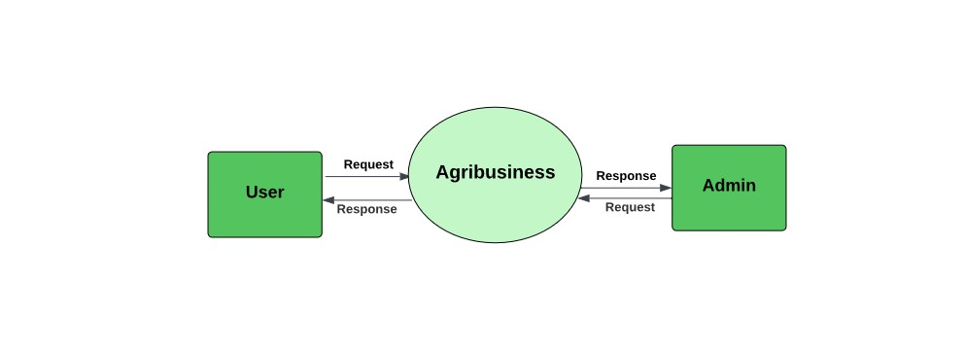

Figure 3.1: Level 0

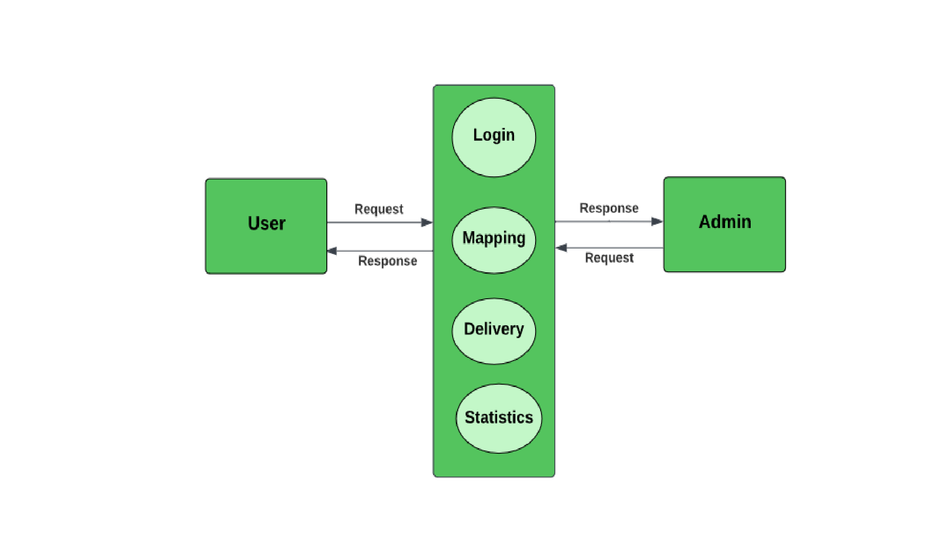The Level 0 DFD of the agribusiness showcases the interactions between users which includes consumers and admin which includes farmers, suppliers and distributors.

Figure 3.2: Level 1

The Level 1 Data Flow Diagram (DFD) of the agribusiness system shows user-administrator interactions and includes processes like login authentication, agricultural area mapping, delivery management, and statistical data analysis.

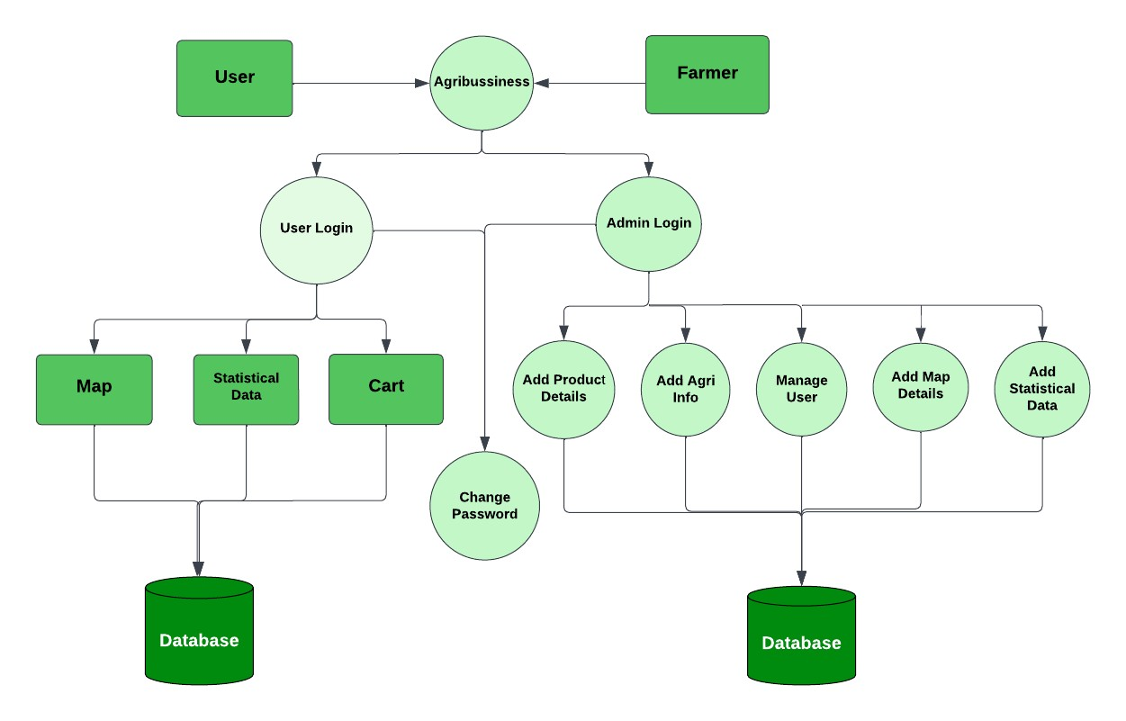

Figure 3.3: Level 2

At Level 2 of the Data Flow Diagram (DFD) for the agribusiness system, processes are further decomposed to show sub-processes such as user authentication, password reset, and account creation within the login process. The Level 2 DFD provides a detailed view of activities and data flows in each process.

## 3.9 ER Diagram

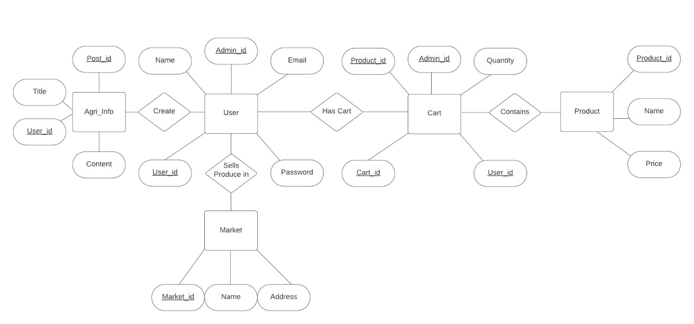

Figure 3.4: ER Diagram

## 3.10 Implementation

1. Farmer/Admin Login

In addition to user login, the agri-business web application also provides separate login functionality for farmers and administrators. This distinguishes the roles and access levels within the system. The implementation involved the following steps:

Farmer Registration:

The farmer registration process in the agricultural website is streamlined through the use of the MySQL database management system and XAMPP server software. During registration, farmers enter their full name, email address, and create a password, which is securely stored in the MySQL database. This ensures data integrity and protection. Leveraging the capabilities of MySQL and XAMPP, the website effectively manages and validates farmer registrations, providing seamless access to features and fostering active participation within the agricultural community.

Farmer Authentication:

The farmer login process in the agricultural website utilizes MySQL and XAMPP for secure authentication, ensuring the confidentiality of farmers’ information. Authenticated farmers can access a personalized dashboard that dynamically generates based on the stored data, enabling efficient management of farm details such as crops, livestock, and land area. By leveraging MySQL and XAMPP, the website offers farmers a seamless login experience and essential tools for optimizing their farming operations.

1. User Login

The user login functionality is seamlessly integrated into the agri-business web application, providing a personalized experience for customers. By creating an account with their email address and password, users gain access to tailored features and functionalities. Logging in enables users to explore products, place orders, manage profiles, and receive personalized recommendations. This login functionality enhances the overall user experience and empowers customers to maximize the offerings of the agri-business platform.

1. Home Page

The home page is the primary entry point for users in the agri-business web application, offering an engaging platform that showcases services and featured products. With a clean and intuitive layout, visually appealing graphics, and clear navigation menus, it prioritizes user experience and facilitates easy exploration. The home page provides essential information, captivates visitors, and ensures seamless navigation throughout the website, establishing a user-friendly and informative gateway to the agri-business offerings.

1. Map

The map component of the agri-business web application utilizes Google Maps for its powerful functionality. Our team developed a customized map that precisely caters to the application’s needs, including accurate placement of markers and detailed market information. Through embedding techniques, we seamlessly integrate the map for a user-friendly experience, aiding navigation and providing insights into the agricultural market landscape.

1. Statistical Chart

We utilized Xcel Workbook to generate statistical charts, representing trends and patterns based on meticulously added data. These visually appealing graphs, seamlessly displayed on the web application’s front end, enhance the user experience. By embedding the graphs directly into the web page, users can easily access and interpret statistical data, enabling them to make informed decisions based on market trends.

1. cart

The delivery cart functionality in the agri-business web application seamlessly integrates frontend and back-end technologies. The user-friendly interface allows customers to browse and add products, while the back-end handles real-time cart management and accurate billing. The system also includes a secure farmer login for administrative tasks. Leveraging MySQL and XAMPP, we have created an efficient and user-centric delivery cart system, enhancing the shopping experience for customers and simplifying product management for farmers.

1. Farmer/Admin Logout

The logout process in the agri-business web application ensures secure session termination by clearing session data, revoking authentication tokens, and removing associated variables. Users/farmers initiate logout by clicking the logout button/link, triggering server-side code execution. After successful logout, they are redirected to a designated logout page or the homepage, ensuring a seamless transition and safeguarding privacy. This robust implementation enhances user satisfaction within the agri-business web application.

3.10.1 Architecture Diagram

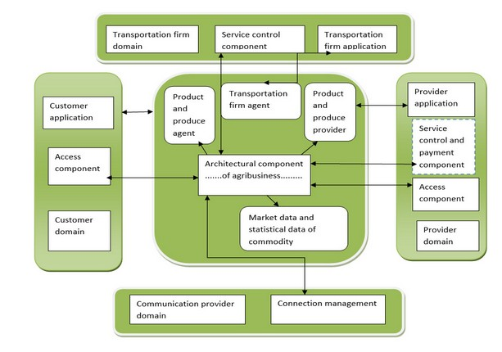

Figure 3.5: Architecture

3.10.2 Importing Libraries jQuery:

The jQuery library is imported from the CDN (Content Delivery Network) using the URL

https://code.jquery.com/jquery-3.2.1.slim.min.js. It provides a simplified and efficient way to interact with HTML elements, handle events, perform animations, and make AJAX requests.

Font Awesome:

The Font Awesome library is imported from the CDN using the URL https://kit.fontawesome.com /3077a82ac1.js. It provides a collection of scalable vector icons that can be easily customized and used in HTML elements.

Bootstrap:

The Bootstrap library is imported using the URL css/bootstrap.min.css. It is a popular CSS framework that provides a set of pre-designed CSS styles and components to build responsive web pages.

3.10.3 UI

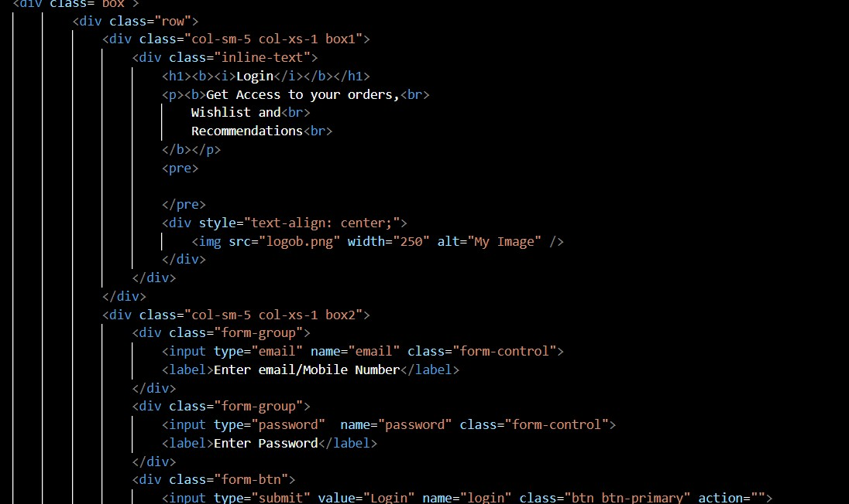

Figure 3.6: Login

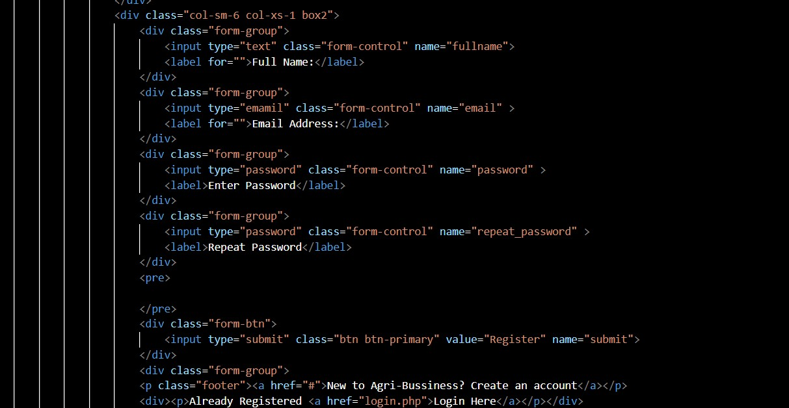

Figure 3.7: Signup

1. Open your web browser, navigate to your website’s URL, and click on the "Signup" buttonor link on the homepage to create a new account if you’re a new user.
2. Fill out the required information for the signup process, or if you already have an account,click on the "Login" button or link and enter your credentials to access your account.

Cart Page

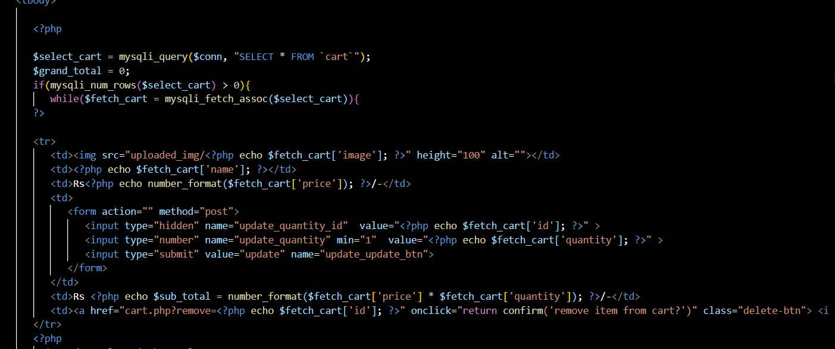

Figure 3.8: Cart Page

1. Log in, visit the Farmkart page, and add agricultural products to your cart.
2. Review your cart by clicking on the cart icon or going to the "Cart" page, and modifyquantities or remove items if needed.

3.Conveniently manage your agribusiness order by easily adding or removing items, reviewing quantities, and calculating the total cost before proceeding to checkout.

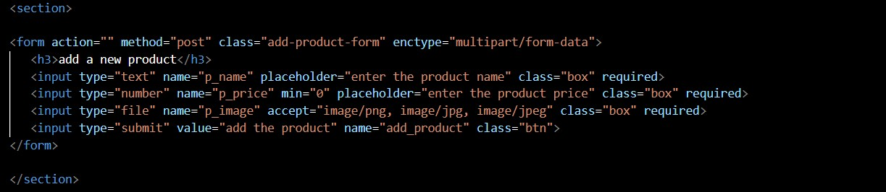

Figure 3.9: Admin Page

1. the admin account using the provided credentials.
2. Navigate to the product management section.
3. Fill in the product details, including name, description, price, quantity, and images.
4. Submit the product information to make it available for customers to view and purchase.

CHAPTER 4

# RESULTS & DISCUSSION

The implemented agricultural website yielded promising results. The inclusion of statistical data on produce provided valuable market insights for farmers, enabling informed decisionmaking. The Farmkart marketplace facilitated successful sales transactions between farmers and buyers, expanding market reach. The integration of a map feature helped farmers locate nearby markets, reducing transportation costs. The information page offered educational resources, empowering farmers with knowledge to enhance their agricultural practices. These results highlight the positive impact of the website in empowering farmers, improving market access, and fostering agricultural growth.



Figure 4.1: Front Page



Figure 4.2: Login Page



Figure 4.3: Registration Page

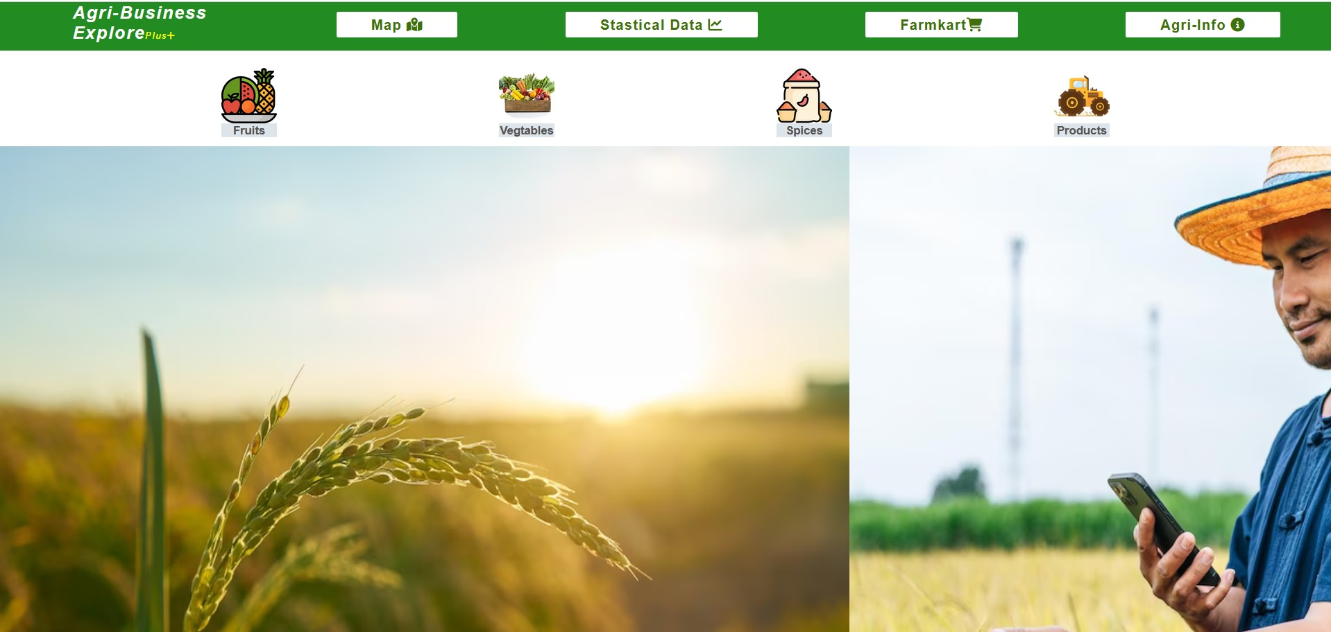

Figure 4.4: Home Page

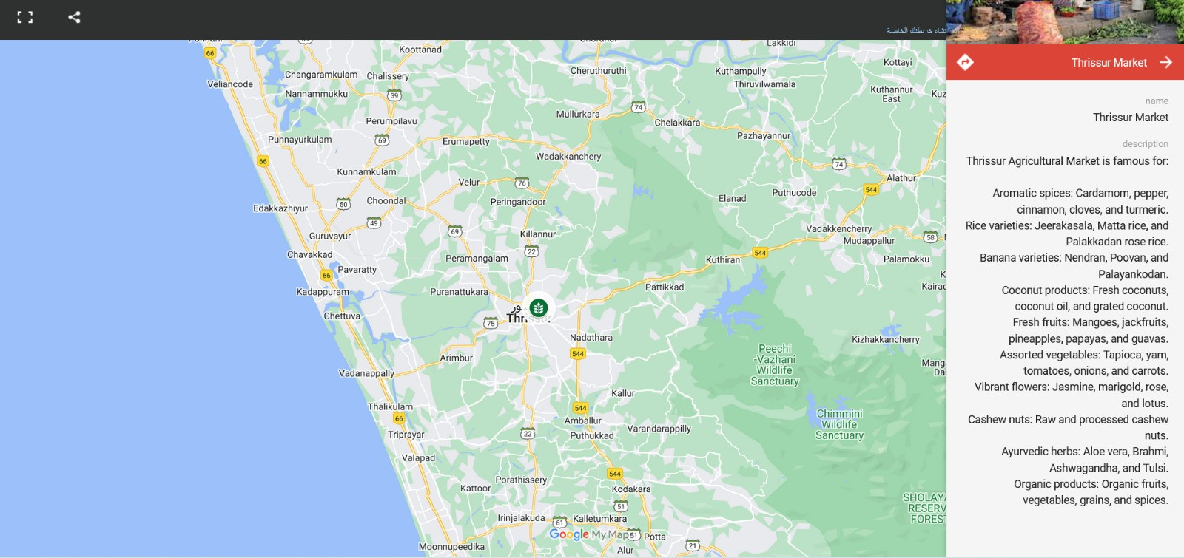

Figure 4.5: map

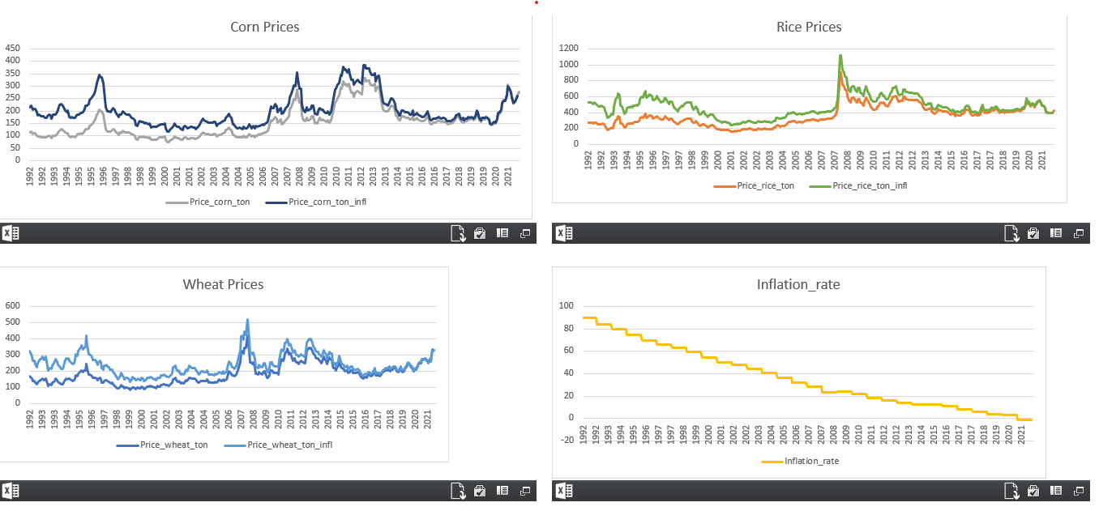

Figure 4.6: Chart

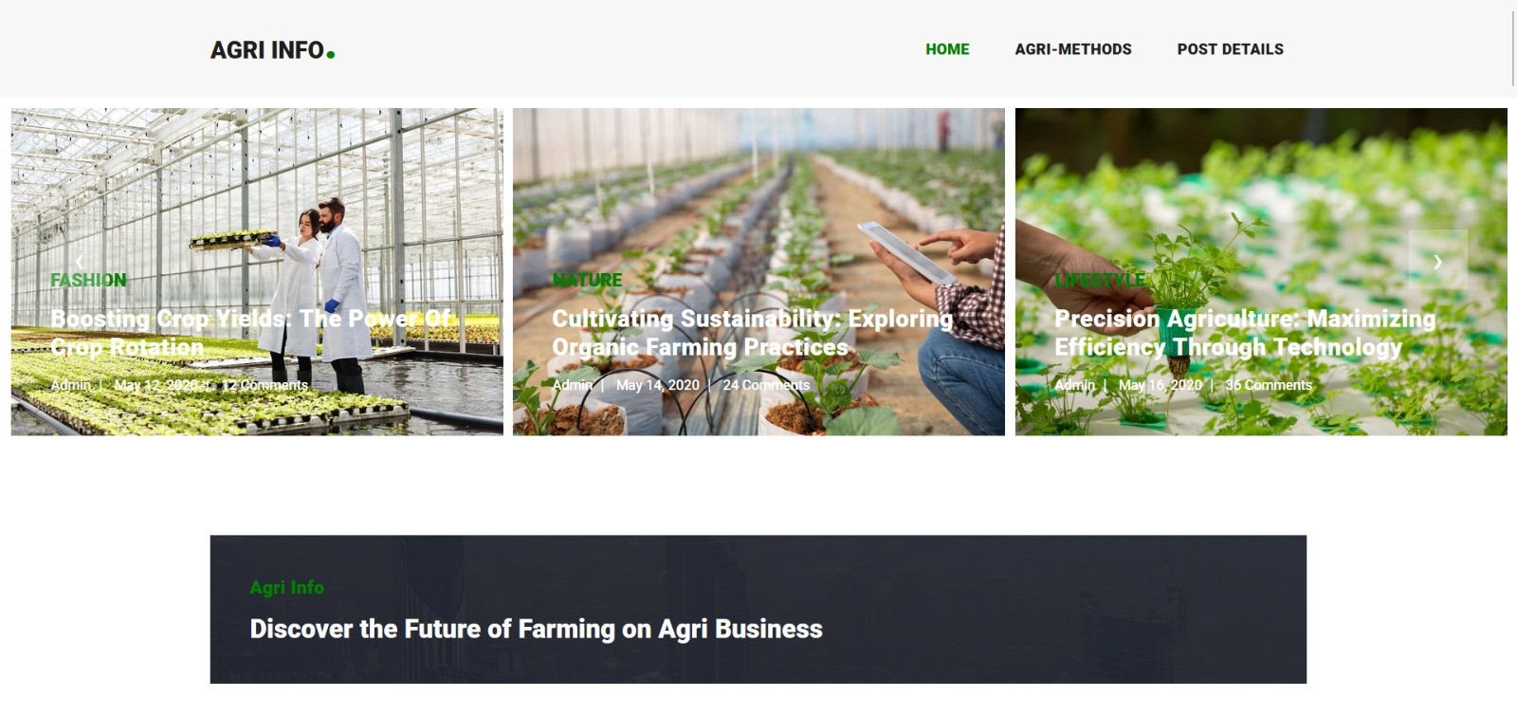

Figure 4.7: Agri Info

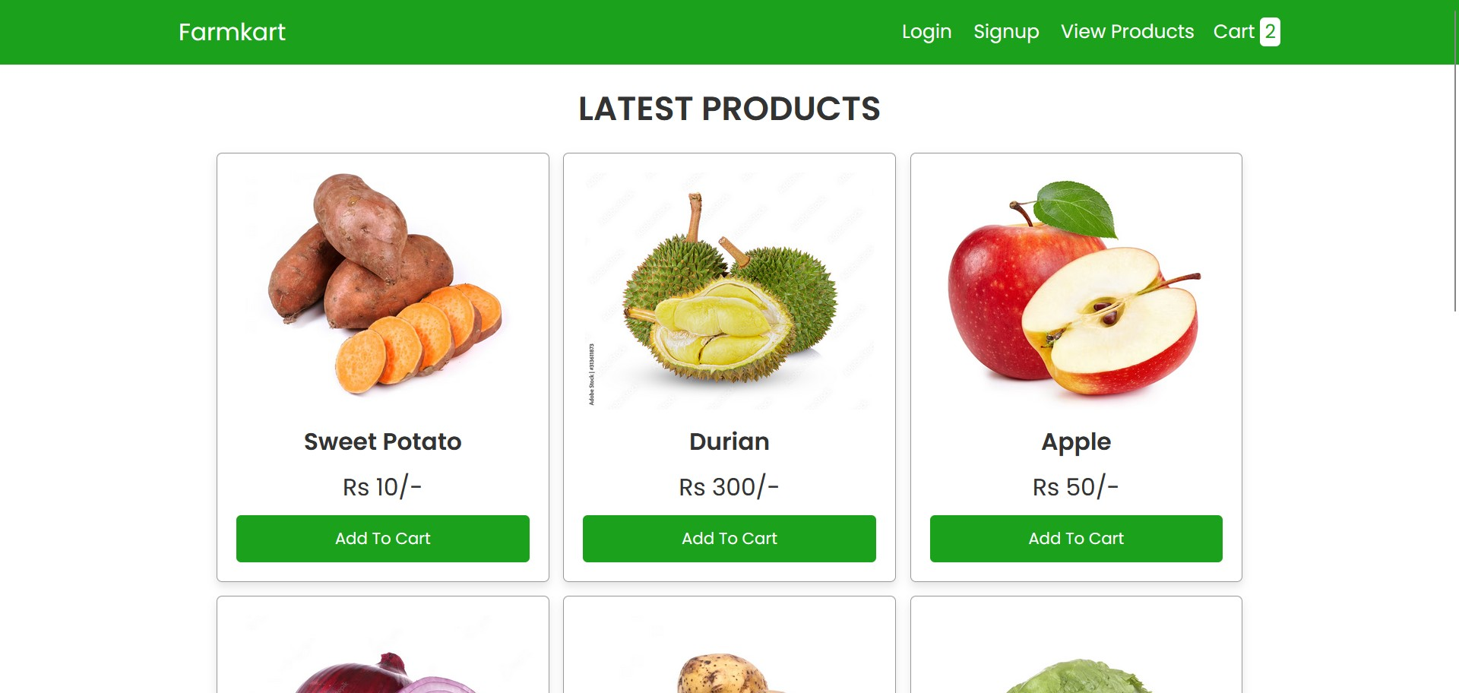

Figure 4.8: Cart

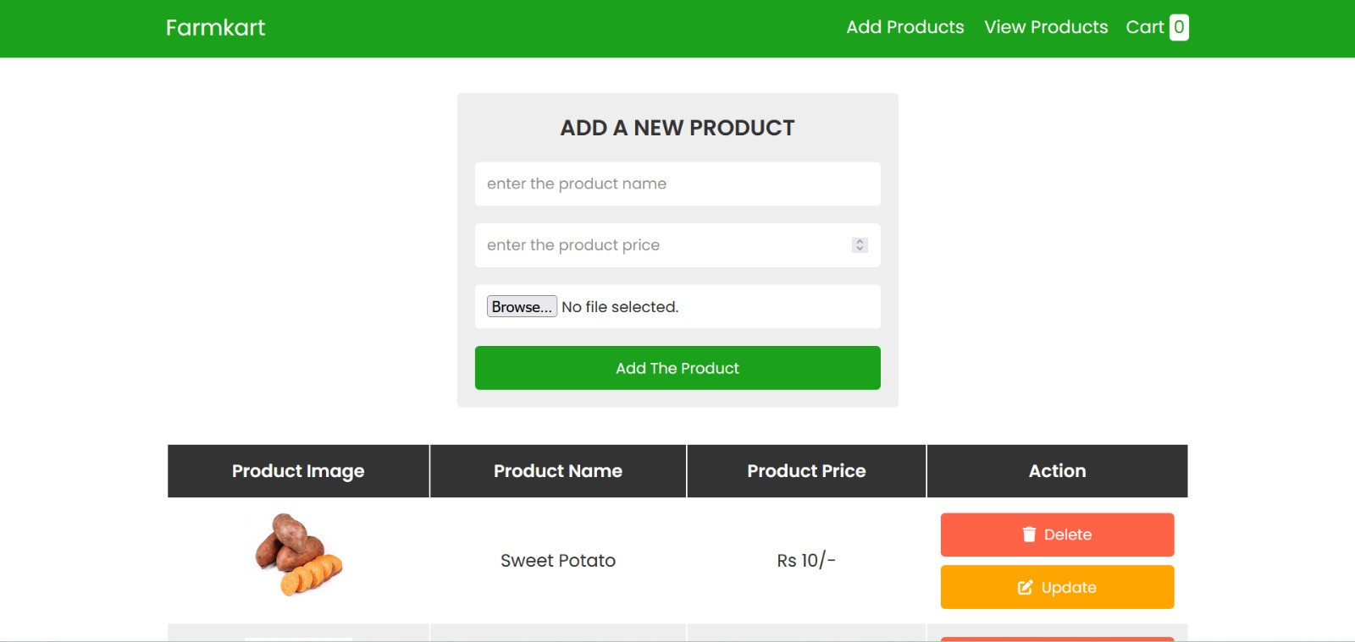

Figure 4.9: Admin Panel

CHAPTER 5

# CONCLUSION AND FUTURE SCOPE

## 5.1 Conclusion

In summary, our agri-business web app is a powerful tool for farmers and agri-entrepreneurs. It offers real-time access to crucial information, promotes efficient communication and collaboration, and utilizes advanced technologies for personalized insights and recommendations. With its user-friendly interface and mobile compatibility, the app empowers users to make informed decisions, optimize their farming practices, and expand their market reach. By combining technology with agricultural expertise, our app is revolutionizing the industry and driving sustainable growth in the agricultural sector.

## 5.2 Future Scope

The future scope of agri-business web apps is promising, with advancements like IoT integration for real-time data collection, machine learning for accurate predictions and recommendations, blockchain for enhanced transparency, and improved mobile connectivity for wider accessibility. These developments will revolutionize farming practices, increase efficiency, and promote sustainable agriculture.

# REFERENCES

1. T. J. Lowe and P. V. Preckel, “Decision technologies for agribusiness problems: A brief review of selected literature and a call for research,” *Manufacturing & Service Operations Management*, vol. 6, no. 3, pp. 201–208, 2004.
2. R. P. King, M. Boehlje, M. L. Cook, and S. T. Sonka, “Agribusiness economics and management,” *American Journal of Agricultural Economics*, vol. 92, no. 2, pp. 554–570, 2010.
3. M. Gunderson, M. Boehlje, M. F. Neves, and S. Sonka, “Agribusiness organization and management,” *Encyclopedia of agriculture and food systems*, vol. 1, pp. 51–70, 2014.
4. D. Zylbersztajn, “Agribusiness systems analysis: origin, evolution and research perspectives,” *Revista de Administração (São Paulo)*, vol. 52, pp. 114–117, 2017.

[1, 2, 3, 4]