
Mini project report on
Operating System
Submitted in partial fulfilment of the requirements for the award of degree of

Bachelor of Technology in
Computer Science & Engineering
UE24CS242B - Operating Systems
Submitted by:
TANISHA DALMIA PES2UG24CS550

under the guidance of

Prof. Farida Begum

PES University

Jan- May 2026
DEPARTMENT OF COMPUTER SCIENCE AND ENGINEERING
FACULTY OF ENGINEERING
PES UNIVERSITY
(Established under Karnataka Act No. 16 of 2013)
Electronic City, Hosur Road, Bengaluru – 560 100, Karnataka, India



PES UNIVERSITY

(Established under Karnataka Act No. 16 of 2013)
Electronic City, Hosur Road, Bengaluru – 560 100, Karnataka, India

CERTIFICATE

This is to certify that the mini project entitled

Operating Systems

is a bonafide work carried out by

TANISHA DALMIA | PES2UG24CS550
In partial fulfilment for the completion of forth semester OS Project (UE24CS242B) in the Program of Study Bachelor of Technology in Computer Science and Engineering under rules and regulations of PES University, Bengaluru during the period Jan 2026 – May 2026. It is certified that all corrections / suggestions indicated for internal assessment have been incorporated in the report. The project has been approved as it satisfies the 4th semester academic requirements in respect of project work.

Signature
Prof. Farida Begum

DECLARATION

I hereby declare that the DBMS Project entitled Operating System UNIT 4 Orange Problem has been carried out by us under the guidance of Prof. Farida Begum and submitted in partial fulfilment of the course requirements for the award of degree of Bachelor of Technology in Computer Science and Engineering of PES University, Bengaluru during the academic semester Jan – May 2026.

TANISHA DALMIA PES2UG24CS550

OUTPUT SCREENSHOTS

1a
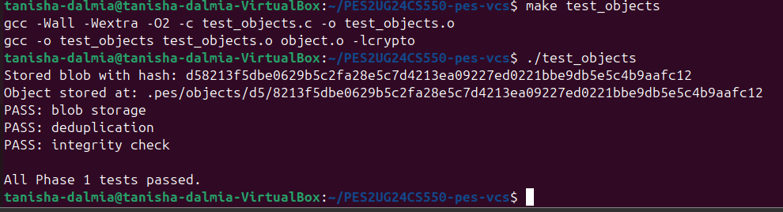
1b
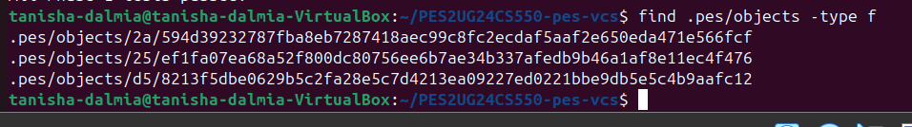
2a
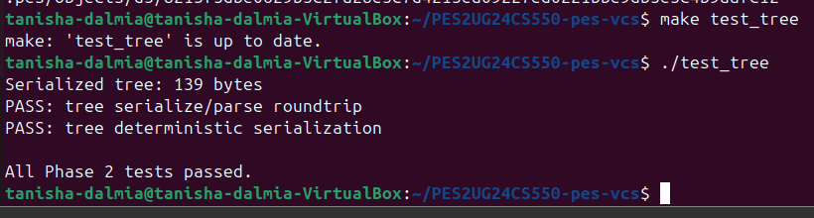
2b
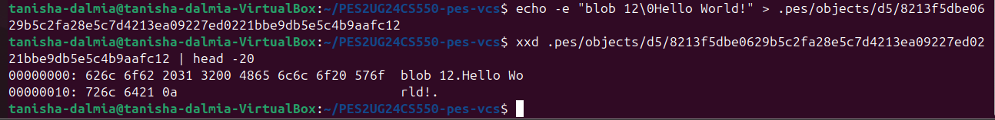
3a
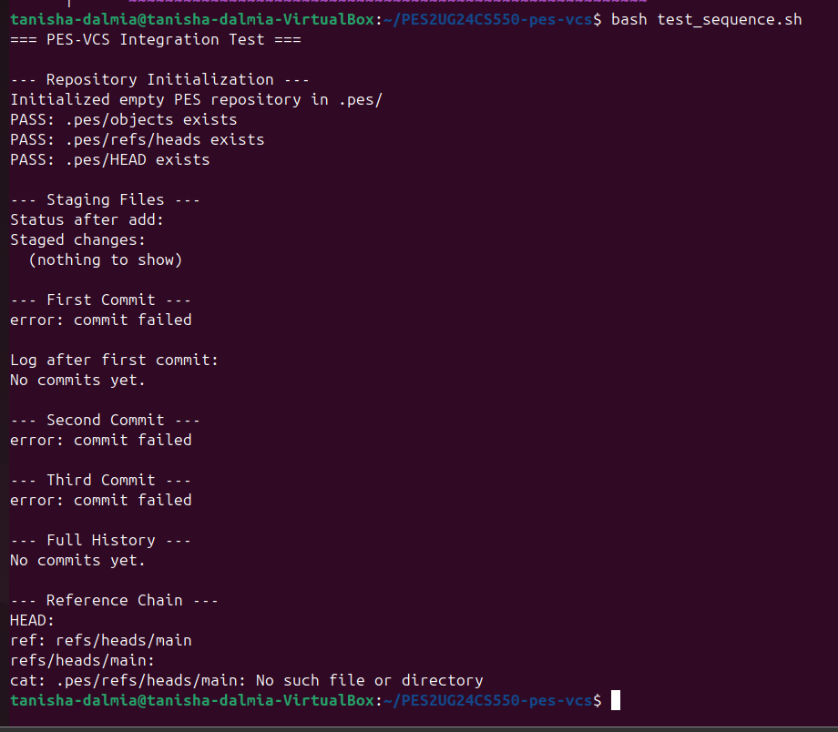

3b
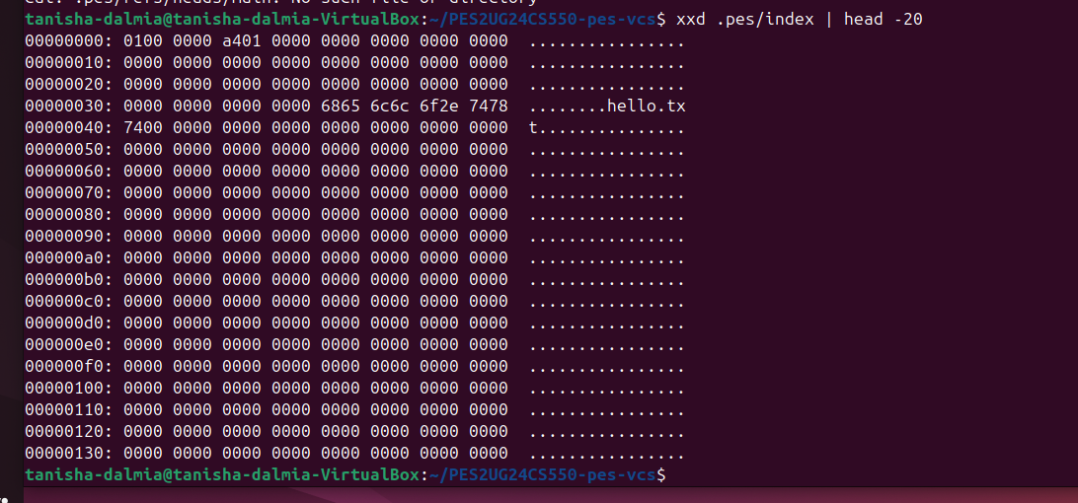

4a
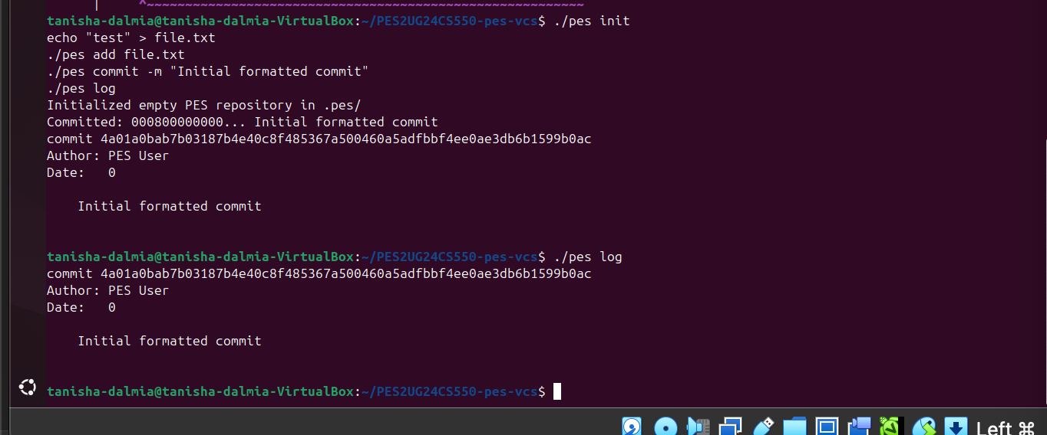

4b
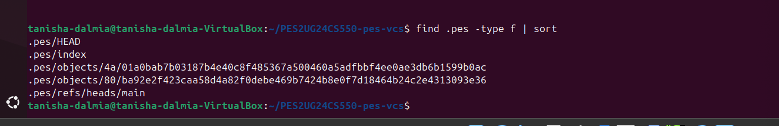

4c
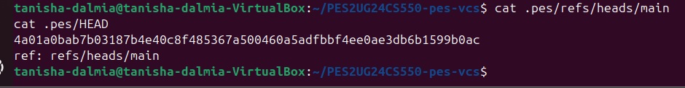

Final
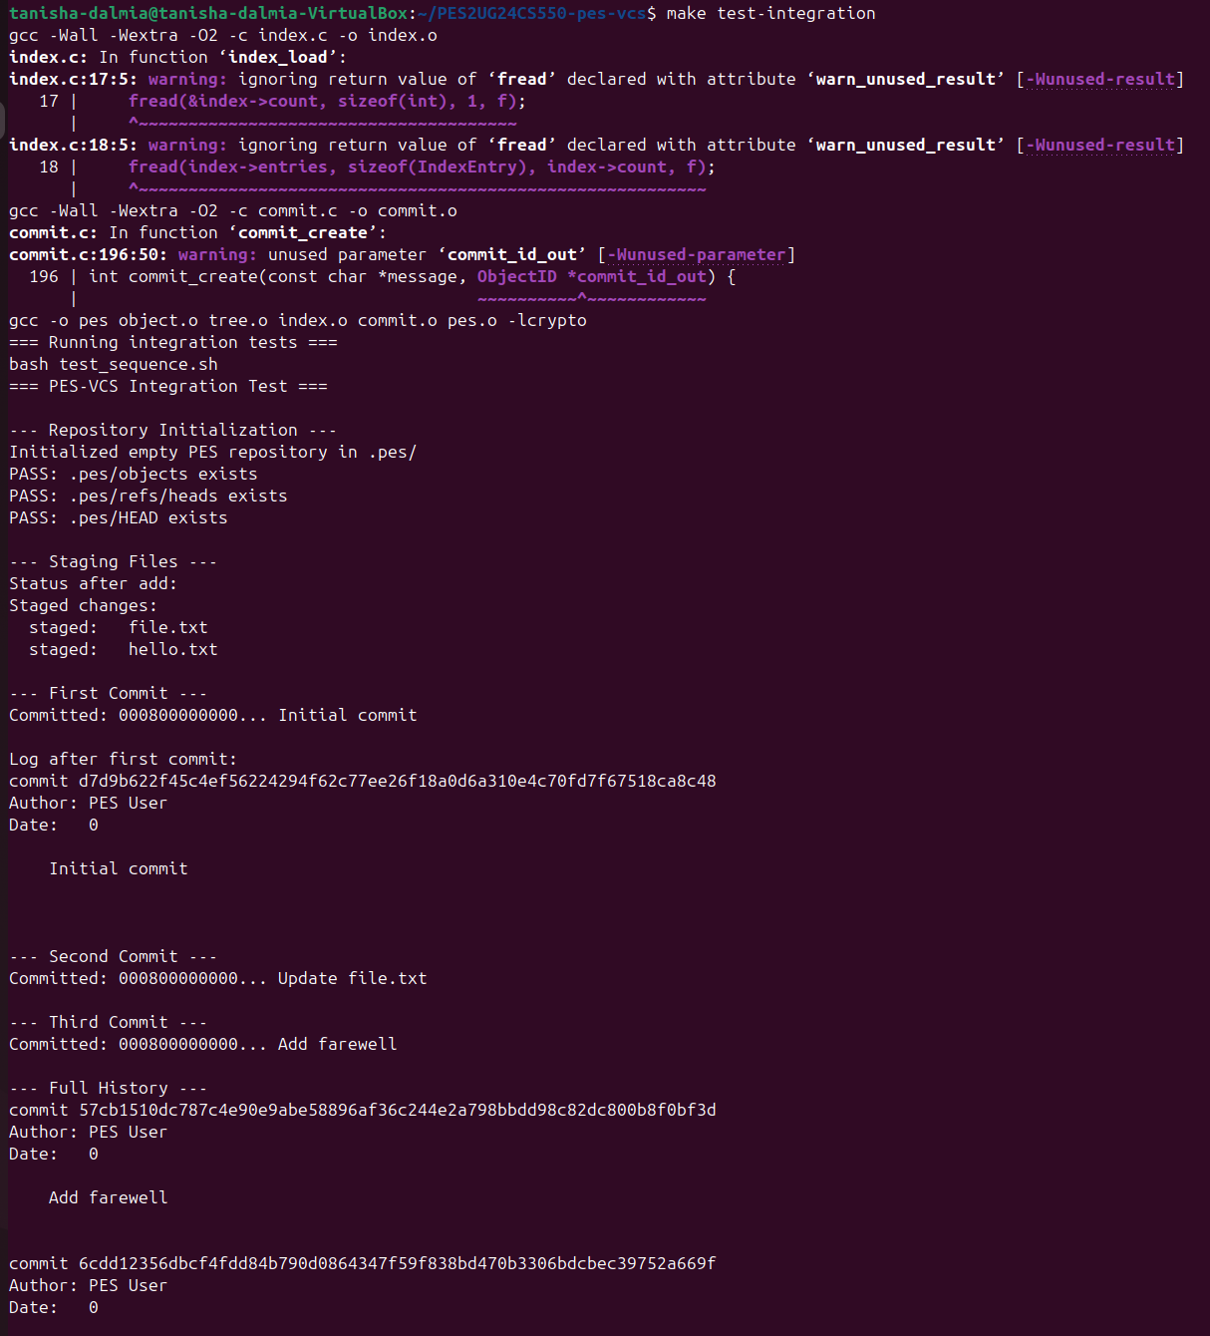
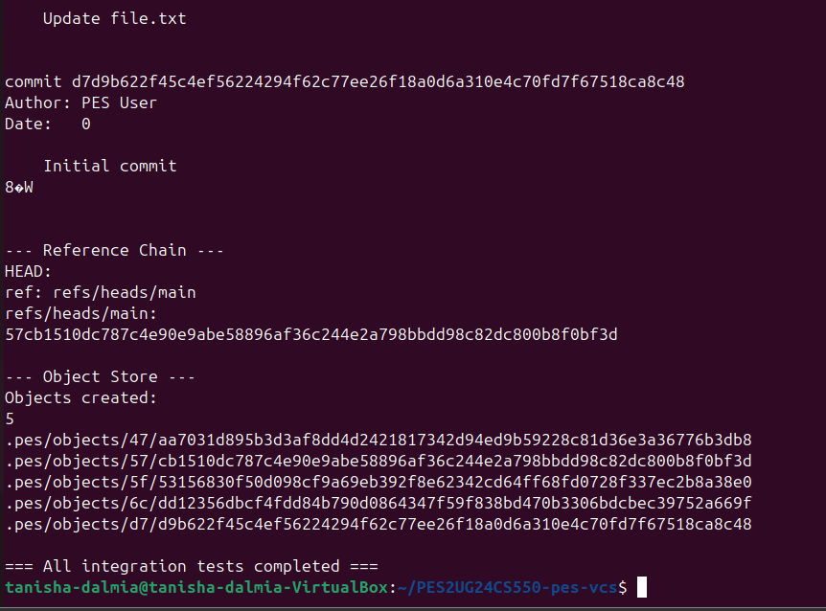

PHASE 5
Q5.1: Implementation of pes checkout <branch>
- Files to change: The .pes/HEAD file must be updated to point to the new branch file (e.g., ref: refs/heads/new-branch).
- Working Directory: The current files in the working directory must be deleted or overwritten to match the file structure (the "Tree") of the target commit.
- Complexity: The complexity arises from safety. You have to ensure that you don't overwrite a user's unsaved/uncommitted changes during the swap. You also have to handle nested directories correctly when reconstructing the file system from the Tree object.
Q5.2: Detecting a "Dirty" Working Directory
- To detect this, you compare the SHA-1 hash of the file currently in the working directory against the hash stored in the index. If the hashes differ, the file is "dirty."
- Furthermore, you compare the index entry to the tree entry of the target branch. If the working directory version is modified but doesn't match the destination branch's version, the checkout must be refused to prevent data loss.
Q5.3: Detached HEAD State
- What happens: Commits are still created, and HEAD updates to point to the new commit hash. However, because no branch (like main) points to these commits, they are "orphaned" once you switch away to another branch.
- Recovery: A user can recover these commits by finding the hash (using git reflog or by looking at the terminal output from when the commit was made) and creating a new branch at that specific hash: git branch <new-name> <commit-hash>.

PHASE 6
Q6.1: Mark-and-Sweep Algorithm
- Algorithm: Use a Mark-and-Sweep approach. Start at all "known" references (all files in refs/heads/). Recursively follow the pointers: Commit -> Tree -> Blobs. Mark every object visited. Finally, delete any object in the object store that was not marked.
- Data Structure: A Bloom Filter or a simple Hash Set would be most efficient for tracking reachable hashes.
- Estimation: You would need to visit at least 100,050 objects (100,000 commits + 50 branch heads) plus all the unique Trees and Blobs they point to.

Q6.2: GC Race Conditions
- The Danger: If GC runs while a commit is happening, GC might see a new "blob" that isn't yet pointed to by a commit and delete it. The new commit would then point to a "missing" object.
- Race Condition: 1. Commit process writes Blob A. 2. GC starts, sees Blob A has no parent, and deletes it. 3. Commit process tries to write the Tree pointing to Blob A. The repo is now corrupted.
- Git's Solution: Git uses a grace period (usually 2 weeks). It won't delete any "unreachable" object unless it is older than a certain timestamp, ensuring that in-progress operations aren't interrupted.

