河南工业大学实验报告
课 程 | 高级Java编程技术 | 实验名称 | 高级Java编程技术实验
专业班级 | 计科1602 | 院 系 | 信息科学与工程学院
姓 名 |  | 学 号
指导老师 |  | 日 期 | 2019.6.24
- 实验目的
综合运用本学期所学知识和技能，完成实验材料所给的基本要求，提高综合实践能力。
- 实验要求
根据本课程实验材料和各次实验列出的任务要求，完成一个相对完整的小型管理系统，涉及到的核心知识包括数据库访问（JDBC、事务）、配置文件、对象序列化与反序列化、多线程、计时器、网络编程、Swing界面与事件驱动模型、正则表达式和格式化显示等。
2）严禁抄袭，否则作废！
- 实验过程及结果
3.1 基本模块1：对象序列化与反序列化（订单和订单项对应的类代码）

订单Orders.java
package water.test1.po;
import java.io.Serializable;
import java.sql.Date;
public class Orders implements Serializable {
private String orderID;
private String customerID;
private Date orderTime;
private double totalMoney;
private String orderState;
private String senderName;
private String senderPhone;
public Orders()
{

}
public Orders(String orderID,String customerID,Date orderTime,double totalMoney,String orderState,String senderName,String senderPhone)
{
this.orderID=orderID;
this.customerID=customerID;
this.orderTime=orderTime;
this.totalMoney=totalMoney;
this.orderState=orderState;
this.senderName=senderName;
this.senderPhone=senderPhone;
}
public void setOrderID(String orderID)
{
this.orderID=orderID;
}
public void setCustomerID(String customerID)
{
this.customerID=customerID;
}
public void setOrderTime(Date orderTime)
{
this.orderTime=orderTime;
}
public void setTotalMoney(double totalMoney)
{
this.totalMoney=totalMoney;
}
public void setOrderState(String orderState)
{
this.orderState=orderState;
}
public void setSenderName(String senderName)
{
this.senderName=senderName;
}
public void setSenderPhone(String senderPhone)
{
this.senderPhone=senderPhone;
}
public String getOrderID()
{
return this.orderID;
}
public String getCustomerID()
{
return this.customerID;
}
public Date getOrderTime()
{
return this.orderTime;
}
public double getTotalMoney()
{
return this.totalMoney;
}
public String getOrderState()
{
return this.orderState;
}
public String getSenderName()
{
return this.senderName;
}
public String getSenderPhone()
{
return this.senderPhone;
}

public String toString() {
return this.getOrderID() + "," + this.getCustomerID() + "," + this.getOrderTime()
+ "," + this.getTotalMoney() + "," + this.getOrderState()+ "," + this.getSenderName()
+ "," + this.getSenderPhone();
}

}
订单项OrderItems.java
package water.test1.po;
import java.io.Serializable;
public class OrderItems implements Serializable {
private String orderID;
private String type;
private double price;
private int number;
private double total;
public OrderItems()
{

}
public OrderItems(String orderID,String type,double price,int number,double total){
this.orderID=orderID;
this.type=type;
this.price=price;
this.number=number;
this.total=total;
}
public void setOrderID(String orderID)
{
this.orderID=orderID;
}
public void setType(String type)
{
this.type=type;
}
public void setPrice(double price)
{
this.price=price;
}
public void setNumber(int number)
{
this.number=number;
}
public void setTotal(double total)
{
this.total=total;
}
public String getOrderID()
{
return this.orderID;
}
public String getType()
{
return this.type;
}
public double getPrice()
{
return this.price;
}
public int getNumber()
{
return this.number;
}
public double getTotal()
{
return this.total;
}

public String toString() {
return this.getOrderID() + "," + this.getType()+ "," + this.getPrice()
+ "," + this.getNumber() + "," + this.getTotal();
}}
3.2 基本模块2：JDBC下单事务和商品浏览功能的相关代码、必要的方案说明。

对于下单，我采用了购物车的方式，浏览商品后可添加至个人购物车，在购物车中选择需要购买的商品可完成下单操作。对于下单事务，包括3个操作——删除购物车中的商品、生成订单、生成订单对应的所有订单项，一旦3个步骤任意一个出现错误，便进行回滚操作。
对于商品浏览，我采用JTree的方式来对商品进行展示，所以需要获取产品集合，然后在JTree中进行展示。
对于数据库操作的部分，我采用的是存储过程的方式，下单事务以及商品浏览时所需调用的存储过程如下：
调用的存储过程
/*查询所有产品*/
alter procedure selectPro
as
select * from Products order by cast(type as decimal)
go
/*添加订单*/
alter procedure addOrd(@orderID varchar(100),@customerID varchar(20),@orderTime datetime,@totalMoney real,@orderState varchar(20),@senderName varchar(20),@senderPhone varchar(20))
as
insert into Orders(orderID,customerID,orderTime,totalMoney,orderState,senderName,senderPhone) values(@orderID,@customerID,@orderTime,@totalMoney,@orderState,@senderName,@senderPhone)
GO
/*添加订单项*/
alter procedure addOrderItems(@orderID varchar(100),@type varchar(10),@price real,@number int,@total real)
as
insert into OrderItems(orderID,type,price,number,total) values(@orderID,@type,@price,@number,@total)
go
/*删除购物车的商品*/
alter procedure deleteShopCar(@customerID varchar(50),@type varchar(10))
as
delete ShopCar where customerID=@customerID and type=@type
go
下单事务PlaceOrdTran.java
package water.test1.transaction;
import java.sql.*;
import java.util.*;
import javax.swing.plaf.synth.SynthSeparatorUI;
import water.test1.db.DBUtil;
import water.test1.po.*;
import water.test1.service.OrderItemsService;
import water.test1.service.OrdersService;
public class PlaceOrdTran {
public boolean placeOrd(Orders order,ArrayList<OrderItems> ordItem,ArrayList<ShopCar> shopCars)
{
DBUtil db=new DBUtil();
String sql="{call addOrd(?,?,?,?,?,?,?)}";
String sql2="{call addOrderItems(?,?,?,?,?)}";
String sql3="{call deleteShopCar(?,?)}";
//删除购物车中的购物项
Connection conn=null;
try {
conn=db.getConnection();
boolean autoCommit=conn.getAutoCommit();

if(autoCommit)
{
conn.setAutoCommit(false);
}
Statement stmt=conn.createStatement();
for(int i=0;i<ordItem.size();i++)
{
db.executeUpdate(sql2, new Object[] {ordItem.get(i).getOrderID(),ordItem.get(i).getType(),
ordItem.get(i).getPrice(),ordItem.get(i).getNumber(),ordItem.get(i).getTotal()}) ;
}
db.executeUpdate(sql, new Object[] {order.getOrderID(),order.getCustomerID(),
order.getOrderTime(),order.getTotalMoney()
,order.getOrderState(),order.getSenderName(),order.getSenderPhone()});

for(int i=0;i<shopCars.size();i++)
{
db.executeUpdate(sql3, new Object[] {shopCars.get(i).getCustomerID(),shopCars.get(i).getType()}) ;
}
conn.commit();
conn.setAutoCommit(autoCommit);
}
catch(Exception e)
{
if(conn!=null)
{
try {
System.out.println("回滚");
conn.rollback();
return false;
}
catch(SQLException e1)
{
e1.printStackTrace();
}
}
e.printStackTrace();
}
finally {
db.closeAll();
}

return true;
}

}
获取商品集合方法
public ArrayList<Products> select()
{
ArrayList<Products> pro=new ArrayList<Products>();
DBUtil db=new DBUtil();
String sql="{call selectPro}";
try {
db.getConnection();
ResultSet rs=db.executeQuery(sql, null);
while(rs.next())
{
Products product=new Products();
System.out.println(rs.getString(1));
product.setType(rs.getString(1));
product.setPrice(rs.getDouble(2));
product.setPath(rs.getString(3));
pro.add(product);
}

} catch (Exception e) {
// TODO Auto-generated catch block
e.printStackTrace();
}
finally {
db.closeAll();
}
return pro;
}
商品浏览客户端代码
JTree tree = new JTree();
tree.setModel(new DefaultTreeModel(
new DefaultMutableTreeNode("Water") {
{

//请求服务器，读取产品类型集合
pro=Client.selectProducts();

DefaultMutableTreeNode node_1;
node_1 = new DefaultMutableTreeNode("产品类型");

for(int i=0;i<pro.size();i++)
{
node_1.add(new DefaultMutableTreeNode(pro.get(i).getType()+"L"));
}
add(node_1);
}
}
));
tree.setBounds(0, 0, 122, 369);

JScrollPane scrollPane_1 = new JScrollPane();
scrollPane_1.setBounds(0, 0, 122, 369);
panel.add(scrollPane_1);
scrollPane_1.setViewportView(tree);

tree.addTreeSelectionListener(new TreeSelectionListener() {
public void valueChanged(TreeSelectionEvent arg0) {

TreePath path=tree.getSelectionPath();
if(path==null)
{
return ;
}

DefaultMutableTreeNode selectedNode=(DefaultMutableTreeNode)path.getLastPathComponent();
if(selectedNode.getUserObject().toString().equals("产品类型"))
{
panel_2.removeAll();
panel_2.add(lblNewLabel_1);
lblNewLabel_1.setVisible(true);
textArea.setText("");
repaint();
}
//浏览商品
for(int i=0;i<pro.size();i++)
{

if(selectedNode.getUserObject().toString().equals(pro.get(i).getType()+"L"))
{
products=pro.get(i);
panel_2.removeAll();
lblNewLabel_1.setVisible(false);
//在文本区添加产品类型的信息
double p=pro.get(i).getPrice();
Locale cnLocale=new Locale("zh", "CN");
NumberFormat cnNumberFormat=NumberFormat.getCurrencyInstance(cnLocale);

textArea.setText(selectedNode.getUserObject().toString()+" "+cnNumberFormat.format(p));

JLabel lblNewLabel = new JLabel("");
String str="./src/images/";
lblNewLabel.setIcon(new ImageIcon(str+pro.get(i).getPath()));
lblNewLabel.setBounds(0, 0, 347, 302);
panel_2.add(lblNewLabel);
JButton btnNewButton1 = new JButton("购物车");
btnNewButton1.setBounds(452, 115, 93, 23);
panel_2.add(btnNewButton1);
JLabel label=new JLabel("",JLabel.CENTER);
label.setBounds(452, 95, 93, 23);
panel_2.add(label);
repaint();
btnNewButton1.addActionListener(new ActionListener() {
public void actionPerformed(ActionEvent arg0) {
//int number=Integer.parseInt(label.getText());
//number++;
if(Login.id==null)
{
JOptionPane.showMessageDialog(btnNewButton1.getParent(), "请先进行登录","",JOptionPane.ERROR_MESSAGE);
}
else
{
ShopCar shopCar=new ShopCar();
shopCar.setCustomerID(Login.id);
shopCar.setType(products.getType());
shopCar.setNum(1);
boolean flag=Client.addShopCar(shopCar);
if(flag)
label.setText("已加入购物车");
else
label.setText("添加失败");
new UpdateShopCar().start();
}
//添加到购物车
}
});

}
}

}
});
3.3 基本模块3：服务器端程序代码（含对模块1和模块2数据相关代码的调用）、必要的方案说明。

对于服务器端，我利用Packet类对客户端传来的数据进封装，根据Packet的flag标志判断用户请求。我利用三个线程：分别是接收socket线程receive、处理客户端请求线程getMess、返回客户端数据的线程sendMess来处理用户请求。接收客户端发来的socket的线程一直处于alive状态用来接收socket，一旦接收到后便开一个处理该socket的线程,处理完请求后开一个返回客户端数据的线程，从而保证支持多用户并发操作。
模块一和模块二的调用：对于下单的操作，我在客户端进行装箱操作（把数据放至ArrayList<Object>），在服务器端进行拆箱操作（把ArrayList<Object>中数据，利用集合中object的getClass().getName()方法判断是何种类型的数据，从而进行转换），然后传参数到处理下单事务的数中，并调用该函数完成下单，返回Boolean型数据给客户端，表示是否下单成功。对于商品浏览的客户端请求，在服务器端直接调用ProductsService中获取全部产品的方法，保存数据到集合中，将该集合封装到Packet,返回给客户端，在客户端进行展示。
服务器ServerService.java
package water.test2.view;
import java.io.IOException;
import java.io.ObjectInputStream;
import java.io.ObjectOutputStream;
import java.net.ServerSocket;
import java.net.Socket;
import java.util.ArrayList;
import java.util.Iterator;
import java.util.Vector;
import water.test1.po.Customers;
import water.test1.po.OrderItems;
import water.test1.po.Orders;
import water.test1.po.Products;
import water.test1.po.ShopCar;
import water.test1.service.CustomersService;
import water.test1.service.OrderItemsService;
import water.test1.service.OrdersService;
import water.test1.service.ProductsService;
import water.test1.service.ShopCarService;
import water.test1.transaction.AddShopCarTran;
import water.test1.transaction.PlaceOrdTran;

public class ServerService {
ServerSocket server;
public ServerService() {
try {
server=new ServerSocket(28890);
System.out.println("服务器已启动");
} catch (IOException e) {
// TODO Auto-generated catch block
e.printStackTrace();
}
new receive().start();

// TODO Auto-generated constructor stub
}
class receive extends Thread
{
public void run()
{
while(this.isAlive()) {
try {

Socket socket=server.accept();
if(socket!=null)
{
new getMess(socket).start();
}

}catch (Exception e) {
e.printStackTrace();
}
}
}
}
class getMess extends Thread
{
Socket socket;
ObjectInputStream ois;
public getMess(Socket socket)
{
this.socket=socket;
try {
ois=new ObjectInputStream(socket.getInputStream());
} catch (IOException e) {
// TODO Auto-generated catch block
e.printStackTrace();
}
}
public void run()
{
//while(this.isAlive()) {
try {
Packet packet=(Packet)ois.readObject();
//if(packet!=null) {
//注册
if(packet.getFlag().equals("注册"))
{
Customers customers=(Customers) packet.getContent();
CustomersService cs=new CustomersService();
int flag=0;
try {
flag=cs.add(customers);
}
catch(Exception e)
{
Packet packet2;
packet2=new Packet("注册结果", false);
new sendMess(socket,packet2).start();
e.printStackTrace();
}
Packet packet2;
if(flag==1)
packet2=new Packet("注册结果", true);
else {
packet2=new Packet("注册结果", false);
}
new sendMess(socket,packet2).start();
}
//登录
if(packet.getFlag().equals("登录"))
{
Customers customers=(Customers) packet.getContent();
CustomersService cs=new CustomersService();
boolean flag=false;
try {
flag=cs.selectCumLog(customers);
}
catch(Exception e)
{
Packet packet2;
packet2=new Packet("登录失败", false);
new sendMess(socket,packet2).start();
e.printStackTrace();
}
Packet packet2;
if(flag)
packet2=new Packet("登录成功", true);
else {
packet2=new Packet("登录失败", false);
}
new sendMess(socket,packet2).start();
}
//添加购物车
if(packet.getFlag().equals("添加购物车"))
{
ShopCar shopCar=(ShopCar) packet.getContent();
AddShopCarTran addShopCarTran=new AddShopCarTran();
boolean flag=false;
try {
flag=addShopCarTran.addShopCar(shopCar);
}
catch(Exception e)
{
Packet packet2;
packet2=new Packet("添加失败", false);
new sendMess(socket,packet2).start();
e.printStackTrace();
}
Packet packet2;
if(flag)
packet2=new Packet("添加成功", true);
else {
packet2=new Packet("添加失败", false);
}
new sendMess(socket,packet2).start();
}
//产品列表
if(packet.getFlag().equals("产品"))
{
ProductsService ps=new ProductsService();
ArrayList<Products> products =new ArrayList<Products>();
products=ps.select();
Packet packet2;
packet2=new Packet("所有产品", products);
new sendMess(socket,packet2).start();
}
//显示购物车
if(packet.getFlag().equals("显示购物车"))
{
ShopCar shopCar=(ShopCar) packet.getContent();
ShopCarService shopCarService=new ShopCarService();
Vector<Vector<Object>> data=new Vector<Vector<Object>>();
data=shopCarService.select(shopCar);
Packet packet2;
packet2=new Packet("购物车内商品", data);
new sendMess(socket,packet2).start();
}
//下单操作
if(packet.getFlag().equals("下单"))
{

ArrayList<Object> a=(ArrayList<Object>)packet.getContent();
Iterator<Object> iterator=a.iterator();
Orders orders=new Orders();
ArrayList<OrderItems> orderItems=new ArrayList<OrderItems>();
ArrayList<ShopCar> shopCars=new ArrayList<ShopCar>();
while(iterator.hasNext())
{
Object object=iterator.next();
if(object.getClass().getName().equals("water.test1.po.Orders"))
orders=(Orders)object;
if(object.getClass().getName().equals("water.test1.po.OrderItems"))
{
OrderItems orderItems2=new OrderItems();
orderItems2=(OrderItems)object;
orderItems.add(orderItems2);
}
if(object.getClass().getName().equals("water.test1.po.ShopCar"))
{
ShopCar shopCar=new ShopCar();
shopCar=(ShopCar)object;
shopCars.add(shopCar);
}

}
PlaceOrdTran p=new PlaceOrdTran();
boolean flag=p.placeOrd(orders, orderItems,shopCars);
Packet packet2;
if(flag)
packet2=new Packet("下单成功", true);
else {
packet2=new Packet("下单失败", false);
}
new sendMess(socket,packet2).start();
}
//显示个人订单
if(packet.getFlag().equals("显示个人订单"))
{
Customers customers=(Customers) packet.getContent();
OrdersService orderService=new OrdersService();
Vector<Vector<Object>> data=new Vector<Vector<Object>>();
data=orderService.selectOrdsByPerson(customers);
Packet packet2;
packet2=new Packet("个人订单", data);
new sendMess(socket,packet2).start();
}
if(packet.getFlag().equals("订单项"))
{
Orders orders=(Orders)packet.getContent();
OrderItemsService os=new OrderItemsService();
ArrayList<OrderItems> orderItems =new ArrayList<OrderItems>();
orderItems=os.select(orders);
Packet packet2;
packet2=new Packet("订单项", orderItems);
new sendMess(socket,packet2).start();
}
if(packet.getFlag().equals("删除订单"))
{
Orders orders=(Orders) packet.getContent();
OrdersService ordersService=new OrdersService();
//方法
boolean flag=true;
Packet packet2;
packet2=new Packet("删除成功否", flag);
new sendMess(socket,packet2).start();
}
}catch(IOException e)
{
e.printStackTrace();
} catch (ClassNotFoundException e) {
// TODO Auto-generated catch block
e.printStackTrace();
}

}
}

class sendMess extends Thread
{
Socket socket;
Packet packet;
public sendMess(Socket socket,Packet packet)
{
this.socket=socket;
this.packet=packet;
}
public void run()
{
try {
ObjectOutputStream oos=new ObjectOutputStream(socket.getOutputStream());
oos.writeObject(packet);
oos.close();
} catch (IOException e) {
// TODO Auto-generated catch block
e.printStackTrace();
}
}
}
public static void main(String args[])
{
ServerService serverService=new ServerService();
}

}
3.4 基本模块4：客户端商品浏览（含格式化价格）和下单界面截图，以及下单操作的处理代码（含使用客户端Socket对象与服务端Sockect对象的通信代码）、必要的方案说明。

商品浏览截图如图一，下单过程的界面截图如下图。
下单操作：我将客户端请求封装到Client类的静态方法中，发送下单请求时调用该类中的静态方法即可。对于下单操作，，根据tabel中复选框是否选中，来对要下单的数据进行判断，如果选中就将该行数据加入到订单项并存到OrderItems类型的集合中，将该行数据放到要购物车要删除的shopCar类型的集合中，利用 Orders类型的对象，存放订单。将这三部分数据存放到ArrayList<Object>的对象中，进行装箱，然后使用客户端Socket对象向服务发送请求，服务器接收到后进行拆箱，使其变回原来的数据类型，在下单的事务中传入这些参数完成下单。将下单结果返回给客户端，进行提示是否成功下单。
该部分中订单编号我是利用UUID的randomUUID()方法来获取随机订单编号，保证随机生成的订单编号尽量避免重复，对于价格和日期进行了格式化显示，下单时对于价格，因为含有“￥”符号，故利用parse()方法，使其变为原来的数字格式。

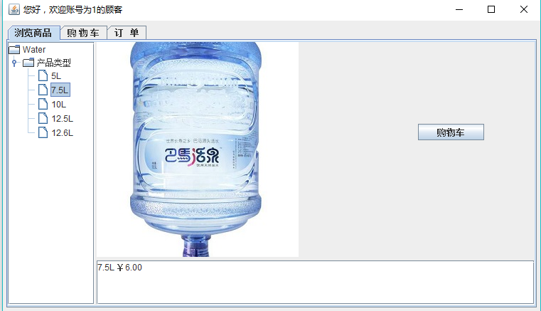
图一 商品浏览截图

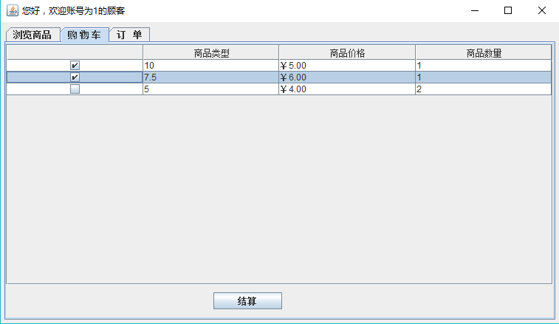
图二 购物车界面截图

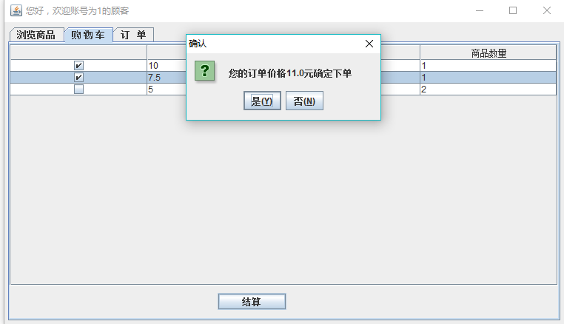
图三 结算界面截图

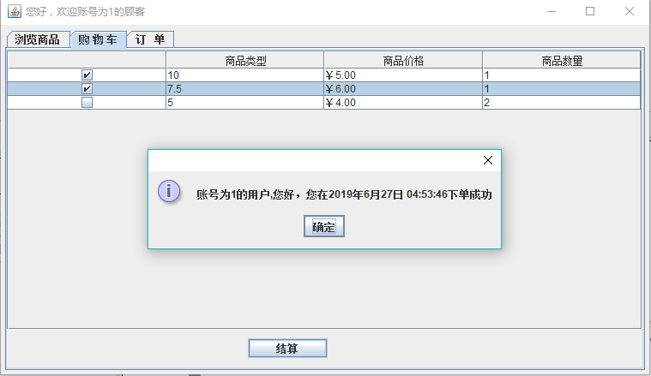
图四 下单成功界面截图

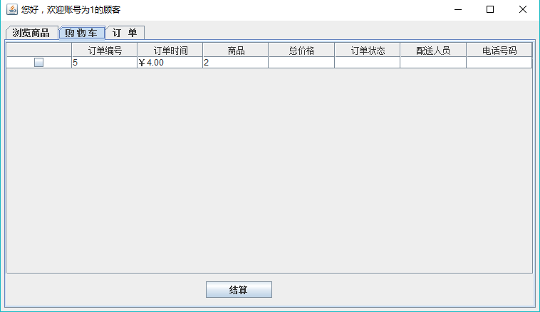
图五 下单后购物车界面截图

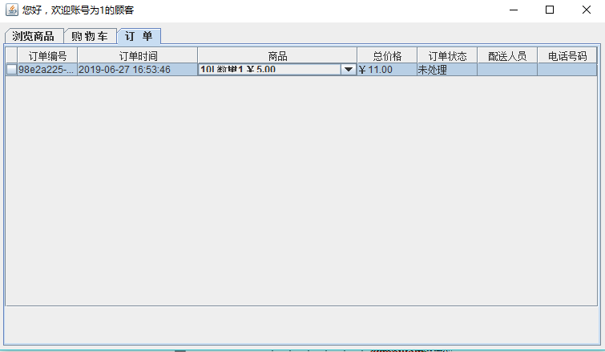
图六 下单后个人订单页面截图

下单操作处理代码：
客户端界面按钮事件提取数据信息
JButton button = new JButton("结算");
button.addActionListener(new ActionListener() {
public void actionPerformed(ActionEvent arg0) {
ArrayList<OrderItems> orderItems=new ArrayList<OrderItems>();
ArrayList<ShopCar> shopCarList=new ArrayList<ShopCar>();
Orders orders=new Orders();
Locale cnLocale=new Locale("zh", "CN");
NumberFormat cnNumberFormat=NumberFormat.getCurrencyInstance(cnLocale);
//int selectRows = table.getSelectedRows().length;// 取得用户所选行的行数
DefaultTableModel tableModel = (DefaultTableModel) table.getModel();
int rows=table.getRowCount();
double sum=0;
String orderID=UUID.randomUUID().toString();
Date orderTime=new Date();
orders.setCustomerID(Login.id);
orders.setOrderID(orderID);
orders.setOrderTime(orderTime);
orders.setOrderState("0");
int flag=0;
for(int i=0;i<rows;i++)
{
boolean select=(Boolean) tableModel.getValueAt(i,0);
if(select)
{
flag=1;
OrderItems items=new OrderItems();
ShopCar shopCar=new ShopCar();
//Date date=new Date();
//SimpleDateFormat nowdate=new SimpleDateFormat("yyyy-MM-dd HH:mm:ss");
String type=tableModel.getValueAt(i,1).toString();
double price=0;
try {
price = Double.parseDouble(cnNumberFormat.parse(tableModel.getValueAt(i,2).toString()).toString());
} catch (NumberFormatException e) {
// TODO Auto-generated catch block
e.printStackTrace();
} catch (ParseException e) {
// TODO Auto-generated catch block
e.printStackTrace();
}//.replace('￥',' ')
int num=Integer.parseInt(tableModel.getValueAt(i,3).toString());
double total=price*num;
sum+=total;
items.setNumber(num);
items.setOrderID(orderID);
items.setPrice(price);
items.setTotal(total);
items.setType(type);
orderItems.add(items);
shopCar.setCustomerID(Login.id);
shopCar.setType(type);
shopCarList.add(shopCar);
}
}
if(flag==1)
{
int r=JOptionPane.showConfirmDialog(table, "您的订单价格"+sum+"元"+"确定下单","确认",JOptionPane.YES_NO_OPTION);
if(r==JOptionPane.YES_OPTION)
{
orders.setTotalMoney(sum);
ArrayList<Object> a =new ArrayList<Object>();
a.add(orders);
for(int i=0;i<orderItems.size();i++)
{
a.add(orderItems.get(i));
}
Iterator iterator=shopCarList.iterator();
while(iterator.hasNext())
{
a.add(iterator.next());
}
boolean flag2=Client.placeOrder(a);//调用下单请求函数，同时返回下单
Object[] msg= {Login.id,orderTime};
Locale locale=Locale.getDefault();
String pattern="账号为{0}的用户,您好，您在{1,date,long} {1,time,hh:mm:ss}下单成功";
if(flag2)
{
JOptionPane.showMessageDialog(button.getParent(), FormatDate.msgFormat(pattern, locale, msg),"",JOptionPane.INFORMATION_MESSAGE);
new UpdateShopCar().start();
new UpdateOrders2().start();
}
else
{
JOptionPane.showMessageDialog(button.getParent(), "下单失败","",JOptionPane.ERROR_MESSAGE);
}
}
else
{
JOptionPane.showMessageDialog(button.getParent(), "取消下单成功","",JOptionPane.INFORMATION_MESSAGE);
}
}
else
{
JOptionPane.showMessageDialog(button.getParent(), "请选择商品后进行下单","",JOptionPane.ERROR_MESSAGE);
}
}
});
Cilent中
客户端发送下单请求调用的方法
public static boolean placeOrder(ArrayList<Object> a)
{
boolean reg=false;
try {
Socket socket=new Socket(Login.ip,Login.port);
ObjectOutputStream oos=new ObjectOutputStream(socket.getOutputStream());
Packet packet=new Packet("下单", a);
oos.writeObject(packet);
Packet packet2=(Packet)new ObjectInputStream(socket.getInputStream()).readObject();
reg=(boolean) packet2.getContent();
oos.close();
socket.close();
}catch (Exception e) {
// TODO: handle exception
e.printStackTrace();
}
return reg;

}
服务器处理主要代码
if(packet.getFlag().equals("下单"))
{

ArrayList<Object> a=(ArrayList<Object>)packet.getContent();
Iterator<Object> iterator=a.iterator();
Orders orders=new Orders();
ArrayList<OrderItems> orderItems=new ArrayList<OrderItems>();
ArrayList<ShopCar> shopCars=new ArrayList<ShopCar>();
while(iterator.hasNext())
{
Object object=iterator.next();
if(object.getClass().getName().equals("water.test1.po.Orders"))
orders=(Orders)object;
if(object.getClass().getName().equals("water.test1.po.OrderItems"))
{
OrderItems orderItems2=new OrderItems();
orderItems2=(OrderItems)object;
orderItems.add(orderItems2);
}
if(object.getClass().getName().equals("water.test1.po.ShopCar"))
{
ShopCar shopCar=new ShopCar();
shopCar=(ShopCar)object;
shopCars.add(shopCar);
}
}
PlaceOrdTran p=new PlaceOrdTran();
boolean flag=p.placeOrd(orders, orderItems,shopCars);
Packet packet2;
if(flag)
packet2=new Packet("下单成功", true);
else {
packet2=new Packet("下单失败", false);
}
new sendMess(socket,packet2).start();
}
3.5 基本模块5：注册界面的正则表达式验证

对于注册验证部分，我采用类似网页注册验证的方式，逐个进行验证，只有当前验证通过才可以填写下一部分信息。该部分验证包括对姓名、电话号码、账号、密码的验证，对于姓名只可输入中文或英文，电话号码要求符合电话号码规则，账号和密码是6-10位的数字或字母的组合，验证用到的方法如下：
public static boolean verifyPhoneno(String input) {
boolean ck = false;
String regex = "^(13[0-9]|14[579]|15[0-3,5-9]|16[6]|17[0135678]|18[0-9]|19[89])\\d{8}$";
Pattern pattern = Pattern.compile(regex);
Matcher matcher = pattern.matcher(input);
if (matcher.matches()) {
ck = true;
}
return ck;
}
public static boolean verifyID(String input) {
boolean ck = false;
String regex = "^[a-zA-Z0-9]{6,10}$";
Pattern pattern = Pattern.compile(regex);
Matcher matcher = pattern.matcher(input);
if (matcher.matches()) {
ck = true;
}
return ck;
}
public static boolean verifyName(String input) {
boolean ck = false;
String regex = "^([\\u4e00-\\u9fa5]{1,20}|[A-Za-z\\.\\s]{1,20})$";
Pattern pattern = Pattern.compile(regex);
Matcher matcher = pattern.matcher(input);
if (matcher.matches()) {
ck = true;
}
return ck;
}
public static boolean verifyPsd(String input) {
boolean ck = false;
String regex = "^[a-zA-Z0-9]{6,10}$";
Pattern pattern = Pattern.compile(regex);
Matcher matcher = pattern.matcher(input);
if (matcher.matches()) {
ck = true;
}
return ck;
}
界面调用验证方法（对姓名验证，其余验证操作与之相似，不在罗列）
textField_tel.addFocusListener(new FocusAdapter() {
@Override
public void focusLost(FocusEvent arg0) {
if (!FormatDate.verifyPhoneno(textField_tel.getText().trim())) { //调用验证方法
textField_tel.selectAll();
textField_tel.requestFocus();
lblNewLabel_5.setText("输入不合法");
}
else {
lblNewLabel_5.setText("√") }}});

3.6 实验总结及其他补充内容

这是前6个学期的最后一次实验，在做实验之前，自己对过去的实验进行总结，希望可以做好本次实验。自己首先端正了自己的态度，为自己定下了尽可能充分的运用该课程中老师所传授的全部知识，对实验的每一个模块都不仅实现，而且要理解并且掌握所用的知识的一个小目标，在此目标的基础上进行扩展。自己在本次实验中，虽然遇到了一些问题，但是最终都解决了，在这个过程中自己收获了很多，对于该课程涉及的GUI界面设计、JDBC事务处理、网络通信编程、多线程、数据格式化、正则表达式等有了更深的理解。
在这次的实验中，对于用户密码，我使用了MD5加密，不再是明文形式，也是较之前实验一个小的改变；另外对于界面的设计，我尽量集于一个主界面，不弹出较多的窗体，而且对于一些商品的浏览，我采用了动态的形式，点击JTree中的节点会在该界面中显示该商品的图片，以及商品的相关信息，这部分界面都是在函数中动态添加的。这次实验使我对Swing中JTbale的理解更加深刻，对于如何在JTable添加checkBox以及combox深刻掌握，对于如何设置表格某列不可编辑，如何操纵model模型也熟练掌握，也对DefaultTableModel有了更深的理解；对JDBC事务处理再次进行了实践，因为这部分自己之前掌握的还可以，所以本次在这部分比较顺利。
对于网络通信编程，自己之前没有接触过socket套接字，所以在这部分一开始自己不知道对服务器的创建该从何下手，自己先是查询了老师上课所讲的Netty框架，因为自己对这部分没有基础的了解，所以最终决定暂时先不使用框架，对基础的进行实践，经过自己看书以及上网查资料，最终有了一个简单的认识，该部分无非就两个问题需要处理：如何判断用户请求，如何处理用户请求。最终我采用了Packet类封装用户请求的数据，根据该类的flag标志去判断是何种请求，然后根据用户请求调用相应的数据库操作，并返回数据给客户端。
虽然在进行作业二时对多线程有了一些理解，但是对于支持多客户端的要求，我一开始有些不太理解，因为毕竟之前没有写过多线程的程序，经过一番功夫，最终才有所理解。主要的思想无非是当服务器端每接收一个socket，就为该socket开一个线程进行处理操作。当时自己还思考了一个问题，对于一个用户是建立一个socket连接，直至其退出登录然后断开该连接好，还是边请求服务器边建立连接，一旦不使用就断开比较好？我查了很多资料，但是并无果，我觉得二者对于该小系统来说没有影响，但是对于大的系统来说应该会有所不同，自己仍然对这两种方式的区别钻研着。
对于数据的格式化，发现之前做过的实验对于数据的格式化，并不满足正规的要求，所以本次对于格式化，我采用正规的格式，包括金钱格式化，日期格式化，登录提醒格式化。另外就是此次实验对于前台、后台分离的思想，以及规范代码有了认识。
经过这次实验，我深刻体会到了一分耕耘一分收获，当你用心做一件事情时，你也会有所收获，最后的这几门课程的成绩对于自己很重要，越是到了关键的时刻，也往往越使人紧张，最近自己常常夜里失眠，睡不着时我便对自己前三年学习以及生活进了总结。我怀着求知的心来到这所大学，我觉得这三年对自己很不满意的就是大三上学期，那学期自己经常熬夜敲代码，因为那学期的3个课设，我选了3个不同的题目，没有任何的交集，很多人只写了一个，我想锻炼一下自己就选了3个。那学期自己没有合理的安排时间，熬夜一个很大的影响就是白天上课时，注意力难以集中，而且熬夜效率低，因此那学期自己的成绩不理想。所以寒假回来后，我立刻调整自己，这一学期对于自己的表现还算满意，三年来自己几乎没有逃过任何一节课，现在这学期还剩最后一节课，我会好好珍惜这堂课。希望自己可以放平心态，不忘初心，昂首向前，不管结果如何，至少曾经努力过。

