Cilindro pequeño

Frequency Table for d_CILINDROP

------------------------------------------------------------------------
Relativ Cumulative Cum. Rel.
Class Value Frequency Frequency Frequency Frequency
------------------------------------------------------------------------
1 25,05 2 0,1429 2 0,1429
2 25,1 4 0,2857 6 0,4286
3 25,2 5 0,3571 11 0,7857
4 25,25 3 0,2143 14 1,0000
------------------------------------------------------------------------

The StatAdvisor
---------------
This table shows the number of times each value of d_CILINDROP
occurred, as well as percentages and cumulative statistics. For
example, in 2 rows of the data file d_CILINDROP equaled 25,05. This
represents 14,2857% of the 14 values in the file. The rightmost two
columns give cumulative counts and percentages from the top of the
table down.
Frequency Table for d_CILINDROP

------------------------------------------------------------------------
Relative Cumulative Cum. Rel.
Class Value Frequency Frequency Frequency Frequency
------------------------------------------------------------------------
1 25,05 2 0,1429 2 0,1429
2 25,1 4 0,2857 6 0,4286
3 25,2 5 0,3571 11 0,7857
4 25,25 3 0,2143 14 1,0000
------------------------------------------------------------------------

The StatAdvisor
Tabulation - d_CILINDROP

Analysis Summary

Data variable: d_CILINDROP

Number of observations: 14
Number of unique values: 4

The StatAdvisor
---------------
This procedure counts the number of times each of the 4 unique
values of d_CILINDROP occurs. It then displays tables and graphs of
the tabulation.

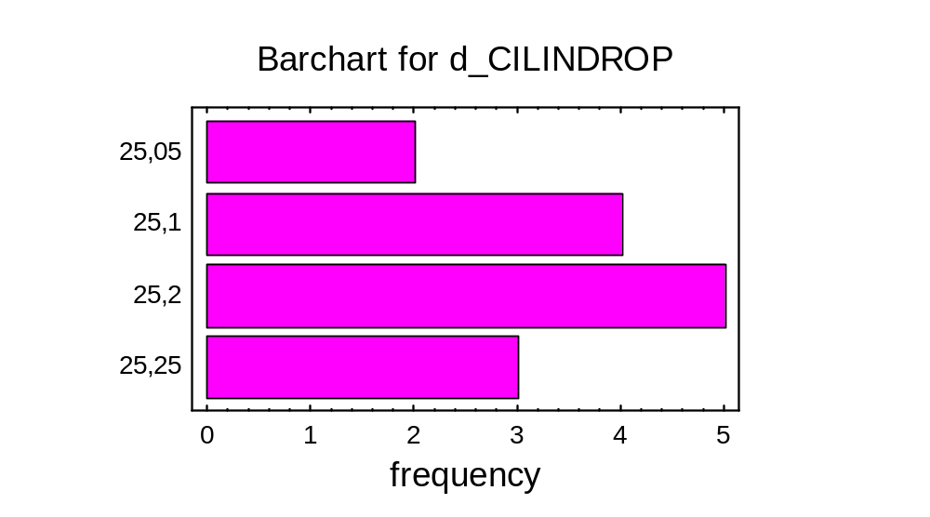
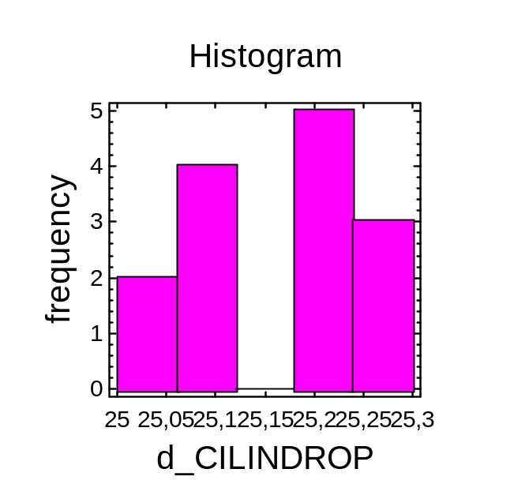
Analysis Summary

Data variable: d_CILINDROP

14 values ranging from 25,05 to 25,25

Fitted normal distribution:
mean = 25,1607
standard deviation = 0,0738464

The StatAdvisor
---------------
This analysis shows the results of fitting a normal distribution to
the data on d_CILINDROP. The estimated parameters of the fitted
distribution are shown above. You can test whether the normal
distribution fits the data adequately by selecting Goodness-of-Fit
Tests from the list of Tabular Options. You can also assess visually
how well the normal distribution fits by selecting Frequency Histogram
from the list of Graphical Options. Other options within the
procedure allow you to compute and display tail areas and critical
values for the distribution. To select a different distribution,
press the alternate mouse button and select Analysis Options.

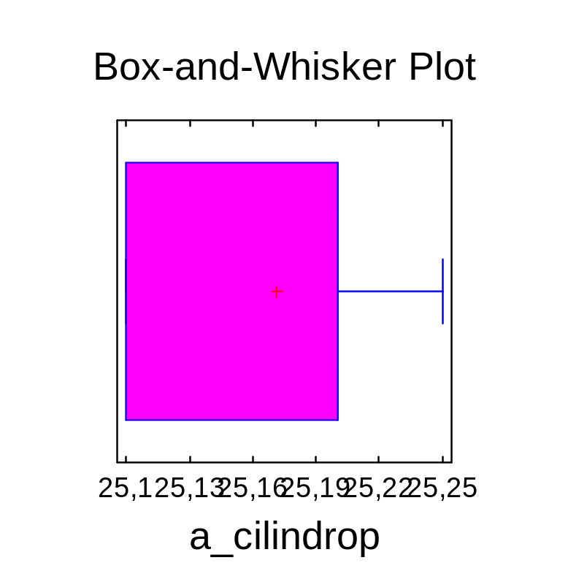
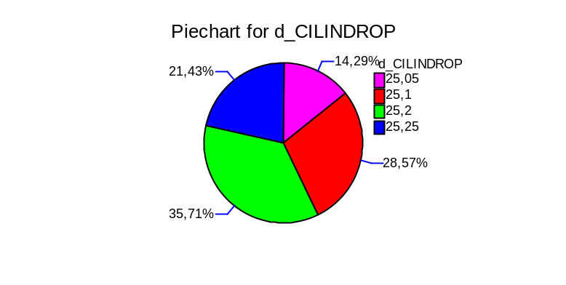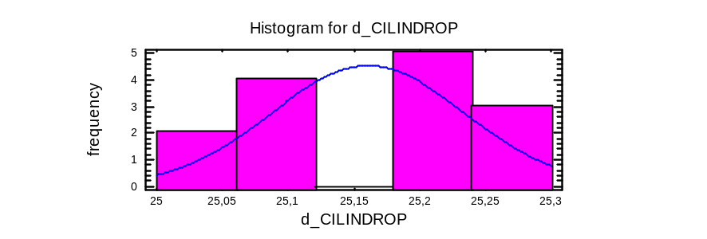

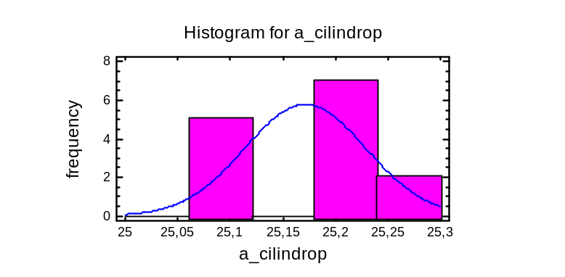
Number of observations: 14
Number of unique values: 4

The StatAdvisor
---------------
This procedure counts the number of times each of the 4 unique
values of d_CILINDROP occurs. It then displays tables and graphs of
the tabulation.

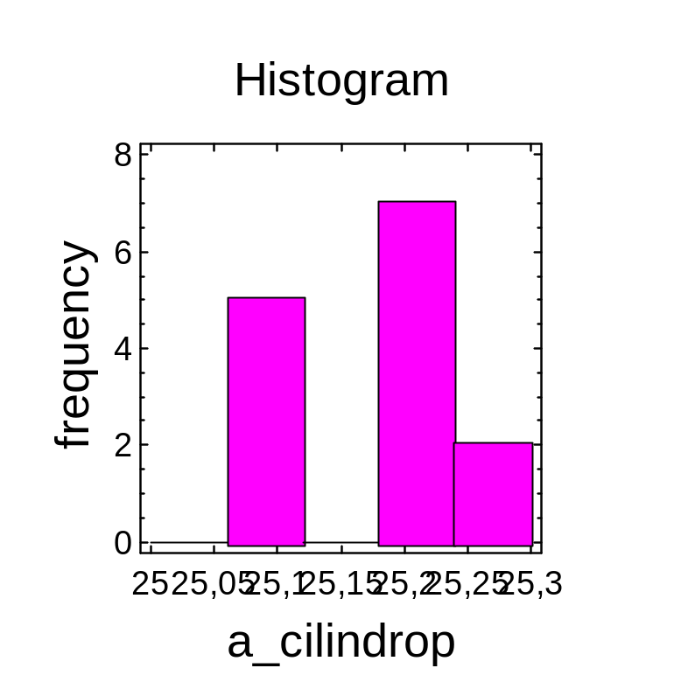

CILINDRO GRANDE

Analysis Summary

Data variable: d_cilindrog

15 values ranging from 44,3 to 44,55

The StatAdvisor
---------------
This procedure displays a box-and-whisker plot of a single column
of data. You can create many other graphs and statistics for the data
by selecting Describe - Numeric Data - One-Variable Analysis from the
main menu.
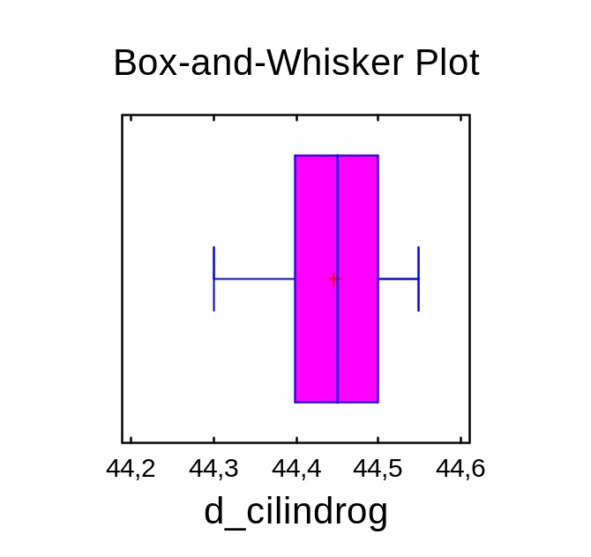Summary Statistics for d_cilindrog

Count = 15
Average = 44,4467
Variance = 0,00516667
Standard deviation = 0,0718795
Minimum = 44,3
Maximum = 44,55
Range = 0,25
Stnd. skewness = -1,63204
Stnd. kurtosis = 0,565596

The StatAdvisor
---------------
This table shows summary statistics for d_cilindrog. It includes
measures of central tendency, measures of variability, and measures of
shape. Of particular interest here are the standardized skewness and
standardized kurtosis, which can be used to determine whether the
sample comes from a normal distribution. Values of these statistics
outside the range of -2 to +2 indicate significant departures from
normality, which would tend to invalidate any statistical test
regarding the standard deviation. In this case, the standardized
skewness value is within the range expected for data from a normal
distribution. The standardized kurtosis value is within the range
expected for data from a normal distribution.
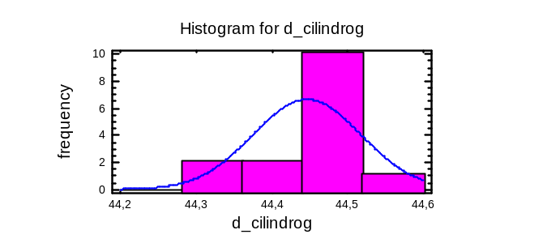Analysis Summary

Data variable: d_cilindrog

15 values ranging from 44,3 to 44,55

The StatAdvisor
---------------
This procedure displays a box-and-whisker plot of a single column
of data. You can create many other graphs and statistics for the data
by selecting Describe - Numeric Data - One-Variable Analysis from the
main menu.

Summary Statistics for d_cilindrog

Count = 15
Average = 44,4467
Variance = 0,00516667
Standard deviation = 0,0718795
Minimum = 44,3
Maximum = 44,55
Range = 0,25
Stnd. skewness = -1,63204
Stnd. kurtosis = 0,565596

The StatAdvisor
---------------
This table shows summary statistics for d_cilindrog. It includes
measures of central tendency, measures of variability, and measures of
shape. Of particular interest here are the standardized skewness and
standardized kurtosis, which can be used to determine whether the
sample comes from a normal distribution. Values of these statistics
outside the range of -2 to +2 indicate significant departures from
normality, which would tend to invalidate any statistical test
regarding the standard deviation. In this case, the standardized
skewness value is within the range expected for data from a normal
distribution. The standardized kurtosis value is within the range
expected for data from a normal distribution.

Analysis Summary

Data variable: d_cilindrog

15 values ranging from 44,3 to 44,55

Fitted normal distribution:
mean = 44,4467
standard deviation = 0,0718795

The StatAdvisor
---------------
This analysis shows the results of fitting a normal distribution to
the data on d_cilindrog. The estimated parameters of the fitted
distribution are shown above. You can test whether the normal
distribution fits the data adequately by selecting Goodness-of-Fit
Tests from the list of Tabular Options. You can also assess visually
how well the normal distribution fits by selecting Frequency Histogram
from the list of Graphical Options. Other options within the
procedure allow you to compute and display tail areas and critical
values for the distribution. To select a different distribution,

press the alternate mouse button and select Analysis Options.

Goodness-of-Fit Tests for d_cilindrog

Chi-Square Test
----------------------------------------------------------------------------
Lower Upper Observed Expected
Limit Limit Frequency Frequency Chi-Square
----------------------------------------------------------------------------
at or below 44,3862 2 3,00 0,33
44,3862 44,4285 2 3,00 0,33
44,4285 44,4649 5 3,00 1,33
44,4649 44,5072 5 3,00 1,33
above 44,5072 1 3,00 1,33
----------------------------------------------------------------------------
Chi-Square = 4,66651 with 2 d.f. P-Value = 0,0969797

Estimated Kolmogorov statistic DPLUS = 0,162381
Estimated Kolmogorov statistic DMINUS = 0,25183
Estimated overall statistic DN = 0,25183
Approximate P-Value = 0,29887

EDF Statistic Value Modified Form P-Value
---------------------------------------------------------------------
Kolmogorov-Smirnov D 0,25183 1,02808 <0.05*
Anderson-Darling A^2 0,896054 0,949818 0,0164*
---------------------------------------------------------------------
*Indicates that the P-Value has been compared to tables of critical values
specially constructed for fitting the currently selected distribution.
Other P-values are based on general tables and may be very conservative.

The StatAdvisor
---------------
This pane shows the results of tests run to determine whether
d_cilindrog can be adequately modeled by a normal distribution. The
chi-square test divides the range of d_cilindrog into nonoverlapping
intervals and compares the number of observations in each class to the
number expected based on the fitted distribution. The
Kolmogorov-Smirnov test computes the maximum distance between the
cumulative distribution of d_cilindrog and the CDF of the fitted
normal distribution. In this case, the maximum distance is 0,25183.
The other EDF statistics compare the empirical distribution function
to the fitted CDF in different ways.
Since the smallest P-value amongst the tests performed is less than
0.05, we can reject the idea that d_cilindrog comes from a normal
distribution with 95% confidence.

Goodness-of-Fit Tests for d_cilindrog

Chi-Square Test
----------------------------------------------------------------------------
Lower Upper Observed Expected
Limit Limit Frequency Frequency Chi-Square
----------------------------------------------------------------------------
at or below 44,3862 2 3,00 0,33
44,3862 44,4285 2 3,00 0,33
44,4285 44,4649 5 3,00 1,33
44,4649 44,5072 5 3,00 1,33
above 44,5072 1 3,00 1,33
----------------------------------------------------------------------------
Chi-Square = 4,66651 with 2 d.f. P-Value = 0,0969797

Estimated Kolmogorov statistic DPLUS = 0,162381
Estimated Kolmogorov statistic DMINUS = 0,25183
Estimated overall statistic DN = 0,25183
Approximate P-Value = 0,29887

Altura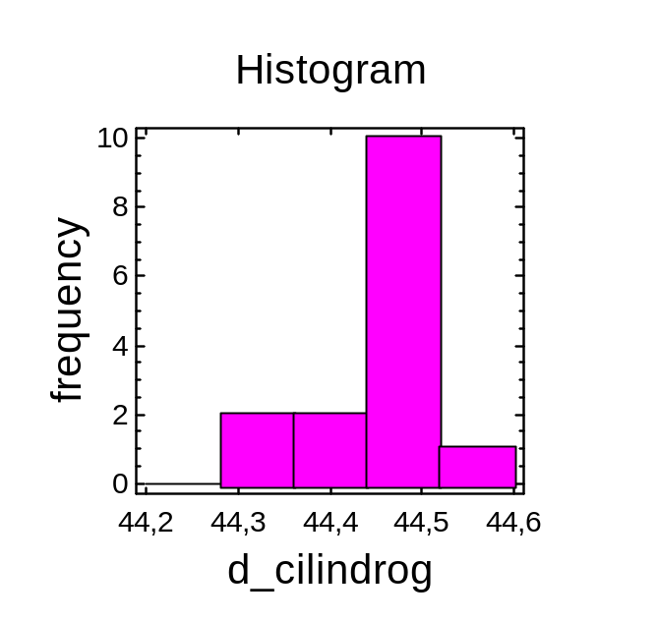

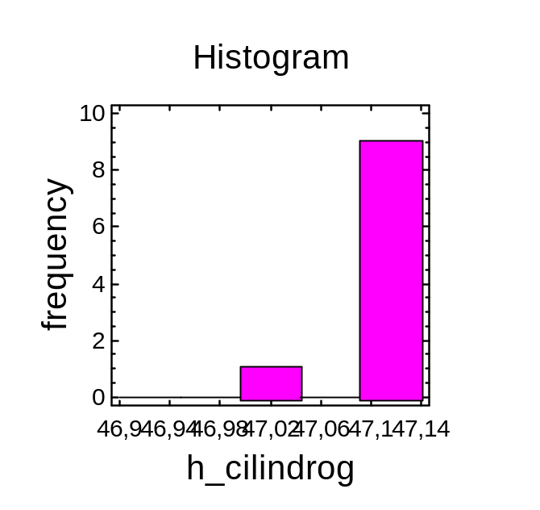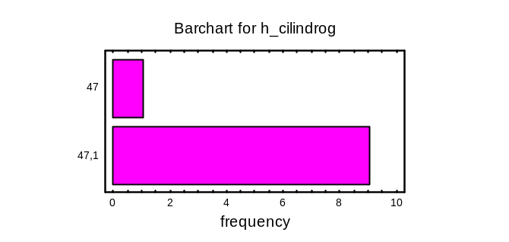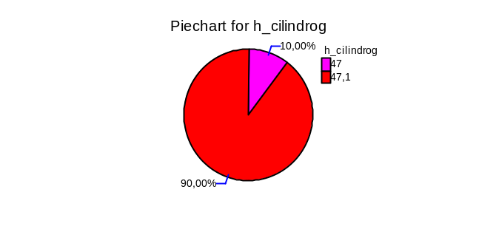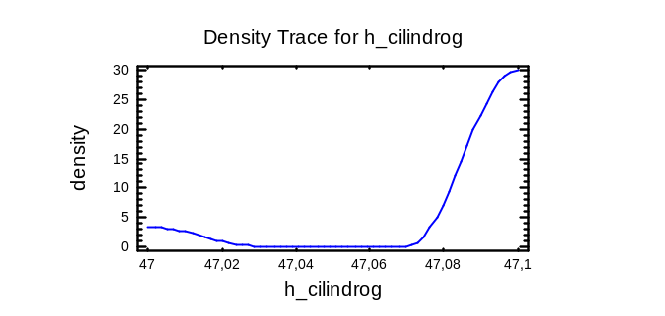
Estimated Kolmogorov statistic DPLUS = 0,375913
Estimated Kolmogorov statistic DMINUS = 0,524087
Estimated overall statistic DN = 0,524087
Approximate P-Value = 0,00822811

EDF Statistic Value Modified Form P-Value
---------------------------------------------------------------------
Kolmogorov-Smirnov D 0,524087 1,79294 <0.01*
Anderson-Darling A^2 3,20807 3,52085 0,0000*
---------------------------------------------------------------------
*Indicates that the P-Value has been compared to tables of critical values
specially constructed for fitting the currently selected distribution.
Other P-values are based on general tables and may be very conservative.

The StatAdvisor
---------------
This pane shows the results of tests run to determine whether
h_cilindrog can be adequately modeled by a normal distribution. The
chi-square test was not run because the number of observations was too
small.
Since the smallest P-value amongst the tests performed is less than
0.01, we can reject the idea that h_cilindrog comes from a normal
distribution with 99% confidence.

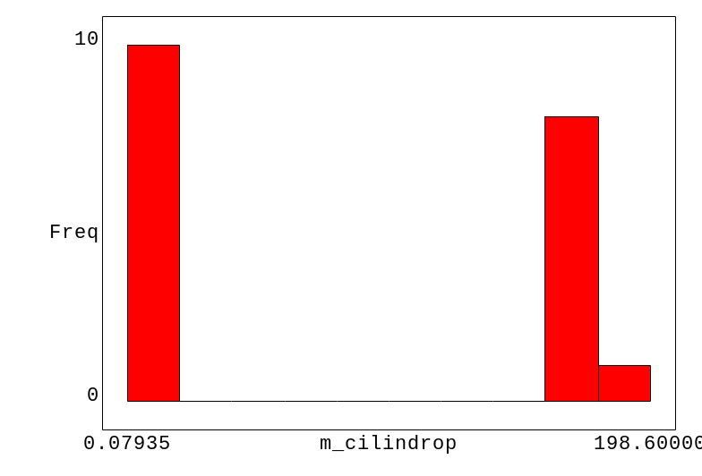
items: 19

minimum value: 0.07935
first quartile: 0.63308
median: 0.99871
third quartile: 198.50000
maximum value: 198.60000

mean value: 94.35028
midrange: 99.33967

range: 198.52065
interquartile range: 197.86692
mean deviation: 98.66816
sample std dev (n): 98.80534
sample std dev (n-1): 101.51284
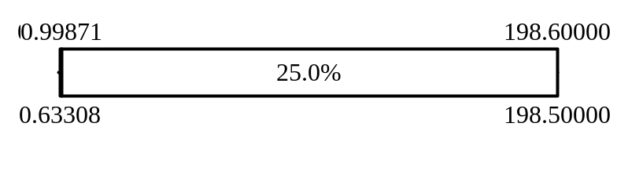
0|0001111111
1|
2|
3|
4|
5|
6|
7|
8|
9|
10|
11|
12|
13|
14|
15|
16|
17|
18|
19|899999999

0.07935 ... 22.13720 10 52.63%
22.13720 ... 44.19505 0
44.19505 ... 66.25290 0
66.25290 ... 88.31075 0
88.31075 ... 110.36860 0
110.36860 ... 132.42645 0
132.42645 ... 154.48430 0
154.48430 ... 176.54215 0
176.54215 ... 198.60000 8 42.11%
198.60000 ... 220.65785 1 5.26%

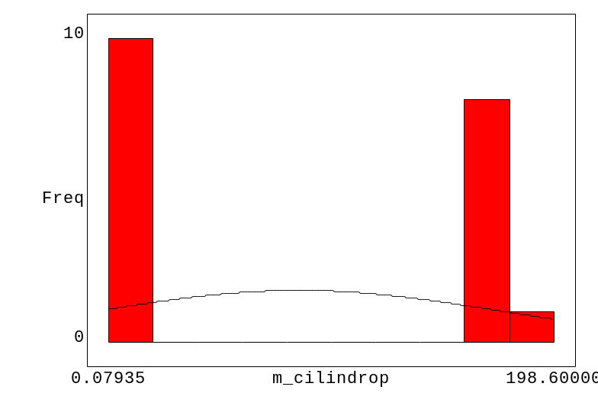
Summary Statistics for m_cilindrog

Count = 14
Average = 198,536
Variance = 0,00401099
Standard deviation = 0,0633324
Minimum = 198,4
Maximum = 198,6
Range = 0,2
Stnd. skewness = -0,6608
Stnd. kurtosis = -0,301158

The StatAdvisor
---------------
This table shows summary statistics for m_cilindrog. It includes
measures of central tendency, measures of variability, and measures of
shape. Of particular interest here are the standardized skewness and
standardized kurtosis, which can be used to determine whether the
sample comes from a normal distribution. Values of these statistics
outside the range of -2 to +2 indicate significant departures from
normality, which would tend to invalidate any statistical test
regarding the standard deviation. In this case, the standardized
skewness value is within the range expected for data from a normal
distribution. The standardized kurtosis value is within the range
expected for data from a normal distribution.

Analysis Summary

Data variable: m_cilindrog

14 values ranging from 198,4 to 198,6

Fitted normal distribution:
mean = 198,536
standard deviation = 0,0633324

The StatAdvisor
---------------
This analysis shows the results of fitting a normal distribution to
the data on m_cilindrog. The estimated parameters of the fitted
distribution are shown above. You can test whether the normal
distribution fits the data adequately by selecting Goodness-of-Fit
Tests from the list of Tabular Options. You can also assess visually
how well the normal distribution fits by selecting Frequency Histogram
from the list of Graphical Options. Other options within the
procedure allow you to compute and display tail areas and critical
values for the distribution. To select a different distribution,
press the alternate mouse button and select Analysis Options.

Goodness-of-Fit Tests for m_cilindrog

Chi-Square Test
----------------------------------------------------------------------------
Lower Upper Observed Expected
Limit Limit Frequency Frequency Chi-Square
----------------------------------------------------------------------------
at or below 198,482 1 2,80 1,16
198,482 198,52 7 2,80 6,30
198,52 198,552 0 2,80 2,80
198,552 198,589 0 2,80 2,80
above 198,589 6 2,80 3,66
----------------------------------------------------------------------------
Chi-Square = 16,7145 with 2 d.f. P-Value = 0,00023469

Estimated Kolmogorov statistic DPLUS = 0,285025
Estimated Kolmogorov statistic DMINUS = 0,273532
Estimated overall statistic DN = 0,285025
Approximate P-Value = 0,205767

EDF Statistic Value Modified Form P-Value
---------------------------------------------------------------------
Kolmogorov-Smirnov D 0,285025 1,12837 <0.01*
Anderson-Darling A^2 1,5403 1,64049 0,0003*
---------------------------------------------------------------------
*Indicates that the P-Value has been compared to tables of critical values
specially constructed for fitting the currently selected distribution.
Other P-values are based on general tables and may be very conservative.

The StatAdvisor
---------------
This pane shows the results of tests run to determine whether
m_cilindrog can be adequately modeled by a normal distribution. The
chi-square test divides the range of m_cilindrog into nonoverlapping
intervals and compares the number of observations in each class to the
number expected based on the fitted distribution. The
Kolmogorov-Smirnov test computes the maximum distance between the
cumulative distribution of m_cilindrog and the CDF of the fitted
normal distribution. In this case, the maximum distance is 0,285025.
The other EDF statistics compare the empirical distribution function
to the fitted CDF in different ways.
Since the smallest P-value amongst the tests performed is less than
0.01, we can reject the idea that m_cilindrog comes from a normal
distribution with 99% confidence.
Frequency Table for m_cilindrog

------------------------------------------------------------------------
Relative Cumulative Cum. Rel.
Class Value Frequency Frequency Frequency Frequency
------------------------------------------------------------------------
1 198,4 1 0,0714 1 0,0714
2 198,5 7 0,5000 8 0,5714
3 198,6 6 0,4286 14 1,0000
------------------------------------------------------------------------

The StatAdvisor
---------------
This table shows the number of times each value of m_cilindrog
occurred, as well as percentages and cumulative statistics. For
example, in 1 rows of the data file m_cilindrog equaled 198,4. This
represents 7,14286% of the 14 values in the file. The rightmost two
columns give cumulative counts and percentages from the top of the
table down.

