Test Plan

GSC Team

Van Lang University

Document Information

This section contains the basic information of document – which will be presented in below table.

|  |  |
| --- | --- |
| Document Name | Test Plan |
| Version Number | 2.0 |
| Created by | Cuong Ngo |
| Date created | August 19, 2015 |
| Last updated by | Cuong Ngo |
| Date last updated | March 1, 2016 |

Version Tracking

This section contains all of change information of document – which should be tracked version by version and presented in below table.

|  |  |  |  |
| --- | --- | --- | --- |
|  | Release Date | Author | Abstract |
| 1.0 | August 19, 2015 | Cuong Ngo | Establish Test Document |
| 1.1 | 13.09.2015 | Khanh Nguyen | Update Milestone |
| 2.0 | March 1, 2016 | Cuong Ngo | Baseline document |

Tables of Content

1. Introduction 1-6

1.1. Purpose 1-6

1.2. Scope 1-6

1.3. Intended Audiences 1-6

2. Test Phase 2-6

2.1. Integration Testing 2-6

2.2. System Testing 2-7

2.2.1. Functional Testing 2-7

2.2.2. Quality Attribute Testing 2-7

2.3. Acceptance Testing 2-7

3. Test Results 3-8

3.1. Integration Testing 3-8

3.2. System Testing 3-8

3.3. Acceptance Test 3-8

4. Schedule 4-9

5. Testing Human Resource 5-10

5.1. Team Information 5-10

5.2. Role and Responsibility 5-11

6. Test Environment 6-11

6.1. Hardware 6-11

6.2. Software 6-12

6.3. Test Tools 6-12

7. Entry and Exit Criteria 7-12

7.1. Entry Criteria 7-12

7.1.1. System Testing 7-12

7.1.2. Integration Testing 7-12

7.1.3. Acceptance Testing 7-13

7.2. Exit Criteria 7-13

7.2.1. Integration Testing 7-13

7.2.2. System Testing 7-13

7.2.3. Acceptance Testing 7-13

8. Appendix: Priority Definition 8-14

9. Glossary and Acronym list 9-14

Table list

Table 1: Intended Audience 1-6

Table 2: Test Schedule 4-10

Table 3: Team information 5-11

Table 5: Role and responsibility 5-11

Table 6: Hardware 6-12

Table 7: Software 6-12

Table 9: Bug Priority 8-14

Table 10: Bug severity 8-14

Table 11: Glossary and Acronym 9-14

Figure list

Figure 1:Test Milestone 4-10

# Introduction

## Purpose

This specification describes detailed plan and approach to implement testing methods for GSC system project. At the same time, personnel requirements, tools and materials needed for testing is also defined here. Test manager will ensure that software testing is performed according to the process defined in test plan and project plan

## Scope

Scope of test plan is to help test members to do tasks following test plan and schedule that are defined and approved. This specification describes strategies and plan to implement phases of the testing in the GSC system project. The detailed descriptions of test cases in each phase will be executed in the test specifications document.

## Intended Audiences

This document is used by the PM, Test leader involved in GSC project.

|  |  |  |
| --- | --- | --- |
| No. | Readers | Reason for reading |
| 1 | PM | Test plan, personnel involved, related documents |
| 2 | Test Leader | Guideline and approach to implement testing phase |
| 3 | Tester | Understand and implement test planed |

Table 1: Intended Audience

# Test Phase

## Integration Testing

* Integration testing is complete and meets requirements for built-in SDS.
* Integration test-cases and test reports should be clear and complete. These documents will be updated continuously throughout project development cycle.
* Bug report log and list of outstanding bugs.
* The status of the bug and bug lifecycle must be reported regularly
* The requirements were described in requirement specifications about integration between components have to express correctly in Integration test specification
* The information flows among components have to express completely in Integration test specification
* When develop integration test cases & test data need to apply integration test strategies, such as:
  + Top Down
  + Bottom Up
* Just use two methods to implement because it meets the test's outcomes and it check almost cases.

## System Testing

* The Quality attributes of SRS must be fully tested
* The functionality (functionalities) is described in the use case in SRS must be fully tested.
* System test cases and test reports should be clear and completed. These documents will be updated continuously throughout the project development cycle.
* Bug report log and list of outstanding bugs.
* The status of the bug and bug lifecycle frequently reported

### Functional Testing

* The use case descriptions (functionalities) in the SRS must be fully reflected in the System test specification
* When develop Functional test cases & test data should apply Black box testing techniques:
  + Boundary Testing
  + Decision Table

### Quality Attribute Testing

* Attributes about interface (GUI) of each screen in the GUI specification must be fully reflected in the System test specification

## Acceptance Testing

* A set of test cases are taken from System test cases and executed in the user working environment.
* In this type of test, the software will be tested by the user to find out whether it meets with their requirements and expectations.
* In this phase, the tester can perform or the customer has their own tester to perform it.
* A group system test case is implemented at user environment
* It is final step of testing, acceptance tests are generally performed as "black box" tests, and the tester uses specified inputs into the system and verifies that the resulting outputs are correct, without knowledge of the system's internal workings

# Test Results

## Integration Testing

* System is executed Integration testing and meets requirements of integrating components in SDS
* Make sure Unit test must be tested fully and completely
* Integration Test cases and Test reports must be clear and full. These documents will be updated continuously in project lifecycle
* Bug log report and outstanding bug list
* Status of bugs and bug lifecycle must be reported regularly

## System Testing

* Quality attributes of the SRS must be tested fully
* Functionalities are described in use cases of the SRS must be tested fully
* System test cases and test reports must be clear and full. These documents will be updated continuously in project lifecycle
* Bug log report and outstanding bug list
* Status of bugs and bug lifecycle must be reported regularly

## Acceptance Test

* Acceptance test cases must be executed fully at the work environment of user
* In this type of test, the software will be tested by the user to find out whether it meets with their requirements and expectations.
* In this phase, the tester can perform or the customer has their own tester to perform it.

# Schedule

Test plan for GSC system project will be established and implemented for System testing. Training plan and make Unit testing will be specifically described in the Master Plan

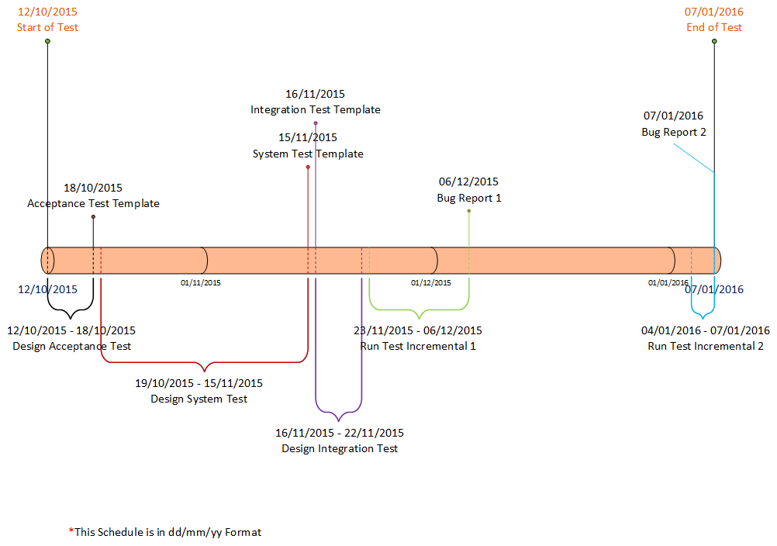

Figure 1: Test Milestone

|  |  |  |  |  |
| --- | --- | --- | --- | --- |
| No | Task description | Start date | Finish date | Participants |
| 1 | Design Acceptance Test Case | 12/10/15 | 18/10/15 |  |
| 2 | Design System Test Case | 19/10/15 | 15/11/15 |  |
| 3 | Design Integration Test Case | 16/11/15 | 22/11/15 |  |
| Increment 1 | | | | |
| 1 | Run System Test Case | 23/11/15 | 31/11/15 |  |
| 2 | Run Integration Test Case | 31/11/15 | 3/12/15 |  |
| 3 | Run Acceptance Test Case | 4/12/15 | 6/12/15 |  |
| 4 | Bug Report-IC1 | 23/11/15 | 6/12/15 |  |
| Increment 2 | | | | |
| 1 | Run System Test Case | 04/01/15 | 14/01/15 |  |
| 2 | Run Integration Test Case | 15/01/15 | 19/01/15 |  |
| 3 | Run Acceptance Test Case | 20/01/15 | 24/01/15 |  |
| 4 | Bug Report-IC2 | 04/01/15 | 24/01/15 |  |

Table 2: Test Schedule

# Testing Human Resource

## Team Information

Testing team consists of six members:

|  |  |  |  |  |
| --- | --- | --- | --- | --- |
| No. | Name | Role | Team | Email |
| 1 | An Tang | Project Manager | GSC Team | Email: truong.an1193@gmail.com |
| 2 | Cuong Ngo | Test Leader | GSC Team | Email: tricuong081193@gmail.com |
| 3 | Quoc Do | Tester | GSC Team | Email: dothanhwuoc@gmail.com |
| 4 | Triem Nguyen | Tester | GSC Team | Email: mr.bill0311@gmail.com |
| 5 | Khanh Nguyen | Tester | GSC Team | Email: nguyenchaukhanh130892@gmail.com |
| 6 | Phong Lai | Tester | GSC Team | Email: laithanhphongcntt@gmail.com |
| 7 | Hoa Nguyen | Tester | GSC Team | Email: htran6883@gmail.com |

Table 3: Team information

## Role and Responsibility

|  |  |  |
| --- | --- | --- |
| No. | Role | Responsibilities |
| 1 | Project Manager | Responsible for Project schedules and the overall success of the project |
| 2 | Test Leader | Responsible for guidance, plan and track the progress of the work of the test group, collect data from tester, reports directly to the PM. |
| 3 | Tester | Responsible execute testing system following testing documents and discuss with testers about fixing bugs, reports to Test leader directly. |
| 4 | Document writer | Responsible to develop testing documents (test plan, test cases, test report) (All member) |

Table 5: Role and responsibility

# Test Environment

## Hardware

|  |  |  |
| --- | --- | --- |
| No. | Description | Minimum Configuration Requirements |
| 1 | Computer is installed “GSC System ” software | * CPU: Core dual (1,8 GHz) or Pentium 3 (1,8 GHz) * RAM: 1GB * HDD: 80 – 120 GB |

Table 6: Hardware

## Software

|  |  |  |
| --- | --- | --- |
| No. | Description | Software |
| 1 | Computer of customer | OS: Windows 7 or later  .Net framework 4.0 |
| 2 | Computer of software developer team and testing team. | .Net framework 4.0  MS Visual Studio 2013  MD SQLite  MS Office 2013 |

Table 7: Software

## Test Tools

Team will implement test by manually: save test report by Microsoft Excel.

# Entry and Exit Criteria

## Entry Criteria

### System Testing

* Environment and test tools must be set up.
* Functions must be done.
* Tester must be available
* Test documents must be reviewed

### Integration Testing

* Environment and test tools must be set up.
* Feature must be done.
* Tester must be available
* Test documents must be reviewed

### Acceptance Testing

* User Acceptance Test Plan and test case must be approved and available
* All other test had been successfully completed
* Tester must be available
* Environment test and test tools must be available
* Test documents must be reviewed

## Exit Criteria

### Integration Testing

* 100% integration test must be executed
* Pass rate: 95%
* All bugs are found that must repair and retest must completed
* Don’t have bugs with High priority
* Issues list and outstanding bugs list

### System Testing

* 100% System test cases must be executed
* Pass rate : 95%
* Don't have bugs with High priority
* Issues list and outstanding bugs list

### Acceptance Testing

* 100% User Acceptance test cases must be executed and passed if customer approves that the GSC system software meets their requirement
* If some test cases failed, must have a report of issues that software product need to be changed to fix the problems following customer’s expectation

# Appendix: Priority Definition

|  |  |
| --- | --- |
| Bug Priority | Description |
| High | Test Case is very important and must not fail. Bug must be fixed to right away if Test Case fail |
| Medium | Test Case is important and should not fail. Bug must be fixed early if Test Case fail |
| Low | Test Case is not important and it can be done or not, depending on the test plan |

Table 8: Bug Priority

# Glossary and Acronym list

|  |  |
| --- | --- |
| Term or Acronym | Definition |
| SDS | Software Design Specification |
| SRS | Software Requirement Specification |
| GUI | Graphic User Interface |
| TDD | Test Driven Development |

Table 9: Glossary and Acronym