Antara Choudhury

February 19, 2023

**Neural Network Model Report – Charity Funding Predictor**

**Overview**

The purpose of this analysis was to produce an algorithm using machine learning and neural networks to predict whether or not applicants will be successful if they receive funding from the fictional non-profit foundation, Alphabet Soup.

**Results**

* **Data Preprocessing**
  + The target variable for the model is: IS_SUCCESSFUL: 1 is considered yes (successful) and 0 is considered no (not successful)
  + The feature variables for the model are: 9 features: (APPLICATION_TYPE, AFFILIATION, CLASSIFICATION, USE_CASE, ORGANIZATION, STATUS, INCOME_AMT, SPECIAL_CONSIDERATIONS, ASK_AMT)
  + The variables that should be removed from the input data because they are neither targets nor features are EIN and NAME.
* **Compiling, Training and Evaluating the Model**
  + The objective for this model was to achieve a target predictive accuracy higher than 75%. Three tries were made using machine learning and neural networks to achieve this. All three attempts resulted in the same accuracy rate around 72%, a little less than the required target accuracy.

**Results from each model attempt:**

ATTEMPT #1

The first attempt (Resources/AlphabetSoupCharity1.h5) ensued in an accuracy score of 72.8%. This was the highest accuracy score out of the three models. This meant that 72.8% of the model’s predicted values align with the dataset’s true values.

The hyperparameters that were used were:

* layers = 2
  + layer1 = 9 neurons and ‘relu’ activation function
  + layer2 = 18 neurons and ‘relu’ activation function
* epochs = 100

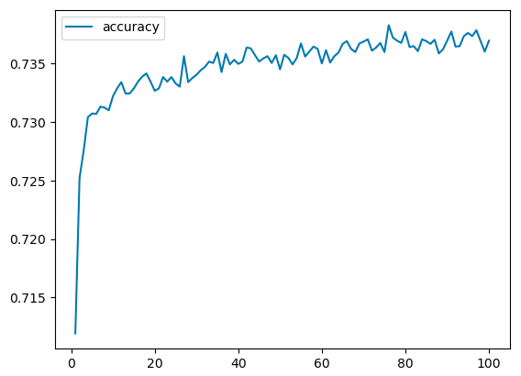

ATTEMPT #2

For the second attempt (Resources/AlphabetSoupCharity2.h5), I added another layer. This attempt ensued in an accuracy score of 72.6%. This meant that 72.6% of the model’s predicted values aligned with the dataset’s true values.

The hyperparameters used were:

* layers = 3
  + layer1 = 9 neurons : activation function = ‘relu’
  + layer2 = 18 neurons : activation function = ‘relu’
  + layer3 = 27 neurons : activation function = ‘relu’
* epochs = 100

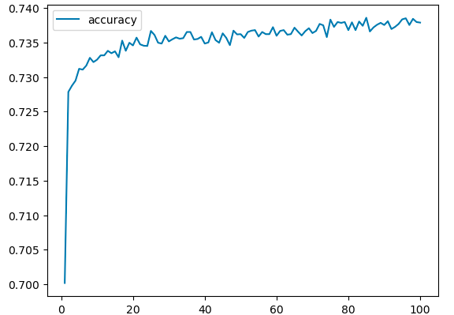

ATTEMPT #3

For the third attempt (Resources/AlphabetSoupCharity3.h5) I kept the third layer and changed the activation function for layers 2 and 3. This effort resulted in an accuracy score of 72.7%. This meant that 72.7% of the model’s predicted values aligned with the dataset’s true values.

The hyperparameters used were:

* layers = 3
  + layer1 = 9 neurons : activation function = ‘relu’
  + layer2 = 18 neurons : activation function = ‘tanh’
  + layer3 = 27 neurons : activation function = ‘tanh’
* epochs = 100

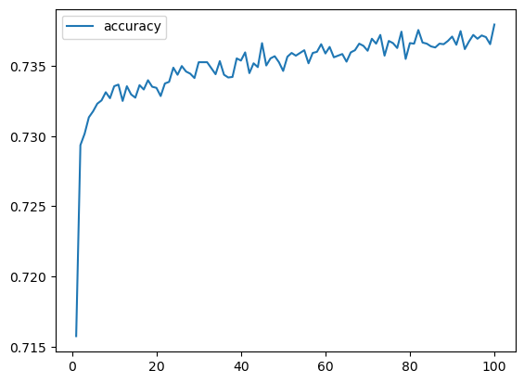

**Summary**

In the three attempts that I made, the model was unable to achieve a target predictive accuracy higher than 72.8%. Hypertuning the model resulted in no significant improvement. A different classification model could be used to solve this classification problem because a different model could be better at predicting whether applications would be successful if funded by Alphabet Soup.