1.1.1

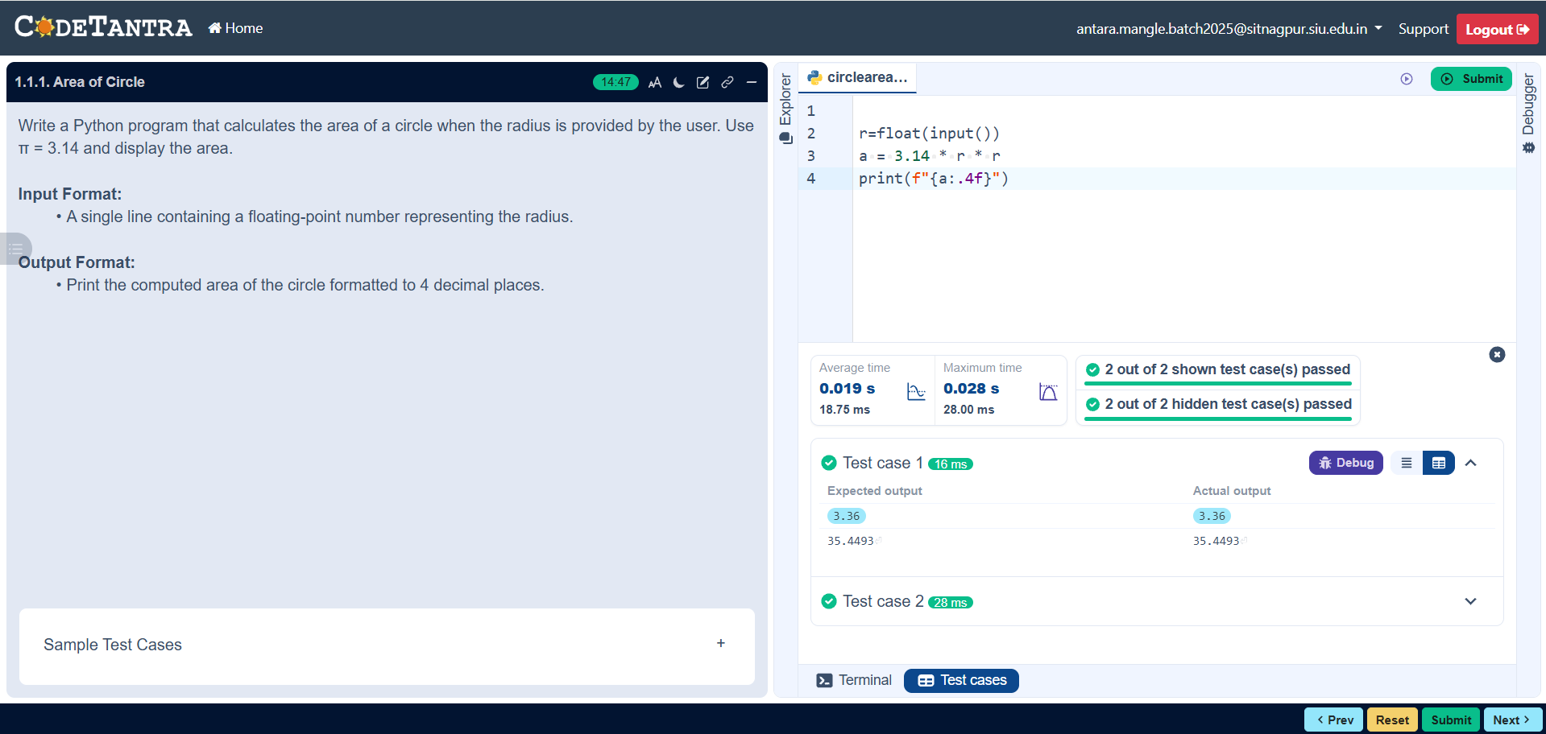

Algorithm

Step 1: Start
Step 2: Read the radius
Step3: Calculate the area: $\text{area}=π×\text{radius}×\text{radius}$
Step 4: Display the Result
Step 5: End

Flow chart

Start

Output: Area

End
Area= 3.14 * radius * radius

Input: Radius

