1.1.2

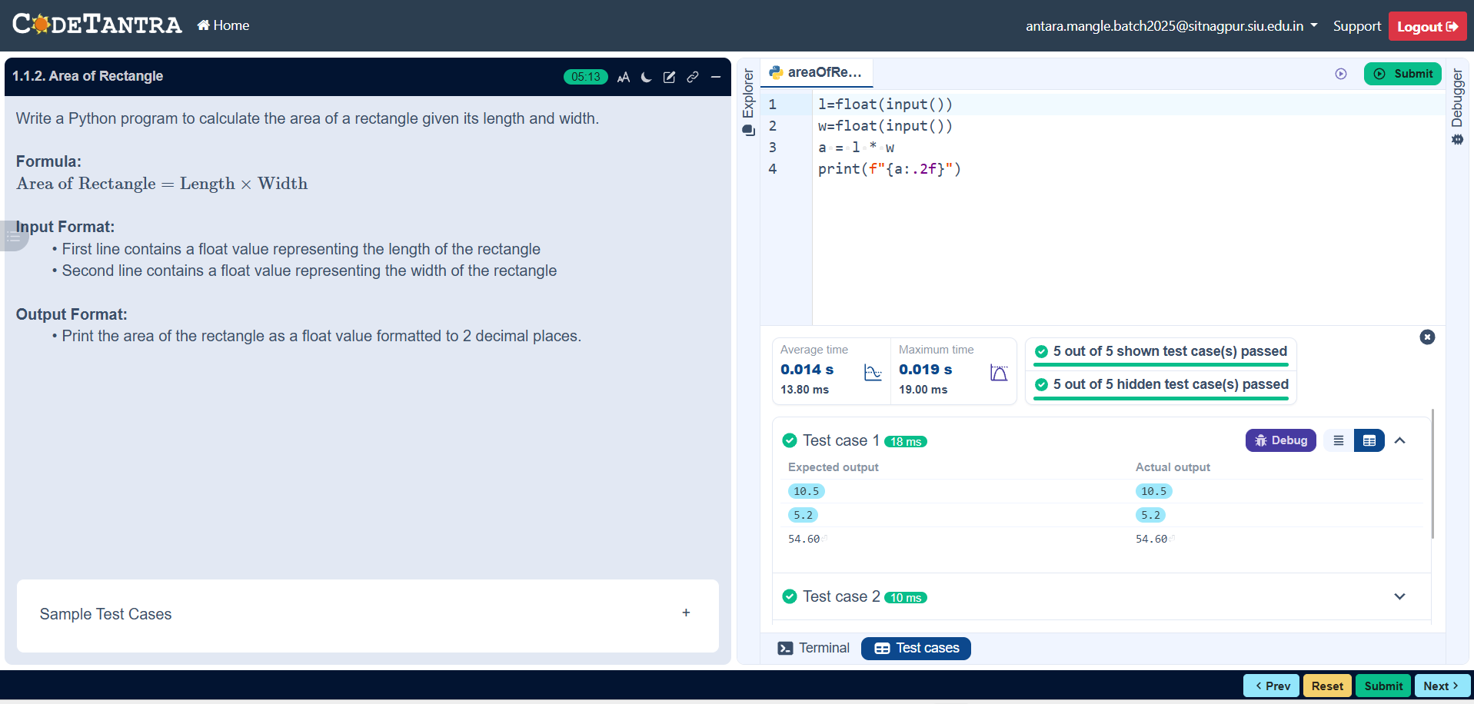

Algorithm

Step 1: Start
Step 2: Read length and breadth
Step 3: Calculate the area: Area= Length * Breadth
Step 4: Display the Result
Step 5: End

Flow Chart

Start

Output: Area

End
Area= Length* Breadth

Input: Length, Breadth

