1.1.3 Area of square

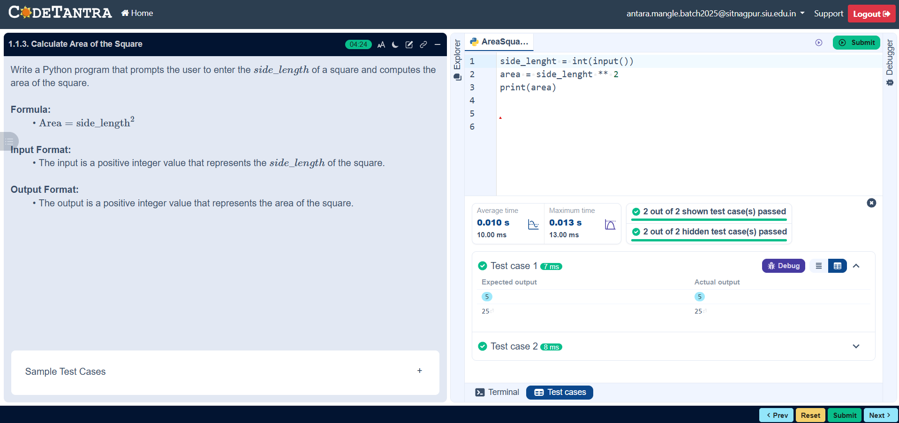

Algorithm

Step 1: Start
Step 2: Read the radius
Step3: Calculate the area: 4 * Side
Step 4: Display the Result
Step 5: End

Flow Chart

Start

Output: Area

End
Area= 4 * Sides

Input: Side

