1.1.5
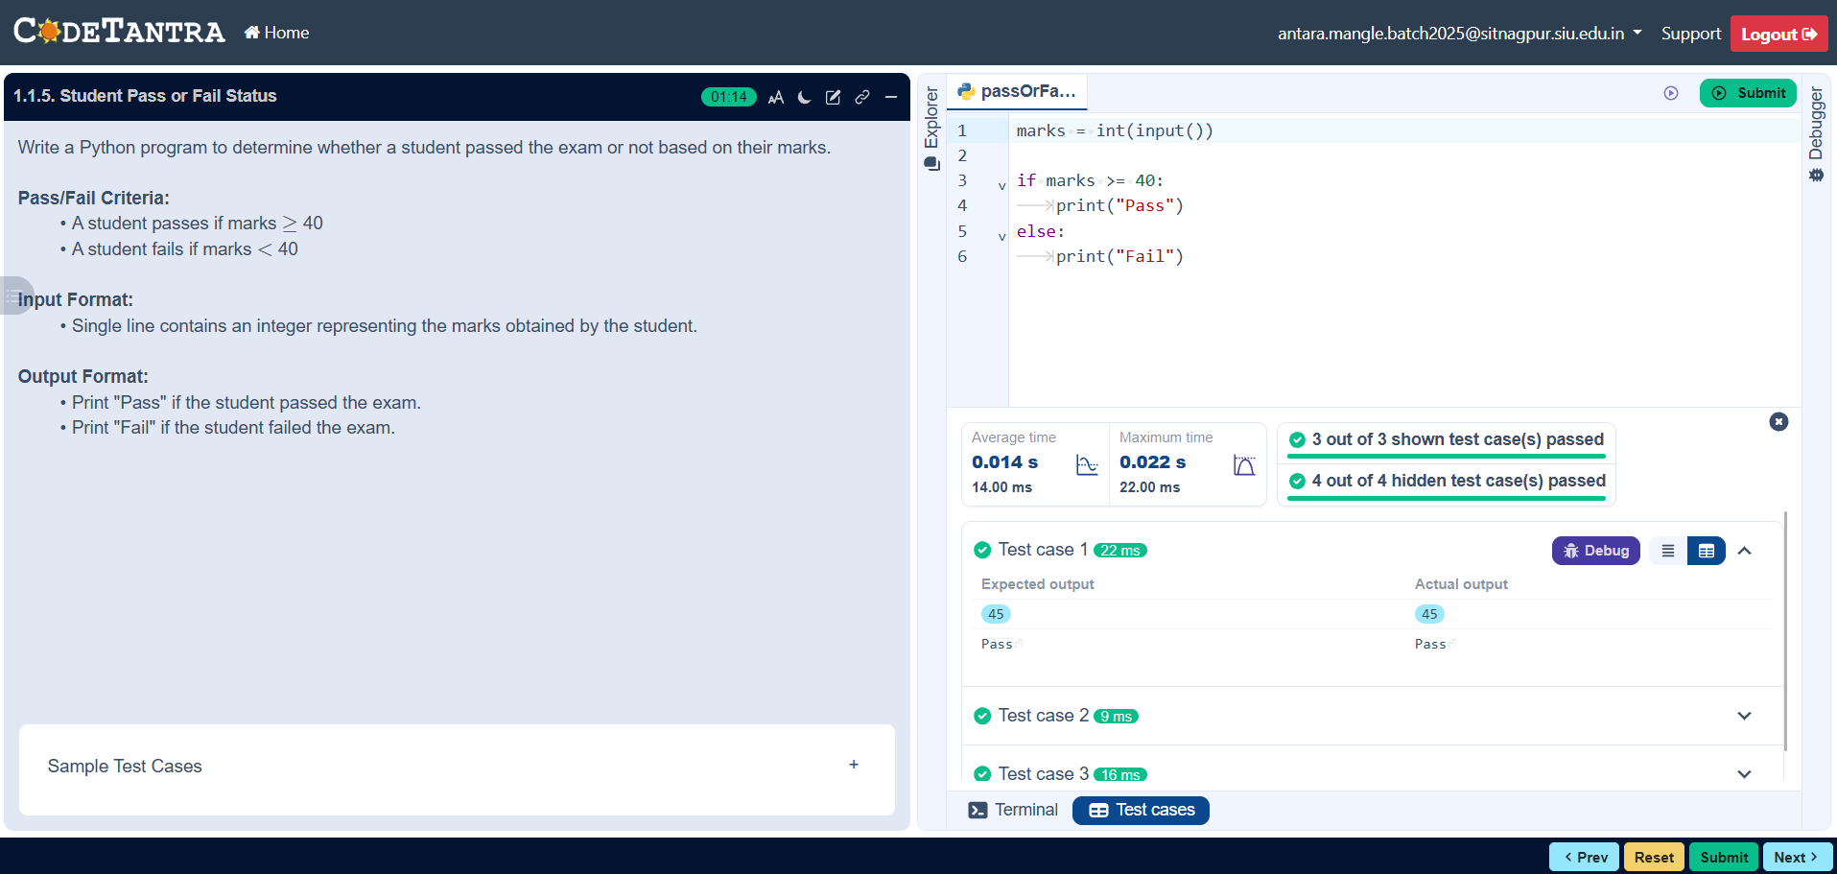

Algorithm

Step 1: Start
Step 2: Input the student’s marks
Step 3: Check if the marks are 40 or more
Step 4: If marks are 40 or more, print “Pass”
Step 5: If marks are less than 40, print “Fail”
Step 6: Stop

Flowchart
Start

Input: Marks

M>40

YES NO

Result: Fail
Result: Pass

Output: Result

End

