2.1.1

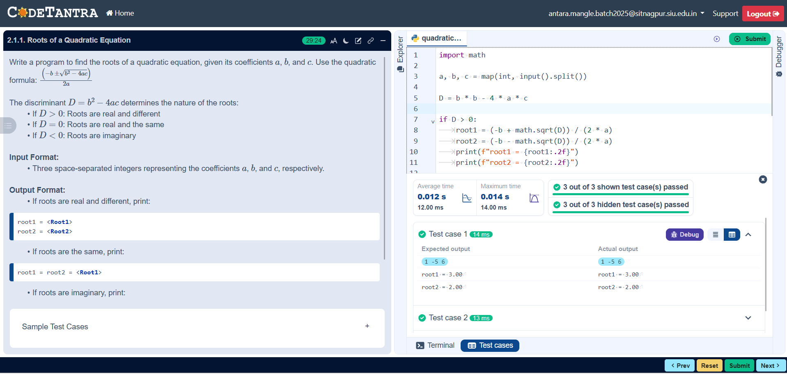

Algorithm
Step 1: Start
Step 2: Input the values of a, b, and c
Step 3: Calculate the discriminant D= b^2 – 4ac
Step 4: If D > 0, print “Two different real roots”
Step 5: If D = 0, print “Two equal real roots”
Step 6: If D < 0, print “No real roots”
Step 7: Stop

Flowchart
Start

Input= a, b, c

D= -b^2 – 4ac

D>0

D=0
Print: Two different real roots

Print: No real roots
Print: Two equal real roots

Stop

