3.1.1
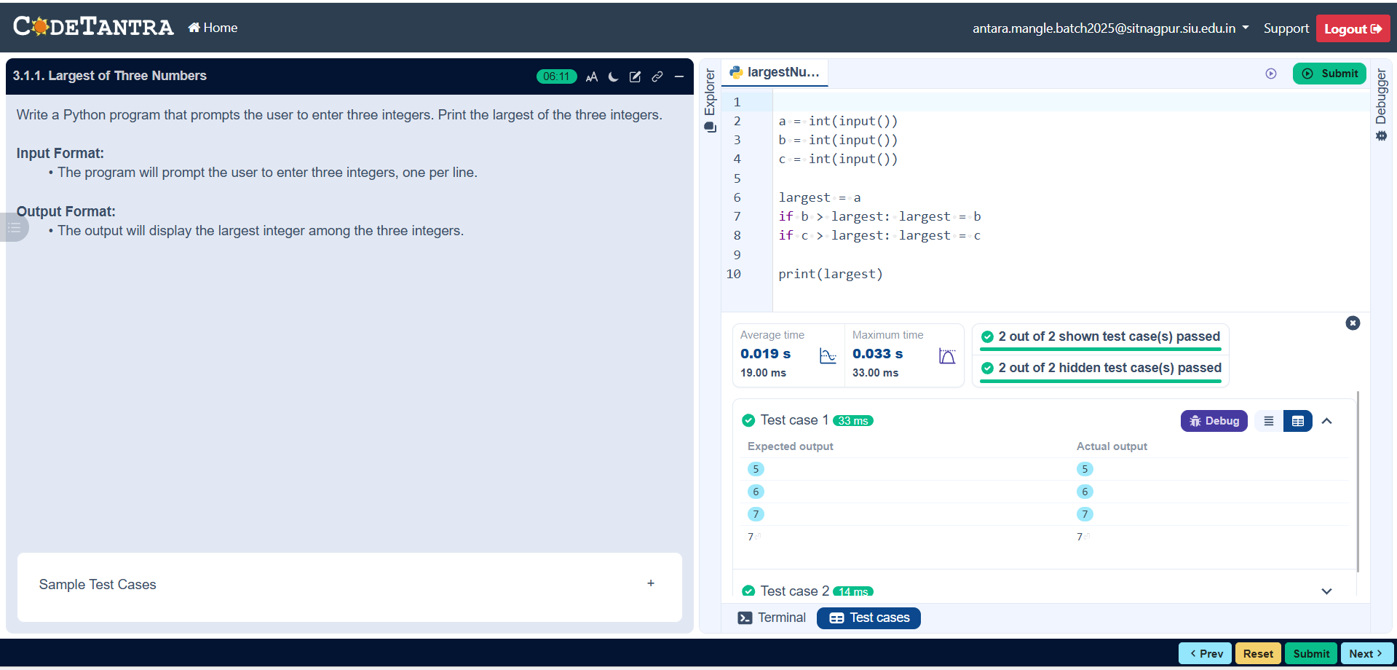

Algorithm

Step 1: Start
Step 2: Input three numbers: A, B, and C
Step 3: Compare A and B
- If A is greater than B, go to step 4
- Otherwise, go to step 5
Step 4: Compare A and C
- If A is greater than C, then A is the largest
- Otherwise, C is the largest
Step 5: Compare B and C
- If B is greater than C, then B is the largest
- Otherwise, C is the largest
Step 6: Display the largest number
Step 7: Stop

Flowchart
Start

Input: a, b, c

If a > b

No Yes

If a > c
If b > c

Yes No No Yes

Print a is the largest number
Print c is the largest number
Print b is the largest number

Stop

