3.1.2

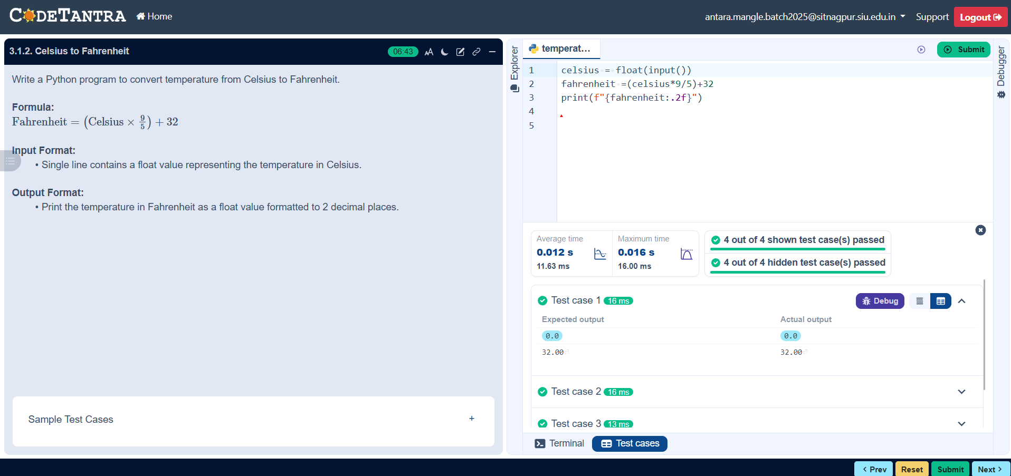

Algorithm
Step 1: Start
Step 2: Input temperature in Celsius (C)
Step 3: Calculate Fahrenheit using the formula
F = (C * 9 / 5) + 32
Step 4: Display the temperature in Fahrenheit
Step 5: Stop

Flowchart
Start

Input: Celsius

F= ( C * 9/5) + 32

Output: Fahrenheit

Stop

