A

PROJECT REPORT

ON

BookHub: An It-Driven Portal For Book
Sales And Purchases
Submitted in partial fulfillment for the award of

Post Graduate Diploma in Advance Computing

(PG-DAC)
from

INSTITUTE OF EMERGING TECHNOLOGIES

Authorized Training Centre


Under the Guidance of
Mrs. Sampada Tarare

By

Nilesh Pandhare 250245920057
Vaibhav Chaudhari 250245920091
Om Ghatol 250245920057
Antara Nandeshwar 250245920016


CERTIFICATE

This is to certify that the project report entitled BookHub: An It-Driven Portal For Book Sales And Purchases is a bonfire work carried out by Nilesh Pandhare, Vaibhav Chaudhari, Om Ghatol, Antara Nandeshwar and submitted in partial fulfilment of the requirement for the C-DAC ACTS, DAC course in Institute of Emerging Technology in the batch of Feb 2025.

Course Coordinator External Examiner

ACKNOWLEDGEMENT

This project Bookhub was a great learning experience for us and we are submitting this work to Advanced Computing Training School (CDAC).

We are very glad to mention the Ms. Sayali Patil for her valuable guidance to work on this project. Her guidance and support helped us to overcome various obstacles and intricacies during the course of project work.

Our most heart full thanks goes to Mr. Sangram Patil (Director ,IET)who gave all the required support and kind coordination to provide all the necessities like required hardware, internet facility and extra lab hours to complete the project and throughout the course up to the last day here in C-DAC ACTS, Pune.

Sign of student

Nilesh Pandhare 250245920057
Vaibhav Chaudhari 250245920091
Om Ghatol 250245920054
Antara Nandeshwar 250245920016

Abstract

The need for budget-friendly resources has risen sharply, especially as students contend with the high costs of acquiring new textbooks every semester. Many students look to purchase used books but struggle to find an accessible, reliable marketplace for buying and selling them. Traditional book markets often fall short, as they lack transparency, fair pricing, and ease of access. An online platform dedicated to connecting book buyers and sellers directly could be a valuable solution, making it easy for users to negotiate prices, check. By facilitating direct exchanges, such a platform can promote the reuse of books, making learning resources more affordable and accessible for students while supporting sustainable practices in education.

Index

Sr. No. | Title | Page No.
1 | Introduction
2 | Problem Definition & Scope
2.1 | Problem Definition
2.2 | Goals & Objectives
2.3 | Major Constraints& Outcomes
3 | Software Requirement Specification
3.1 | Purposed System
3.2 | Scope
4 | System Modules
5 | Performance-Requirements
5.1 | H/W Requirements & S/W Requirements
6 | UML Diagram
6.1 | DFD
6.2 | ERD
6.3 | Use case diagram
6.4 | Class Diagram
6.5 | Sequence diagram
6.6 | Activity Diagram
6.7 | Deployment diagram
6.8 | System Architecture
7 | Test Cases
8 | Screenshots
9 | References

1. Introduction

BookHub is a web-based platform designed to facilitate buying and selling books directly between users. The primary goal of the project is to make books more accessible and affordable by enabling peer-to-peer transactions without the need for costly intermediaries.

In many cases, readers are left with books they no longer need, while others struggle to find affordable copies. Existing platforms often focus only on selling new books or have limited options for second-hand purchases. BookHub solves this problem by allowing users to:

- Buy – Easily purchase books listed by other members at competitive prices.
- Sell – List books for sale, helping others while recovering value from unused items.

The platform is built using React for the frontend and ASP.NET Core Web API for the backend. It uses Entity Framework Core with Identity for database management and secure authentication, along with JWT for protected communication between the client and server.

By promoting direct transactions between readers, BookHub not only encourages reading but also supports a sustainable reuse culture, reducing waste and making knowledge more accessible to all.

2. Problem Definition & Scope

2.1. Problem Definition

Students often face significant financial burdens when purchasing new textbooks, and many find it difficult to resell these books once their courses are over. Existing platforms do not fully address the specific needs of students, lacking features such as fair price suggestions and personalized book recommendations. There is a need for an online system that enables students to buy and sell books directly with one another in an affordable and convenient way. BookHub aims to fulfill this need by providing a user-friendly platform that simplifies book exchange, promotes sustainability through reuse, and helps reduce the overall cost of education.

2.2. The key objectives of the project are as follows:

- Facilitate Book Transactions

  - Develop a reliable and easy-to-use platform where users can post books for sale and browse listings from other members.
  - Implement features such as search, filter, and category selection to help buyers find the desired books quickly.

- Promote Affordability

  - Encourage the sale of second-hand books at reasonable prices, making reading materials more accessible to students, professionals, and book lovers.
  - Provide users the flexibility to negotiate prices directly with sellers.

- Encourage Reuse and Sustainability

  - Reduce the number of unused books lying idle or being discarded.
  - Support the concept of a circular economy by giving books a longer life cycle through multiple owners.

- Ensure Secure User Authentication

  - Protect user accounts with robust authentication using ASP.NET Core Identity and JWT (JSON Web Token) for secure session handling.
  - Safeguard personal data and ensure only authorized users can list or purchase books.

- Provide a User-Friendly Interface

  - Design a clean and responsive React-based frontend that works seamlessly on desktops, tablets, and mobile devices.
  - Focus on an intuitive layout so even first-time users can navigate without difficulty.

- Efficient Data Management

  - Use Entity Framework Core to handle database operations, ensuring smooth storage and retrieval of user profiles, book listings, and transaction records.
  - Maintain data consistency and integrity across all operations.

- Build a Community of Readers

  - Foster connections between buyers and sellers who share a passion for reading.
  - Create a trusted environment where members can interact, review books, and provide feedback on transactions.

3. Software Requirement Specification

3.1 Purpose of the Project

The purpose of the BookHub project is to create an online platform that enables users to buy and sell books directly with each other in a secure, convenient, and cost-effective manner. The project aims to bridge the gap between individuals who have books they no longer use and those who are looking for affordable reading material.

By providing a centralized marketplace for books, BookHub:

- Promotes the reuse of books, reducing waste and environmental impact.
- Makes books more affordable for students, professionals, and avid readers.
- Offers a user-friendly interface for quick listing, searching, and purchasing of books.
- Ensures secure transactions and data privacy through robust authentication and authorization mechanisms.

Ultimately, the platform’s purpose is to make knowledge and learning resources more accessible while fostering a community of readers who can share resources in an economical and sustainable way.

3.2 Scope

The project enables user registration with role-based access, book listing for buy/sale/rent, search and filtering, recommendation for similar books, rental option, in-app chat, and an admin dashboard. Built using React (frontend), .NET Core (backend), and MongoDB (database).

Functional Scope:
- User Registration & Authentication
  - Secure signup/login with ASP.NET Core Identity.
  - Role-based access control (user, admin, super admin).
  - JWT token–based session management.
  - Password recovery and account management features.

- Book Catalog Management
  - Create, update, delete, and view book listings.
  - Support for both sale and rental modes.
  - Upload book images and descriptions.
  - Categorization and tagging for easier browsing.
- Advanced Search & Filtering
  - Search by book title, author, category, or keyword.
  - Filter by price range, condition, availability (sale/rent), and location.
- Recommendation Engine
  - Suggest similar books based on search history and preferences.
  - Highlight trending and popular books.
- Transaction Handling
  - Maintain cart and wishlist functionalities.
  - Direct checkout for purchases and rental bookings.
  - Maintain transaction logs for both buyer and seller.
- In-App Chat System
  - Real-time messaging between buyers and sellers.
  - Support for price negotiation and inquiries.
  - Message history stored securely.
Technical Scope:
- Frontend: Built using React with responsive design for desktop, tablet, and mobile.
- Backend: ASP.NET Core Web API with modular service-based architecture.
- Database: Entity Framework Core (for relational data) and MongoDB (for chat/message storage).
- Authentication: Secure JWT tokens for protected endpoints.
- Cloud Deployment: Hosted on Microsoft Azure (App Service for backend, Static Web Apps for frontend, Azure SQL Database for data storage).
- Scalability & Performance: Optimized for future growth, with APIs designed for high concurrency.
- Security: HTTPS encryption, secure password storage (BCrypt), and strict access policies.

4. System Modules

The BookHub platform is structured into multiple interdependent modules, each responsible for a distinct part of the system’s functionality. This modular design ensures scalability, maintainability, and easier future enhancements.

1. Authentication & Authorization Module
- Purpose: Manage user identity, login, and role-based access.
- Key Features:
  - User registration and login with ASP.NET Core Identity.
  - Role-based permissions.
  - JWT token generation for secure API communication.
  - Token expiration and refresh mechanisms.

2. User Profile Management Module
- Purpose: Maintain and update user details.
- Key Features:
  - View and edit personal profile information.
  - Upload/change profile picture.
  - Manage contact information for communication with buyers/sellers.

3. Book Management Module
- Purpose: Enable sellers to list, update, or remove books.
- Key Features:
  - Add books with title, author, price, description, category, and images.
  - Edit or delete existing listings.
  - Set availability for sale or rent.
  - Automatic association of listings with seller’s profile.
- Interconnections:
  - Works with Search & Filter module for discoverability.
  - Linked to Order Management for transactions.

4. Search & Filter Module
- Purpose: Help buyers quickly find relevant books.

- Key Features:
  - Keyword-based search across title, author, and description.
  - Filters for price, category, condition (new/used), and availability (sale/rent).
  - Pagination and sorting (by price, date added, popularity).

5. Order & Cart Management Module
- Purpose: Handle book purchase workflows.
- Key Features:
  - Add/remove items in the shopping cart.
  - Place orders requests.
  - Maintain transaction history for both buyer and seller.

6. Admin Dashboard Module
- Purpose: Manage platform content and users.
- Key Features:
  - View, approve, or delete book listings.
  - Suspend or ban problematic users.
  - View site analytics (total users, active listings, transactions).
  - Generate downloadable reports.

5.Performance Requirements
The performance requirements for BookHub ensure that the platform operates efficiently, reliably, and securely under various load conditions, providing a smooth user experience for both buyers and sellers.

5.1. Hardware Requirements

Minimum Configuration (Development / Local Testing)
- Processor: Intel Core i3 (or equivalent)
- RAM: 4 GB
- Storage: 500 GB HDD or 128 GB SSD
- Display: 1366x768 resolution
- Network: Broadband internet (5 Mbps or higher)

Recommended Configuration (Production Server / Deployment)
- Processor: Intel Xeon / AMD EPYC (4+ cores)
- RAM: 8–16 GB
- Storage: 256 GB SSD (NVMe preferred)
- Network: Minimum 100 Mbps bandwidth
- Scalability: Support for horizontal scaling in cloud environment

5.2. Software Requirements

Development Environment
- OS: Windows 10/11 (64-bit) or Linux (Ubuntu 20.04+)
- Frontend Tools: Node.js (v18+), npm, React
- Backend Tools: .NET 8 SDK, Visual Studio / VS Code
- Database: SQL Server / Azure SQL, MongoDB (for chat storage)
- Version Control: GitHub / GitLab
- Package Managers: npm

Production Environment
- OS: Windows Server 2022 or Linux Server
- Web Server: Kestrel with Azure App Service or Nginx reverse proxy
- Database Hosting: Azure SQL Database, Azure Cosmos DB (for NoSQL needs)

6.UML Diagram

6.1 Data Flow Diagram

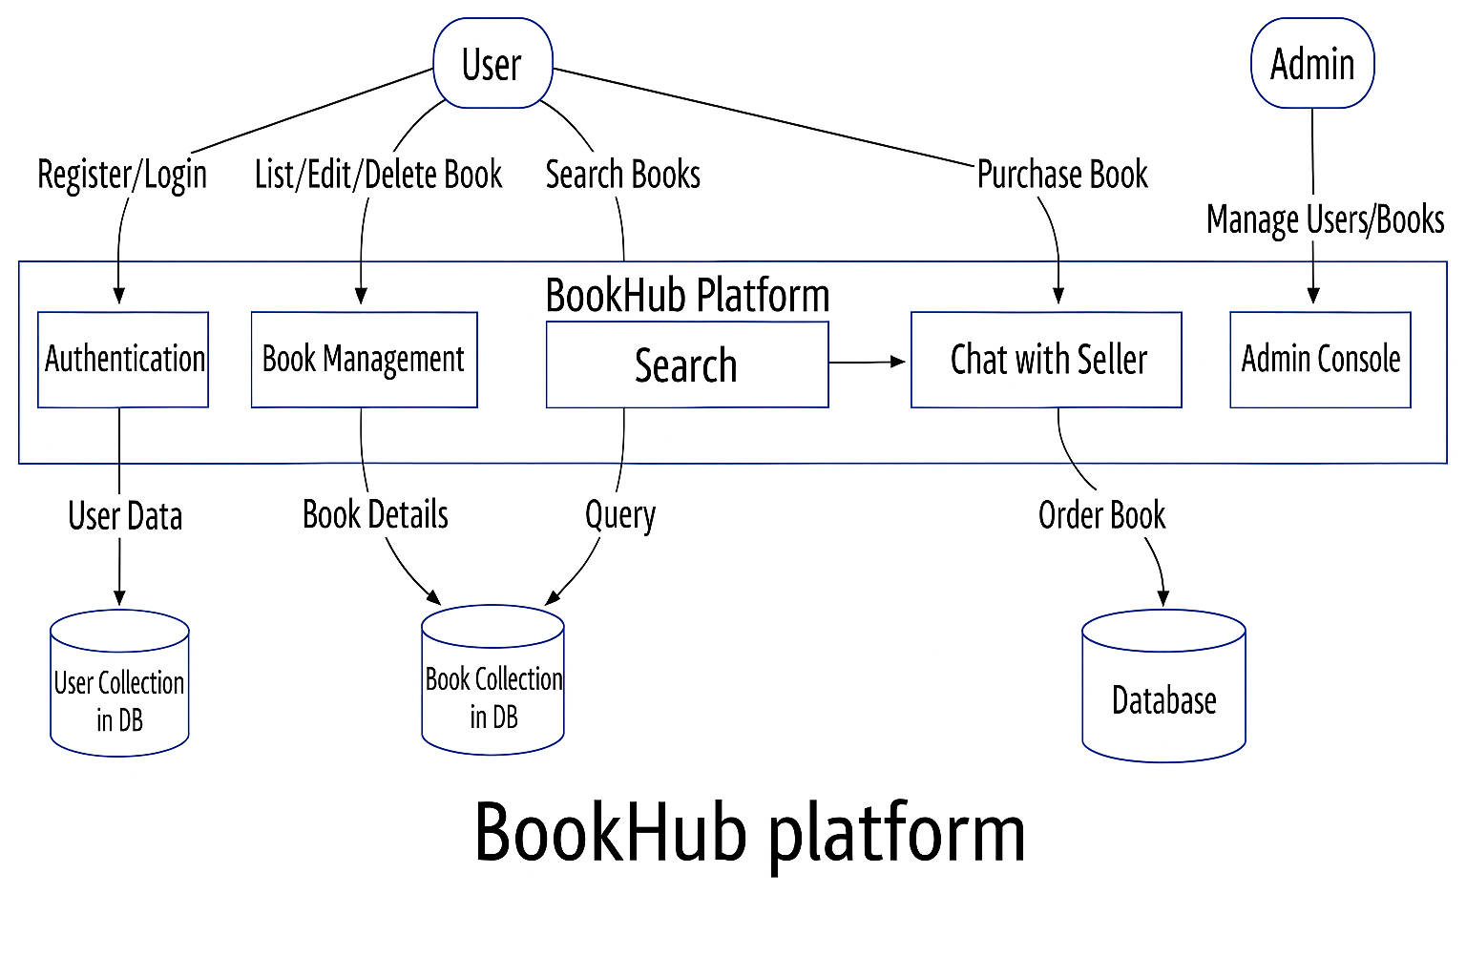

6.2 Entity Relationship Diagram

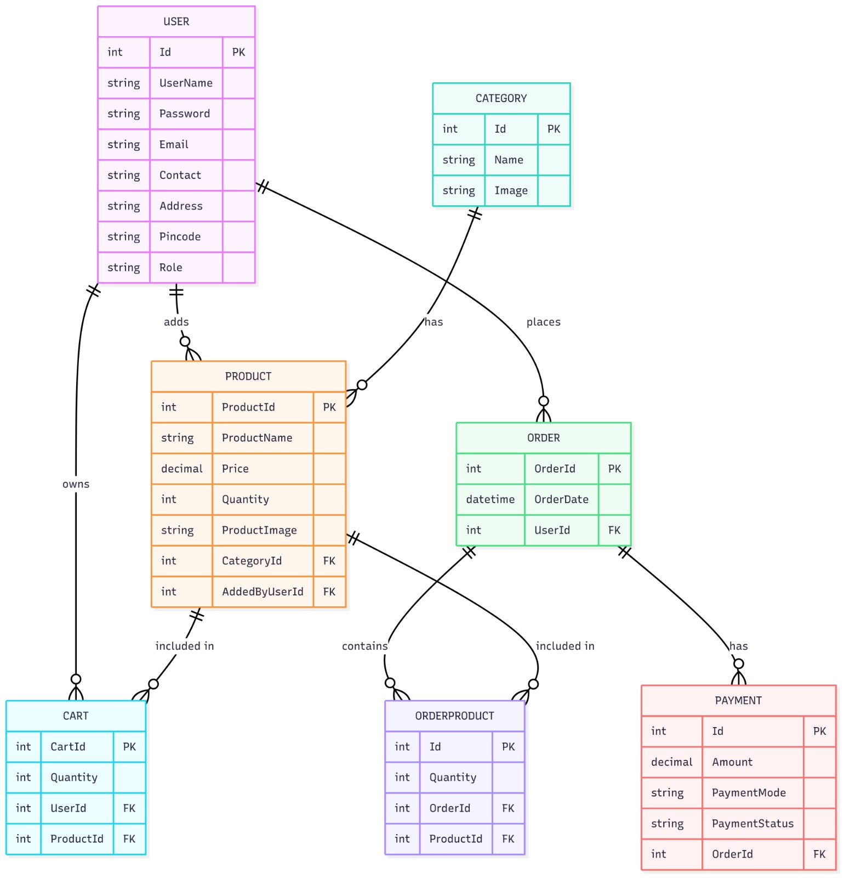

6.3 Use Case Diagram

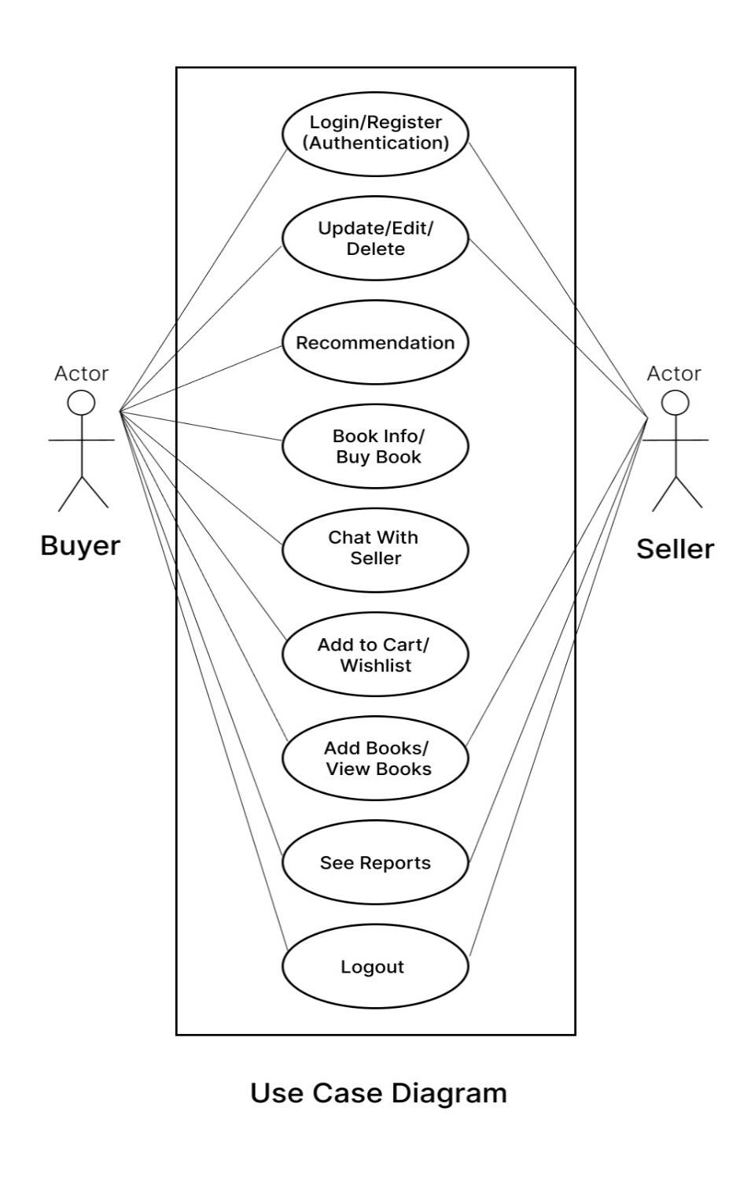

6.4. Class Diagram

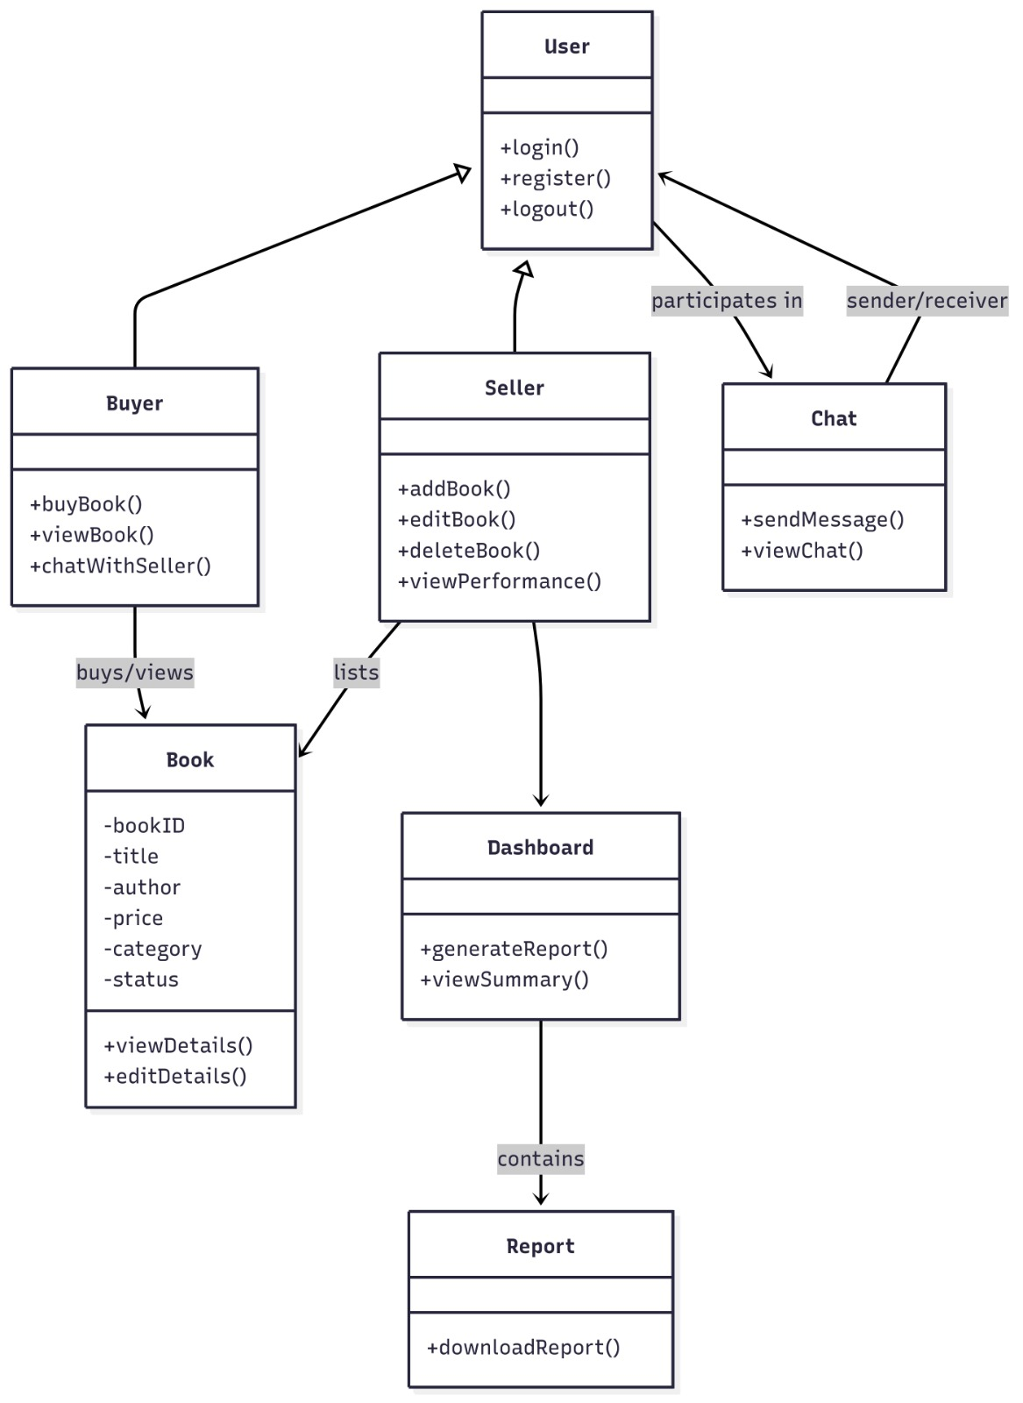

6.5 Sequence Diagram

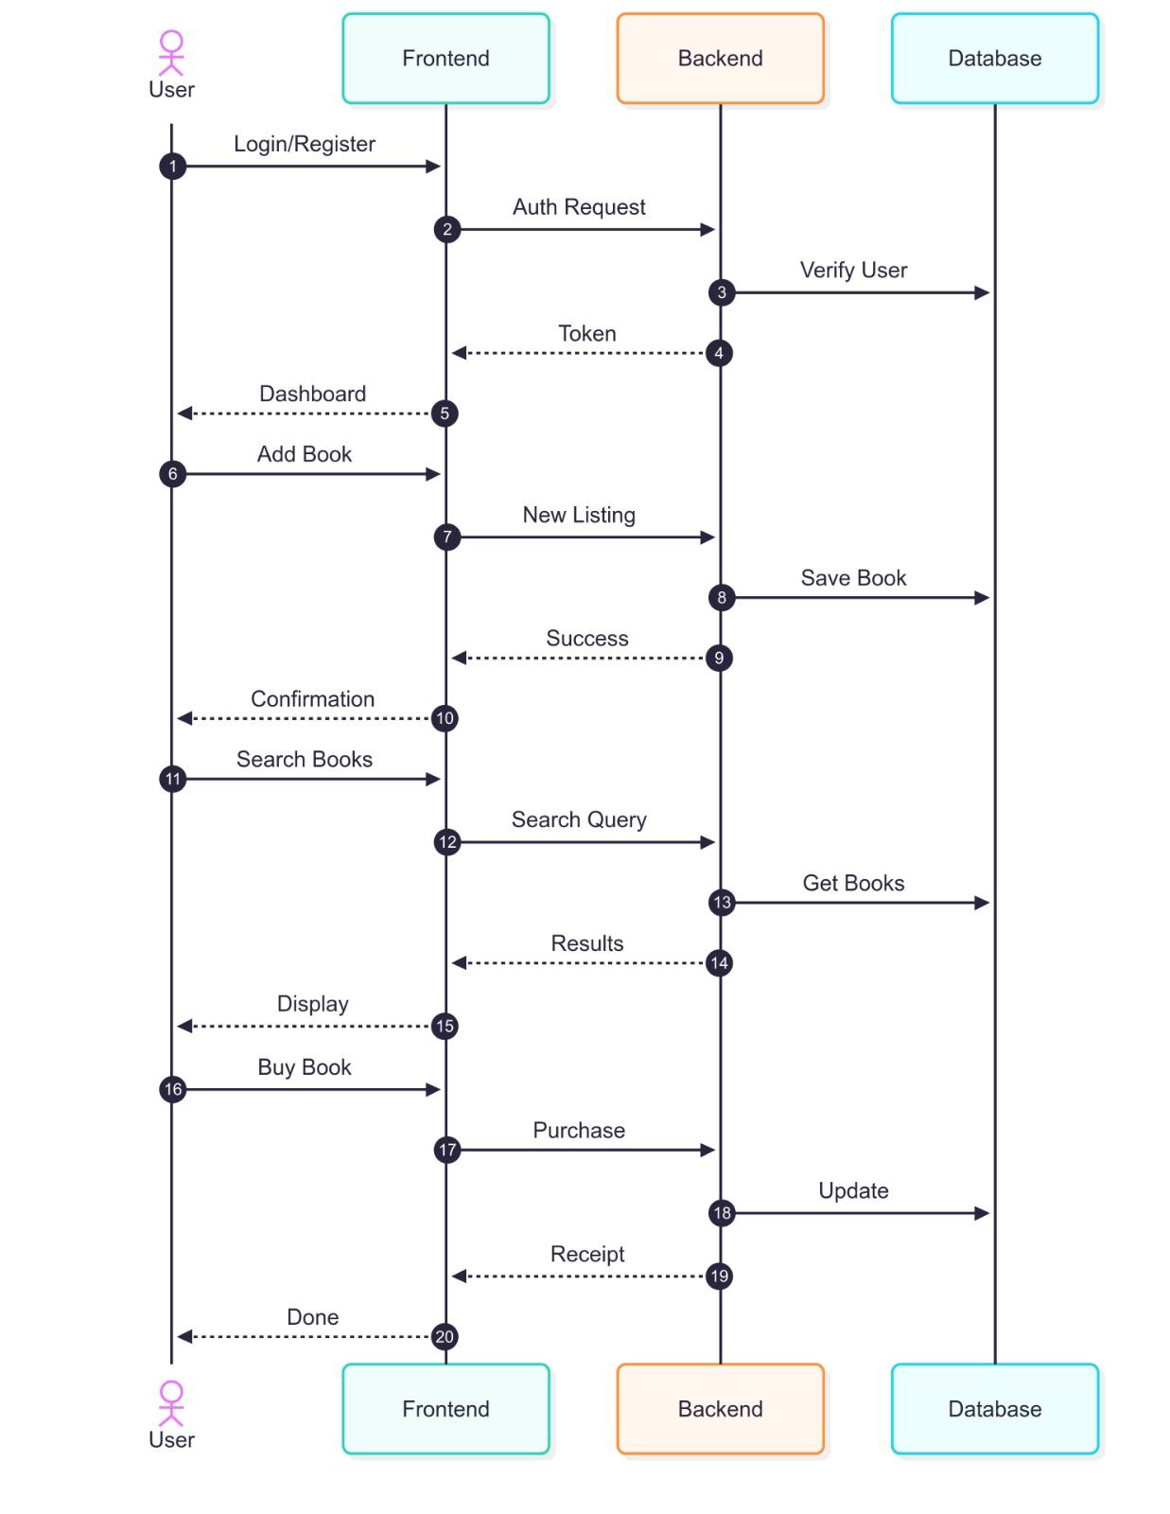

6.6 Activity Diagram

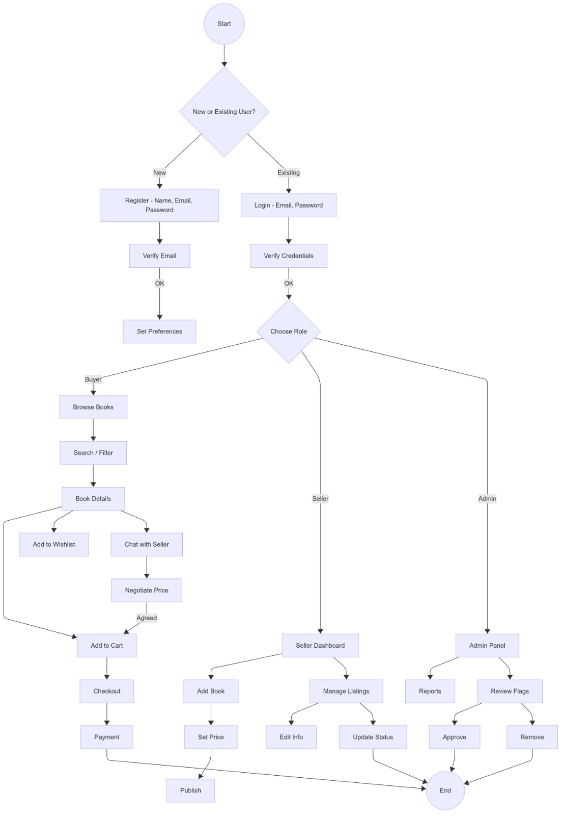

6.7 Deployment Diagram

6.8 System Architecture Diagram

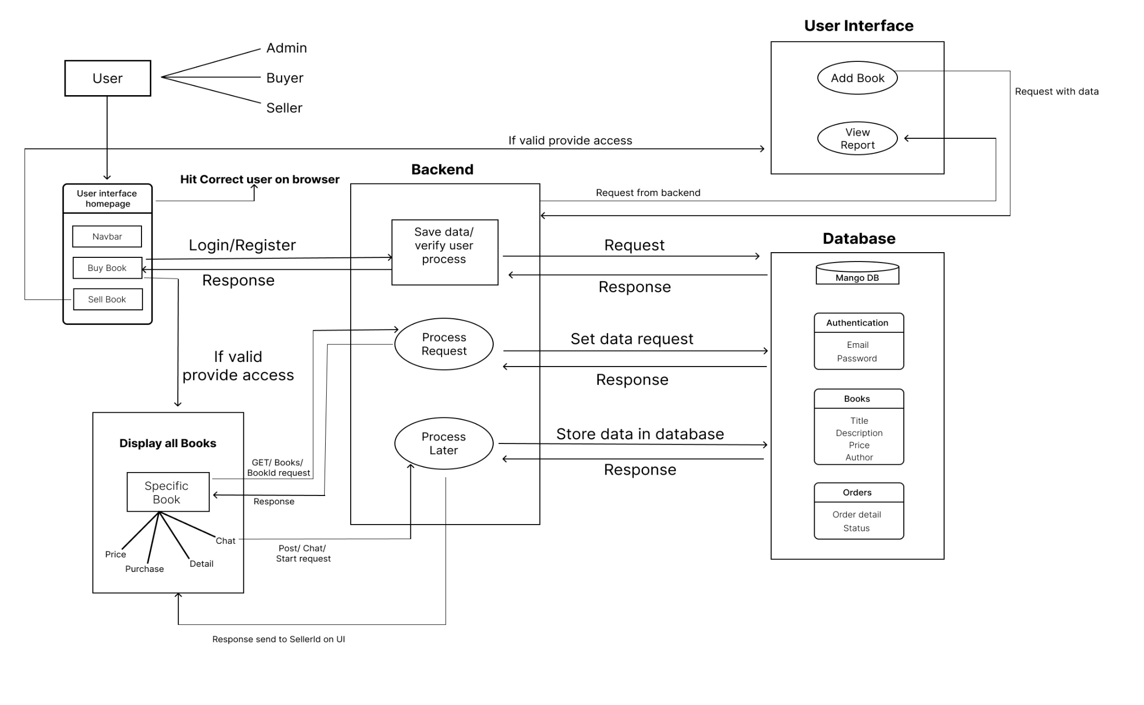

- Test Cases

Test Cases – Book Store Project
ID | Feature | Input | Expected Output | Actual Result | Status
1 | Login (valid) | Username: john, Password: pass123 | Success message + redirect to homepage | As expected | Pass
2 | Login (invalid) | Username: john, Password: wrong | Error message: "Invalid credentials" | As expected | Pass
3 | Add to Cart | Book ID: 5, Quantity: 1 | Book appears in cart | As expected | Pass
4 | Remove from Cart | Book ID: 5 | Book removed from cart | As expected | Pass
5 | Place Order | Cart with items | Order confirmation message with ID | As expected | Pass
6 | View Orders | Logged-in user | List of user’s past orders | As expected | Pass
7 | Payment (valid) | Valid card details | Payment successful message | As expected | Pass
8 | Payment (invalid) | Invalid card number | Payment failed message | As expected | Pass
9 | Add Book (Seller) | Book details form | Book listed in store | As expected | Pass
10 | Update Profile | New email, phone | Profile updated successfully | As expected | Pass

The test cases above verify the core functionalities of the Book Store Project, covering authentication, cart management, order placement, payment processing, seller operations, and user profile updates. Each case specifies the feature being tested, the input provided, and the expected output, along with the actual observed result and pass/fail status. This ensures that both customer-facing operations (like browsing, purchasing, and account management) and seller/admin features (like adding or removing books) work as intended. The table confirms that all tested scenarios meet the functional requirements, providing confidence in the stability and usability of the application.

- Screenshot

8.1 Home page



8.2 Admin Login Page

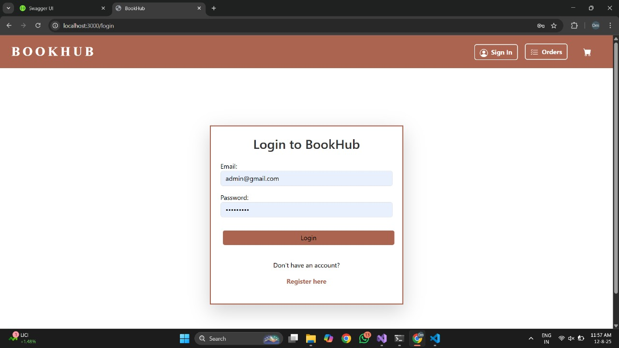

8.3 Admin Functionality

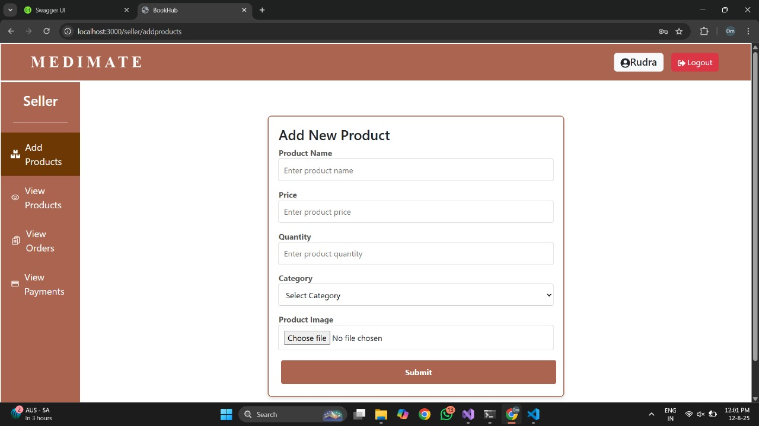

8.4 Books Category



8.5 Cart page

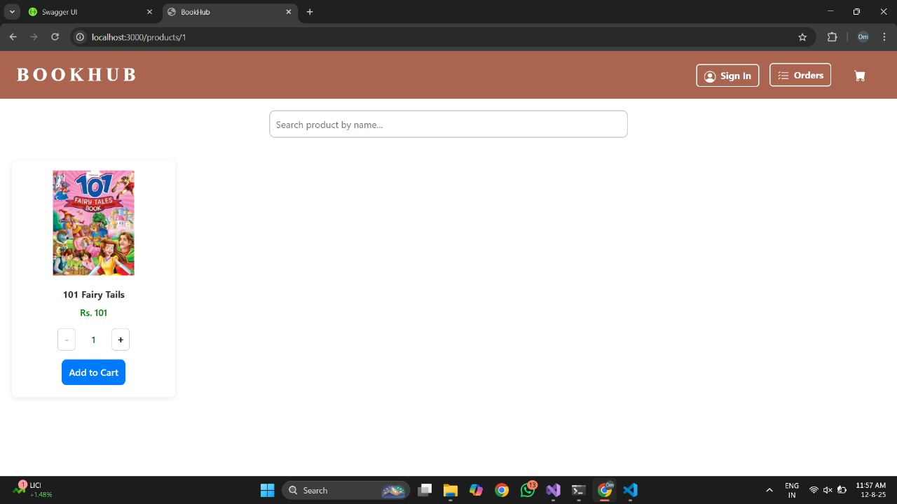

8.6 Payment Page



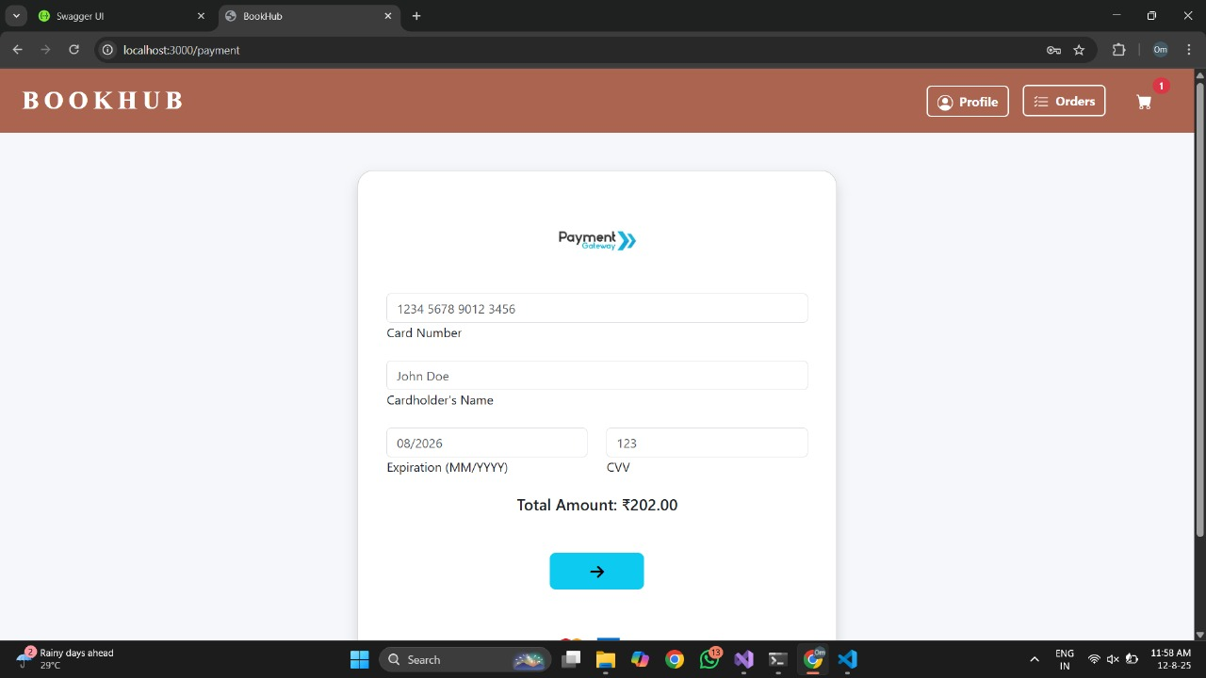

- References

[1] Ganesh, G. B., Gautham, C. R., & Gupta, N. K. “WEB BASED BOORESELLING
STORE.” ResearchGate. July 2021.
[2] Pera, M. S., & Ng, Y.-K. (2018). “A Recommendation-Based Book-ExchangSystem
Without using chatbot”. IEEE. 2018.
[3] A Thorat, Sandeep A. and Jadhav, Vishakha,A Review on Implementation Issues of
Rule-based Chatbot Systems’’ (April 2, 2020). Proceedings of the Internatio Conference on Innovative Computing & Communications (ICICC) 2020, SSRN.
[4] Bhat Pooja, Nitya Kulkarni: “Online Book Exchange System.” Springer 20 May 2019.
[5] Ganesh G B, gautham C R, Nitish Kumar Gupta, WEB BASED BOOK-RESELLING

