**Humpback whale assessment model results – 29 January 2019**

**0. Bayes factor comparison of scenarios**

|  |  |  |  |
| --- | --- | --- | --- |
| **Scenario** | **Bayes Factor 1** | **Scenario** | **Bayes Factor 2** |
| Reference | 0.088 | Reference | 0.107 |
| Sdata 1 | 0.088 | Sdata 1 | 0.107 |
| Sdata 6 | 0.090 | Sdata 6 | 0.109 |
| Scatch 1 | 0.035 | Scatch 1 | 0.043 |
| Scatch 2 | 0.047 | Scatch 2 | 0.057 |
| Scatch 3 | 0.089 | Scatch 3 | 0.108 |
| Scatch 4 | 0.088 | Scatch 4 | 0.107 |
| Scatch 5 | 0.048 | Scatch 5 | 0.058 |
| GC 1 | 0.088 | MSYR 1 | 0.142 |
| GC 2 | 0.088 | MSYR 2 | 0.165 |
| MSYR 1 | 0.117 |  |  |
| MSYR 2 | 0.136 |  |  |

**1. Cross Scenario Comparison Plots**

* 1. **K**

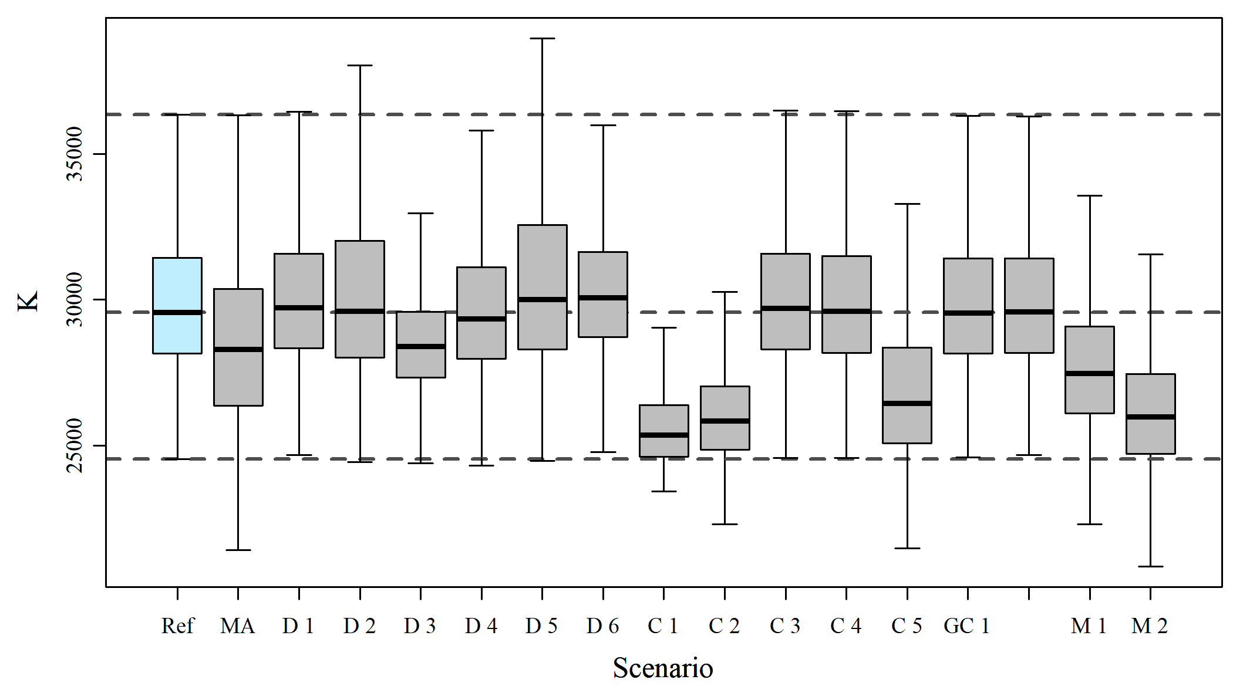

* 1. **R_max**

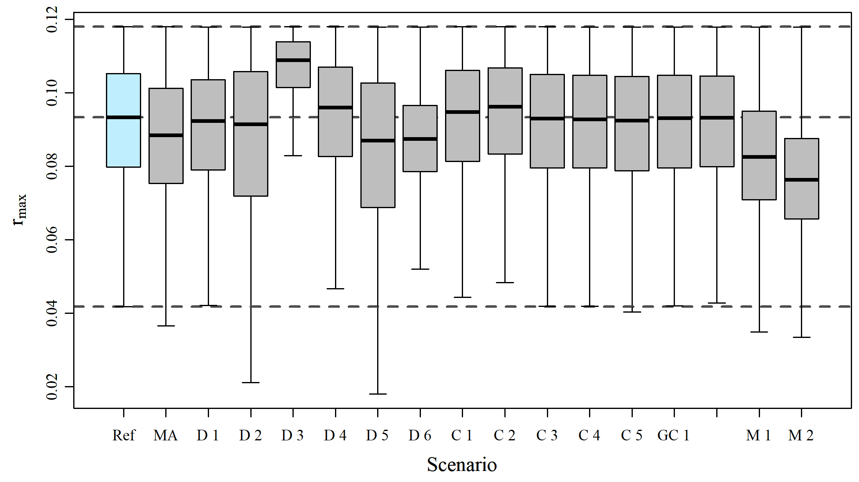

* 1. **N_min**

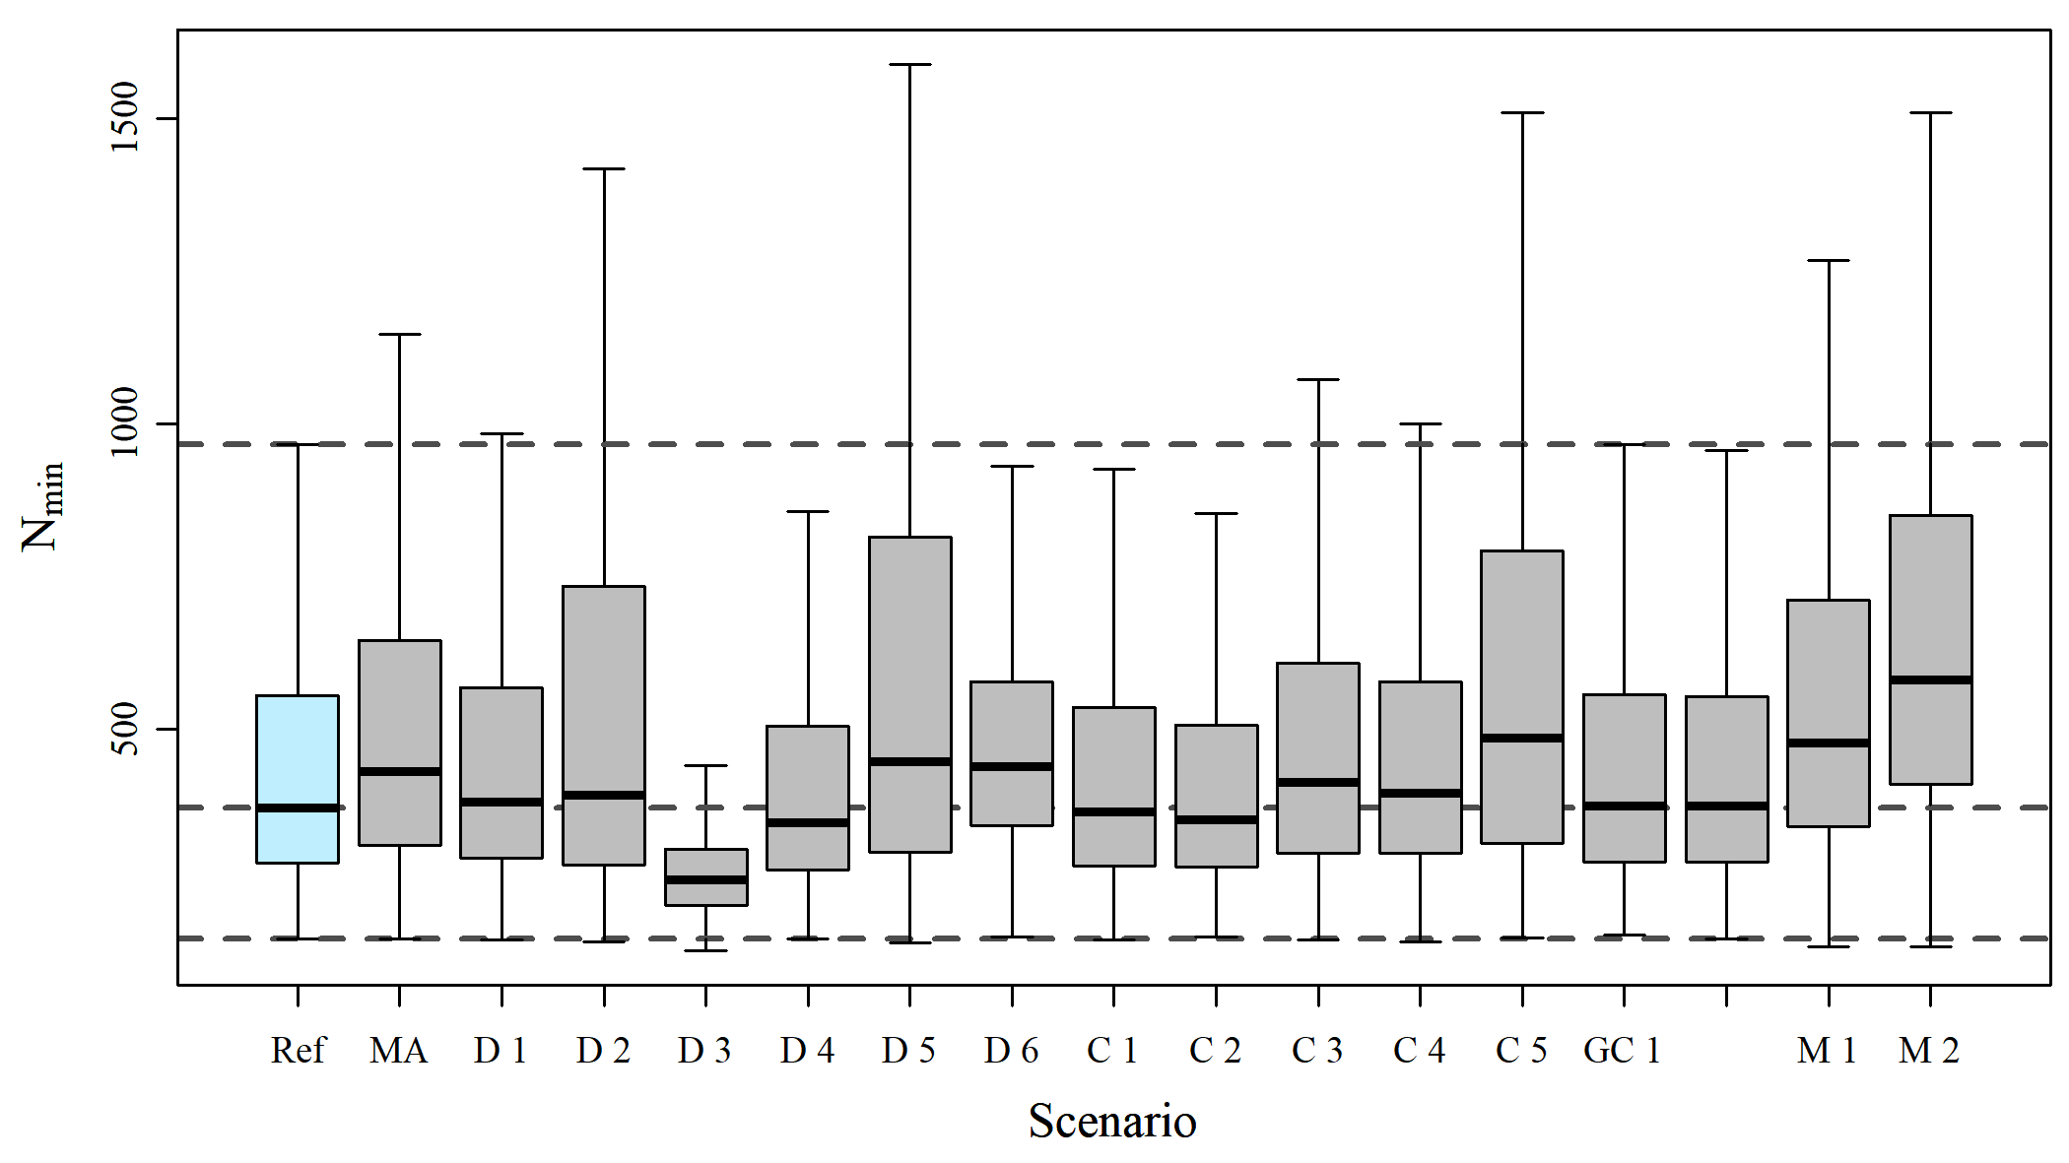

* 1. **N_2008**

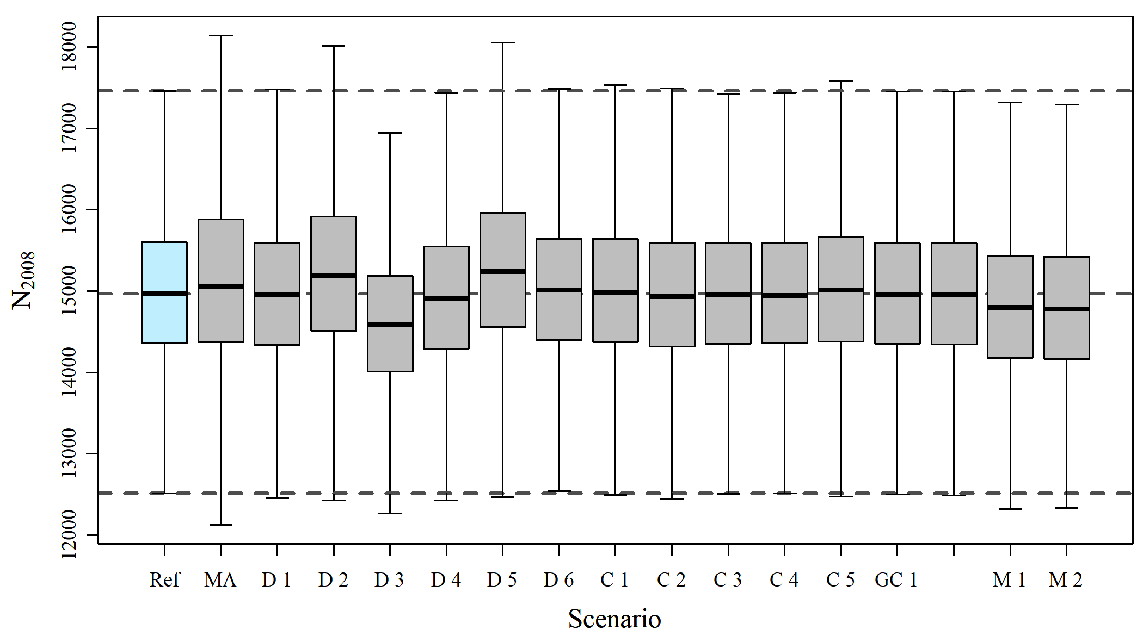

* 1. **N_2019**

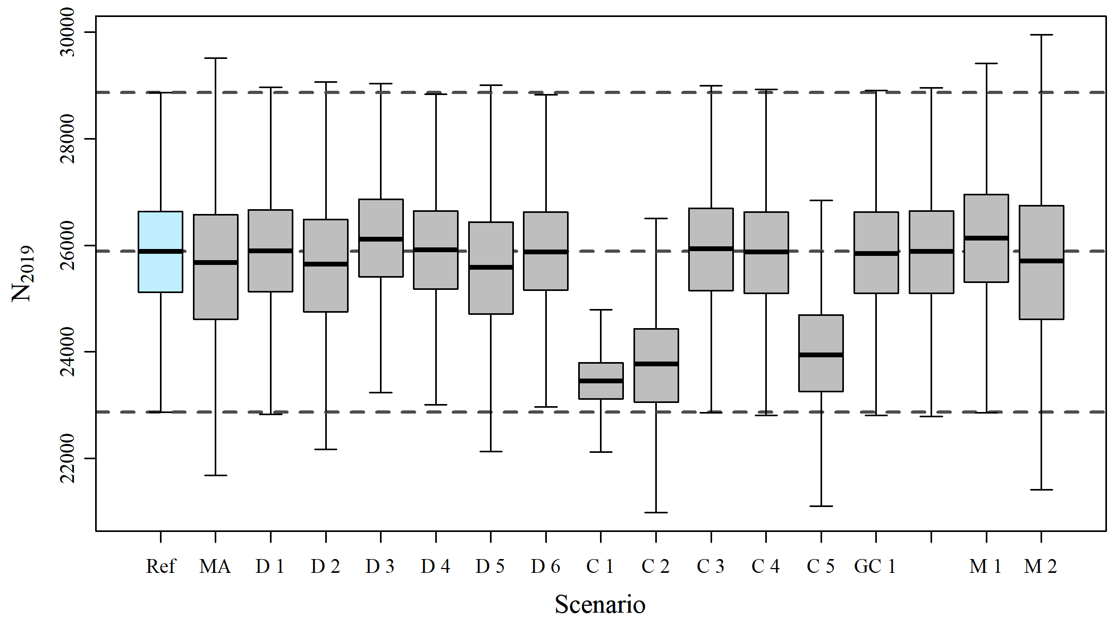

* 1. **Maximum Depletion**

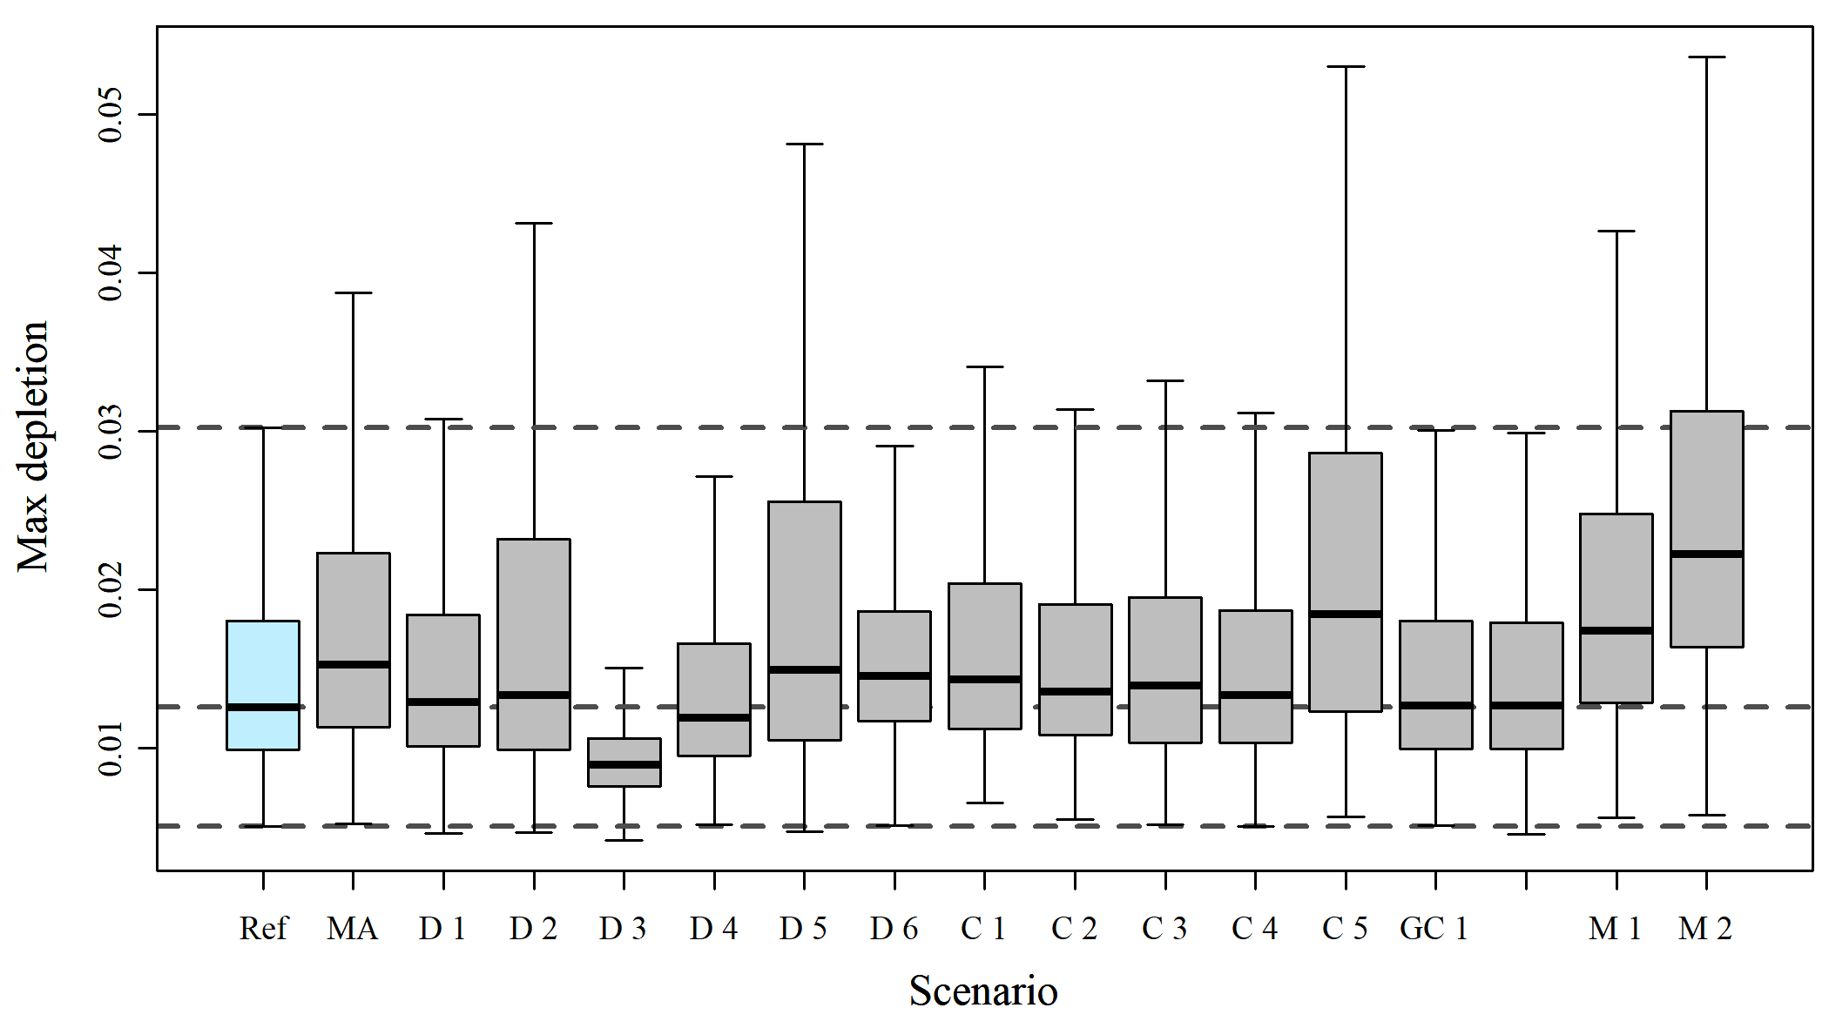

* 1. **Status 2008**



* 1. **Status 2019**

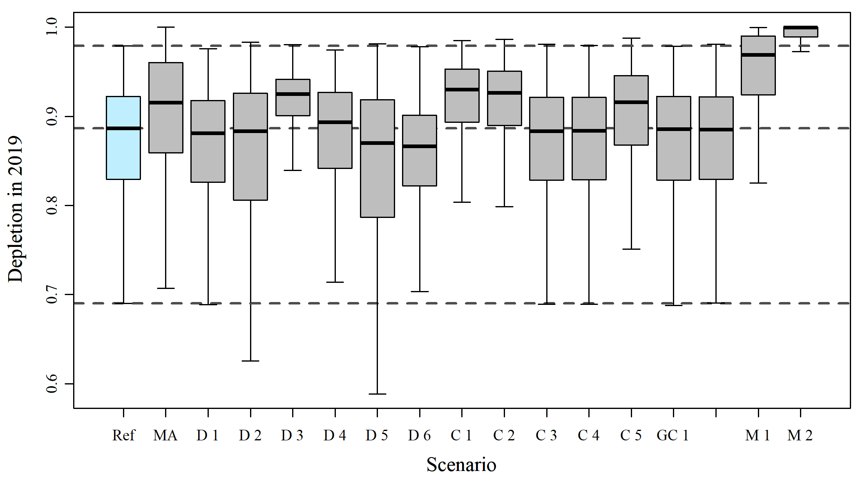

1. **Population Trajectories**
   1. **Model Average**

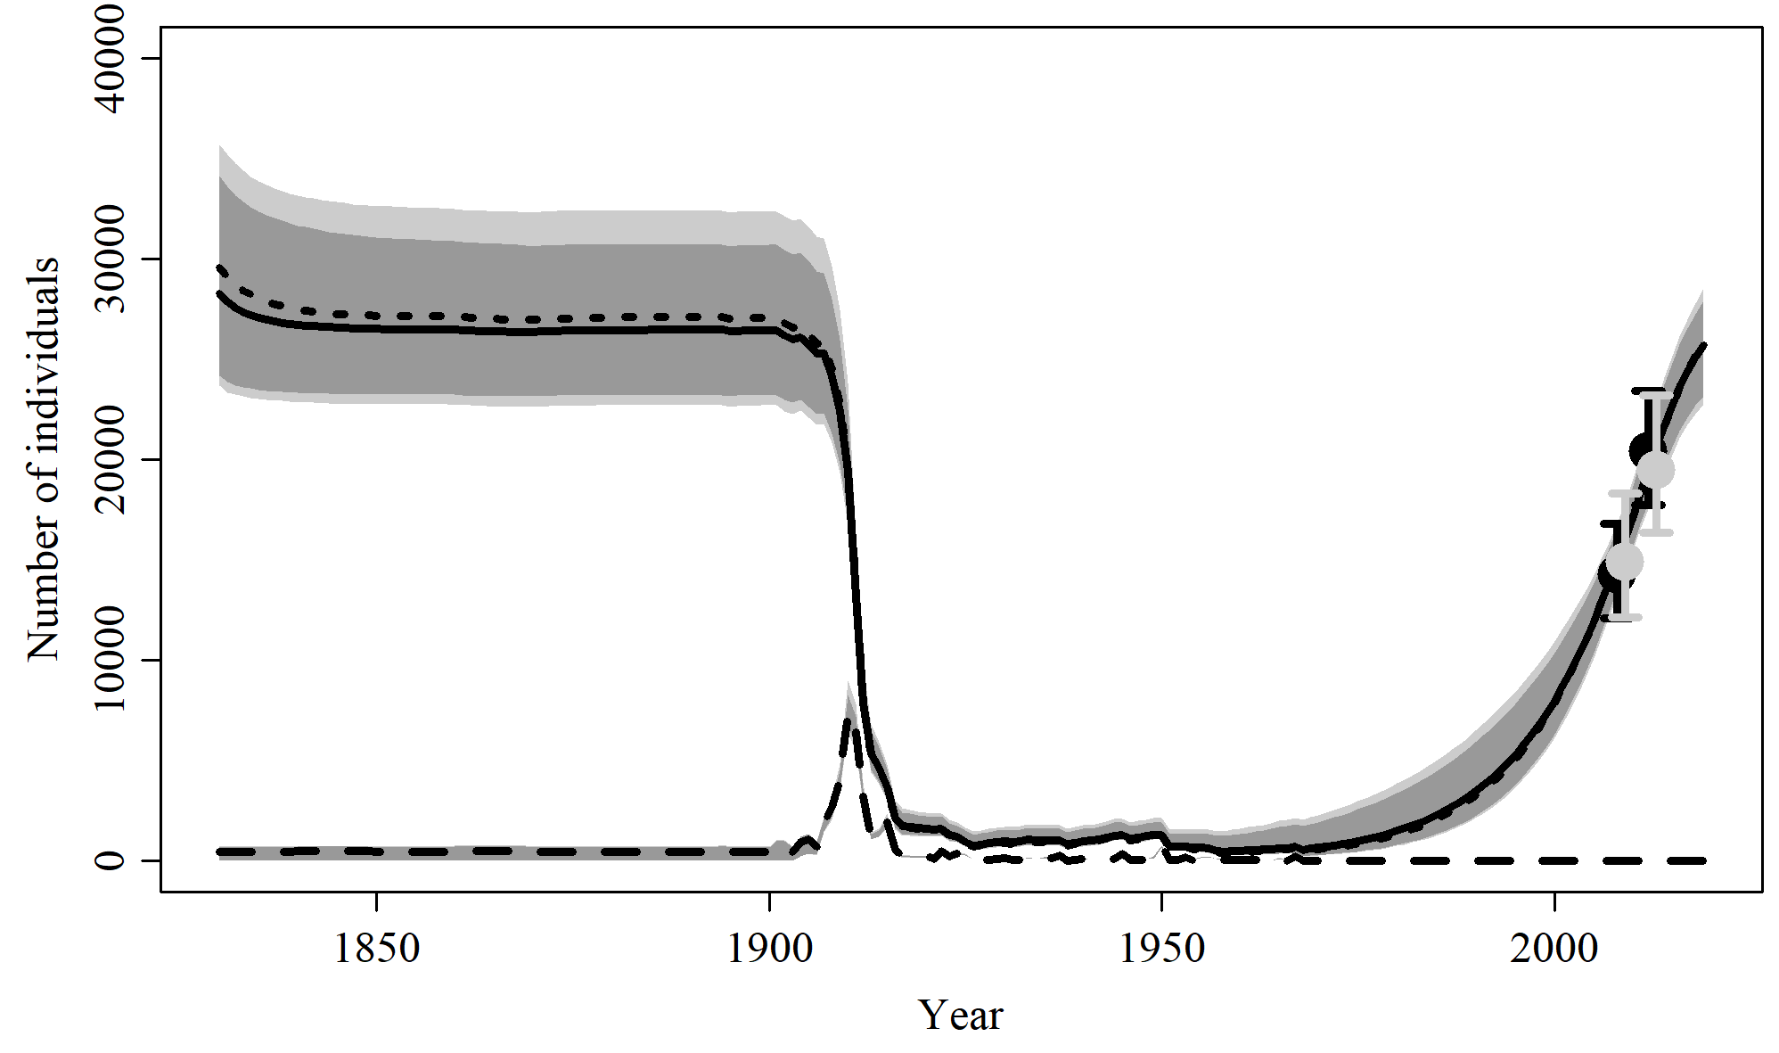

* 1. **Reference Case**

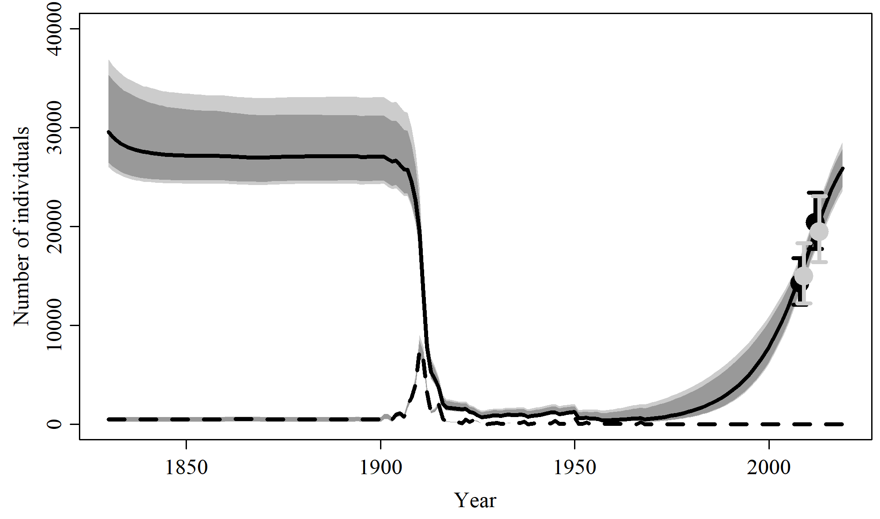

* 1. **Sensitivities to Abundance and Trends**

|  |  |
| --- | --- |
|  |  |
| **SData 1** | **SData 2** |
|  |  |
|  |  |
| **SData 3** | **SData 4** |
|  |  |
|  |  |
| **SData 5** | **SData 6** |

* 1. **Sensitivites to Catch Allocation**

|  |  |
| --- | --- |
|  |  |
| **SCatch 1** | **SCatch 2** |
|  |  |
|  |  |
| **SCatch 3** | **SCatch 4** |
|  |  |
|  |  |
| **SCatch 5** |  |

* 1. **Sensitivities to Genetic Constraint and MSYL**

|  |  |
| --- | --- |
|  |  |
| **GC 1** | **GC 2** |
|  |  |
|  |  |
| **MSYL 1** | **MSYL 2** |

1. **Fit of the Indices of Abundance**
   1. **Model Average**

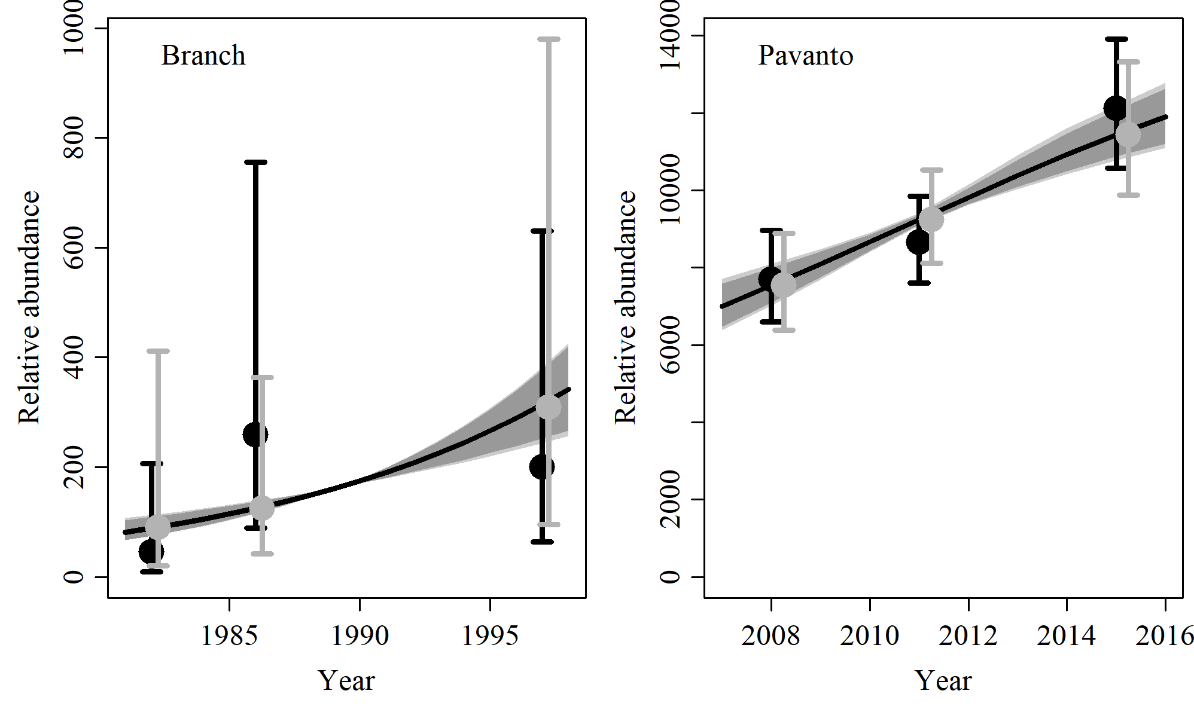

* 1. **Reference Case**

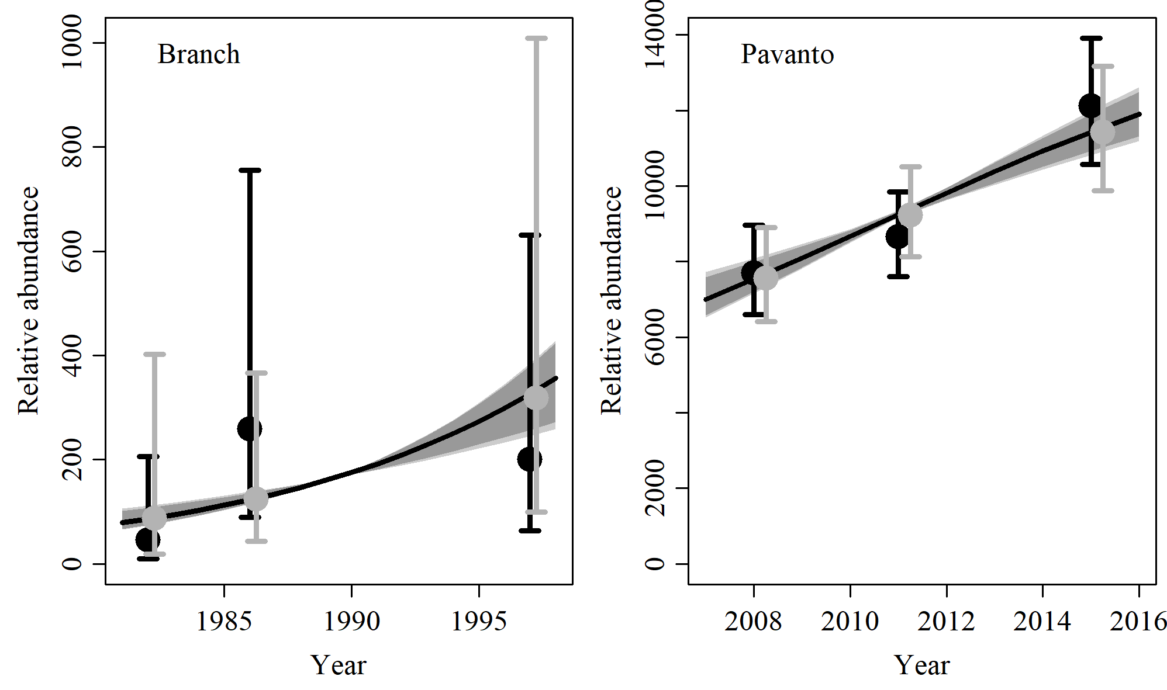

* 1. **SData 1**

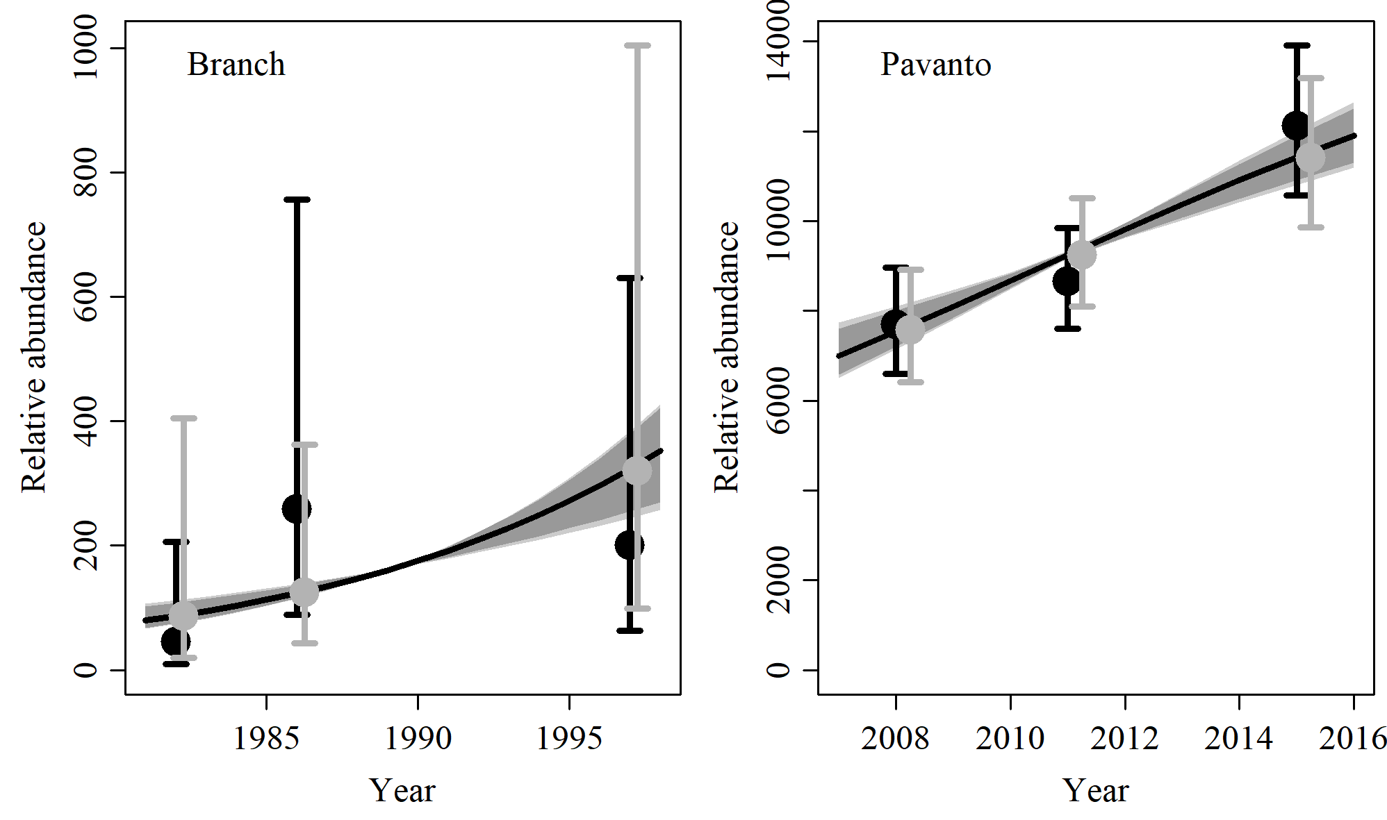

* 1. **SData 2**

No output

* 1. **SData 3**

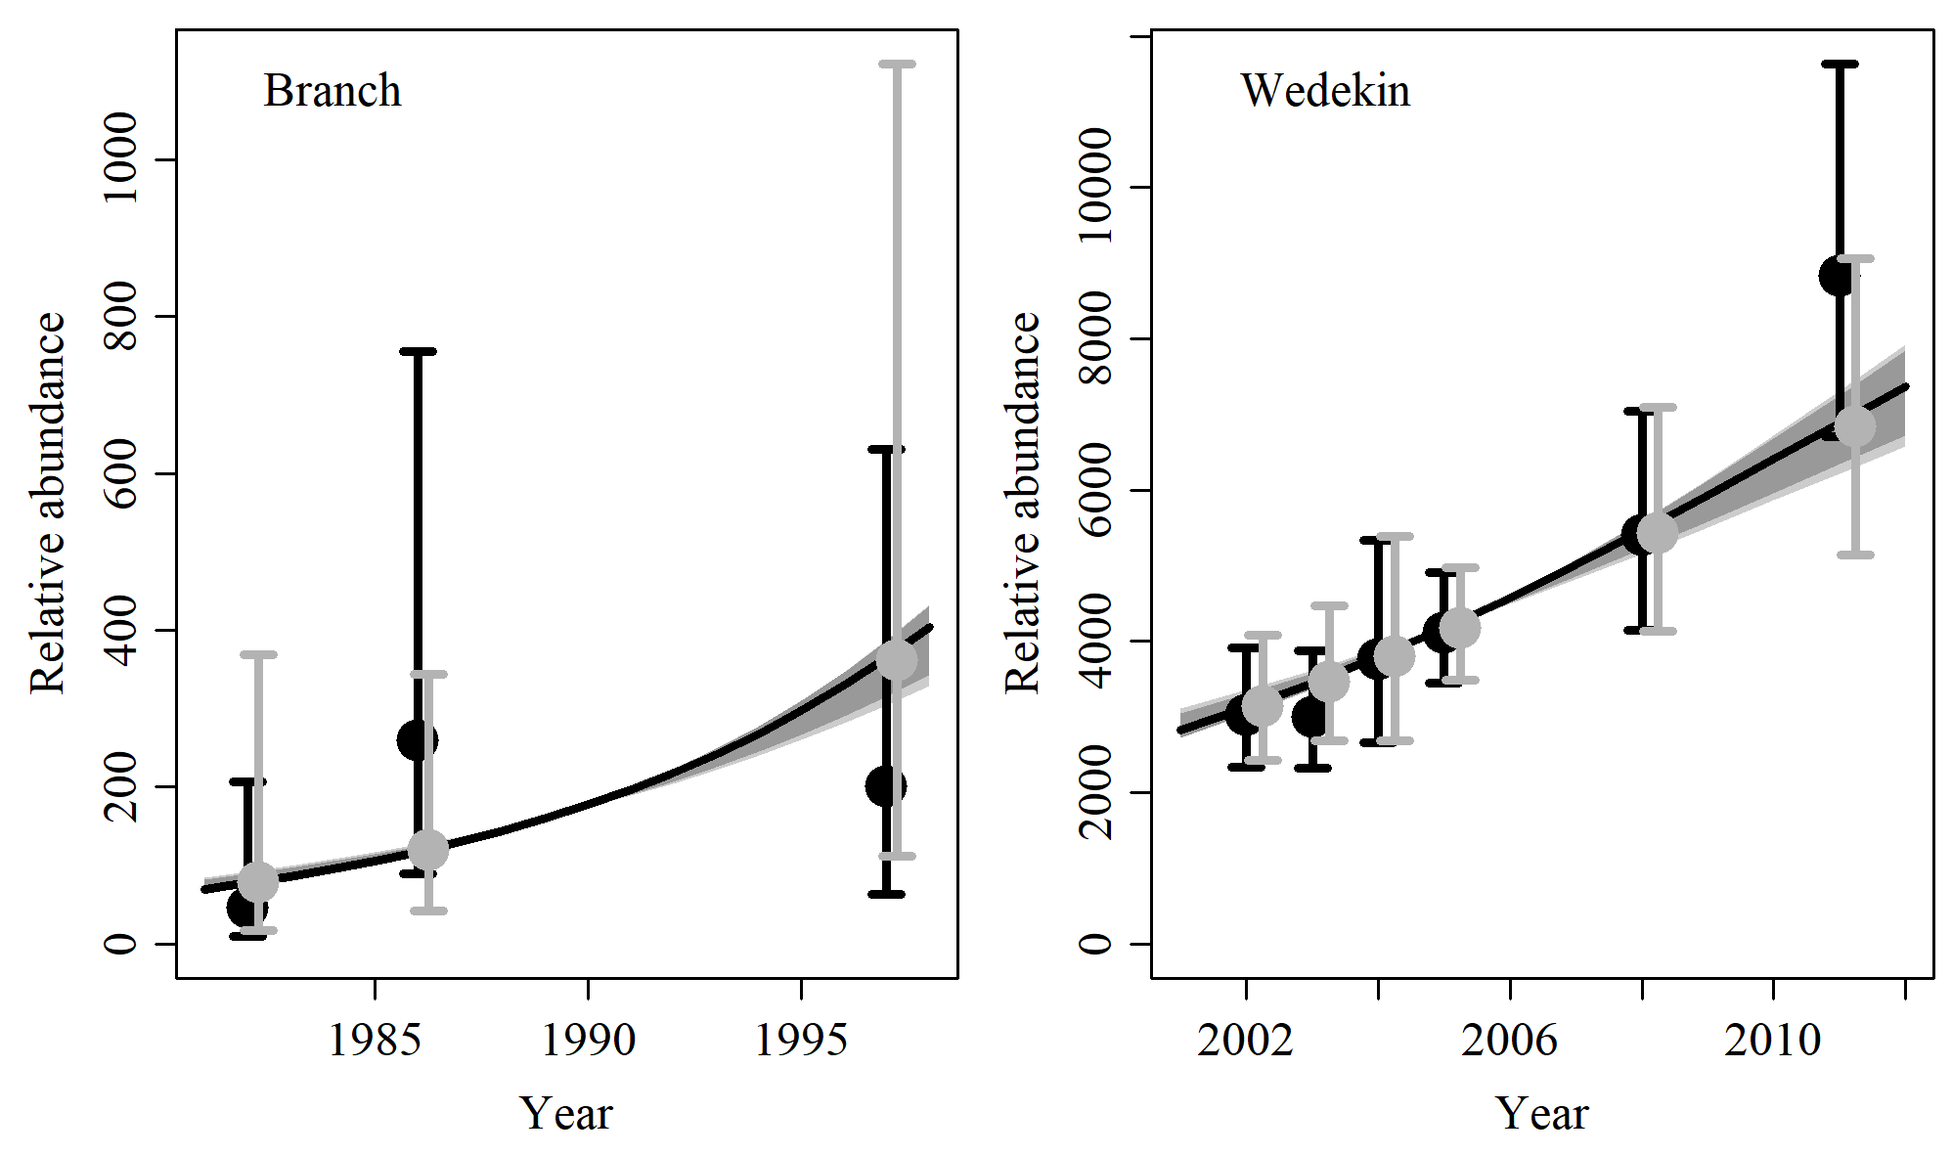

* 1. **SData 4**

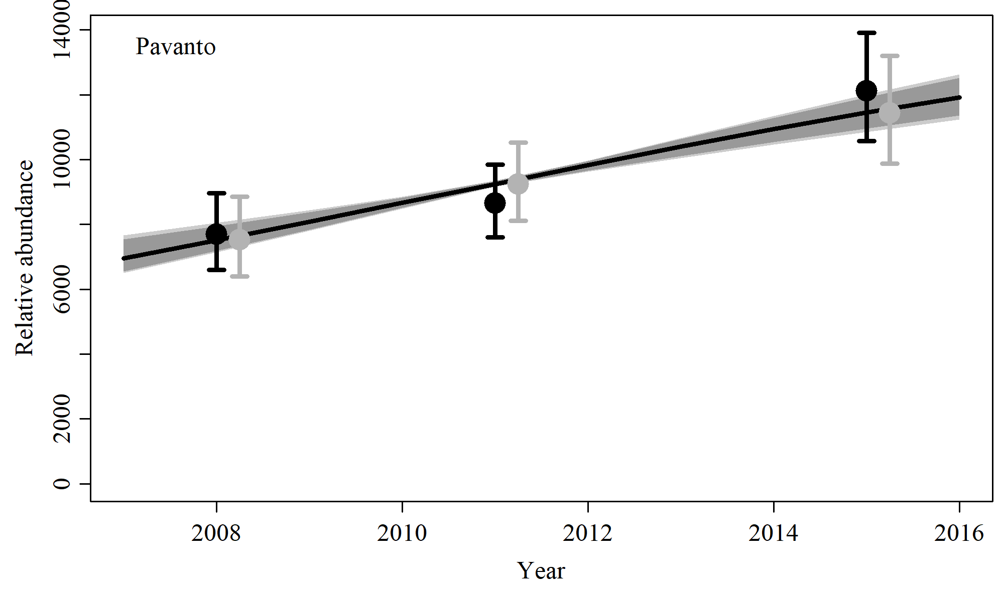

* 1. **SData 5**

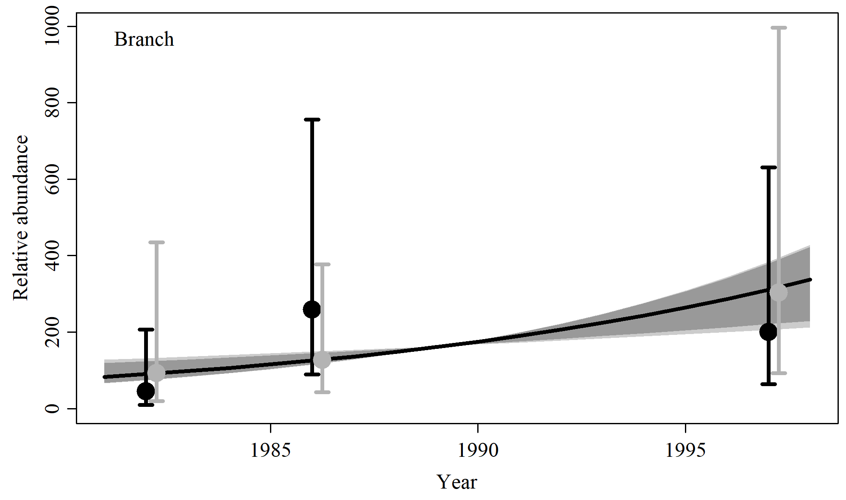

* 1. **SData 6**

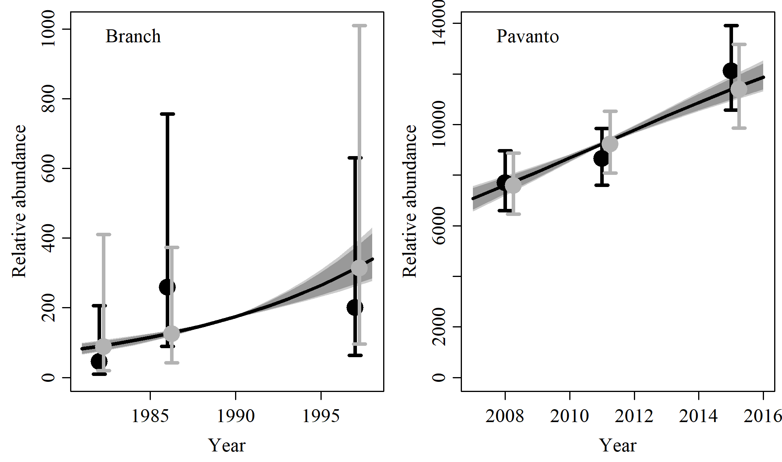

1. **Posterior Density Plots**
   1. **Model average**

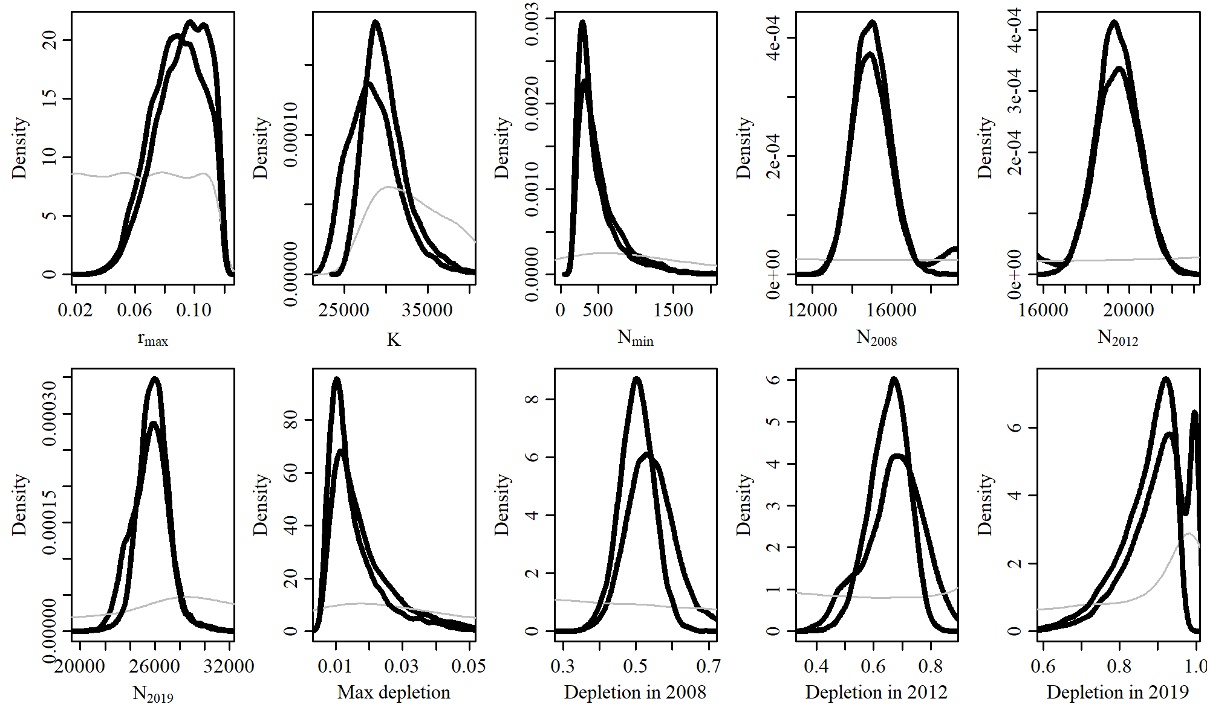

* 1. **Reference Case**

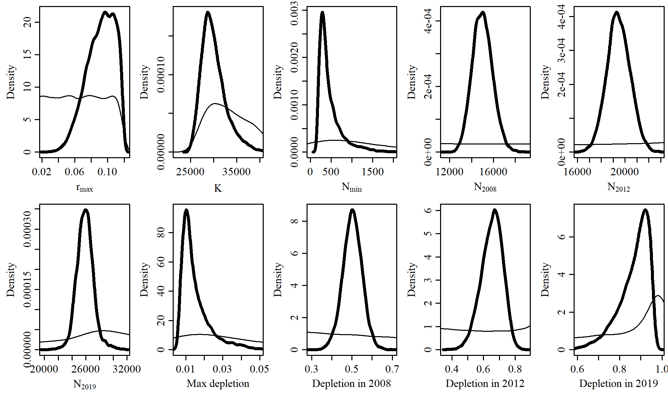

* 1. **SData 1**

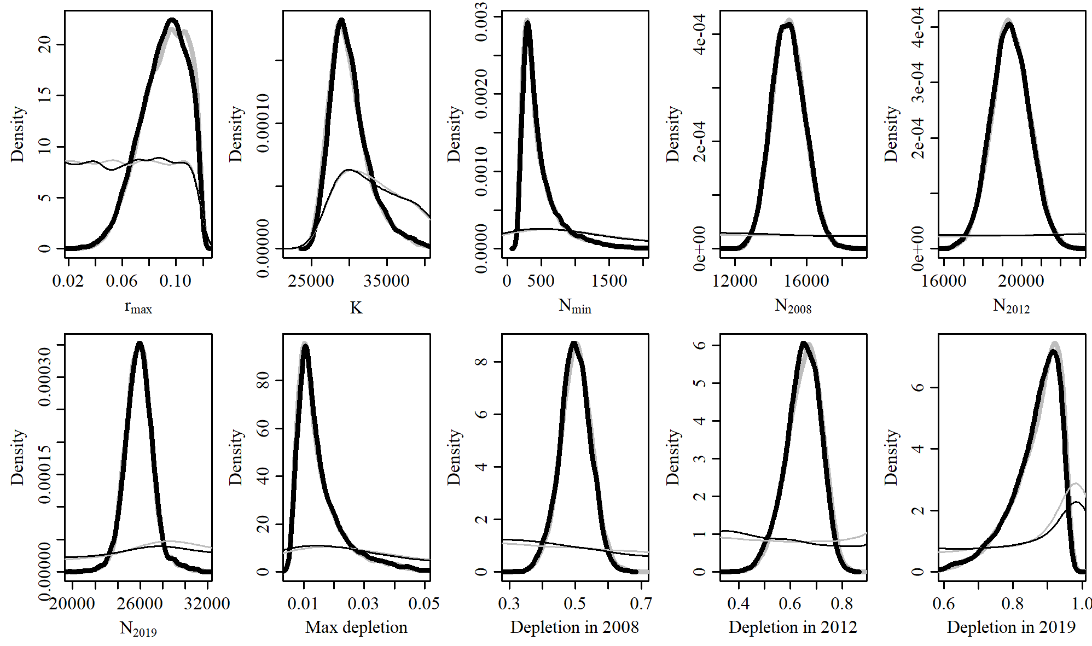

* 1. **SData 2**

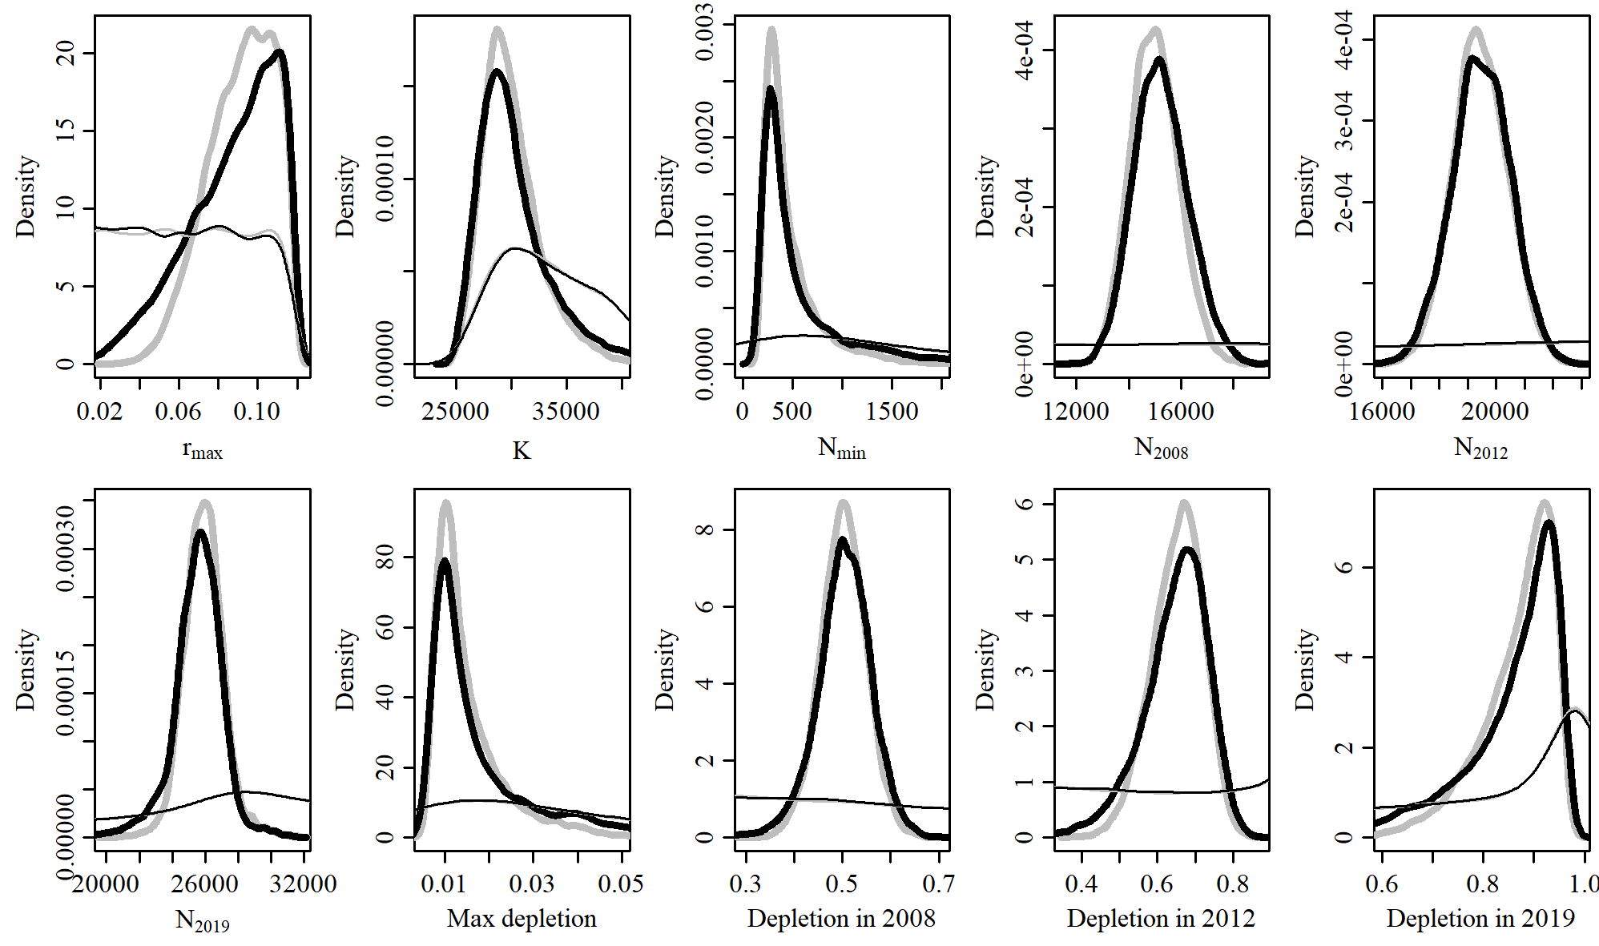

* 1. **SData 3**

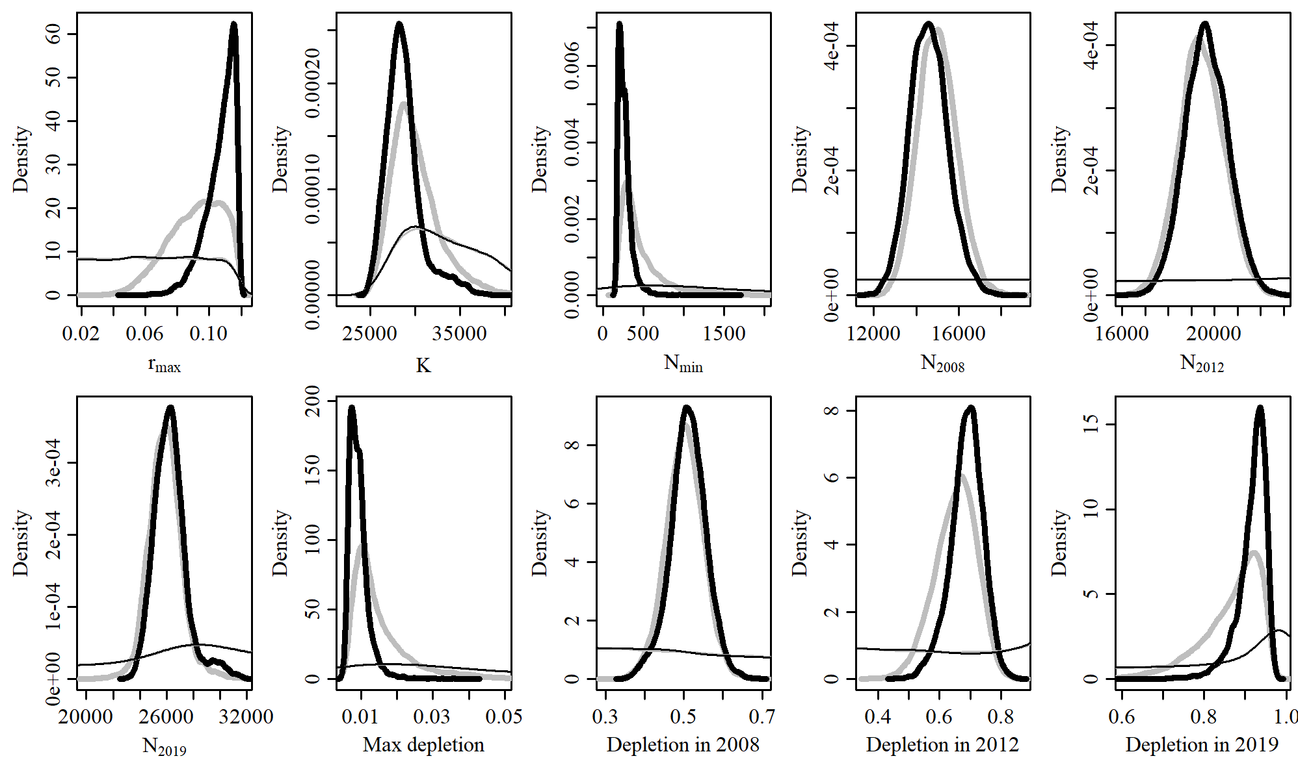

* 1. **SData 4**

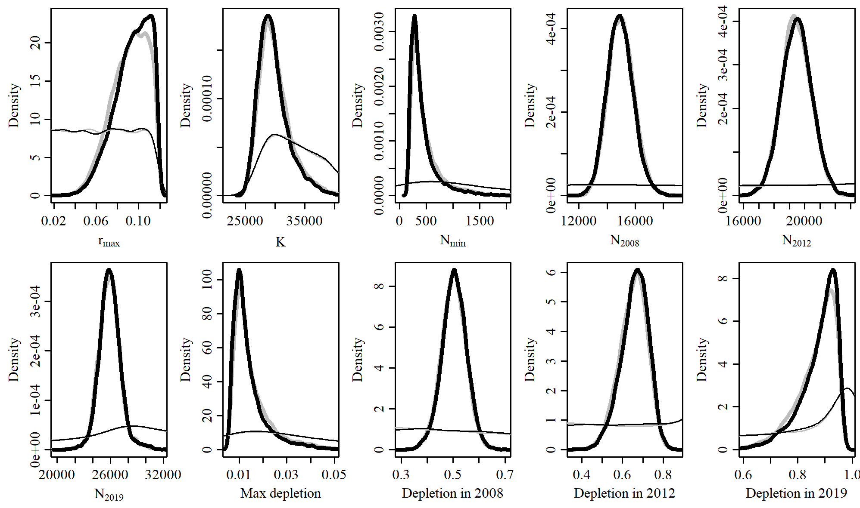

* 1. **SData 5**

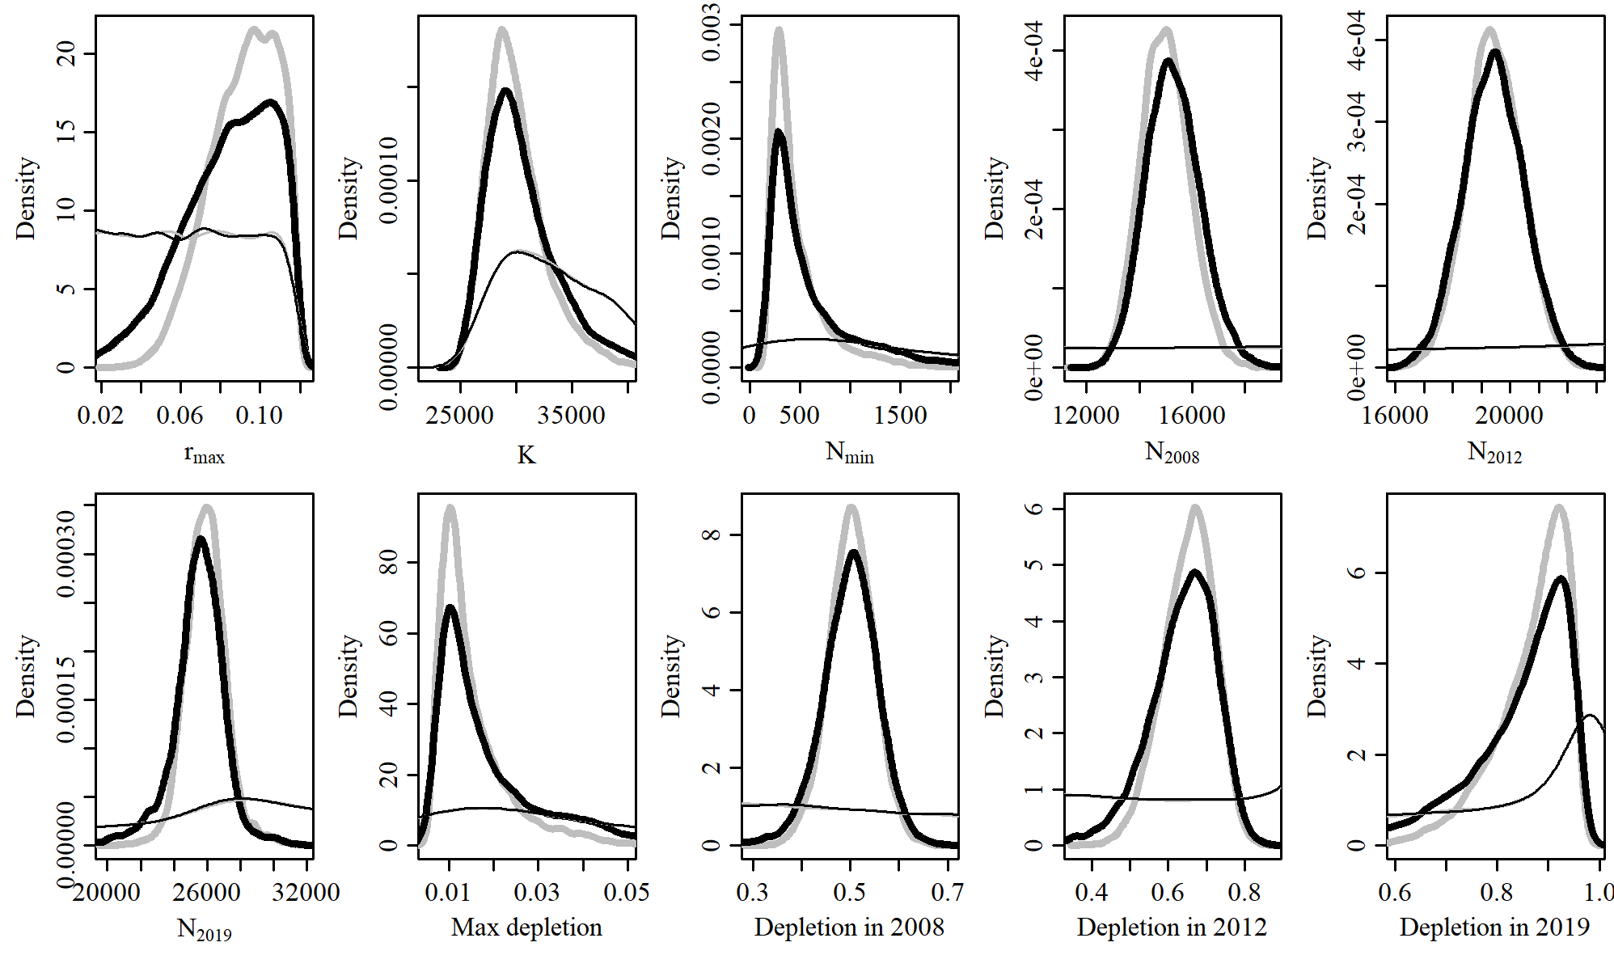

* 1. **SData 6**

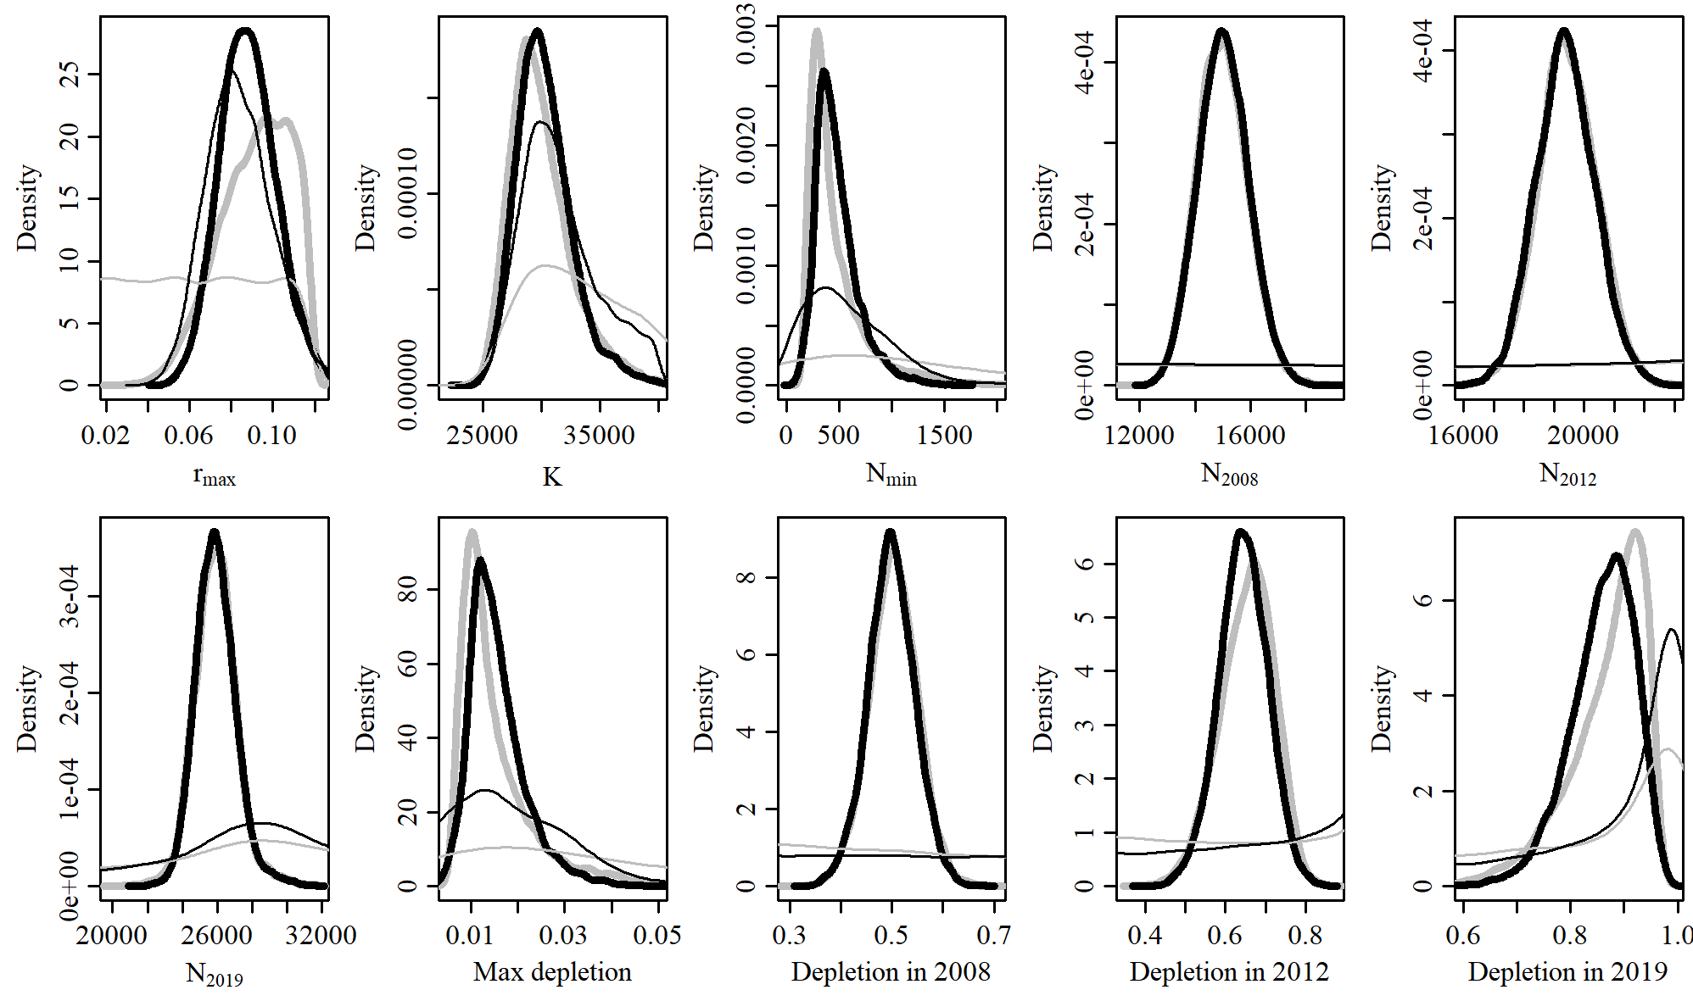

* 1. **SCatch 1**

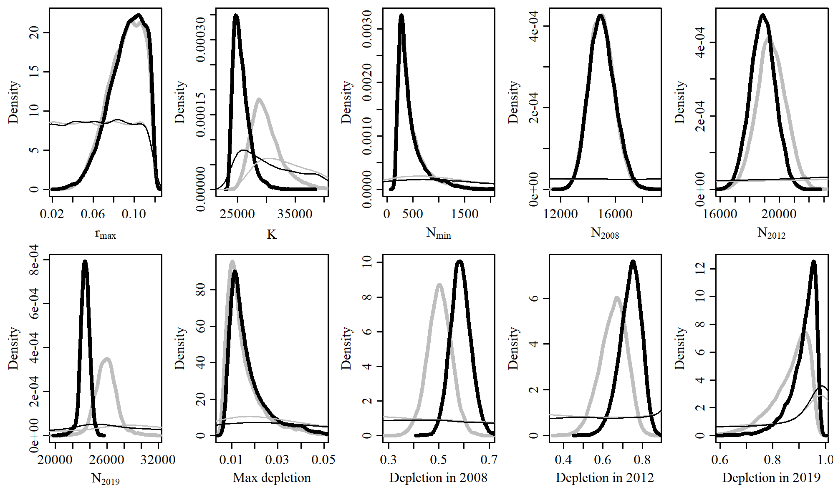

* 1. **SCatch 2**

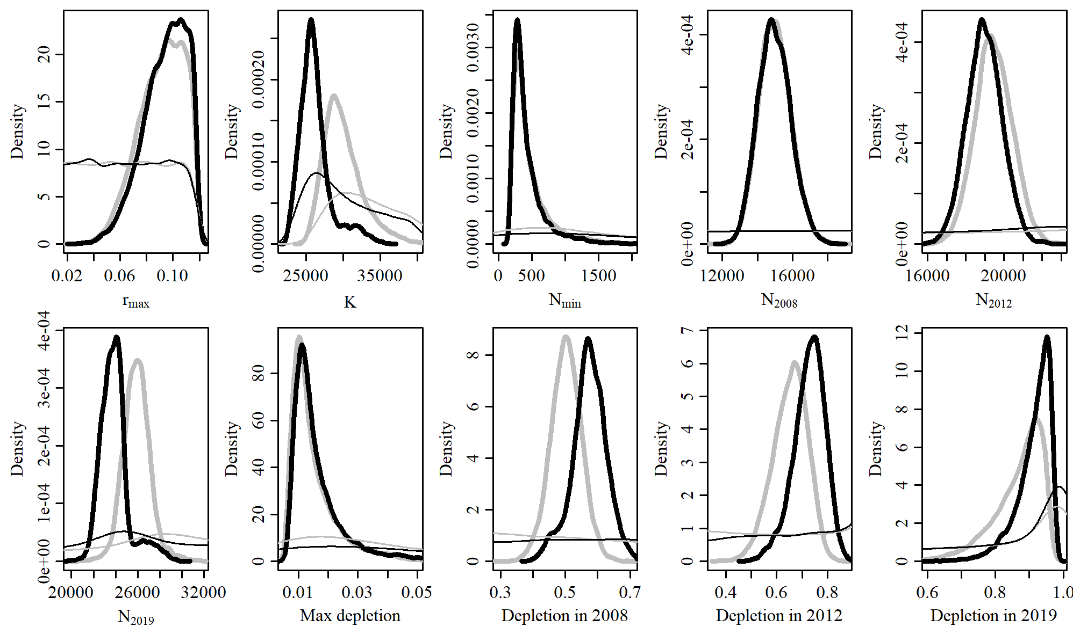

* 1. **SCatch 3**

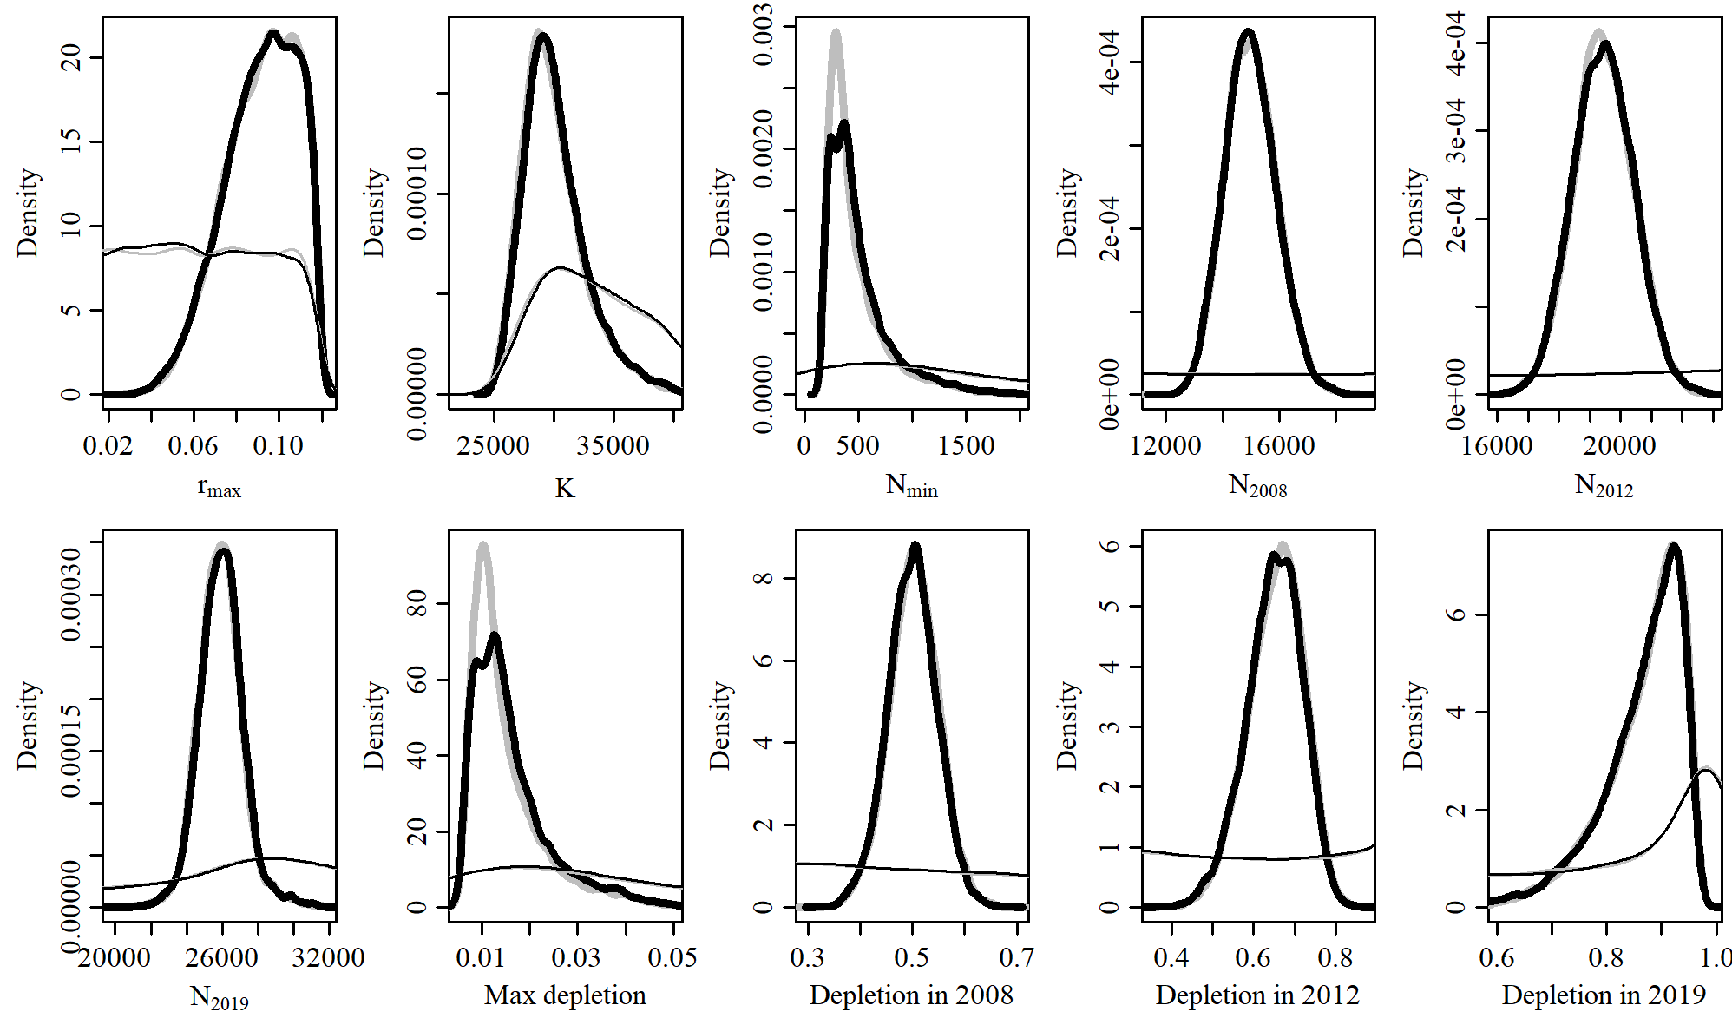

* 1. **SCatch 4**

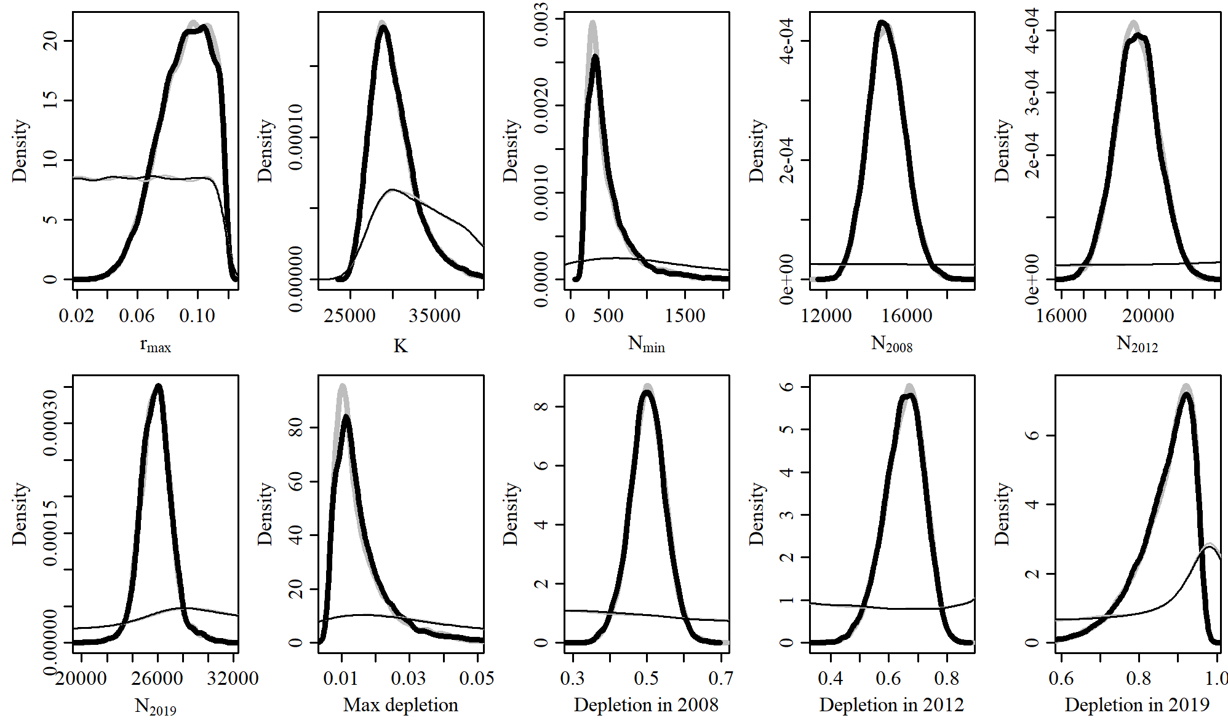

* 1. **SCatch 5**

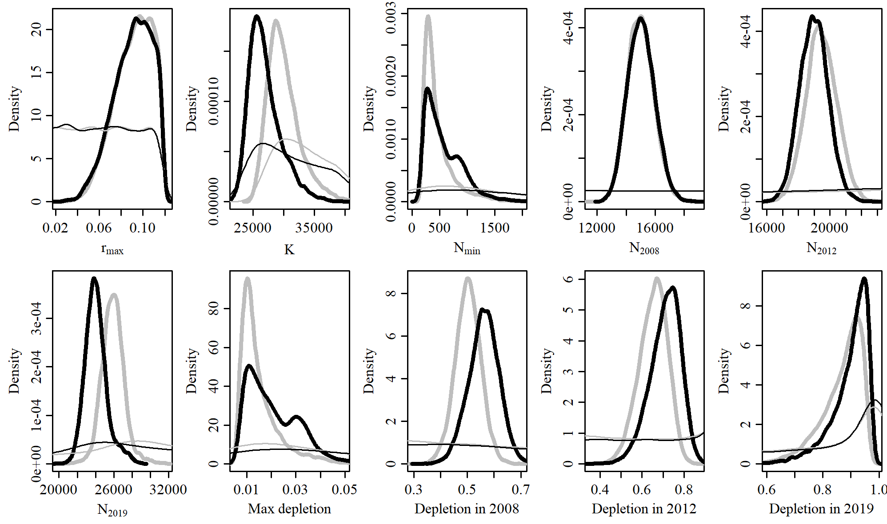

* 1. **GC 1**

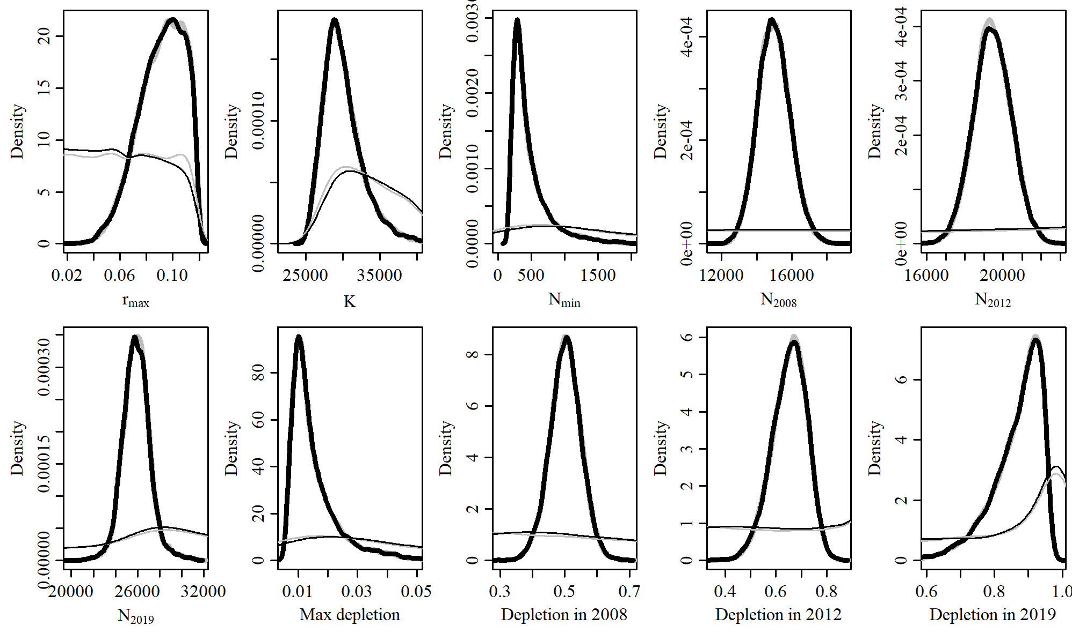

* 1. **GC 2**

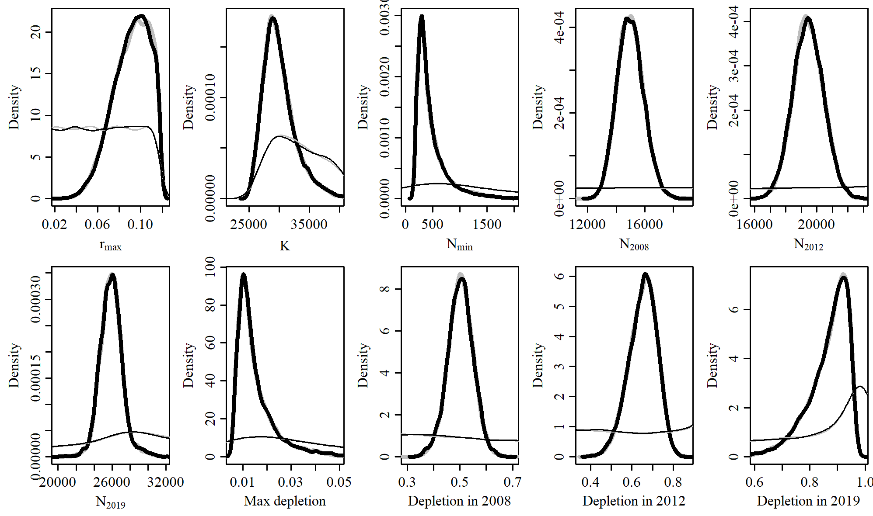

* 1. **MSYL 1**

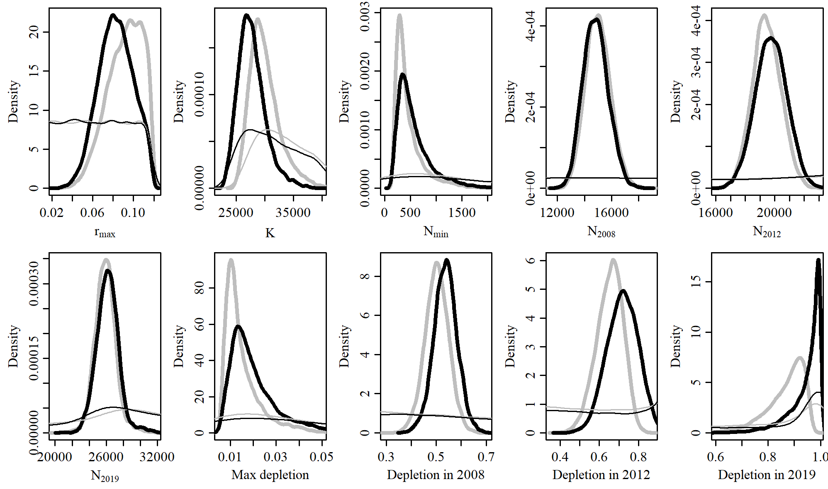

* 1. **MSYL 2**

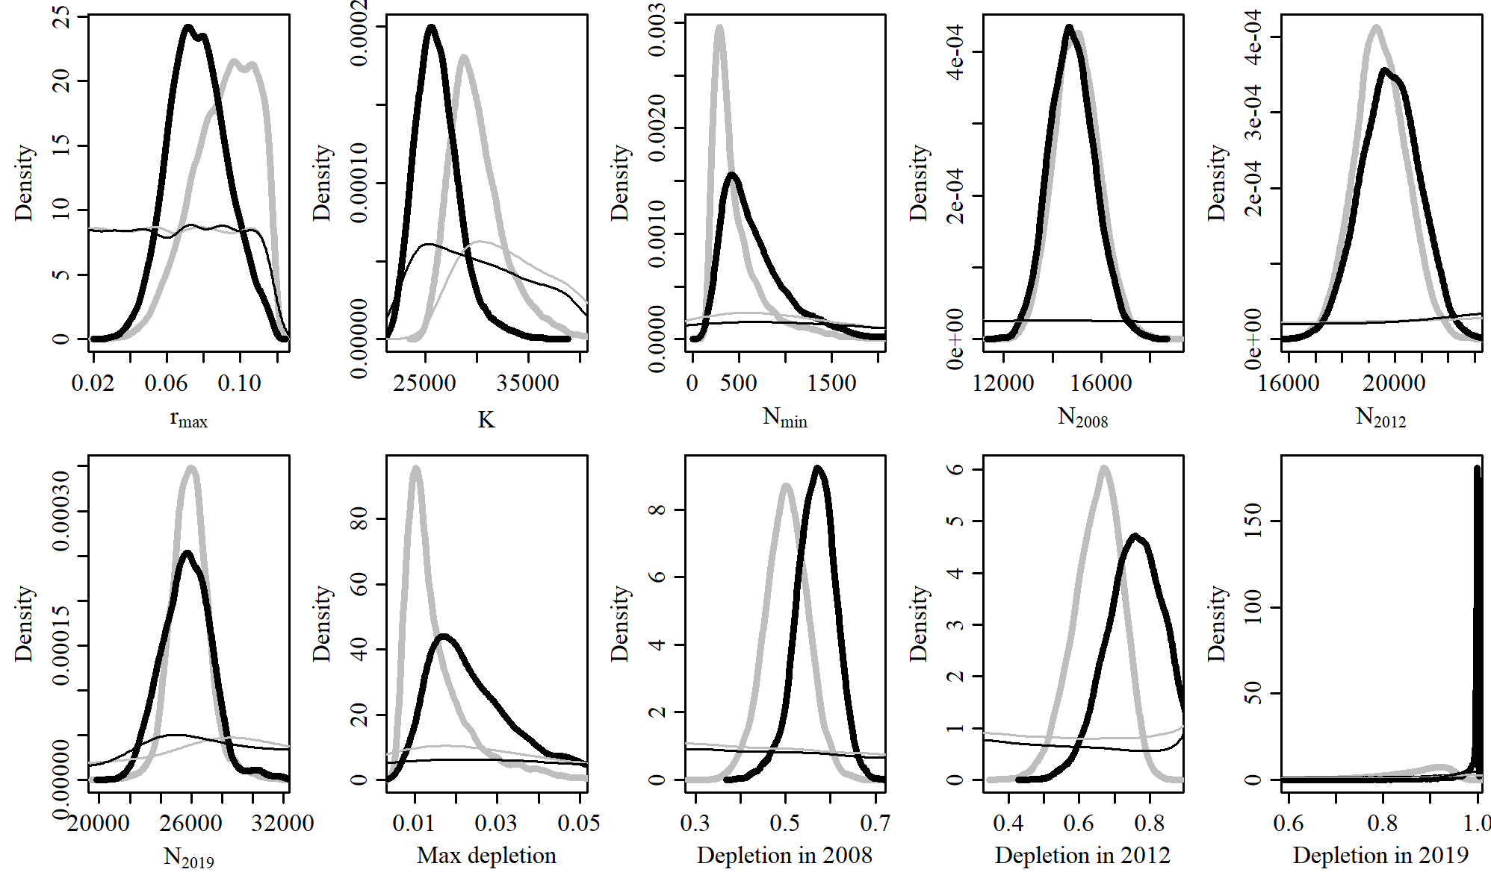

1. **Output Tables**
   1. **Model Average**

|  |  |  |  |  |  |  |  |
| --- | --- | --- | --- | --- | --- | --- | --- |
| Parameter | Mean | Median | 2.5% CI | 5% CI | 95% CI | 97.5% CI | Unique |
| R_max | 0.088 | 0.089 | 0.053 | 0.058 | 0.114 | 0.116 |  |
| K | 28,594 | 28,296 | 23,687 | 24,191 | 34,135 | 35,709 |  |
| N_min | 530 | 432 | 196 | 211 | 1,194 | 1,384 |  |
| N_2008 | 15,425 | 15,061 | 13,249 | 13,518 | 19,491 | 20,151 |  |
| N_2012 | 19,003 | 19,312 | 14,334 | 14,896 | 21,160 | 21,494 |  |
| N_2018 | 25,608 | 25,677 | 22,739 | 23,132 | 27,929 | 28,536 |  |
| Max depletion | 0.018 | 0.015 | 0.007 | 0.008 | 0.039 | 0.045 |  |
| Dep. in 2008 | 0.544 | 0.539 | 0.422 | 0.441 | 0.664 | 0.699 |  |
| Dep. in 2012 | 0.673 | 0.681 | 0.462 | 0.487 | 0.829 | 0.855 |  |
| Dep. in 2018 | 0.903 | 0.915 | 0.716 | 0.755 | 1 | 1 |  |

* 1. **Reference Case**

|  |  |  |  |  |  |  |  |
| --- | --- | --- | --- | --- | --- | --- | --- |
| Parameter | Mean | Median | 2.5% CI | 5% CI | 95% CI | 97.5% CI | Unique |
| R_max | 0.091 | 0.093 | 0.055 | 0.061 | 0.115 | 0.117 | 10,000 |
| K | 30,052 | 29,563 | 26,015 | 26,472 | 35,366 | 36,898 | 10,000 |
| N_min | 473 | 371 | 192 | 205 | 1,106 | 1,331 | 10,000 |
| N_2008 | 14,997 | 14,968 | 13,301 | 13,531 | 16,563 | 16,882 | 10,000 |
| N_2012 | 19,460 | 19,430 | 17,554 | 17,866 | 21,089 | 21,393 | 10,000 |
| N_2018 | 25,903 | 25,883 | 23,608 | 24,036 | 27,886 | 28,595 | 10,000 |
| Max depletion | 0.015 | 0.013 | 0.007 | 0.007 | 0.033 | 0.039 | 10,000 |
| Dep. in 2008 | 0.502 | 0.503 | 0.407 | 0.424 | 0.579 | 0.596 | 10,000 |
| Dep. in 2012 | 0.653 | 0.659 | 0.512 | 0.535 | 0.755 | 0.77 | 10,000 |
| Dep. in 2018 | 0.868 | 0.886 | 0.684 | 0.724 | 0.951 | 0.956 | 10,000 |

* 1. **SData 1**

|  |  |  |  |  |  |  |  |
| --- | --- | --- | --- | --- | --- | --- | --- |
| Parameter | Mean | Median | 2.5% CI | 5% CI | 95% CI | 97.5% CI | Unique |
| R_max | 0.090 | 0.092 | 0.054 | 0.06 | 0.115 | 0.116 | 10,000 |
| K | 30,245 | 29,728 | 26,221 | 26,651 | 35,574 | 37,365 | 10,000 |
| N_min | 488 | 382 | 194 | 206 | 1,124 | 1,370 | 10,000 |
| N_2008 | 14,982 | 14,951 | 13,257 | 13,523 | 16,534 | 16,868 | 10,000 |
| N_2012 | 19,419 | 19,406 | 17,531 | 17,838 | 21,034 | 21,370 | 10,000 |
| N_2018 | 25,917 | 25,901 | 23,464 | 23,941 | 27,913 | 28,727 | 10,000 |
| Max depletion | 0.016 | 0.013 | 0.007 | 0.007 | 0.034 | 0.04 | 10,000 |
| Dep. in 2008 | 0.499 | 0.499 | 0.401 | 0.419 | 0.574 | 0.588 | 10,000 |
| Dep. in 2012 | 0.647 | 0.652 | 0.503 | 0.529 | 0.748 | 0.762 | 10,000 |
| Dep. in 2018 | 0.863 | 0.881 | 0.673 | 0.716 | 0.948 | 0.954 | 10,000 |

* 1. **SData 2**

|  |  |  |  |  |  |  |  |
| --- | --- | --- | --- | --- | --- | --- | --- |
| Parameter | Mean | Median | 2.5% CI | 5% CI | 95% CI | 97.5% CI | Unique |
| R_max | 0.087 | 0.091 | 0.033 | 0.042 | 0.116 | 0.117 | 10,000 |
| K | 30,707 | 29,614 | 25,843 | 26,287 | 38,354 | 41,916 | 10,000 |
| N_min | 695 | 392 | 190 | 202 | 2,016 | 2,822 | 10,000 |
| N_2008 | 15,238 | 15,186 | 13,327 | 13,609 | 17,033 | 17,416 | 10,000 |
| N_2012 | 19,477 | 19,480 | 17,413 | 17,725 | 21,157 | 21,476 | 10,000 |
| N_2018 | 25,546 | 25,649 | 21,932 | 22,863 | 27,654 | 28,278 | 10,000 |
| Max depletion | 0.02 | 0.013 | 0.007 | 0.007 | 0.054 | 0.071 | 10,000 |
| Dep. in 2008 | 0.503 | 0.505 | 0.38 | 0.405 | 0.592 | 0.61 | 10,000 |
| Dep. in 2012 | 0.646 | 0.658 | 0.44 | 0.485 | 0.766 | 0.783 | 10,000 |
| Dep. in 2018 | 0.847 | 0.884 | 0.537 | 0.616 | 0.954 | 0.96 | 10,000 |

* 1. **SData 3**

|  |  |  |  |  |  |  |  |
| --- | --- | --- | --- | --- | --- | --- | --- |
| Parameter | Mean | Median | 2.5% CI | 5% CI | 95% CI | 97.5% CI | Unique |
| R_max | 0.107 | 0.109 | 0.084 | 0.089 | 0.117 | 0.118 | 9,787 |
| K | 28,721 | 28,430 | 25,647 | 25,999 | 33,056 | 34,417 | 9,787 |
| N_min | 270 | 251 | 174 | 180 | 423 | 490 | 9,787 |
| N_2008 | 14,610 | 14,584 | 12,927 | 13,192 | 16,140 | 16,486 | 9,787 |
| N_2012 | 19,663 | 19,644 | 17,853 | 18,148 | 21,244 | 21,531 | 9,787 |
| N_2018 | 26,283 | 26,178 | 24,223 | 24,483 | 28,693 | 29,738 | 9,787 |
| Max depletion | 0.009 | 0.009 | 0.006 | 0.006 | 0.014 | 0.016 | 9,787 |
| Dep. in 2008 | 0.511 | 0.511 | 0.412 | 0.433 | 0.586 | 0.6 | 9,787 |
| Dep. in 2012 | 0.688 | 0.691 | 0.57 | 0.593 | 0.768 | 0.781 | 9,787 |
| Dep. in 2018 | 0.917 | 0.925 | 0.825 | 0.849 | 0.957 | 0.962 | 9,787 |

* 1. **SData 4**

|  |  |  |  |  |  |  |  |
| --- | --- | --- | --- | --- | --- | --- | --- |
| Parameter | Mean | Median | 2.5% CI | 5% CI | 95% CI | 97.5% CI | Unique |
| R_max | 0.094 | 0.096 | 0.057 | 0.063 | 0.116 | 0.117 | 9,856 |
| K | 29,775 | 29,309 | 25,962 | 26,405 | 34,870 | 36,347 | 9,856 |
| N_min | 435 | 346 | 187 | 198 | 997 | 1,258 | 9,856 |
| N_2008 | 14,932 | 14,907 | 13,234 | 13,466 | 16,497 | 16,847 | 9,856 |
| N_2012 | 19,487 | 19,485 | 17,568 | 17,868 | 21,126 | 21,452 | 9,856 |
| N_2018 | 25,942 | 25,900 | 23,663 | 24,093 | 27,873 | 28,634 | 9,856 |
| Max depletion | 0.014 | 0.012 | 0.007 | 0.007 | 0.03 | 0.036 | 9,856 |
| Dep. in 2008 | 0.505 | 0.505 | 0.407 | 0.426 | 0.582 | 0.597 | 9,856 |
| Dep. in 2012 | 0.66 | 0.665 | 0.514 | 0.54 | 0.758 | 0.774 | 9,856 |
| Dep. in 2018 | 0.877 | 0.895 | 0.699 | 0.734 | 0.953 | 0.958 | 9,856 |

* 1. **SData 5**

|  |  |  |  |  |  |  |  |
| --- | --- | --- | --- | --- | --- | --- | --- |
| Parameter | Mean | Median | 2.5% CI | 5% CI | 95% CI | 97.5% CI | Unique |
| R_max | 0.084 | 0.087 | 0.031 | 0.041 | 0.115 | 0.116 | 10,000 |
| K | 31,080 | 30,008 | 26,027 | 26,491 | 38,838 | 42,670 | 10,000 |
| N_min | 748 | 447 | 195 | 210 | 2,099 | 3,122 | 10,000 |
| N_2008 | 15,291 | 15,241 | 13,380 | 13,674 | 17,081 | 17,463 | 10,000 |
| N_2012 | 19,423 | 19,421 | 17,372 | 17,703 | 21,188 | 21,499 | 10,000 |
| N_2018 | 25,482 | 25,593 | 21,760 | 22,624 | 27,686 | 28,397 | 10,000 |
| Max depletion | 0.022 | 0.015 | 0.007 | 0.008 | 0.056 | 0.075 | 10,000 |
| Dep. in 2008 | 0.499 | 0.502 | 0.374 | 0.401 | 0.589 | 0.606 | 10,000 |
| Dep. in 2012 | 0.637 | 0.647 | 0.432 | 0.475 | 0.76 | 0.778 | 10,000 |
| Dep. in 2018 | 0.835 | 0.87 | 0.525 | 0.602 | 0.952 | 0.958 | 10,000 |

* 1. **SData 6**

|  |  |  |  |  |  |  |  |
| --- | --- | --- | --- | --- | --- | --- | --- |
| Parameter | Mean | Median | 2.5% CI | 5% CI | 95% CI | 97.5% CI | Unique |
| R_max | 0.088 | 0.088 | 0.063 | 0.067 | 0.112 | 0.117 | 10,000 |
| K | 30,297 | 29,978 | 26,326 | 26,890 | 34,820 | 36,319 | 10,000 |
| N_min | 480 | 436 | 189 | 228 | 889 | 1,011 | 10,000 |
| N_2008 | 15,031 | 15,009 | 13,323 | 13,571 | 16,571 | 16,876 | 10,000 |
| N_2012 | 19,391 | 19,382 | 17,541 | 17,801 | 21,019 | 21,348 | 10,000 |
| N_2018 | 25,919 | 25,854 | 23,835 | 24,157 | 27,856 | 28,469 | 10,000 |
| Max depletion | 0.016 | 0.014 | 0.007 | 0.008 | 0.027 | 0.031 | 10,000 |
| Dep. in 2008 | 0.499 | 0.499 | 0.407 | 0.422 | 0.575 | 0.589 | 10,000 |
| Dep. in 2012 | 0.644 | 0.644 | 0.521 | 0.542 | 0.743 | 0.76 | 10,000 |
| Dep. in 2018 | 0.86 | 0.867 | 0.724 | 0.75 | 0.944 | 0.954 | 10,000 |

* 1. **SCatch 1**

|  |  |  |  |  |  |  |  |
| --- | --- | --- | --- | --- | --- | --- | --- |
| Parameter | Mean | Median | 2.5% CI | 5% CI | 95% CI | 97.5% CI | Unique |
| R_max | 0.093 | 0.095 | 0.055 | 0.061 | 0.116 | 0.117 | 10,000 |
| K | 25,679 | 25,366 | 23,788 | 23,943 | 28,394 | 29,393 | 10,000 |
| N_min | 464 | 364 | 197 | 209 | 1,088 | 1,279 | 10,000 |
| N_2008 | 15,030 | 14,986 | 13,289 | 13,558 | 16,650 | 16,977 | 10,000 |
| N_2012 | 18,882 | 18,881 | 17,230 | 17,491 | 20,286 | 20,512 | 10,000 |
| N_2018 | 23,443 | 23,457 | 22,272 | 22,599 | 24,291 | 24,443 | 10,000 |
| Max depletion | 0.018 | 0.014 | 0.008 | 0.009 | 0.038 | 0.044 | 10,000 |
| Dep. in 2008 | 0.586 | 0.585 | 0.509 | 0.521 | 0.655 | 0.669 | 10,000 |
| Dep. in 2012 | 0.738 | 0.743 | 0.617 | 0.64 | 0.819 | 0.831 | 10,000 |
| Dep. in 2018 | 0.916 | 0.93 | 0.78 | 0.813 | 0.969 | 0.973 | 10,000 |

* 1. **SCatch 2**

|  |  |  |  |  |  |  |  |
| --- | --- | --- | --- | --- | --- | --- | --- |
| Parameter | Mean | Median | 2.5% CI | 5% CI | 95% CI | 97.5% CI | Unique |
| R_max | 0.094 | 0.096 | 0.058 | 0.064 | 0.116 | 0.117 | 10,000 |
| K | 26,265 | 25,845 | 23,138 | 23,516 | 31,404 | 32,536 | 10,000 |
| N_min | 443 | 351 | 194 | 206 | 1,015 | 1,260 | 10,000 |
| N_2008 | 14,973 | 14,935 | 13,256 | 13,502 | 16,565 | 16,880 | 10,000 |
| N_2012 | 18,988 | 18,970 | 17,185 | 17,487 | 20,522 | 20,829 | 10,000 |
| N_2018 | 23,903 | 23,774 | 21,858 | 22,117 | 26,903 | 27,680 | 10,000 |
| Max depletion | 0.017 | 0.014 | 0.008 | 0.008 | 0.036 | 0.045 | 10,000 |
| Dep. in 2008 | 0.573 | 0.575 | 0.451 | 0.474 | 0.658 | 0.675 | 10,000 |
| Dep. in 2012 | 0.727 | 0.733 | 0.587 | 0.615 | 0.819 | 0.832 | 10,000 |
| Dep. in 2018 | 0.913 | 0.926 | 0.783 | 0.813 | 0.968 | 0.973 | 10,000 |

* 1. **SCatch 3**

|  |  |  |  |  |  |  |  |
| --- | --- | --- | --- | --- | --- | --- | --- |
| Parameter | Mean | Median | 2.5% CI | 5% CI | 95% CI | 97.5% CI | Unique |
| R_max | 0.091 | 0.093 | 0.054 | 0.06 | 0.115 | 0.116 | 10,000 |
| K | 30,199 | 29,711 | 26,133 | 26,551 | 35,536 | 37,163 | 10,000 |
| N_min | 507 | 414 | 192 | 205 | 1,161 | 1,392 | 10,000 |
| N_2008 | 14,986 | 14,954 | 13,305 | 13,524 | 16,563 | 16,863 | 10,000 |
| N_2012 | 19,455 | 19,450 | 17,578 | 17,850 | 21,105 | 21,418 | 10,000 |
| N_2018 | 25,952 | 25,935 | 23,591 | 24,042 | 27,939 | 28,642 | 10,000 |
| Max depletion | 0.016 | 0.014 | 0.007 | 0.007 | 0.034 | 0.039 | 10,000 |
| Dep. in 2008 | 0.5 | 0.5 | 0.404 | 0.421 | 0.576 | 0.592 | 10,000 |
| Dep. in 2012 | 0.65 | 0.653 | 0.506 | 0.531 | 0.752 | 0.768 | 10,000 |
| Dep. in 2018 | 0.865 | 0.883 | 0.677 | 0.718 | 0.95 | 0.956 | 10,000 |

* 1. **SCatch 4**

|  |  |  |  |  |  |  |  |
| --- | --- | --- | --- | --- | --- | --- | --- |
| Parameter | Mean | Median | 2.5% CI | 5% CI | 95% CI | 97.5% CI | Unique |
| R_max | 0.091 | 0.093 | 0.055 | 0.061 | 0.115 | 0.117 | 10,000 |
| K | 30,096 | 29,602 | 26,066 | 26,529 | 35,419 | 37,083 | 10,000 |
| N_min | 497 | 395 | 192 | 204 | 1,125 | 1,436 | 10,000 |
| N_2008 | 14,985 | 14,948 | 13,265 | 13,503 | 16,545 | 16,886 | 10,000 |
| N_2012 | 19,440 | 19,440 | 17,530 | 17,818 | 21,074 | 21,391 | 10,000 |
| N_2018 | 25,895 | 25,879 | 23,598 | 24,028 | 27,834 | 28,539 | 10,000 |
| Max depletion | 0.016 | 0.013 | 0.007 | 0.007 | 0.034 | 0.042 | 10,000 |
| Dep. in 2008 | 0.501 | 0.501 | 0.405 | 0.421 | 0.58 | 0.593 | 10,000 |
| Dep. in 2012 | 0.651 | 0.655 | 0.508 | 0.532 | 0.755 | 0.77 | 10,000 |
| Dep. in 2018 | 0.866 | 0.884 | 0.682 | 0.722 | 0.951 | 0.957 | 10,000 |

* 1. **SCatch 5**

|  |  |  |  |  |  |  |  |
| --- | --- | --- | --- | --- | --- | --- | --- |
| Parameter | Mean | Median | 2.5% CI | 5% CI | 95% CI | 97.5% CI | Unique |
| R_max | 0.091 | 0.093 | 0.053 | 0.059 | 0.115 | 0.116 | 10,000 |
| K | 26,997 | 26,461 | 23,140 | 23,558 | 32,147 | 33,594 | 10,000 |
| N_min | 586 | 486 | 198 | 212 | 1,226 | 1,442 | 10,000 |
| N_2008 | 15,037 | 15,013 | 13,298 | 13,556 | 16,606 | 16,929 | 10,000 |
| N_2012 | 18,994 | 18,984 | 17,265 | 17,533 | 20,499 | 20,799 | 10,000 |
| N_2018 | 24,050 | 23,948 | 21,959 | 22,260 | 26,384 | 27,079 | 10,000 |
| Max depletion | 0.021 | 0.018 | 0.008 | 0.008 | 0.04 | 0.045 | 10,000 |
| Dep. in 2008 | 0.562 | 0.563 | 0.446 | 0.466 | 0.651 | 0.67 | 10,000 |
| Dep. in 2012 | 0.71 | 0.718 | 0.552 | 0.58 | 0.815 | 0.83 | 10,000 |
| Dep. in 2018 | 0.897 | 0.916 | 0.72 | 0.762 | 0.968 | 0.972 | 10,000 |

* 1. **GC 1**

|  |  |  |  |  |  |  |  |
| --- | --- | --- | --- | --- | --- | --- | --- |
| Parameter | Mean | Median | 2.5% CI | 5% CI | 95% CI | 97.5% CI | Unique |
| R_max | 0.091 | 0.093 | 0.054 | 0.061 | 0.115 | 0.117 | 10,000 |
| K | 30,066 | 29,551 | 26,043 | 26,428 | 35,388 | 36,959 | 10,000 |
| N_min | 476 | 374 | 192 | 206 | 1,103 | 1,363 | 10,000 |
| N_2008 | 14,990 | 14,957 | 13,241 | 13,509 | 16,554 | 16,926 | 10,000 |
| N_2012 | 19,441 | 19,431 | 17,485 | 17,805 | 21,079 | 21,379 | 10,000 |
| N_2018 | 25,877 | 25,848 | 23,526 | 23,986 | 27,886 | 28,529 | 10,000 |
| Max depletion | 0.015 | 0.013 | 0.007 | 0.007 | 0.033 | 0.04 | 10,000 |
| Dep. in 2008 | 0.502 | 0.503 | 0.405 | 0.422 | 0.58 | 0.597 | 10,000 |
| Dep. in 2012 | 0.652 | 0.657 | 0.507 | 0.531 | 0.755 | 0.772 | 10,000 |
| Dep. in 2018 | 0.867 | 0.885 | 0.681 | 0.721 | 0.951 | 0.957 | 10,000 |

* 1. **GC 2**

|  |  |  |  |  |  |  |  |
| --- | --- | --- | --- | --- | --- | --- | --- |
| Parameter | Mean | Median | 2.5% CI | 5% CI | 95% CI | 97.5% CI | Unique |
| R_max | 0.091 | 0.093 | 0.054 | 0.061 | 0.115 | 0.117 | 10,000 |
| K | 30,080 | 29,579 | 25,962 | 26,442 | 35,464 | 37,107 | 10,000 |
| N_min | 474 | 374 | 192 | 205 | 1,097 | 1,362 | 10,000 |
| N_2008 | 14,988 | 14,955 | 13,254 | 13,513 | 16,572 | 16,882 | 10,000 |
| N_2012 | 19,446 | 19,438 | 17,517 | 17,841 | 21,091 | 21,391 | 10,000 |
| N_2018 | 25,899 | 25,883 | 23,596 | 23,992 | 27,890 | 28,656 | 10,000 |
| Max depletion | 0.015 | 0.013 | 0.007 | 0.007 | 0.033 | 0.04 | 10,000 |
| Dep. in 2008 | 0.502 | 0.502 | 0.404 | 0.42 | 0.58 | 0.595 | 10,000 |
| Dep. in 2012 | 0.652 | 0.658 | 0.506 | 0.533 | 0.754 | 0.77 | 10,000 |
| Dep. in 2018 | 0.867 | 0.885 | 0.683 | 0.722 | 0.951 | 0.956 | 10,000 |

* 1. **MSYL 1**

|  |  |  |  |  |  |  |  |
| --- | --- | --- | --- | --- | --- | --- | --- |
| Parameter | Mean | Median | 2.5% CI | 5% CI | 95% CI | 97.5% CI | Unique |
| R_max | 0.083 | 0.083 | 0.05 | 0.055 | 0.111 | 0.114 | 10,000 |
| K | 27,786 | 27,470 | 23,934 | 24,405 | 32,368 | 33,736 | 10,000 |
| N_min | 583 | 478 | 191 | 215 | 1,315 | 1,543 | 10,000 |
| N_2008 | 14,829 | 14,798 | 13,152 | 13,369 | 16,409 | 16,725 | 10,000 |
| N_2012 | 19,762 | 19,761 | 17,645 | 17,999 | 21,531 | 21,846 | 10,000 |
| N_2018 | 26,160 | 26,138 | 23,641 | 24,065 | 28,218 | 29,045 | 10,000 |
| Max depletion | 0.02 | 0.017 | 0.008 | 0.009 | 0.043 | 0.049 | 10,000 |
| Dep. in 2008 | 0.537 | 0.537 | 0.442 | 0.459 | 0.613 | 0.63 | 10,000 |
| Dep. in 2012 | 0.717 | 0.719 | 0.562 | 0.586 | 0.844 | 0.864 | 10,000 |
| Dep. in 2018 | 0.946 | 0.969 | 0.772 | 0.818 | 0.998 | 0.999 | 10,000 |

* 1. **MSYL 2**

|  |  |  |  |  |  |  |  |
| --- | --- | --- | --- | --- | --- | --- | --- |
| Parameter | Mean | Median | 2.5% CI | 5% CI | 95% CI | 97.5% CI | Unique |
| R_max | 0.077 | 0.076 | 0.048 | 0.052 | 0.105 | 0.11 | 10,000 |
| K | 26,234 | 25,996 | 22,707 | 23,131 | 30,156 | 31,492 | 10,000 |
| N_min | 680 | 581 | 218 | 263 | 1,433 | 1,641 | 10,000 |
| N_2008 | 14,812 | 14,778 | 13,074 | 13,351 | 16,392 | 16,695 | 10,000 |
| N_2012 | 19,818 | 19,816 | 17,691 | 18,006 | 21,605 | 21,889 | 10,000 |
| N_2018 | 25,709 | 25,711 | 22,683 | 23,094 | 28,166 | 28,965 | 10,000 |
| Max depletion | 0.025 | 0.022 | 0.009 | 0.011 | 0.05 | 0.056 | 10,000 |
| Dep. in 2008 | 0.567 | 0.569 | 0.472 | 0.493 | 0.635 | 0.647 | 10,000 |
| Dep. in 2012 | 0.761 | 0.762 | 0.599 | 0.625 | 0.892 | 0.912 | 10,000 |
| Dep. in 2018 | 0.982 | 1 | 0.844 | 0.892 | 1 | 1 | 10,000 |