January Humpback Runs

Grant Adams

January 10, 2019

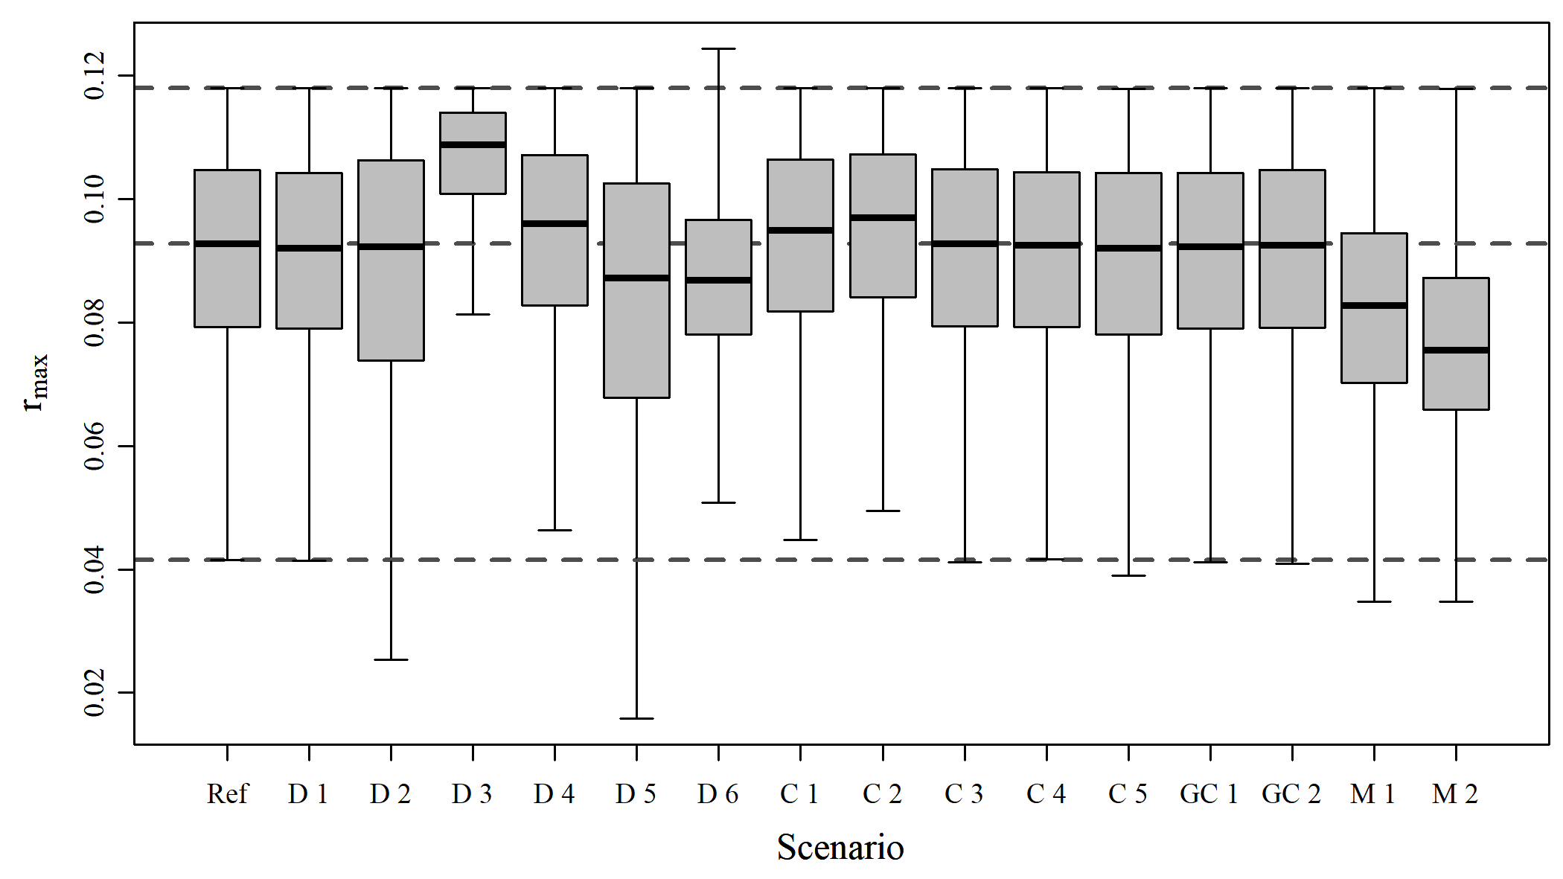

Figure A1. Boxplots of estimated quantities

$$$newpage

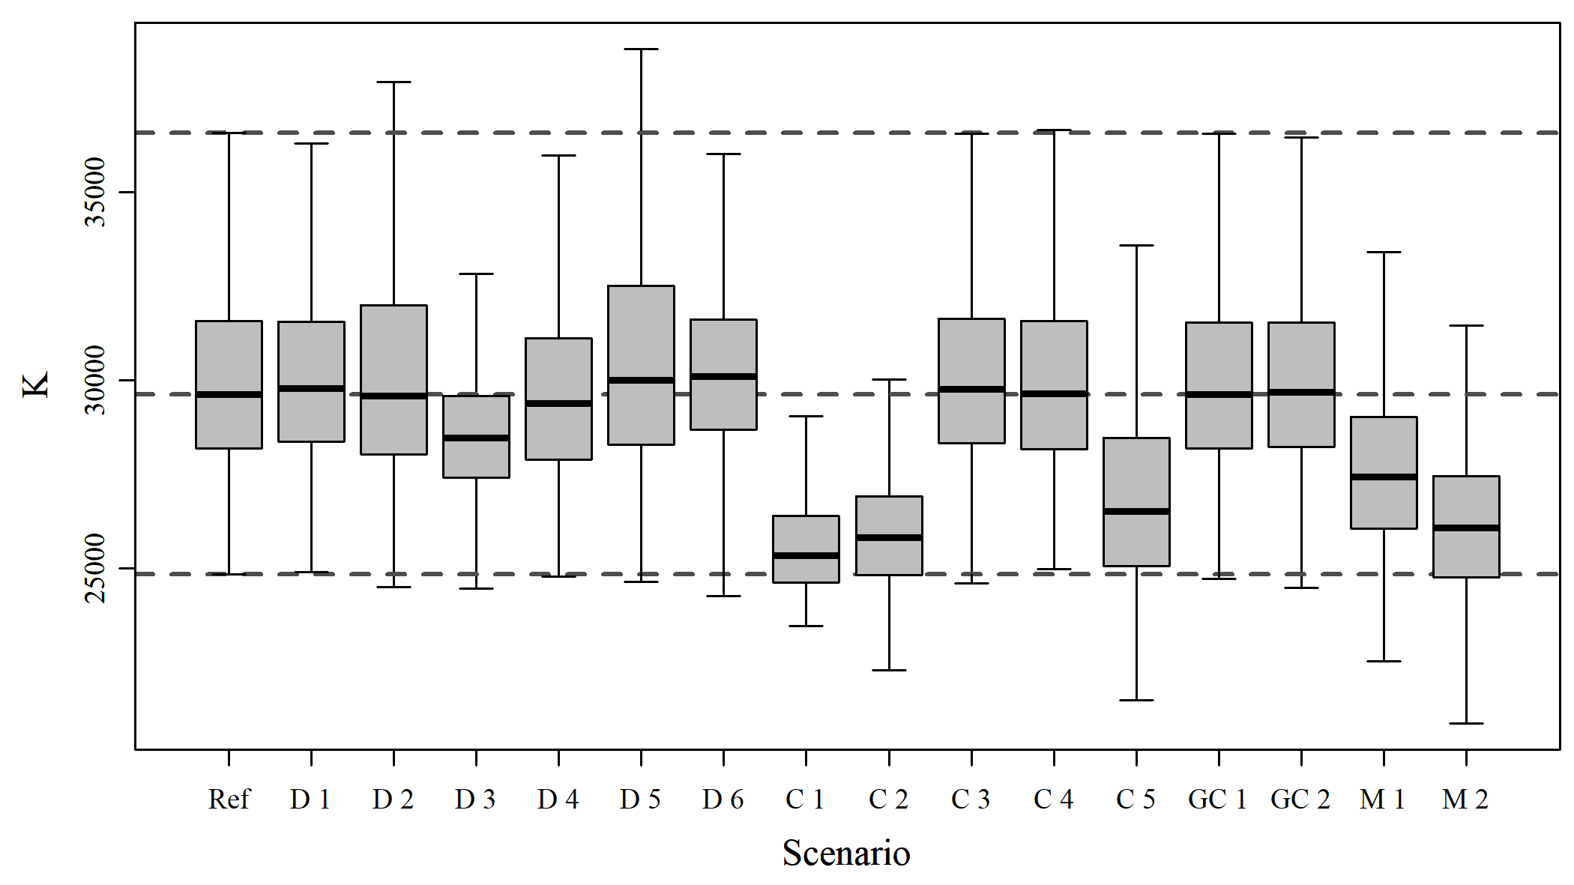

Figure A2. Boxplots of estimated quantities

$$$newpage

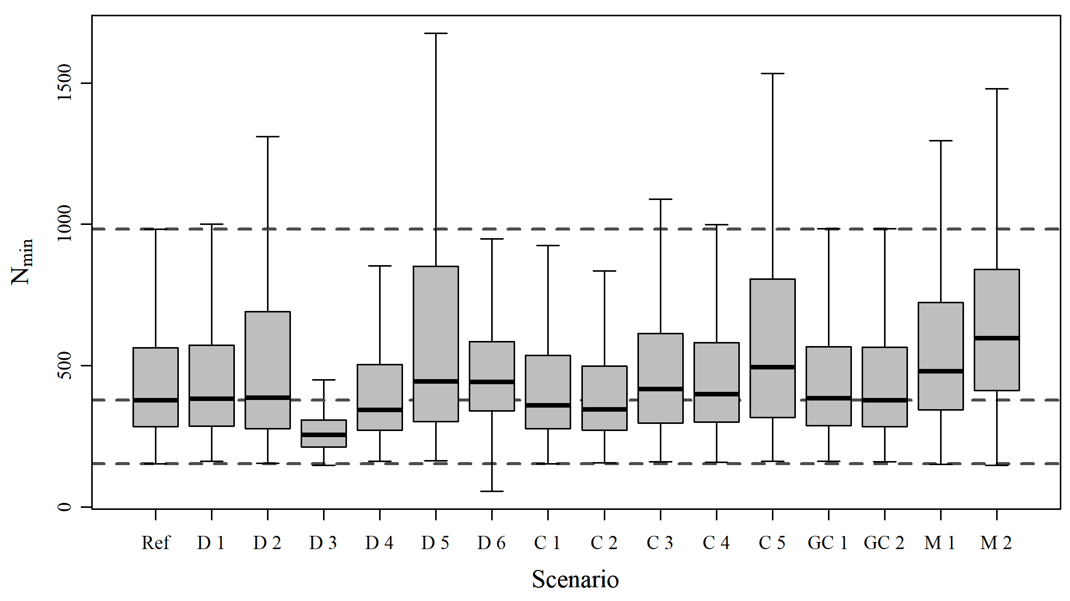

Figure A3. Boxplots of estimated quantities

$$$newpage

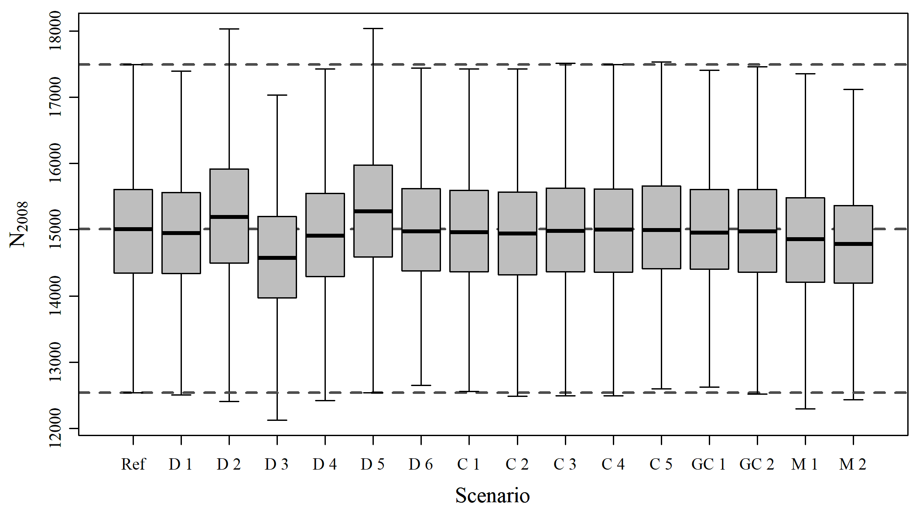

Figure A4. Boxplots of estimated quantities

$$$newpage

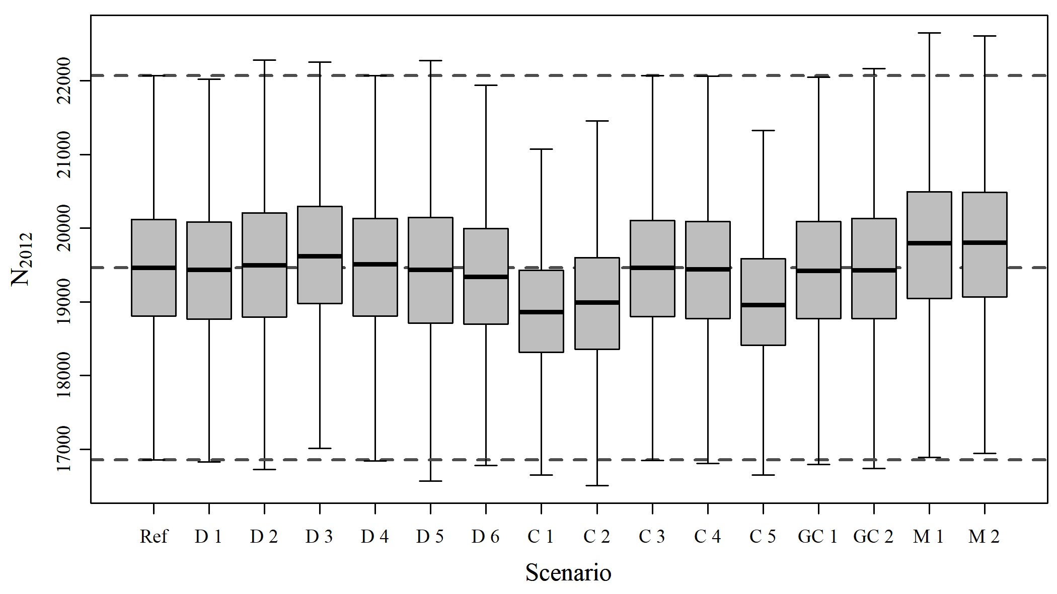

Figure A5. Boxplots of estimated quantities

$$$newpage

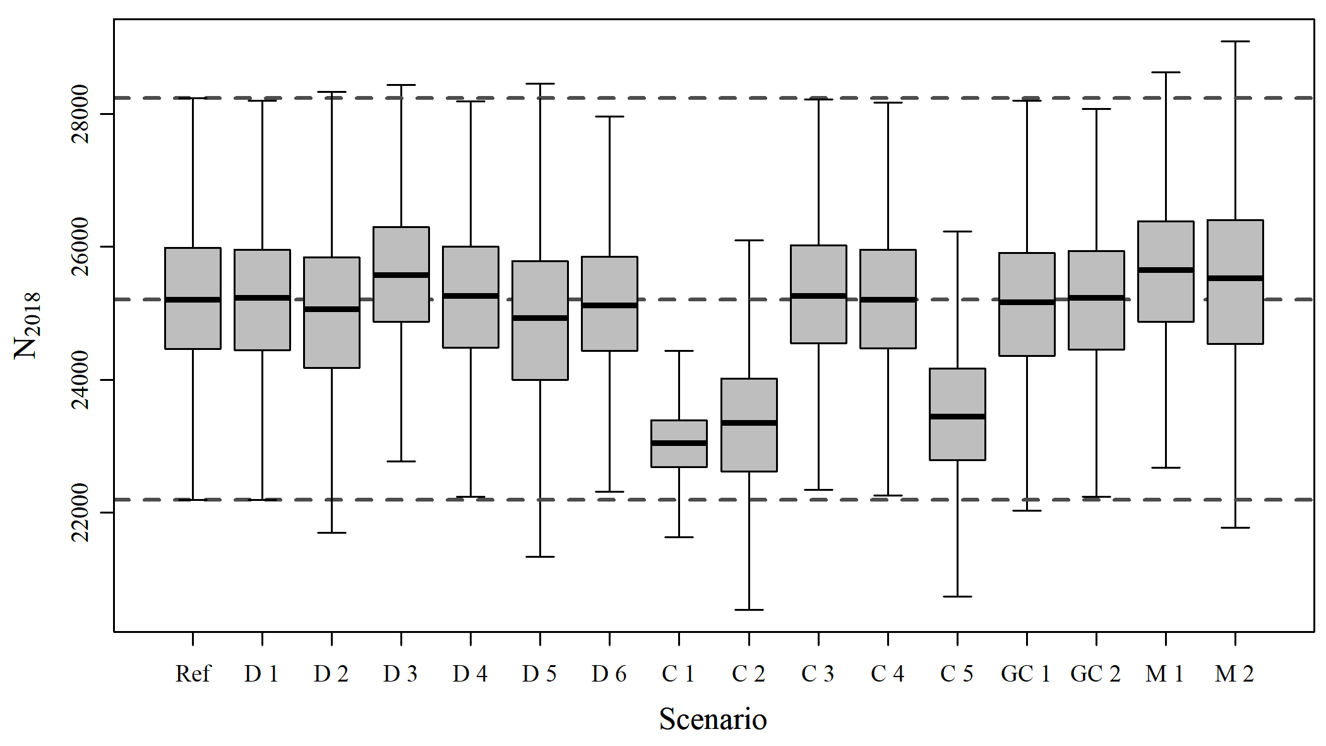

Figure A6. Boxplots of estimated quantities

$$$newpage

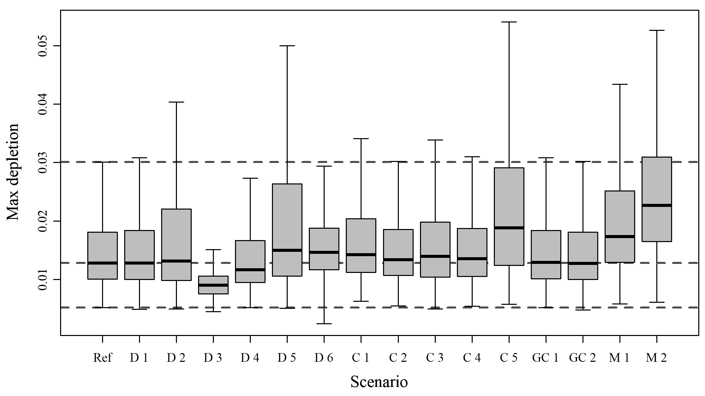

Figure A7. Boxplots of estimated quantities

$$$newpage

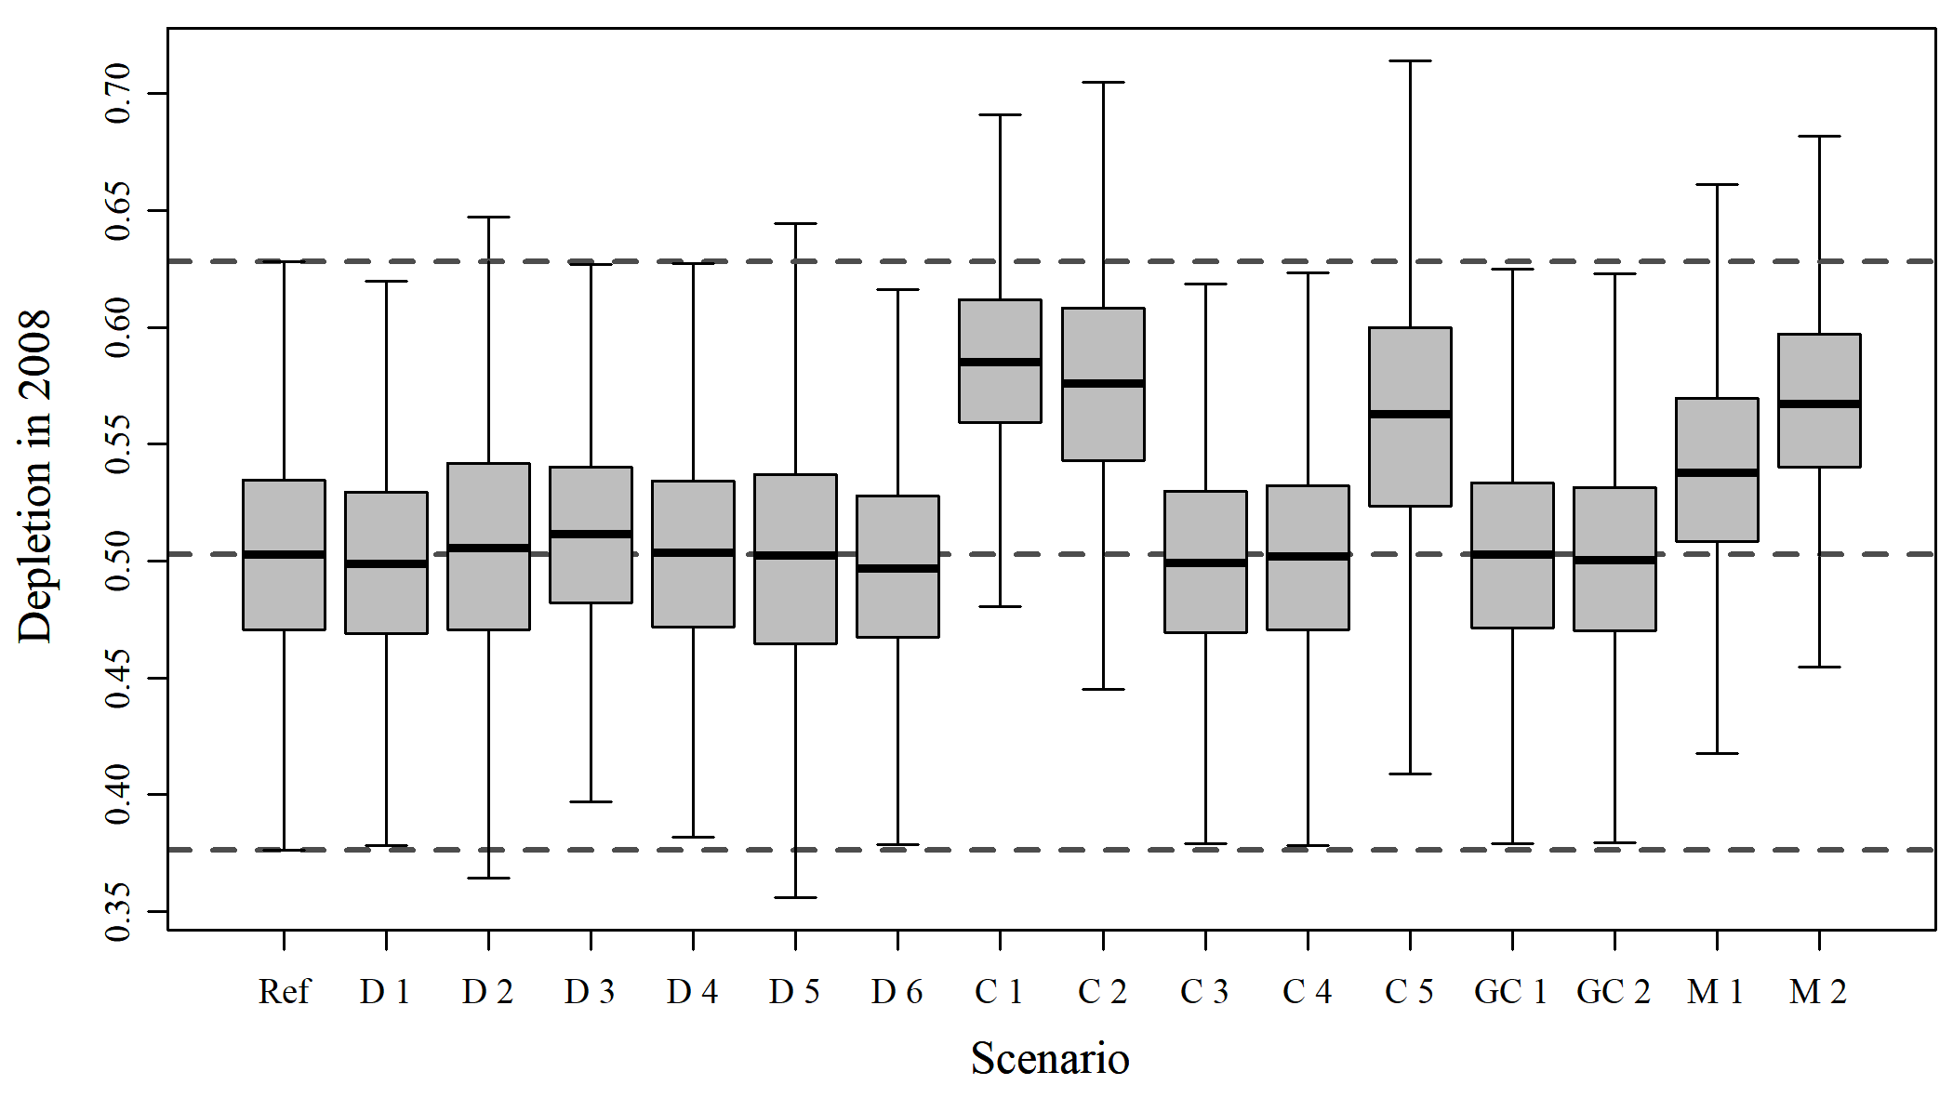

Figure A8. Boxplots of estimated quantities

$$$newpage

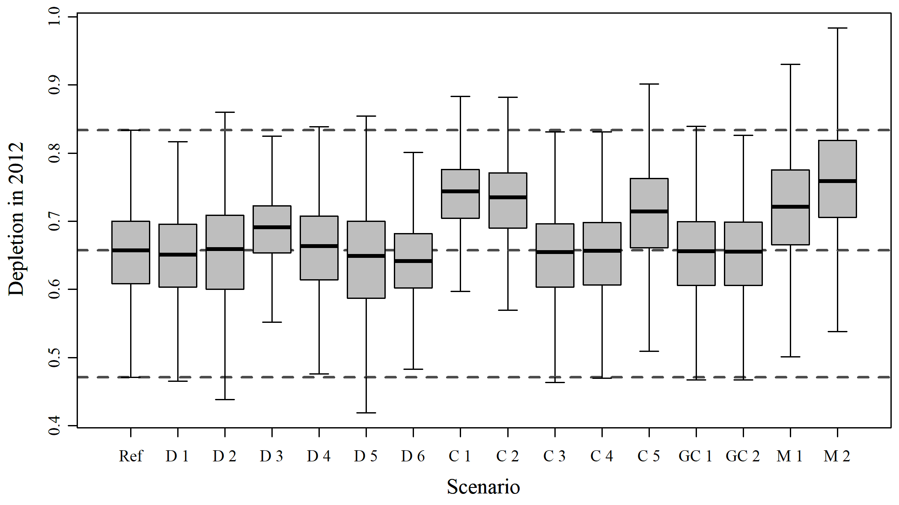

Figure A9. Boxplots of estimated quantities

$$$newpage

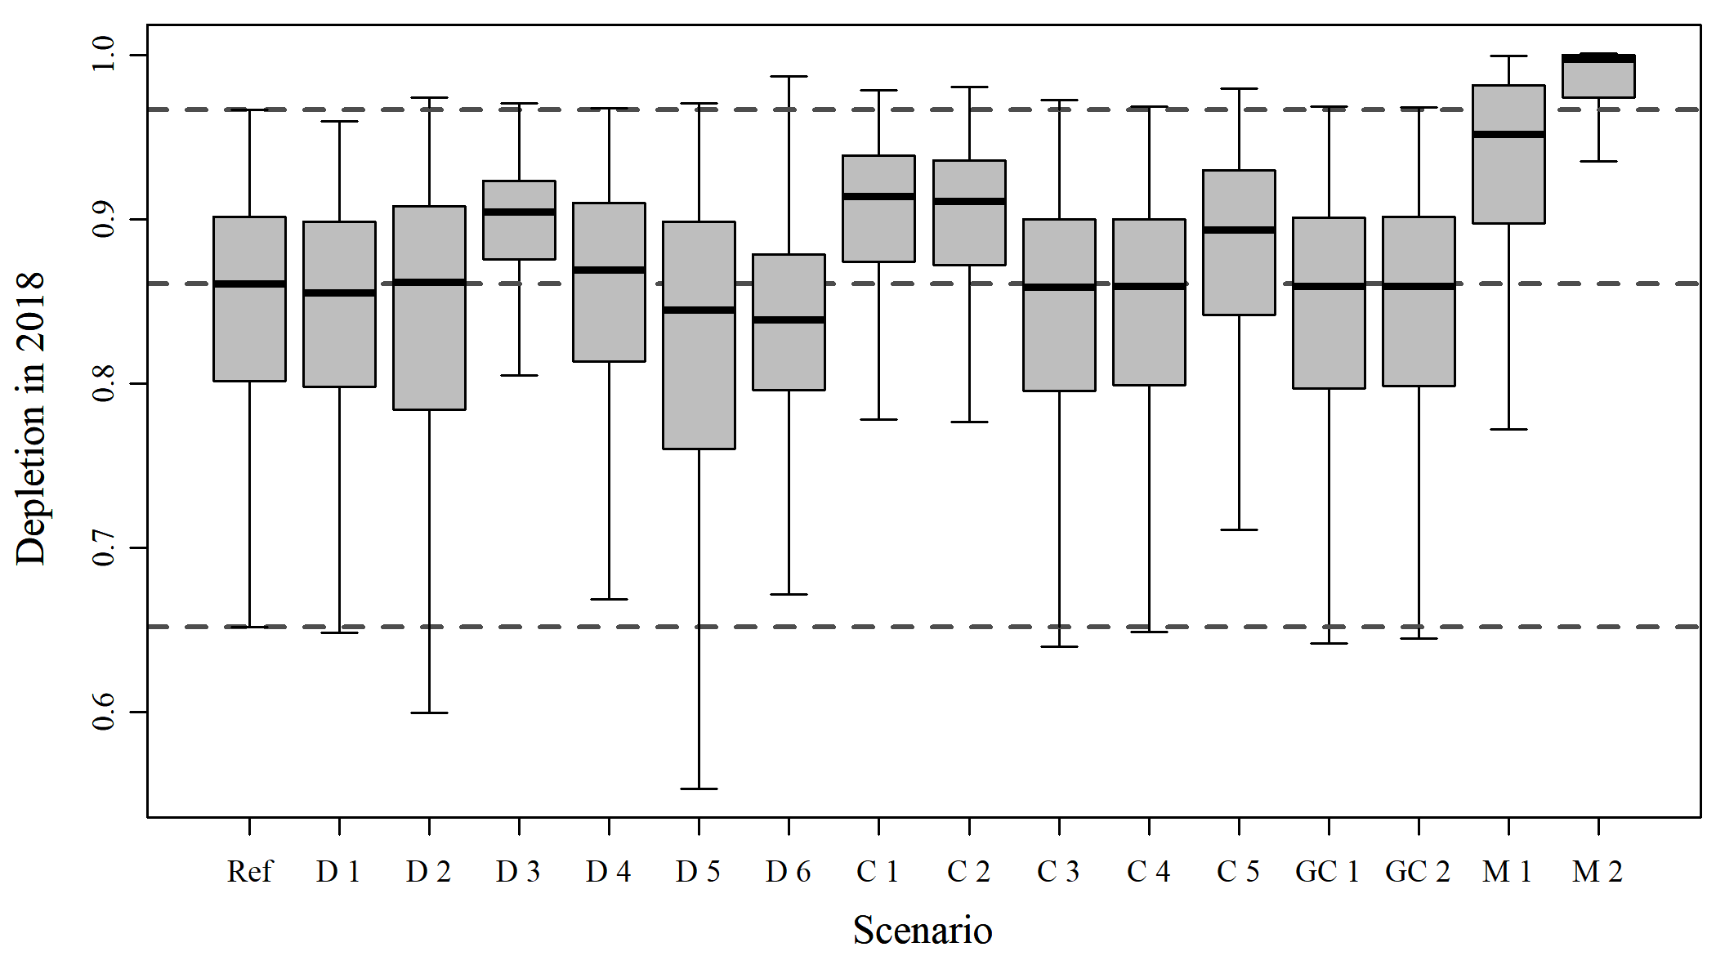

Figure A10. Boxplots of estimated quantities

$$$newpage

$$$newpage

# Reference

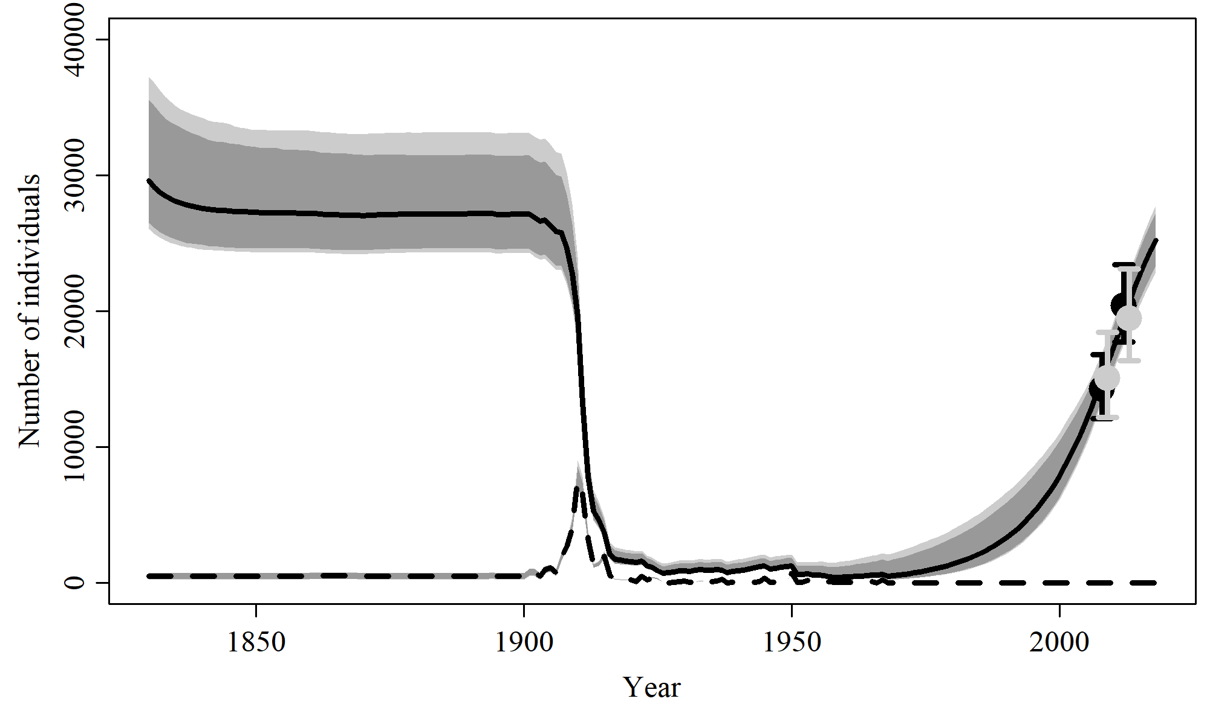

Figure 1. Population trajectory and fit of the model fit to the absolute abundance from the reference case scenario. The solid line corresponds to the posterior median, light grey to the 95% credible interval, grey to the 90% credible interval, black error bars to the 95% confidence interval of the abundance estimate, grey error bars to the 95% credible interval of the posterior predicted abundance estimate, and the dashed line to the catch series.

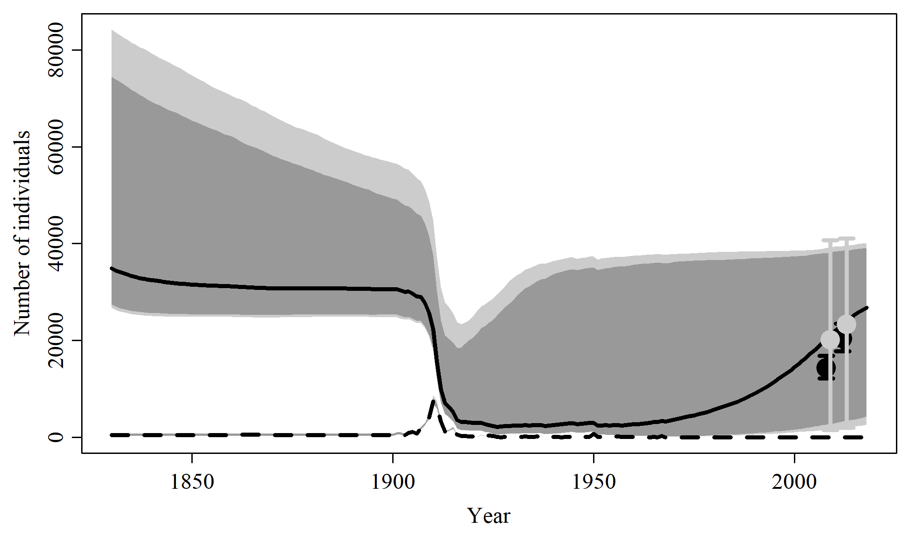

Figure 2. Prior predictive check of population trajectory the model from the reference case scenario. The solid line corresponds to the posterior median, light grey to the 95% credible interval, grey to the 90% credible interval, black error bars to the 95% confidence interval of the abundance estimate, grey error bars to the 95% credible interval of the posterior predicted abundance estimate, and the dashed line to the catch series.

$$$newpage

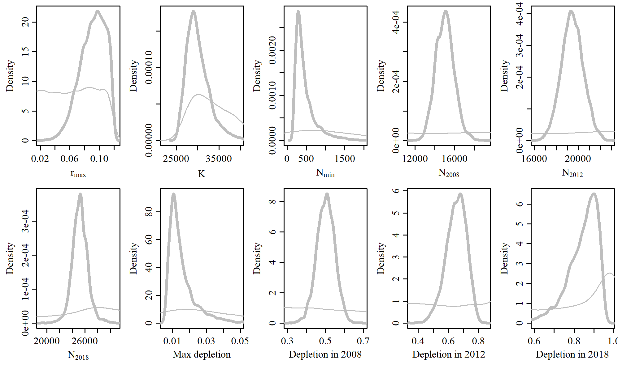

Figure 3. Posterior probability distributions of model parameters and derived quantities from the model fit to the absolute abundance from the reference case scenario.

$$$newpage

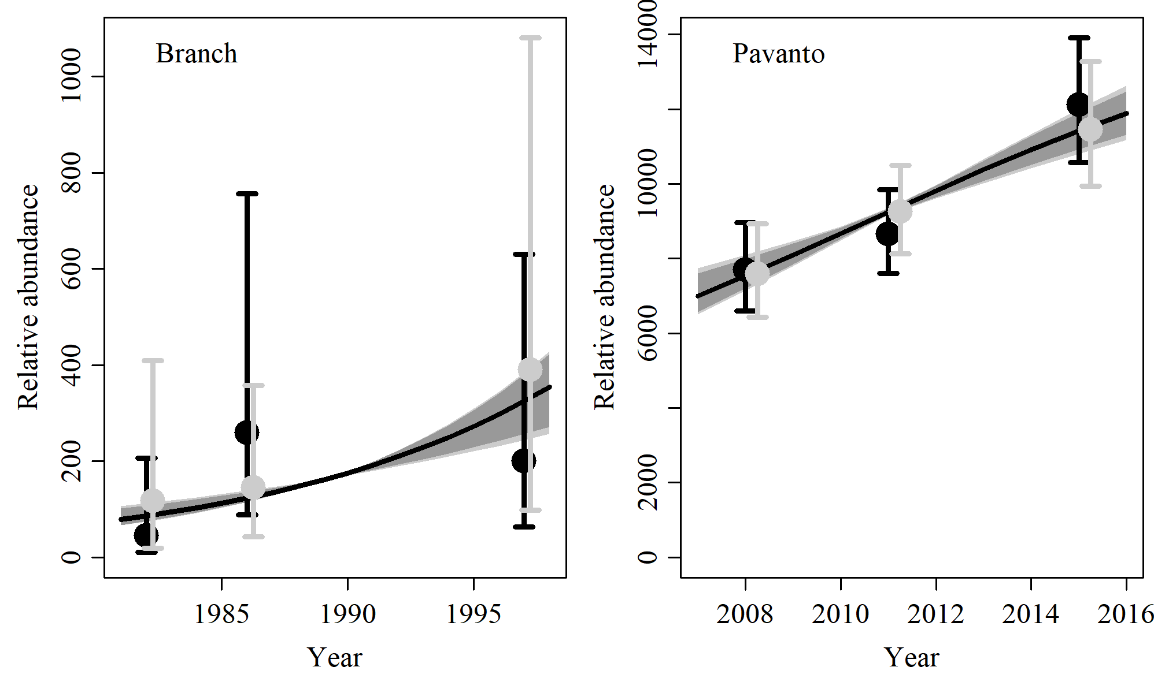

Figure 4. Fit of the model fit from the reference scenario to indices of abundance. The solid line corresponds to the posterior median, light grey to the 95% credible interval, grey to the 90% credible interval, black error bars to the 95% confidence interval of the relative abundance estimates, and grey error bars to the 95% credible interval of the posterior predicted relative abundance.

$$$newpage

Table 1. Population and parameter estimates from the model fit from the reference scenario.

|  |  |  |  |  |  |  |
| --- | --- | --- | --- | --- | --- | --- |
| Parameter | Mean | Median | 2.5% CI | 5% CI | 95% CI | 97.5% CI |
|  | 0.091 | 0.093 | 0.054 | 0.06 | 0.117 | 0.115 |
|  | 30,135 | 29,615 | 26,068 | 26,507 | 37,272 | 35,590 |
|  | 482 | 378 | 190 | 203 | 1,391 | 1,115 |
|  | 15,020 | 15,012 | 13,263 | 13,513 | 16,926 | 16,572 |
|  | 19,472 | 19,465 | 17,558 | 17,857 | 21,461 | 21,154 |
|  | 25,225 | 25,206 | 22,858 | 23,333 | 27,794 | 27,243 |
| Max depletion | 0.015 | 0.013 | 0.007 | 0.007 | 0.039 | 0.033 |
| Depletion in 2008 | 0.502 | 0.503 | 0.406 | 0.423 | 0.593 | 0.579 |
| Depletion in 2012 | 0.652 | 0.657 | 0.505 | 0.531 | 0.766 | 0.753 |
| Depletion in 2018 | 0.843 | 0.861 | 0.65 | 0.69 | 0.941 | 0.935 |

$$$newpage

# SData 1

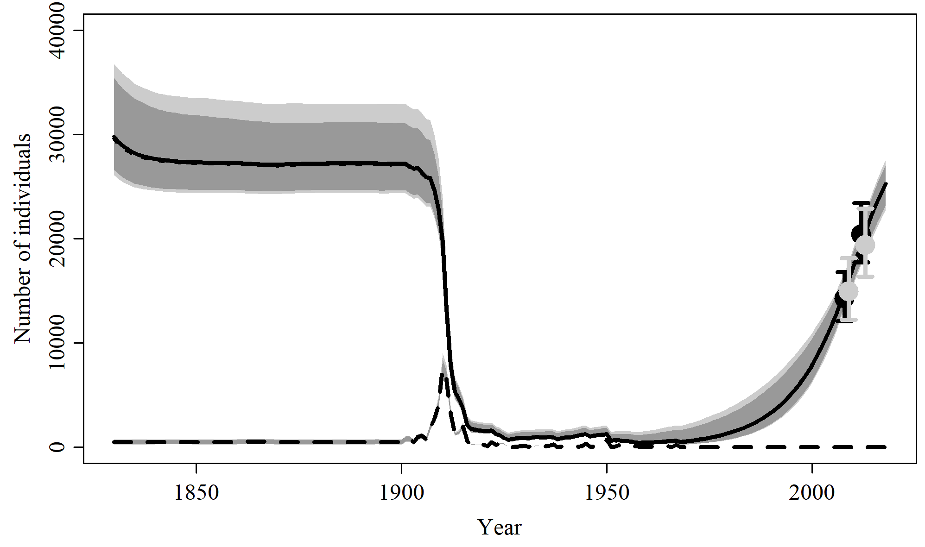

Figure 5. Population trajectory and fit of the model fit to the absolute abundance from the SData 1 case scenario. The solid line corresponds to the posterior median, light grey to the 95% credible interval, grey to the 90% credible interval, black error bars to the 95% confidence interval of the abundance estimate, grey error bars to the 95% credible interval of the posterior predicted abundance estimate, and the dashed line to the catch series.

$$$newpage

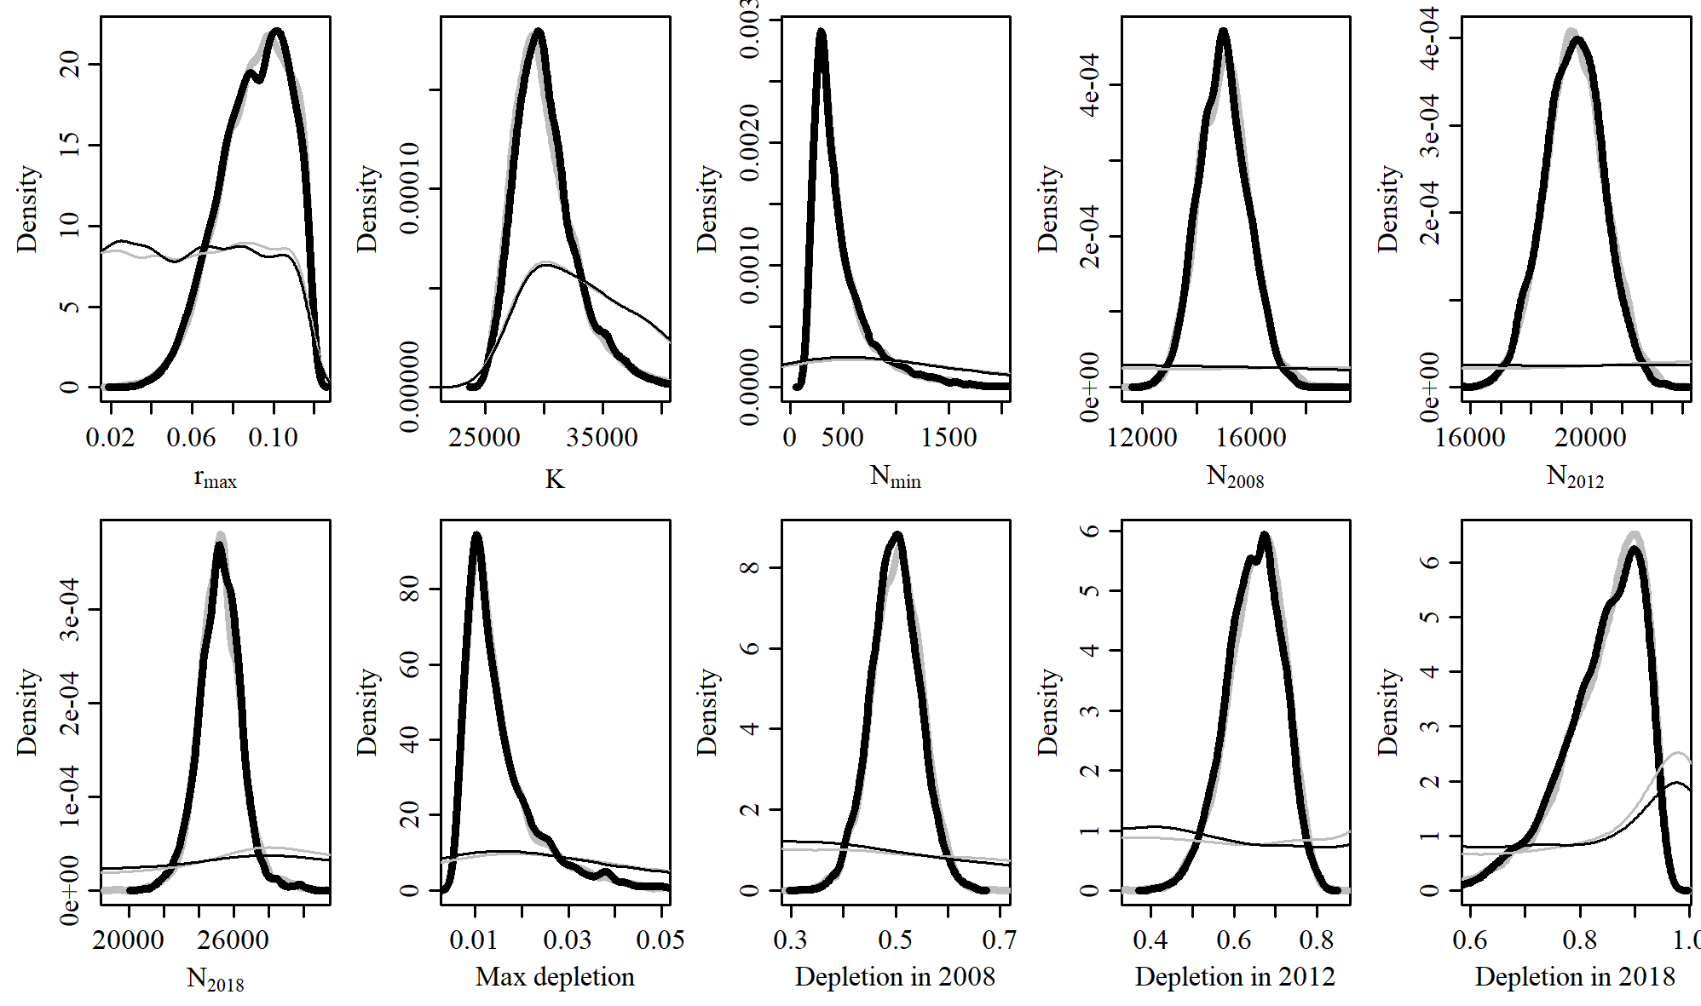

Figure 6. Posterior probability distributions of model parameters and derived quantities from the model fit to the absolute abundance from the SData 1 case scenario.

$$$newpage

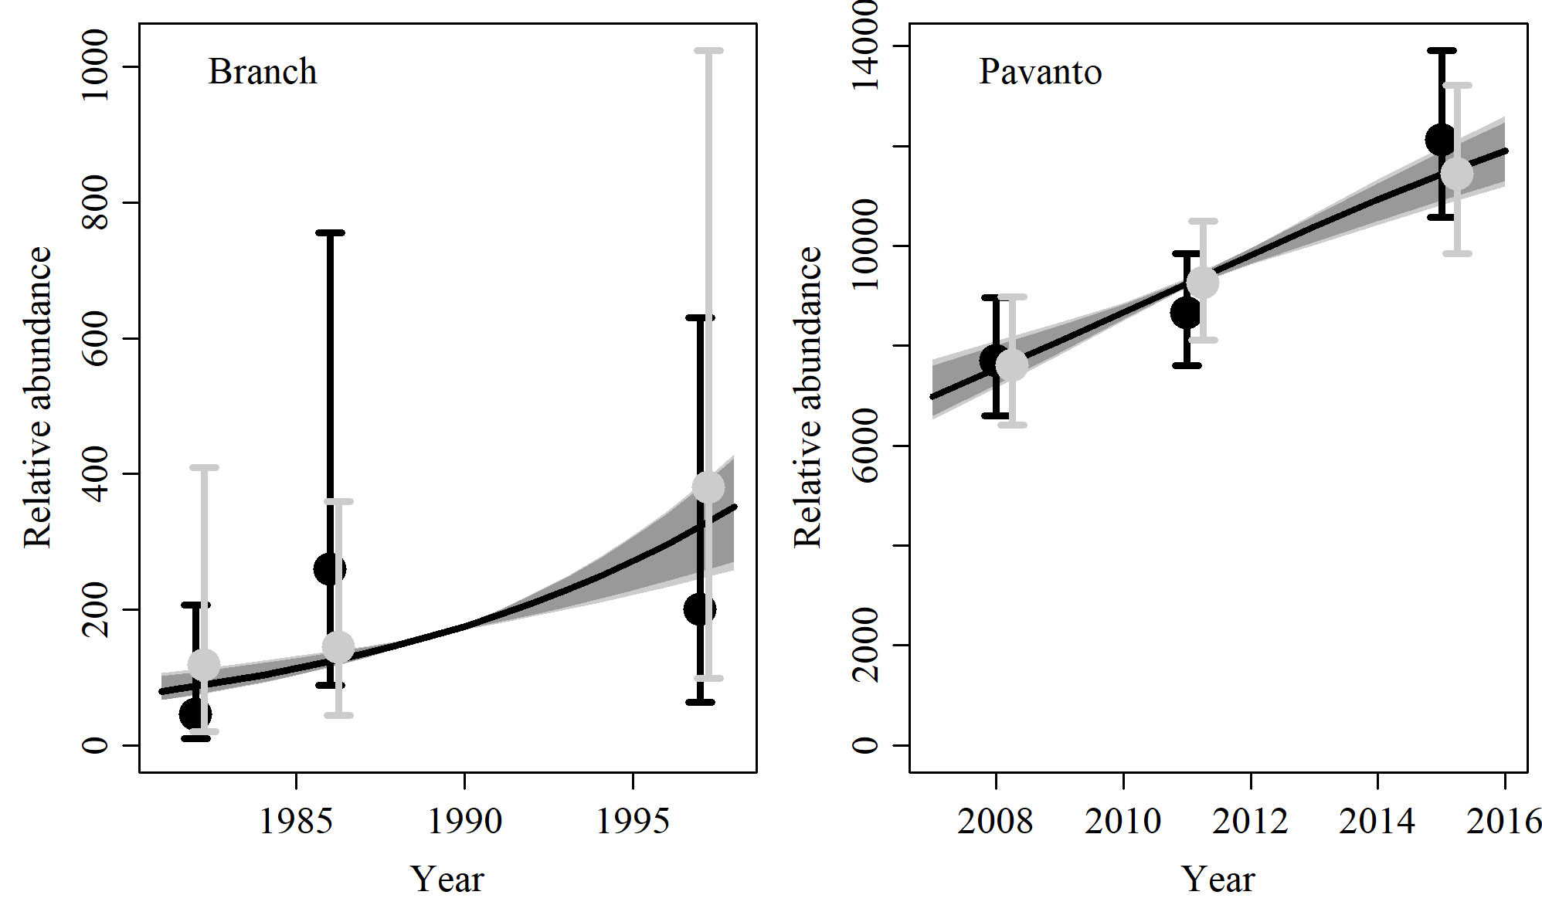

Figure 7. Fit of the model fit from the SData 1 scenario to indices of abundance. The solid line corresponds to the posterior median, light grey to the 95% credible interval, grey to the 90% credible interval, black error bars to the 95% confidence interval of the relative abundance estimates, and grey error bars to the 95% credible interval of the posterior predicted relative abundance.

$$$newpage

Table 2. Population and parameter estimates from the model fit from the SData 1 scenario.

|  |  |  |  |  |  |  |
| --- | --- | --- | --- | --- | --- | --- |
| Parameter | Mean | Median | 2.5% CI | 5% CI | 95% CI | 97.5% CI |
|  | 0.091 | 0.092 | 0.055 | 0.06 | 0.117 | 0.115 |
|  | 30,211 | 29,778 | 26,104 | 26,606 | 36,764 | 35,432 |
|  | 483 | 384 | 192 | 204 | 1,344 | 1,113 |
|  | 19,418 | 19,433 | 17,529 | 17,768 | 21,318 | 20,995 |
|  | 14,971 | 14,947 | 13,284 | 13,531 | 16,765 | 16,505 |
|  | 25,211 | 25,230 | 22,760 | 23,223 | 27,603 | 27,062 |
| Max depletion | 0.016 | 0.013 | 0.007 | 0.007 | 0.039 | 0.033 |
| Depletion in 2012 | 0.648 | 0.651 | 0.508 | 0.534 | 0.764 | 0.748 |
| Depletion in 2008 | 0.499 | 0.499 | 0.408 | 0.422 | 0.59 | 0.575 |
| Depletion in 2018 | 0.84 | 0.855 | 0.657 | 0.691 | 0.941 | 0.932 |

$$$newpage

# SData 2

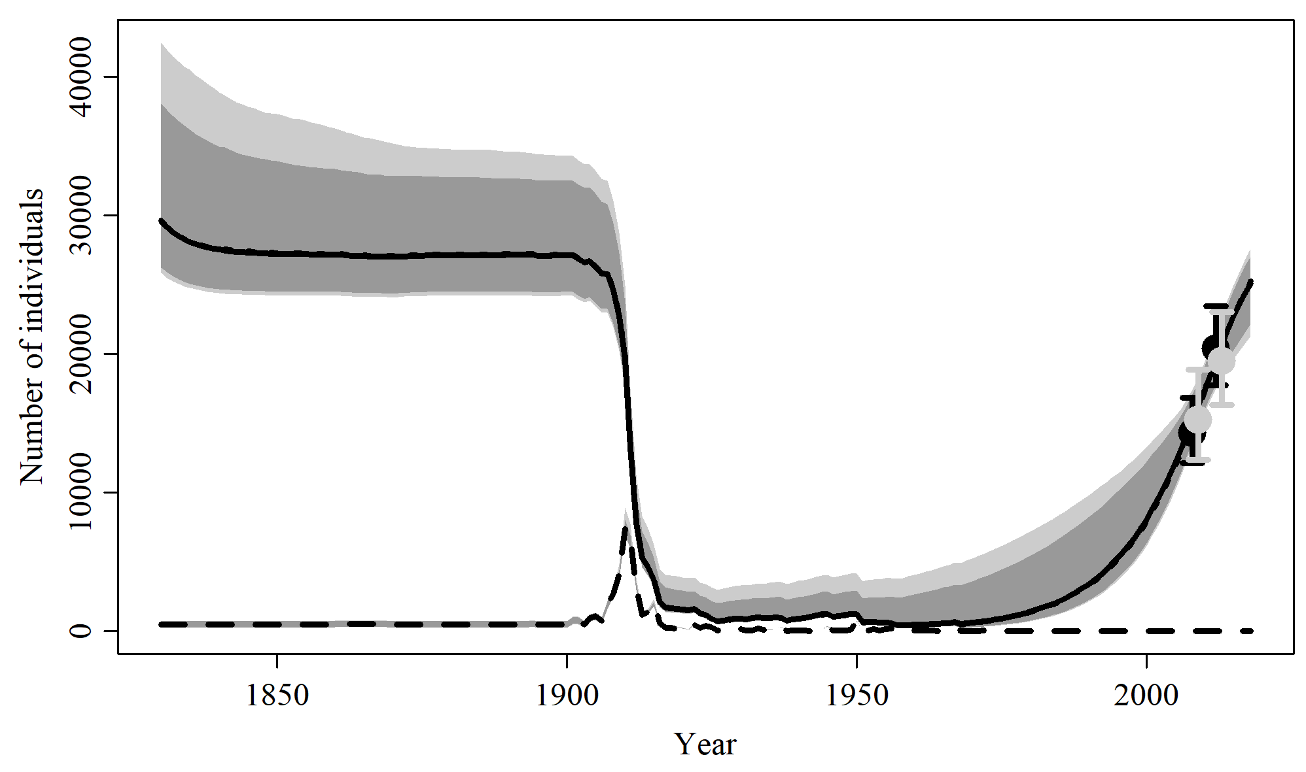

Figure 8. Population trajectory and fit of the model fit to the absolute abundance from the SData 2 case scenario. The solid line corresponds to the posterior median, light grey to the 95% credible interval, grey to the 90% credible interval, black error bars to the 95% confidence interval of the abundance estimate, grey error bars to the 95% credible interval of the posterior predicted abundance estimate, and the dashed line to the catch series.

$$$newpage

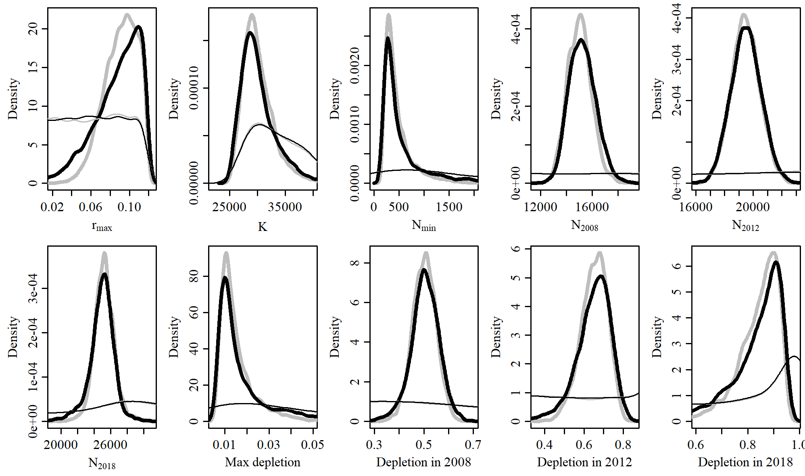

Figure 9. Posterior probability distributions of model parameters and derived quantities from the model fit to the absolute abundance from the SData 2 case scenario.

$$$newpage

Table 3. Population and parameter estimates from the model fit from the SData 2 scenario.

|  |  |  |  |  |  |  |
| --- | --- | --- | --- | --- | --- | --- |
| Parameter | Mean | Median | 2.5% CI | 5% CI | 95% CI | 97.5% CI |
|  | 0.087 | 0.092 | 0.032 | 0.042 | 0.117 | 0.116 |
|  | 30,681 | 29,586 | 25,843 | 26,234 | 42,430 | 38,041 |
|  | 687 | 386 | 189 | 200 | 2,953 | 1,986 |
|  | 15,247 | 15,195 | 13,376 | 13,648 | 17,415 | 17,062 |
|  | 19,507 | 19,500 | 17,504 | 17,780 | 21,587 | 21,237 |
|  | 24,927 | 25,057 | 21,265 | 22,180 | 27,609 | 27,042 |
| Max depletion | 0.02 | 0.013 | 0.007 | 0.007 | 0.071 | 0.054 |
| Depletion in 2008 | 0.504 | 0.506 | 0.378 | 0.405 | 0.612 | 0.593 |
| Depletion in 2012 | 0.648 | 0.659 | 0.434 | 0.485 | 0.786 | 0.769 |
| Depletion in 2018 | 0.828 | 0.862 | 0.516 | 0.596 | 0.949 | 0.941 |

$$$newpage

# SData 3

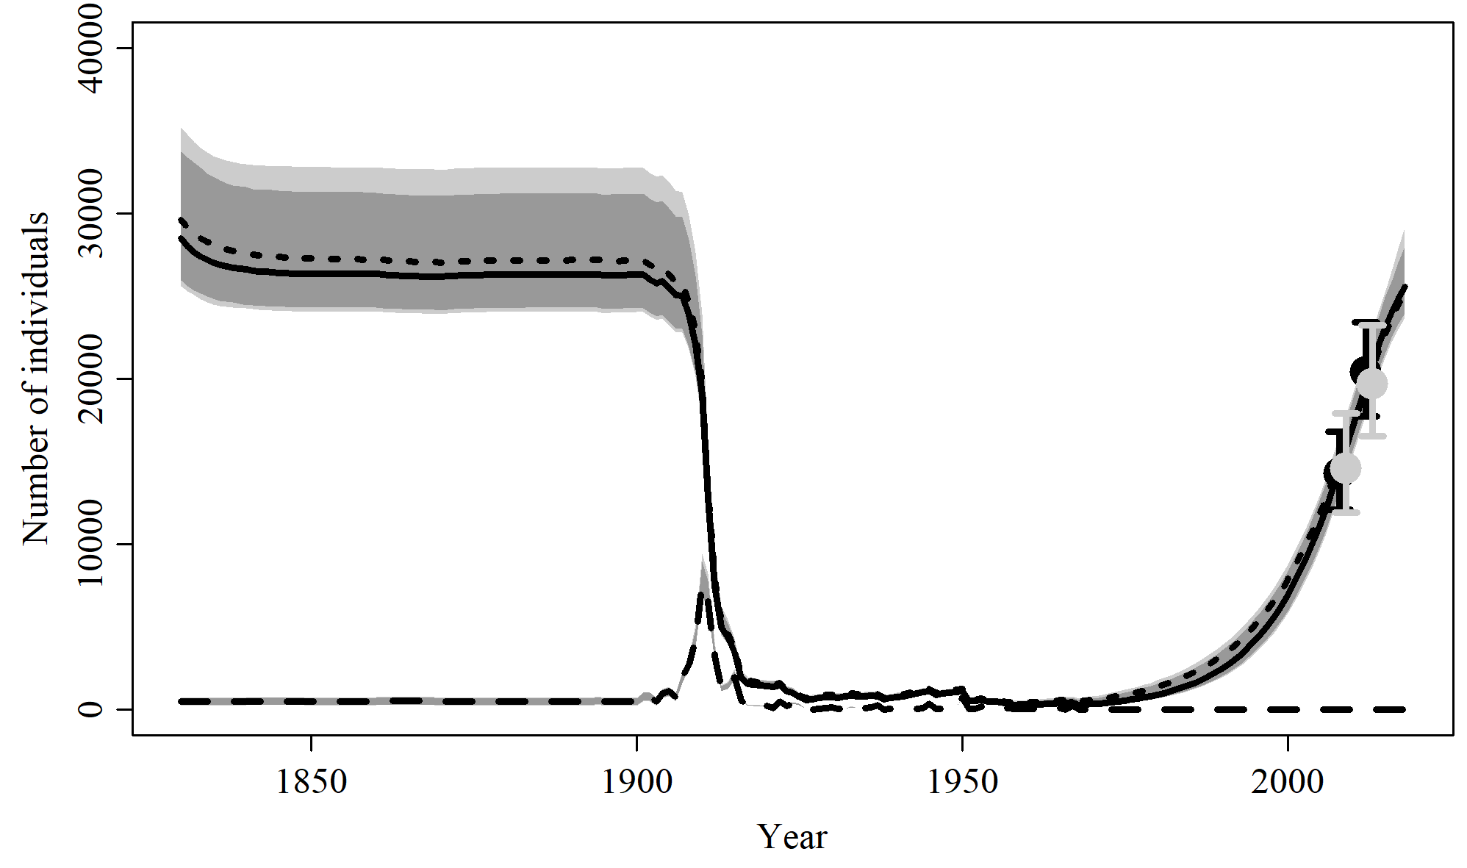

Figure 10. Population trajectory and fit of the model fit to the absolute abundance from the SData 3 case scenario. The solid line corresponds to the posterior median, light grey to the 95% credible interval, grey to the 90% credible interval, black error bars to the 95% confidence interval of the abundance estimate, grey error bars to the 95% credible interval of the posterior predicted abundance estimate, and the dashed line to the catch series.

$$$newpage

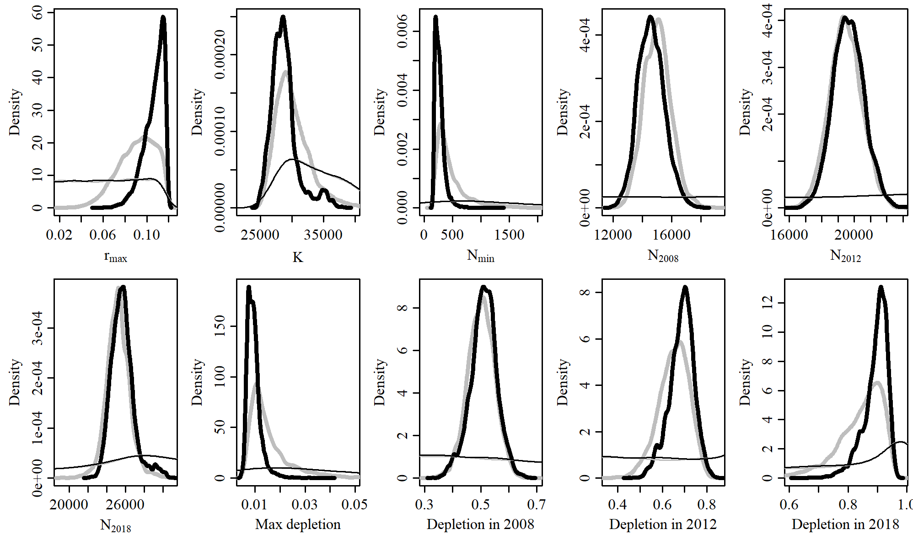

Figure 11. Posterior probability distributions of model parameters and derived quantities from the model fit to the absolute abundance from the SData 3 case scenario.

$$$newpage

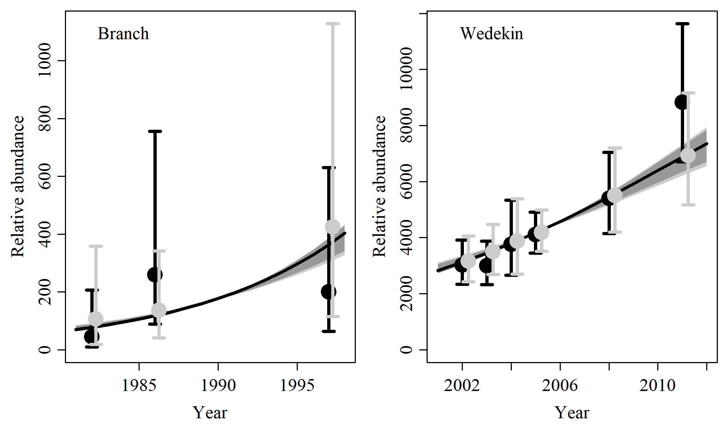

Figure 12. Fit of the model fit from the SData 3 scenario to indices of abundance. The solid line corresponds to the posterior median, light grey to the 95% credible interval, grey to the 90% credible interval, black error bars to the 95% confidence interval of the relative abundance estimates, and grey error bars to the 95% credible interval of the posterior predicted relative abundance.

$$$newpage

Table 4. Population and parameter estimates from the model fit from the SData 3 scenario.

|  |  |  |  |  |  |  |
| --- | --- | --- | --- | --- | --- | --- |
| Parameter | Mean | Median | 2.5% CI | 5% CI | 95% CI | 97.5% CI |
|  | 0.107 | 0.109 | 0.084 | 0.088 | 0.117 | 0.117 |
|  | 28,791 | 28,477 | 25,621 | 25,944 | 35,223 | 33,735 |
|  | 273 | 255 | 174 | 181 | 493 | 426 |
|  | 14,609 | 14,575 | 12,924 | 13,204 | 16,500 | 16,198 |
|  | 19,651 | 19,617 | 17,809 | 18,104 | 21,555 | 21,282 |
|  | 25,672 | 25,570 | 23,686 | 23,942 | 29,160 | 28,019 |
| Max depletion | 0.009 | 0.009 | 0.006 | 0.006 | 0.016 | 0.014 |
| Depletion in 2008 | 0.51 | 0.512 | 0.405 | 0.429 | 0.601 | 0.586 |
| Depletion in 2012 | 0.686 | 0.691 | 0.566 | 0.581 | 0.782 | 0.767 |
| Depletion in 2018 | 0.894 | 0.904 | 0.79 | 0.814 | 0.949 | 0.943 |

$$$newpage

# SData 4

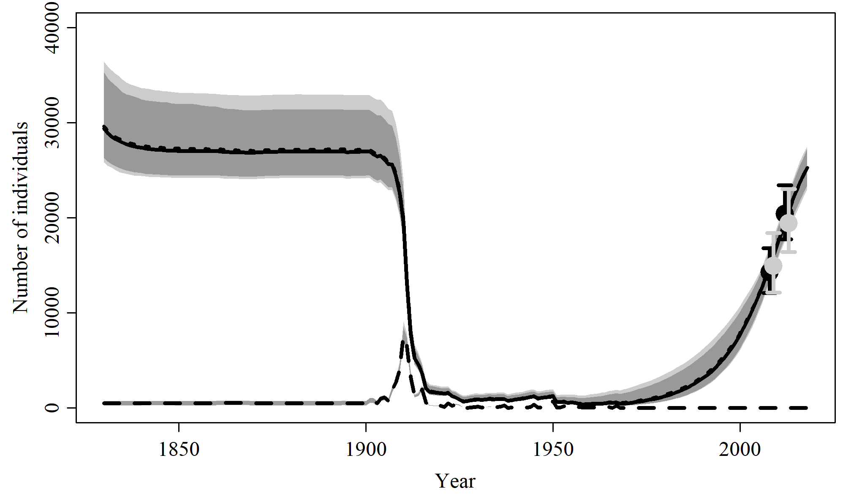

Figure 13. Population trajectory and fit of the model fit to the absolute abundance from the SData 4 case scenario. The solid line corresponds to the posterior median, light grey to the 95% credible interval, grey to the 90% credible interval, black error bars to the 95% confidence interval of the abundance estimate, grey error bars to the 95% credible interval of the posterior predicted abundance estimate, and the dashed line to the catch series.

$$$newpage

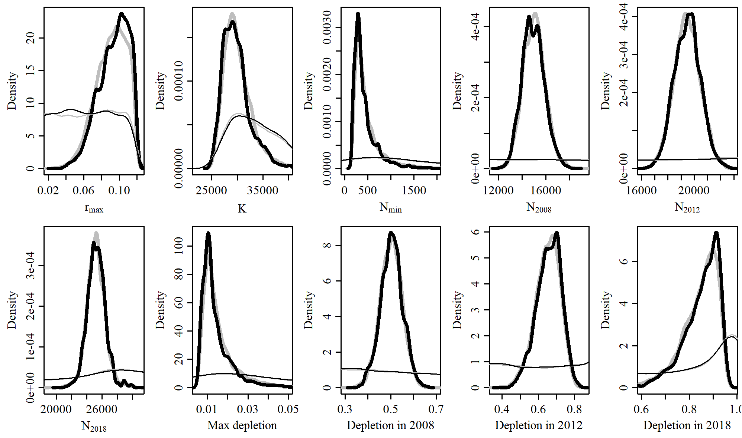

Figure 14. Posterior probability distributions of model parameters and derived quantities from the model fit to the absolute abundance from the SData 4 case scenario.

$$$newpage

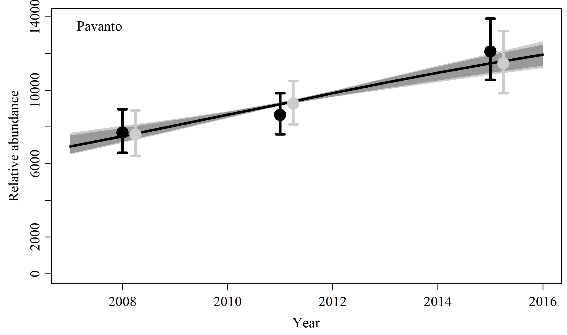

Figure 15. Fit of the model fit from the SData 4 scenario to indices of abundance. The solid line corresponds to the posterior median, light grey to the 95% credible interval, grey to the 90% credible interval, black error bars to the 95% confidence interval of the relative abundance estimates, and grey error bars to the 95% credible interval of the posterior predicted relative abundance.

$$$newpage

Table 5. Population and parameter estimates from the model fit from the SData 4 scenario.

|  |  |  |  |  |  |  |
| --- | --- | --- | --- | --- | --- | --- |
| Parameter | Mean | Median | 2.5% CI | 5% CI | 95% CI | 97.5% CI |
|  | 0.094 | 0.096 | 0.058 | 0.064 | 0.117 | 0.117 |
|  | 29,828 | 29,385 | 25,810 | 26,321 | 36,432 | 35,295 |
|  | 440 | 343 | 183 | 193 | 1,244 | 990 |
|  | 14,939 | 14,908 | 13,244 | 13,440 | 16,883 | 16,533 |
|  | 19,484 | 19,514 | 17,568 | 17,882 | 21,420 | 21,073 |
|  | 25,266 | 25,262 | 22,984 | 23,387 | 27,533 | 27,275 |
| Max depletion | 0.014 | 0.012 | 0.007 | 0.007 | 0.036 | 0.03 |
| Depletion in 2008 | 0.504 | 0.504 | 0.405 | 0.422 | 0.598 | 0.582 |
| Depletion in 2012 | 0.658 | 0.663 | 0.515 | 0.536 | 0.774 | 0.759 |
| Depletion in 2018 | 0.853 | 0.869 | 0.672 | 0.705 | 0.944 | 0.938 |

$$$newpage

# SData 5

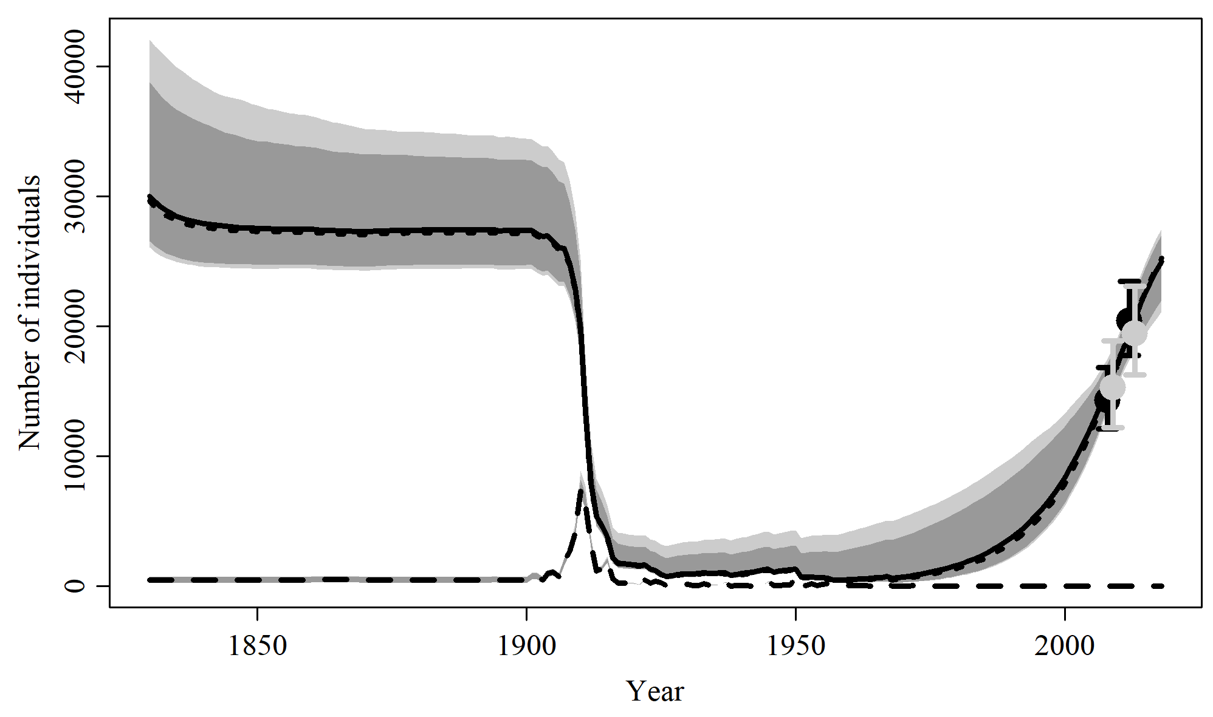

Figure 16. Population trajectory and fit of the model fit to the absolute abundance from the SData 5 case scenario. The solid line corresponds to the posterior median, light grey to the 95% credible interval, grey to the 90% credible interval, black error bars to the 95% confidence interval of the abundance estimate, grey error bars to the 95% credible interval of the posterior predicted abundance estimate, and the dashed line to the catch series.

$$$newpage

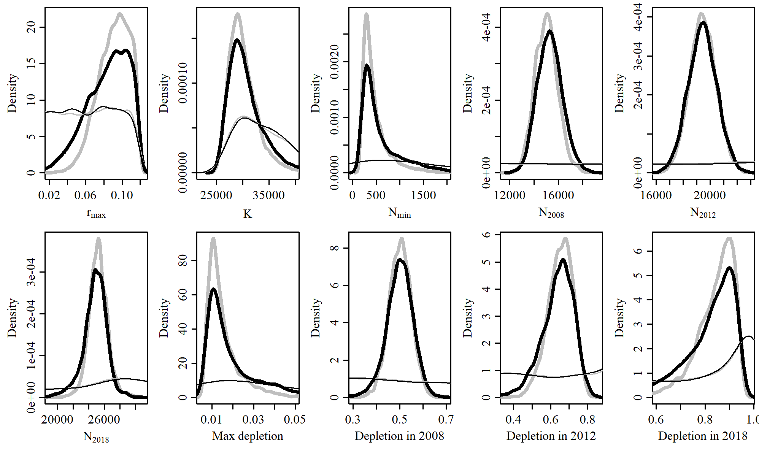

Figure 17. Posterior probability distributions of model parameters and derived quantities from the model fit to the absolute abundance from the SData 5 case scenario.

$$$newpage

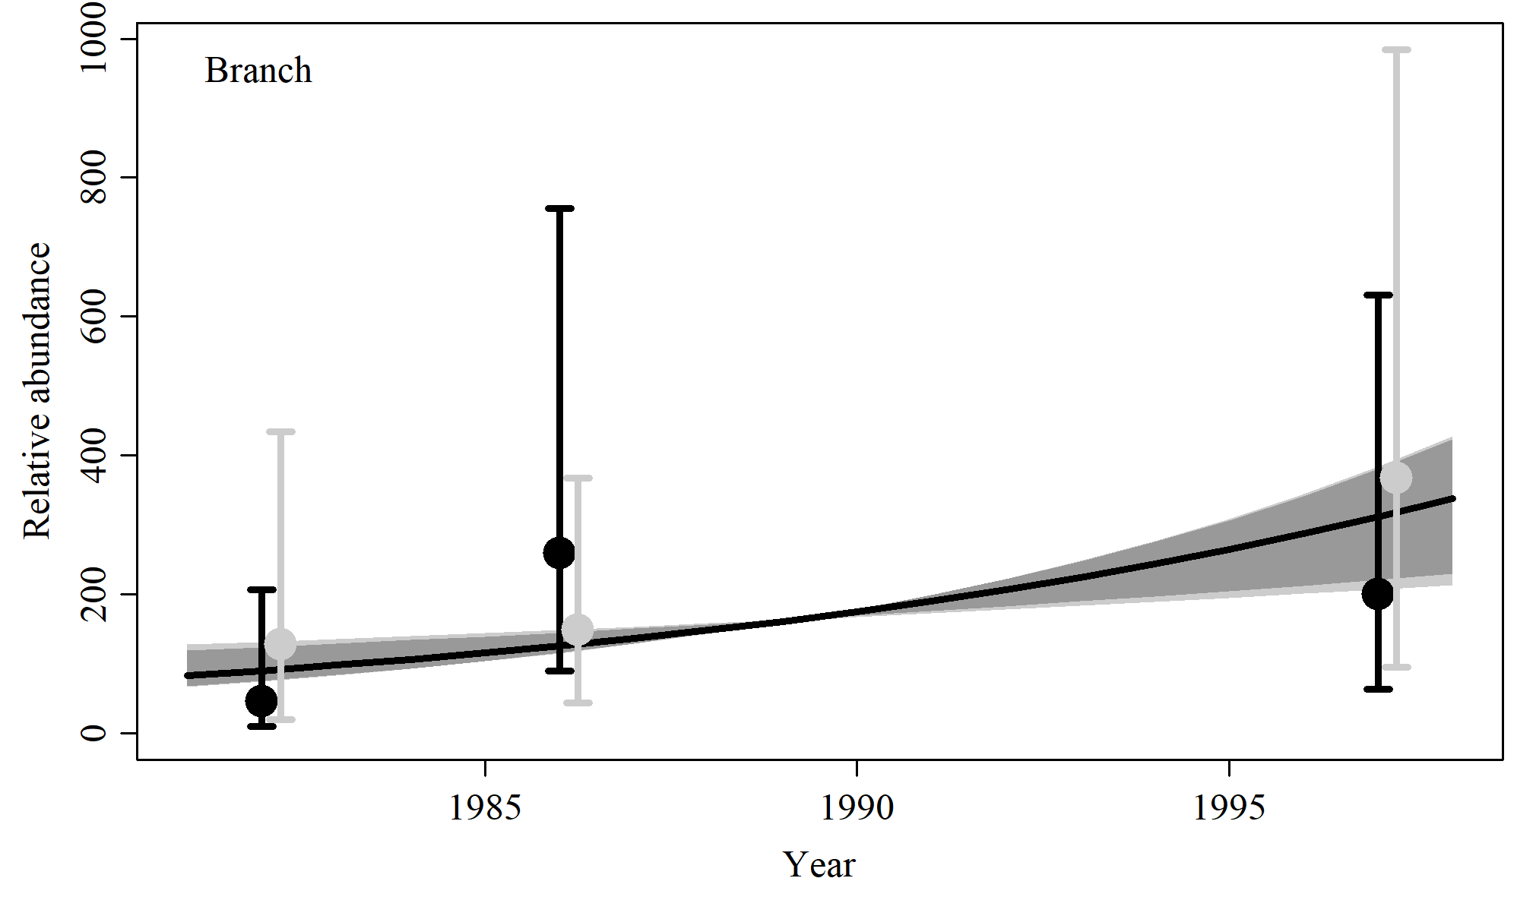

Figure 18. Fit of the model fit from the SData 5 scenario to indices of abundance. The solid line corresponds to the posterior median, light grey to the 95% credible interval, grey to the 90% credible interval, black error bars to the 95% confidence interval of the relative abundance estimates, and grey error bars to the 95% credible interval of the posterior predicted relative abundance.

$$$newpage

Table 6. Population and parameter estimates from the model fit from the SData 5 scenario.

|  |  |  |  |  |  |  |
| --- | --- | --- | --- | --- | --- | --- |
| Parameter | Mean | Median | 2.5% CI | 5% CI | 95% CI | 97.5% CI |
|  | 0.084 | 0.087 | 0.032 | 0.041 | 0.116 | 0.115 |
|  | 31,077 | 30,000 | 26,037 | 26,525 | 42,016 | 38,757 |
|  | 758 | 444 | 195 | 208 | 3,060 | 2,133 |
|  | 15,309 | 15,279 | 13,423 | 13,668 | 17,464 | 17,070 |
|  | 19,433 | 19,437 | 17,342 | 17,696 | 21,520 | 21,208 |
|  | 24,803 | 24,926 | 21,104 | 22,001 | 27,454 | 26,995 |
| Max depletion | 0.022 | 0.015 | 0.007 | 0.007 | 0.075 | 0.056 |
| Depletion in 2008 | 0.5 | 0.502 | 0.374 | 0.402 | 0.605 | 0.588 |
| Depletion in 2012 | 0.637 | 0.649 | 0.433 | 0.477 | 0.779 | 0.759 |
| Depletion in 2018 | 0.814 | 0.845 | 0.514 | 0.585 | 0.944 | 0.936 |

$$$newpage

# SData 6

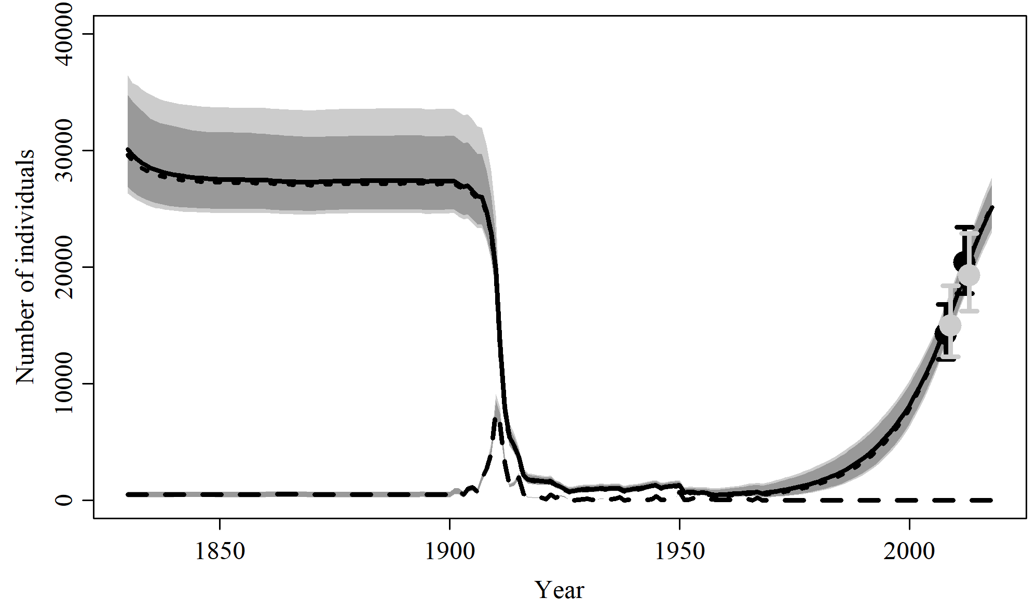

Figure 19. Population trajectory and fit of the model fit to the absolute abundance from the SData 6 case scenario. The solid line corresponds to the posterior median, light grey to the 95% credible interval, grey to the 90% credible interval, black error bars to the 95% confidence interval of the abundance estimate, grey error bars to the 95% credible interval of the posterior predicted abundance estimate, and the dashed line to the catch series.

$$$newpage

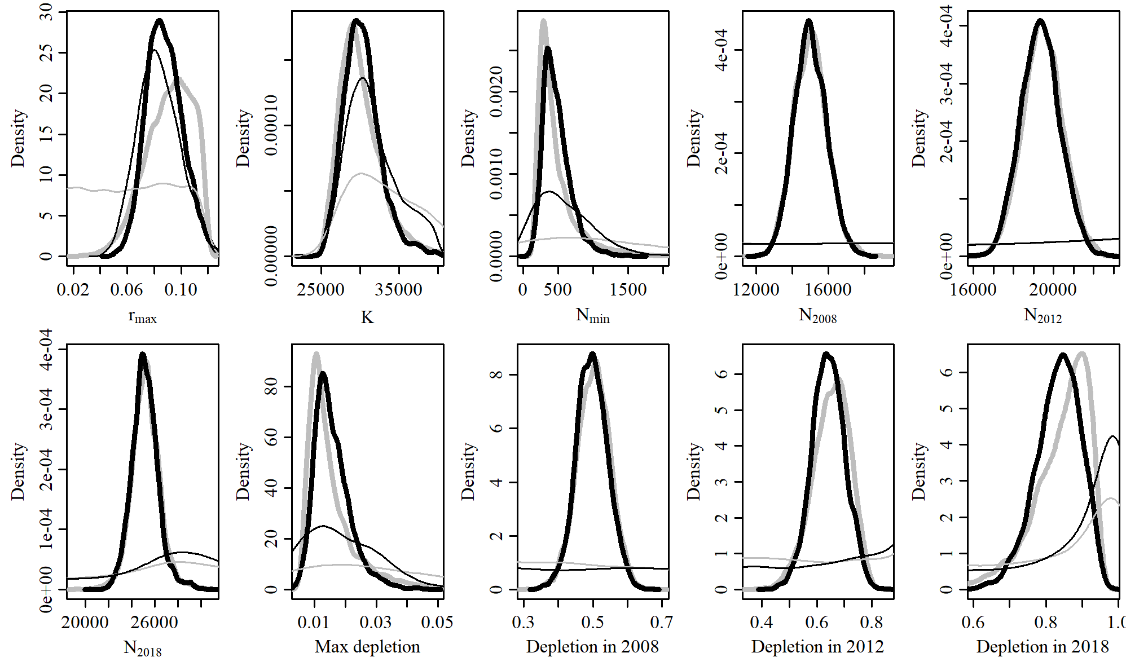

Figure 20. Posterior probability distributions of model parameters and derived quantities from the model fit to the absolute abundance from the SData 6 case scenario.

$$$newpage

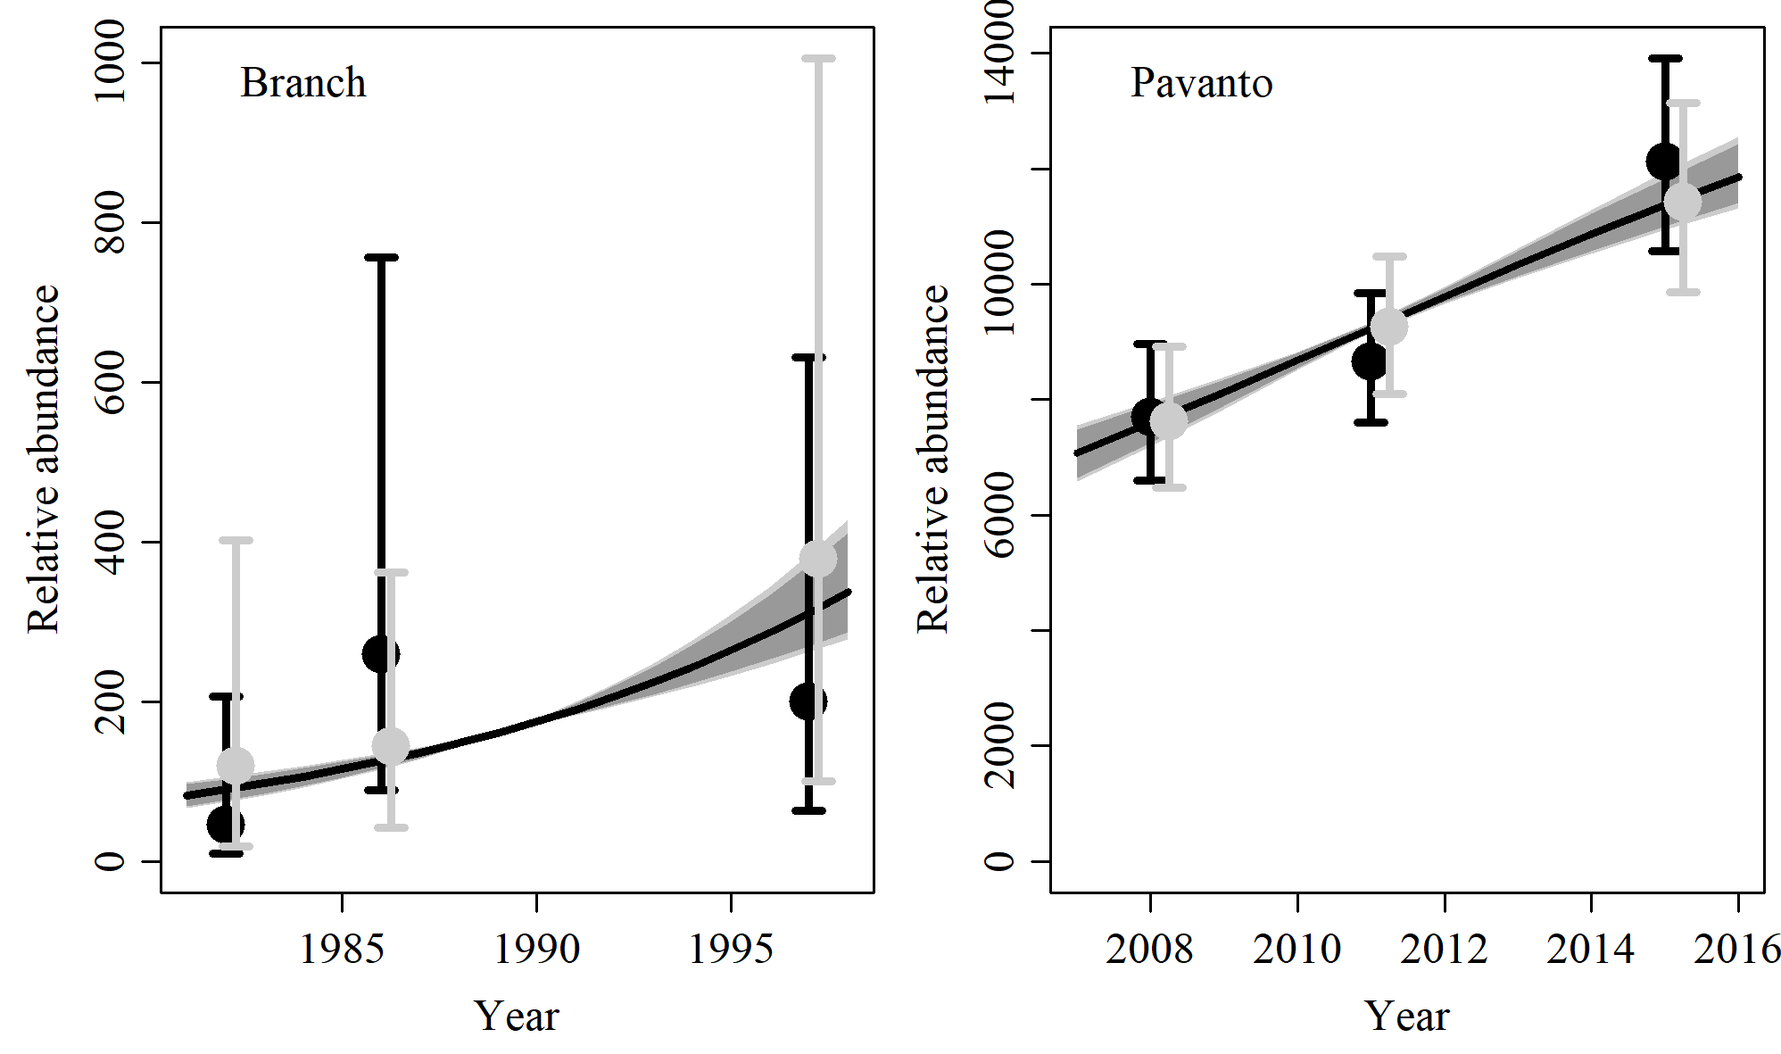

Figure 21. Fit of the model fit from the SData 6 scenario to indices of abundance. The solid line corresponds to the posterior median, light grey to the 95% credible interval, grey to the 90% credible interval, black error bars to the 95% confidence interval of the relative abundance estimates, and grey error bars to the 95% credible interval of the posterior predicted relative abundance.

$$$newpage

Table 7. Population and parameter estimates from the model fit from the SData 6 scenario.

|  |  |  |  |  |  |  |
| --- | --- | --- | --- | --- | --- | --- |
| Parameter | Mean | Median | 2.5% CI | 5% CI | 95% CI | 97.5% CI |
|  | 0.088 | 0.087 | 0.063 | 0.067 | 0.116 | 0.111 |
|  | 30,333 | 30,095 | 26,303 | 26,898 | 36,456 | 34,764 |
|  | 484 | 443 | 197 | 232 | 981 | 857 |
|  | 15,010 | 14,976 | 13,325 | 13,543 | 16,868 | 16,540 |
|  | 19,355 | 19,342 | 17,487 | 17,754 | 21,320 | 20,994 |
|  | 25,166 | 25,113 | 22,996 | 23,363 | 27,734 | 27,069 |
| Max depletion | 0.016 | 0.015 | 0.007 | 0.008 | 0.03 | 0.027 |
| Depletion in 2008 | 0.498 | 0.497 | 0.407 | 0.425 | 0.589 | 0.574 |
| Depletion in 2012 | 0.642 | 0.642 | 0.522 | 0.545 | 0.758 | 0.742 |
| Depletion in 2018 | 0.834 | 0.839 | 0.699 | 0.723 | 0.937 | 0.926 |

$$$newpage

# SCatch 1

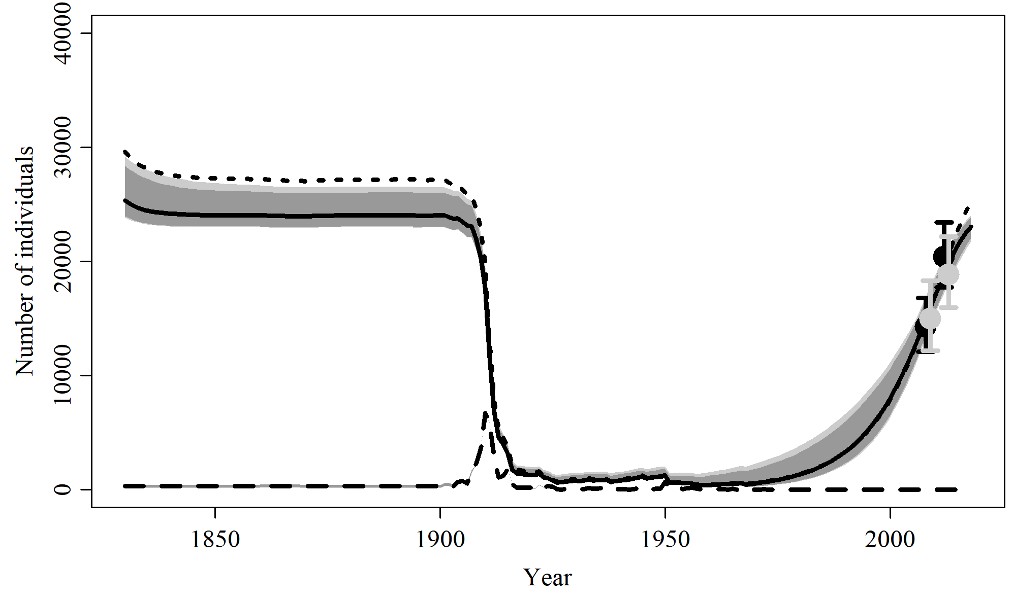

Figure 22. Population trajectory and fit of the model fit to the absolute abundance from the SCatch 1 case scenario. The solid line corresponds to the posterior median, light grey to the 95% credible interval, grey to the 90% credible interval, black error bars to the 95% confidence interval of the abundance estimate, grey error bars to the 95% credible interval of the posterior predicted abundance estimate, and the dashed line to the catch series.

$$$newpage

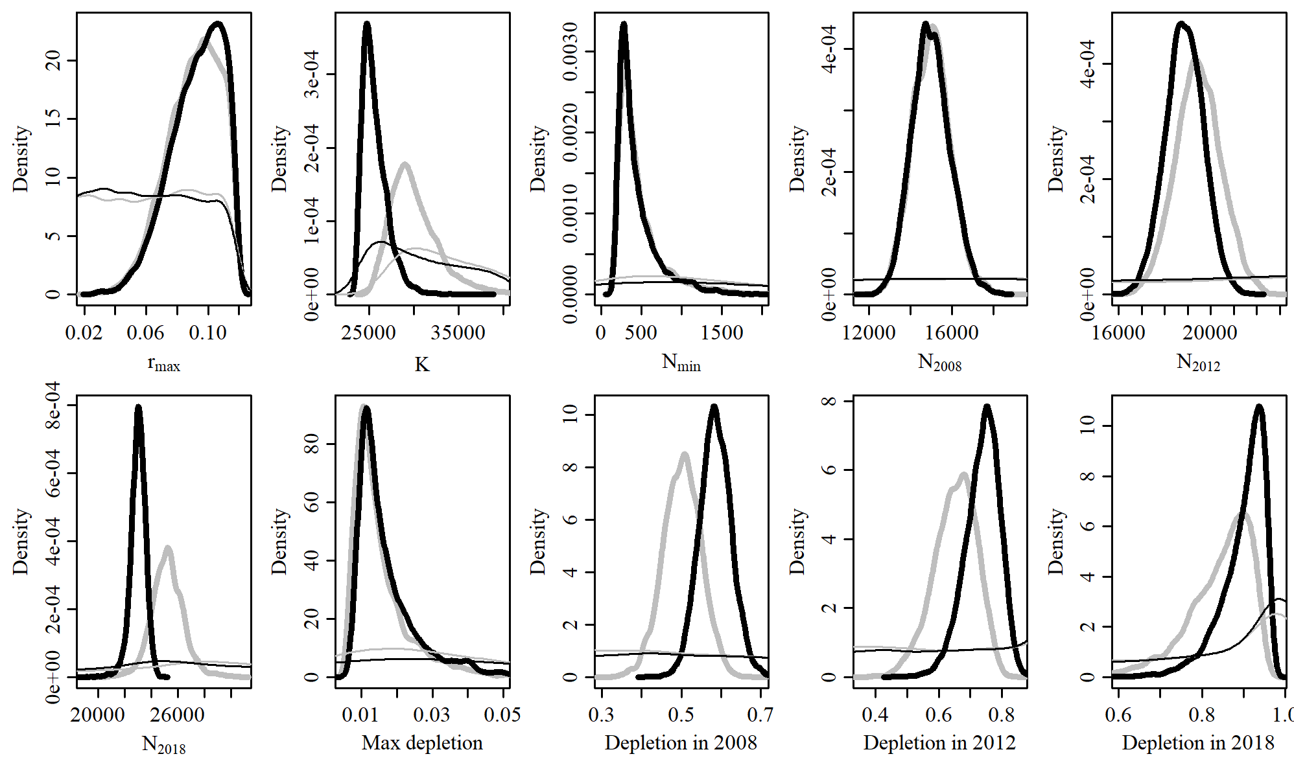

Figure 23. Posterior probability distributions of model parameters and derived quantities from the model fit to the absolute abundance from the SCatch 1 case scenario.

$$$newpage

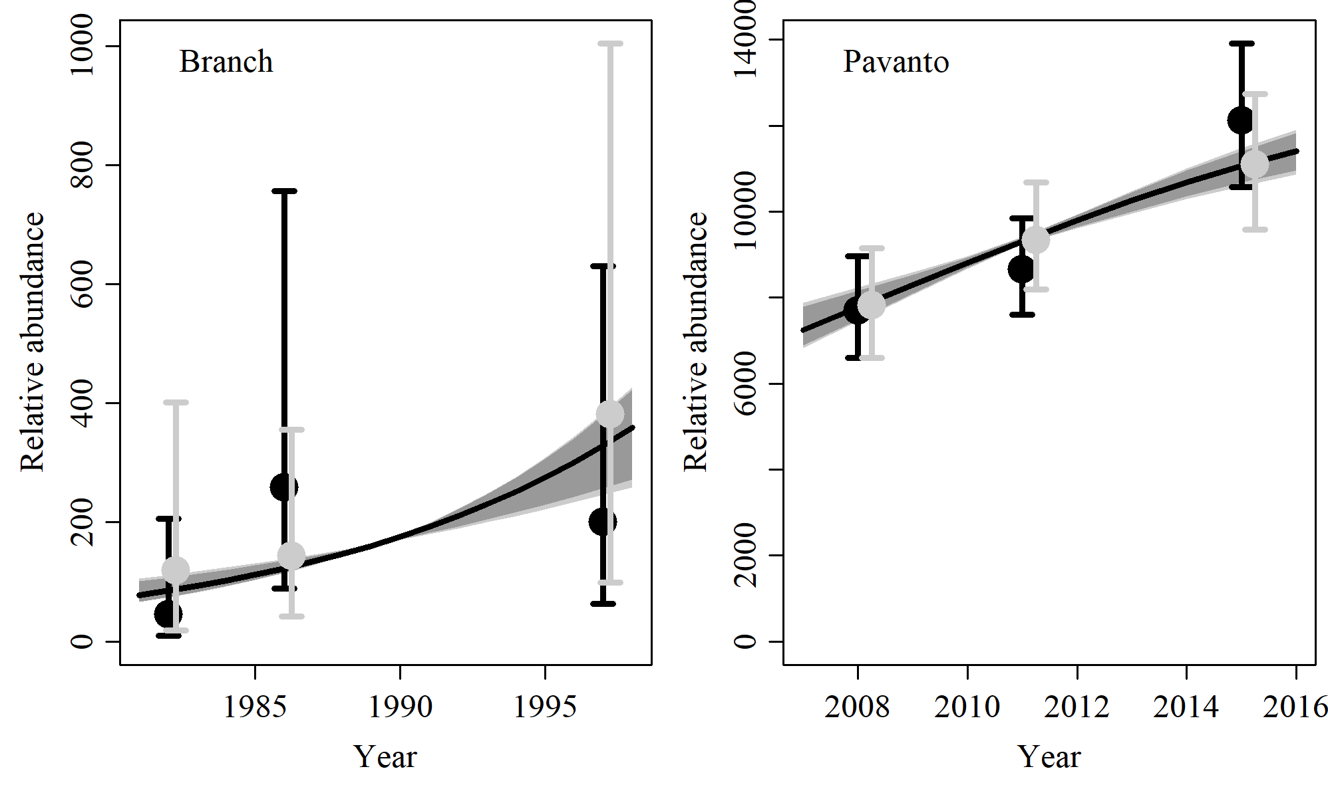

Figure 24. Fit of the model fit from the SCatch 1 scenario to indices of abundance. The solid line corresponds to the posterior median, light grey to the 95% credible interval, grey to the 90% credible interval, black error bars to the 95% confidence interval of the relative abundance estimates, and grey error bars to the 95% credible interval of the posterior predicted relative abundance.

$$$newpage

Table 8. Population and parameter estimates from the model fit from the SCatch 1 scenario.

|  |  |  |  |  |  |  |
| --- | --- | --- | --- | --- | --- | --- |
| Parameter | Mean | Median | 2.5% CI | 5% CI | 95% CI | 97.5% CI |
|  | 0.093 | 0.095 | 0.056 | 0.062 | 0.117 | 0.115 |
|  | 25,671 | 25,345 | 23,818 | 23,962 | 29,155 | 28,376 |
|  | 460 | 360 | 199 | 210 | 1,237 | 1,055 |
|  | 15,003 | 14,962 | 13,303 | 13,545 | 16,893 | 16,571 |
|  | 18,864 | 18,861 | 17,192 | 17,490 | 20,478 | 20,219 |
|  | 23,009 | 23,043 | 21,737 | 22,042 | 24,020 | 23,870 |
| Max depletion | 0.017 | 0.014 | 0.008 | 0.009 | 0.042 | 0.038 |
| Depletion in 2008 | 0.586 | 0.585 | 0.509 | 0.52 | 0.666 | 0.653 |
| Depletion in 2012 | 0.737 | 0.744 | 0.617 | 0.639 | 0.829 | 0.817 |
| Depletion in 2018 | 0.899 | 0.914 | 0.759 | 0.793 | 0.963 | 0.958 |

$$$newpage

# SCatch 2

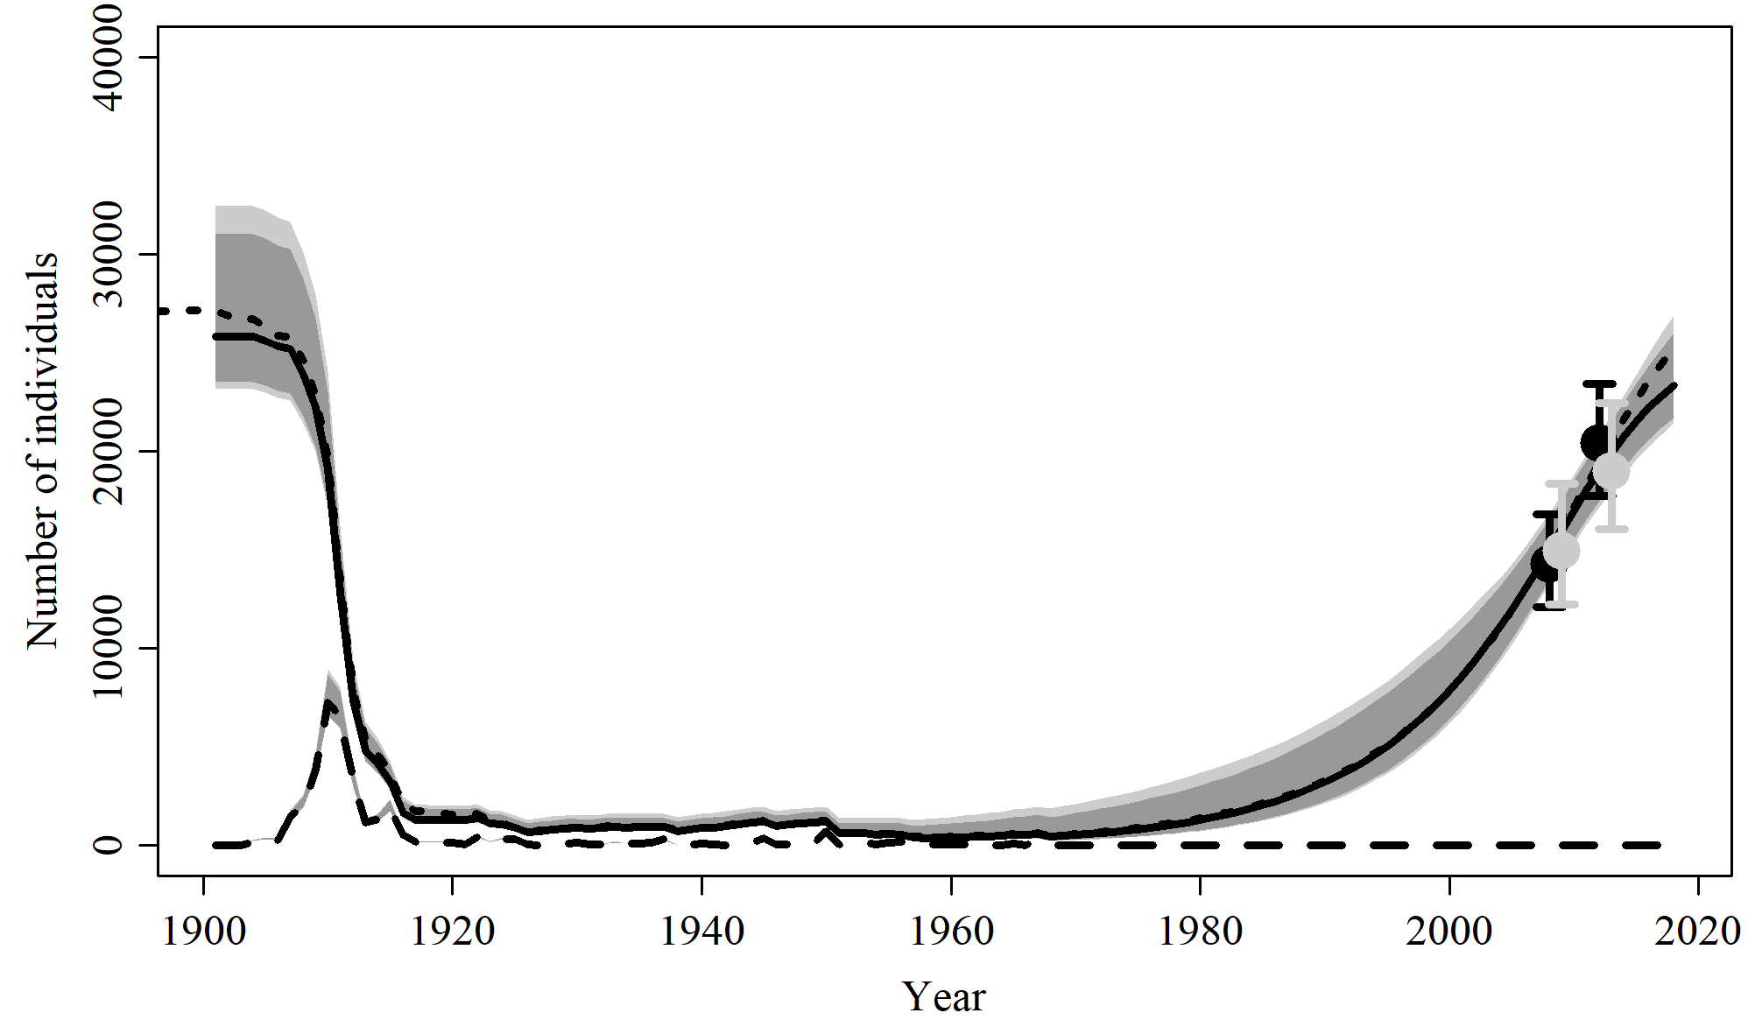

Figure 25. Population trajectory and fit of the model fit to the absolute abundance from the SCatch 2 case scenario. The solid line corresponds to the posterior median, light grey to the 95% credible interval, grey to the 90% credible interval, black error bars to the 95% confidence interval of the abundance estimate, grey error bars to the 95% credible interval of the posterior predicted abundance estimate, and the dashed line to the catch series.

$$$newpage

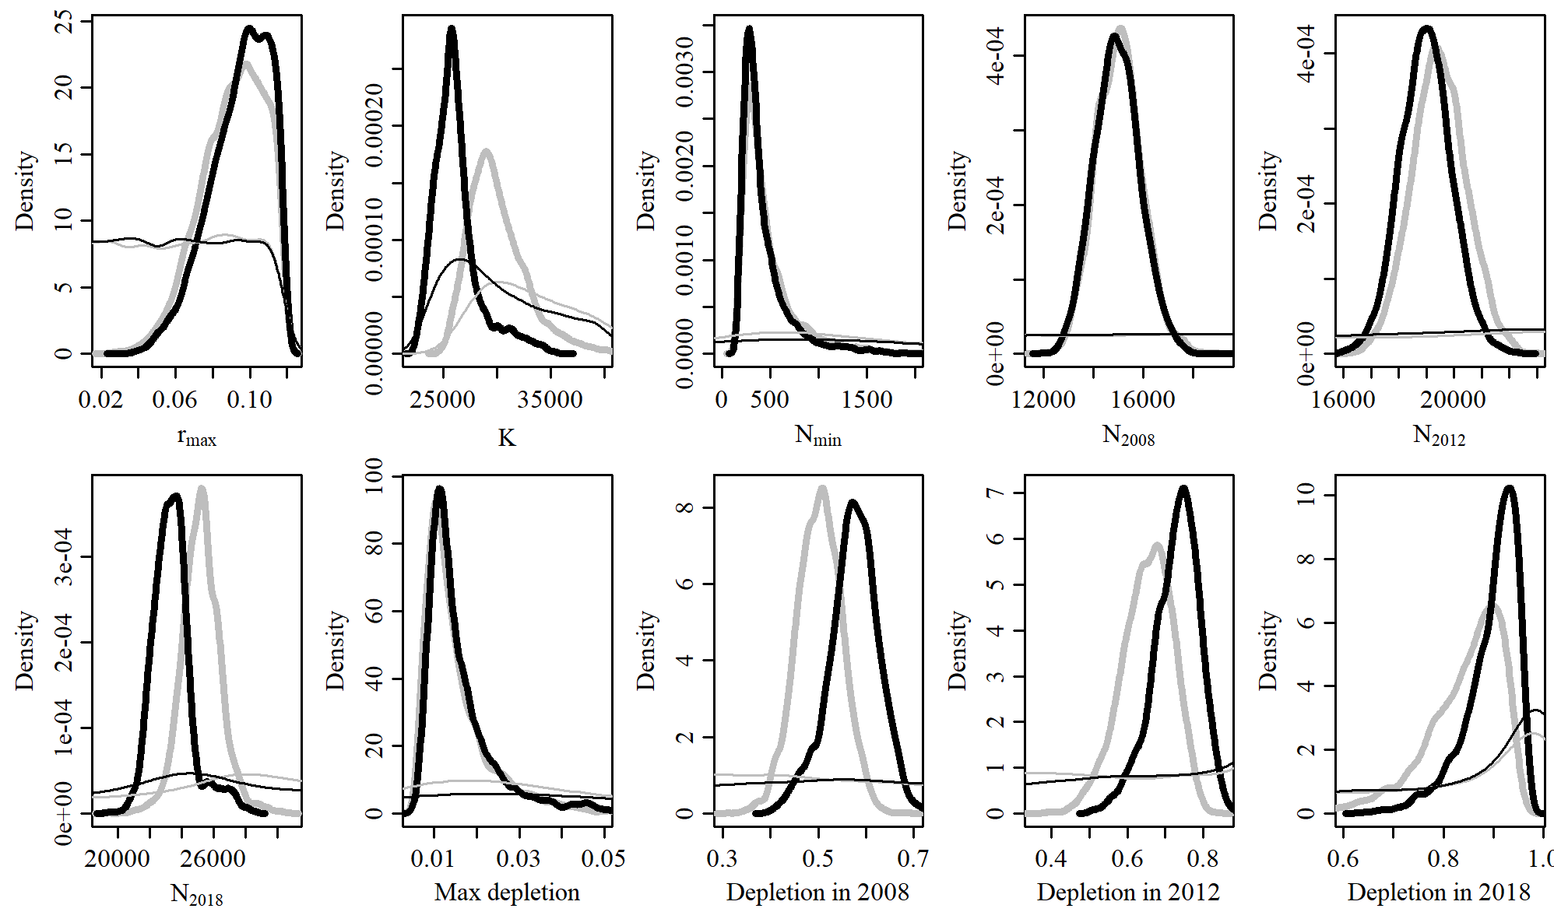

Figure 26. Posterior probability distributions of model parameters and derived quantities from the model fit to the absolute abundance from the SCatch 2 case scenario.

$$$newpage

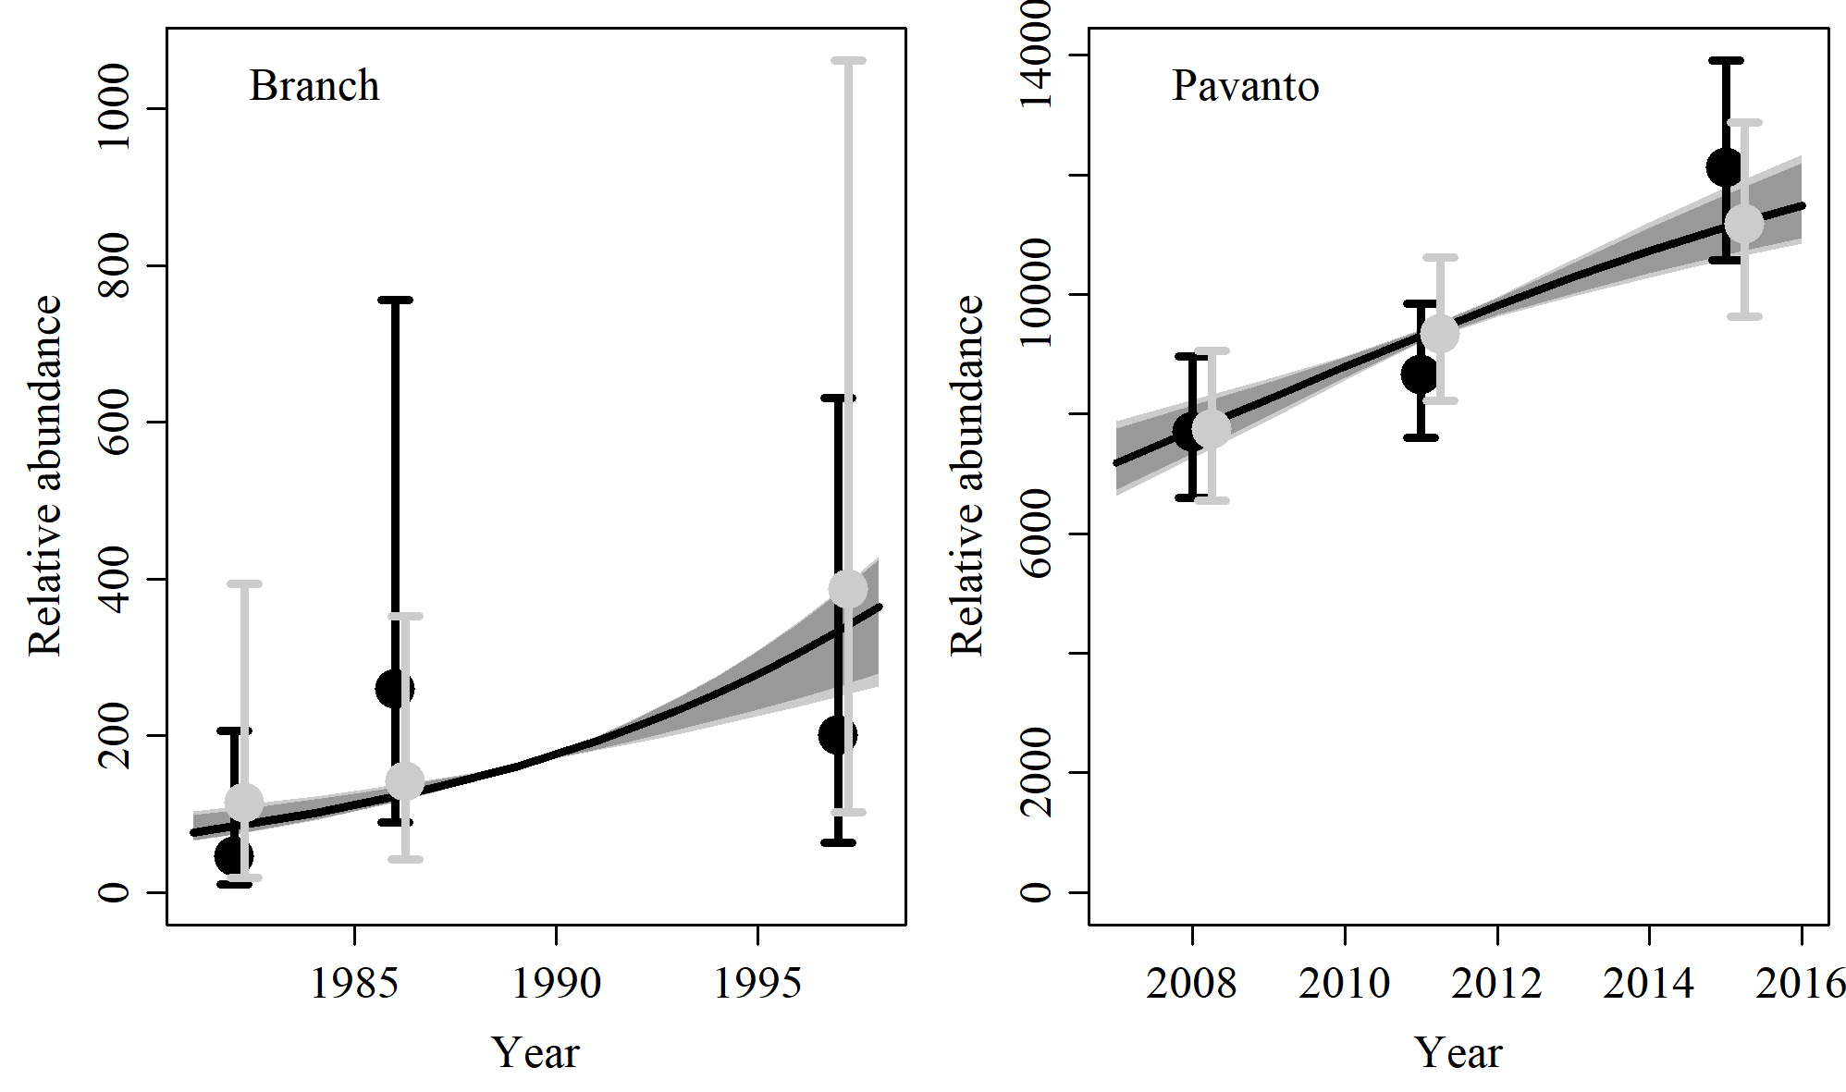

Figure 27. Fit of the model fit from the SCatch 2 scenario to indices of abundance. The solid line corresponds to the posterior median, light grey to the 95% credible interval, grey to the 90% credible interval, black error bars to the 95% confidence interval of the relative abundance estimates, and grey error bars to the 95% credible interval of the posterior predicted relative abundance.

$$$newpage

Table 9. Population and parameter estimates from the model fit from the SCatch 2 scenario.

|  |  |  |  |  |  |  |
| --- | --- | --- | --- | --- | --- | --- |
| Parameter | Mean | Median | 2.5% CI | 5% CI | 95% CI | 97.5% CI |
|  | 0.094 | 0.097 | 0.058 | 0.065 | 0.117 | 0.116 |
|  | 26,215 | 25,829 | 23,167 | 23,511 | 32,461 | 31,043 |
|  | 435 | 346 | 191 | 204 | 1,252 | 979 |
|  | 14,959 | 14,941 | 13,221 | 13,465 | 16,856 | 16,533 |
|  | 18,988 | 18,993 | 17,160 | 17,483 | 20,857 | 20,518 |
|  | 23,432 | 23,349 | 21,407 | 21,699 | 26,901 | 26,015 |
| Max depletion | 0.016 | 0.013 | 0.007 | 0.008 | 0.045 | 0.036 |
| Depletion in 2008 | 0.574 | 0.576 | 0.457 | 0.478 | 0.67 | 0.657 |
| Depletion in 2012 | 0.728 | 0.735 | 0.592 | 0.615 | 0.831 | 0.818 |
| Depletion in 2018 | 0.897 | 0.911 | 0.755 | 0.789 | 0.963 | 0.958 |

$$$newpage

# SCatch 3

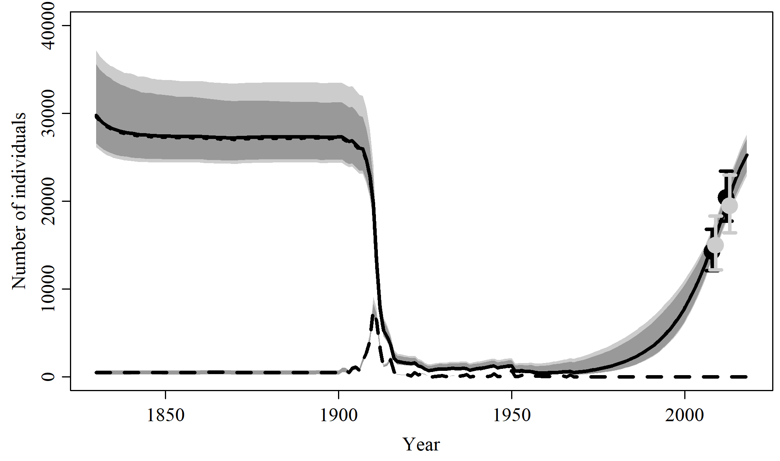

Figure 28. Population trajectory and fit of the model fit to the absolute abundance from the SCatch 3 case scenario. The solid line corresponds to the posterior median, light grey to the 95% credible interval, grey to the 90% credible interval, black error bars to the 95% confidence interval of the abundance estimate, grey error bars to the 95% credible interval of the posterior predicted abundance estimate, and the dashed line to the catch series.

$$$newpage

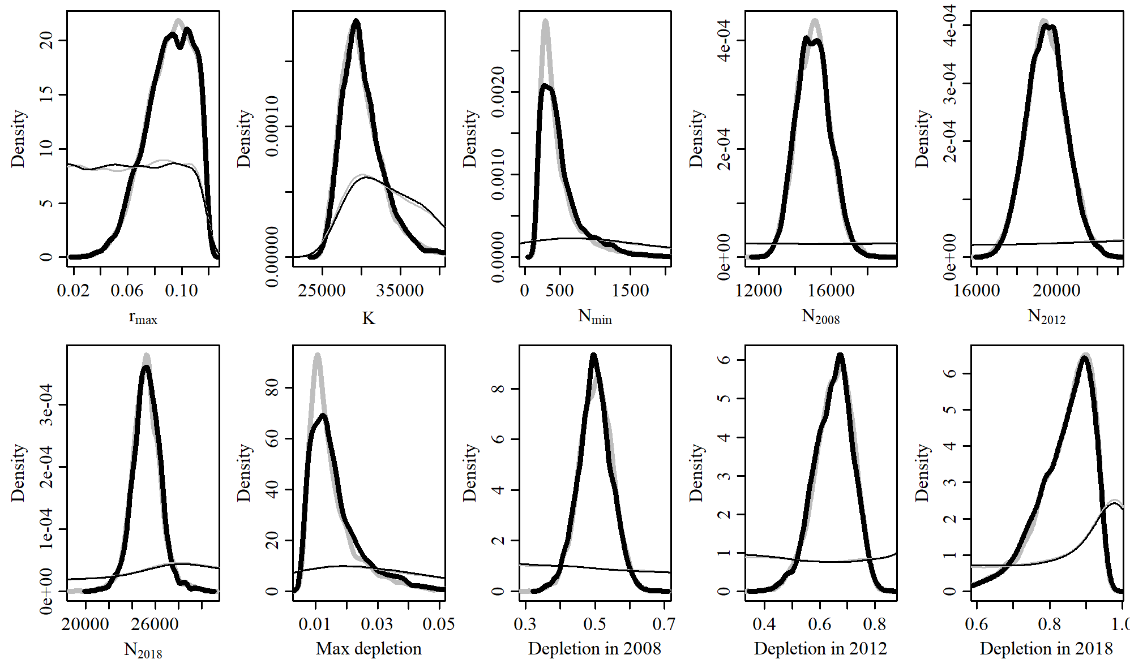

Figure 29. Posterior probability distributions of model parameters and derived quantities from the model fit to the absolute abundance from the SCatch 3 case scenario.

$$$newpage

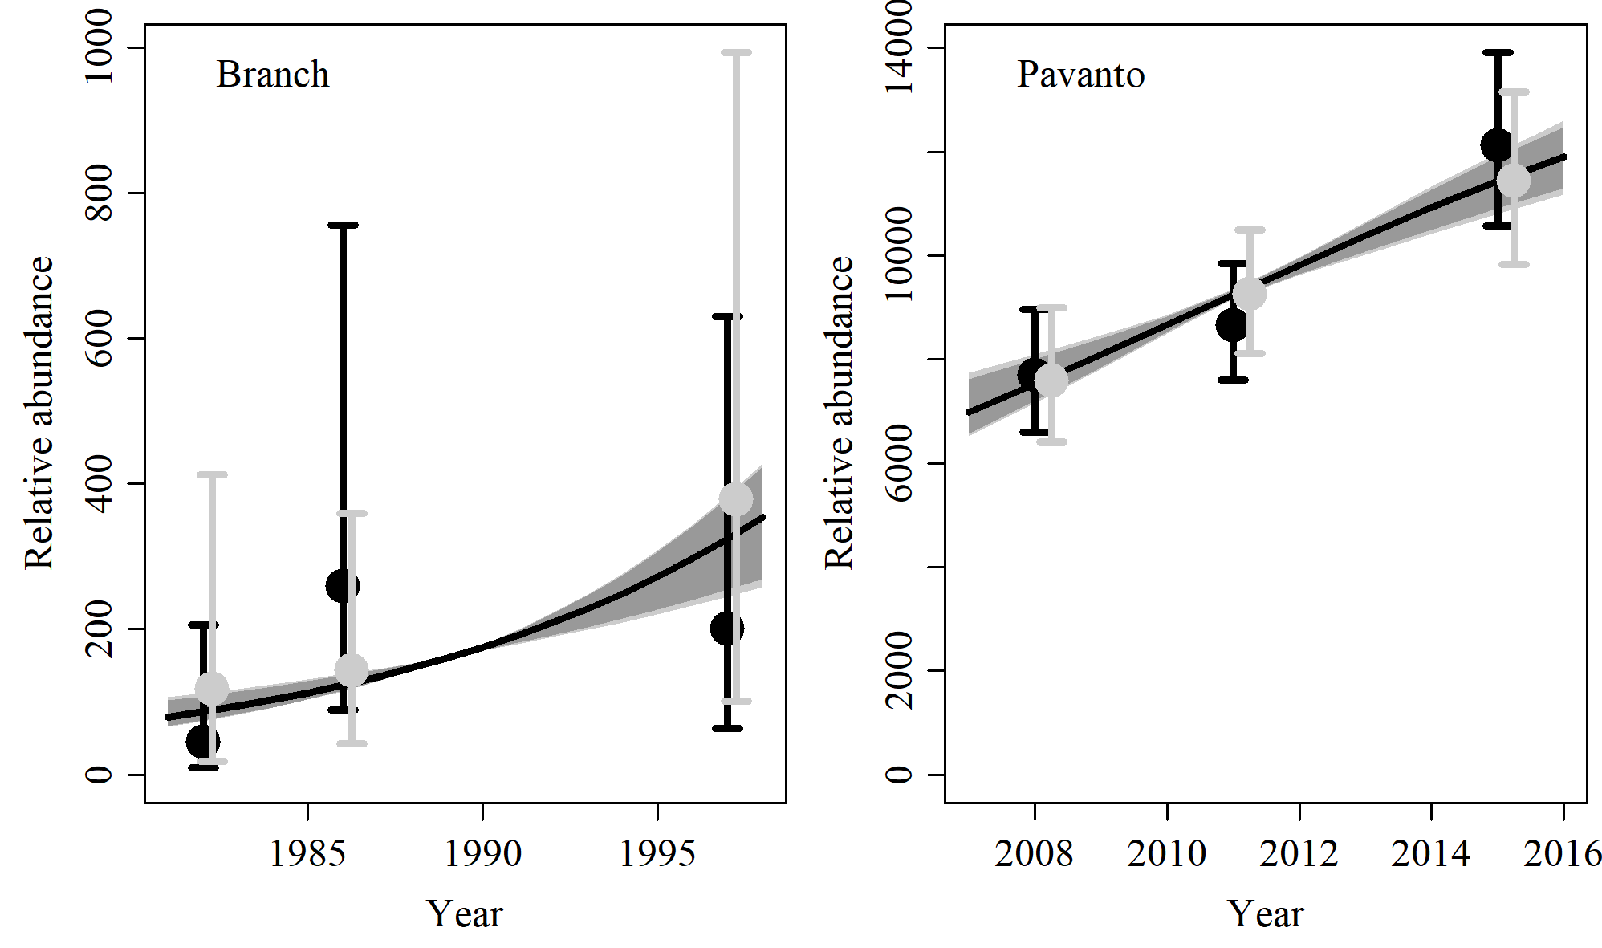

Figure 30. Fit of the model fit from the SCatch 3 scenario to indices of abundance. The solid line corresponds to the posterior median, light grey to the 95% credible interval, grey to the 90% credible interval, black error bars to the 95% confidence interval of the relative abundance estimates, and grey error bars to the 95% credible interval of the posterior predicted relative abundance.

$$$newpage

Table 10. Population and parameter estimates from the model fit from the SCatch 3 scenario.

|  |  |  |  |  |  |  |
| --- | --- | --- | --- | --- | --- | --- |
| Parameter | Mean | Median | 2.5% CI | 5% CI | 95% CI | 97.5% CI |
|  | 0.091 | 0.093 | 0.055 | 0.06 | 0.117 | 0.115 |
|  | 30,272 | 29,769 | 26,157 | 26,571 | 37,154 | 35,605 |
|  | 514 | 418 | 191 | 204 | 1,391 | 1,186 |
|  | 15,013 | 14,981 | 13,325 | 13,536 | 16,880 | 16,570 |
|  | 19,478 | 19,464 | 17,612 | 17,891 | 21,441 | 21,088 |
|  | 25,274 | 25,264 | 22,903 | 23,388 | 27,668 | 27,132 |
| Max depletion | 0.016 | 0.014 | 0.007 | 0.007 | 0.04 | 0.035 |
| Depletion in 2008 | 0.499 | 0.499 | 0.406 | 0.419 | 0.593 | 0.577 |
| Depletion in 2012 | 0.649 | 0.655 | 0.504 | 0.532 | 0.77 | 0.753 |
| Depletion in 2018 | 0.841 | 0.858 | 0.651 | 0.694 | 0.942 | 0.935 |

$$$newpage

# SCatch 4

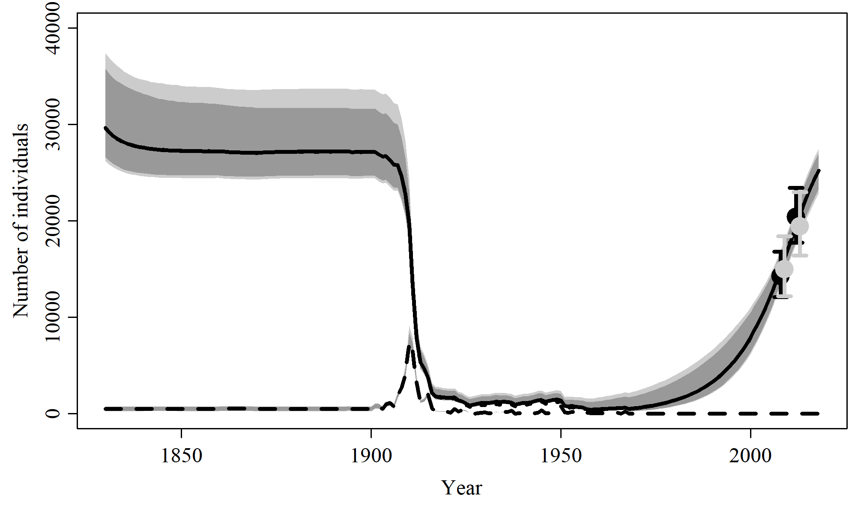

Figure 31. Population trajectory and fit of the model fit to the absolute abundance from the SCatch 4 case scenario. The solid line corresponds to the posterior median, light grey to the 95% credible interval, grey to the 90% credible interval, black error bars to the 95% confidence interval of the abundance estimate, grey error bars to the 95% credible interval of the posterior predicted abundance estimate, and the dashed line to the catch series.

$$$newpage

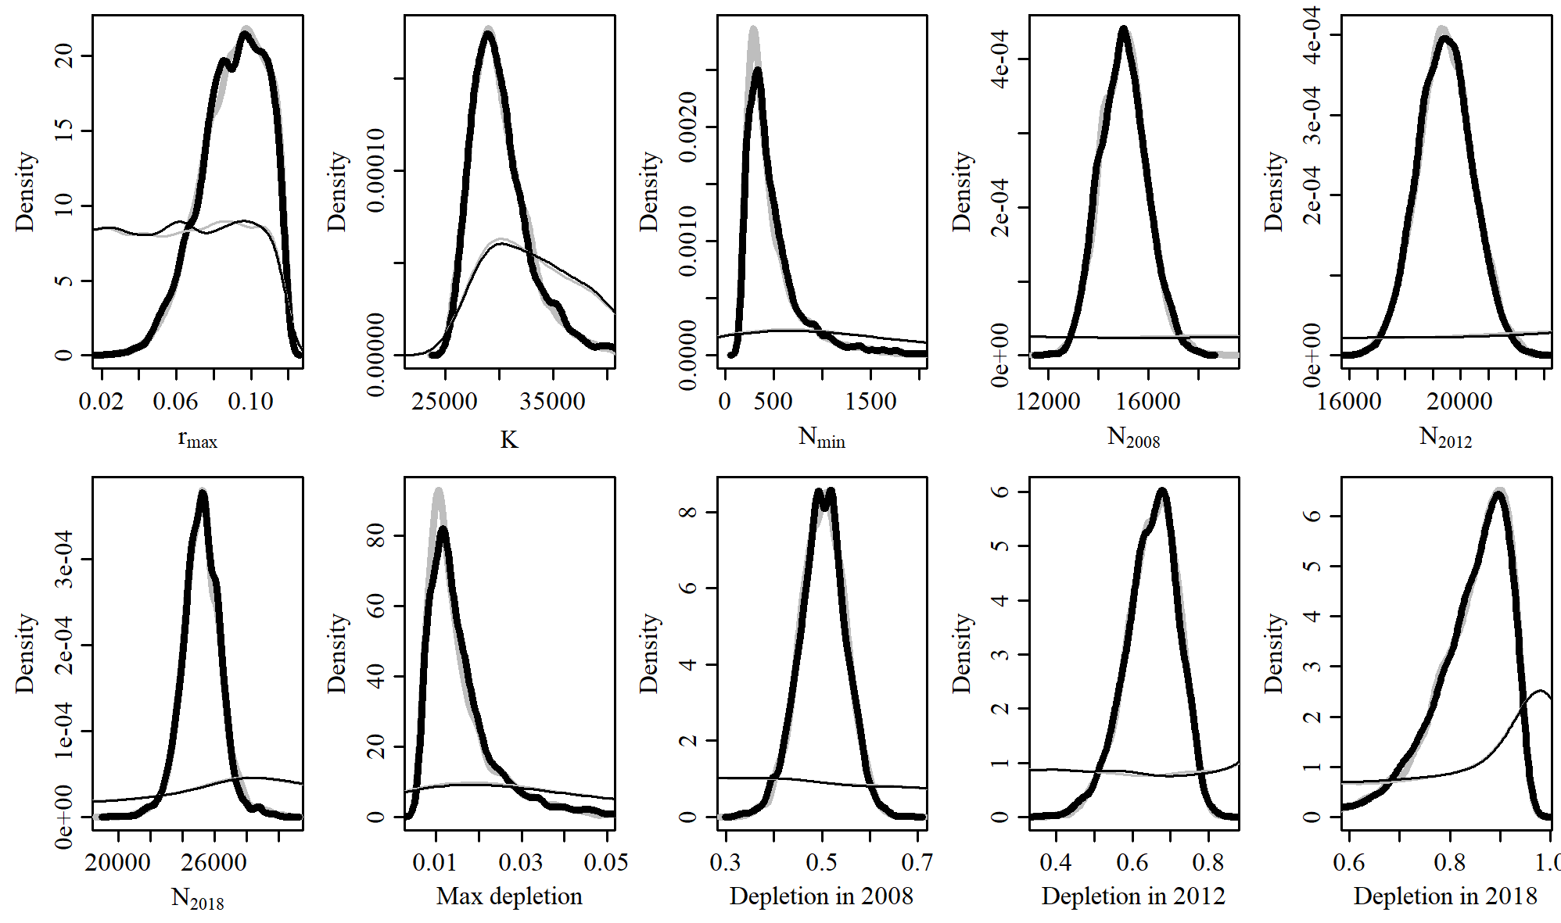

Figure 32. Posterior probability distributions of model parameters and derived quantities from the model fit to the absolute abundance from the SCatch 4 case scenario.

$$$newpage

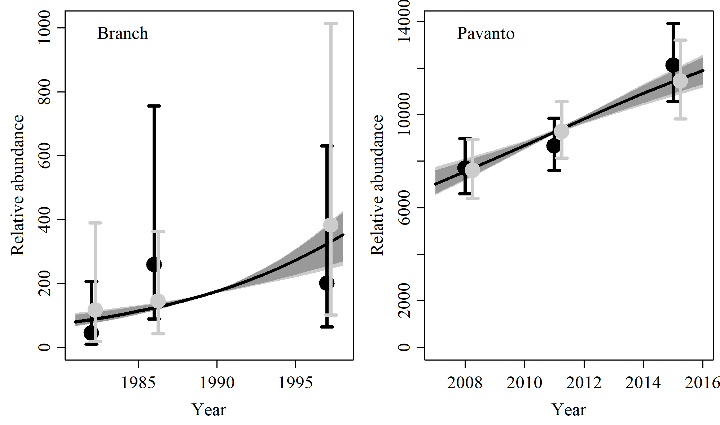

Figure 33. Fit of the model fit from the SCatch 4 scenario to indices of abundance. The solid line corresponds to the posterior median, light grey to the 95% credible interval, grey to the 90% credible interval, black error bars to the 95% confidence interval of the relative abundance estimates, and grey error bars to the 95% credible interval of the posterior predicted relative abundance.

$$$newpage

Table 11. Population and parameter estimates from the model fit from the SCatch 4 scenario.

|  |  |  |  |  |  |  |
| --- | --- | --- | --- | --- | --- | --- |
| Parameter | Mean | Median | 2.5% CI | 5% CI | 95% CI | 97.5% CI |
|  | 0.091 | 0.093 | 0.053 | 0.059 | 0.116 | 0.115 |
|  | 30,188 | 29,644 | 26,192 | 26,604 | 37,394 | 35,777 |
|  | 510 | 398 | 197 | 208 | 1,529 | 1,182 |
|  | 15,012 | 15,005 | 13,307 | 13,534 | 16,929 | 16,629 |
|  | 19,445 | 19,441 | 17,552 | 17,849 | 21,372 | 21,071 |
|  | 25,191 | 25,207 | 22,830 | 23,295 | 27,531 | 26,986 |
| Max depletion | 0.016 | 0.014 | 0.007 | 0.007 | 0.044 | 0.035 |
| Depletion in 2008 | 0.501 | 0.502 | 0.398 | 0.421 | 0.591 | 0.578 |
| Depletion in 2012 | 0.65 | 0.656 | 0.501 | 0.527 | 0.766 | 0.754 |
| Depletion in 2018 | 0.841 | 0.859 | 0.646 | 0.69 | 0.941 | 0.935 |

$$$newpage

# SCatch 5

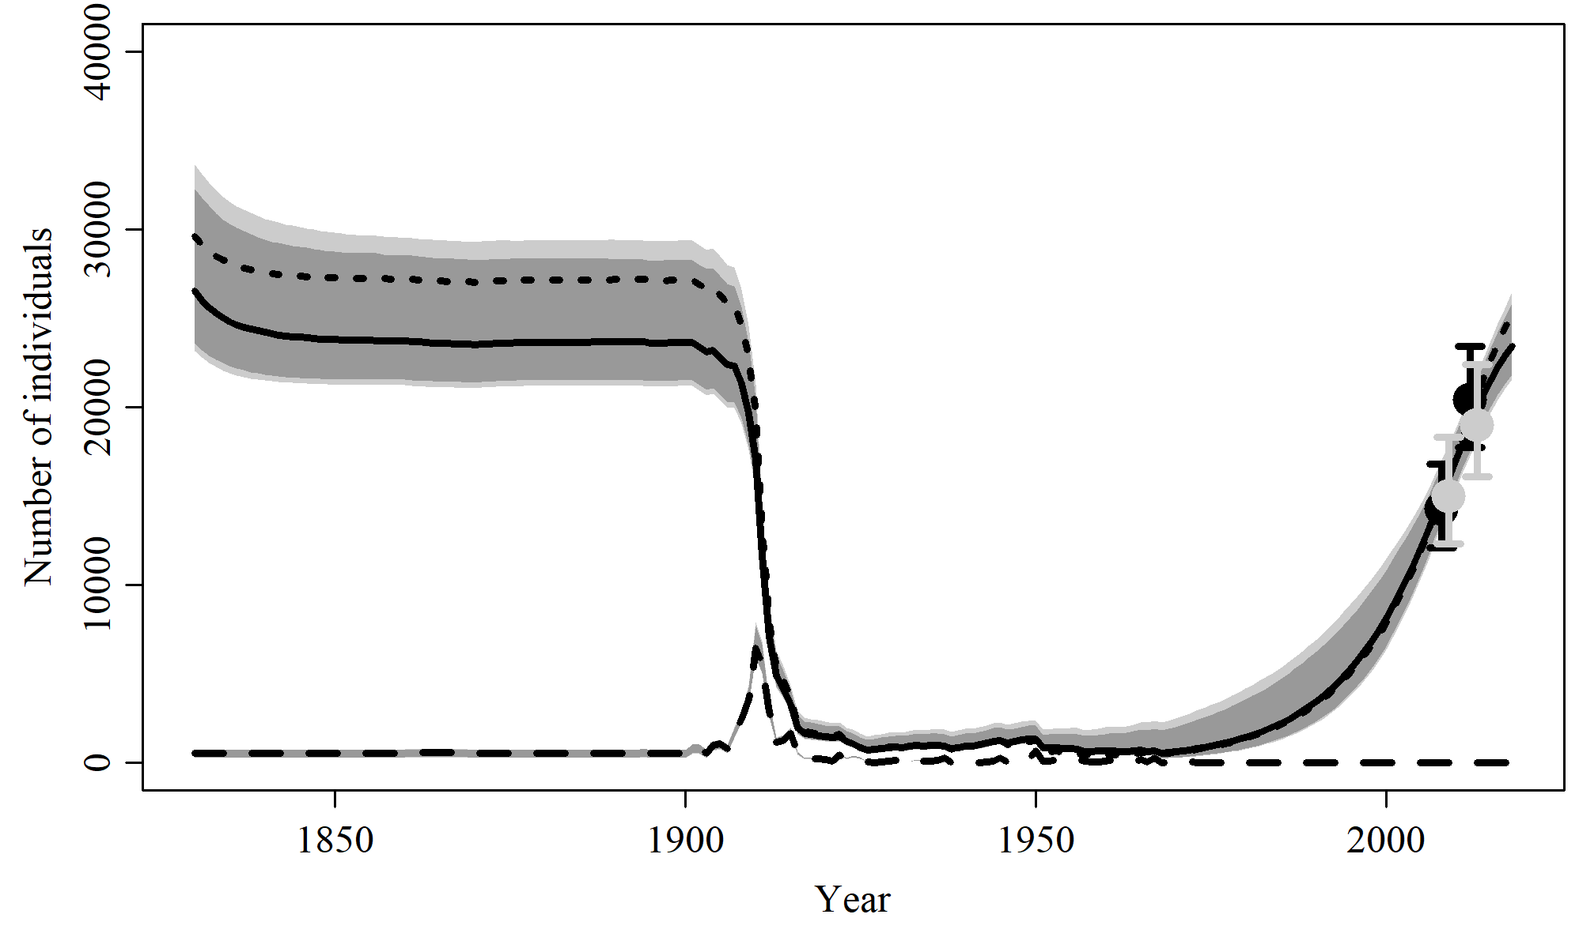

Figure 34. Population trajectory and fit of the model fit to the absolute abundance from the SCatch 5 case scenario. The solid line corresponds to the posterior median, light grey to the 95% credible interval, grey to the 90% credible interval, black error bars to the 95% confidence interval of the abundance estimate, grey error bars to the 95% credible interval of the posterior predicted abundance estimate, and the dashed line to the catch series.

$$$newpage

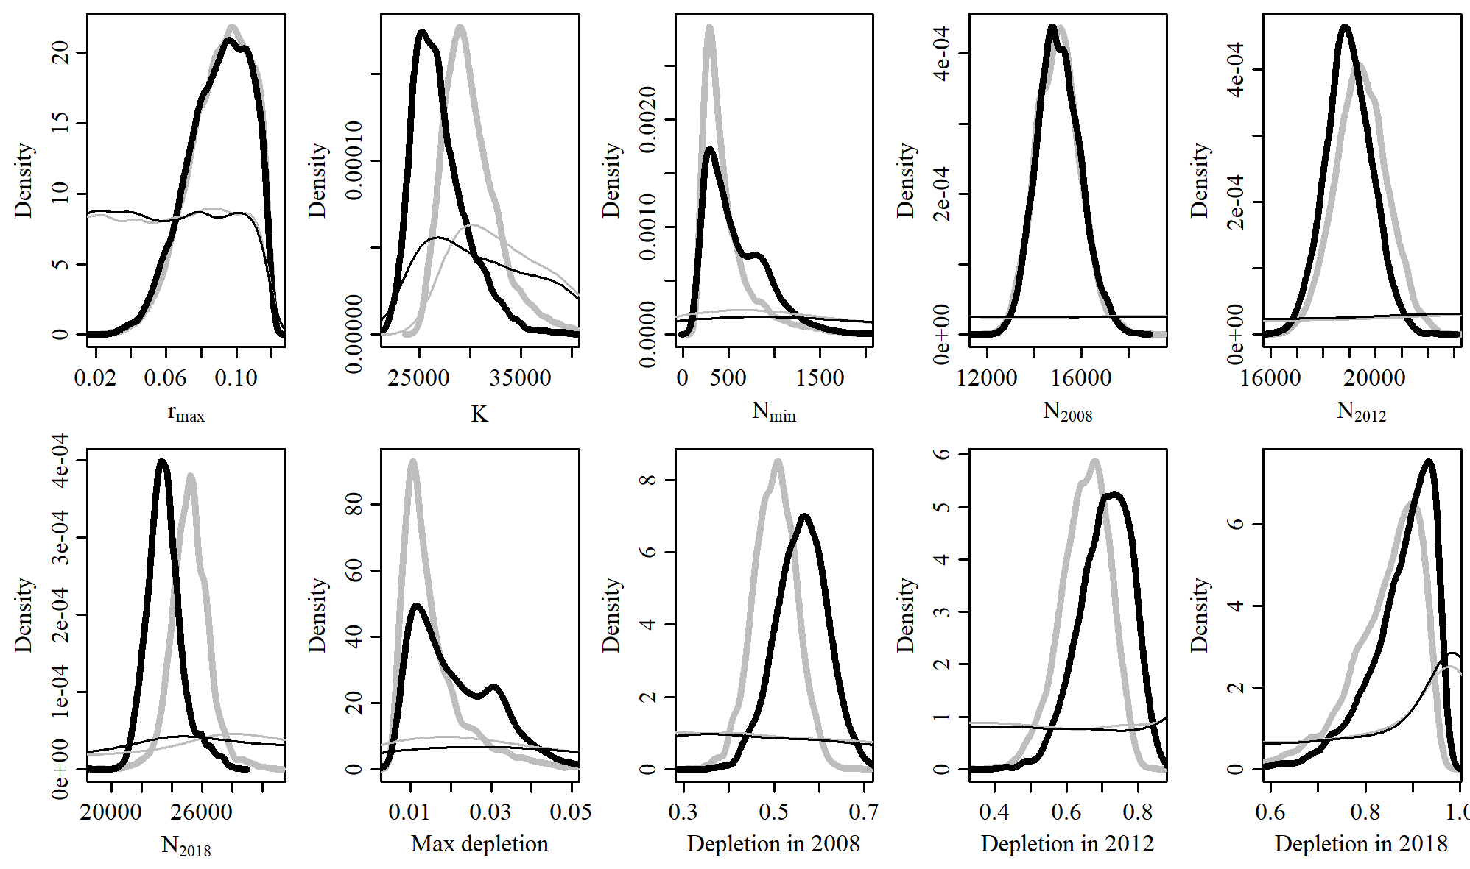

Figure 35. Posterior probability distributions of model parameters and derived quantities from the model fit to the absolute abundance from the SCatch 5 case scenario.

$$$newpage

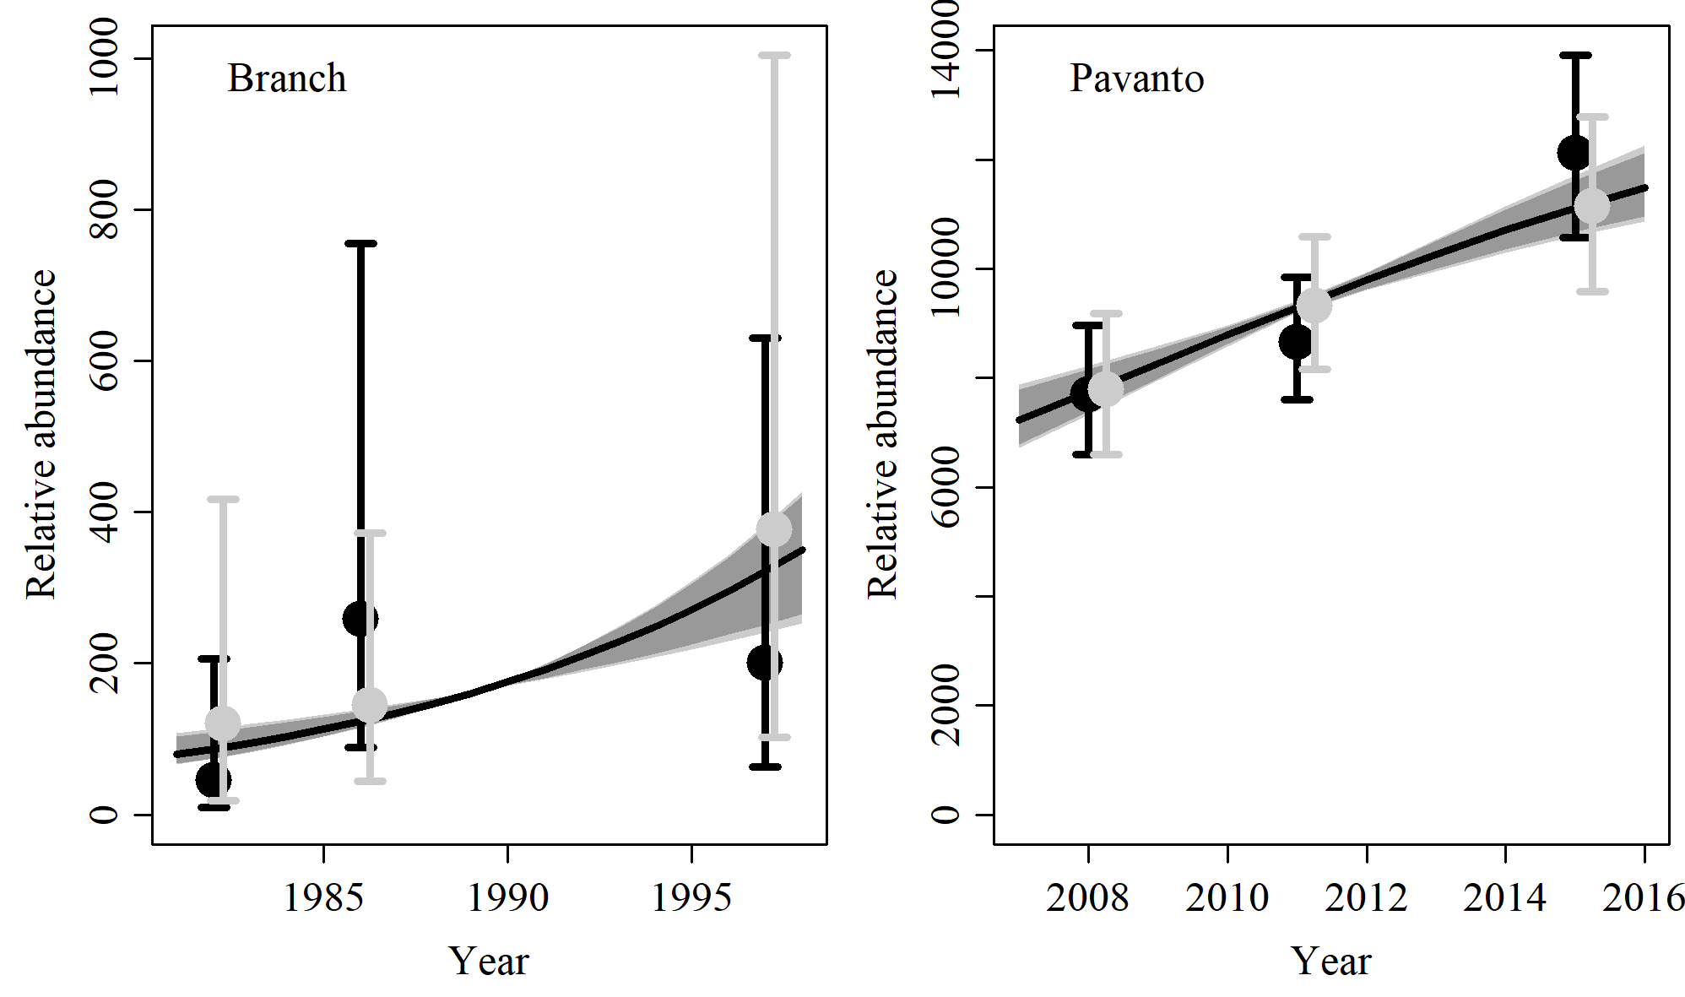

Figure 36. Fit of the model fit from the SCatch 5 scenario to indices of abundance. The solid line corresponds to the posterior median, light grey to the 95% credible interval, grey to the 90% credible interval, black error bars to the 95% confidence interval of the relative abundance estimates, and grey error bars to the 95% credible interval of the posterior predicted relative abundance.

$$$newpage

Table 12. Population and parameter estimates from the model fit from the SCatch 5 scenario.

|  |  |  |  |  |  |  |
| --- | --- | --- | --- | --- | --- | --- |
| Parameter | Mean | Median | 2.5% CI | 5% CI | 95% CI | 97.5% CI |
|  | 0.09 | 0.092 | 0.053 | 0.058 | 0.116 | 0.115 |
|  | 27,057 | 26,524 | 23,171 | 23,589 | 33,678 | 32,285 |
|  | 598 | 494 | 201 | 215 | 1,457 | 1,253 |
|  | 15,049 | 14,995 | 13,356 | 13,604 | 17,012 | 16,628 |
|  | 18,990 | 18,960 | 17,259 | 17,527 | 20,786 | 20,483 |
|  | 23,543 | 23,443 | 21,537 | 21,817 | 26,487 | 25,817 |
| Max depletion | 0.021 | 0.019 | 0.008 | 0.009 | 0.046 | 0.041 |
| Depletion in 2008 | 0.561 | 0.563 | 0.445 | 0.464 | 0.669 | 0.652 |
| Depletion in 2012 | 0.709 | 0.715 | 0.554 | 0.581 | 0.829 | 0.815 |
| Depletion in 2018 | 0.877 | 0.893 | 0.7 | 0.736 | 0.962 | 0.956 |

$$$newpage

# GC 1

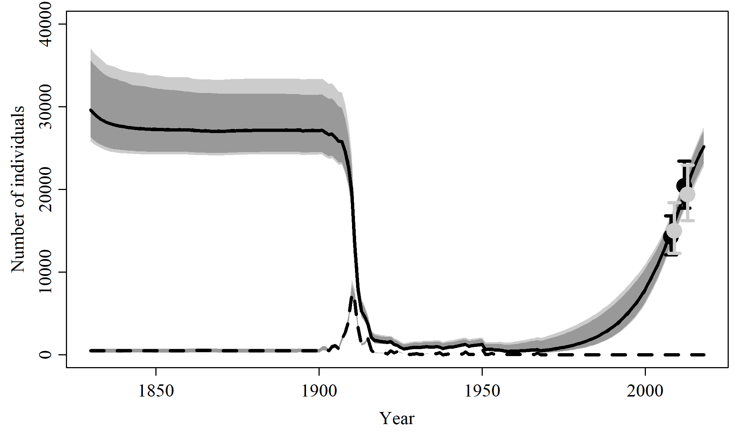

Figure 37. Population trajectory and fit of the model fit to the absolute abundance from the GC 1 case scenario. The solid line corresponds to the posterior median, light grey to the 95% credible interval, grey to the 90% credible interval, black error bars to the 95% confidence interval of the abundance estimate, grey error bars to the 95% credible interval of the posterior predicted abundance estimate, and the dashed line to the catch series.

$$$newpage

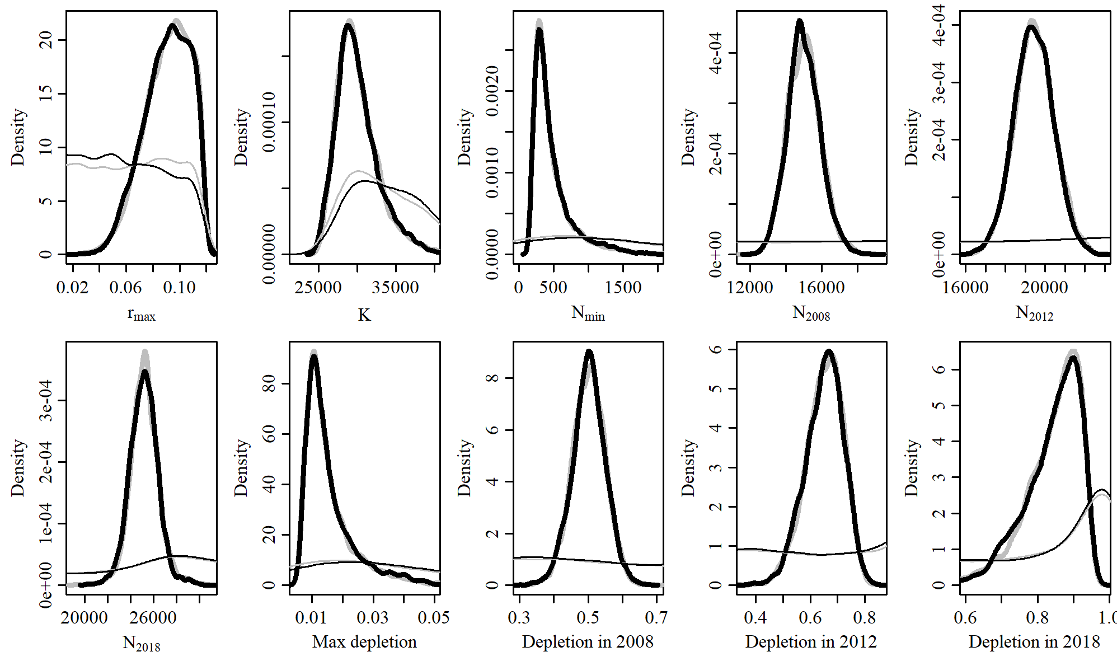

Figure 38. Posterior probability distributions of model parameters and derived quantities from the model fit to the absolute abundance from the GC 1 case scenario.

$$$newpage

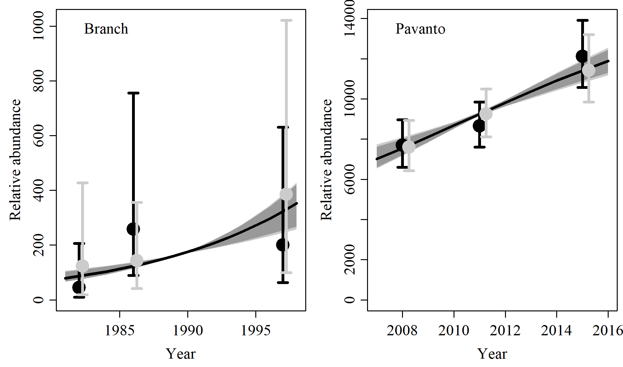

Figure 39. Fit of the model fit from the GC 1 scenario to indices of abundance. The solid line corresponds to the posterior median, light grey to the 95% credible interval, grey to the 90% credible interval, black error bars to the 95% confidence interval of the relative abundance estimates, and grey error bars to the 95% credible interval of the posterior predicted relative abundance.

$$$newpage

Table 13. Population and parameter estimates from the model fit from the GC 1 scenario.

|  |  |  |  |  |  |  |
| --- | --- | --- | --- | --- | --- | --- |
| Parameter | Mean | Median | 2.5% CI | 5% CI | 95% CI | 97.5% CI |
|  | 0.09 | 0.092 | 0.054 | 0.059 | 0.117 | 0.115 |
|  | 30,126 | 29,622 | 25,830 | 26,315 | 37,054 | 35,620 |
|  | 488 | 385 | 192 | 207 | 1,369 | 1,165 |
|  | 15,007 | 14,955 | 13,277 | 13,530 | 16,925 | 16,563 |
|  | 19,429 | 19,425 | 17,490 | 17,811 | 21,361 | 21,056 |
|  | 25,153 | 25,166 | 22,752 | 23,181 | 27,562 | 27,080 |
| Max depletion | 0.016 | 0.013 | 0.007 | 0.007 | 0.04 | 0.035 |
| Depletion in 2008 | 0.502 | 0.503 | 0.404 | 0.42 | 0.595 | 0.579 |
| Depletion in 2012 | 0.651 | 0.656 | 0.508 | 0.531 | 0.77 | 0.753 |
| Depletion in 2018 | 0.841 | 0.859 | 0.662 | 0.693 | 0.943 | 0.935 |

$$$newpage

# GC 2

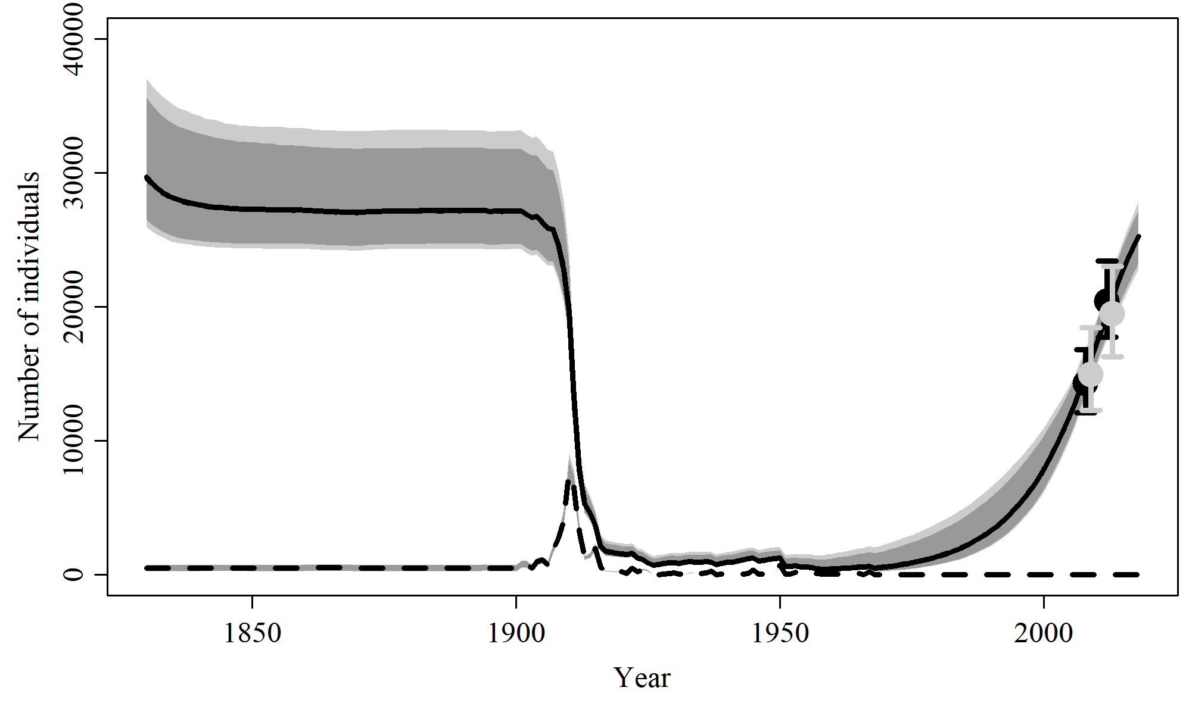

Figure 40. Population trajectory and fit of the model fit to the absolute abundance from the GC 2 case scenario. The solid line corresponds to the posterior median, light grey to the 95% credible interval, grey to the 90% credible interval, black error bars to the 95% confidence interval of the abundance estimate, grey error bars to the 95% credible interval of the posterior predicted abundance estimate, and the dashed line to the catch series.

$$$newpage

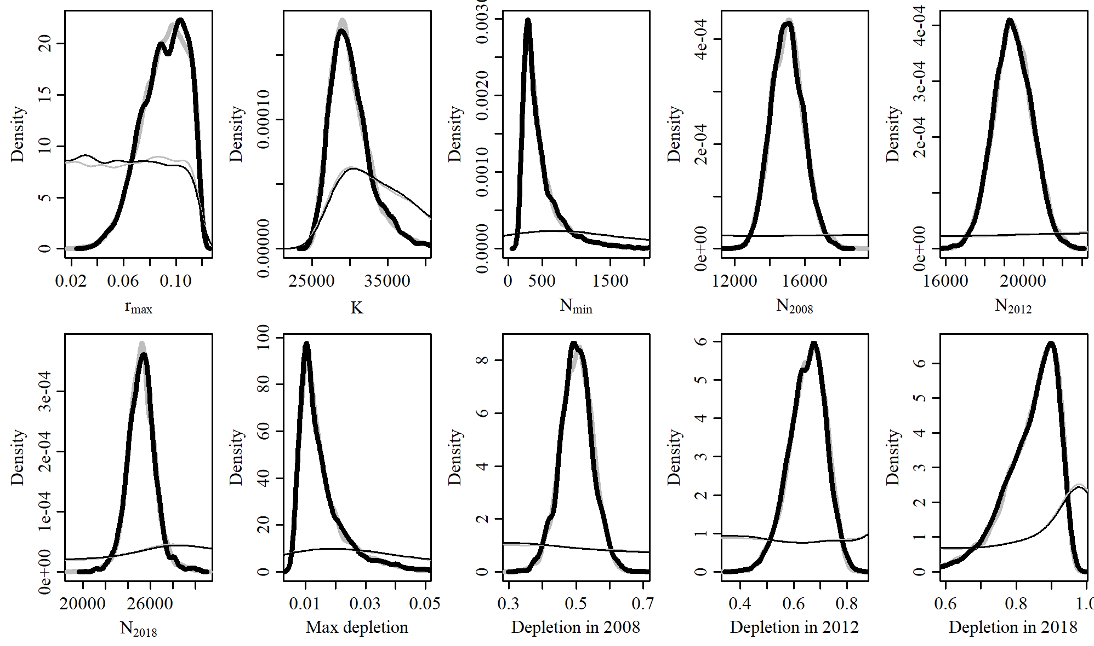

Figure 41. Posterior probability distributions of model parameters and derived quantities from the model fit to the absolute abundance from the GC 2 case scenario.

$$$newpage

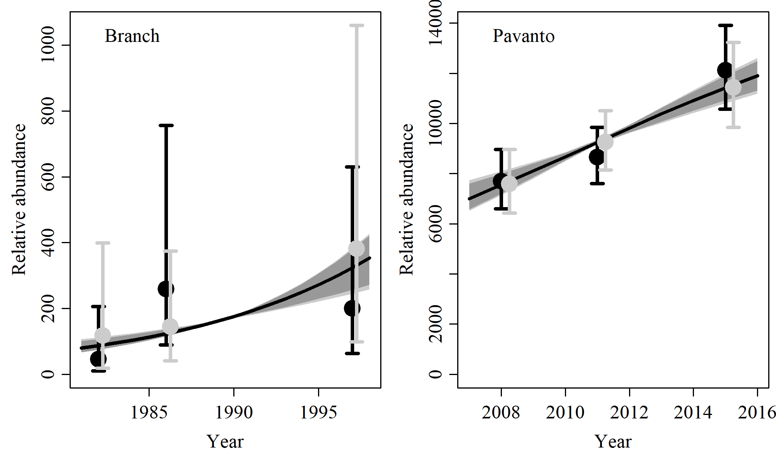

Figure 42. Fit of the model fit from the GC 2 scenario to indices of abundance. The solid line corresponds to the posterior median, light grey to the 95% credible interval, grey to the 90% credible interval, black error bars to the 95% confidence interval of the relative abundance estimates, and grey error bars to the 95% credible interval of the posterior predicted relative abundance.

$$$newpage

Table 14. Population and parameter estimates from the model fit from the GC 2 scenario.

|  |  |  |  |  |  |  |
| --- | --- | --- | --- | --- | --- | --- |
| Parameter | Mean | Median | 2.5% CI | 5% CI | 95% CI | 97.5% CI |
|  | 0.091 | 0.093 | 0.055 | 0.061 | 0.116 | 0.114 |
|  | 30,162 | 29,680 | 25,968 | 26,561 | 37,056 | 35,619 |
|  | 479 | 378 | 197 | 206 | 1,352 | 1,093 |
|  | 14,998 | 14,976 | 13,297 | 13,553 | 16,852 | 16,536 |
|  | 19,452 | 19,428 | 17,559 | 17,871 | 21,347 | 21,069 |
|  | 25,222 | 25,234 | 22,784 | 23,253 | 27,906 | 27,169 |
| Max depletion | 0.015 | 0.013 | 0.007 | 0.007 | 0.039 | 0.033 |
| Depletion in 2008 | 0.501 | 0.5 | 0.404 | 0.419 | 0.597 | 0.582 |
| Depletion in 2012 | 0.65 | 0.655 | 0.506 | 0.532 | 0.773 | 0.757 |
| Depletion in 2018 | 0.842 | 0.859 | 0.656 | 0.698 | 0.944 | 0.936 |

$$$newpage

# MSYR 1

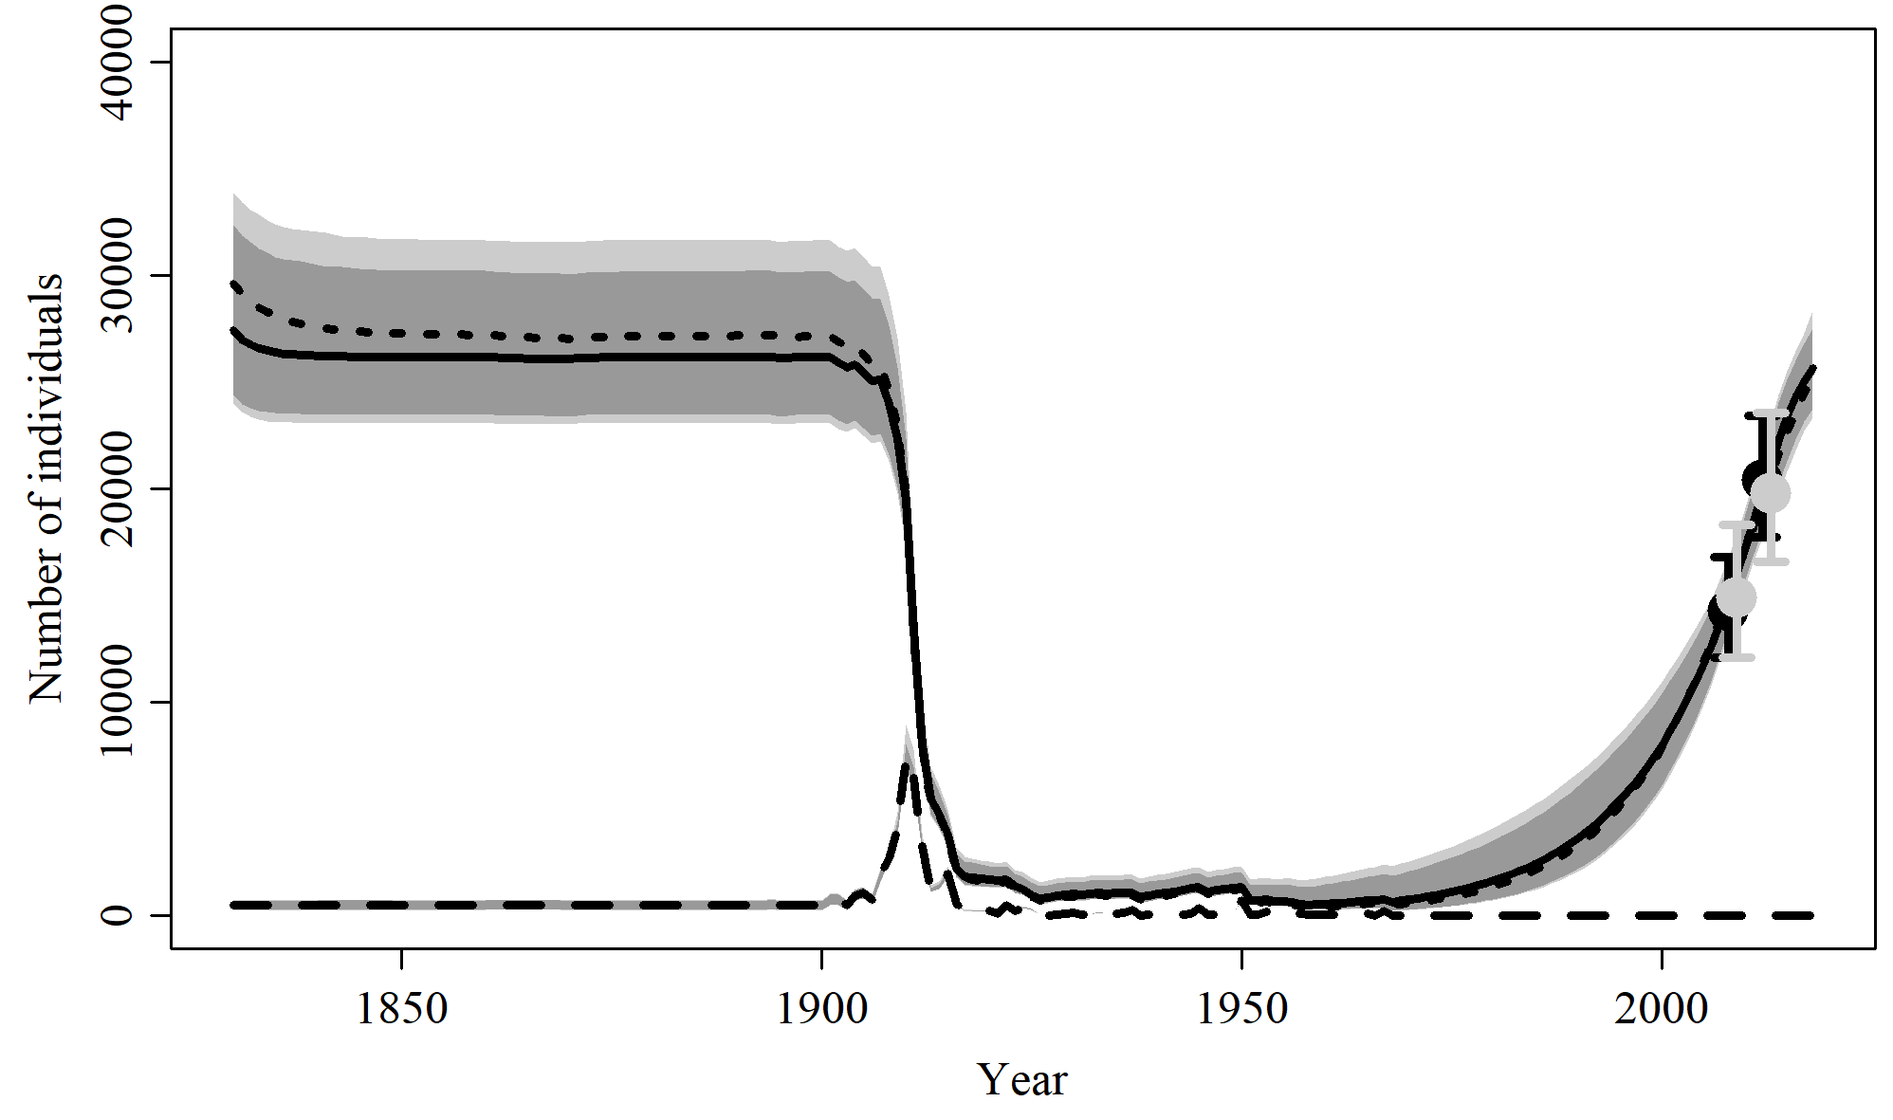

Figure 43. Population trajectory and fit of the model fit to the absolute abundance from the MSYR 1 case scenario. The solid line corresponds to the posterior median, light grey to the 95% credible interval, grey to the 90% credible interval, black error bars to the 95% confidence interval of the abundance estimate, grey error bars to the 95% credible interval of the posterior predicted abundance estimate, and the dashed line to the catch series.

$$$newpage

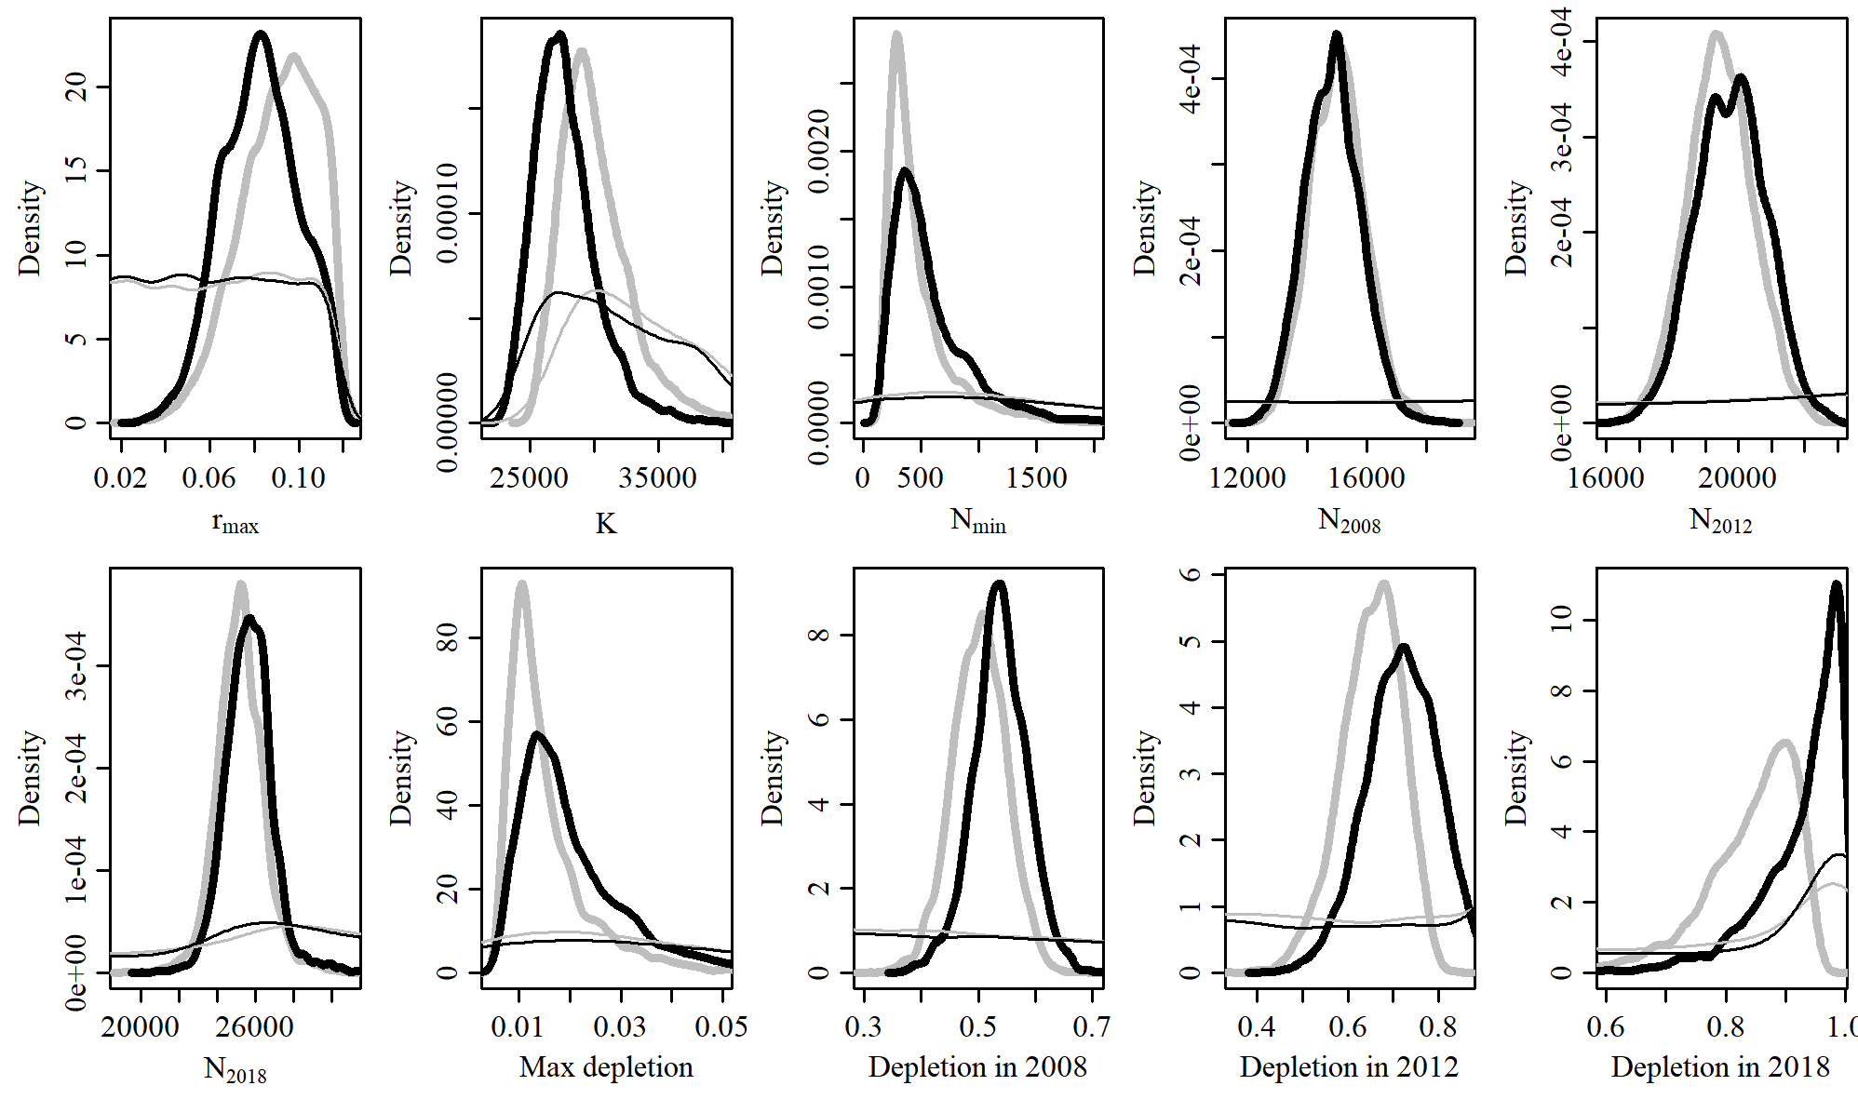

Figure 44. Posterior probability distributions of model parameters and derived quantities from the model fit to the absolute abundance from the MSYR 1 case scenario.

$$$newpage

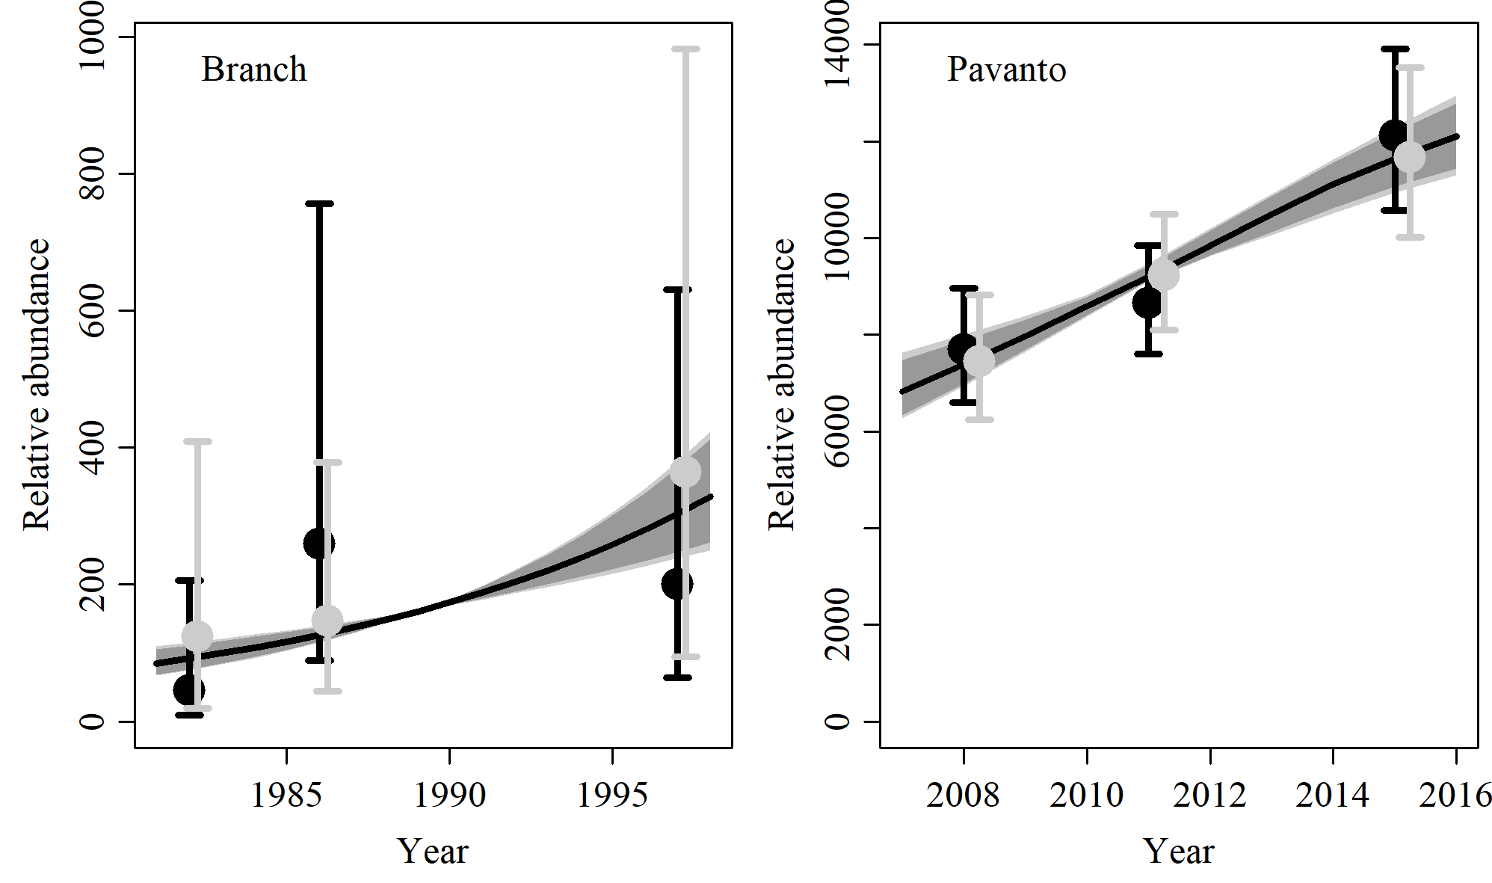

Figure 45. Fit of the model fit from the MSYR 1 scenario to indices of abundance. The solid line corresponds to the posterior median, light grey to the 95% credible interval, grey to the 90% credible interval, black error bars to the 95% confidence interval of the relative abundance estimates, and grey error bars to the 95% credible interval of the posterior predicted relative abundance.

$$$newpage

Table 15. Population and parameter estimates from the model fit from the MSYR 1 scenario.

|  |  |  |  |  |  |  |
| --- | --- | --- | --- | --- | --- | --- |
| Parameter | Mean | Median | 2.5% CI | 5% CI | 95% CI | 97.5% CI |
|  | 0.083 | 0.083 | 0.05 | 0.055 | 0.114 | 0.111 |
|  | 27,783 | 27,428 | 23,996 | 24,397 | 33,902 | 32,349 |
|  | 586 | 480 | 191 | 212 | 1,539 | 1,298 |
|  | 14,855 | 14,860 | 13,102 | 13,362 | 16,748 | 16,416 |
|  | 19,784 | 19,801 | 17,702 | 18,062 | 21,815 | 21,523 |
|  | 25,655 | 25,648 | 23,330 | 23,755 | 28,361 | 27,535 |
| Max depletion | 0.02 | 0.017 | 0.008 | 0.008 | 0.049 | 0.042 |
| Depletion in 2008 | 0.538 | 0.538 | 0.438 | 0.458 | 0.63 | 0.615 |
| Depletion in 2012 | 0.718 | 0.721 | 0.559 | 0.584 | 0.863 | 0.845 |
| Depletion in 2018 | 0.929 | 0.952 | 0.733 | 0.79 | 0.997 | 0.996 |

$$$newpage

# MSYR 2

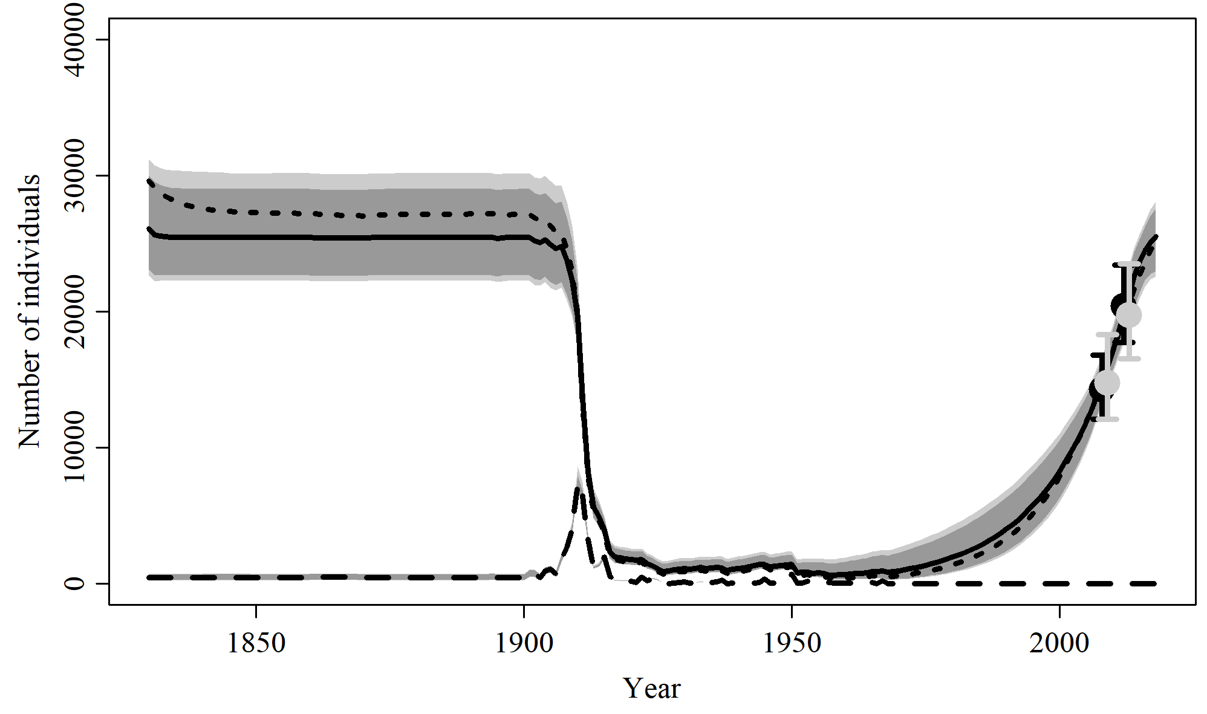

Figure 46. Population trajectory and fit of the model fit to the absolute abundance from the MSYR 2 case scenario. The solid line corresponds to the posterior median, light grey to the 95% credible interval, grey to the 90% credible interval, black error bars to the 95% confidence interval of the abundance estimate, grey error bars to the 95% credible interval of the posterior predicted abundance estimate, and the dashed line to the catch series.

$$$newpage

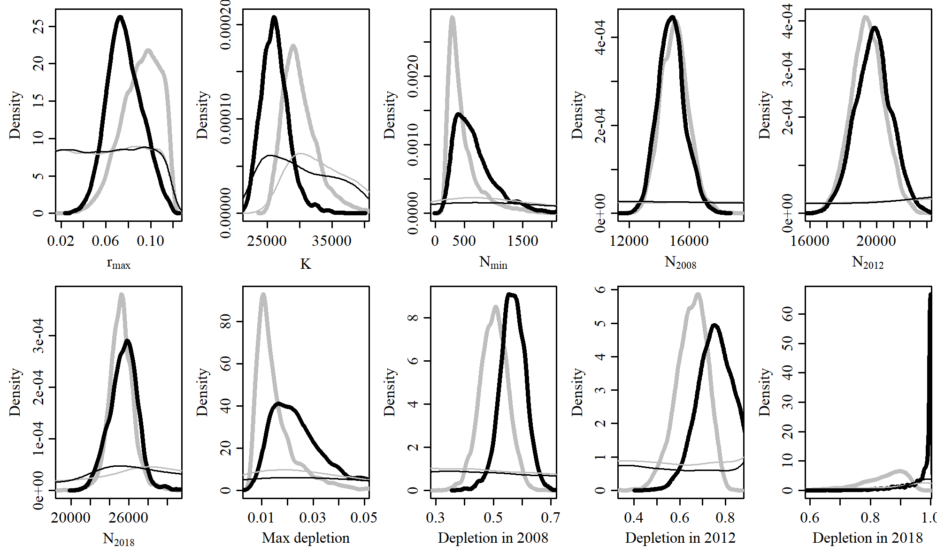

Figure 47. Posterior probability distributions of model parameters and derived quantities from the model fit to the absolute abundance from the MSYR 2 case scenario.

$$$newpage

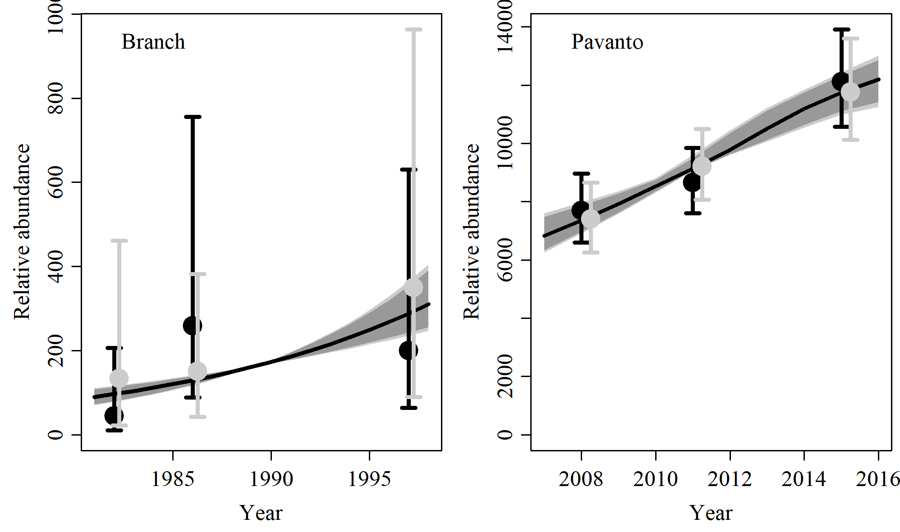

Figure 48. Fit of the model fit from the MSYR 2 scenario to indices of abundance. The solid line corresponds to the posterior median, light grey to the 95% credible interval, grey to the 90% credible interval, black error bars to the 95% confidence interval of the relative abundance estimates, and grey error bars to the 95% credible interval of the posterior predicted relative abundance.

$$$newpage

Table 16. Population and parameter estimates from the model fit from the MSYR 2 scenario.

|  |  |  |  |  |  |  |
| --- | --- | --- | --- | --- | --- | --- |
| Parameter | Mean | Median | 2.5% CI | 5% CI | 95% CI | 97.5% CI |
|  | 0.077 | 0.076 | 0.048 | 0.052 | 0.109 | 0.104 |
|  | 26,245 | 26,078 | 22,680 | 23,124 | 31,203 | 29,995 |
|  | 681 | 597 | 228 | 265 | 1,619 | 1,432 |
|  | 14,813 | 14,785 | 13,139 | 13,380 | 16,688 | 16,395 |
|  | 19,806 | 19,807 | 17,683 | 18,033 | 21,951 | 21,601 |
|  | 25,450 | 25,530 | 22,560 | 22,989 | 28,084 | 27,573 |
| Max depletion | 0.025 | 0.023 | 0.01 | 0.011 | 0.055 | 0.05 |
| Depletion in 2008 | 0.567 | 0.567 | 0.477 | 0.496 | 0.649 | 0.637 |
| Depletion in 2012 | 0.76 | 0.759 | 0.601 | 0.629 | 0.915 | 0.895 |
| Depletion in 2018 | 0.973 | 0.997 | 0.815 | 0.858 | 1 | 1 |

$$$newpage