January Humpback Runs

January 10, 2019

Modeling Scenarios for the Western South Atlantic Humpback Whale Assessment, 14 December 2018.

|  |  |  |  |  |  |  |  |  |  |  |  |
| --- | --- | --- | --- | --- | --- | --- | --- | --- | --- | --- | --- |
| Scenario | Absolute Abundance(s) | Target Year | Prior on R_max | Indices of Abundance | Shape parameter | Modern Whaling Catches | Pre-Modern Whaling Catches | Struck and lost rate | Genetic Constraint | Recent Anthropogenic Mortality | Observations |
| *Reference Case (RC)* | N(2008)=14264, CV=0.08 and N(2012)=20389, CV=0.07 | 2008 | Uniform [0-0.118] | Pavanato et al., 2017 (Breeding Grounds) and Branch et al. 2011 (Feeding Grounds). | Z = 2.39 | Core | Morais et al., 2017 | - Pre-modern whaling: correction factor is N(1.71, 0.073),  - Modern whaling prior to 1939: some distribution with a 5% probability that the SLR is greater than 13.9%. If we need an upper bound on that use 30%. We convert the SLR as 1/(1-%SLR), so for the period pre 1939, the correction factor should be a distribution with a 5% probability that the value of the correction factor is greater than 1.16 and it is truncated at 1 and 1.42  - 1939-1945: The correction factor for the period 1939 to 1945 should be U(1.25, 1.42).  - For the period after 1945, the correction factor should be N(1.0185, 0.0028). | None | TBD |  |
| Sensitivity to Input Data |  |  |  |  |  |  |  |  |  |  |  |
| DI 1 | N(2008)=14264, CV=0.08 and N(2012)=20389, CV=0.07 | **2012** | Uniform [0-0.118] | Pavanato et al., 2017 (Breeding Grounds) and Branch et al. 2011 (Feeding Grounds). | Z = 2.39 | Core | Morais et al., 2017 | Correction factors for struck and lost similar to Reference Case | None | TBD | This scenario assumes 2012 as the target year and trend comes from fitting the two absolute abundance estimates. It’s identical to RC. The purpose is to assess whether there are differences in the model outputs if the target year is set to 2012 |
| DI 2 | N(2008)=14264, CV=0.08 and N(2012)=20389, CV=0.07 | 2008 | Uniform [0-0.118] | **None** | Z = 2.39 | Core | Morais et al., 2017 | Correction factors for struck and lost similar to Reference Case | None | TBD | This scenario assumes information to estimate trends come only from the two estimates of absolute abundance (2008 and 2012) no other data are used to inform trends. |
| DI 3 | N(2008)=14264, CV=0.08 and N(2012)=20389, CV=0.07 | 2008 | Uniform [0-0.118] | **Wedekin et al. 2017 (Breeding Grounds)** and Branch et al. 2011 (Feeding Grounds). | Z = 2.39 | Core | Morais et al., 2017 | Correction factors for struck and lost similar to Reference Case | None | TBD | In this scenario, the indices of abundance from Pavanato et al. (2017) are replaced by those from Wedekin et al. (2017). These use data from the same surveys and can’t be used in combination. This scenario assess the effects of using the latter in the model outputs. |
| DI 4 | N(2008)=14264, CV=0.08 and N(2012)=20389, CV=0.07 | 2008 | Uniform [0-0.118] | Pavanato et al. 2017 (Breeding Grounds).  **Removal of feeding grounds indices of abundance.** | Z = 2.39 | Core | Morais et al., 2017 | Correction factors for struck and lost similar to Reference Case | None | TBD | In this scenario, the indices of abundance from the feeding grounds (Branch et al., 2011) were removed. This scenario assess the effects of using only indices of abundance in the breeding grounds. |
| DI 5 | N(2008)=14264, CV=0.08 and N(2012)=20389, CV=0.07 | 2008 | Uniform [0-0.118] | **Branch et al. 2011 (Feeding Grounds).** | Z = 2.39 | Core | Morais et al., 2017 | Correction factors for struck and lost similar to Reference Case | None | TBD | In this scenario, data to infer trends in abundance from the breeding grounds are removed and only the index of abundance in the feeding grounds from Branch et al. (2011) is used. |
| DI 6 | N(2008)=14264, CV=0.08 and N(2012)=20389, CV=0.07 | 2008 | **Approximate the distribution of Rmax computed by Zerbini et al. (2010)**  **Mean = 0.086, 95% CI = 0.05-0.114** | Pavanato et al., 2017 (Breeding Grounds) and Branch et al. 2011 (Feeding Grounds). | Z = 2.39 | Core | Morais et al., 2017 | Correction factors for struck and lost similar to Reference Case | None | TBD | This scenario replaces a uniform prior on Rmax with a more informative prior that approximates rates of increase for humpback whales derived from life history data. |
| Sensitivity to Catch Allocation |  |  |  |  |  |  |  |  |  |  |  |
| CA 1 | N(2008)=14264, CV=0.08 and N(2012)=20389, CV=0.07 | 2008 | Uniform [0-0.118] | Pavanato et al., 2017 (Breeding Grounds) and Branch et al. 2011 (Feeding Grounds). | Z = 2.39 | Core | Morais et al., 2017 | **None** | None | TBD | This scenario evaluates the impact of disconsidering the struck and lost rates both for modern and pre-modern whaling catches from the model in the parameter estimates. |
| CA 2 | N(2008)=14264, CV=0.08 and N(2012)=20389, CV=0.07 | 2008 | Uniform [0-0.118] | Pavanato et al., 2017 (Breeding Grounds) and Branch et al. 2011 (Feeding Grounds). | Z = 2.39 | Core | **None** | **Just include struck and lost rates for modern whaling catches** | None | TBD | This scenario evaluates the impact of disconsidering pre-modern whaling catches and respective struck and lost rates in the model parameters. |
| CA 3 | N(2008)=14264, CV=0.08 and N(2012)=20389, CV=0.07 | 2008 | Uniform [0-0.118] | Pavanato et al., 2017 (Breeding Grounds) and Branch et al. 2011 (Feeding Grounds). | Z = 2.39 | Core + **Falkland Islands** | Morais et al., 2017 | Correction factors for struck and lost similar to Reference Case | None | TBD | This scenario evaluates the impact of adding catches from the Falkland Islands in the modern whaling period. |
| CA 4 | N(2008)=14264, CV=0.08 and N(2012)=20389, CV=0.07 | 2008 | Uniform [0-0.118] | Pavanato et al., 2017 (Breeding Grounds) and Branch et al. 2011 (Feeding Grounds). | Z = 2.39 | **Fringe** | Morais et al., 2017 | Correction factors for struck and lost similar to Reference Case | None | TBD | This scenario evaluates the impact of using the Fringe catches instead of Core. |
| CA 5 | N(2008)=14264, CV=0.08 and N(2012)=20389, CV=0.07 | 2008 | Uniform [0-0.118] | Pavanato et al., 2017 (Breeding Grounds) and Branch et al. 2011 (Feeding Grounds). | Z = 2.39 | **Overlap** | Morais et al., 2017 | Correction factors for struck and lost similar to Reference Case | None | TBD | This scenario evaluates the impact of using the Fringe catches instead of Core. |
| Sensitivity to Genetic Constraints |  |  |  |  |  |  |  |  |  |  |  |
| GC 1 | N(2008)=14264, CV=0.08 and N(2012)=20389, CV=0.07 | 2008 | Uniform [0-0.118] | Pavanato et al., 2017 (Breeding Grounds) and Branch et al. 2011 (Feeding Grounds). | Z = 2.39 | Core | Morais et al., 2017 | Correction factors for struck and lost similar to Reference Case | **Yes, value of 54 * 3 = 162.** | TBD | Similar to RC but with a lower limit on the minimum population. Testing the effect of the genetic constraint in the model outputs, assuming a minimum of 162 individuals were left when this population reached its lowest abundances. |
| GC 2 | N(2008)=14264, CV=0.08 and N(2012)=20389, CV=0.07 | 2008 | Uniform [0-0.118] | Pavanato et al., 2017 (Breeding Grounds) and Branch et al. 2011 (Feeding Grounds). | Z = 2.39 | Core | Morais et al., 2017 | Correction factors for struck and lost similar to Reference Case | **Yes, value of 5 * 3 = 15.** | TBD | Similar to RC but with a lower limit on the minimum population. Testing the effect of the genetic constraint in the model outputs, assuming a minimum of 15 individuals were left when this population reached its lowest abundances. |
| Sensitivity to different assumptions of MSYL |  |  |  |  |  |  |  |  |  |  |  |
| M 1 | N(2008)=14264, CV=0.08 and N(2012)=20389, CV=0.07 | 2008 | Uniform [0-0.118] | Pavanato et al., 2017 (Breeding Grounds) and Branch et al. 2011 (Feeding Grounds). | **Z = 5.04** | Core | Morais et al., 2017 | Correction factors for struck and lost similar to Reference Case | None | TBD | Similar to RC but with a higher value of z, which assumes that MSYL occurs at 70% of K. |
| M 1 | N(2008)=14264, CV=0.08 and N(2012)=20389, CV=0.07 | 2008 | Uniform [0-0.118] | Pavanato et al., 2017 (Breeding Grounds) and Branch et al. 2011 (Feeding Grounds). | **Z = 11.22** | Core | Morais et al., 2017 | Correction factors for struck and lost similar to Reference Case | None | TBD | Similar to RC but with a higher value of z, which assumes that MSYL occurs at 80% of K. |
|  |  |  |  |  |  |  |  |  |  |  |  |
|  |  |  |  |  |  |  |  |  |  |  |  |

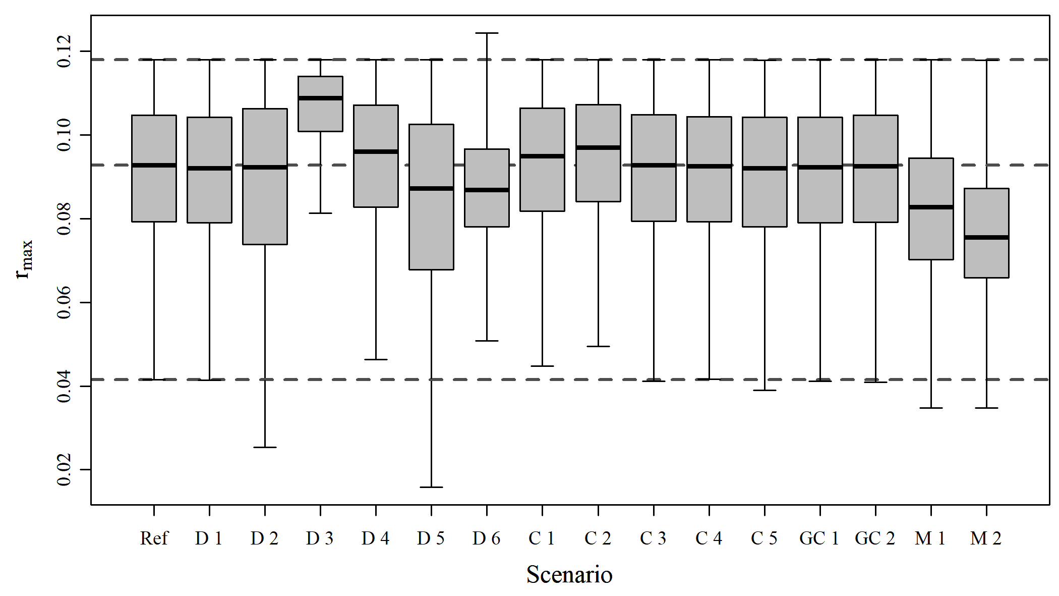

Figure A1. Boxplots of estimated quantities

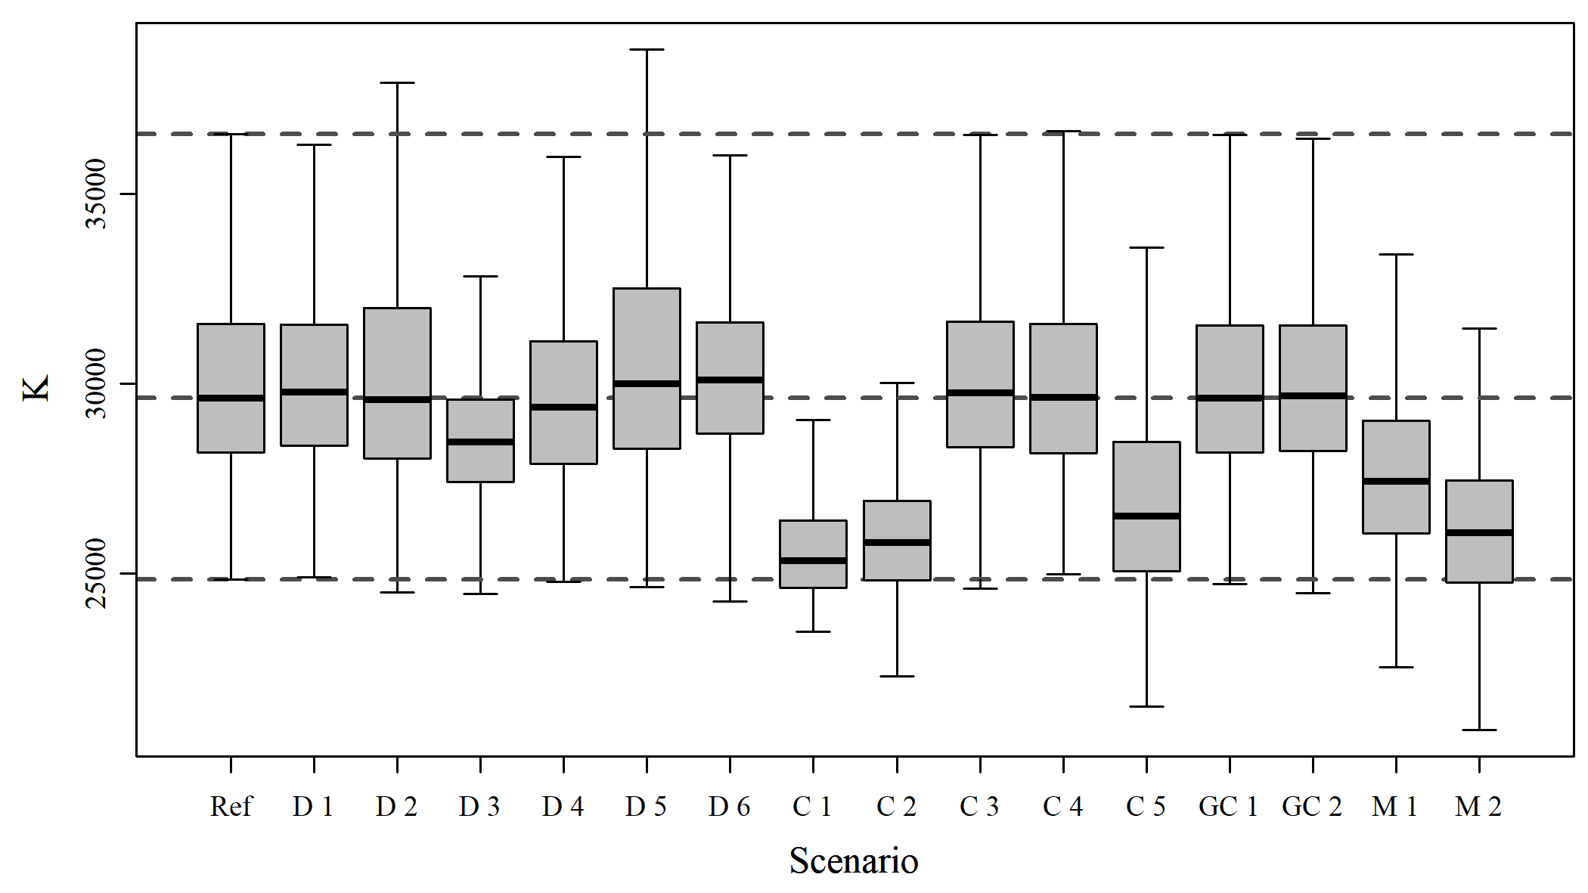

Figure A2. Boxplots of estimated quantities

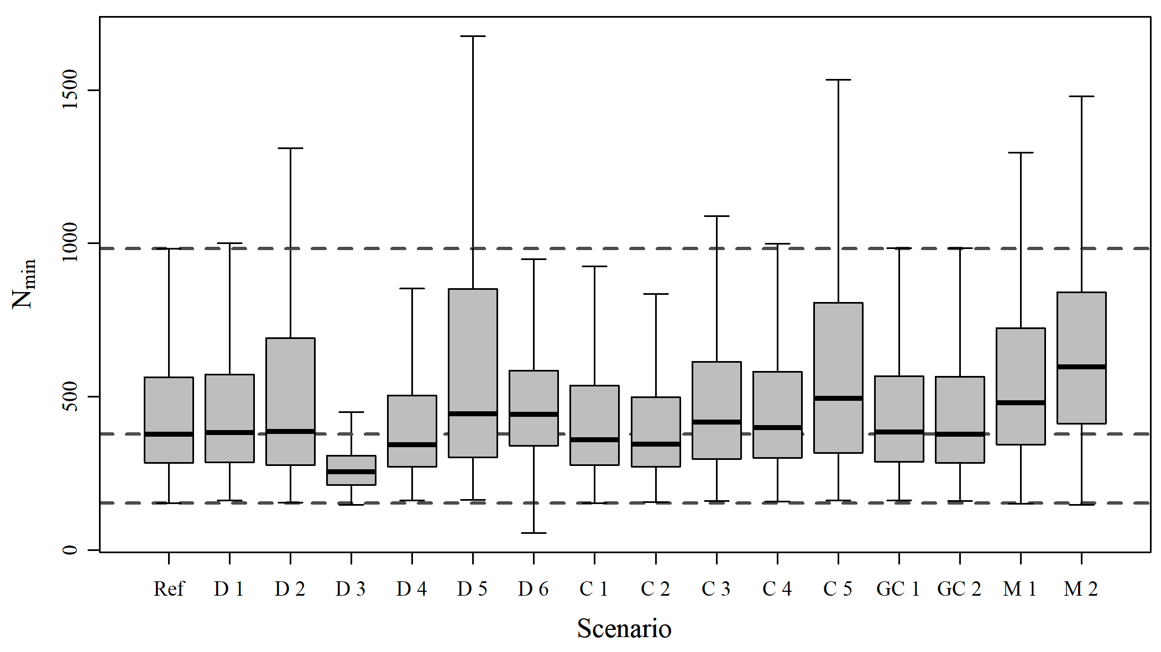

Figure A3. Boxplots of estimated quantities

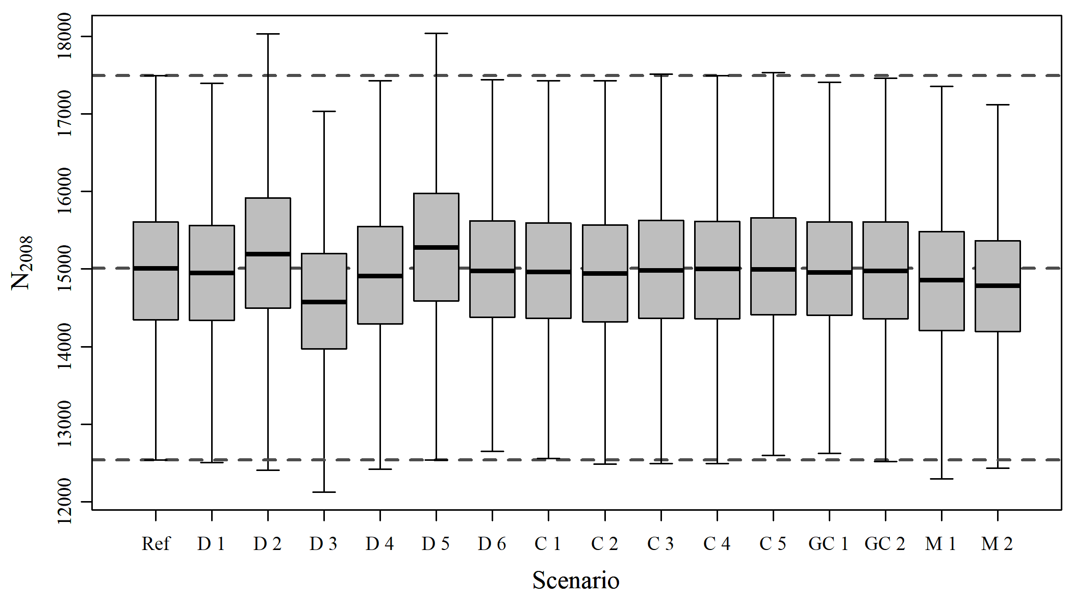

Figure A4. Boxplots of estimated quantities

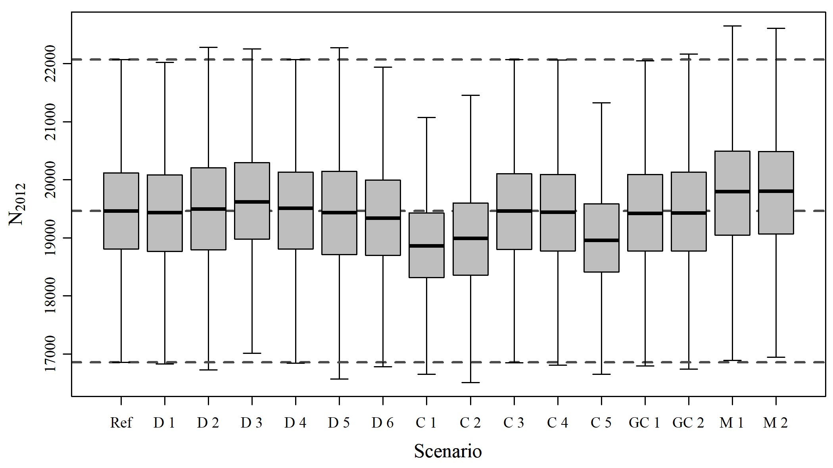

Figure A5. Boxplots of estimated quantities

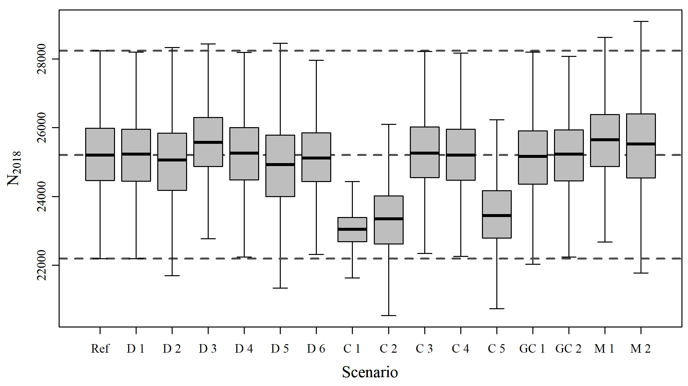

Figure A6. Boxplots of estimated quantities

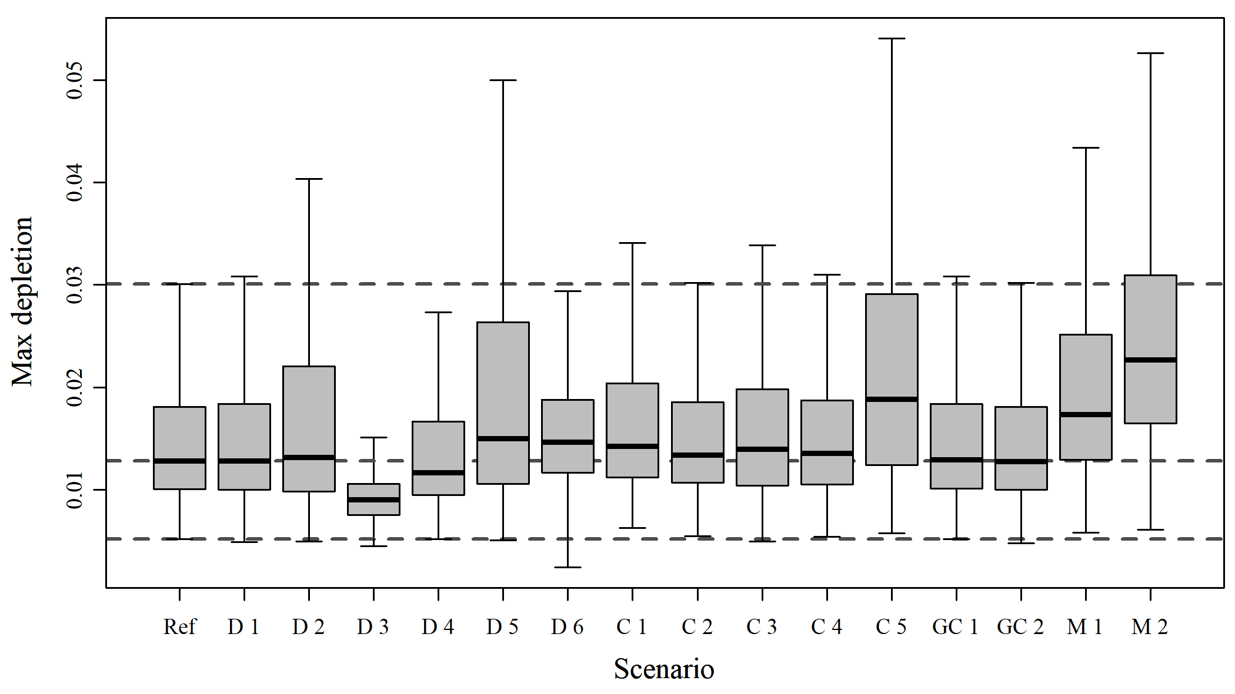

Figure A7. Boxplots of estimated quantities

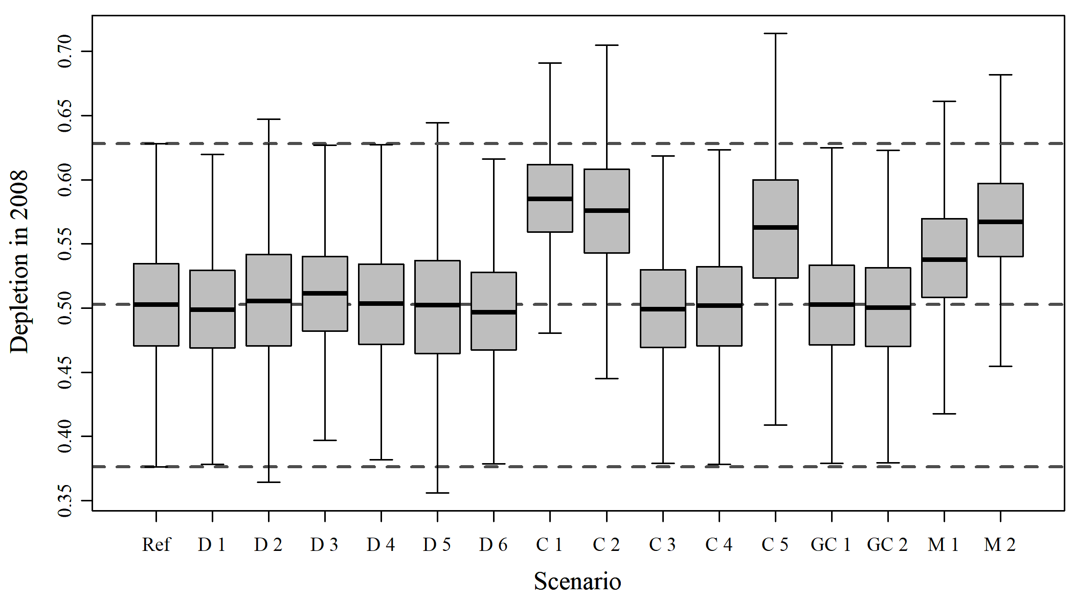

Figure A8. Boxplots of estimated quantities

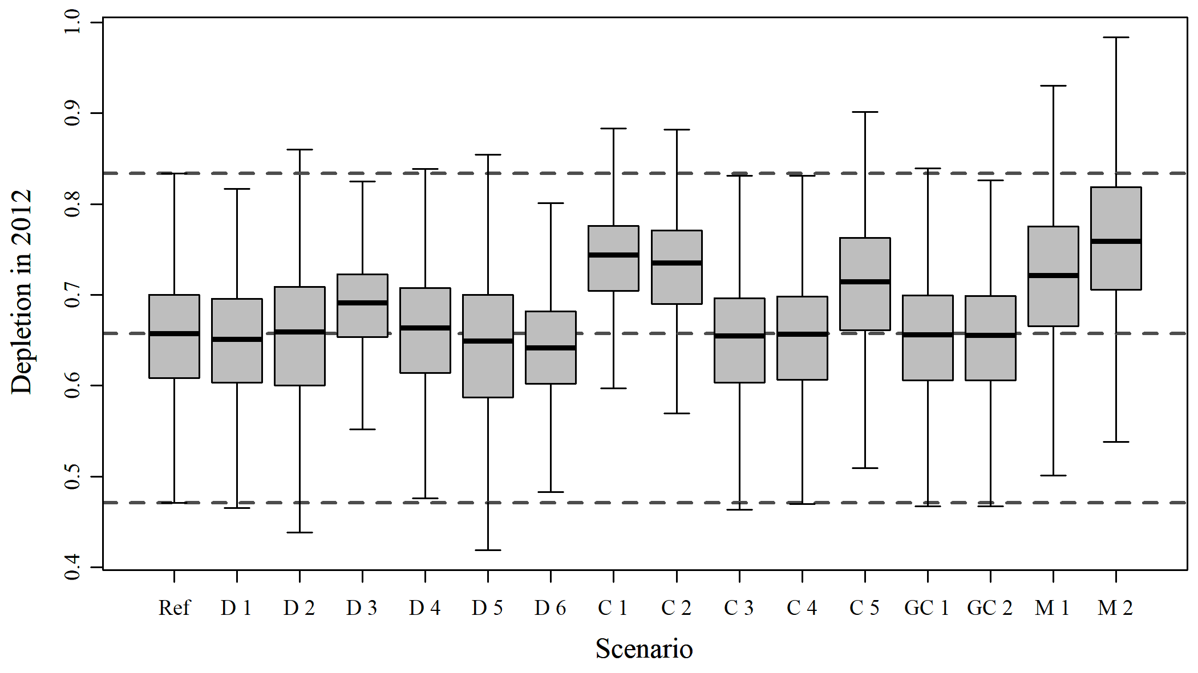

Figure A9. Boxplots of estimated quantities

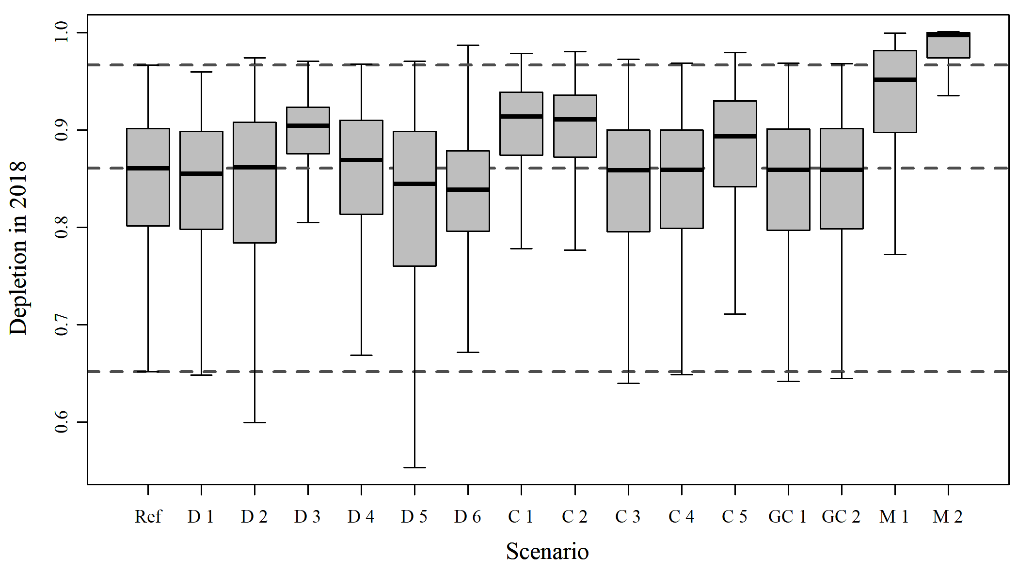

Figure A10. Boxplots of estimated quantities

# Reference

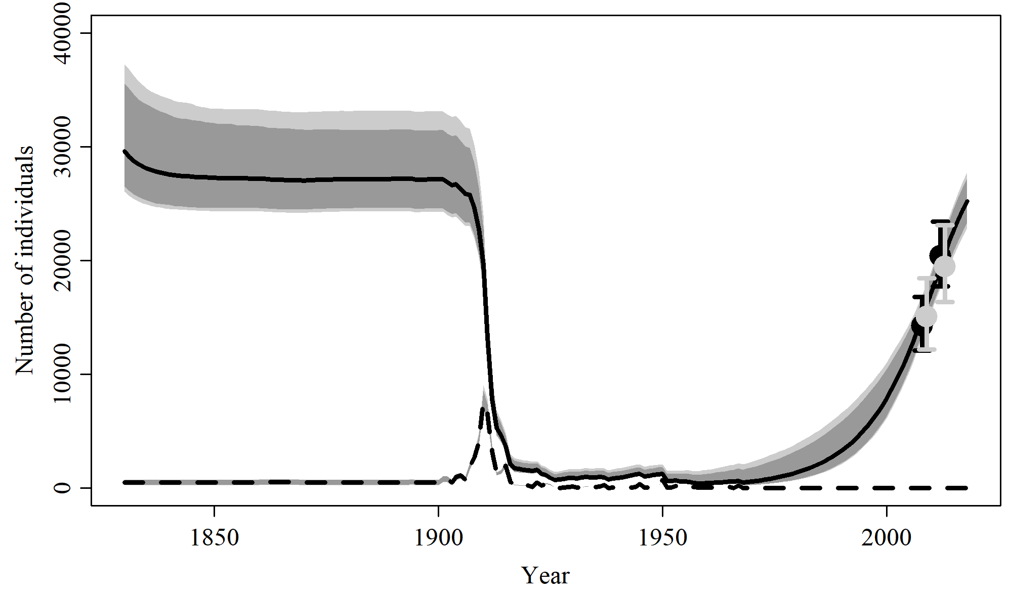

Figure 1. Population trajectory and fit of the model fit to the absolute abundance from the reference case scenario. The solid line corresponds to the posterior median, light grey to the 95% credible interval, grey to the 90% credible interval, black error bars to the 95% confidence interval of the abundance estimate, grey error bars to the 95% credible interval of the posterior predicted abundance estimate, and the dashed line to the catch series.

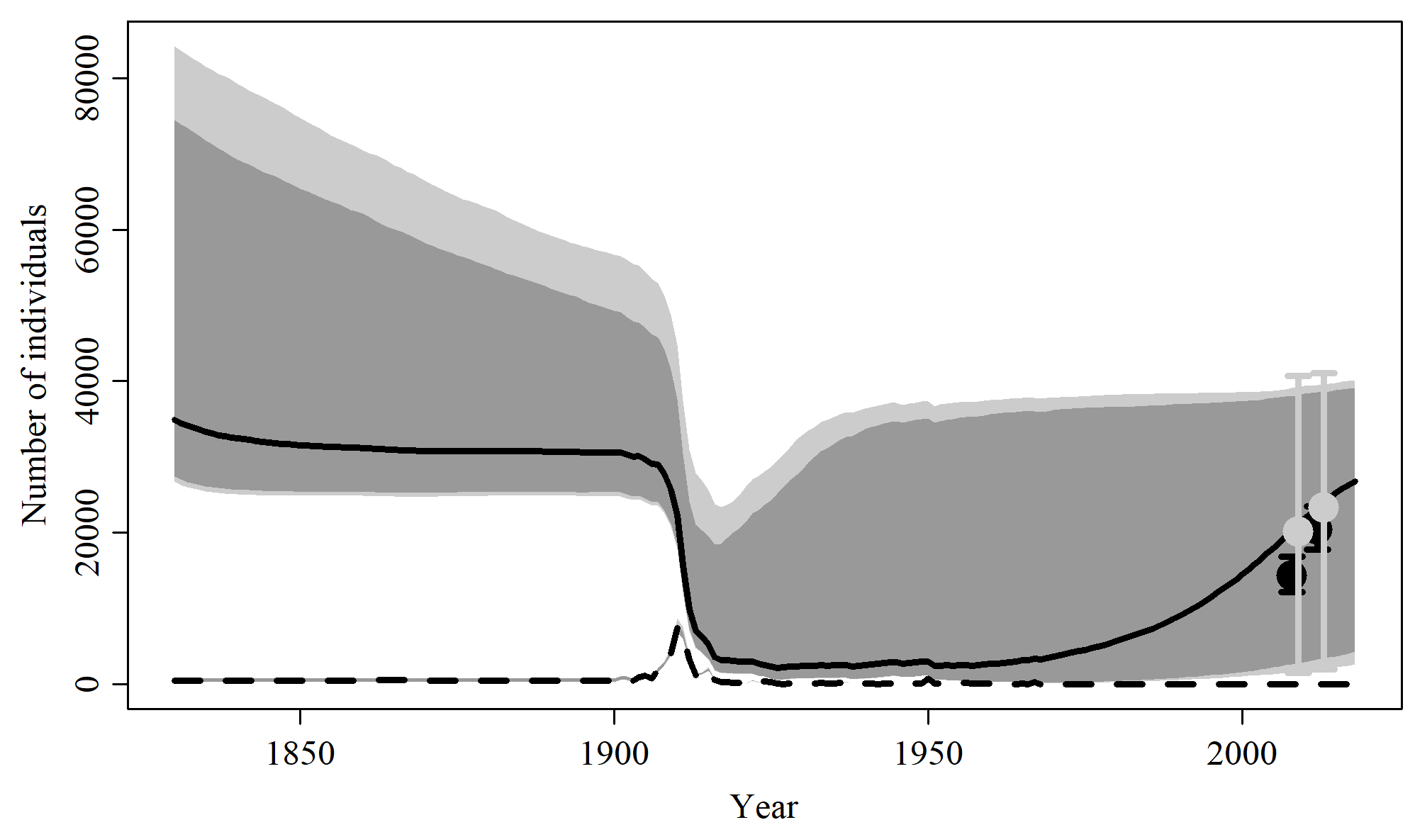

Figure 2. Prior predictive check of population trajectory the model from the reference case scenario.

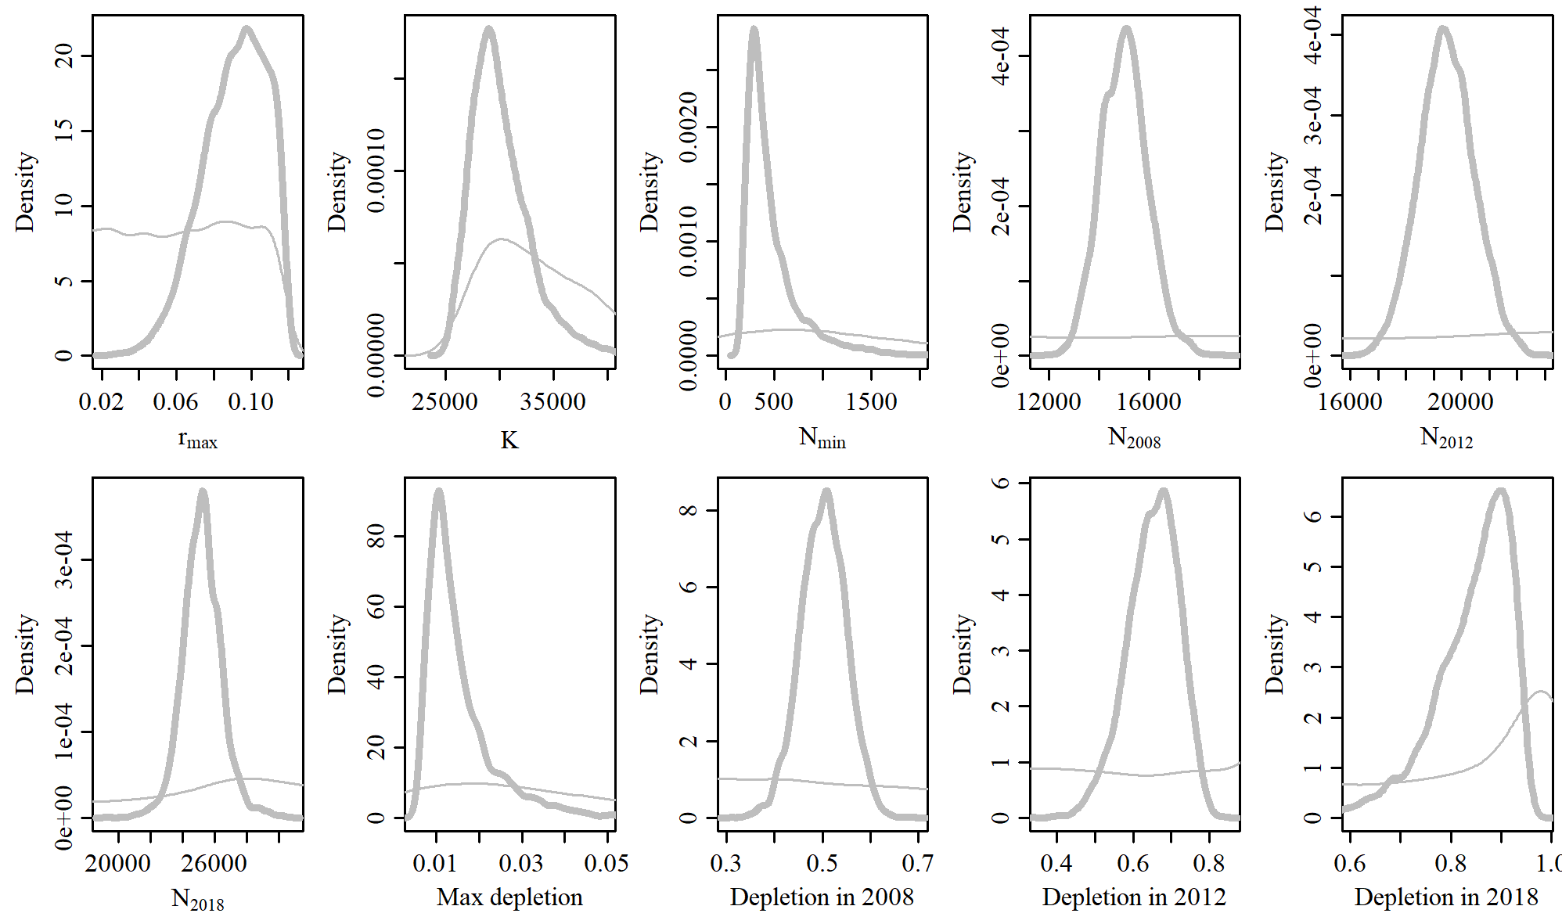

Figure 3. Posterior probability distributions of model parameters and derived quantities from the model fit to the absolute abundance from the reference case scenario.

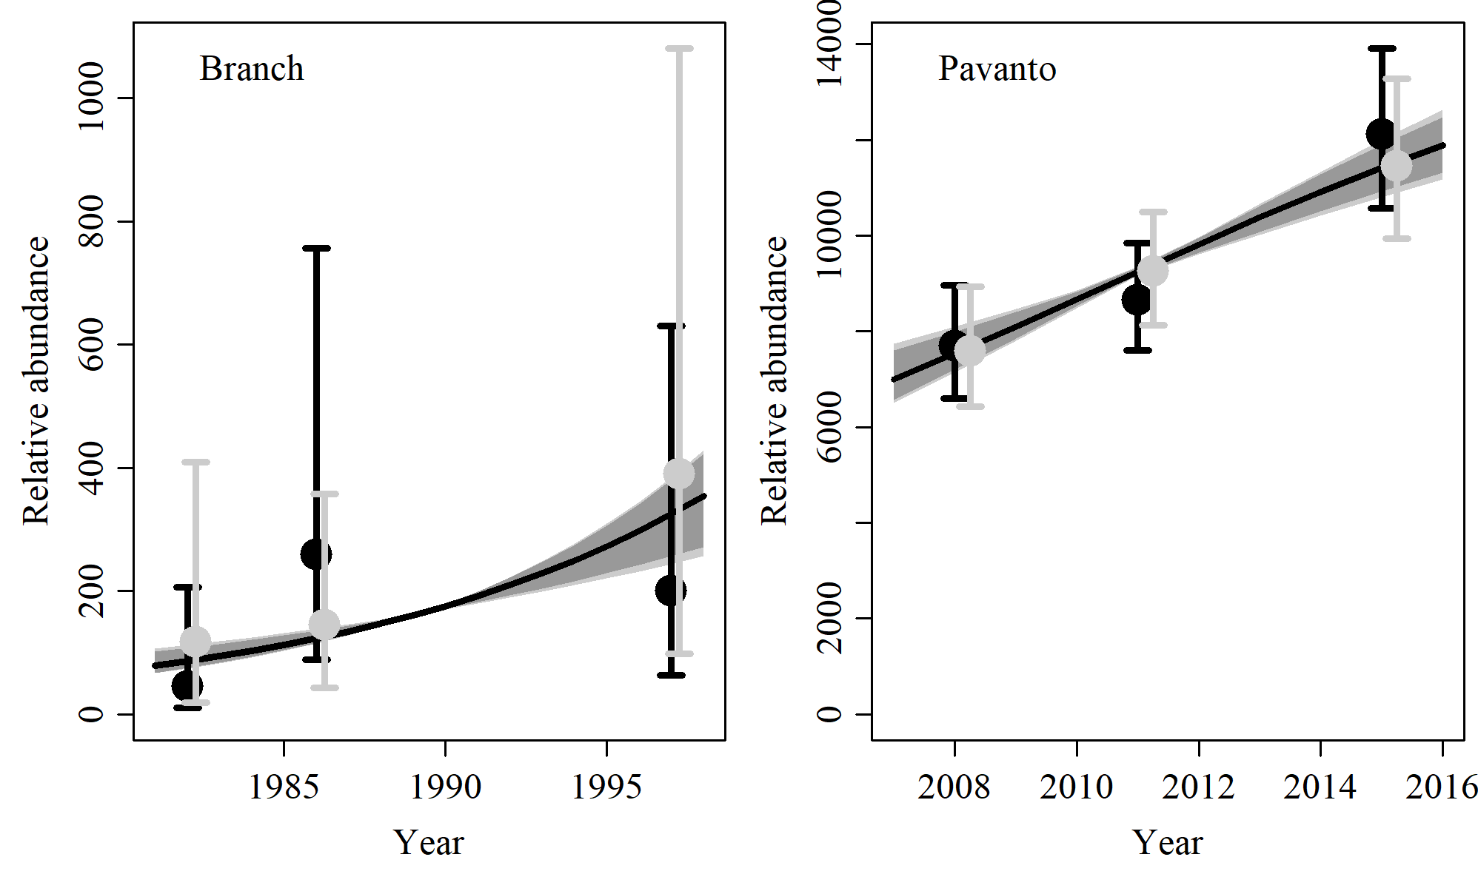

Figure 4. Fit of the model fit from the reference scenario to indices of abundance. The solid line corresponds to the posterior median, light grey to the 95% credible interval, grey to the 90% credible interval, black error bars to the 95% confidence interval of the relative abundance estimates, and grey error bars to the 95% credible interval of the posterior predicted relative abundance.

Table 1. Population and parameter estimates from the model fit from the reference scenario.

|  |  |  |  |  |  |  |
| --- | --- | --- | --- | --- | --- | --- |
| Parameter | Mean | Median | 2.5% CI | 5% CI | 95% CI | 97.5% CI |
|  | 0.091 | 0.093 | 0.054 | 0.06 | 0.117 | 0.115 |
|  | 30,135 | 29,615 | 26,068 | 26,507 | 37,272 | 35,590 |
|  | 482 | 378 | 190 | 203 | 1,391 | 1,115 |
|  | 15,020 | 15,012 | 13,263 | 13,513 | 16,926 | 16,572 |
|  | 19,472 | 19,465 | 17,558 | 17,857 | 21,461 | 21,154 |
|  | 25,225 | 25,206 | 22,858 | 23,333 | 27,794 | 27,243 |
| Max depletion | 0.015 | 0.013 | 0.007 | 0.007 | 0.039 | 0.033 |
| Depletion in 2008 | 0.502 | 0.503 | 0.406 | 0.423 | 0.593 | 0.579 |
| Depletion in 2012 | 0.652 | 0.657 | 0.505 | 0.531 | 0.766 | 0.753 |
| Depletion in 2018 | 0.843 | 0.861 | 0.65 | 0.69 | 0.941 | 0.935 |

# SData 1

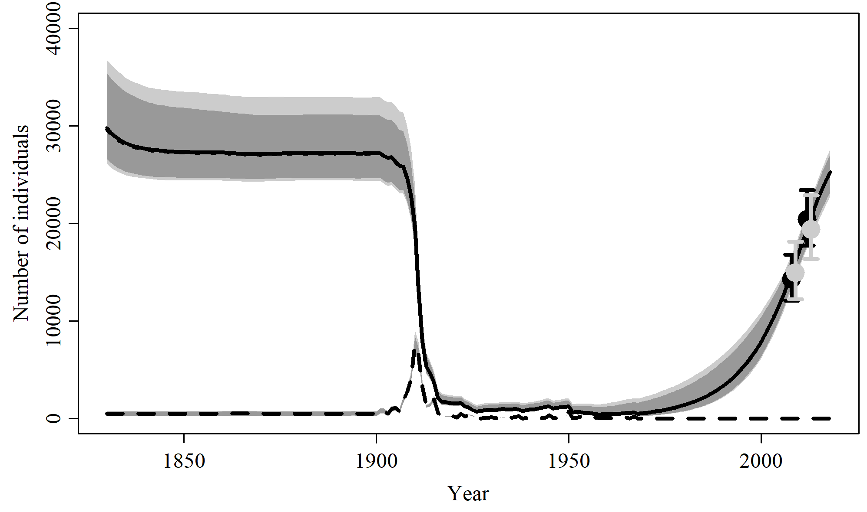

Figure 5. Population trajectory and fit of the model fit to the absolute abundance from the SData 1 case scenario. The solid line corresponds to the posterior median, dotted line to the posterior mean of the reference scenariolight grey to the 95% credible interval, grey to the 90% credible interval, black error bars to the 95% confidence interval of the abundance estimate, grey error bars to the 95% credible interval of the posterior predicted abundance estimate, and the dashed line to the catch series.

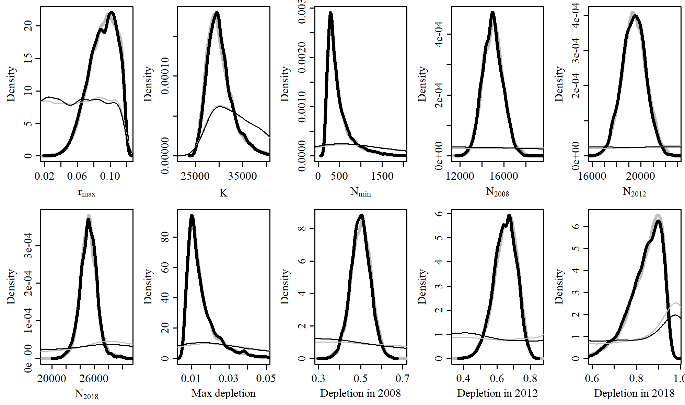

Figure 6. Posterior probability distributions of model parameters and derived quantities from the model fit to the absolute abundance from the SData 1 case scenario.

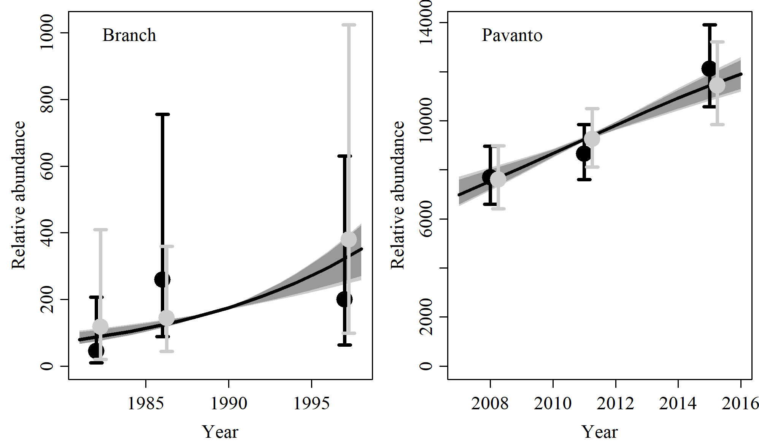

Figure 7. Fit of the model fit from the SData 1 scenario to indices of abundance. The solid line corresponds to the posterior median, light grey to the 95% credible interval, grey to the 90% credible interval, black error bars to the 95% confidence interval of the relative abundance estimates, and grey error bars to the 95% credible interval of the posterior predicted relative abundance.

Table 2. Population and parameter estimates from the model fit from the SData 1 scenario.

|  |  |  |  |  |  |  |
| --- | --- | --- | --- | --- | --- | --- |
| Parameter | Mean | Median | 2.5% CI | 5% CI | 95% CI | 97.5% CI |
|  | 0.091 | 0.092 | 0.055 | 0.06 | 0.117 | 0.115 |
|  | 30,211 | 29,778 | 26,104 | 26,606 | 36,764 | 35,432 |
|  | 483 | 384 | 192 | 204 | 1,344 | 1,113 |
|  | 19,418 | 19,433 | 17,529 | 17,768 | 21,318 | 20,995 |
|  | 14,971 | 14,947 | 13,284 | 13,531 | 16,765 | 16,505 |
|  | 25,211 | 25,230 | 22,760 | 23,223 | 27,603 | 27,062 |
| Max depletion | 0.016 | 0.013 | 0.007 | 0.007 | 0.039 | 0.033 |
| Depletion in 2012 | 0.648 | 0.651 | 0.508 | 0.534 | 0.764 | 0.748 |
| Depletion in 2008 | 0.499 | 0.499 | 0.408 | 0.422 | 0.59 | 0.575 |
| Depletion in 2018 | 0.84 | 0.855 | 0.657 | 0.691 | 0.941 | 0.932 |

# SData 2

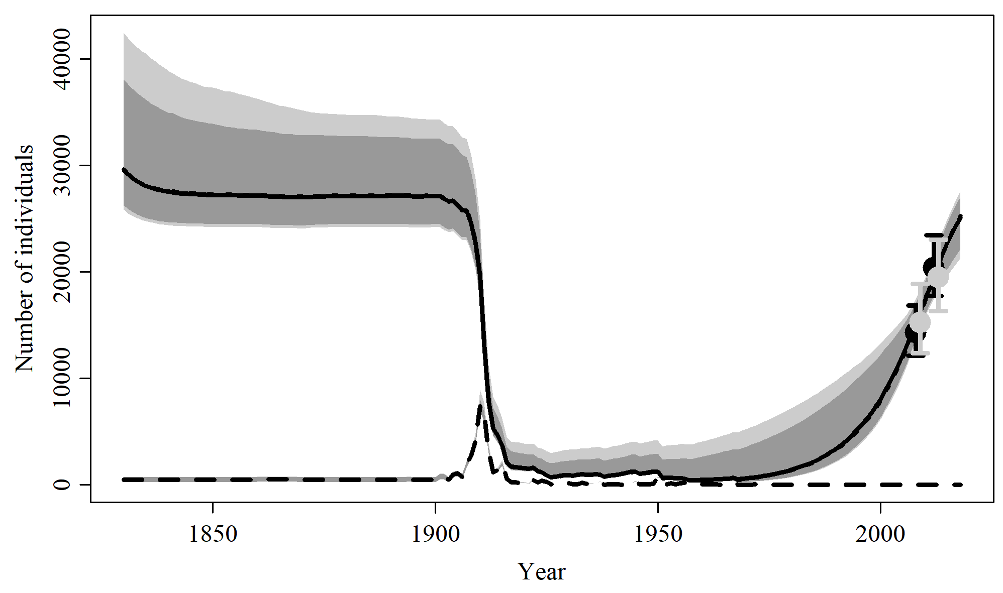

Figure 8. Population trajectory and fit of the model fit to the absolute abundance from the SData 2 case scenario. The solid line corresponds to the posterior median, dotted line to the posterior mean of the reference scenariolight grey to the 95% credible interval, grey to the 90% credible interval, black error bars to the 95% confidence interval of the abundance estimate, grey error bars to the 95% credible interval of the posterior predicted abundance estimate, and the dashed line to the catch series.

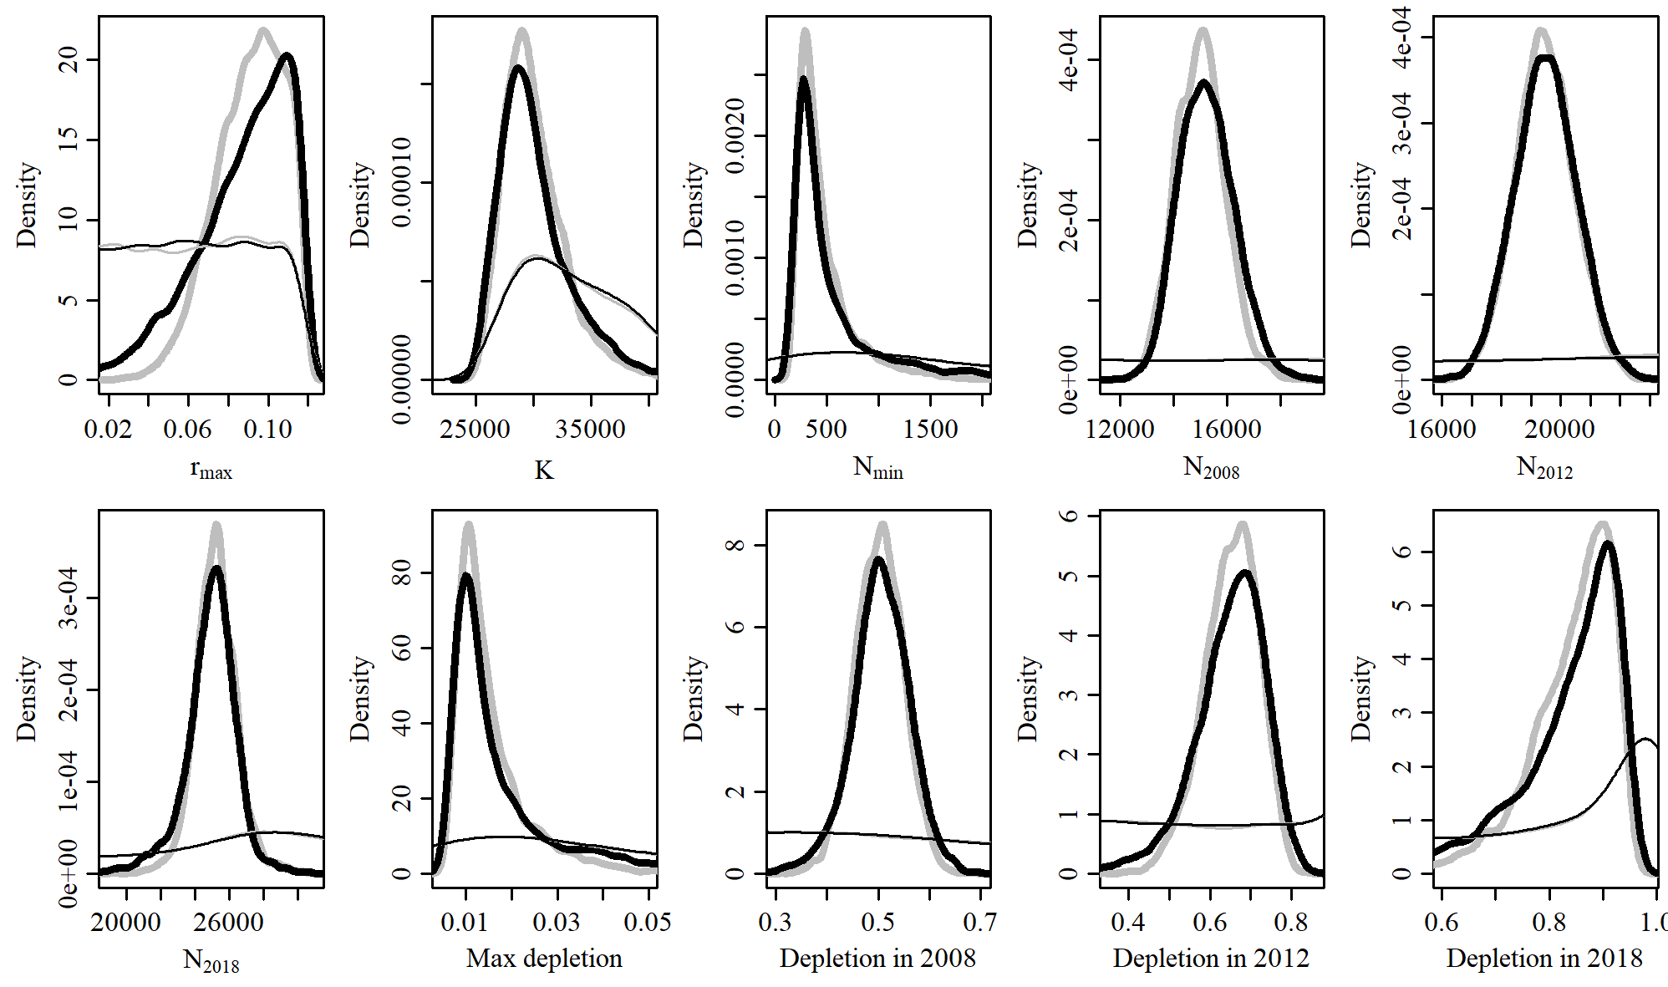

Figure 9. Posterior probability distributions of model parameters and derived quantities from the model fit to the absolute abundance from the SData 2 case scenario.

Table 3. Population and parameter estimates from the model fit from the SData 2 scenario.

|  |  |  |  |  |  |  |
| --- | --- | --- | --- | --- | --- | --- |
| Parameter | Mean | Median | 2.5% CI | 5% CI | 95% CI | 97.5% CI |
|  | 0.087 | 0.092 | 0.032 | 0.042 | 0.117 | 0.116 |
|  | 30,681 | 29,586 | 25,843 | 26,234 | 42,430 | 38,041 |
|  | 687 | 386 | 189 | 200 | 2,953 | 1,986 |
|  | 15,247 | 15,195 | 13,376 | 13,648 | 17,415 | 17,062 |
|  | 19,507 | 19,500 | 17,504 | 17,780 | 21,587 | 21,237 |
|  | 24,927 | 25,057 | 21,265 | 22,180 | 27,609 | 27,042 |
| Max depletion | 0.02 | 0.013 | 0.007 | 0.007 | 0.071 | 0.054 |
| Depletion in 2008 | 0.504 | 0.506 | 0.378 | 0.405 | 0.612 | 0.593 |
| Depletion in 2012 | 0.648 | 0.659 | 0.434 | 0.485 | 0.786 | 0.769 |
| Depletion in 2018 | 0.828 | 0.862 | 0.516 | 0.596 | 0.949 | 0.941 |

# SData 3

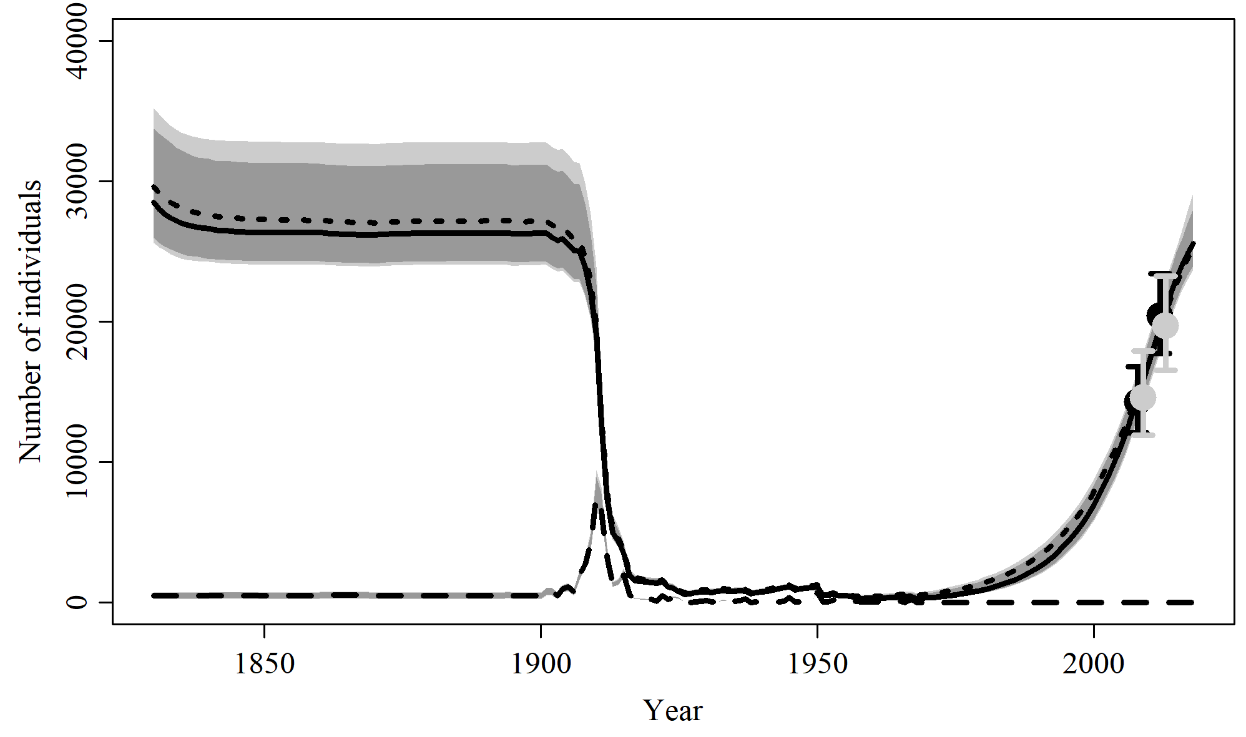

Figure 10. Population trajectory and fit of the model fit to the absolute abundance from the SData 3 case scenario. The solid line corresponds to the posterior median, dotted line to the posterior mean of the reference scenariolight grey to the 95% credible interval, grey to the 90% credible interval, black error bars to the 95% confidence interval of the abundance estimate, grey error bars to the 95% credible interval of the posterior predicted abundance estimate, and the dashed line to the catch series.

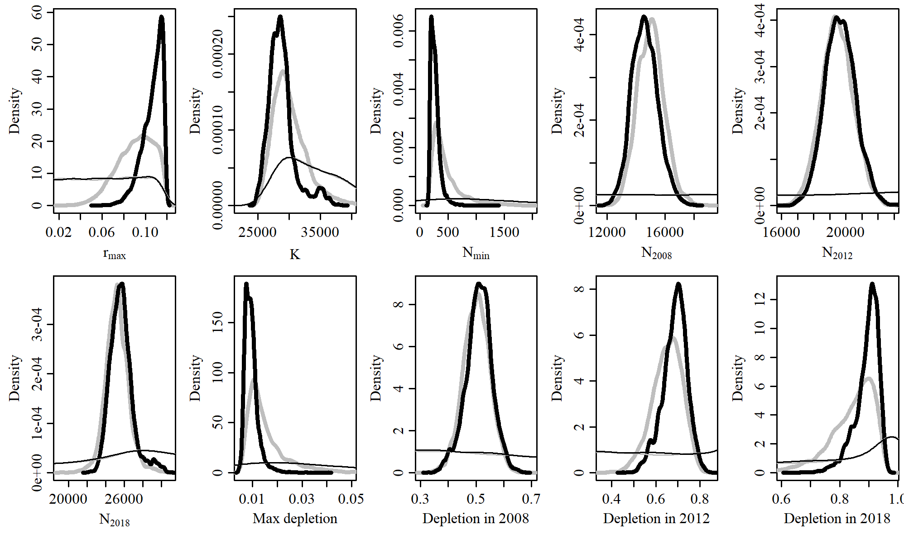

Figure 11. Posterior probability distributions of model parameters and derived quantities from the model fit to the absolute abundance from the SData 3 case scenario.

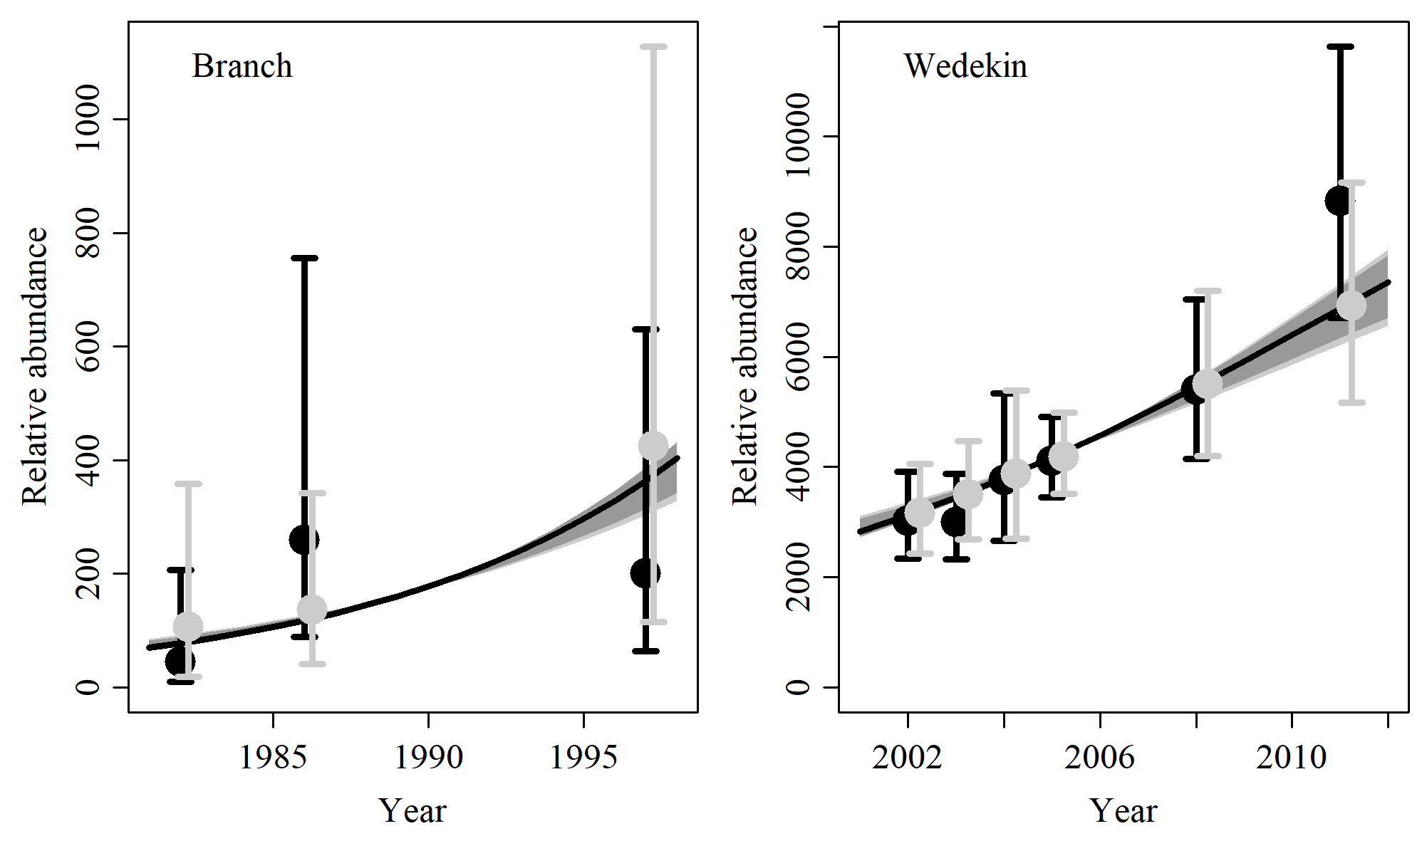

Figure 12. Fit of the model fit from the SData 3 scenario to indices of abundance. The solid line corresponds to the posterior median, light grey to the 95% credible interval, grey to the 90% credible interval, black error bars to the 95% confidence interval of the relative abundance estimates, and grey error bars to the 95% credible interval of the posterior predicted relative abundance.

Table 4. Population and parameter estimates from the model fit from the SData 3 scenario.

|  |  |  |  |  |  |  |
| --- | --- | --- | --- | --- | --- | --- |
| Parameter | Mean | Median | 2.5% CI | 5% CI | 95% CI | 97.5% CI |
|  | 0.107 | 0.109 | 0.084 | 0.088 | 0.117 | 0.117 |
|  | 28,791 | 28,477 | 25,621 | 25,944 | 35,223 | 33,735 |
|  | 273 | 255 | 174 | 181 | 493 | 426 |
|  | 14,609 | 14,575 | 12,924 | 13,204 | 16,500 | 16,198 |
|  | 19,651 | 19,617 | 17,809 | 18,104 | 21,555 | 21,282 |
|  | 25,672 | 25,570 | 23,686 | 23,942 | 29,160 | 28,019 |
| Max depletion | 0.009 | 0.009 | 0.006 | 0.006 | 0.016 | 0.014 |
| Depletion in 2008 | 0.51 | 0.512 | 0.405 | 0.429 | 0.601 | 0.586 |
| Depletion in 2012 | 0.686 | 0.691 | 0.566 | 0.581 | 0.782 | 0.767 |
| Depletion in 2018 | 0.894 | 0.904 | 0.79 | 0.814 | 0.949 | 0.943 |

# SData 4

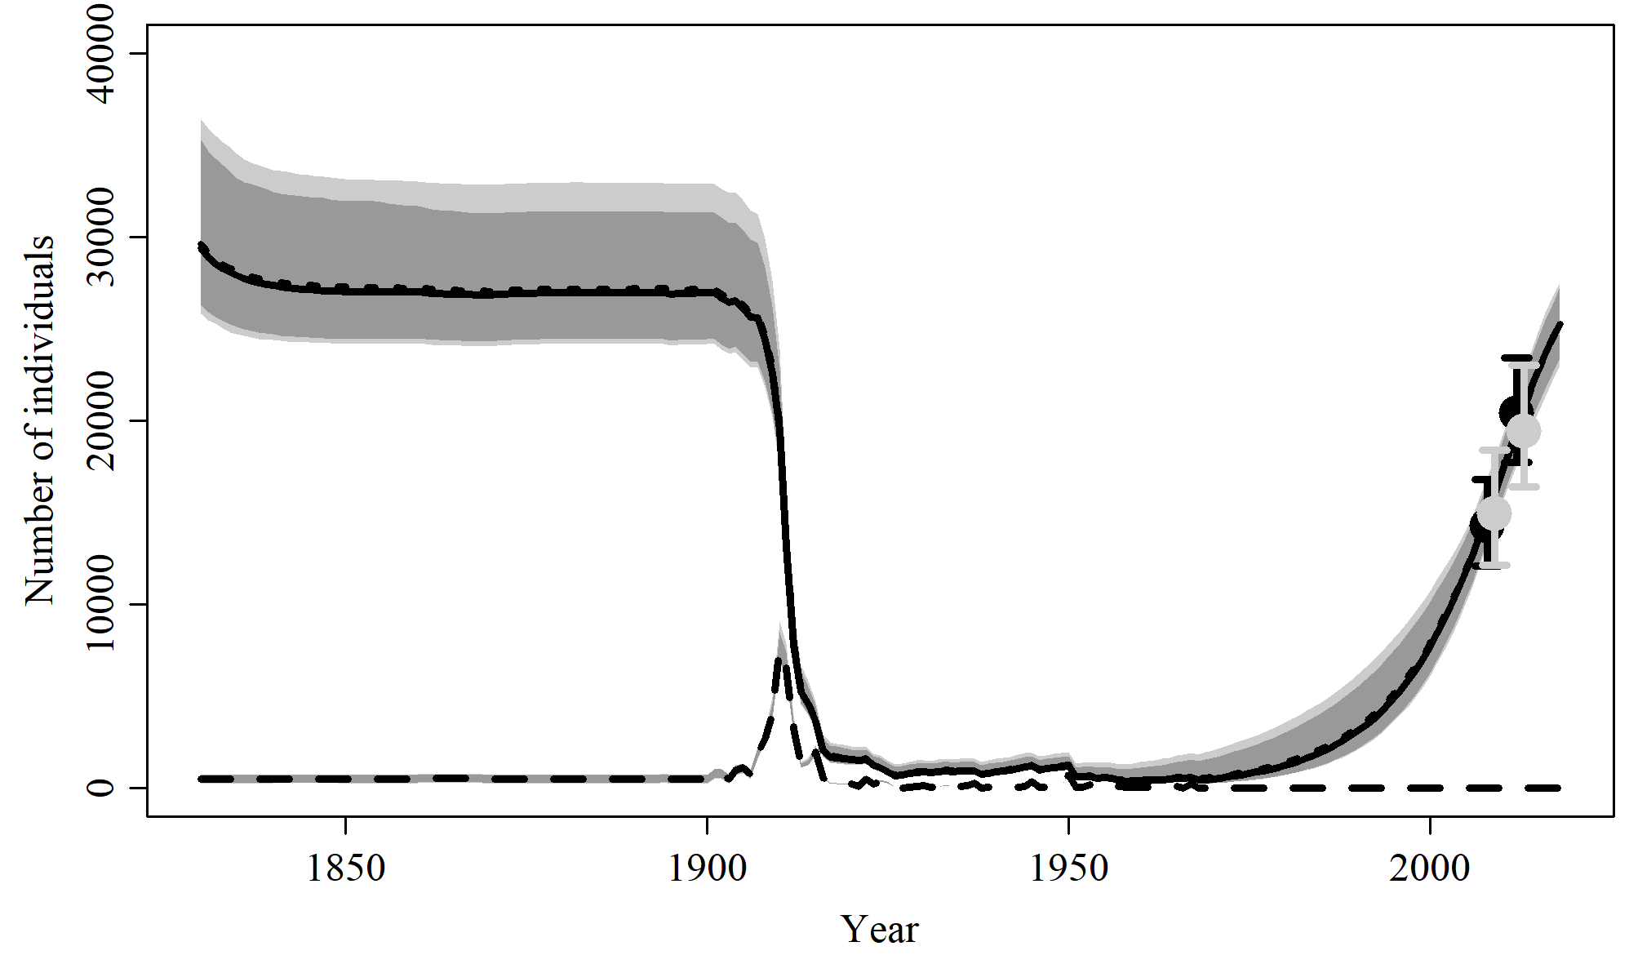

Figure 13. Population trajectory and fit of the model fit to the absolute abundance from the SData 4 case scenario. The solid line corresponds to the posterior median, dotted line to the posterior mean of the reference scenariolight grey to the 95% credible interval, grey to the 90% credible interval, black error bars to the 95% confidence interval of the abundance estimate, grey error bars to the 95% credible interval of the posterior predicted abundance estimate, and the dashed line to the catch series.

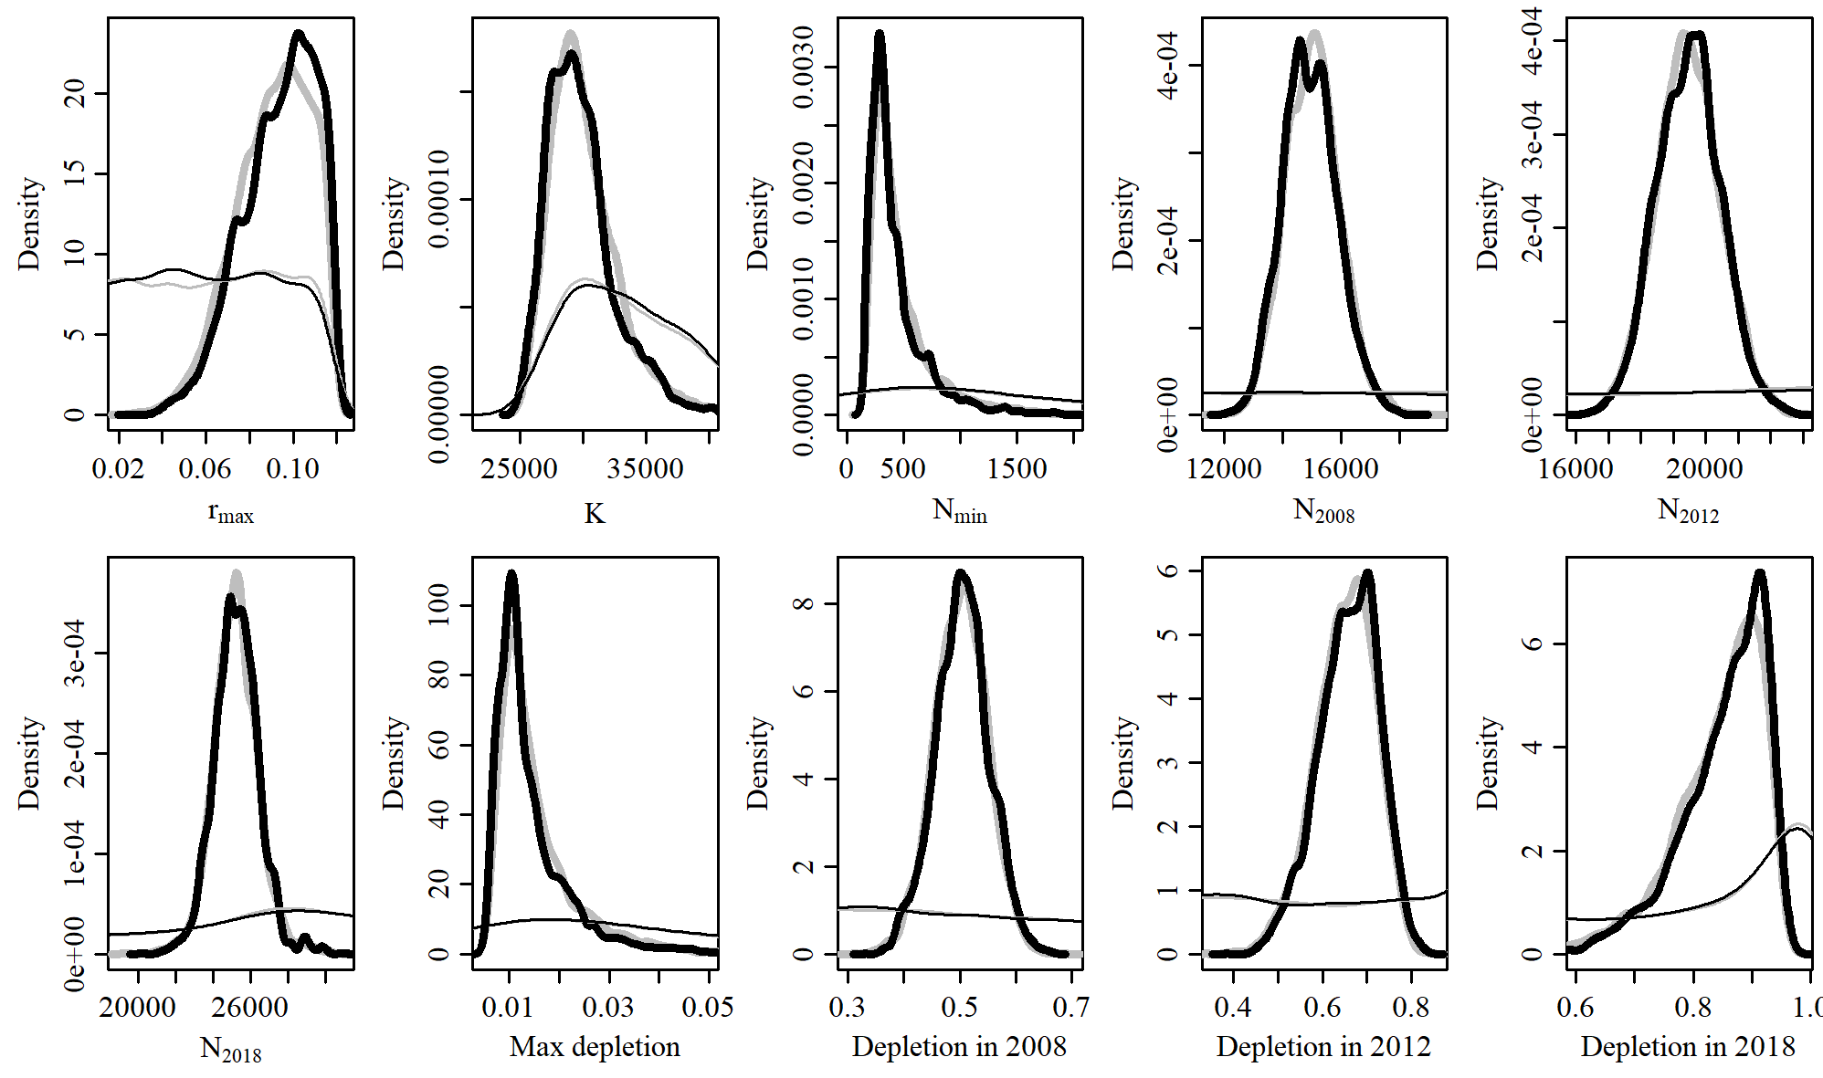

Figure 14. Posterior probability distributions of model parameters and derived quantities from the model fit to the absolute abundance from the SData 4 case scenario.

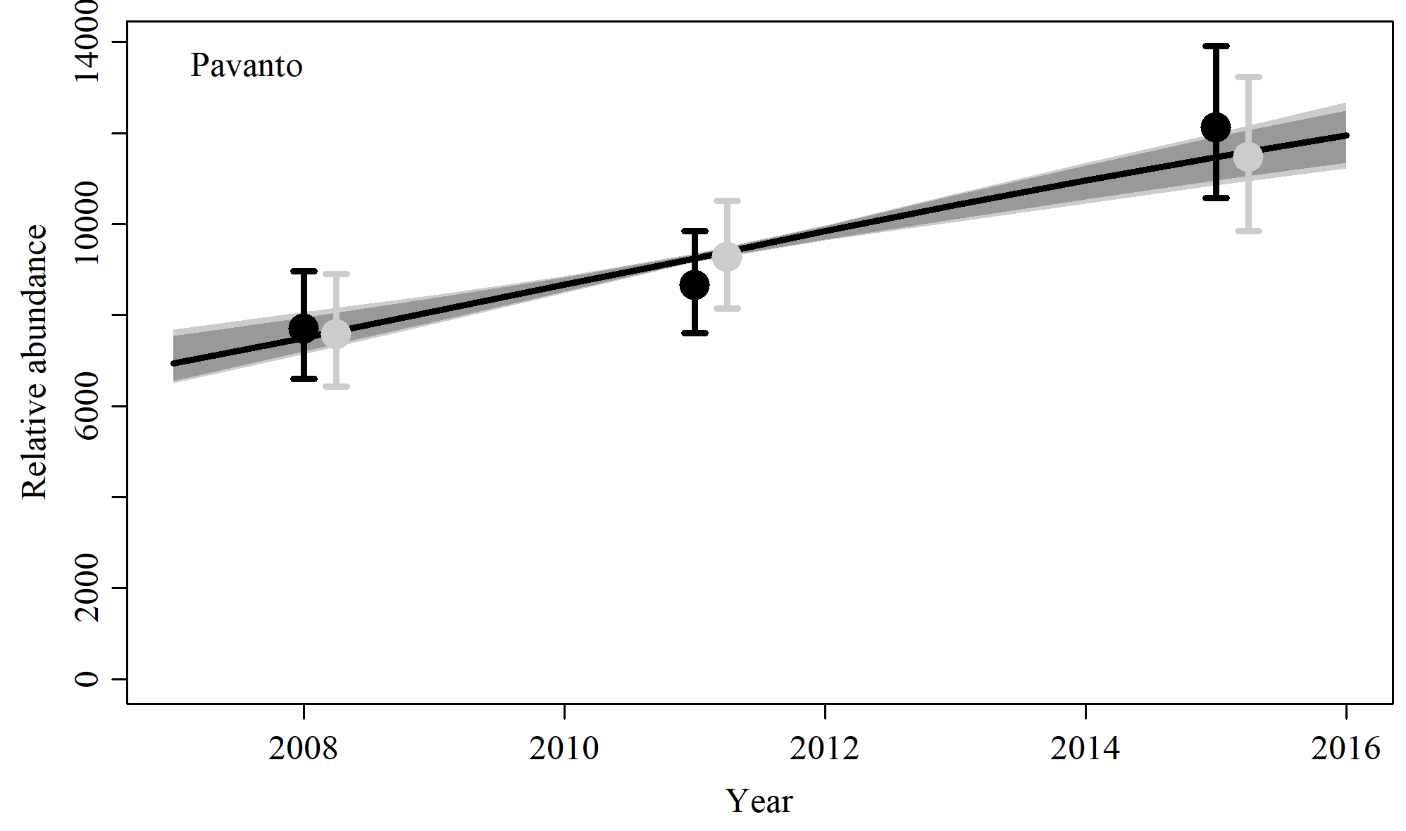

Figure 15. Fit of the model fit from the SData 4 scenario to indices of abundance. The solid line corresponds to the posterior median, light grey to the 95% credible interval, grey to the 90% credible interval, black error bars to the 95% confidence interval of the relative abundance estimates, and grey error bars to the 95% credible interval of the posterior predicted relative abundance.

Table 5. Population and parameter estimates from the model fit from the SData 4 scenario.

|  |  |  |  |  |  |  |
| --- | --- | --- | --- | --- | --- | --- |
| Parameter | Mean | Median | 2.5% CI | 5% CI | 95% CI | 97.5% CI |
|  | 0.094 | 0.096 | 0.058 | 0.064 | 0.117 | 0.117 |
|  | 29,828 | 29,385 | 25,810 | 26,321 | 36,432 | 35,295 |
|  | 440 | 343 | 183 | 193 | 1,244 | 990 |
|  | 14,939 | 14,908 | 13,244 | 13,440 | 16,883 | 16,533 |
|  | 19,484 | 19,514 | 17,568 | 17,882 | 21,420 | 21,073 |
|  | 25,266 | 25,262 | 22,984 | 23,387 | 27,533 | 27,275 |
| Max depletion | 0.014 | 0.012 | 0.007 | 0.007 | 0.036 | 0.03 |
| Depletion in 2008 | 0.504 | 0.504 | 0.405 | 0.422 | 0.598 | 0.582 |
| Depletion in 2012 | 0.658 | 0.663 | 0.515 | 0.536 | 0.774 | 0.759 |
| Depletion in 2018 | 0.853 | 0.869 | 0.672 | 0.705 | 0.944 | 0.938 |

# SData 5

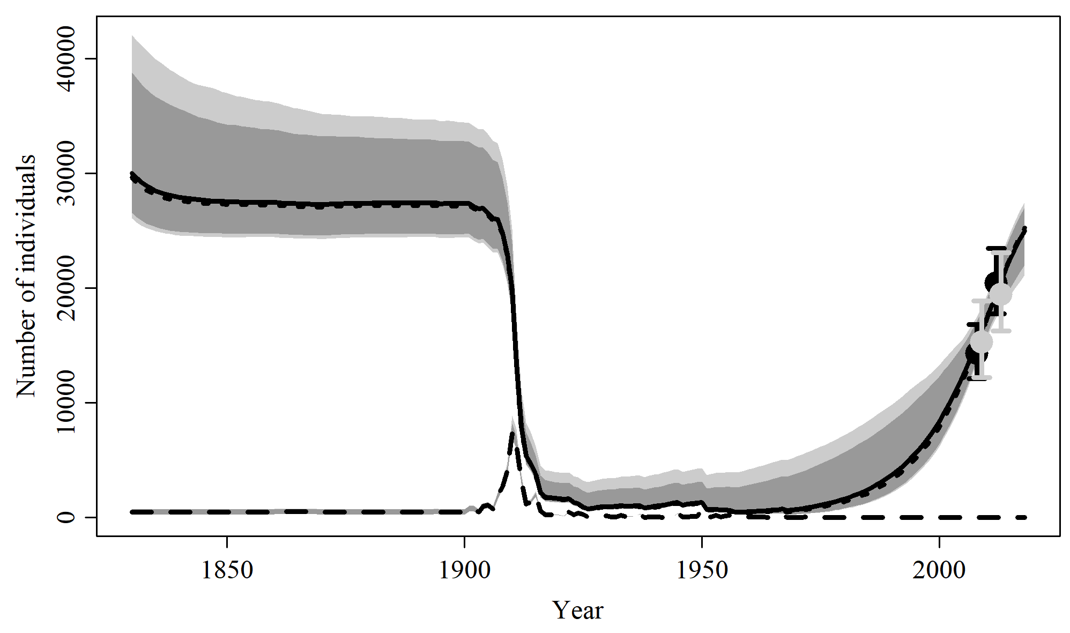

Figure 16. Population trajectory and fit of the model fit to the absolute abundance from the SData 5 case scenario. The solid line corresponds to the posterior median, dotted line to the posterior mean of the reference scenariolight grey to the 95% credible interval, grey to the 90% credible interval, black error bars to the 95% confidence interval of the abundance estimate, grey error bars to the 95% credible interval of the posterior predicted abundance estimate, and the dashed line to the catch series.

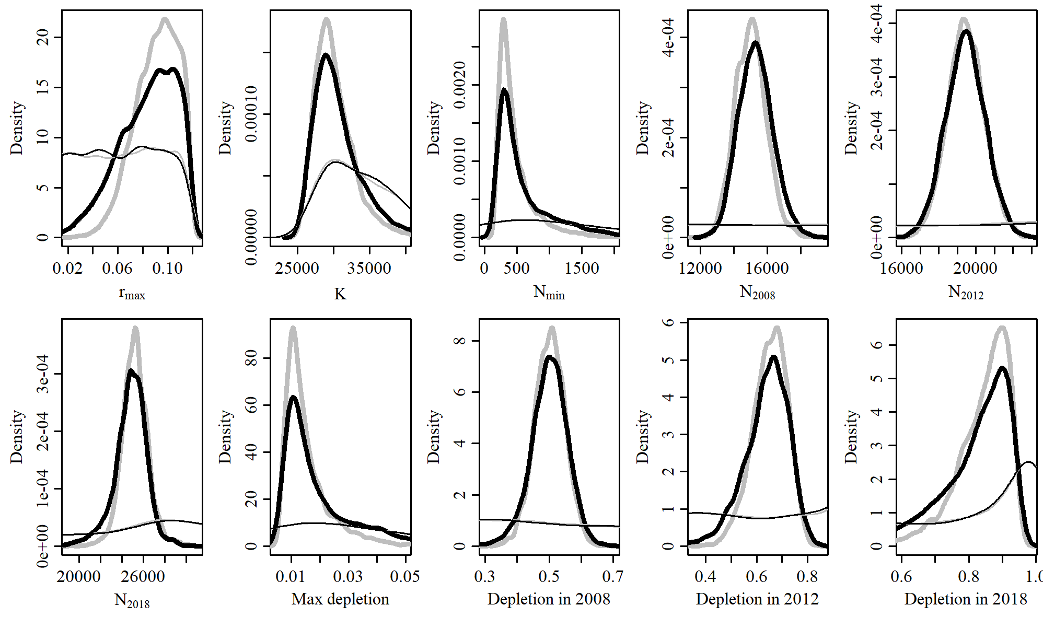

Figure 17. Posterior probability distributions of model parameters and derived quantities from the model fit to the absolute abundance from the SData 5 case scenario.

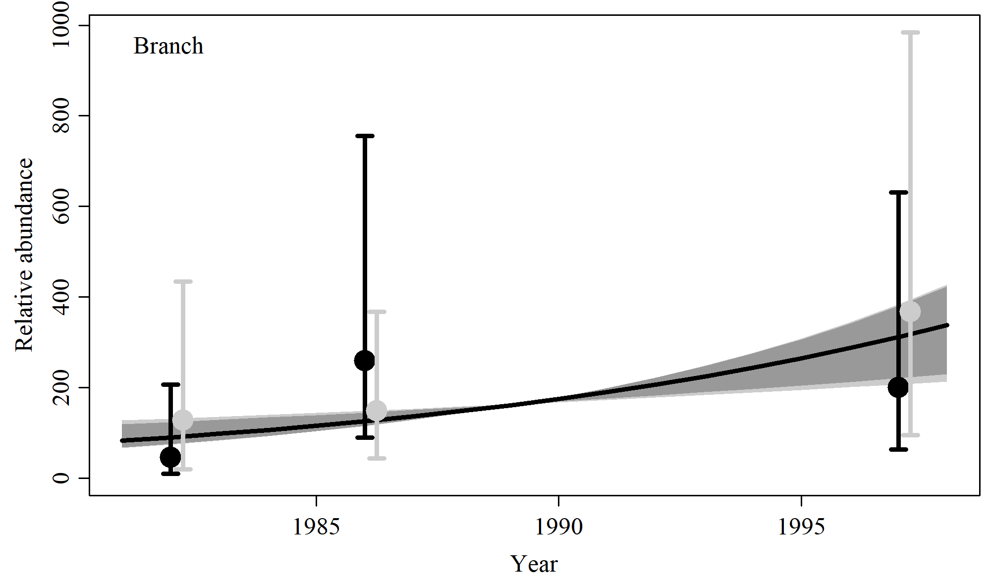

Figure 18. Fit of the model fit from the SData 5 scenario to indices of abundance. The solid line corresponds to the posterior median, light grey to the 95% credible interval, grey to the 90% credible interval, black error bars to the 95% confidence interval of the relative abundance estimates, and grey error bars to the 95% credible interval of the posterior predicted relative abundance.

Table 6. Population and parameter estimates from the model fit from the SData 5 scenario.

|  |  |  |  |  |  |  |
| --- | --- | --- | --- | --- | --- | --- |
| Parameter | Mean | Median | 2.5% CI | 5% CI | 95% CI | 97.5% CI |
|  | 0.084 | 0.087 | 0.032 | 0.041 | 0.116 | 0.115 |
|  | 31,077 | 30,000 | 26,037 | 26,525 | 42,016 | 38,757 |
|  | 758 | 444 | 195 | 208 | 3,060 | 2,133 |
|  | 15,309 | 15,279 | 13,423 | 13,668 | 17,464 | 17,070 |
|  | 19,433 | 19,437 | 17,342 | 17,696 | 21,520 | 21,208 |
|  | 24,803 | 24,926 | 21,104 | 22,001 | 27,454 | 26,995 |
| Max depletion | 0.022 | 0.015 | 0.007 | 0.007 | 0.075 | 0.056 |
| Depletion in 2008 | 0.5 | 0.502 | 0.374 | 0.402 | 0.605 | 0.588 |
| Depletion in 2012 | 0.637 | 0.649 | 0.433 | 0.477 | 0.779 | 0.759 |
| Depletion in 2018 | 0.814 | 0.845 | 0.514 | 0.585 | 0.944 | 0.936 |

# SData 6

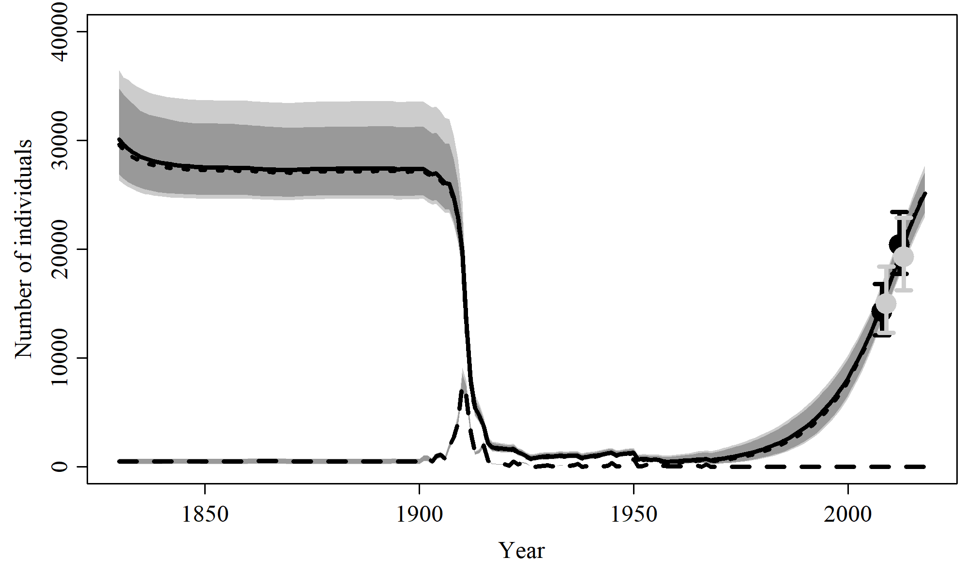

Figure 19. Population trajectory and fit of the model fit to the absolute abundance from the SData 6 case scenario. The solid line corresponds to the posterior median, dotted line to the posterior mean of the reference scenariolight grey to the 95% credible interval, grey to the 90% credible interval, black error bars to the 95% confidence interval of the abundance estimate, grey error bars to the 95% credible interval of the posterior predicted abundance estimate, and the dashed line to the catch series.

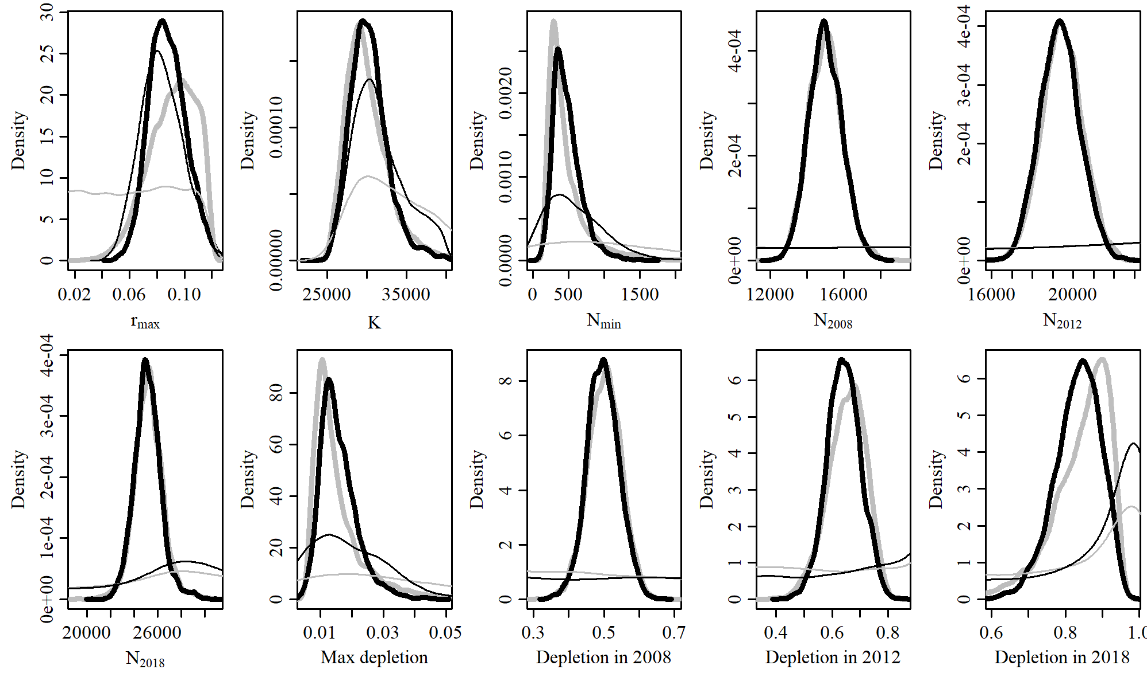

Figure 20. Posterior probability distributions of model parameters and derived quantities from the model fit to the absolute abundance from the SData 6 case scenario.

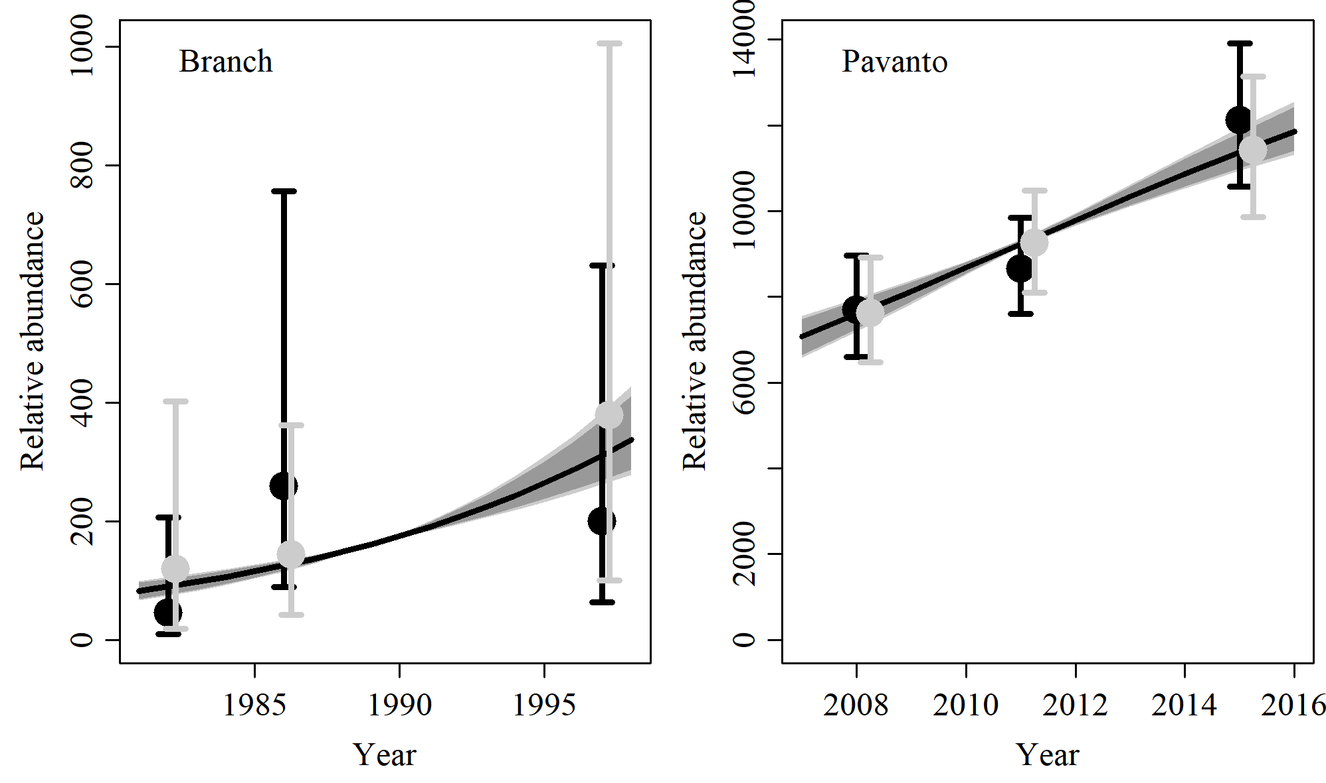

Figure 21. Fit of the model fit from the SData 6 scenario to indices of abundance. The solid line corresponds to the posterior median, light grey to the 95% credible interval, grey to the 90% credible interval, black error bars to the 95% confidence interval of the relative abundance estimates, and grey error bars to the 95% credible interval of the posterior predicted relative abundance.

Table 7. Population and parameter estimates from the model fit from the SData 6 scenario.

|  |  |  |  |  |  |  |
| --- | --- | --- | --- | --- | --- | --- |
| Parameter | Mean | Median | 2.5% CI | 5% CI | 95% CI | 97.5% CI |
|  | 0.088 | 0.087 | 0.063 | 0.067 | 0.116 | 0.111 |
|  | 30,333 | 30,095 | 26,303 | 26,898 | 36,456 | 34,764 |
|  | 484 | 443 | 197 | 232 | 981 | 857 |
|  | 15,010 | 14,976 | 13,325 | 13,543 | 16,868 | 16,540 |
|  | 19,355 | 19,342 | 17,487 | 17,754 | 21,320 | 20,994 |
|  | 25,166 | 25,113 | 22,996 | 23,363 | 27,734 | 27,069 |
| Max depletion | 0.016 | 0.015 | 0.007 | 0.008 | 0.03 | 0.027 |
| Depletion in 2008 | 0.498 | 0.497 | 0.407 | 0.425 | 0.589 | 0.574 |
| Depletion in 2012 | 0.642 | 0.642 | 0.522 | 0.545 | 0.758 | 0.742 |
| Depletion in 2018 | 0.834 | 0.839 | 0.699 | 0.723 | 0.937 | 0.926 |

# SCatch 1

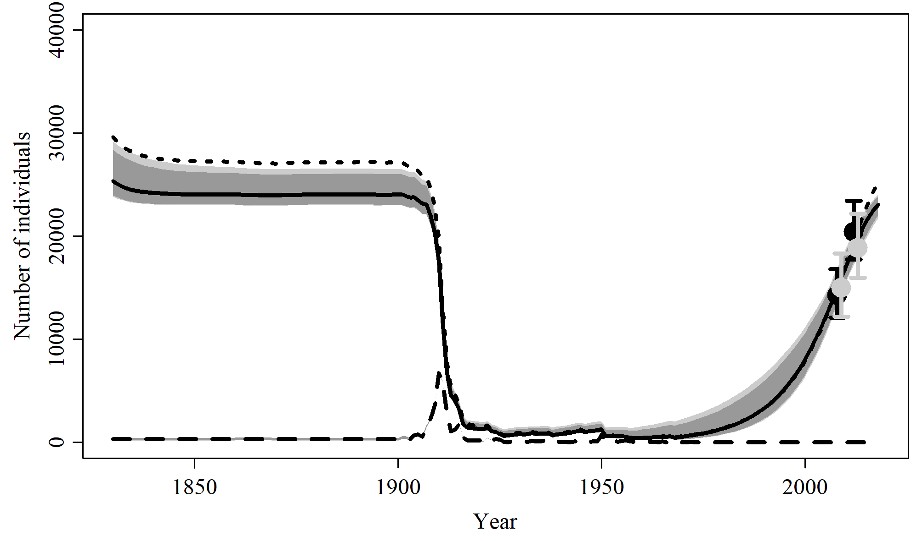

Figure 22. Population trajectory and fit of the model fit to the absolute abundance from the SCatch 1 case scenario. The solid line corresponds to the posterior median, dotted line to the posterior mean of the reference scenariolight grey to the 95% credible interval, grey to the 90% credible interval, black error bars to the 95% confidence interval of the abundance estimate, grey error bars to the 95% credible interval of the posterior predicted abundance estimate, and the dashed line to the catch series.

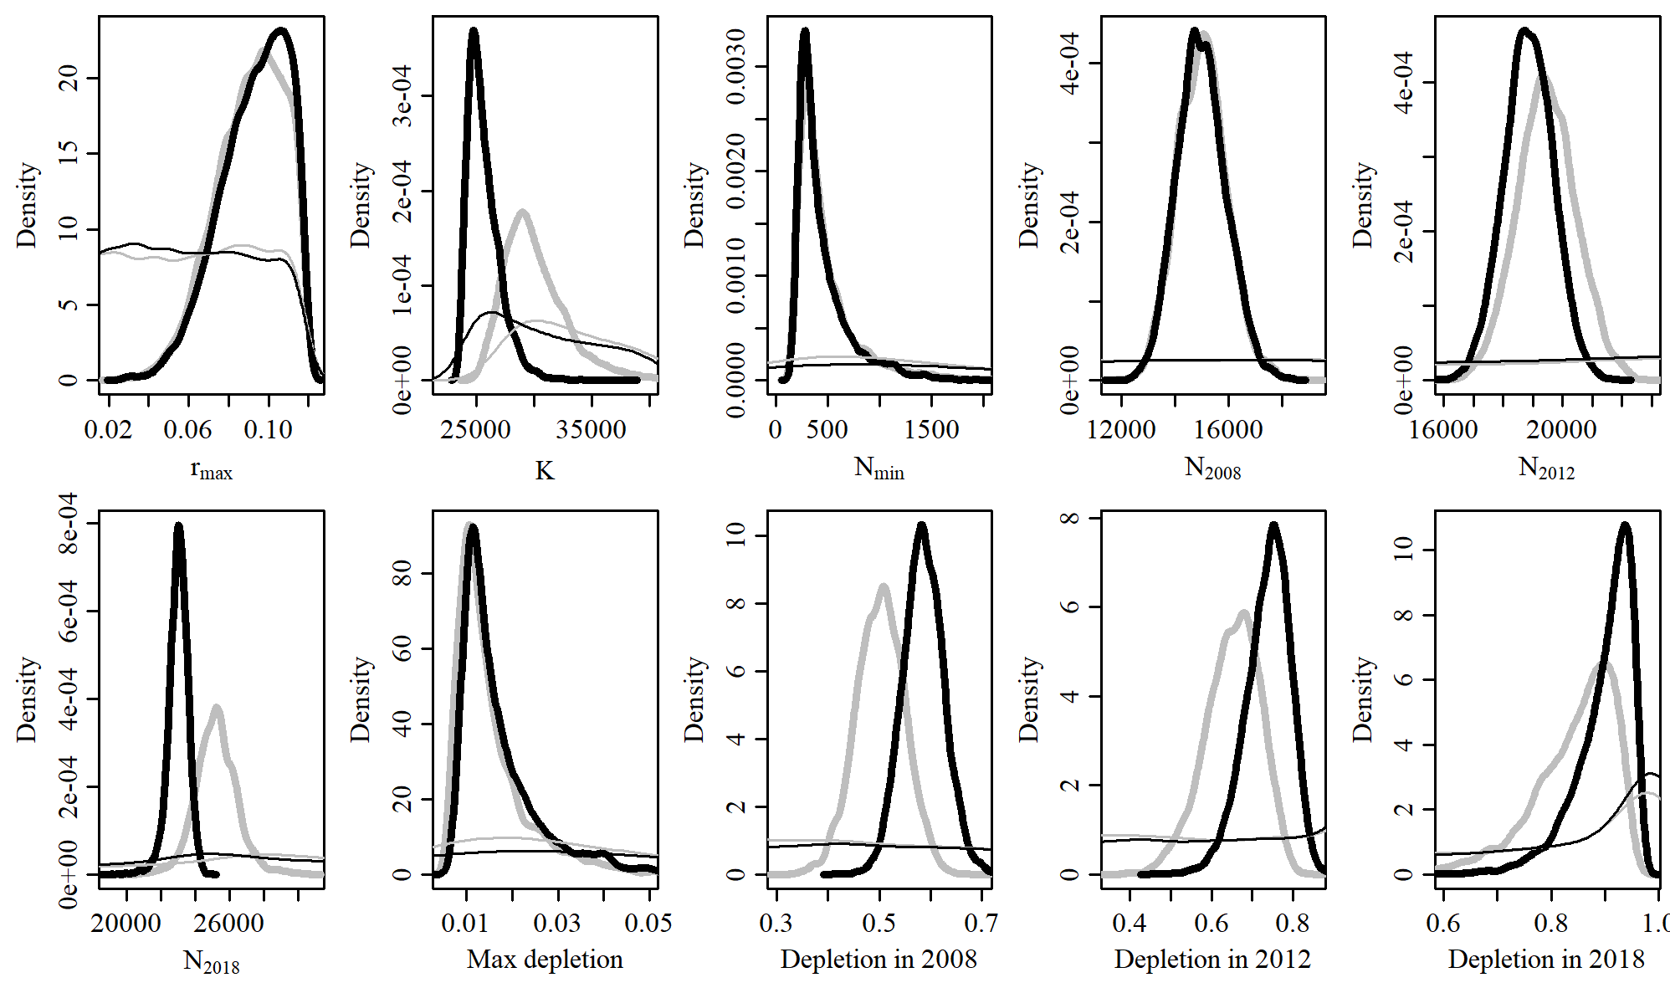

Figure 23. Posterior probability distributions of model parameters and derived quantities from the model fit to the absolute abundance from the SCatch 1 case scenario.

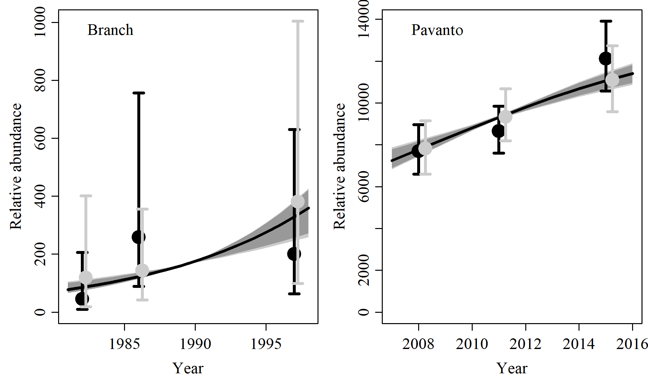

Figure 24. Fit of the model fit from the SCatch 1 scenario to indices of abundance. The solid line corresponds to the posterior median, light grey to the 95% credible interval, grey to the 90% credible interval, black error bars to the 95% confidence interval of the relative abundance estimates, and grey error bars to the 95% credible interval of the posterior predicted relative abundance.

Table 8. Population and parameter estimates from the model fit from the SCatch 1 scenario.

|  |  |  |  |  |  |  |
| --- | --- | --- | --- | --- | --- | --- |
| Parameter | Mean | Median | 2.5% CI | 5% CI | 95% CI | 97.5% CI |
|  | 0.093 | 0.095 | 0.056 | 0.062 | 0.117 | 0.115 |
|  | 25,671 | 25,345 | 23,818 | 23,962 | 29,155 | 28,376 |
|  | 460 | 360 | 199 | 210 | 1,237 | 1,055 |
|  | 15,003 | 14,962 | 13,303 | 13,545 | 16,893 | 16,571 |
|  | 18,864 | 18,861 | 17,192 | 17,490 | 20,478 | 20,219 |
|  | 23,009 | 23,043 | 21,737 | 22,042 | 24,020 | 23,870 |
| Max depletion | 0.017 | 0.014 | 0.008 | 0.009 | 0.042 | 0.038 |
| Depletion in 2008 | 0.586 | 0.585 | 0.509 | 0.52 | 0.666 | 0.653 |
| Depletion in 2012 | 0.737 | 0.744 | 0.617 | 0.639 | 0.829 | 0.817 |
| Depletion in 2018 | 0.899 | 0.914 | 0.759 | 0.793 | 0.963 | 0.958 |

# SCatch 2

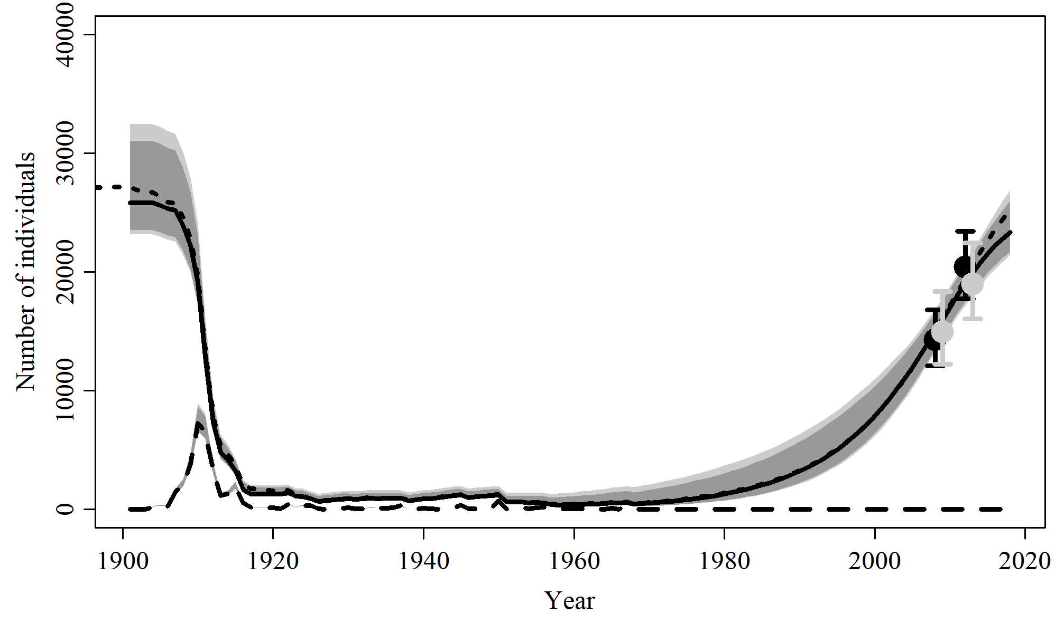

Figure 25. Population trajectory and fit of the model fit to the absolute abundance from the SCatch 2 case scenario. The solid line corresponds to the posterior median, dotted line to the posterior mean of the reference scenariolight grey to the 95% credible interval, grey to the 90% credible interval, black error bars to the 95% confidence interval of the abundance estimate, grey error bars to the 95% credible interval of the posterior predicted abundance estimate, and the dashed line to the catch series.

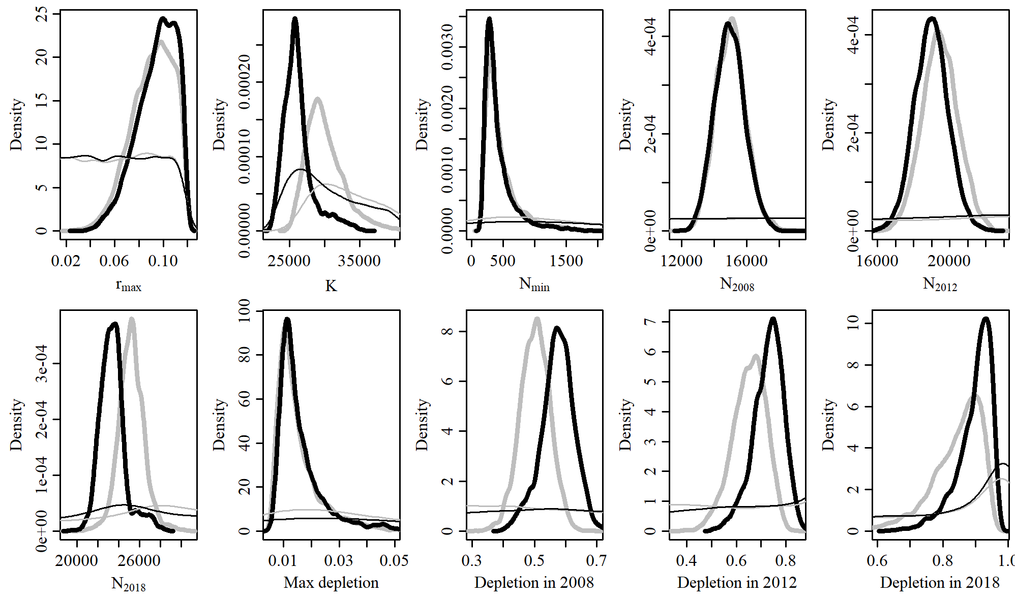

Figure 26. Posterior probability distributions of model parameters and derived quantities from the model fit to the absolute abundance from the SCatch 2 case scenario.

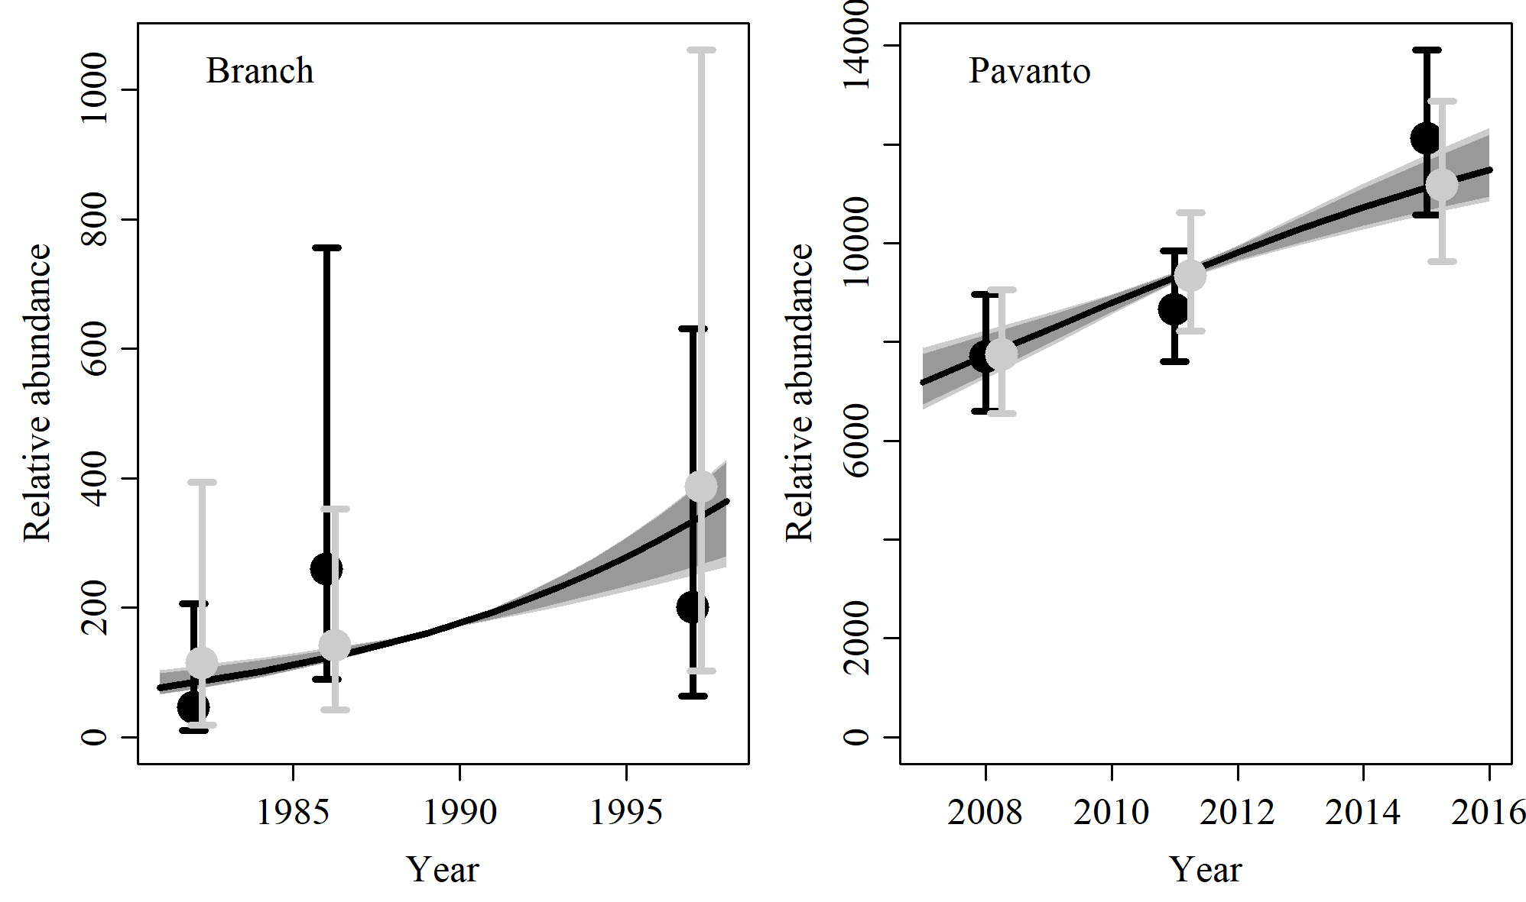

Figure 27. Fit of the model fit from the SCatch 2 scenario to indices of abundance. The solid line corresponds to the posterior median, light grey to the 95% credible interval, grey to the 90% credible interval, black error bars to the 95% confidence interval of the relative abundance estimates, and grey error bars to the 95% credible interval of the posterior predicted relative abundance.

Table 9. Population and parameter estimates from the model fit from the SCatch 2 scenario.

|  |  |  |  |  |  |  |
| --- | --- | --- | --- | --- | --- | --- |
| Parameter | Mean | Median | 2.5% CI | 5% CI | 95% CI | 97.5% CI |
|  | 0.094 | 0.097 | 0.058 | 0.065 | 0.117 | 0.116 |
|  | 26,215 | 25,829 | 23,167 | 23,511 | 32,461 | 31,043 |
|  | 435 | 346 | 191 | 204 | 1,252 | 979 |
|  | 14,959 | 14,941 | 13,221 | 13,465 | 16,856 | 16,533 |
|  | 18,988 | 18,993 | 17,160 | 17,483 | 20,857 | 20,518 |
|  | 23,432 | 23,349 | 21,407 | 21,699 | 26,901 | 26,015 |
| Max depletion | 0.016 | 0.013 | 0.007 | 0.008 | 0.045 | 0.036 |
| Depletion in 2008 | 0.574 | 0.576 | 0.457 | 0.478 | 0.67 | 0.657 |
| Depletion in 2012 | 0.728 | 0.735 | 0.592 | 0.615 | 0.831 | 0.818 |
| Depletion in 2018 | 0.897 | 0.911 | 0.755 | 0.789 | 0.963 | 0.958 |

# SCatch 3

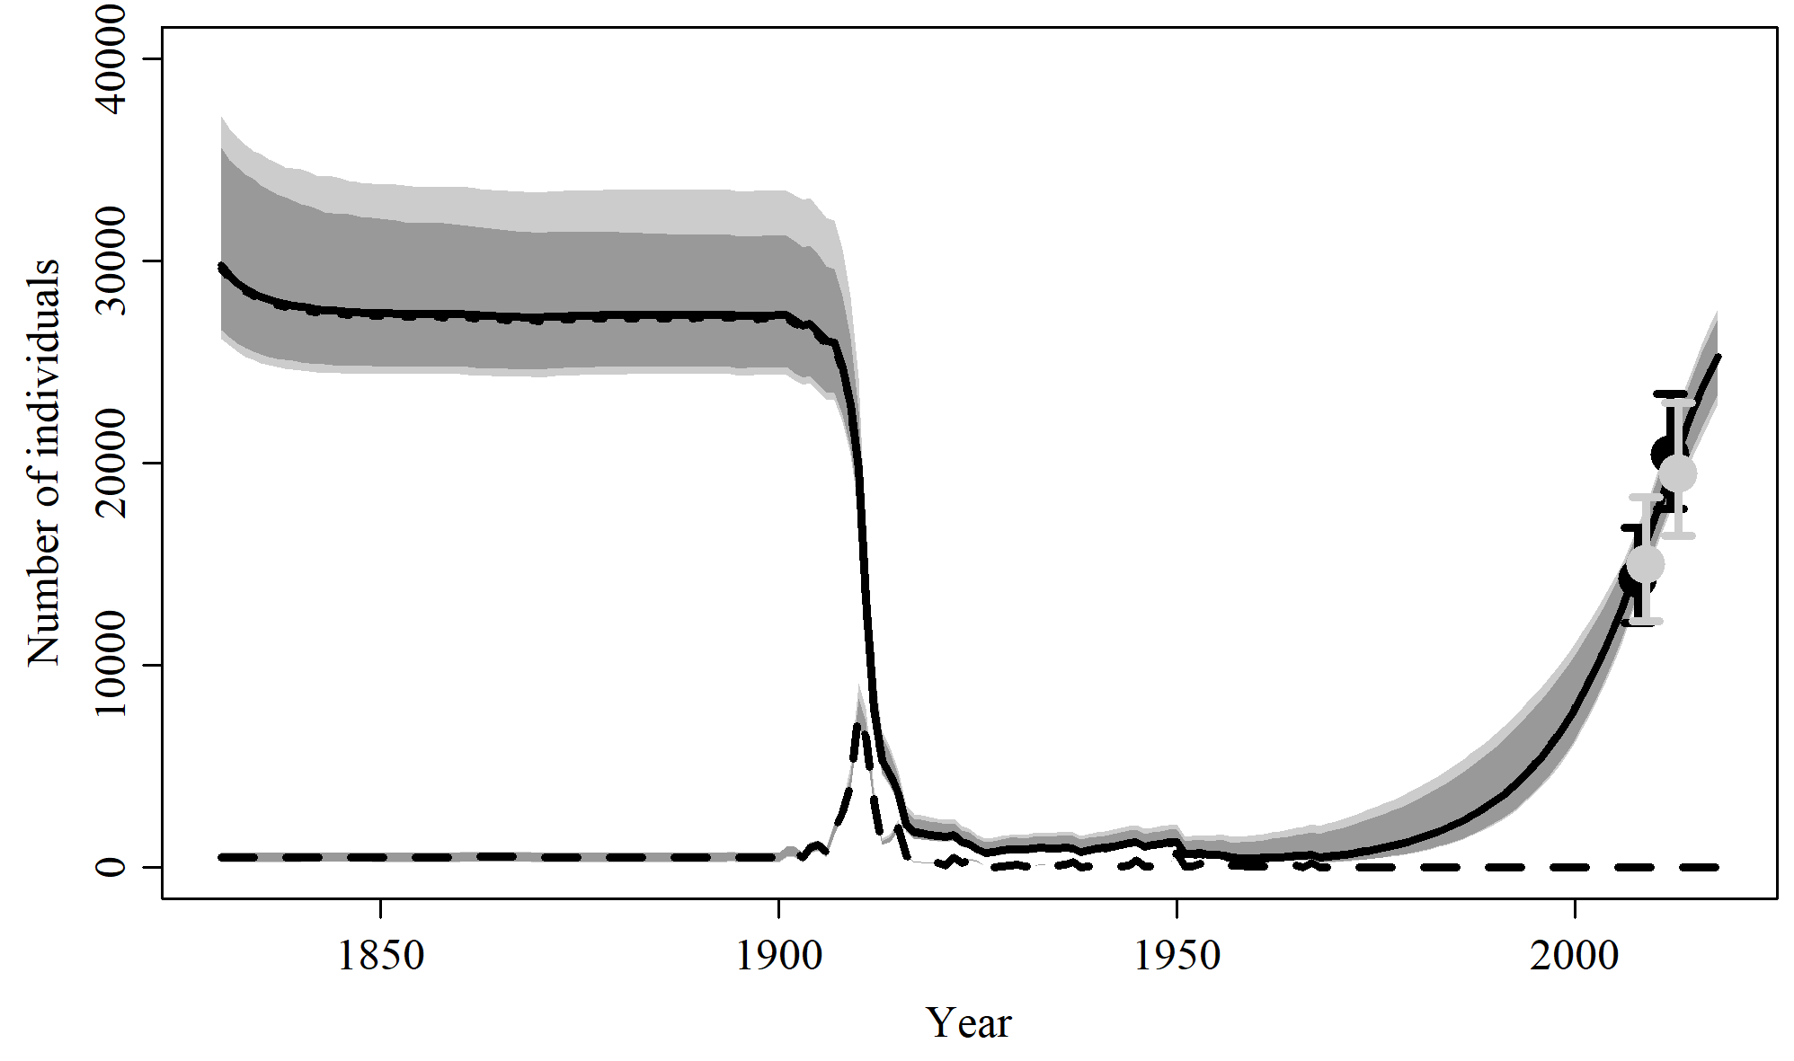

Figure 28. Population trajectory and fit of the model fit to the absolute abundance from the SCatch 3 case scenario. The solid line corresponds to the posterior median, dotted line to the posterior mean of the reference scenariolight grey to the 95% credible interval, grey to the 90% credible interval, black error bars to the 95% confidence interval of the abundance estimate, grey error bars to the 95% credible interval of the posterior predicted abundance estimate, and the dashed line to the catch series.

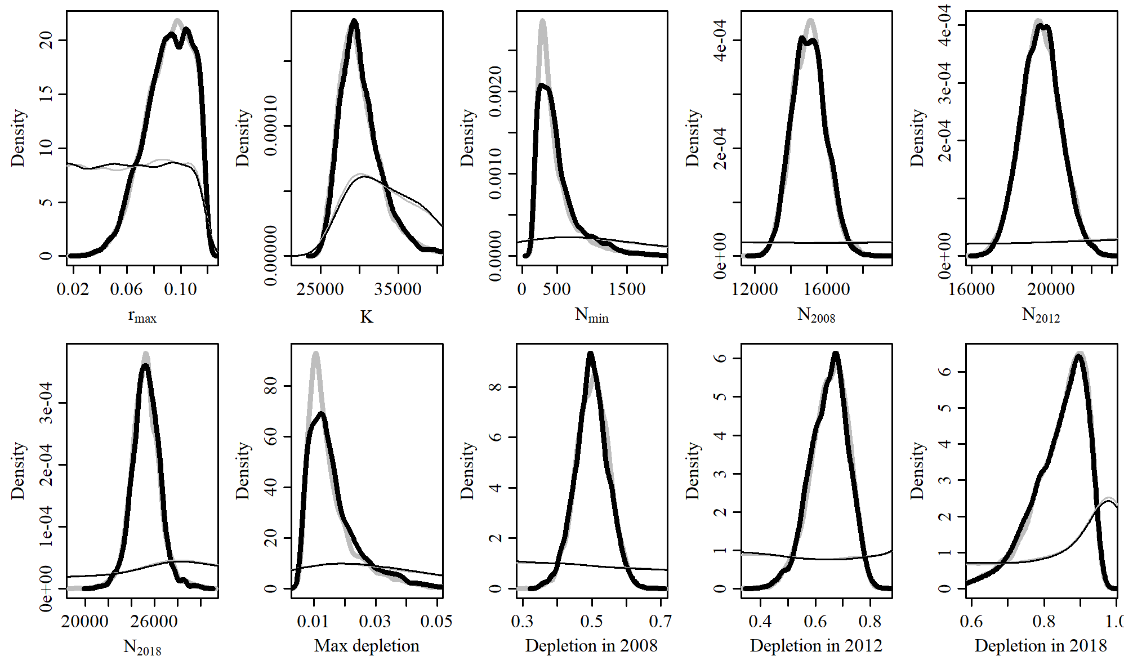

Figure 29. Posterior probability distributions of model parameters and derived quantities from the model fit to the absolute abundance from the SCatch 3 case scenario.

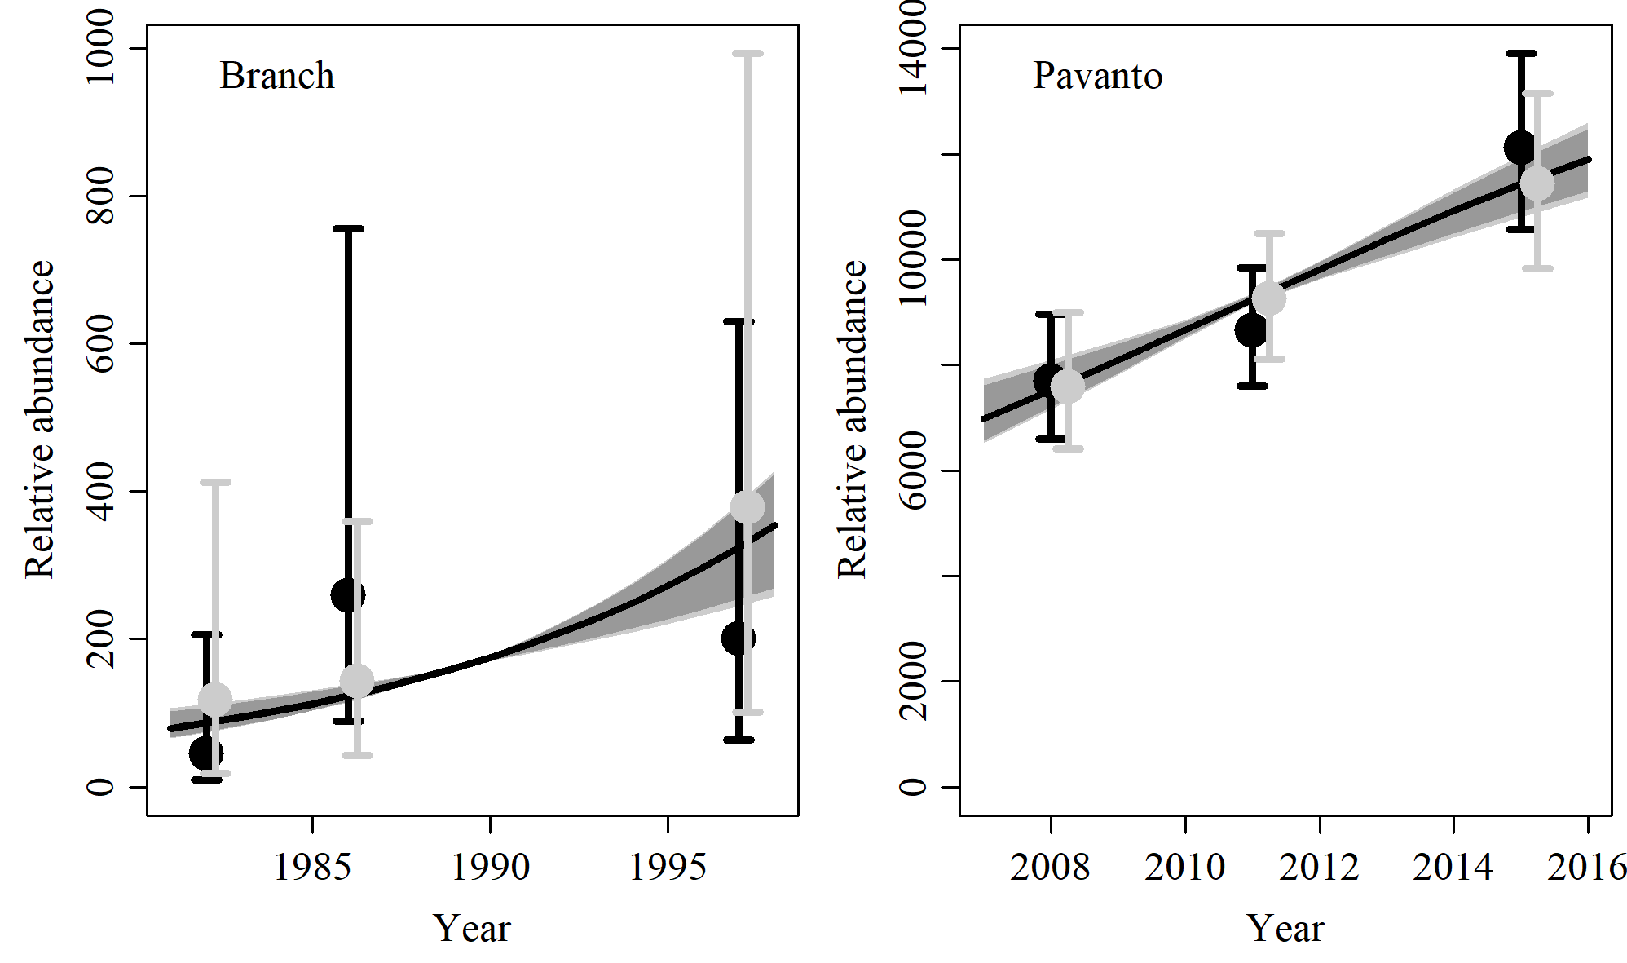

Figure 30. Fit of the model fit from the SCatch 3 scenario to indices of abundance. The solid line corresponds to the posterior median, light grey to the 95% credible interval, grey to the 90% credible interval, black error bars to the 95% confidence interval of the relative abundance estimates, and grey error bars to the 95% credible interval of the posterior predicted relative abundance.

Table 10. Population and parameter estimates from the model fit from the SCatch 3 scenario.

|  |  |  |  |  |  |  |
| --- | --- | --- | --- | --- | --- | --- |
| Parameter | Mean | Median | 2.5% CI | 5% CI | 95% CI | 97.5% CI |
|  | 0.091 | 0.093 | 0.055 | 0.06 | 0.117 | 0.115 |
|  | 30,272 | 29,769 | 26,157 | 26,571 | 37,154 | 35,605 |
|  | 514 | 418 | 191 | 204 | 1,391 | 1,186 |
|  | 15,013 | 14,981 | 13,325 | 13,536 | 16,880 | 16,570 |
|  | 19,478 | 19,464 | 17,612 | 17,891 | 21,441 | 21,088 |
|  | 25,274 | 25,264 | 22,903 | 23,388 | 27,668 | 27,132 |
| Max depletion | 0.016 | 0.014 | 0.007 | 0.007 | 0.04 | 0.035 |
| Depletion in 2008 | 0.499 | 0.499 | 0.406 | 0.419 | 0.593 | 0.577 |
| Depletion in 2012 | 0.649 | 0.655 | 0.504 | 0.532 | 0.77 | 0.753 |
| Depletion in 2018 | 0.841 | 0.858 | 0.651 | 0.694 | 0.942 | 0.935 |

# SCatch 4

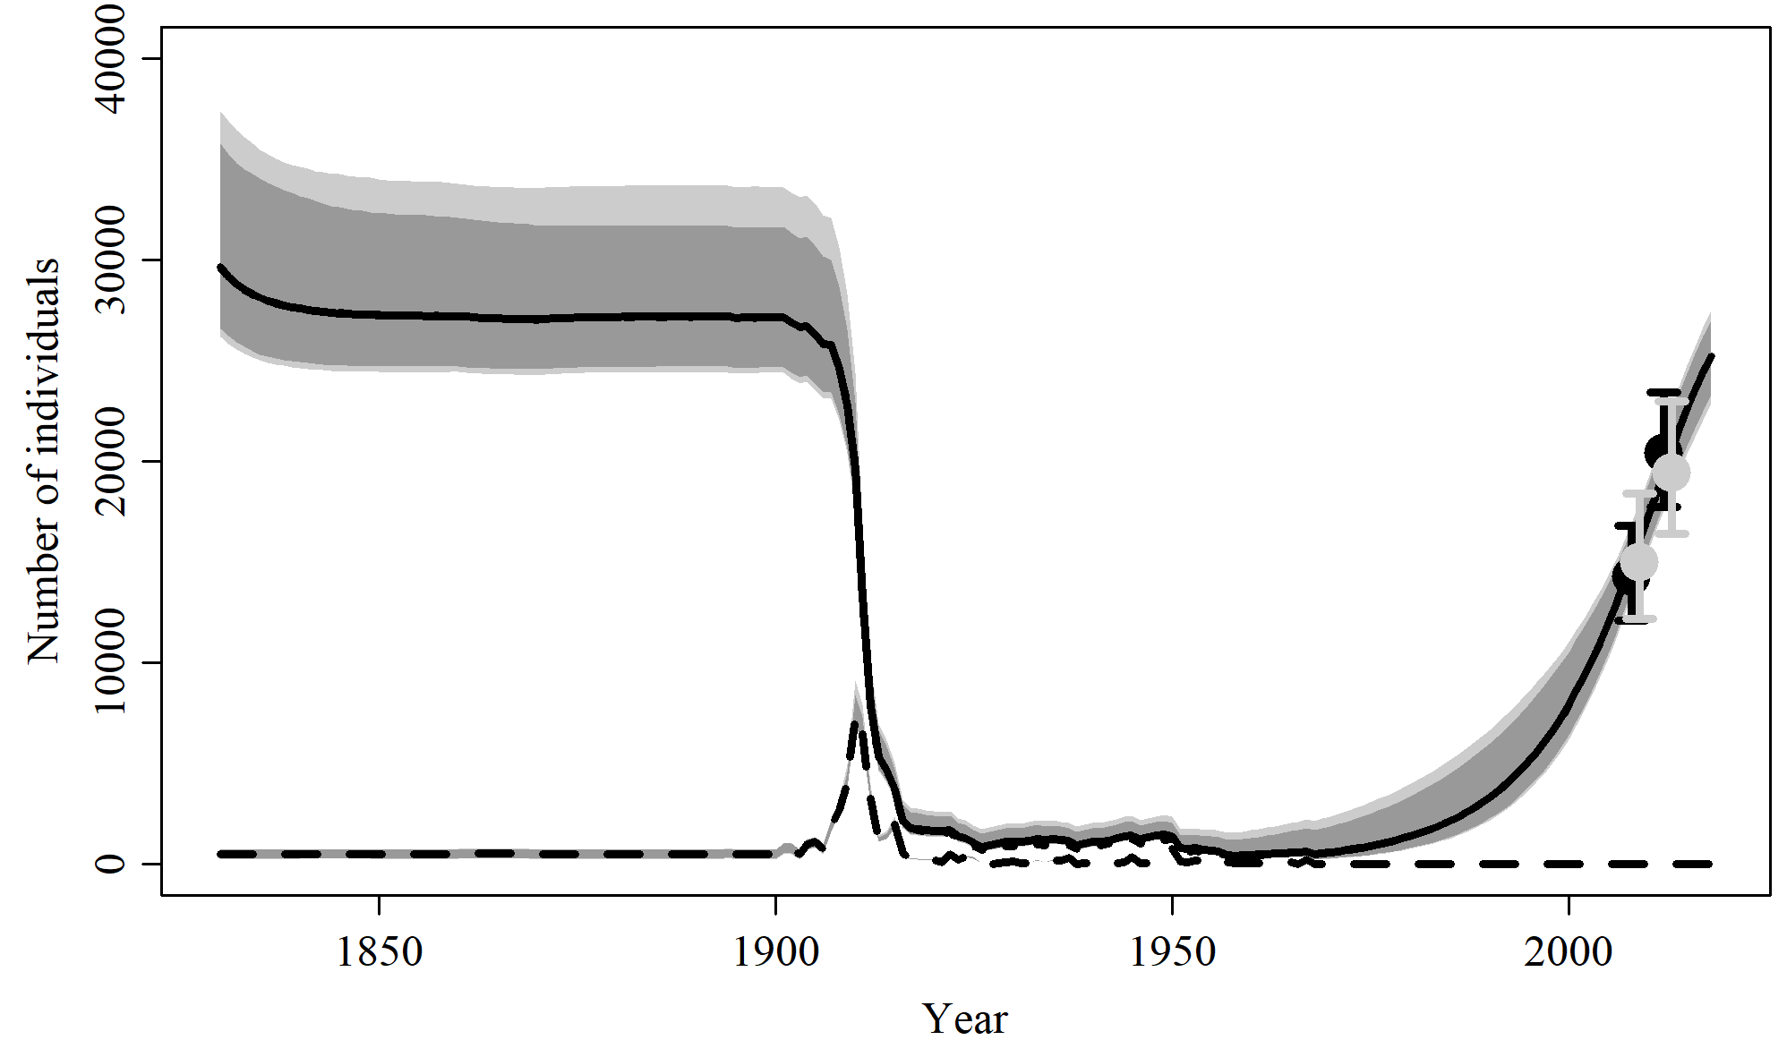

Figure 31. Population trajectory and fit of the model fit to the absolute abundance from the SCatch 4 case scenario. The solid line corresponds to the posterior median, dotted line to the posterior mean of the reference scenariolight grey to the 95% credible interval, grey to the 90% credible interval, black error bars to the 95% confidence interval of the abundance estimate, grey error bars to the 95% credible interval of the posterior predicted abundance estimate, and the dashed line to the catch series.

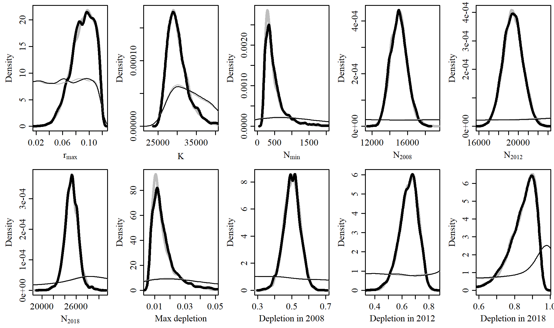

Figure 32. Posterior probability distributions of model parameters and derived quantities from the model fit to the absolute abundance from the SCatch 4 case scenario.

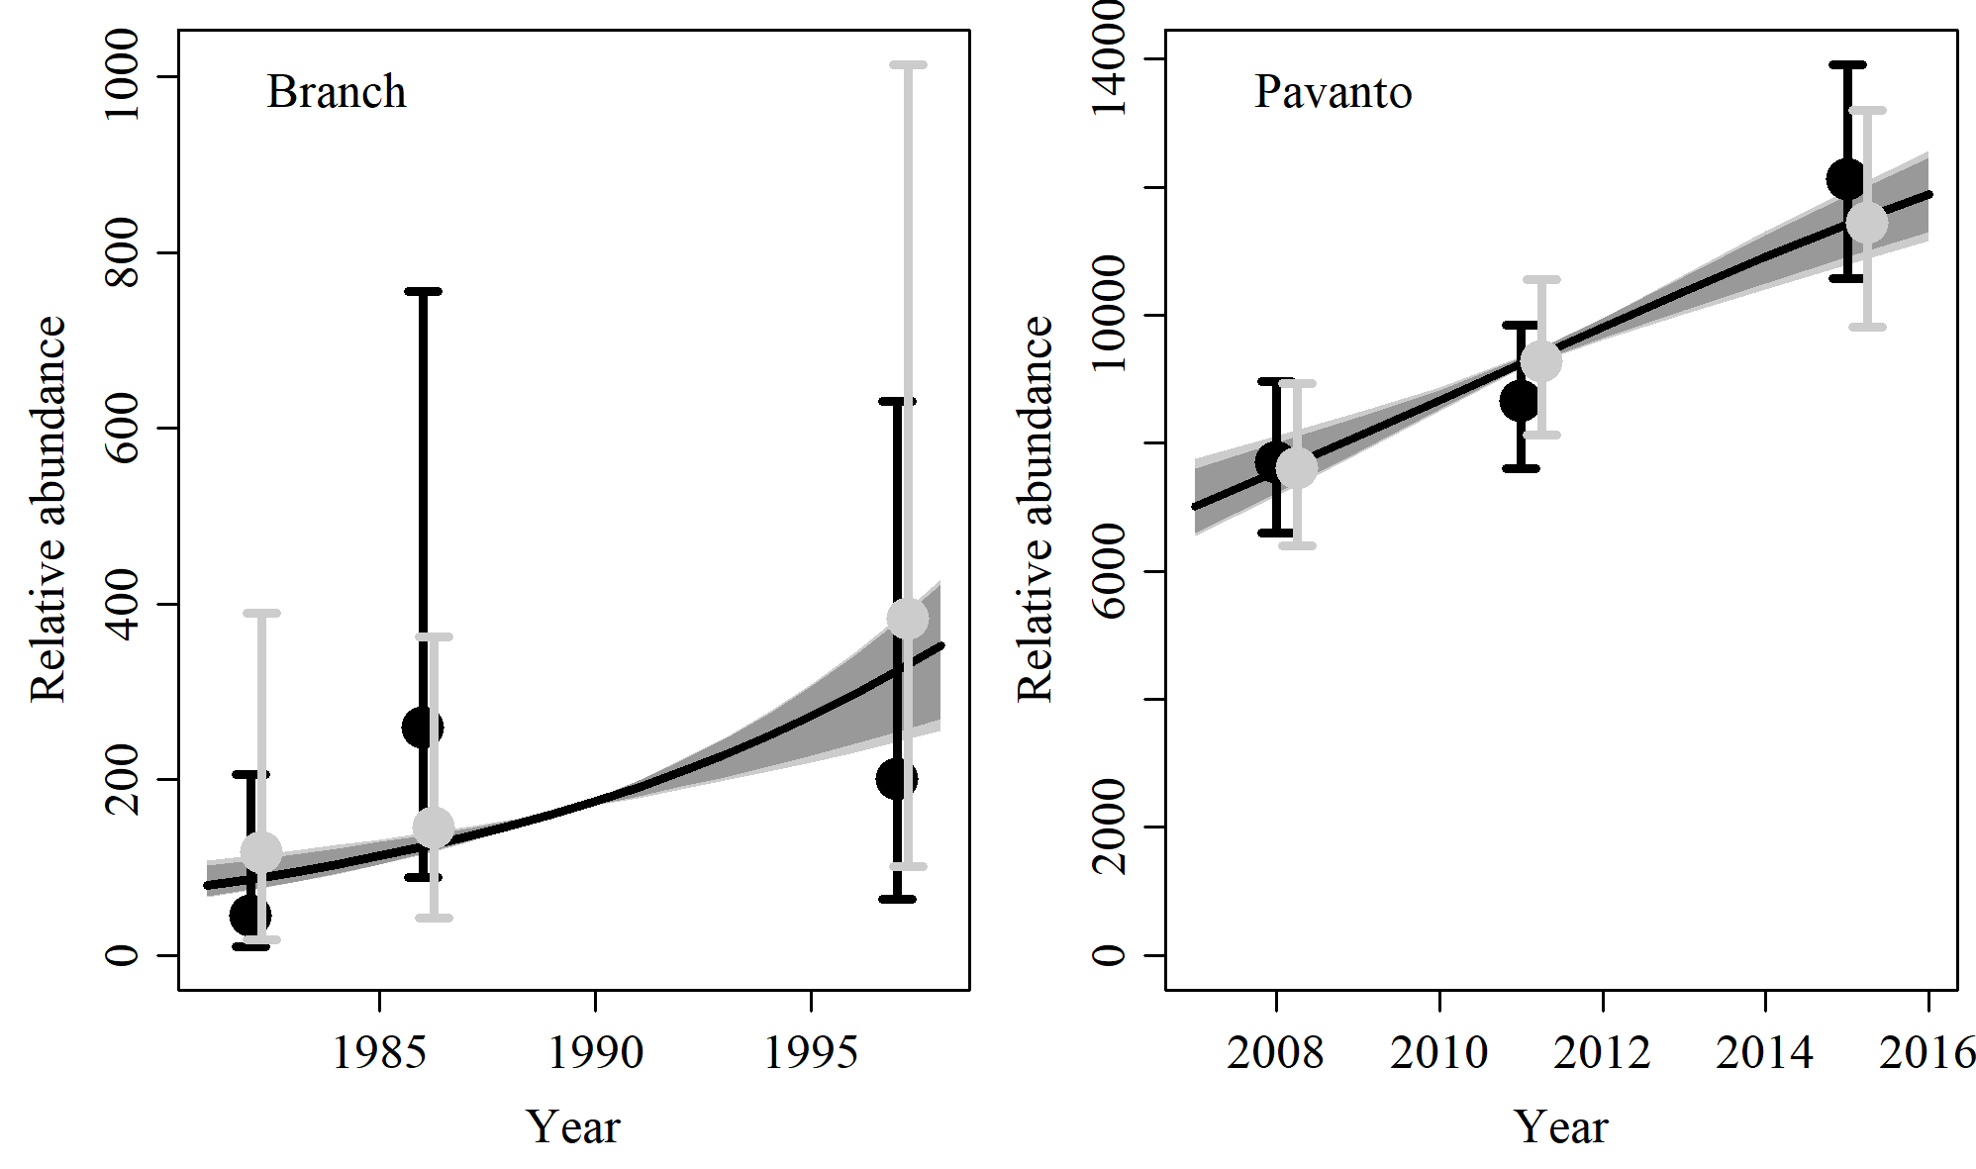

Figure 33. Fit of the model fit from the SCatch 4 scenario to indices of abundance. The solid line corresponds to the posterior median, light grey to the 95% credible interval, grey to the 90% credible interval, black error bars to the 95% confidence interval of the relative abundance estimates, and grey error bars to the 95% credible interval of the posterior predicted relative abundance.

Table 11. Population and parameter estimates from the model fit from the SCatch 4 scenario.

|  |  |  |  |  |  |  |
| --- | --- | --- | --- | --- | --- | --- |
| Parameter | Mean | Median | 2.5% CI | 5% CI | 95% CI | 97.5% CI |
|  | 0.091 | 0.093 | 0.053 | 0.059 | 0.116 | 0.115 |
|  | 30,188 | 29,644 | 26,192 | 26,604 | 37,394 | 35,777 |
|  | 510 | 398 | 197 | 208 | 1,529 | 1,182 |
|  | 15,012 | 15,005 | 13,307 | 13,534 | 16,929 | 16,629 |
|  | 19,445 | 19,441 | 17,552 | 17,849 | 21,372 | 21,071 |
|  | 25,191 | 25,207 | 22,830 | 23,295 | 27,531 | 26,986 |
| Max depletion | 0.016 | 0.014 | 0.007 | 0.007 | 0.044 | 0.035 |
| Depletion in 2008 | 0.501 | 0.502 | 0.398 | 0.421 | 0.591 | 0.578 |
| Depletion in 2012 | 0.65 | 0.656 | 0.501 | 0.527 | 0.766 | 0.754 |
| Depletion in 2018 | 0.841 | 0.859 | 0.646 | 0.69 | 0.941 | 0.935 |

# SCatch 5

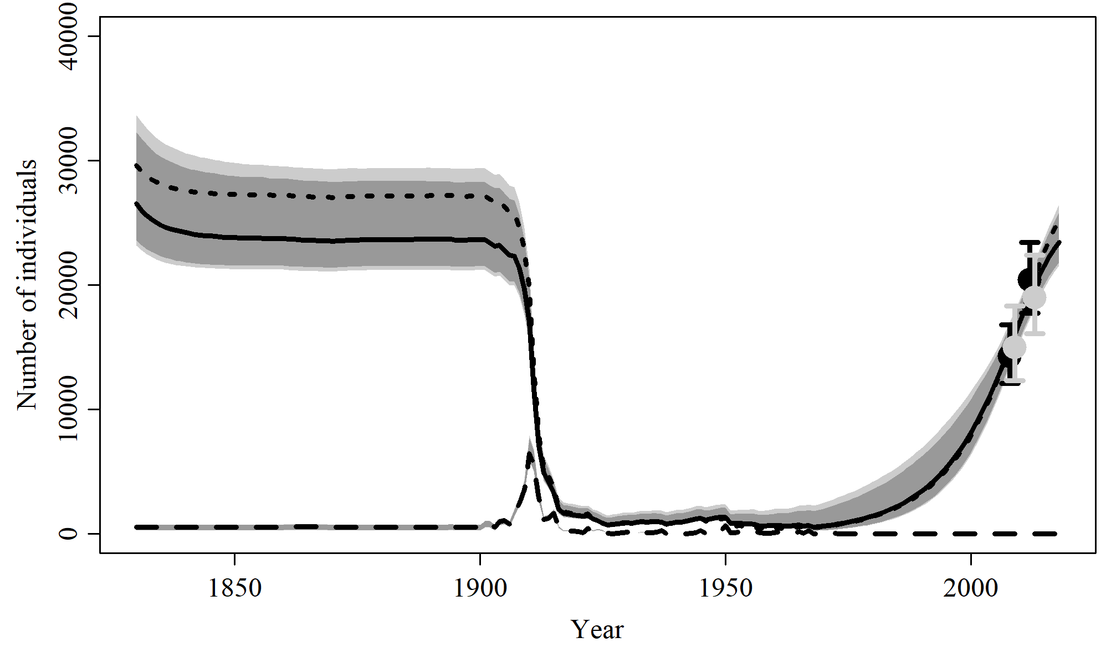

Figure 34. Population trajectory and fit of the model fit to the absolute abundance from the SCatch 5 case scenario. The solid line corresponds to the posterior median, dotted line to the posterior mean of the reference scenariolight grey to the 95% credible interval, grey to the 90% credible interval, black error bars to the 95% confidence interval of the abundance estimate, grey error bars to the 95% credible interval of the posterior predicted abundance estimate, and the dashed line to the catch series.

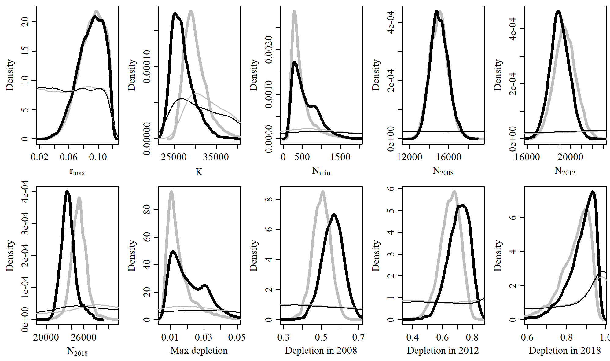

Figure 35. Posterior probability distributions of model parameters and derived quantities from the model fit to the absolute abundance from the SCatch 5 case scenario.

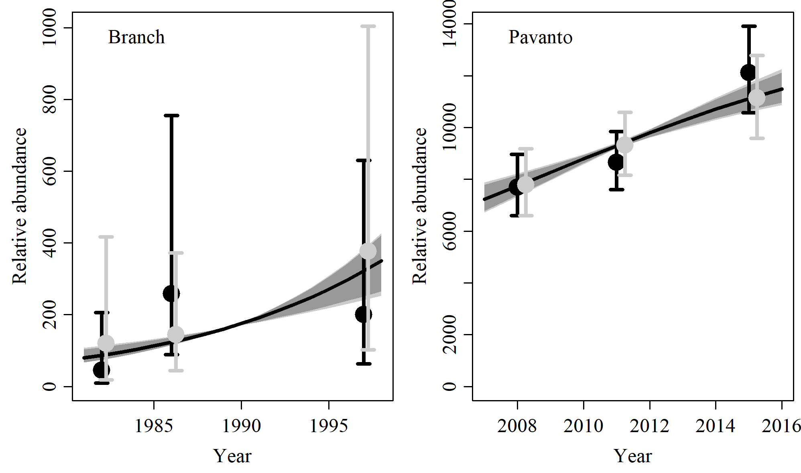

Figure 36. Fit of the model fit from the SCatch 5 scenario to indices of abundance. The solid line corresponds to the posterior median, light grey to the 95% credible interval, grey to the 90% credible interval, black error bars to the 95% confidence interval of the relative abundance estimates, and grey error bars to the 95% credible interval of the posterior predicted relative abundance.

Table 12. Population and parameter estimates from the model fit from the SCatch 5 scenario.

|  |  |  |  |  |  |  |
| --- | --- | --- | --- | --- | --- | --- |
| Parameter | Mean | Median | 2.5% CI | 5% CI | 95% CI | 97.5% CI |
|  | 0.09 | 0.092 | 0.053 | 0.058 | 0.116 | 0.115 |
|  | 27,057 | 26,524 | 23,171 | 23,589 | 33,678 | 32,285 |
|  | 598 | 494 | 201 | 215 | 1,457 | 1,253 |
|  | 15,049 | 14,995 | 13,356 | 13,604 | 17,012 | 16,628 |
|  | 18,990 | 18,960 | 17,259 | 17,527 | 20,786 | 20,483 |
|  | 23,543 | 23,443 | 21,537 | 21,817 | 26,487 | 25,817 |
| Max depletion | 0.021 | 0.019 | 0.008 | 0.009 | 0.046 | 0.041 |
| Depletion in 2008 | 0.561 | 0.563 | 0.445 | 0.464 | 0.669 | 0.652 |
| Depletion in 2012 | 0.709 | 0.715 | 0.554 | 0.581 | 0.829 | 0.815 |
| Depletion in 2018 | 0.877 | 0.893 | 0.7 | 0.736 | 0.962 | 0.956 |

# GC 1

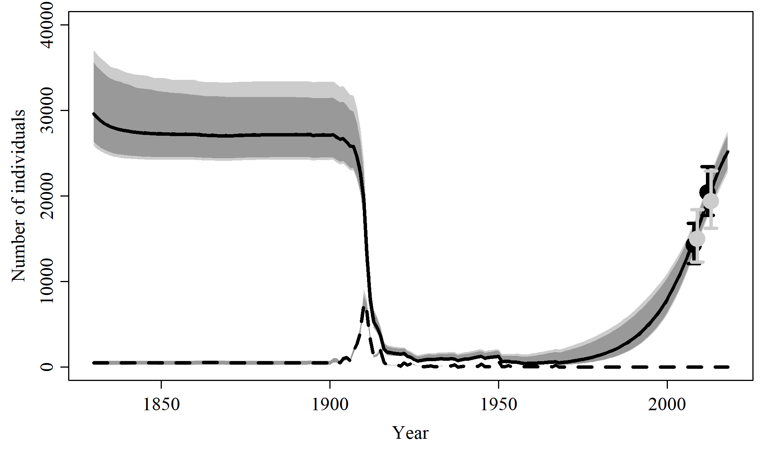

Figure 37. Population trajectory and fit of the model fit to the absolute abundance from the GC 1 case scenario. The solid line corresponds to the posterior median, dotted line to the posterior mean of the reference scenariolight grey to the 95% credible interval, grey to the 90% credible interval, black error bars to the 95% confidence interval of the abundance estimate, grey error bars to the 95% credible interval of the posterior predicted abundance estimate, and the dashed line to the catch series.

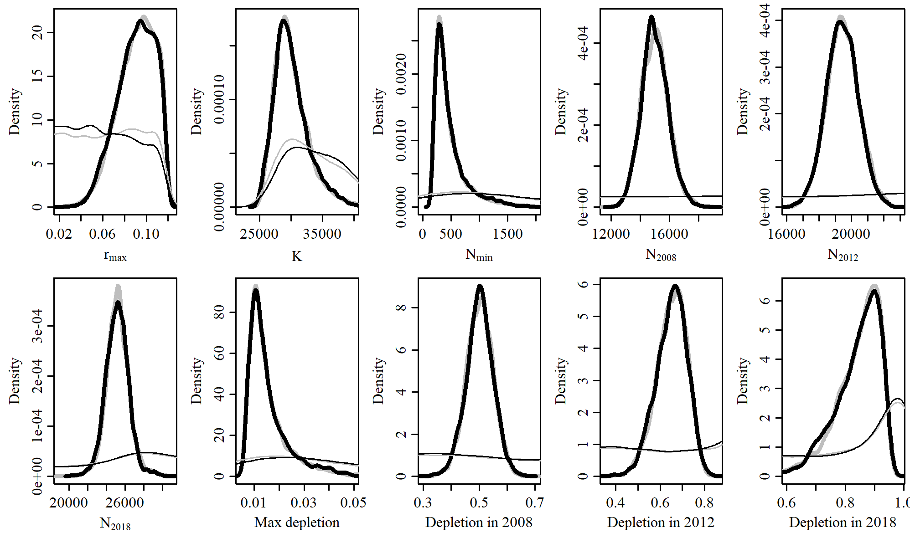

Figure 38. Posterior probability distributions of model parameters and derived quantities from the model fit to the absolute abundance from the GC 1 case scenario.

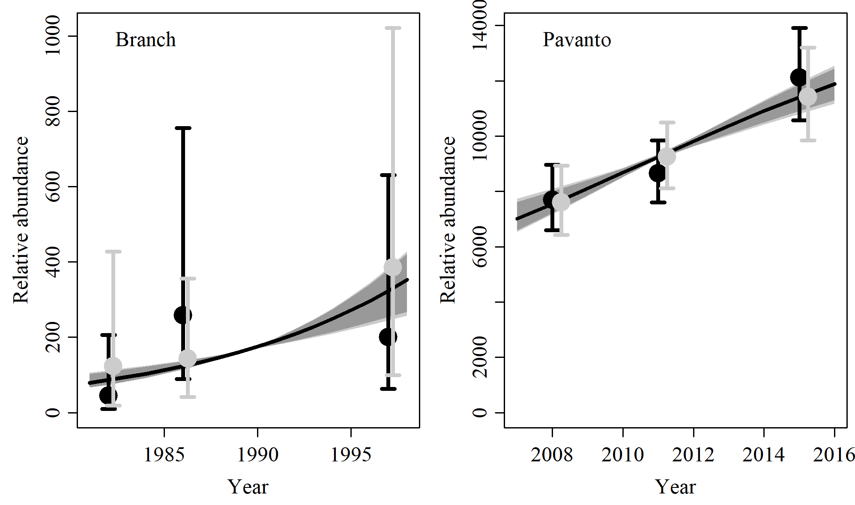

Figure 39. Fit of the model fit from the GC 1 scenario to indices of abundance. The solid line corresponds to the posterior median, light grey to the 95% credible interval, grey to the 90% credible interval, black error bars to the 95% confidence interval of the relative abundance estimates, and grey error bars to the 95% credible interval of the posterior predicted relative abundance.

Table 13. Population and parameter estimates from the model fit from the GC 1 scenario.

|  |  |  |  |  |  |  |
| --- | --- | --- | --- | --- | --- | --- |
| Parameter | Mean | Median | 2.5% CI | 5% CI | 95% CI | 97.5% CI |
|  | 0.09 | 0.092 | 0.054 | 0.059 | 0.117 | 0.115 |
|  | 30,126 | 29,622 | 25,830 | 26,315 | 37,054 | 35,620 |
|  | 488 | 385 | 192 | 207 | 1,369 | 1,165 |
|  | 15,007 | 14,955 | 13,277 | 13,530 | 16,925 | 16,563 |
|  | 19,429 | 19,425 | 17,490 | 17,811 | 21,361 | 21,056 |
|  | 25,153 | 25,166 | 22,752 | 23,181 | 27,562 | 27,080 |
| Max depletion | 0.016 | 0.013 | 0.007 | 0.007 | 0.04 | 0.035 |
| Depletion in 2008 | 0.502 | 0.503 | 0.404 | 0.42 | 0.595 | 0.579 |
| Depletion in 2012 | 0.651 | 0.656 | 0.508 | 0.531 | 0.77 | 0.753 |
| Depletion in 2018 | 0.841 | 0.859 | 0.662 | 0.693 | 0.943 | 0.935 |

# GC 2

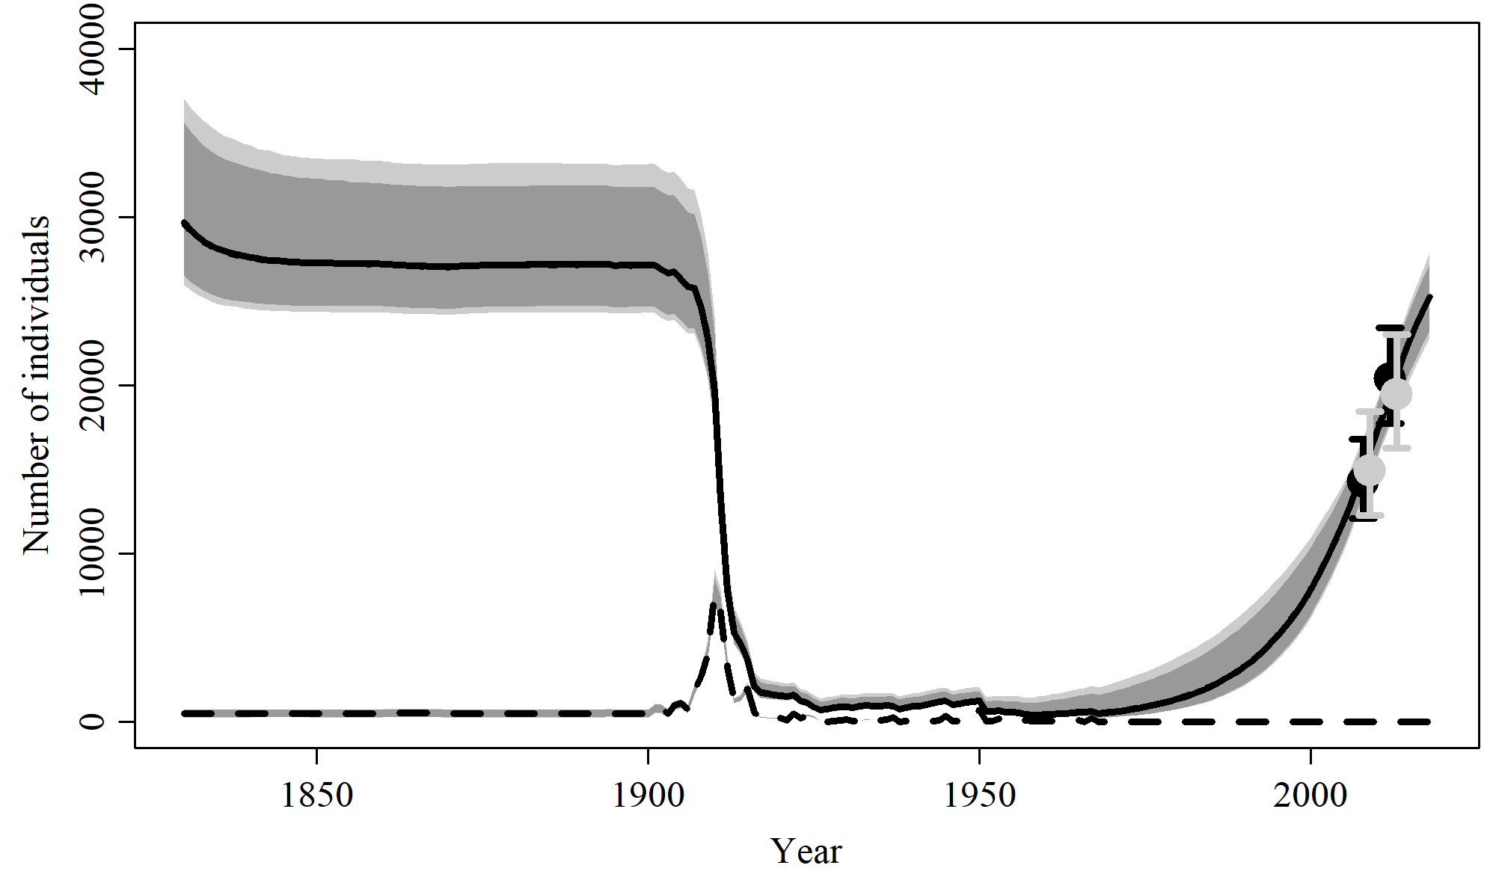

Figure 40. Population trajectory and fit of the model fit to the absolute abundance from the GC 2 case scenario. The solid line corresponds to the posterior median, dotted line to the posterior mean of the reference scenariolight grey to the 95% credible interval, grey to the 90% credible interval, black error bars to the 95% confidence interval of the abundance estimate, grey error bars to the 95% credible interval of the posterior predicted abundance estimate, and the dashed line to the catch series.

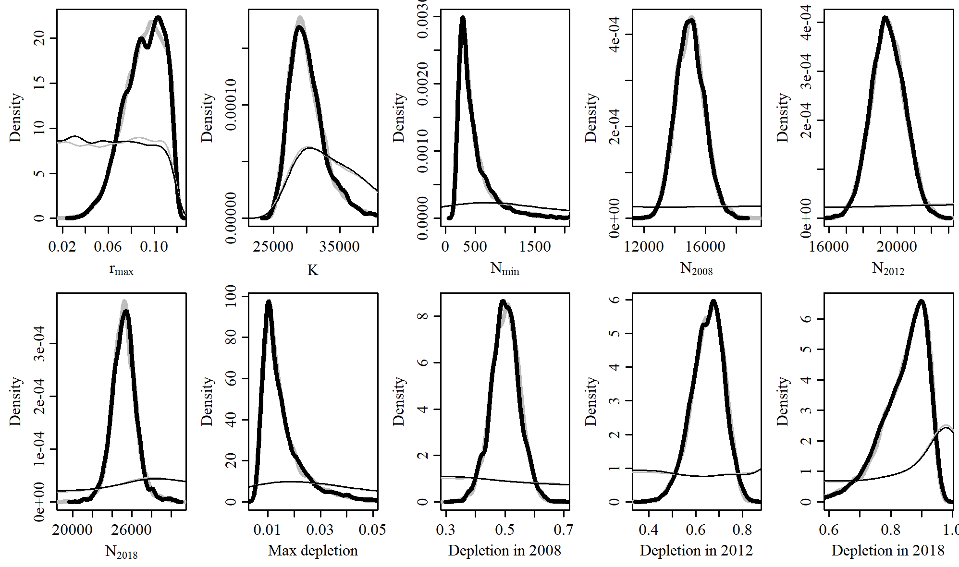

Figure 41. Posterior probability distributions of model parameters and derived quantities from the model fit to the absolute abundance from the GC 2 case scenario.

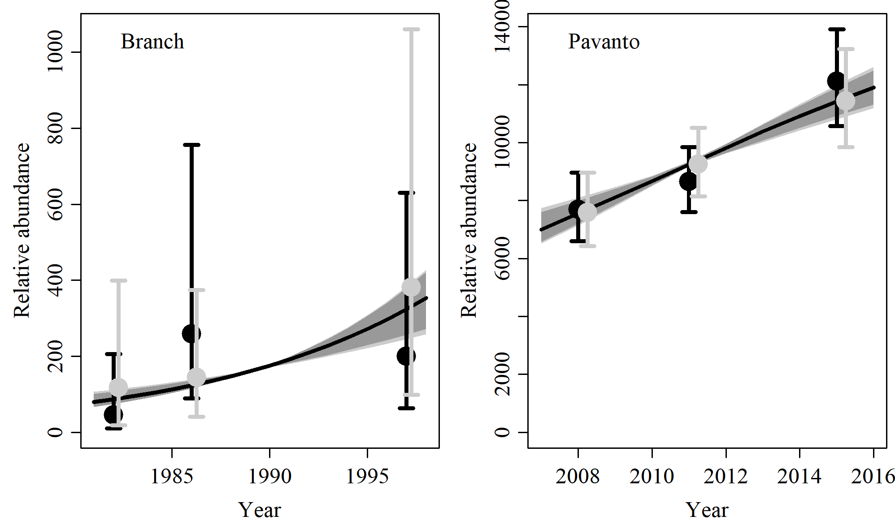

Figure 42. Fit of the model fit from the GC 2 scenario to indices of abundance. The solid line corresponds to the posterior median, light grey to the 95% credible interval, grey to the 90% credible interval, black error bars to the 95% confidence interval of the relative abundance estimates, and grey error bars to the 95% credible interval of the posterior predicted relative abundance.

Table 14. Population and parameter estimates from the model fit from the GC 2 scenario.

|  |  |  |  |  |  |  |
| --- | --- | --- | --- | --- | --- | --- |
| Parameter | Mean | Median | 2.5% CI | 5% CI | 95% CI | 97.5% CI |
|  | 0.091 | 0.093 | 0.055 | 0.061 | 0.116 | 0.114 |
|  | 30,162 | 29,680 | 25,968 | 26,561 | 37,056 | 35,619 |
|  | 479 | 378 | 197 | 206 | 1,352 | 1,093 |
|  | 14,998 | 14,976 | 13,297 | 13,553 | 16,852 | 16,536 |
|  | 19,452 | 19,428 | 17,559 | 17,871 | 21,347 | 21,069 |
|  | 25,222 | 25,234 | 22,784 | 23,253 | 27,906 | 27,169 |
| Max depletion | 0.015 | 0.013 | 0.007 | 0.007 | 0.039 | 0.033 |
| Depletion in 2008 | 0.501 | 0.5 | 0.404 | 0.419 | 0.597 | 0.582 |
| Depletion in 2012 | 0.65 | 0.655 | 0.506 | 0.532 | 0.773 | 0.757 |
| Depletion in 2018 | 0.842 | 0.859 | 0.656 | 0.698 | 0.944 | 0.936 |

# MSYR 1

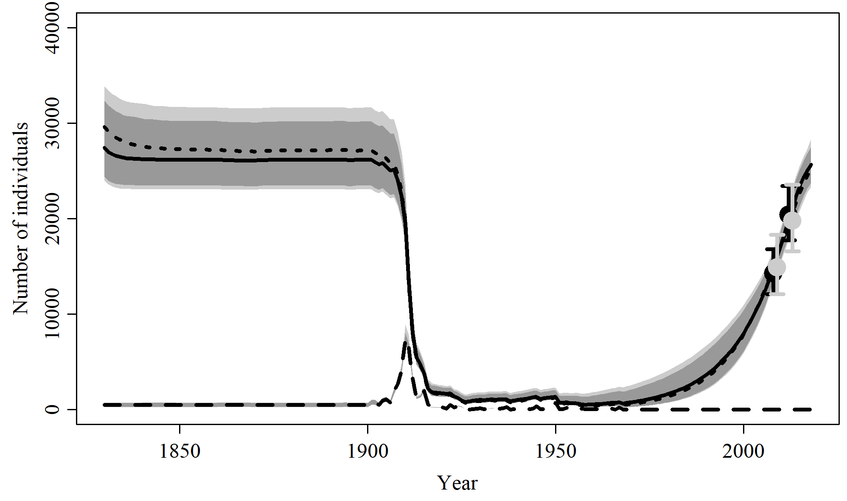

Figure 43. Population trajectory and fit of the model fit to the absolute abundance from the MSYR 1 case scenario. The solid line corresponds to the posterior median, dotted line to the posterior mean of the reference scenariolight grey to the 95% credible interval, grey to the 90% credible interval, black error bars to the 95% confidence interval of the abundance estimate, grey error bars to the 95% credible interval of the posterior predicted abundance estimate, and the dashed line to the catch series.

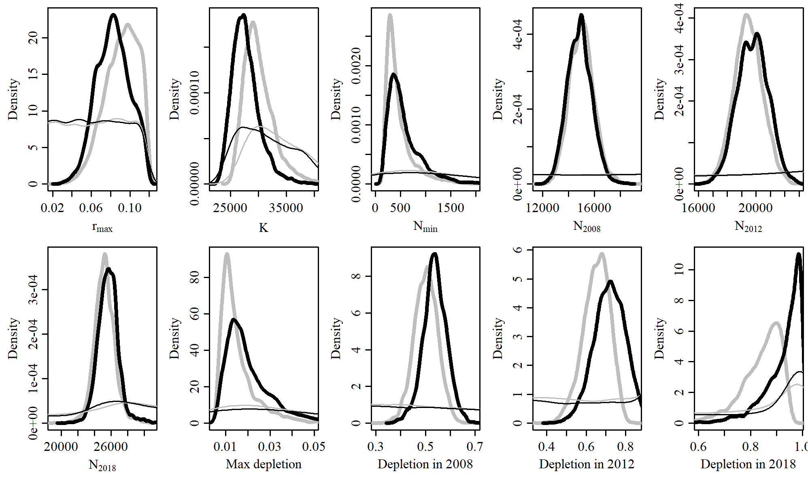

Figure 44. Posterior probability distributions of model parameters and derived quantities from the model fit to the absolute abundance from the MSYR 1 case scenario.

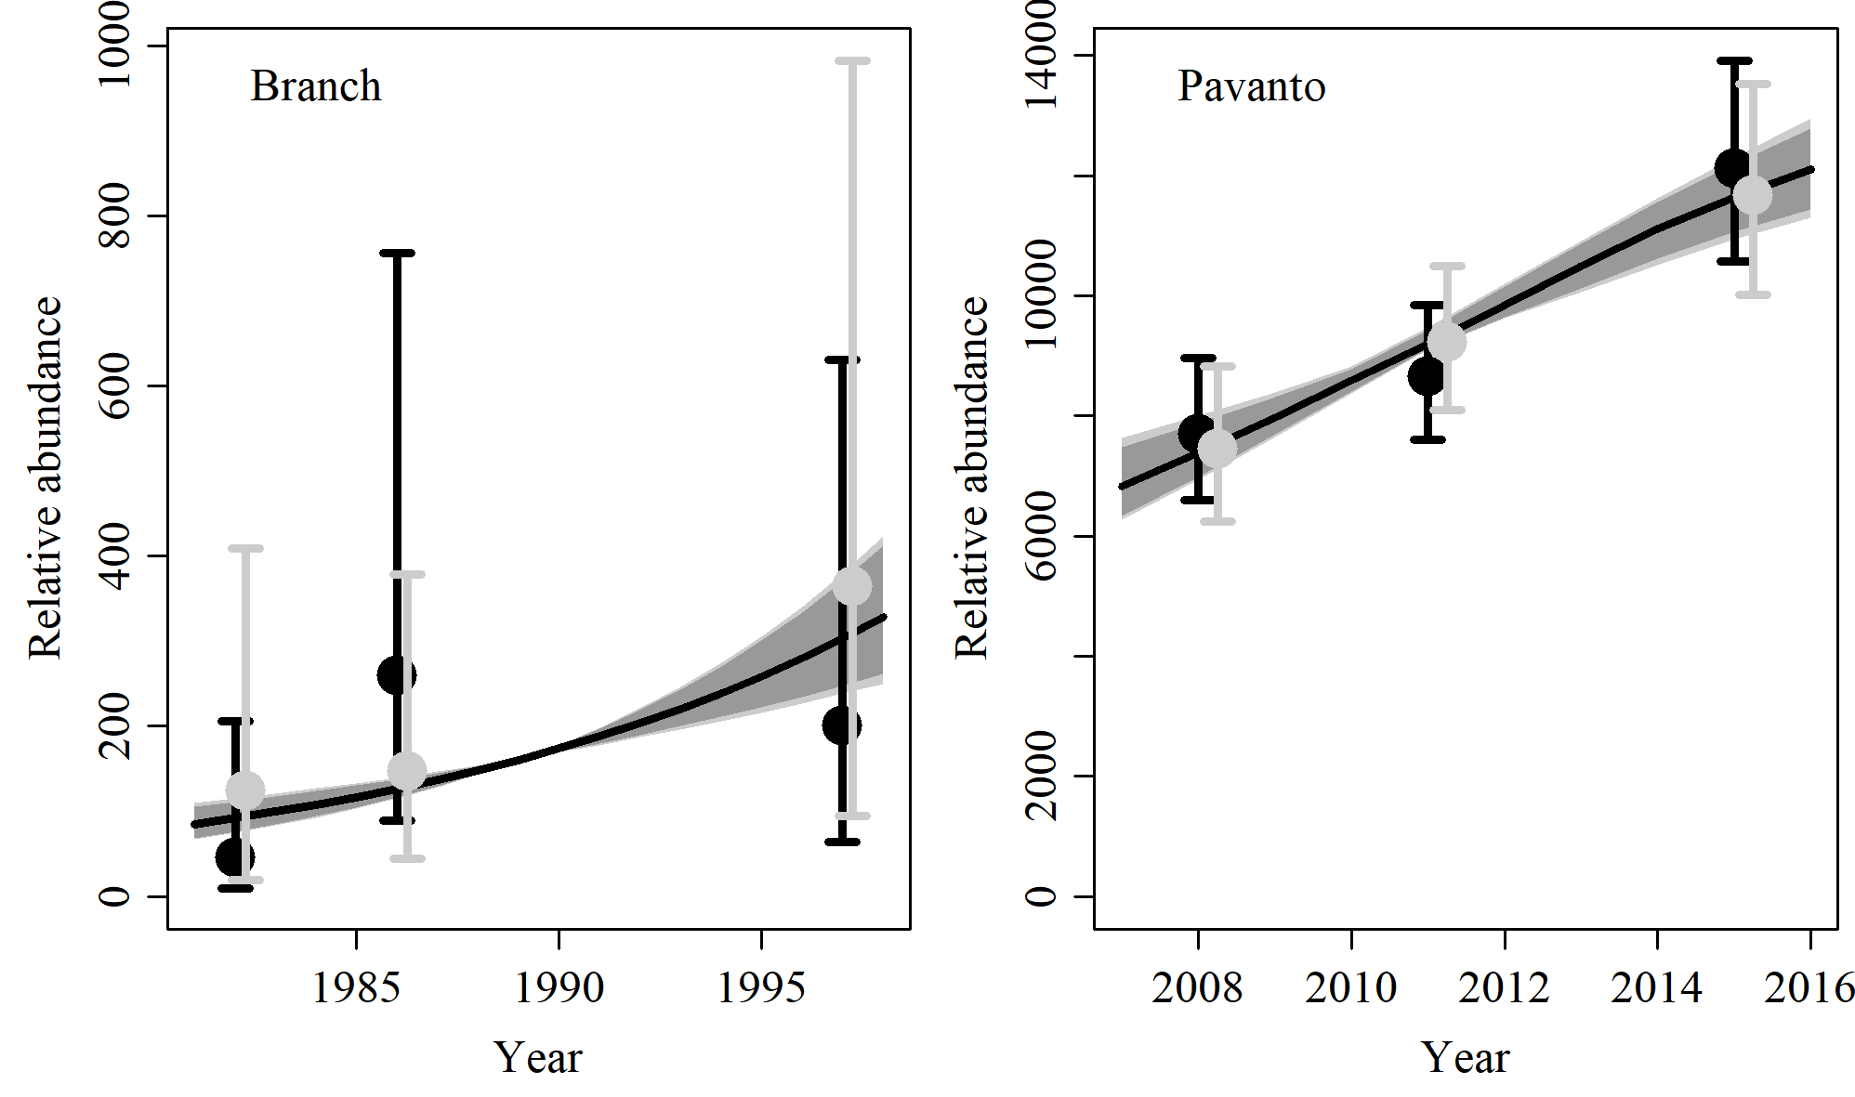

Figure 45. Fit of the model fit from the MSYR 1 scenario to indices of abundance. The solid line corresponds to the posterior median, light grey to the 95% credible interval, grey to the 90% credible interval, black error bars to the 95% confidence interval of the relative abundance estimates, and grey error bars to the 95% credible interval of the posterior predicted relative abundance.

Table 15. Population and parameter estimates from the model fit from the MSYR 1 scenario.

|  |  |  |  |  |  |  |
| --- | --- | --- | --- | --- | --- | --- |
| Parameter | Mean | Median | 2.5% CI | 5% CI | 95% CI | 97.5% CI |
|  | 0.083 | 0.083 | 0.05 | 0.055 | 0.114 | 0.111 |
|  | 27,783 | 27,428 | 23,996 | 24,397 | 33,902 | 32,349 |
|  | 586 | 480 | 191 | 212 | 1,539 | 1,298 |
|  | 14,855 | 14,860 | 13,102 | 13,362 | 16,748 | 16,416 |
|  | 19,784 | 19,801 | 17,702 | 18,062 | 21,815 | 21,523 |
|  | 25,655 | 25,648 | 23,330 | 23,755 | 28,361 | 27,535 |
| Max depletion | 0.02 | 0.017 | 0.008 | 0.008 | 0.049 | 0.042 |
| Depletion in 2008 | 0.538 | 0.538 | 0.438 | 0.458 | 0.63 | 0.615 |
| Depletion in 2012 | 0.718 | 0.721 | 0.559 | 0.584 | 0.863 | 0.845 |
| Depletion in 2018 | 0.929 | 0.952 | 0.733 | 0.79 | 0.997 | 0.996 |

# MSYR 2

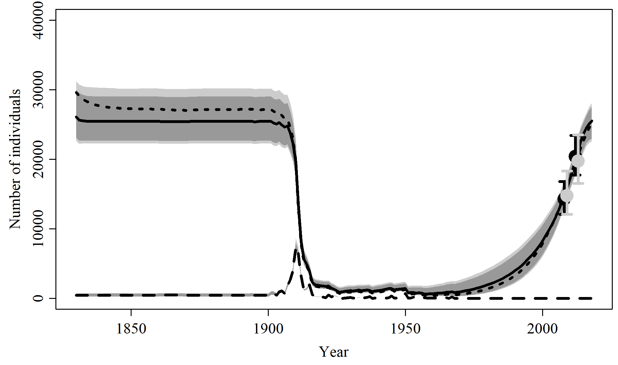

Figure 46. Population trajectory and fit of the model fit to the absolute abundance from the MSYR 2 case scenario. The solid line corresponds to the posterior median, dotted line to the posterior mean of the reference scenariolight grey to the 95% credible interval, grey to the 90% credible interval, black error bars to the 95% confidence interval of the abundance estimate, grey error bars to the 95% credible interval of the posterior predicted abundance estimate, and the dashed line to the catch series.

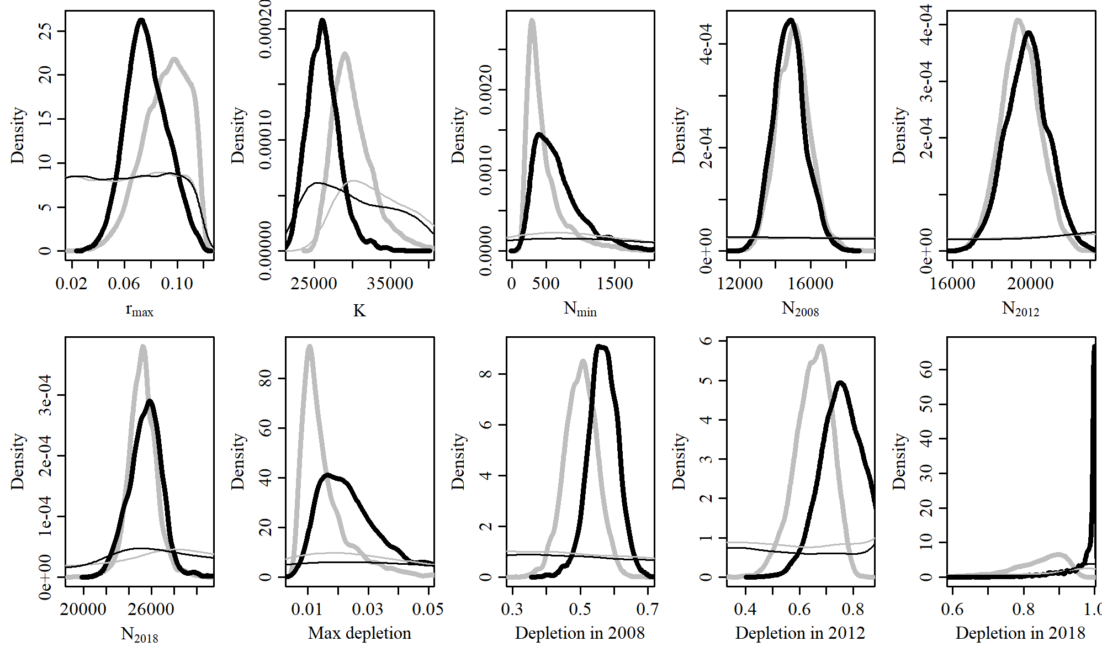

Figure 47. Posterior probability distributions of model parameters and derived quantities from the model fit to the absolute abundance from the MSYR 2 case scenario.

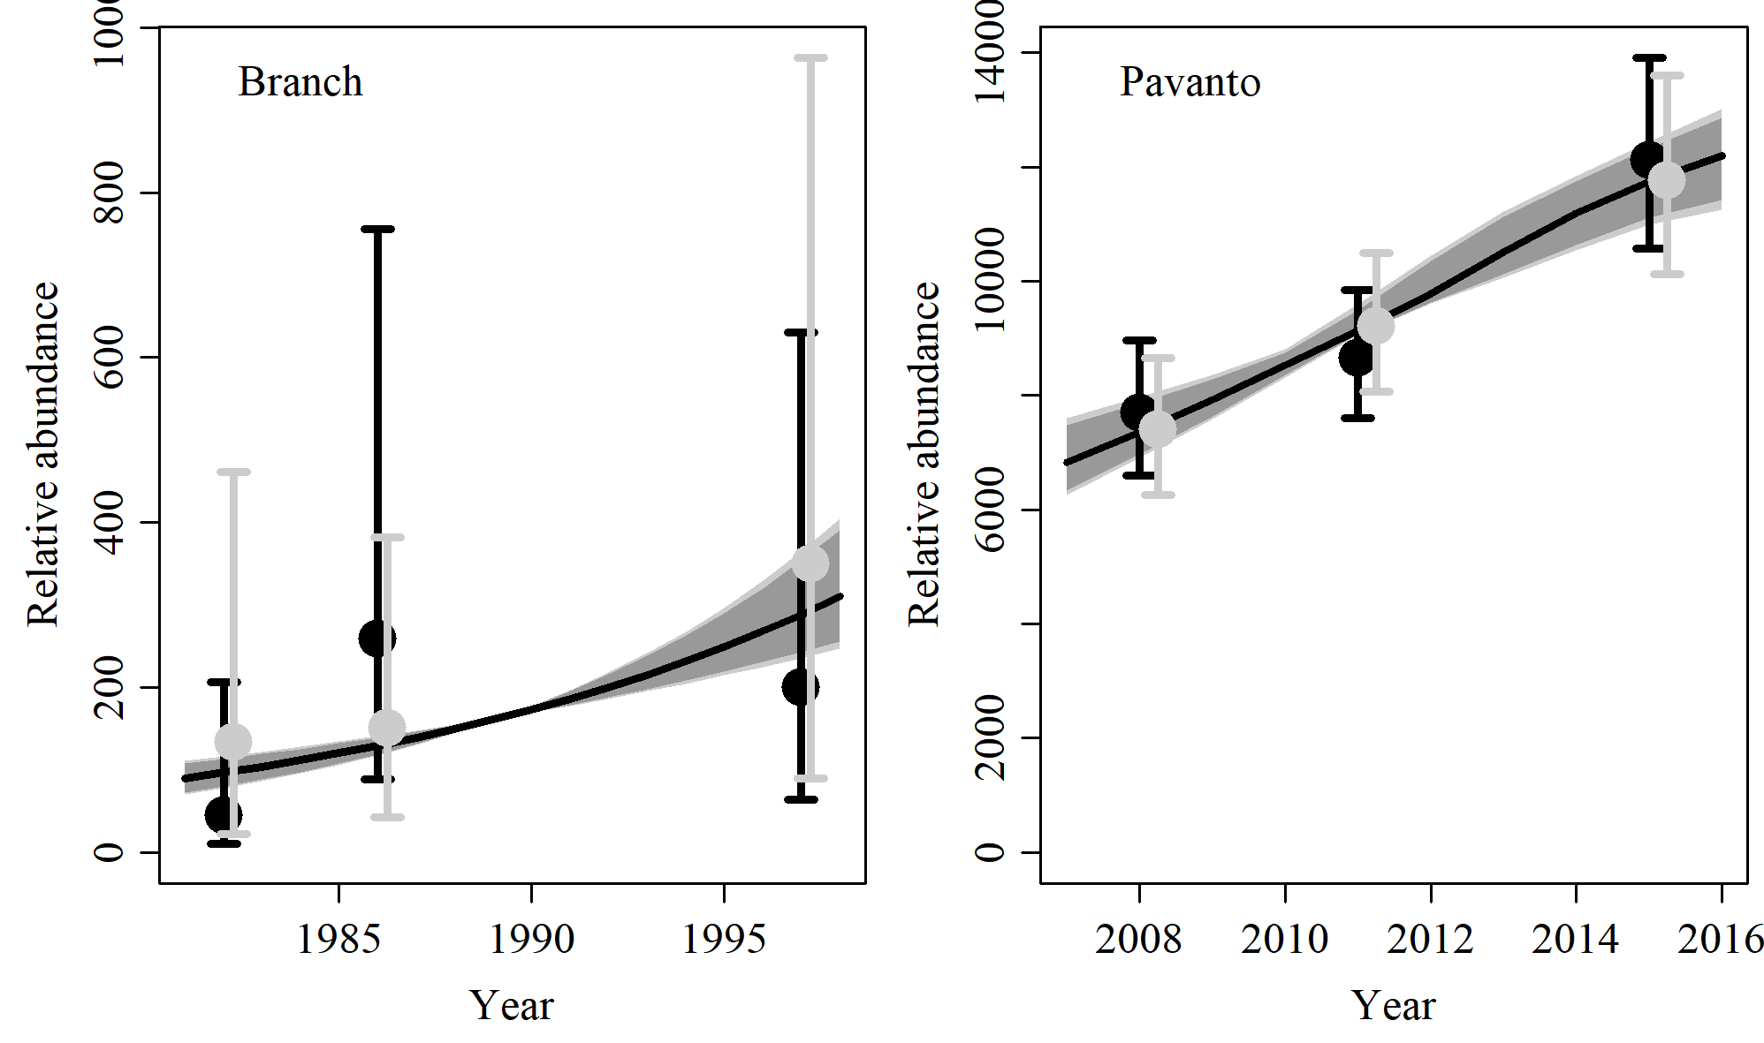

Figure 48. Fit of the model fit from the MSYR 2 scenario to indices of abundance. The solid line corresponds to the posterior median, light grey to the 95% credible interval, grey to the 90% credible interval, black error bars to the 95% confidence interval of the relative abundance estimates, and grey error bars to the 95% credible interval of the posterior predicted relative abundance.

Table 16. Population and parameter estimates from the model fit from the MSYR 2 scenario.

|  |  |  |  |  |  |  |
| --- | --- | --- | --- | --- | --- | --- |
| Parameter | Mean | Median | 2.5% CI | 5% CI | 95% CI | 97.5% CI |
|  | 0.077 | 0.076 | 0.048 | 0.052 | 0.109 | 0.104 |
|  | 26,245 | 26,078 | 22,680 | 23,124 | 31,203 | 29,995 |
|  | 681 | 597 | 228 | 265 | 1,619 | 1,432 |
|  | 14,813 | 14,785 | 13,139 | 13,380 | 16,688 | 16,395 |
|  | 19,806 | 19,807 | 17,683 | 18,033 | 21,951 | 21,601 |
|  | 25,450 | 25,530 | 22,560 | 22,989 | 28,084 | 27,573 |
| Max depletion | 0.025 | 0.023 | 0.01 | 0.011 | 0.055 | 0.05 |
| Depletion in 2008 | 0.567 | 0.567 | 0.477 | 0.496 | 0.649 | 0.637 |
| Depletion in 2012 | 0.76 | 0.759 | 0.601 | 0.629 | 0.915 | 0.895 |
| Depletion in 2018 | 0.973 | 0.997 | 0.815 | 0.858 | 1 | 1 |