**Humpback whale assessment model results – 29 January 2019**

Table XXX – Population modeling scenarios and key quantities of interest used in the assessment of the WSA humpback whale population. Each row in the table illustrates a scenario, with changes relative to the reference case are indicated by text. Dashes indicate same input values as the reference case.

|  |  |  |  |  |  |  |  |  |
| --- | --- | --- | --- | --- | --- | --- | --- | --- |
| Scenario | Target population | *rmax* Prior | Indices of abundance | Pre-modern catches | Modern catch allocation | Struck and lost rates | Bottleneck population lower bound | Shape parameter |
| RC | N2008 | U[0, 0.118] | FG+BG1 | Included | Core | “Conservative” | None | z=2.39 |
| D-1 | N2012 | - | - | - | - | - | - | - |
| D-2 | - | - | None | - | - | - | - | - |
| D-3 | - | - | FG+BG2 | - | - | - | - | - |
| D-4 | - | - | BG1 | - | - | - | - | - |
| D-5 | - | - | BG2 | - | - | - | - | - |
| D-6 | - | - | FG | - | - | - | - | - |
| D-7 | - | Informative based on life history data | - | - | - | - | - | - |
| C-1 | - | - | - | None | - | None | - | - |
| C-2 | - | - | - | None | - | - | - | - |
| C-3 | - | - | - | - | - | None | - | - |
| C-4 |  |  |  |  |  | “Conservative” |  |  |
| C-5 | - | - | - | - | - | “Liberal” | - | - |
| C-6 | - | - | - | - | Core + Falkland Islands | - | - | - |
| C-7 | - | - | - | - | Fringe | - | - | - |
| C-8 | - | - | - | - | Overlap | - | - | - |
| G-1 | - | - | - | - | - | - | 54\*3=162 | - |
| G-2 | - | - | - | - | - | - | 5\*3=15 | - |
| M-1 | - | - | - | - | - | - | - | *z*=5.04 |
| M-2 | - | - | - | - | - | - | - | *z*=11.22 |

**0. Bayes factor comparison of scenarios**

|  |  |  |  |
| --- | --- | --- | --- |
| **Scenario** | **Bayes Factor** |  |  |
| Reference | 0.098 |  |  |
| Sdata 1 | 0.098 |  |  |
| Sdata 7 | 0.100 |  |  |
| Scatch 4 | 0.075 |  |  |
| Scatch 5 | 0.097 |  |  |
| Scatch 6 | 0.100 |  |  |
| Scatch 7 | 0.097 |  |  |
| Scatch 8 | 0.053 |  |  |
| GC 1 | 0.131 |  |  |
| GC 2 | 0.151 |  |  |
| MSYR 1 | 0.098 |  |  |
| MSYR 2 | 0.098 |  |  |

**1. Cross Scenario Comparison Plots**

**(mean is dotted line)**

* 1. **K**

**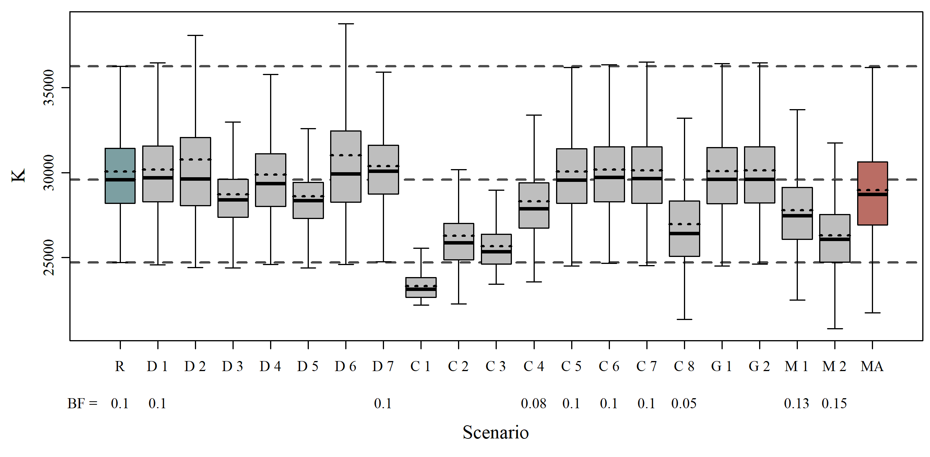**

* 1. **R\_max**

**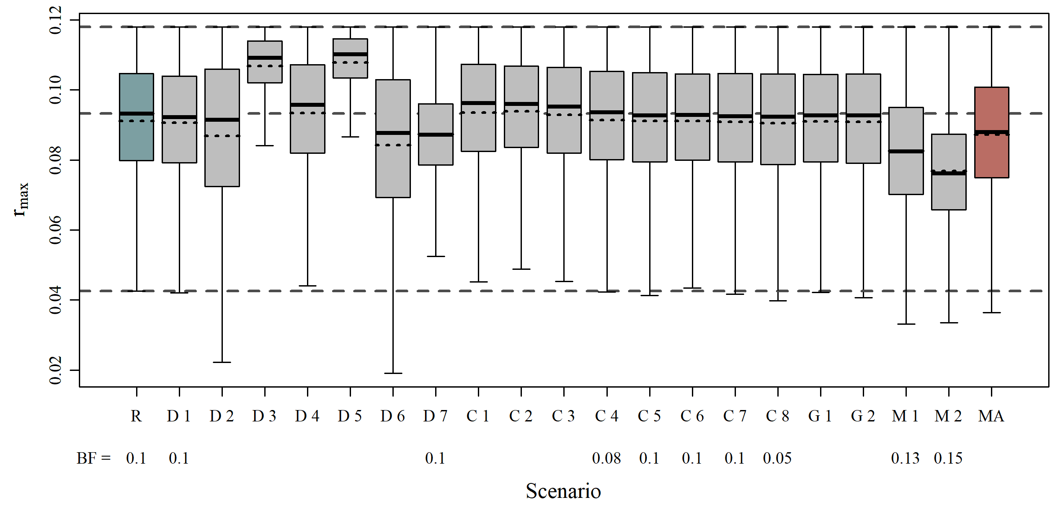**

* 1. **N\_min**

**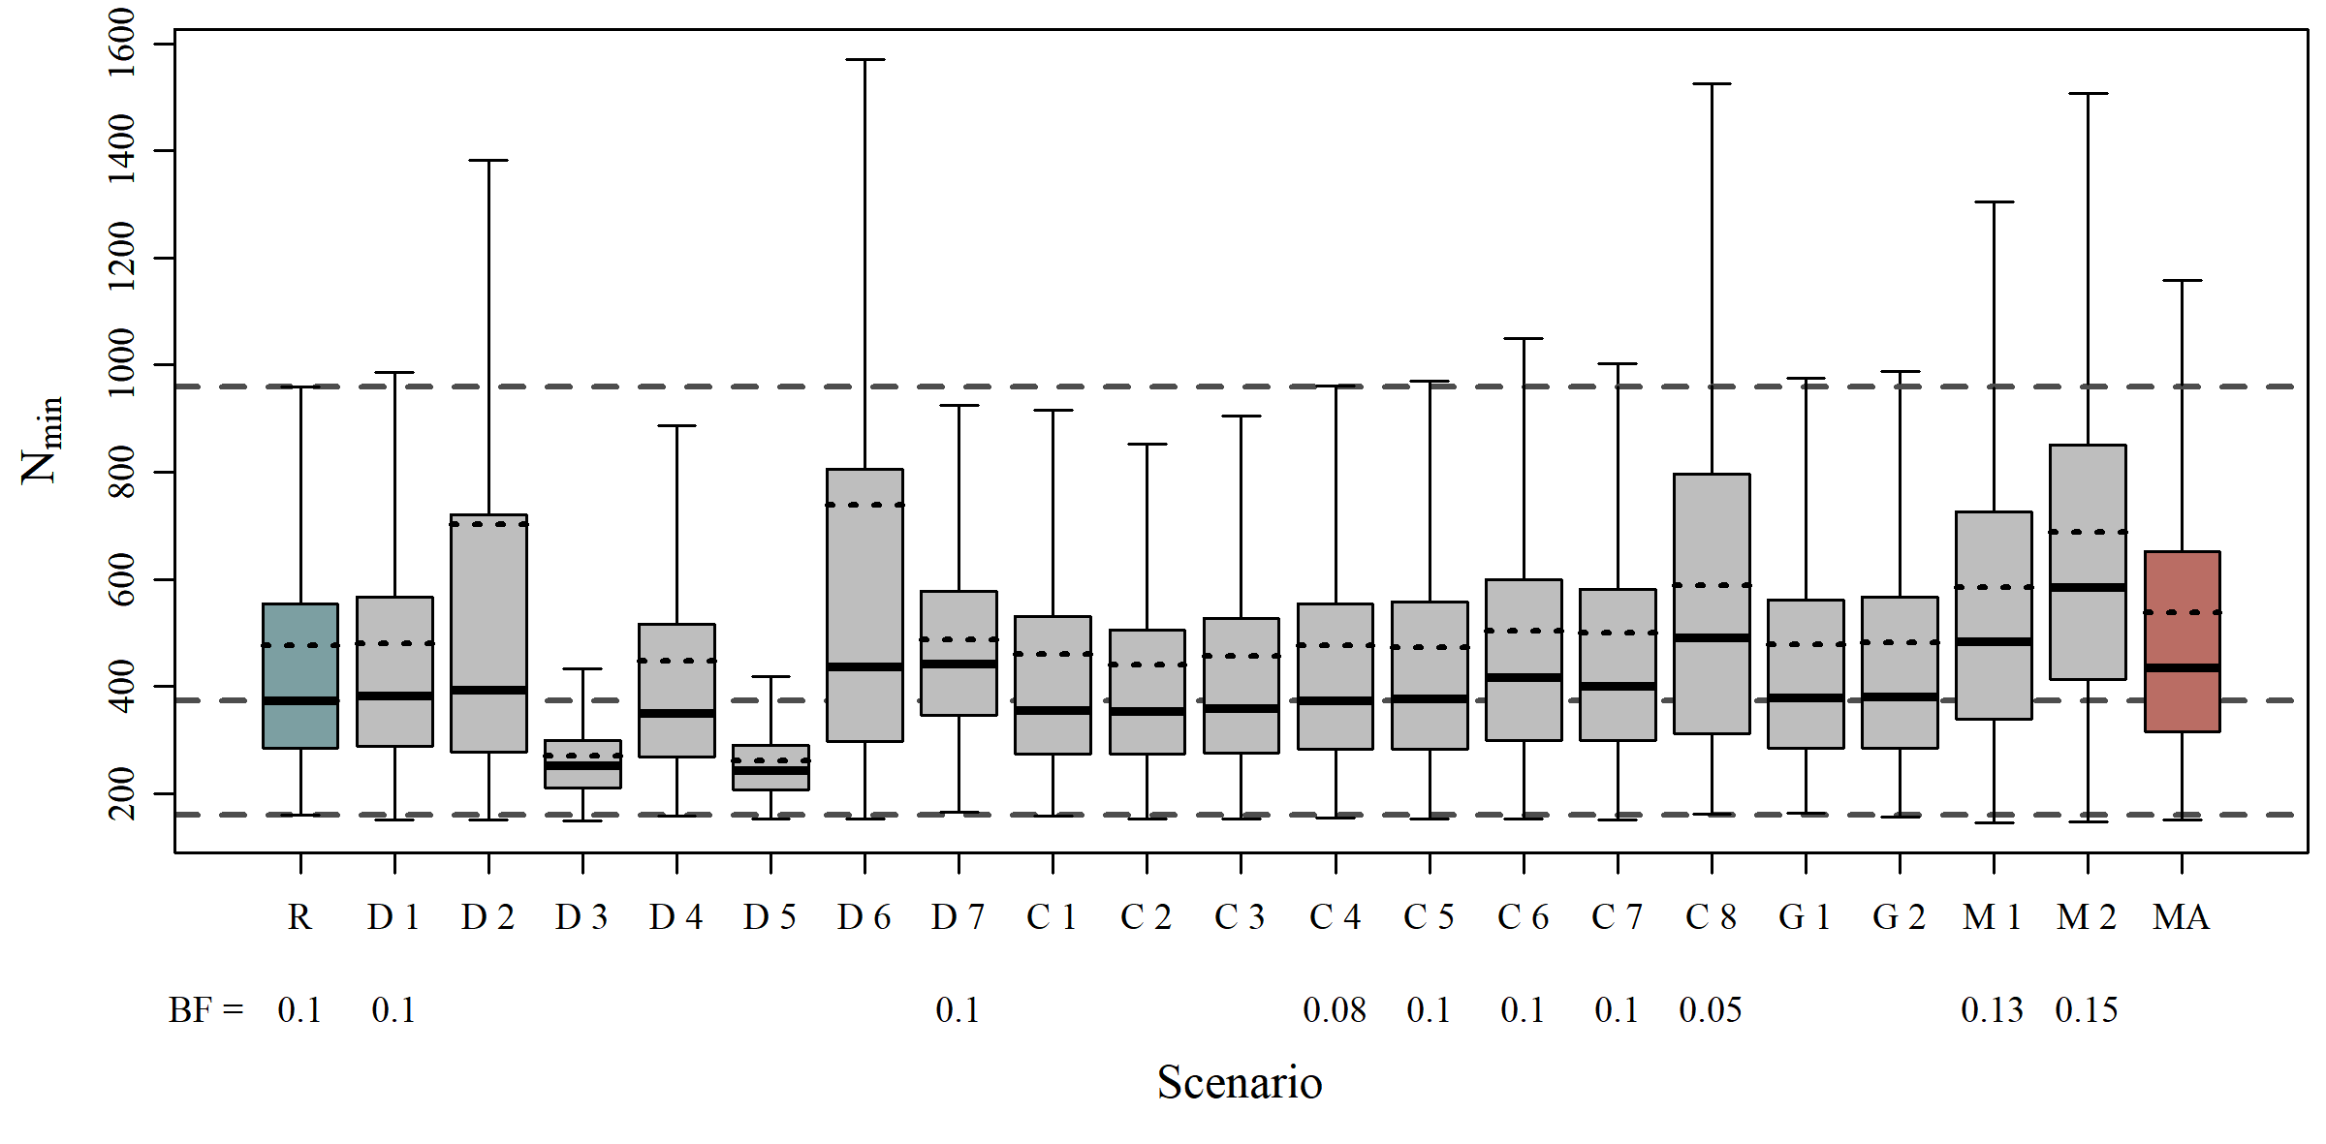**

* 1. **N\_2008**

**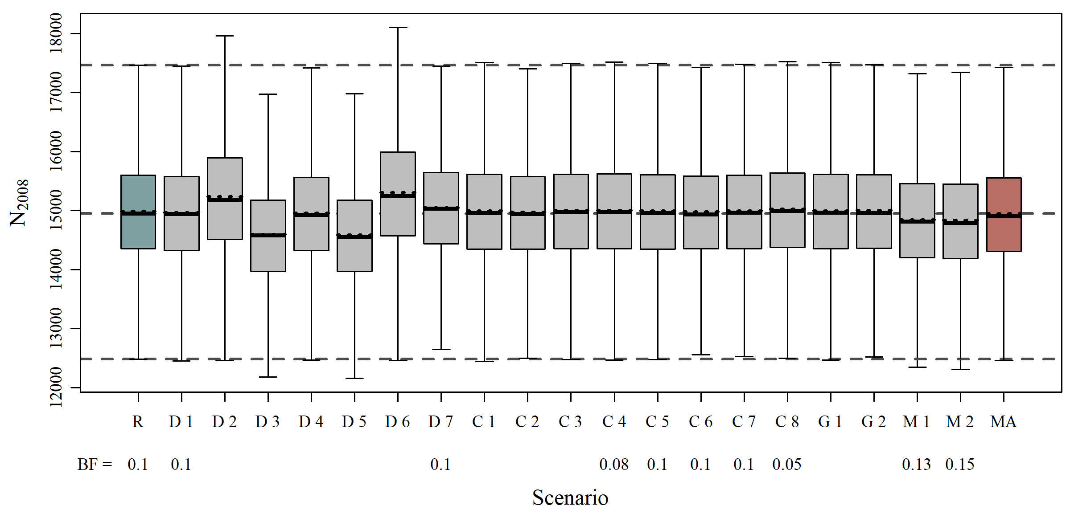**

* 1. **N\_2019**

**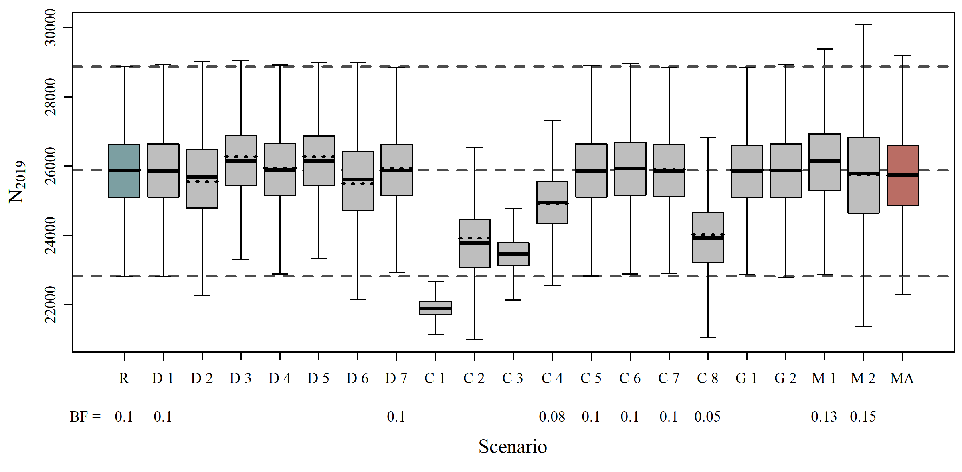**

* 1. **Maximum Depletion**

**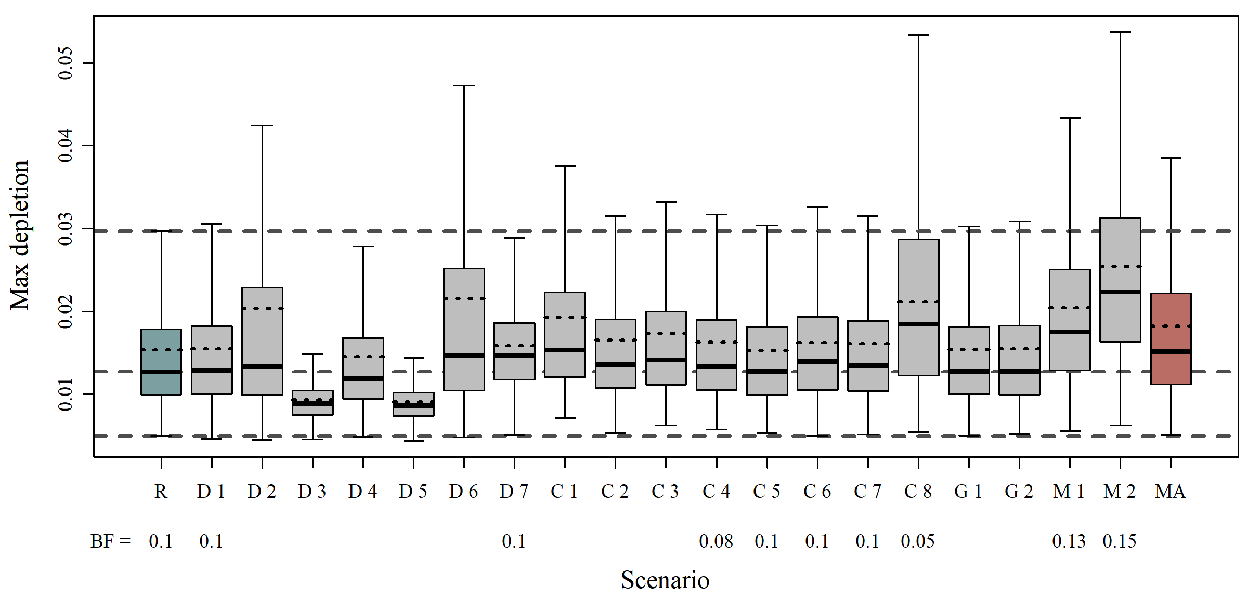**

* 1. **Status 2008**

**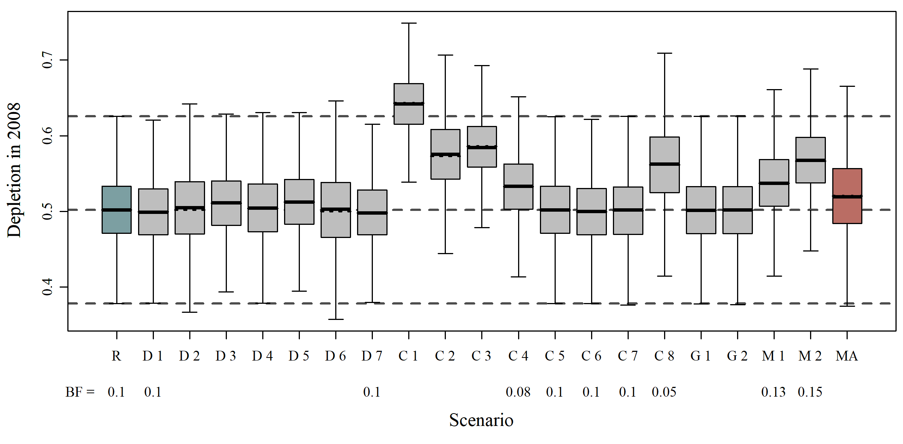**

* 1. **Status 2019**

**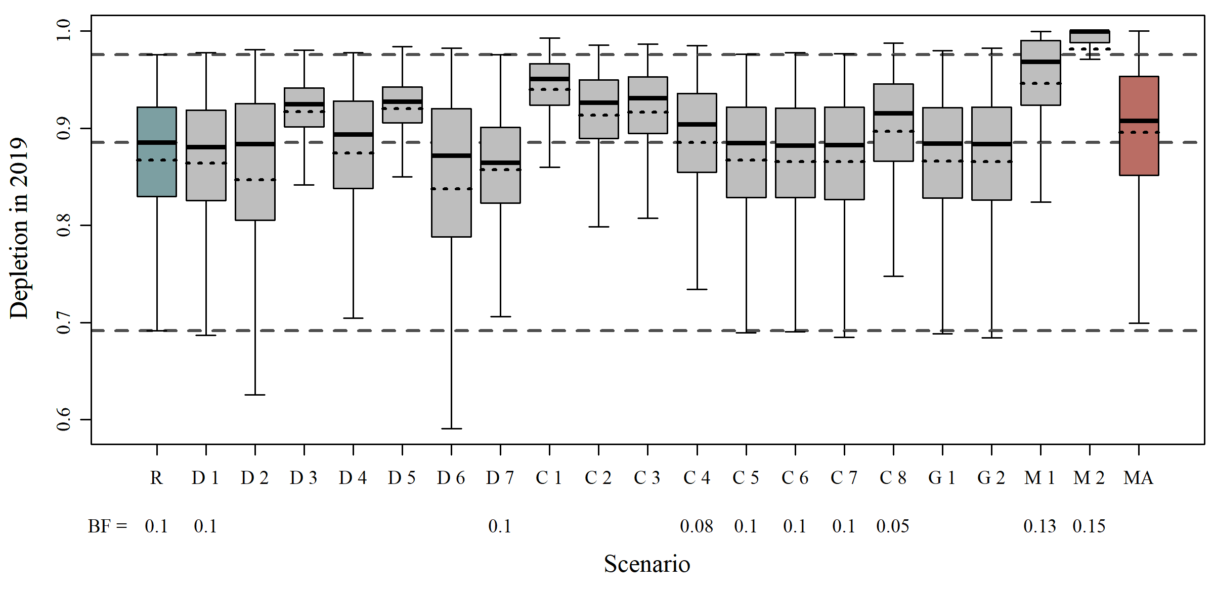**

1. **Population Trajectories**
   1. **Model Average**

**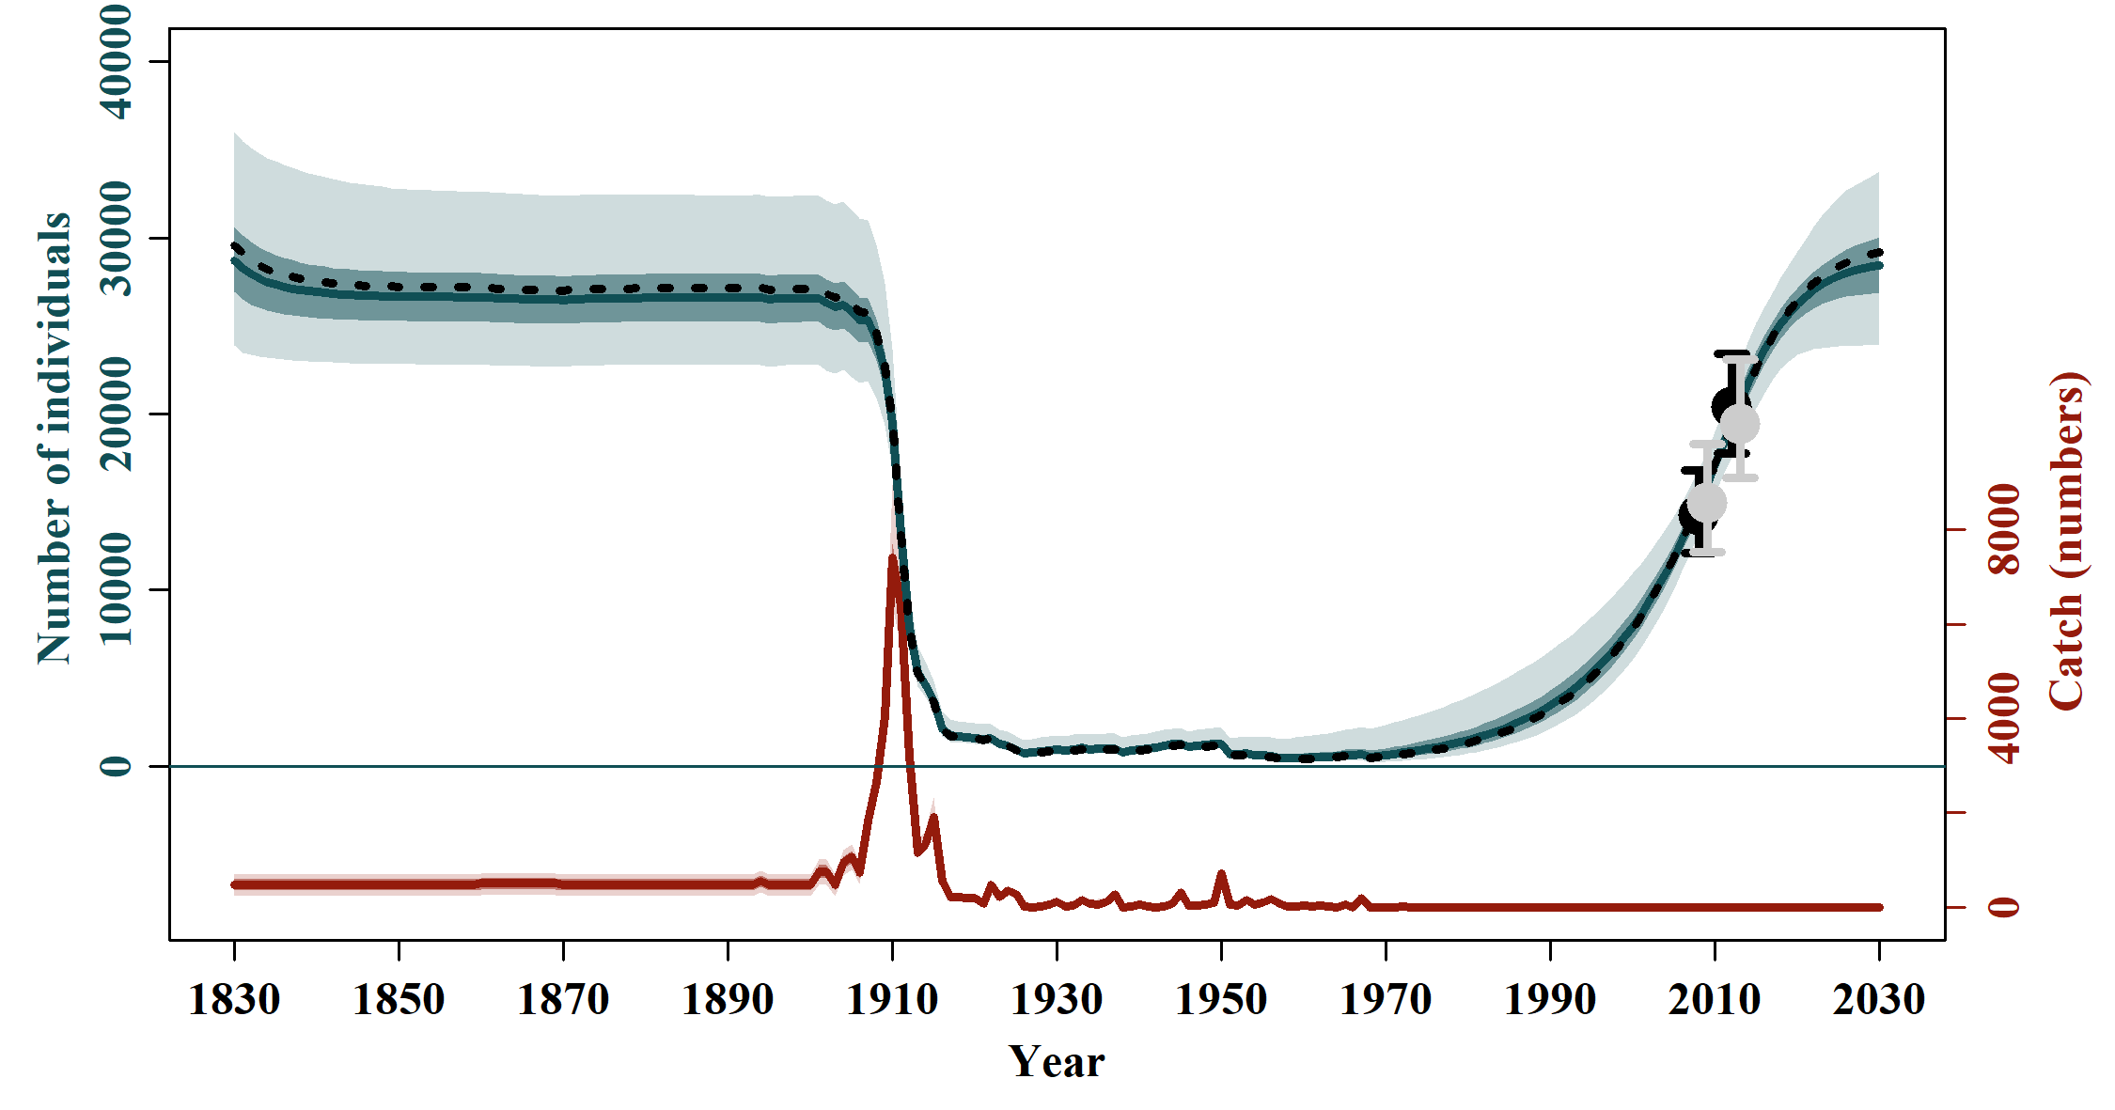**

* 1. **Reference Case**

**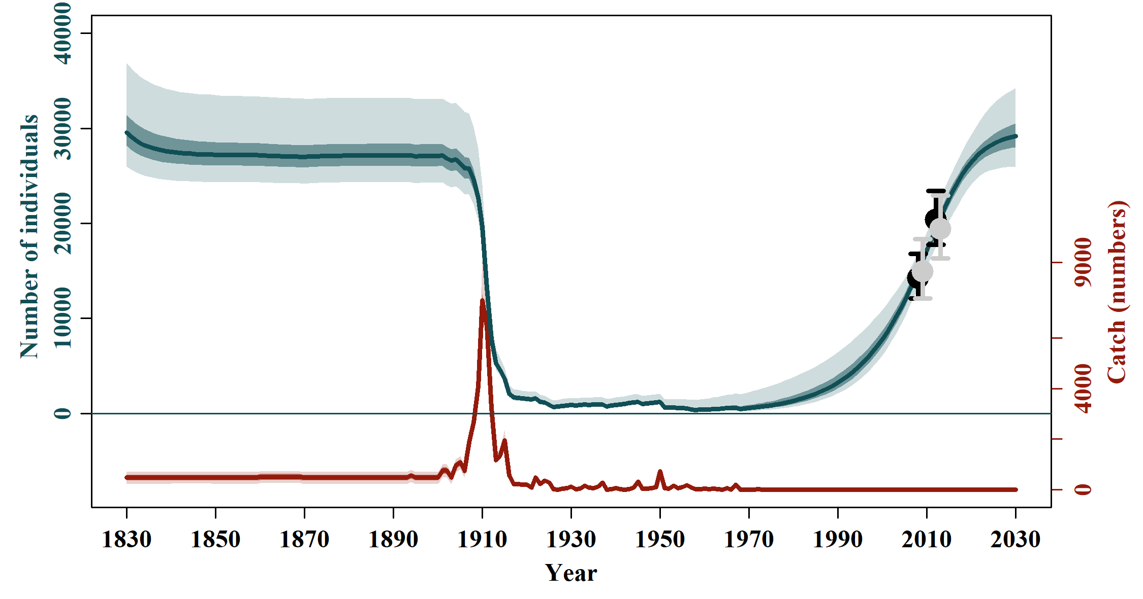**

* 1. **Sensitivities to Abundance and Trends**

|  |  |
| --- | --- |
|  |  |
| **SData 1** | **SData 2** |
|  |  |
|  |  |
| **SData 3** | **SData 4** |
|  |  |
|  |  |
| **SData 5** | **SData 6** |
| C:\Users\Grant Adams\AppData\Local\Microsoft\Windows\INetCache\Content.Word\SData 7_trajectory_summary.png  **SData 7** |  |

* 1. **Sensitivites to Catch Allocation**

|  |  |
| --- | --- |
|  |  |
| **SCatch 1** | **SCatch 2** |
|  |  |
|  |  |
| **SCatch 3** | **SCatch 4** |
|  |  |
|  |  |
| **SCatch 5** | **SCatch 6** |
|  |  |
|  |  |
| **SCatch 7** | **SCatch 8** |

* 1. **Sensitivities to Genetic Constraint and MSYL**

|  |  |
| --- | --- |
|  |  |
| **GC 1** | **GC 2** |
|  |  |
|  |  |
| **MSYL 1** | **MSYL 2** |

1. **Fit of the Indices of Abundance**
   1. **Model Average**

**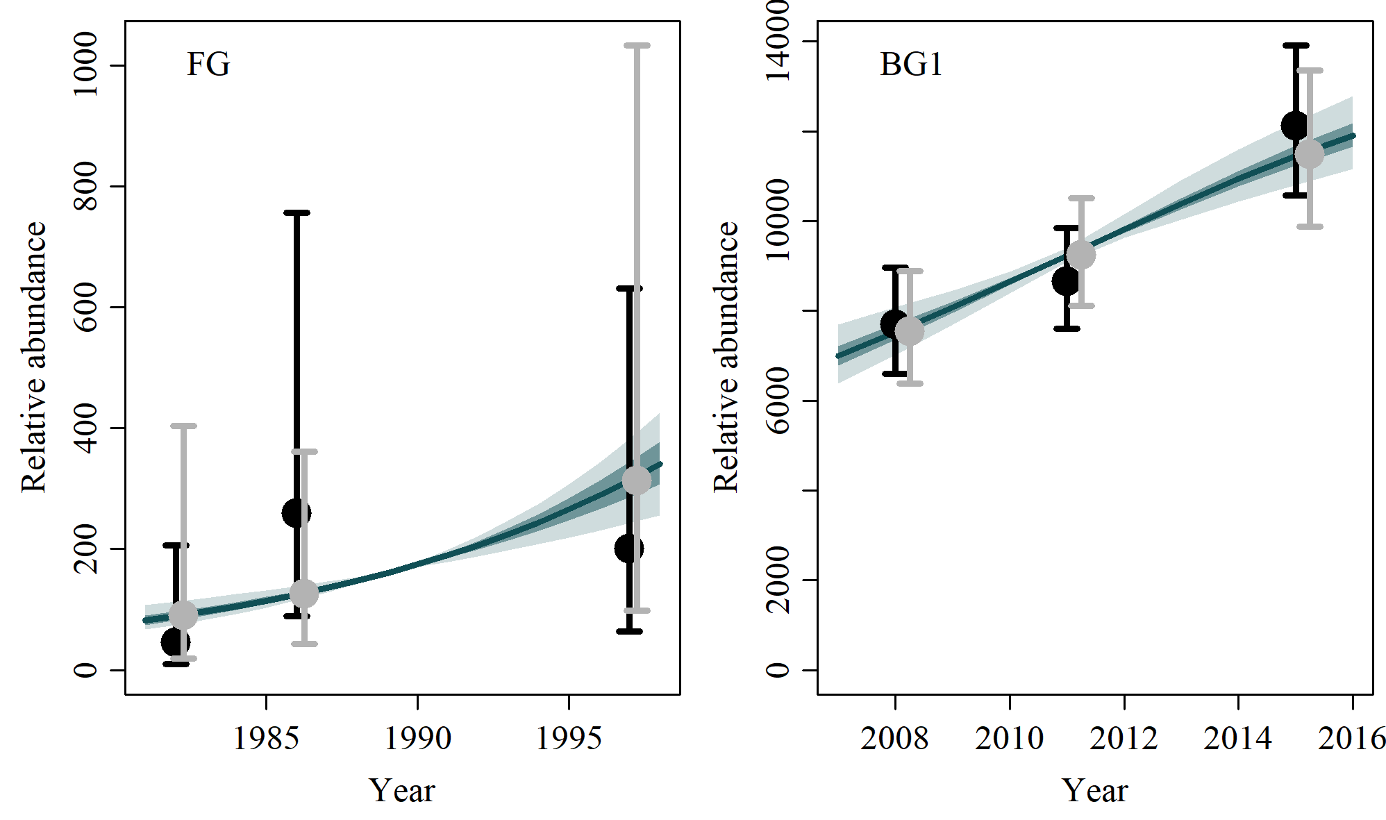**

* 1. **Reference Case**

**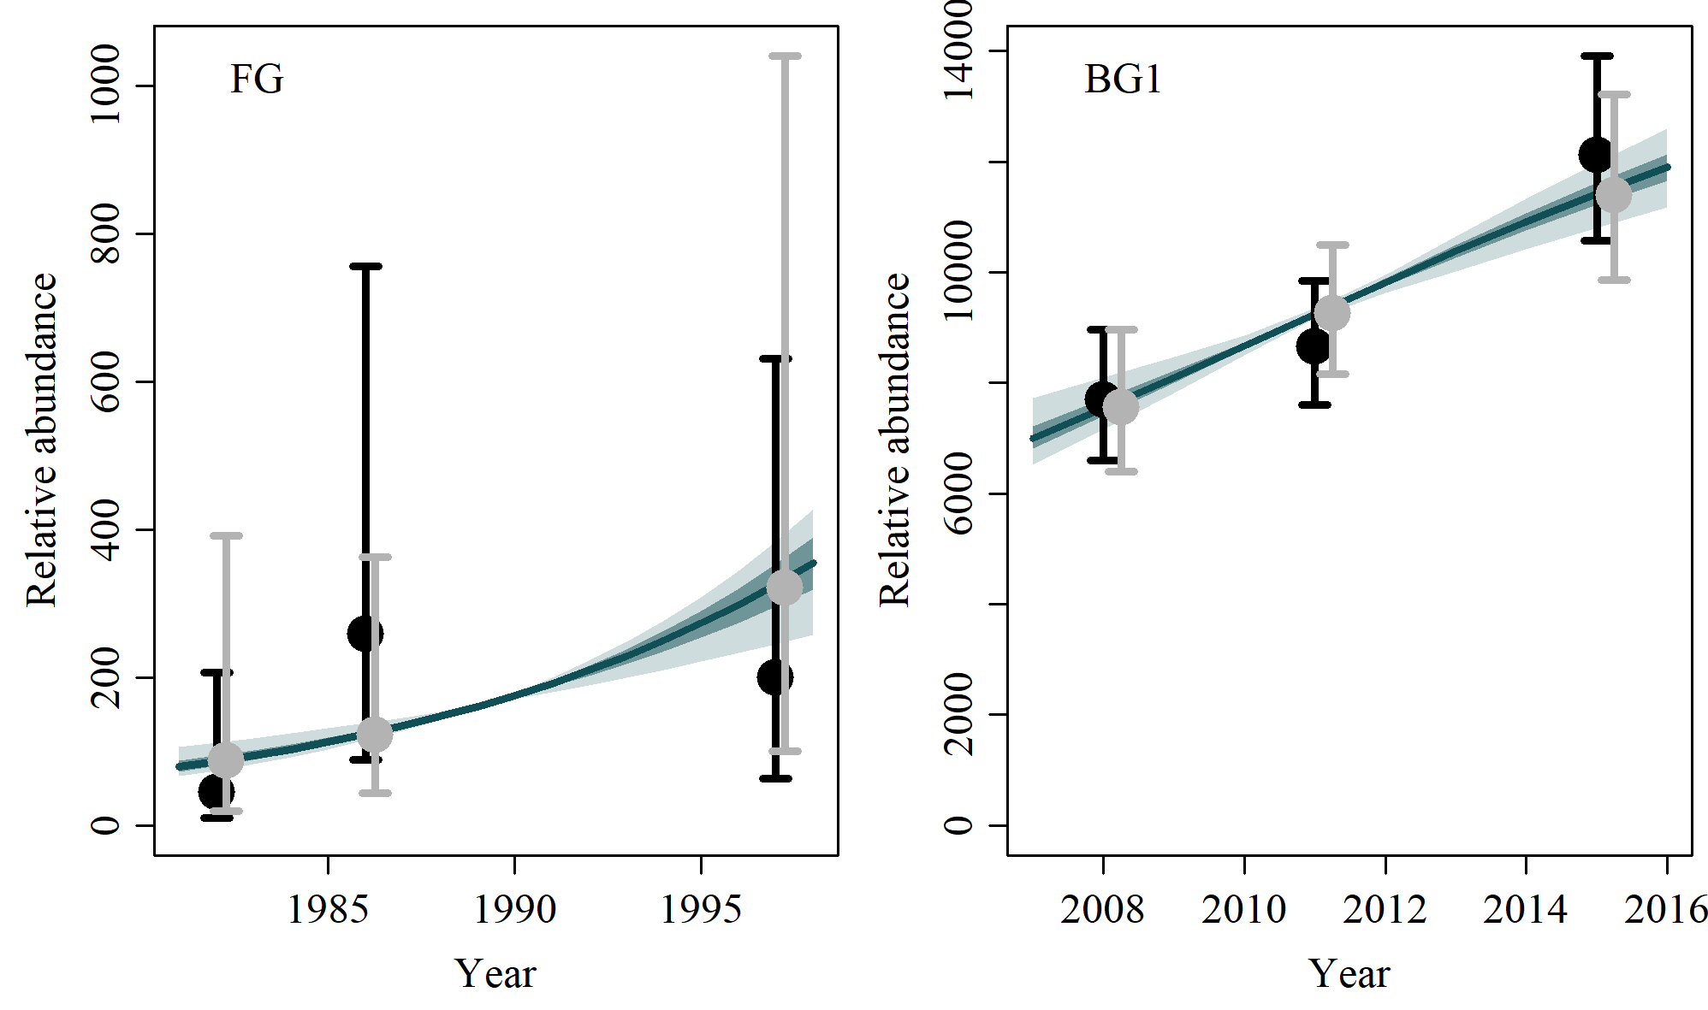**

* 1. **SData 1**

**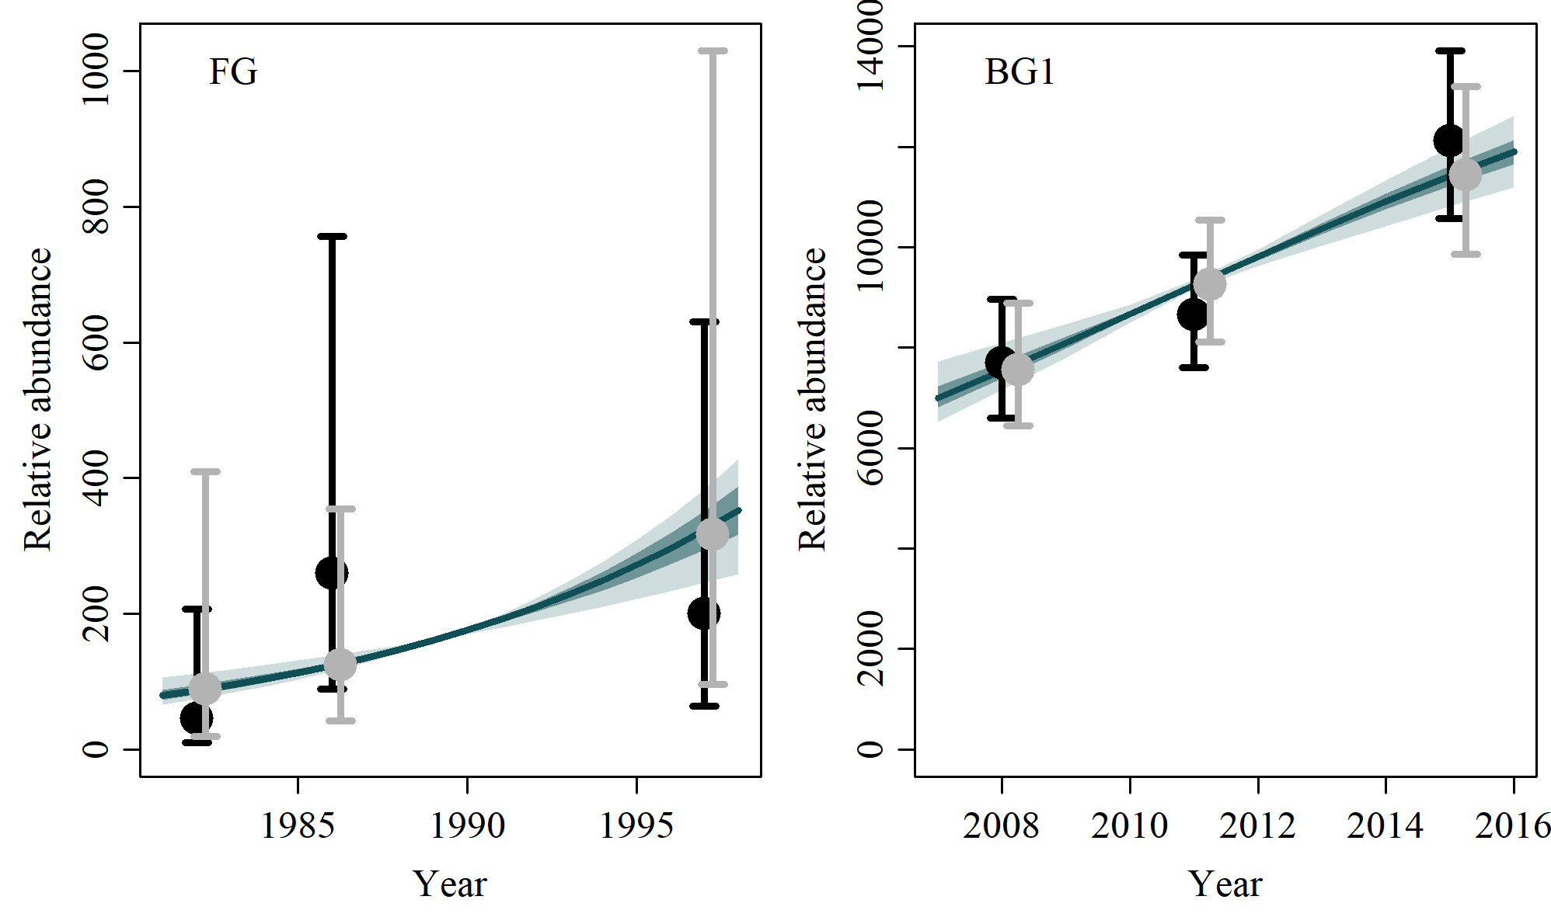**

* 1. **SData 2**

No output

* 1. **SData 3**

**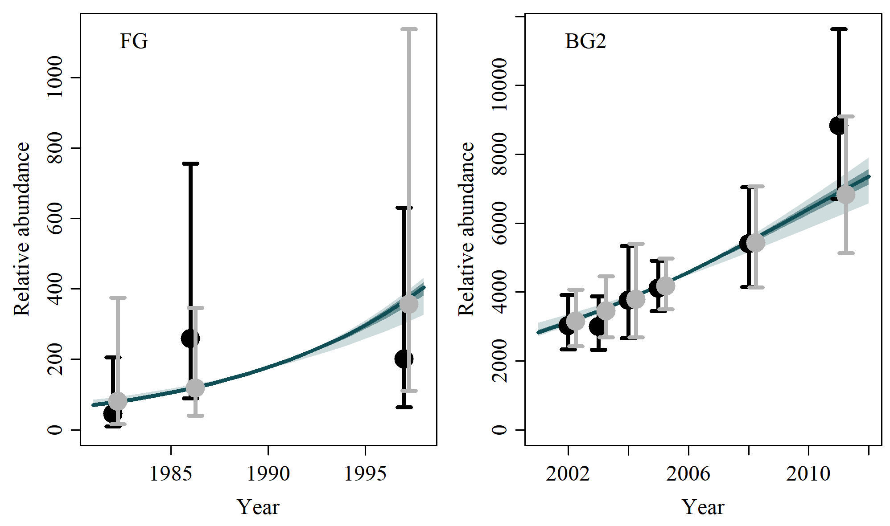**

* 1. **SData 4**

**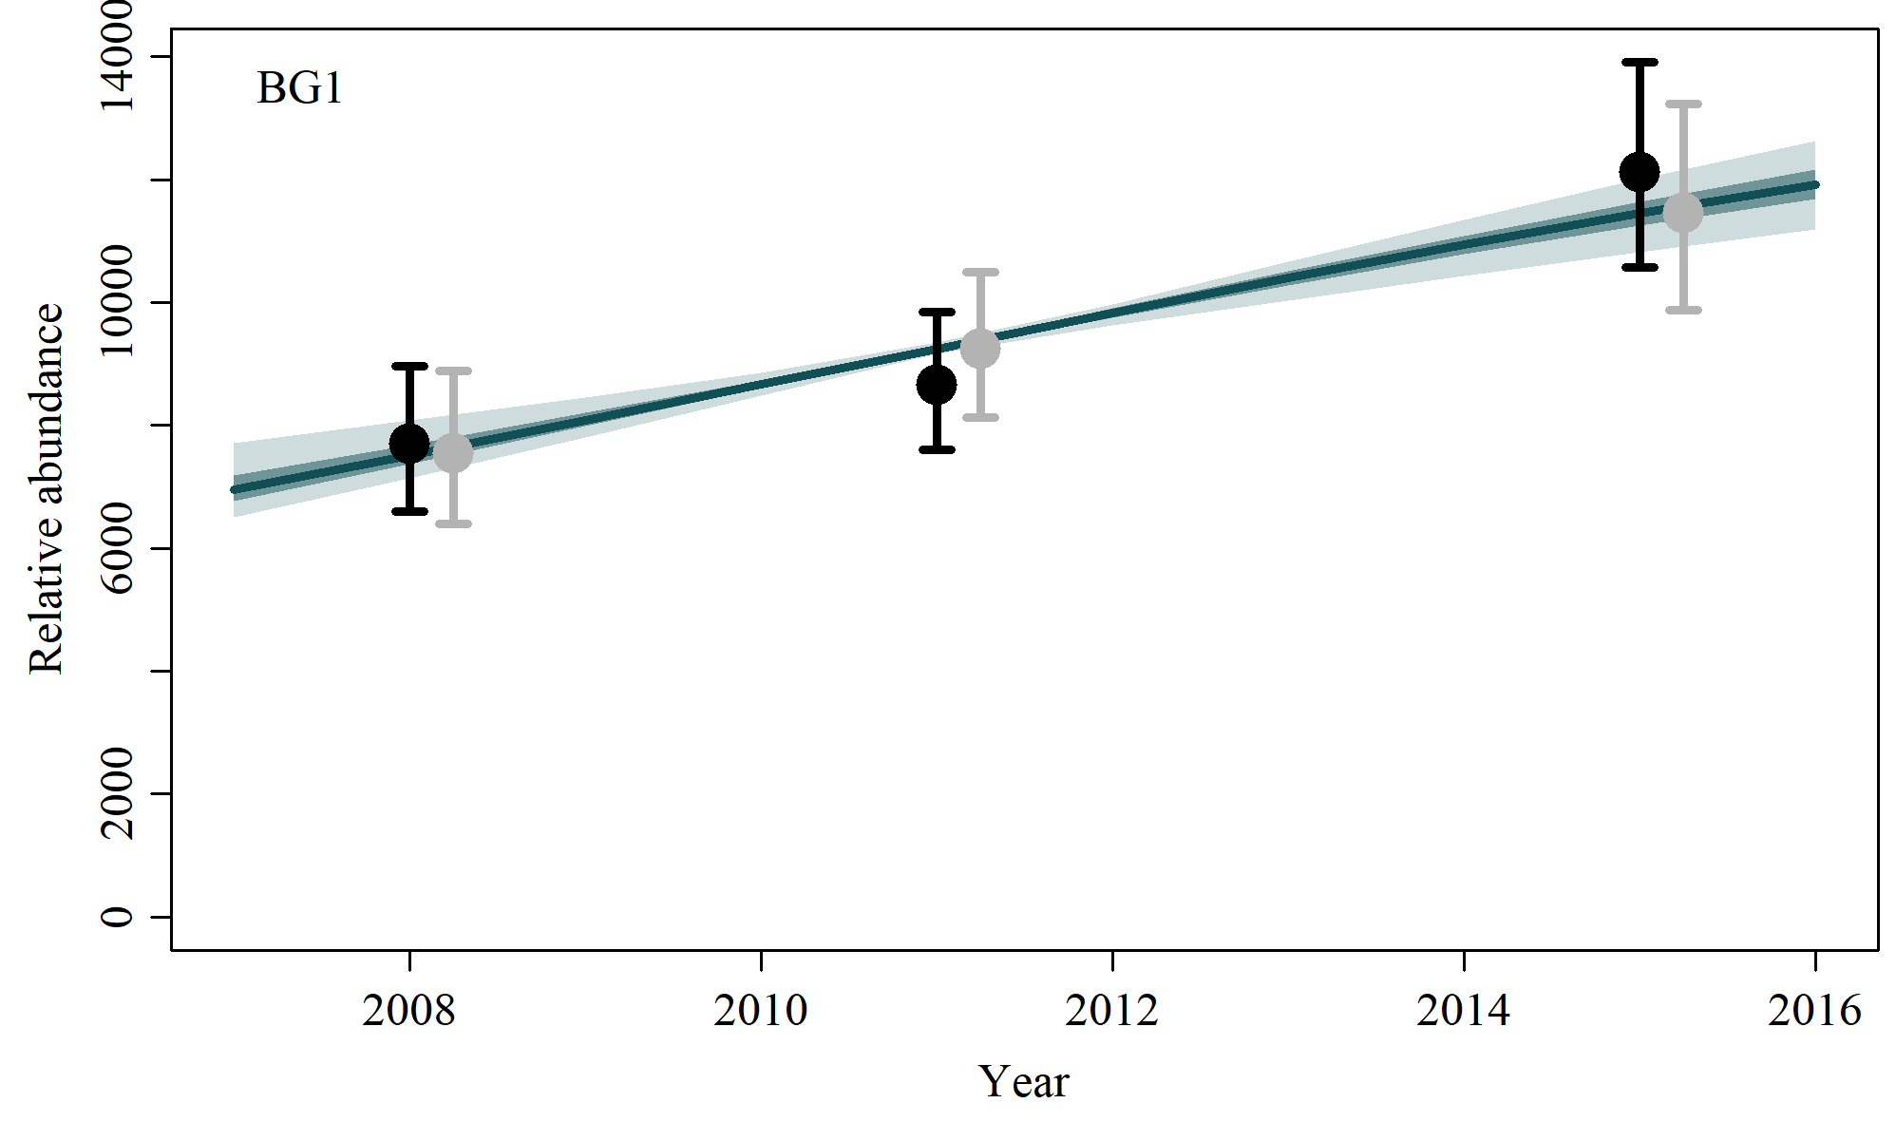**

* 1. **SData 5**

**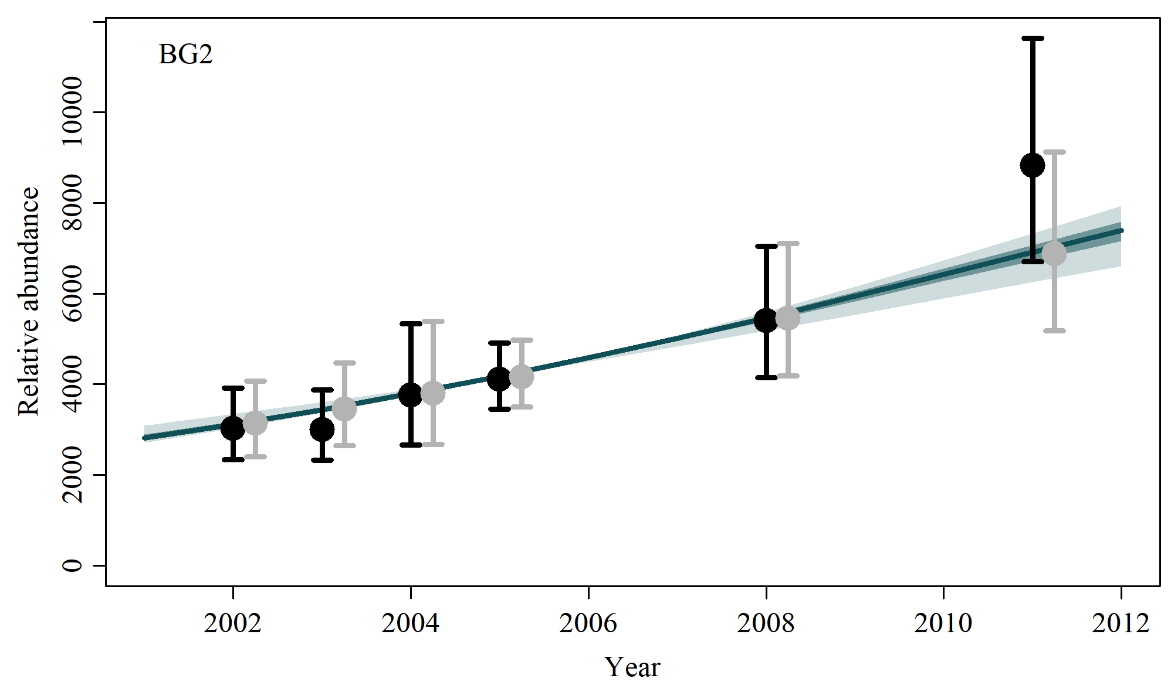**

* 1. **SData 6**

**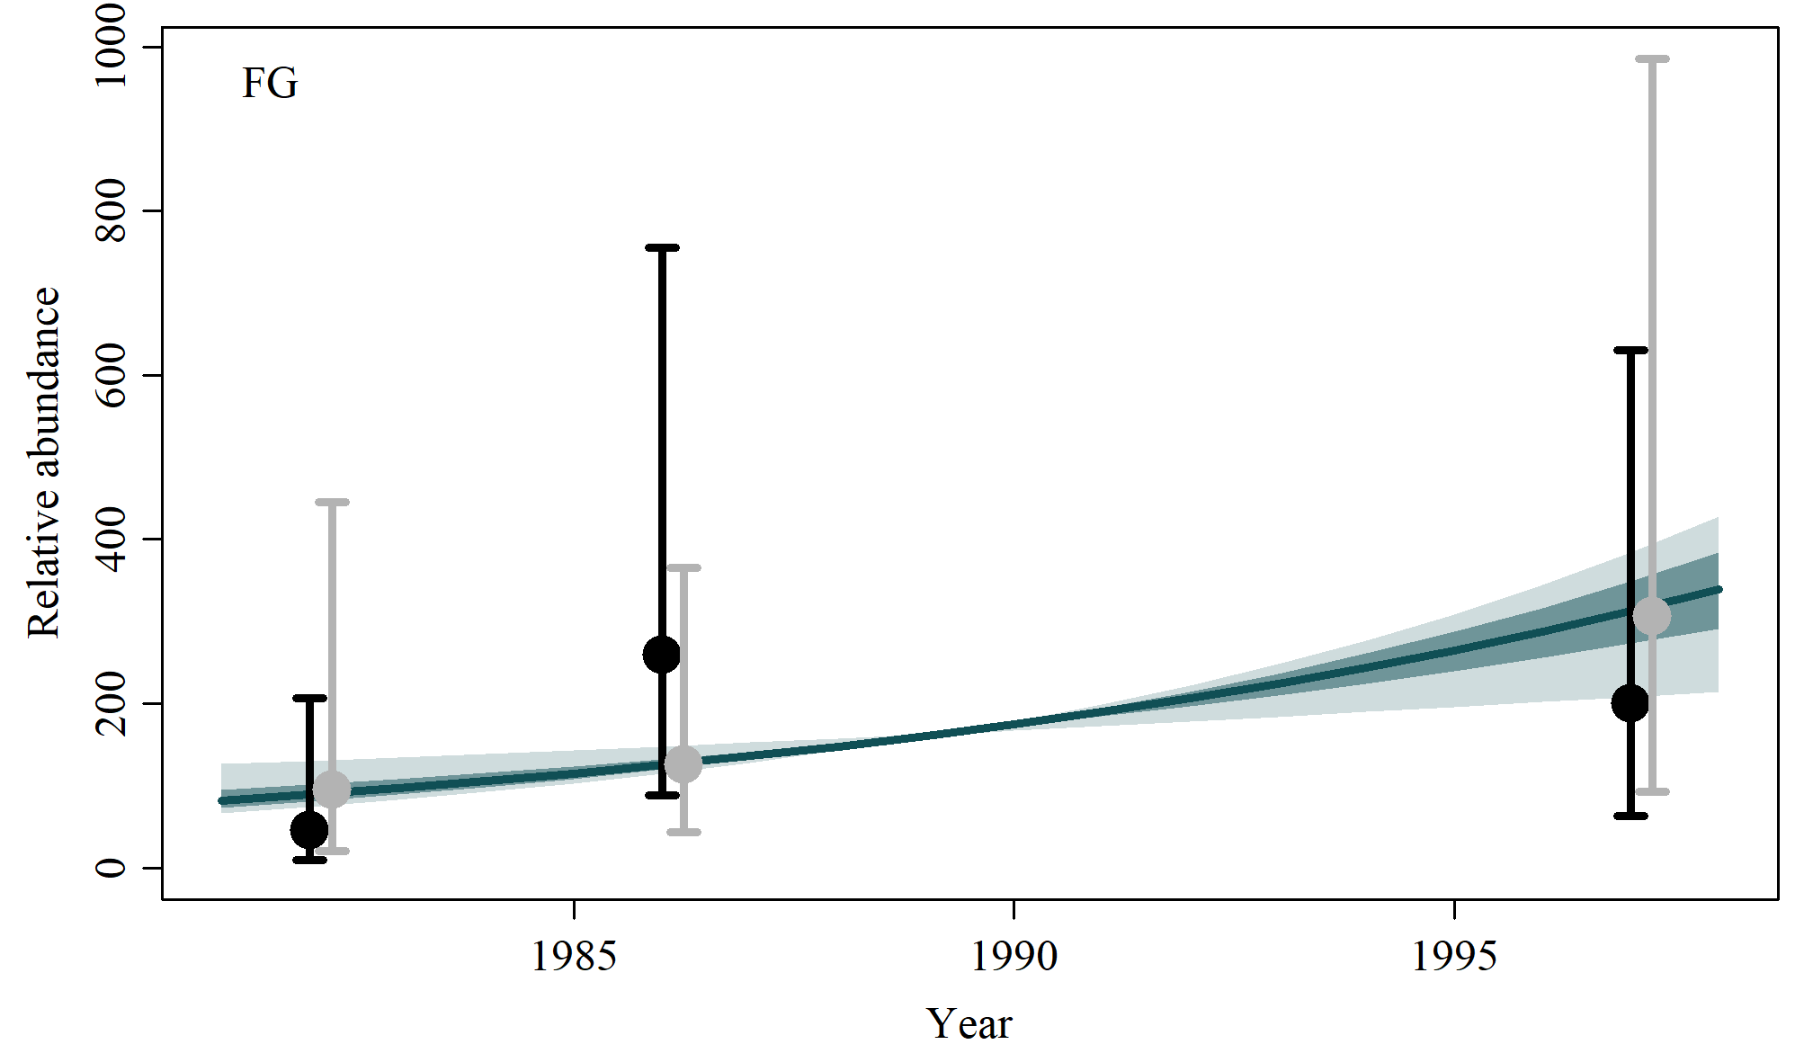**

* 1. **SData 7**

**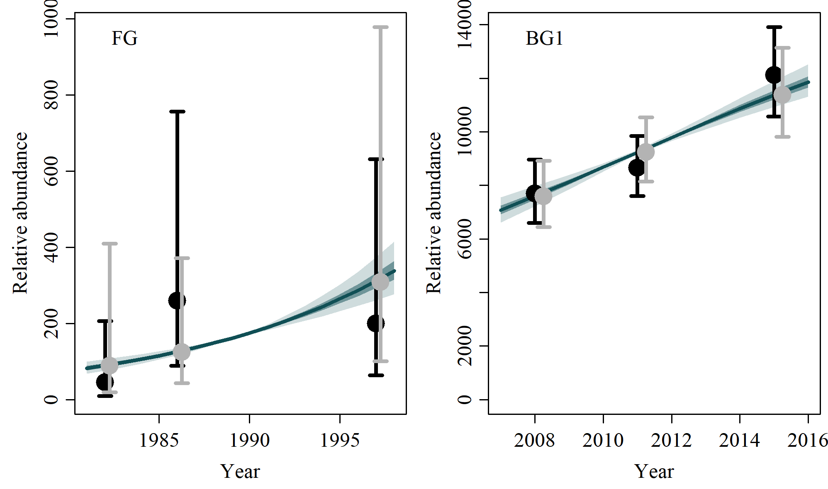**

* 1. **Sensitivites to Catch Allocation**

|  |  |
| --- | --- |
|  |  |
| **SCatch 1** | **SCatch 2** |
|  |  |
|  |  |
| **SCatch 3** | **SCatch 4** |
|  |  |
|  |  |
| **SCatch 5** | **SCatch 6** |
|  |  |
|  |  |
| **SCatch 7** | **SCatch 8** |

* 1. **Sensitivities to Genetic Constraint and MSYL**

|  |  |
| --- | --- |
|  |  |
| **GC 1** | **GC 2** |
|  |  |
|  |  |
| **MSYL 1** | **MSYL 2** |

1. **Posterior Density Plots**
   1. **Model average**

**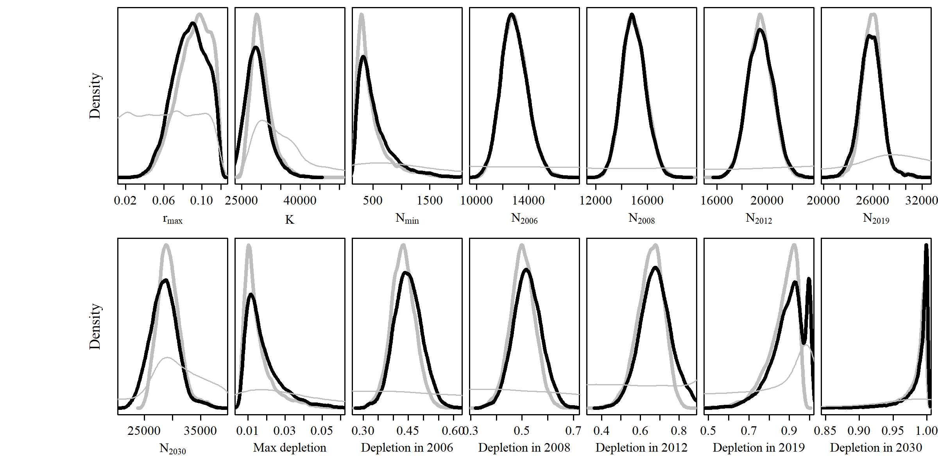**

* 1. **Reference Case**

**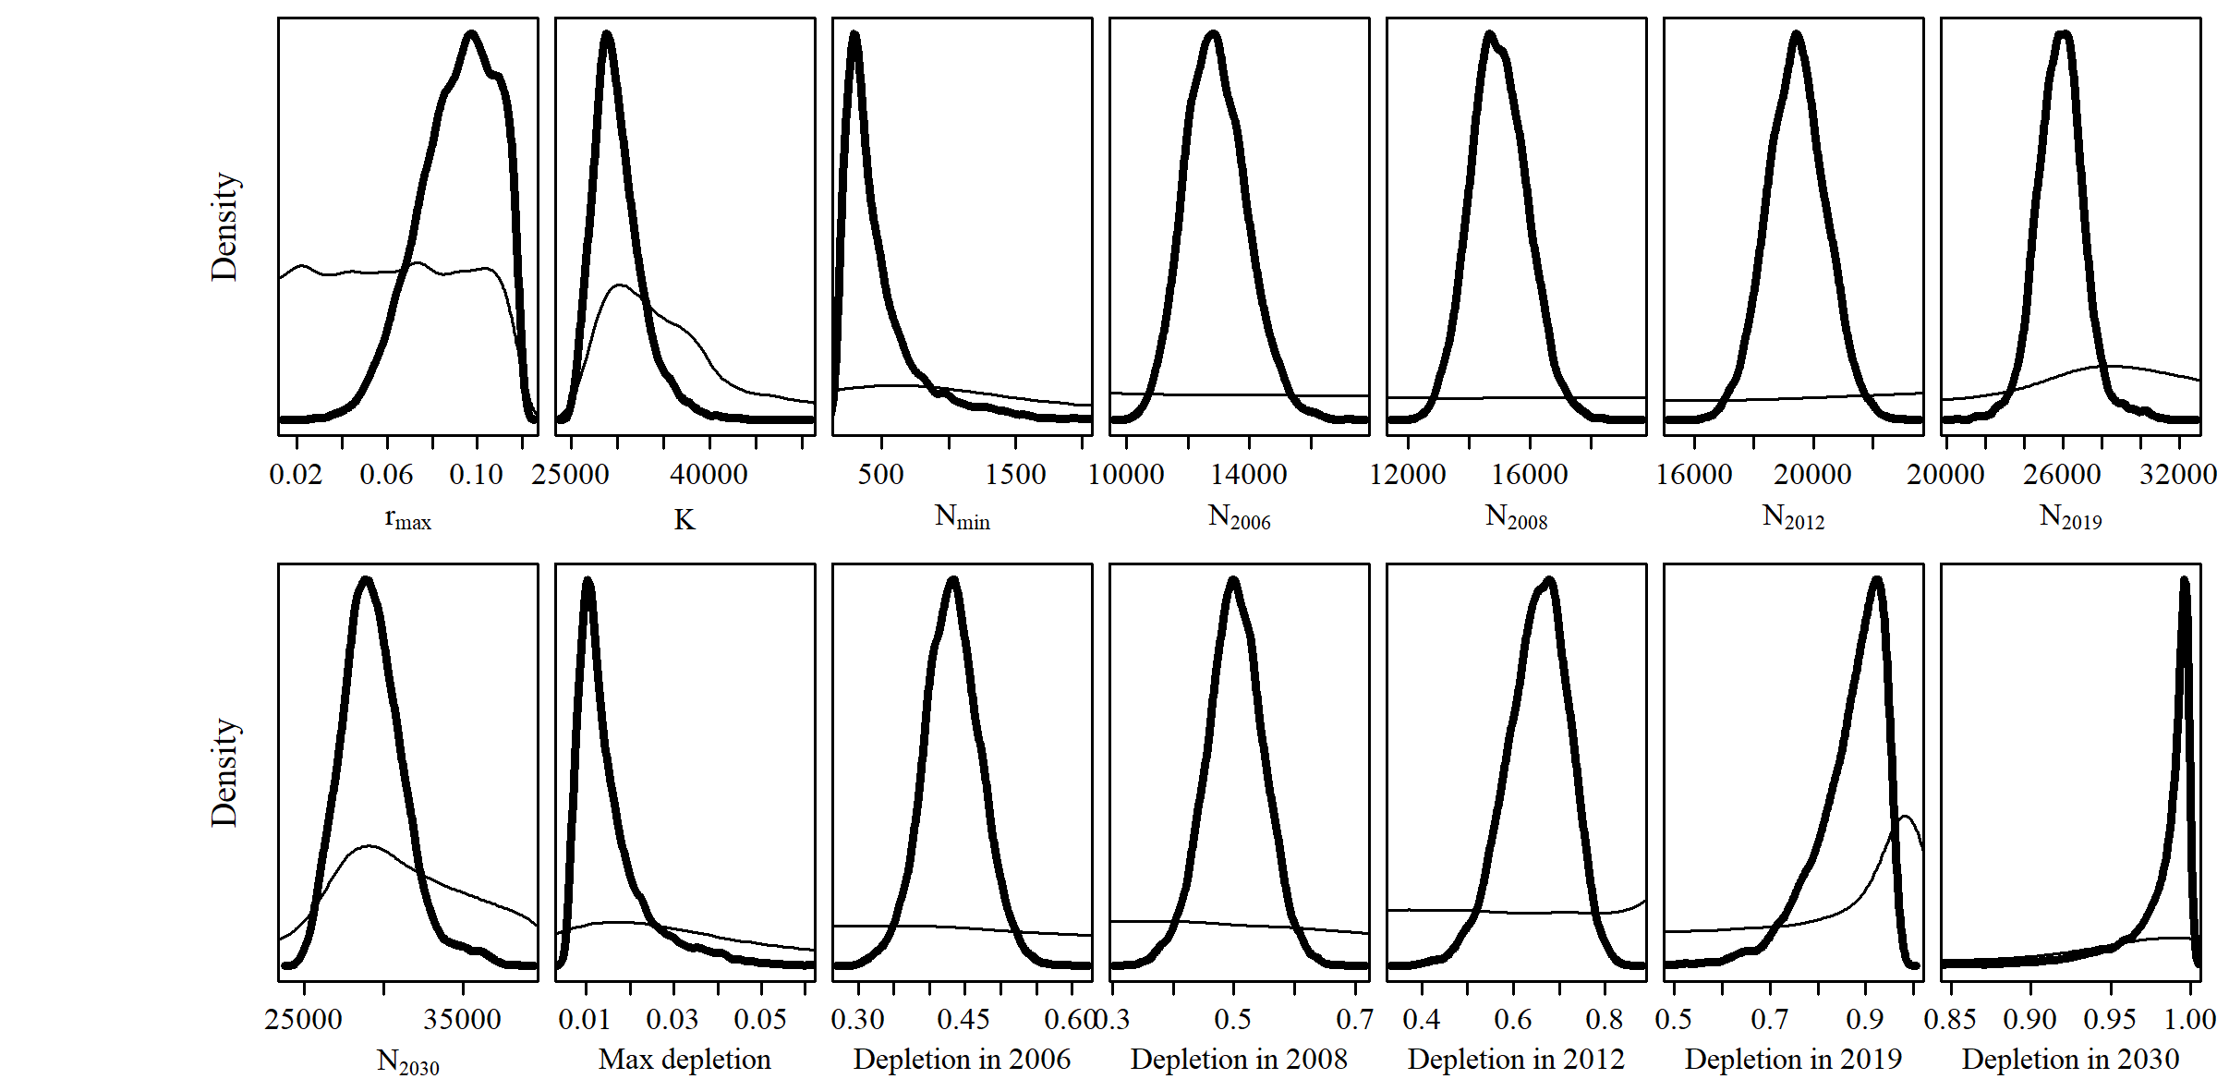**

* 1. **SData 1**

**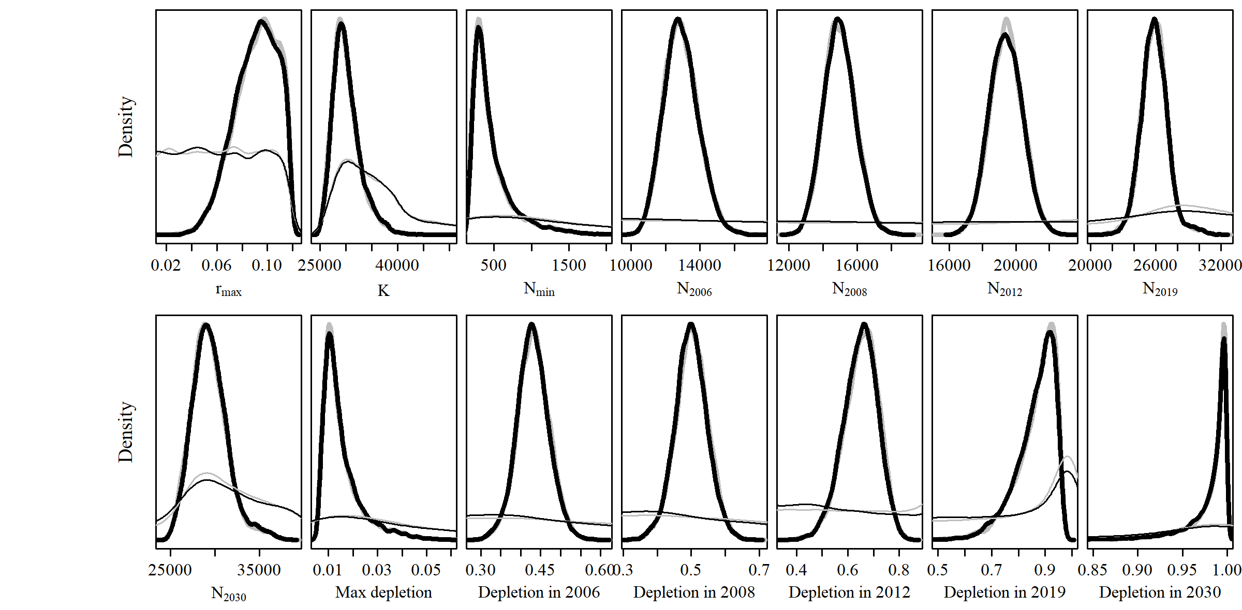**

* 1. **SData 2**

**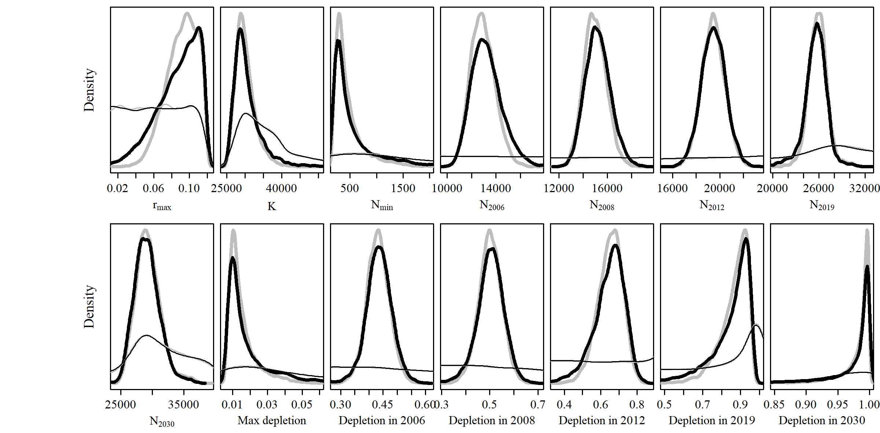**

* 1. **SData 3**

**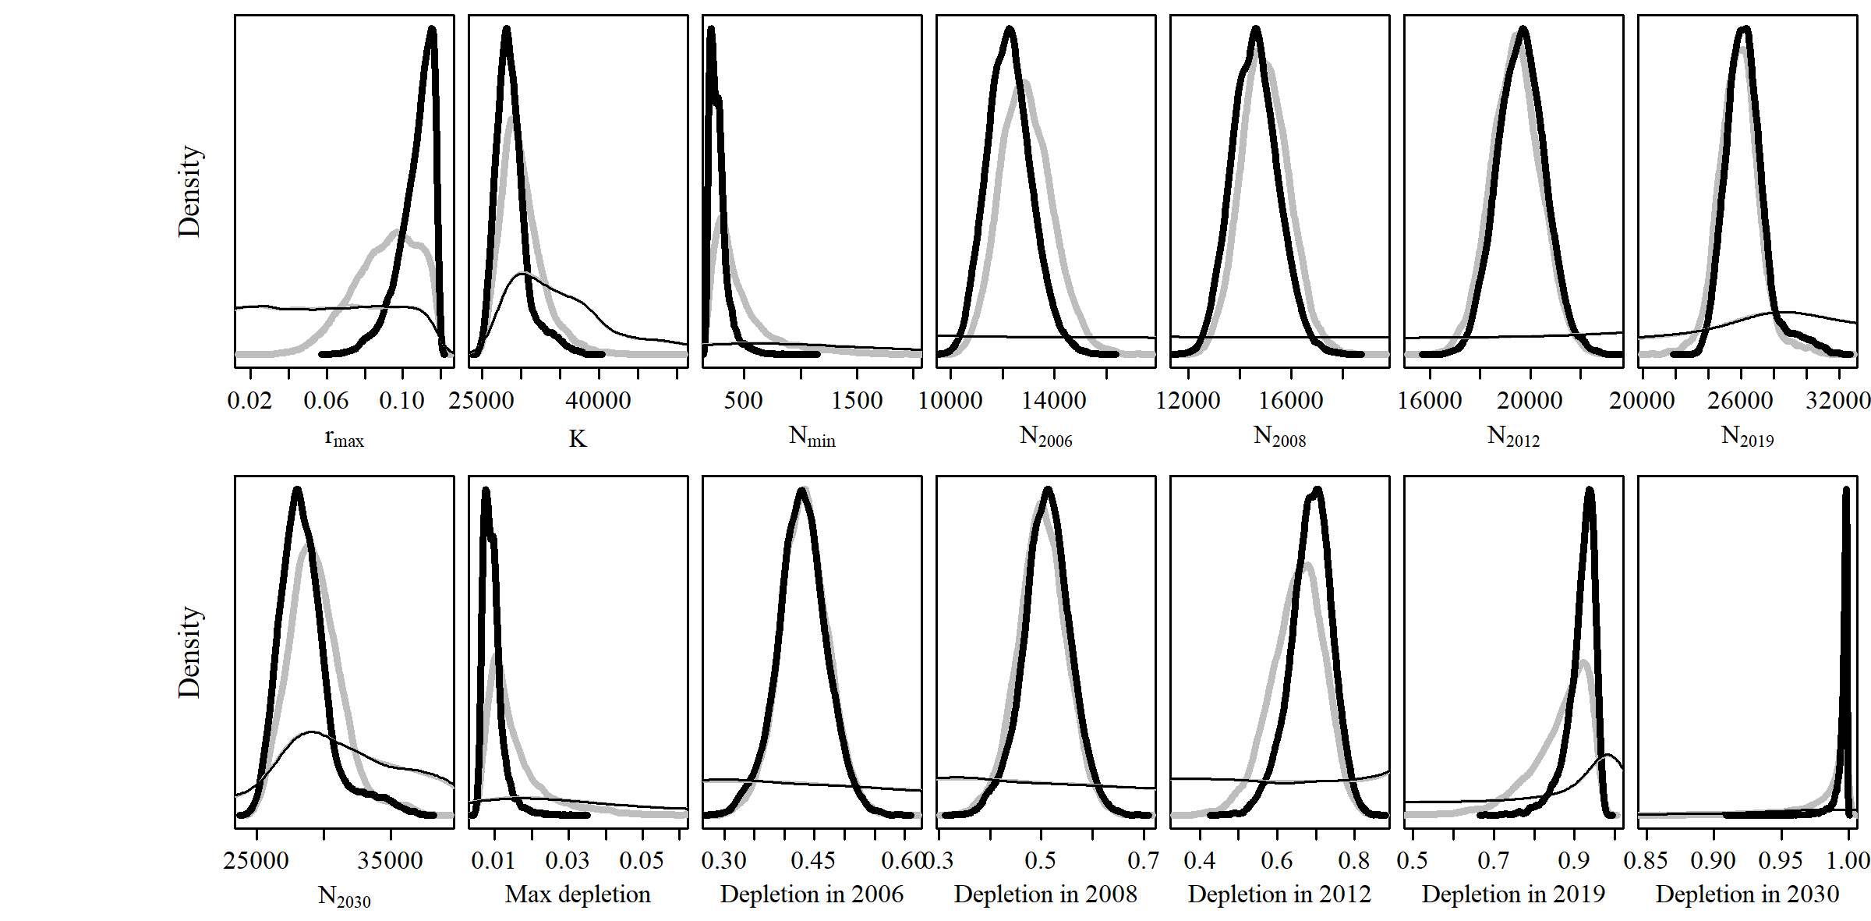**

* 1. **SData 4**

**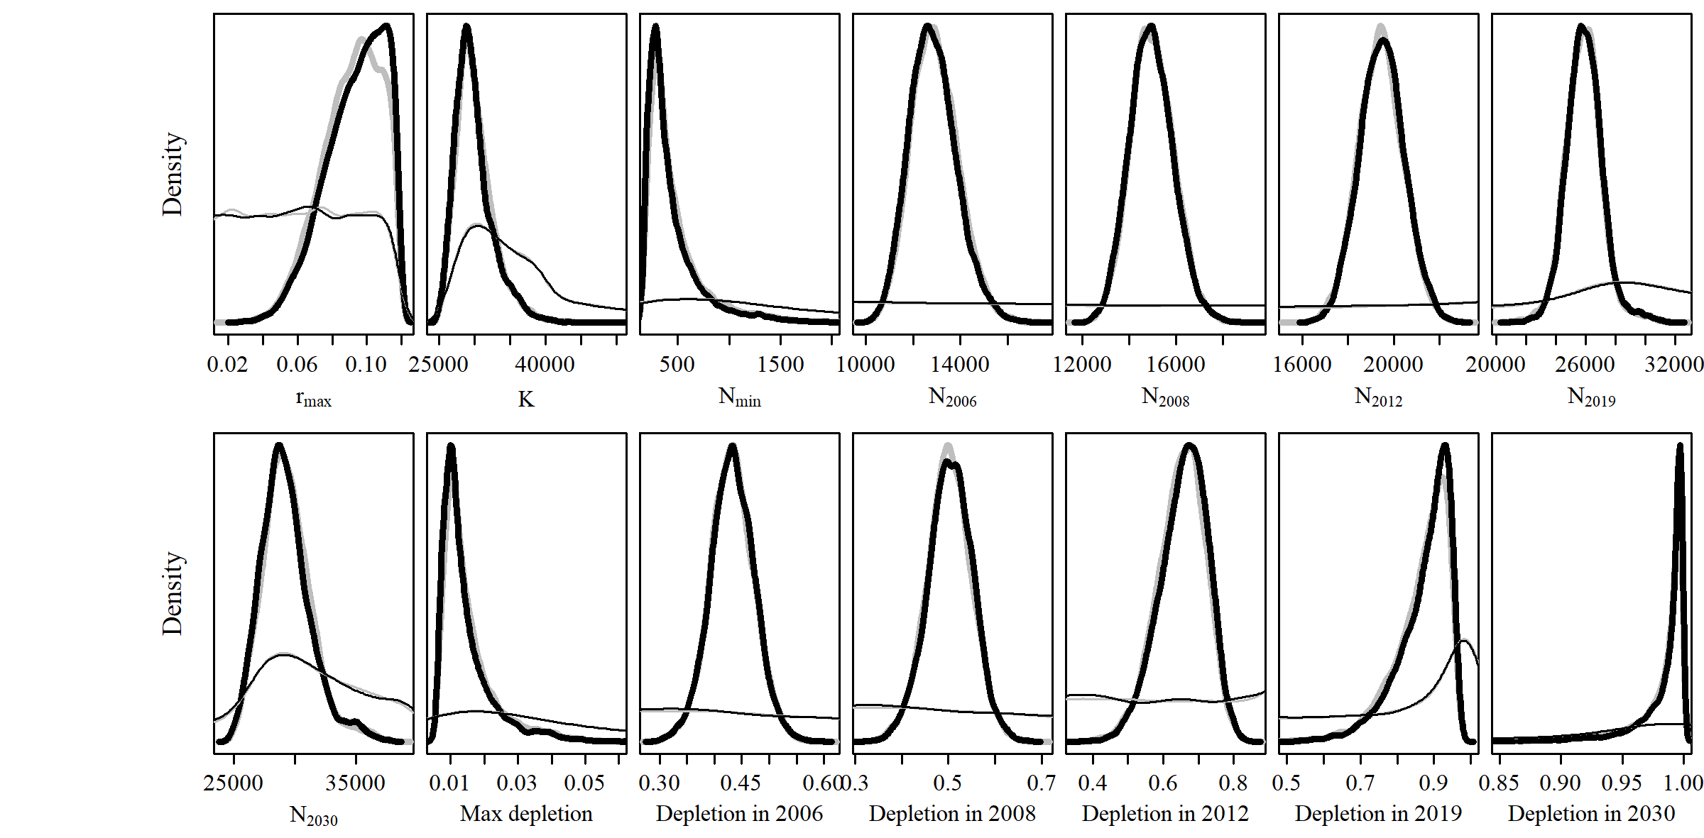**

* 1. **SData 5**

**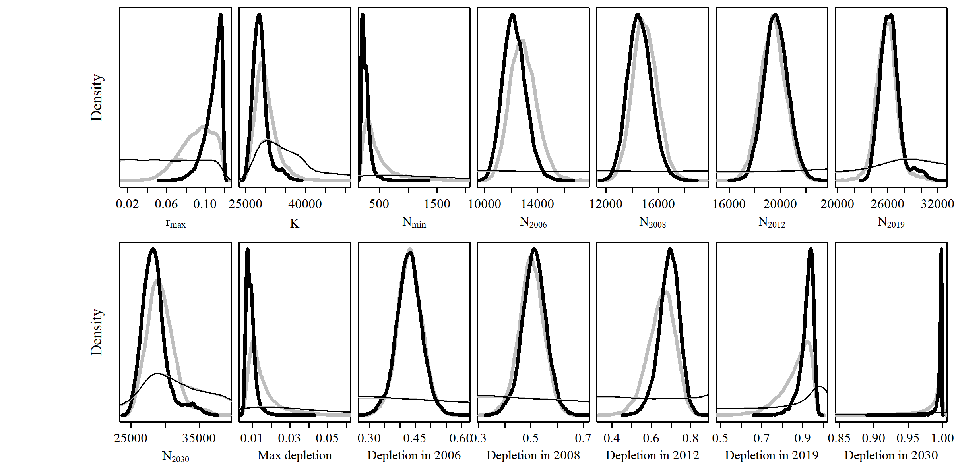**

* 1. **SData 6**

**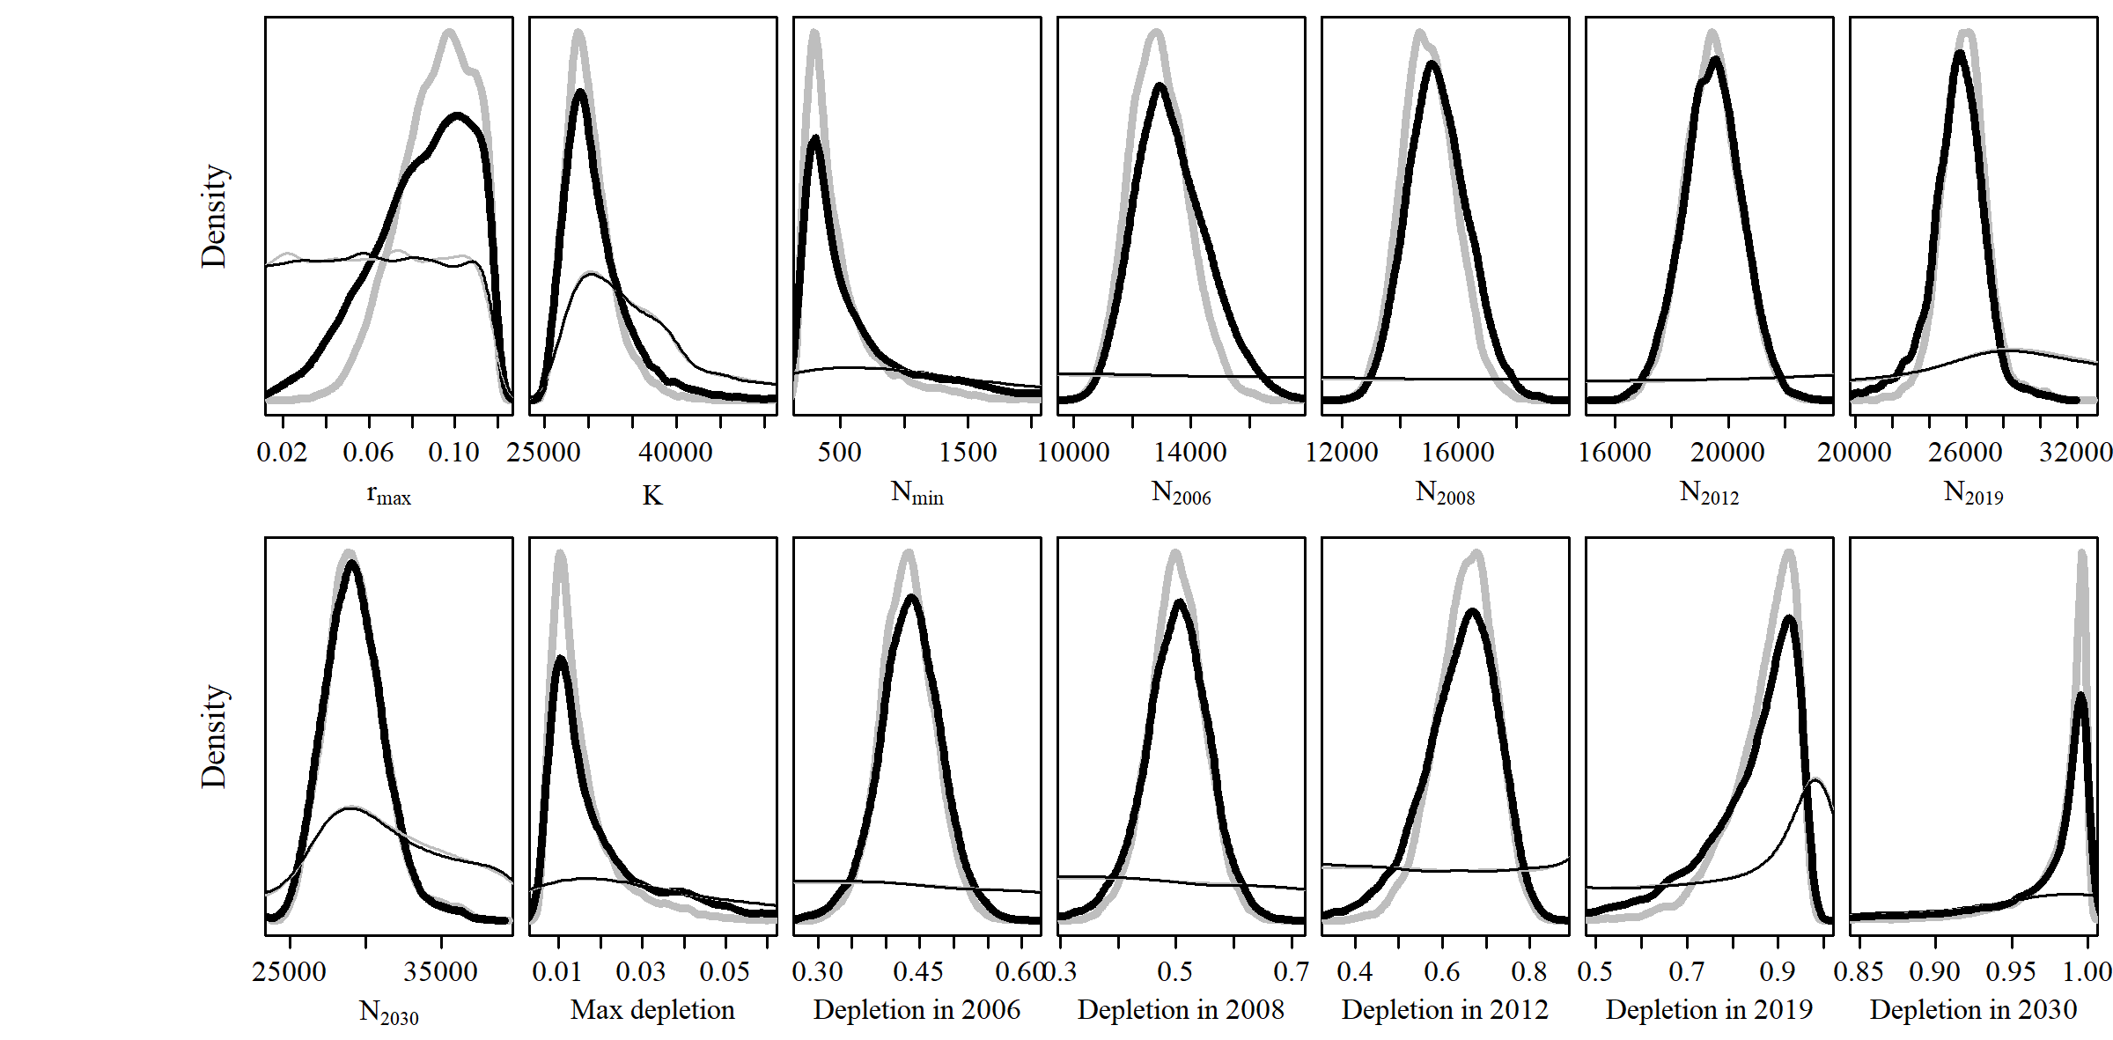**

* 1. **SData 7**

**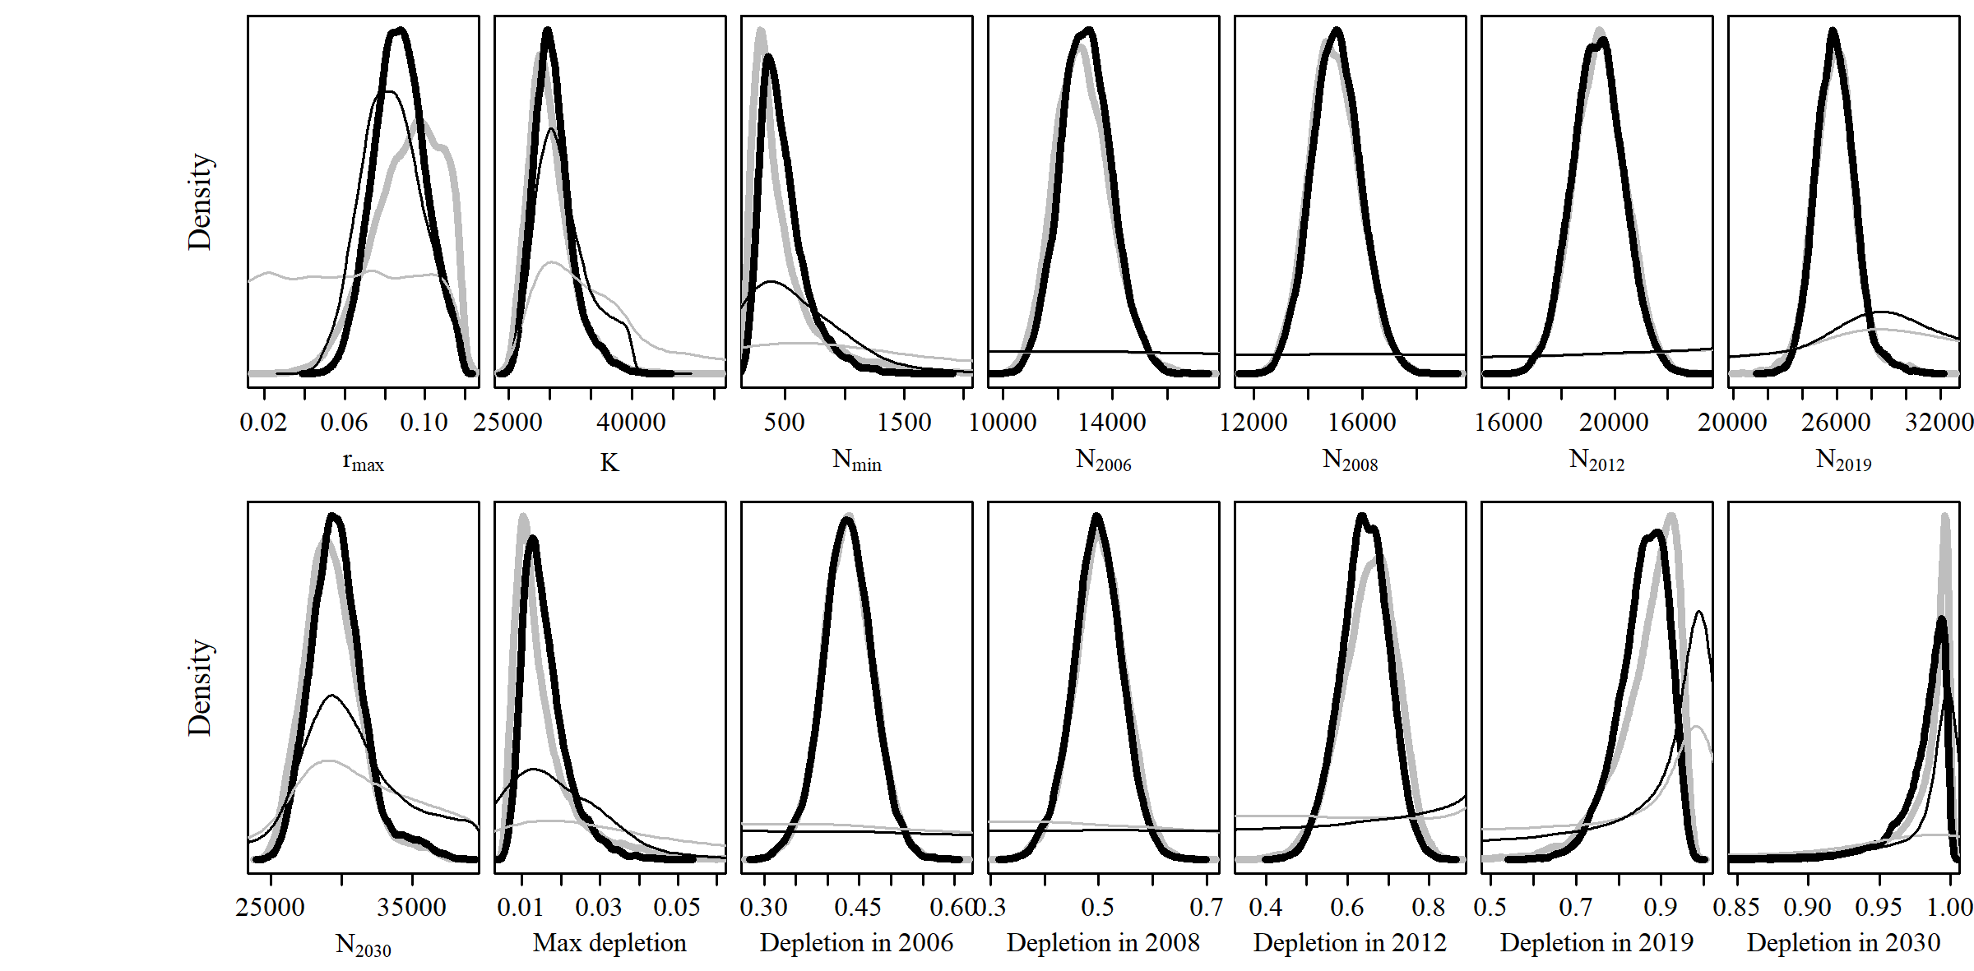**

* 1. **SCatch 1**

**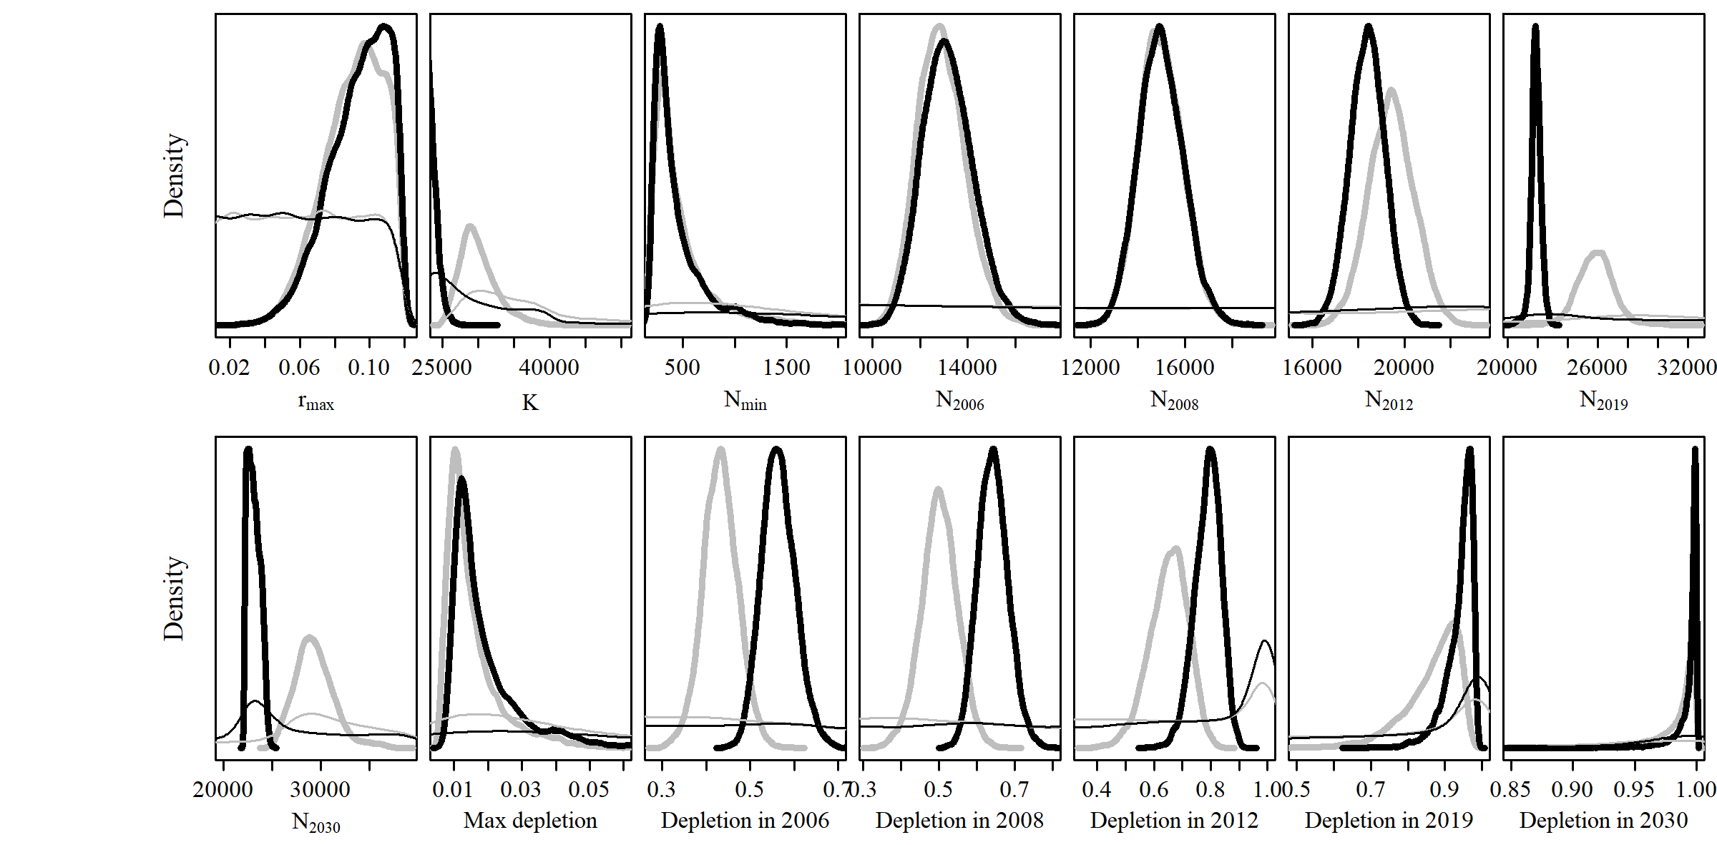**

* 1. **SCatch 2**

**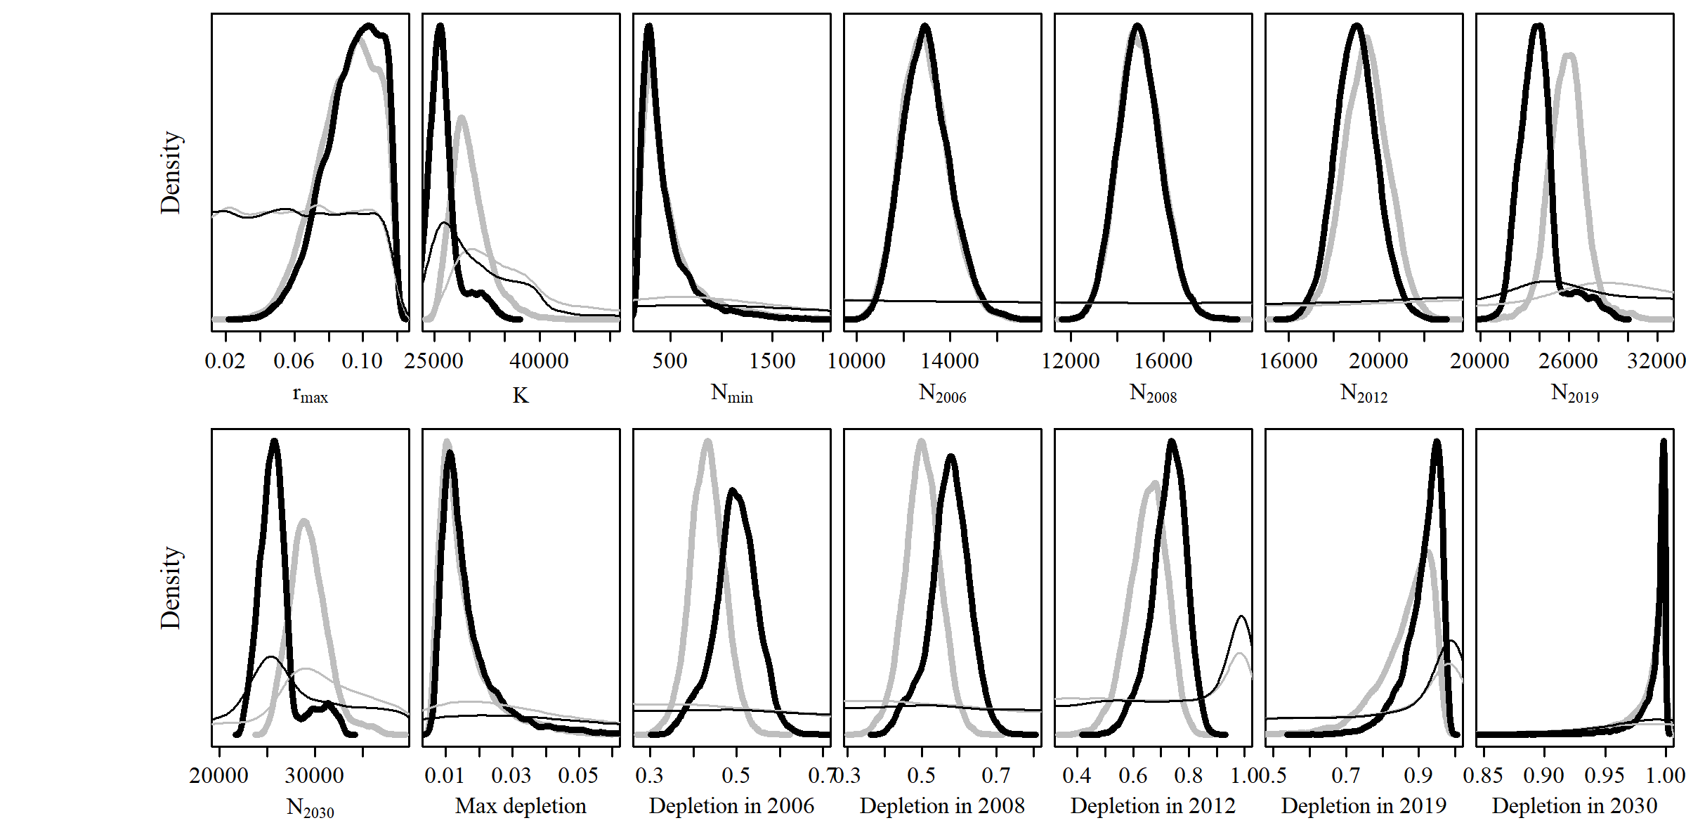**

* 1. **SCatch 3**

**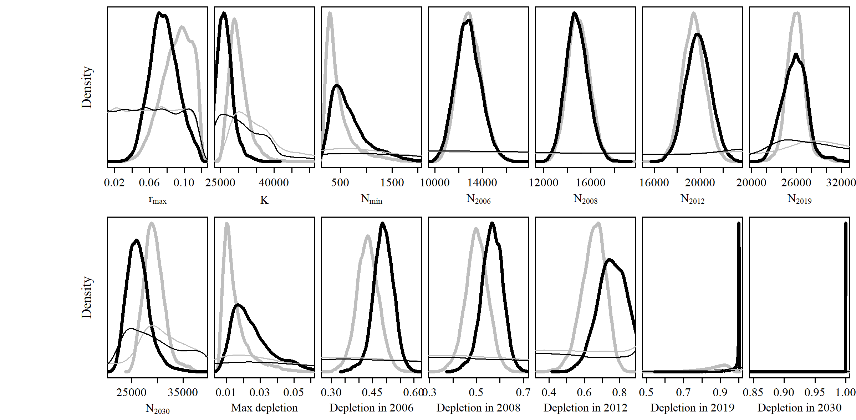**

* 1. **SCatch 4**

**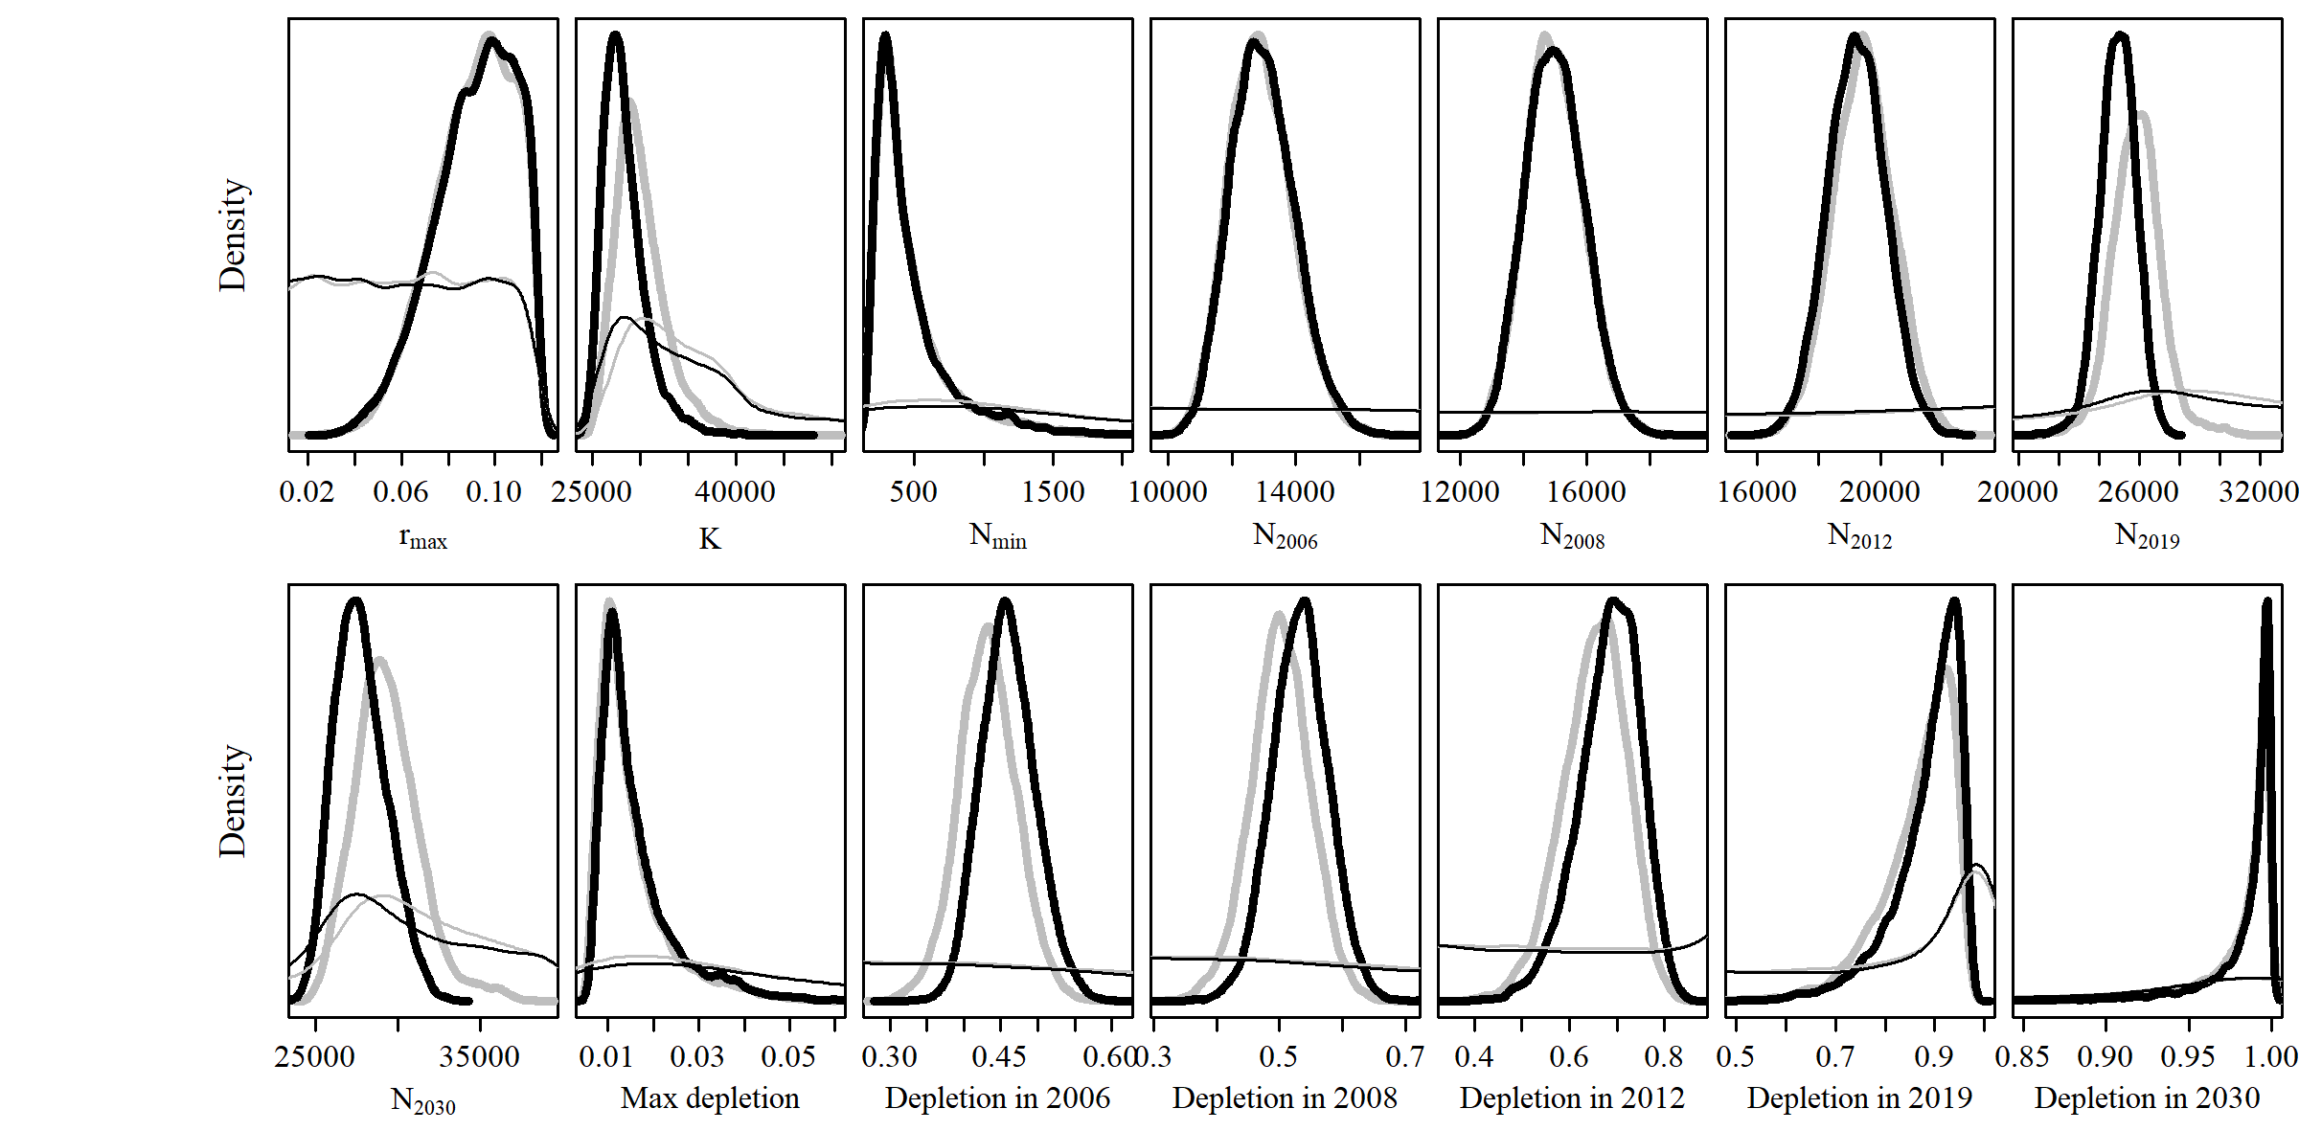**

* 1. **SCatch 5**

**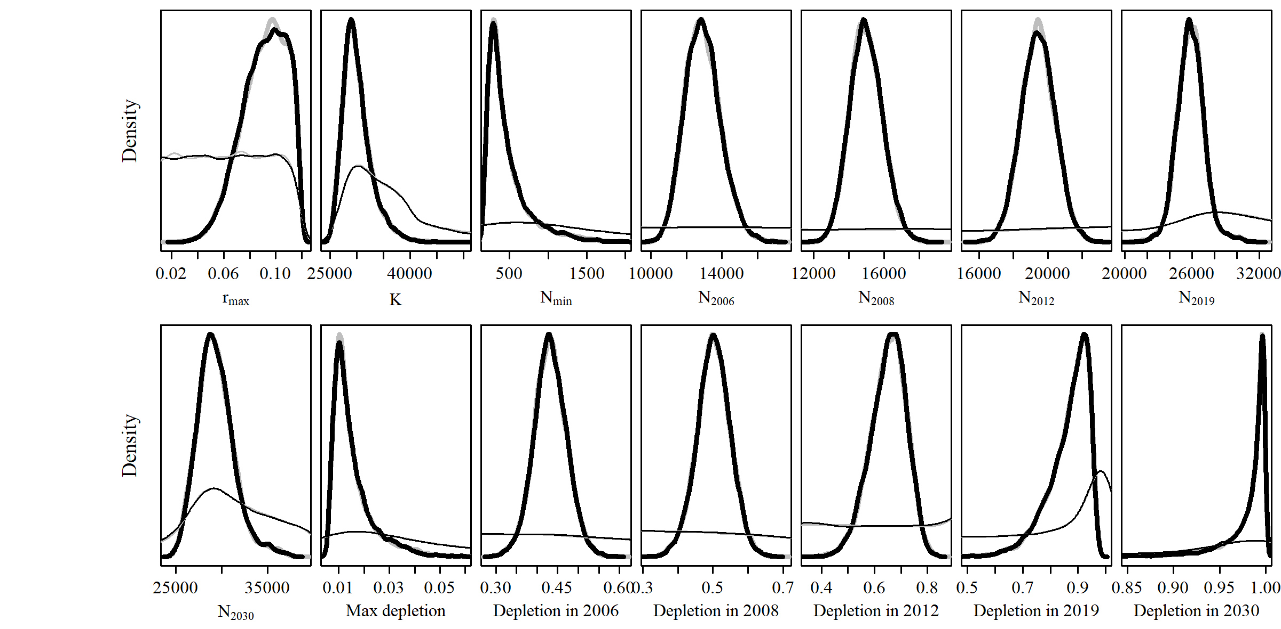**

* 1. **SCatch 6**

**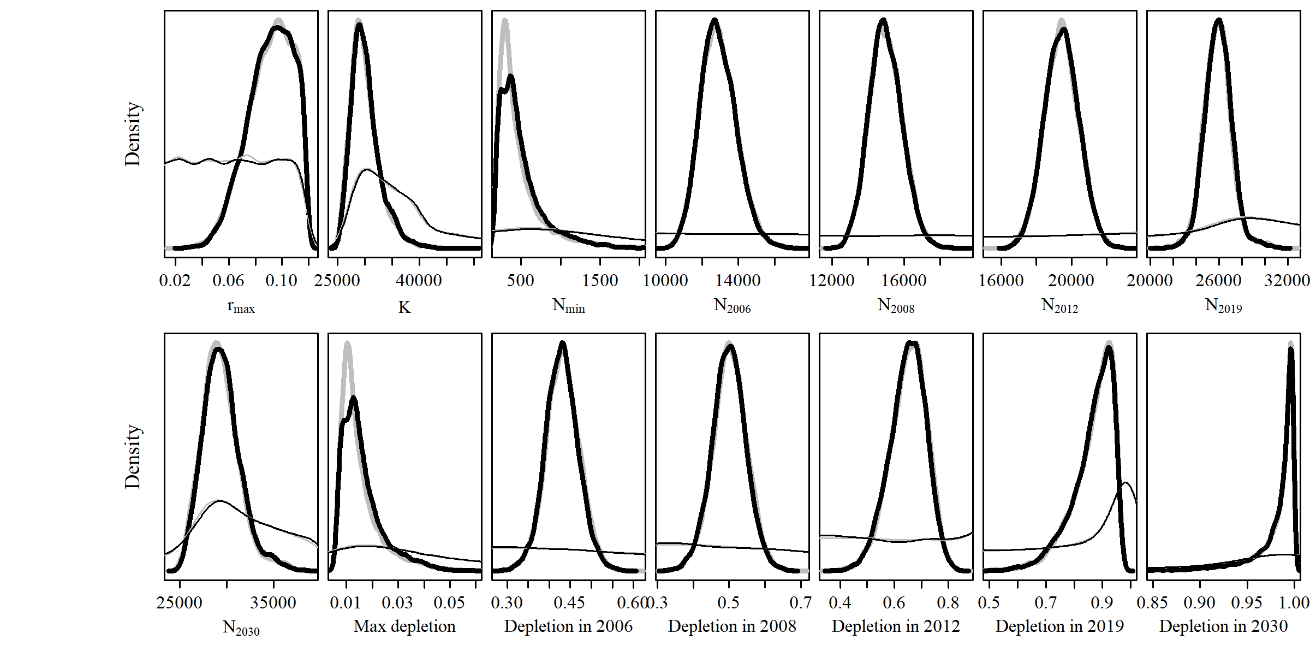**

* 1. **SCatch 7**

**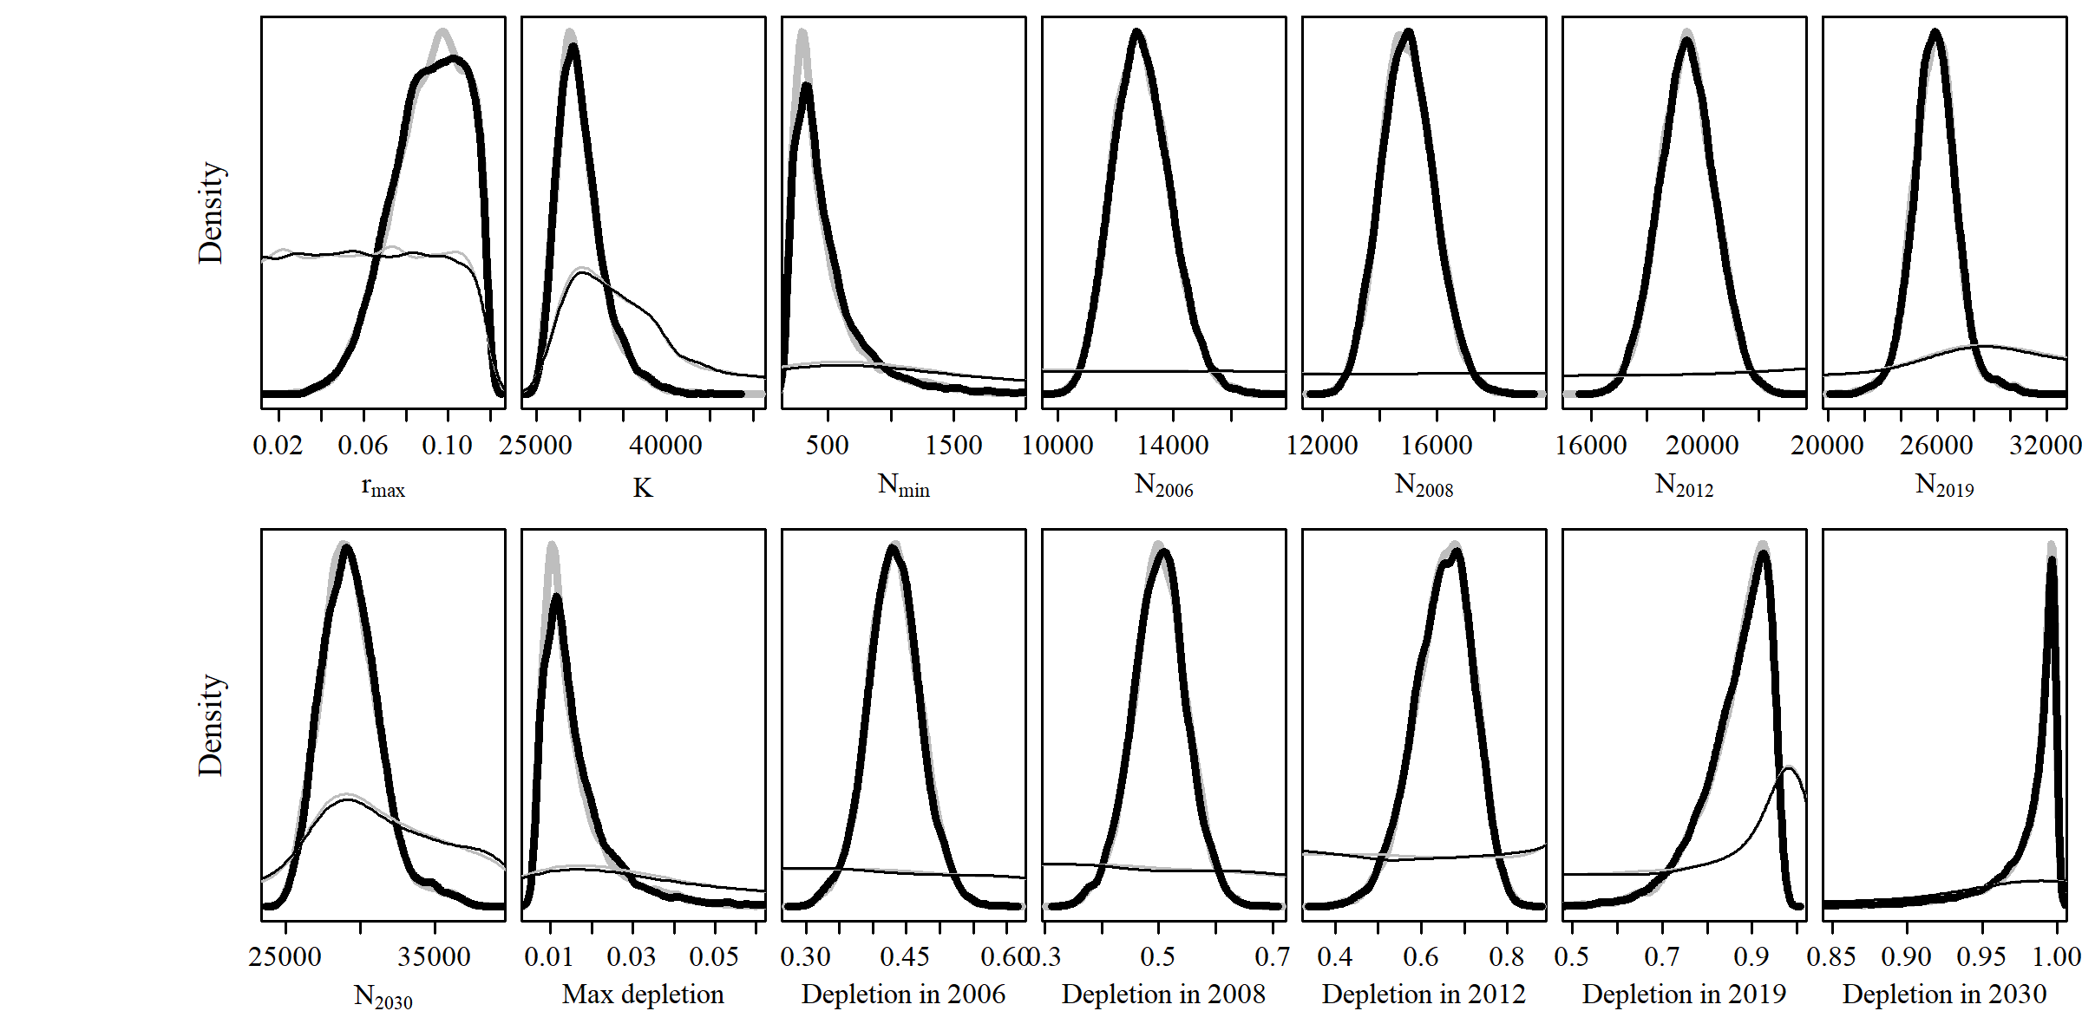**

* 1. **SCatch 8**

**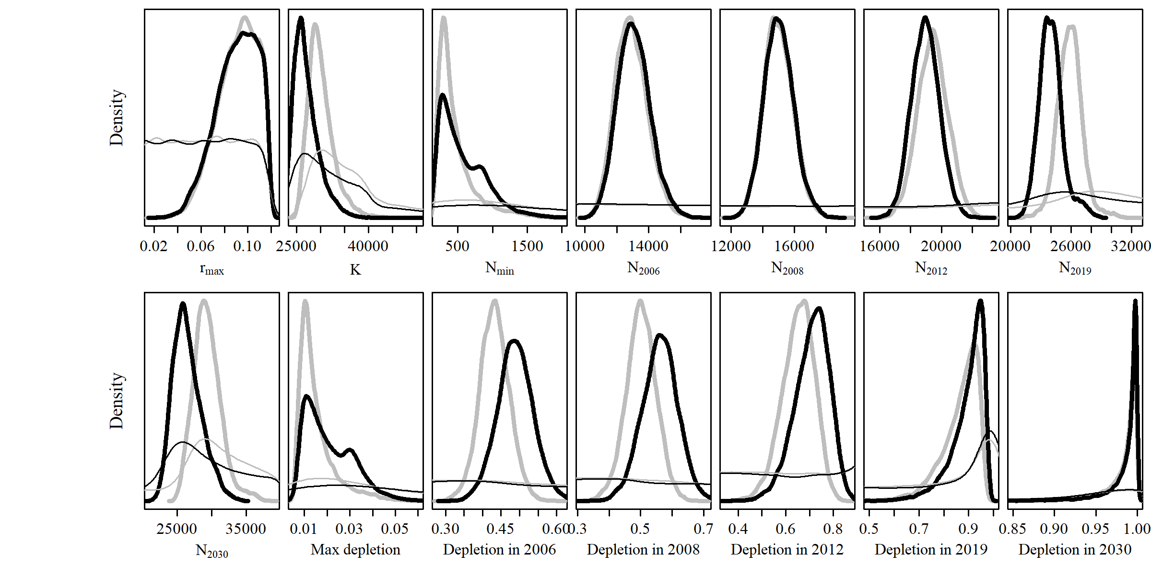**

* 1. **GC 1**

**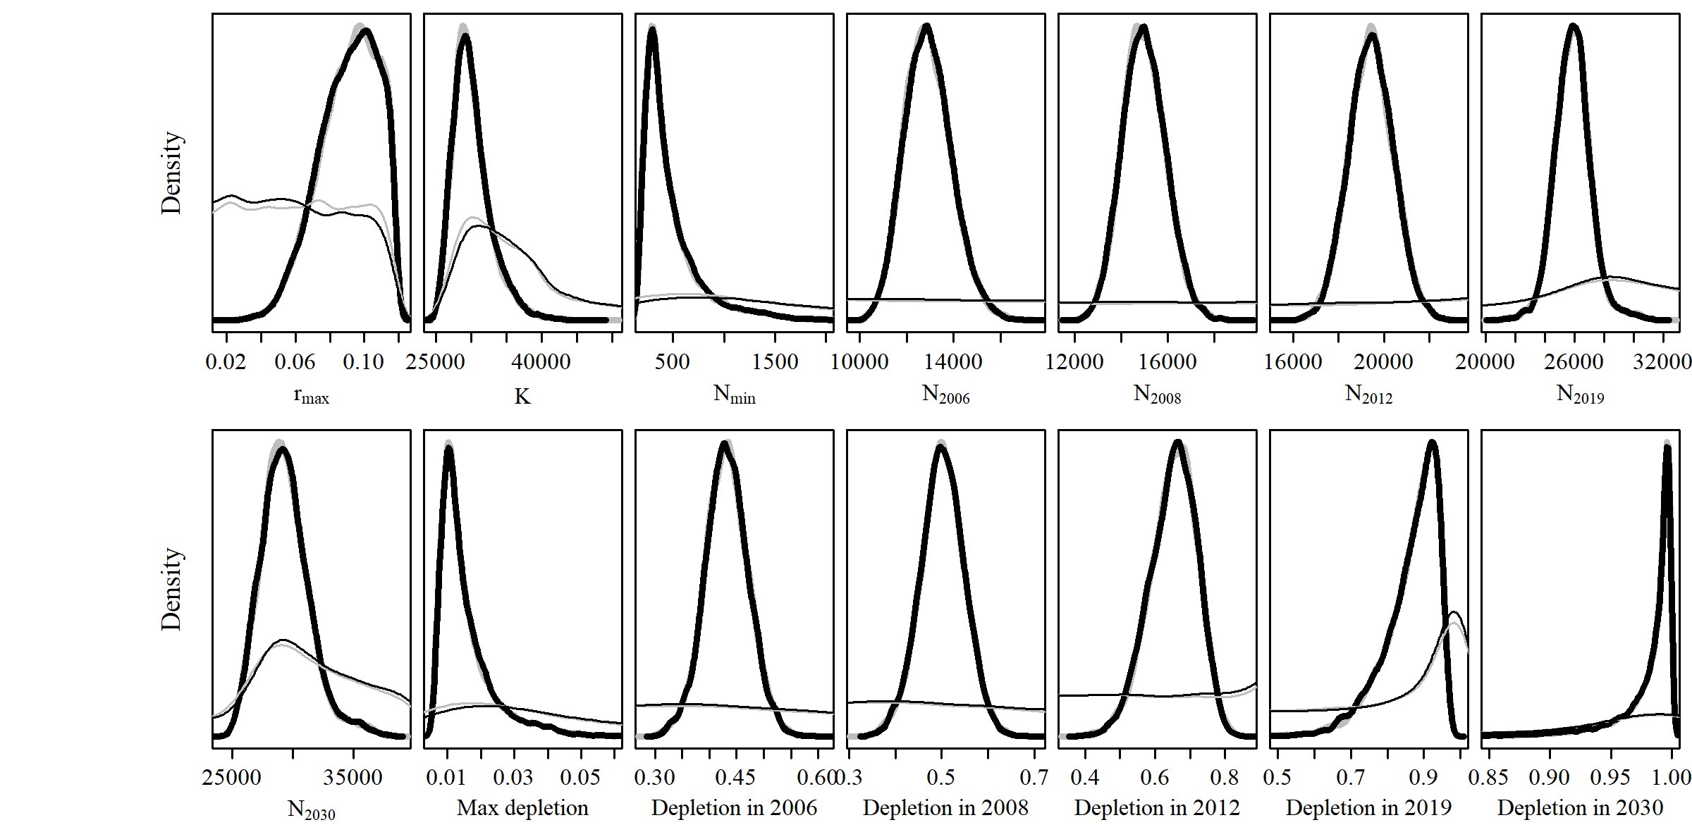**

* 1. **GC 2**

**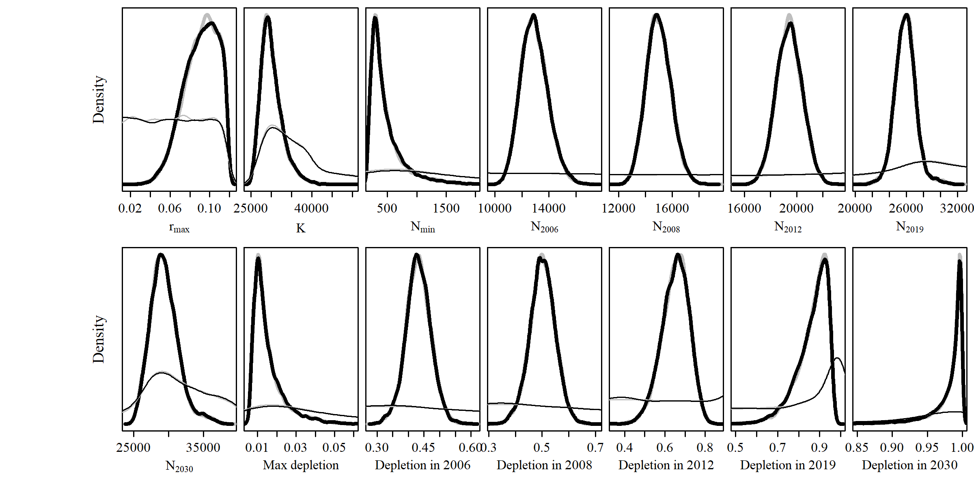**

* 1. **MSYL 1**

**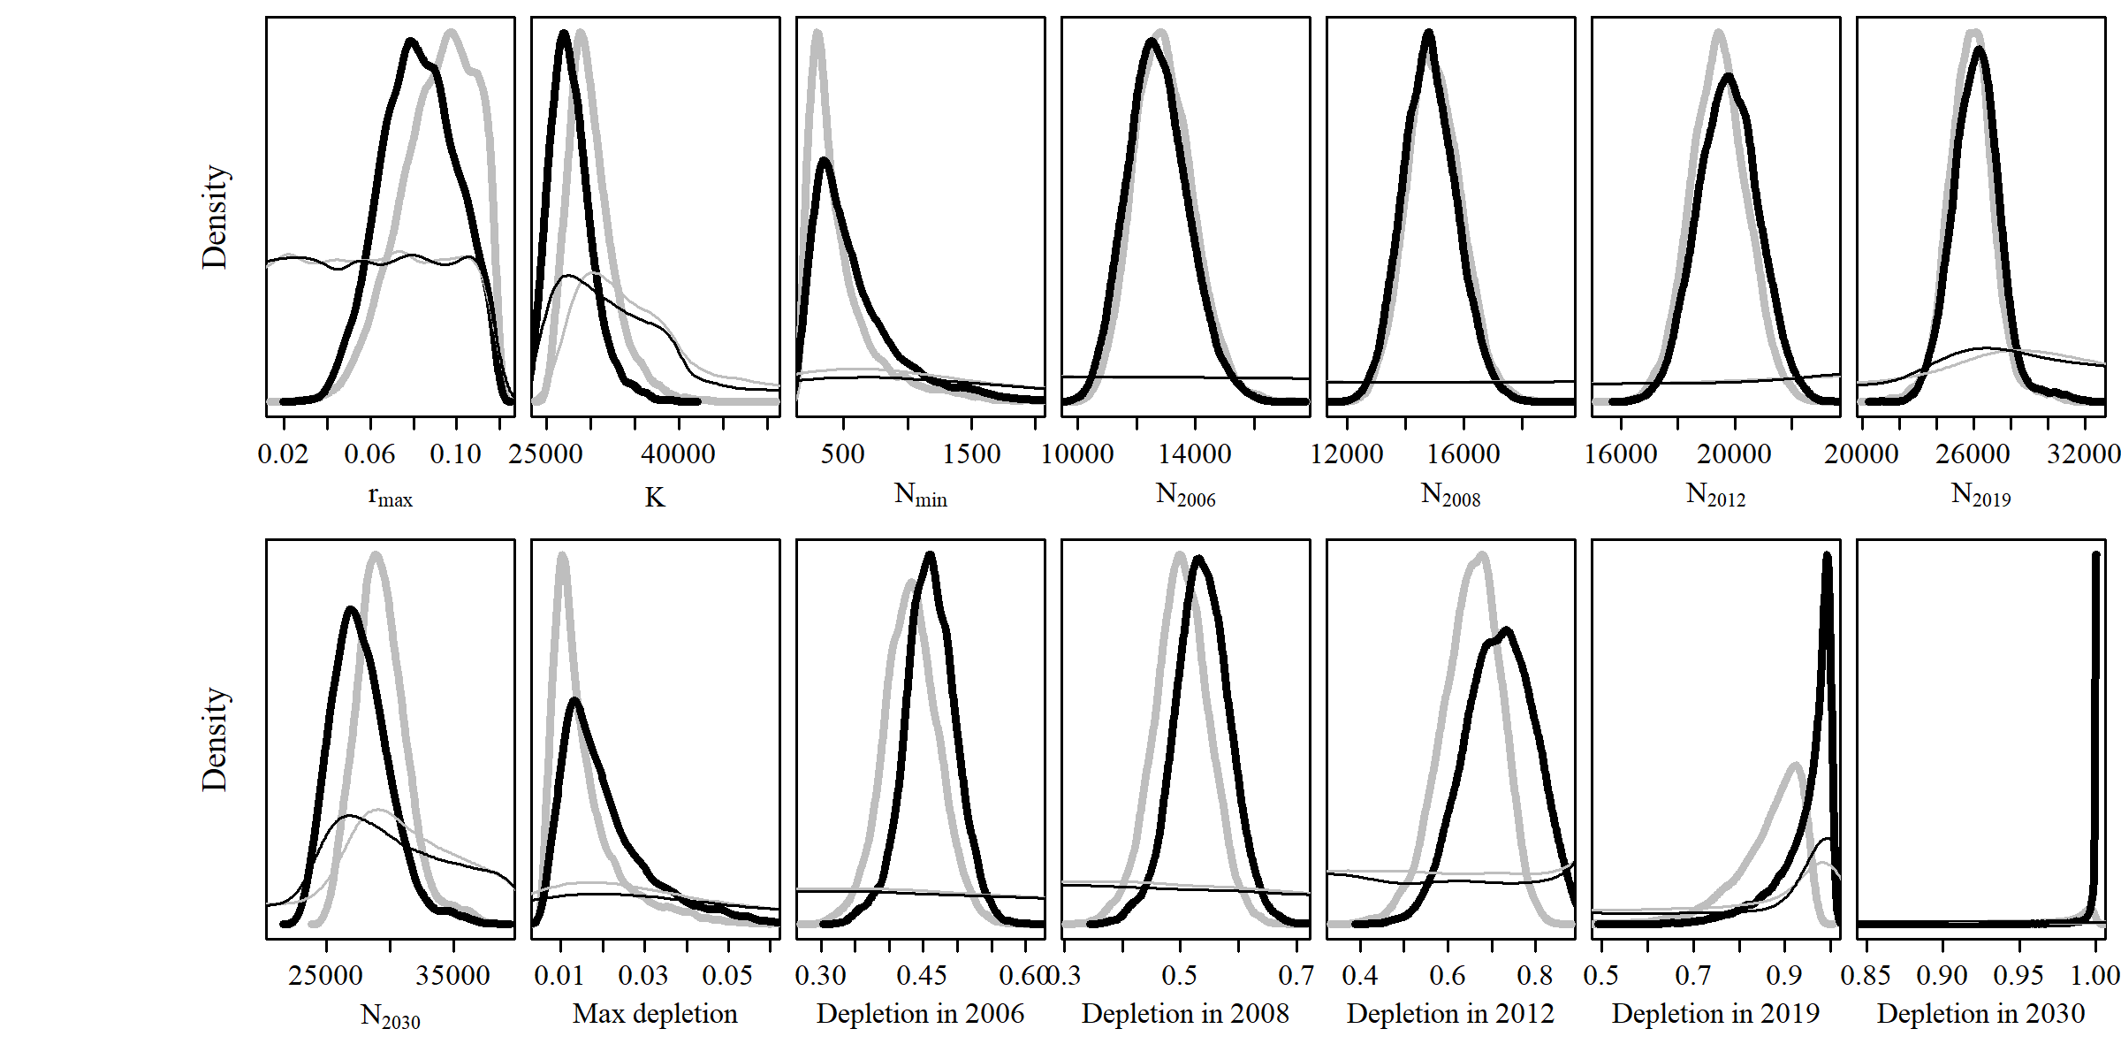**

* 1. **MSYL 2**

****

## Output Tables

# Model Average

|  |  |  |  |  |  |  |  |
| --- | --- | --- | --- | --- | --- | --- | --- |
| Parameter | Mean | Median | 2.5% CI | 25% CI | 75% CI | 97.5% CI | Unique |
| R\_max | 0.087 | 0.088 | 0.052 | 0.075 | 0.101 | 0.116 | 10,000 |
| K | 28,976 | 28,719 | 23,910 | 26,927 | 30,631 | 36,030 | 10,000 |
| N\_min | 537 | 436 | 197 | 315 | 653 | 1,455 | 10,000 |
| N\_2006 | 12,908 | 12,849 | 11,068 | 12,212 | 13,560 | 15,008 | 10,000 |
| N\_2008 | 14,947 | 14,905 | 13,220 | 14,306 | 15,554 | 16,836 | 10,000 |
| N\_2012 | 19,486 | 19,466 | 17,525 | 18,758 | 20,190 | 21,559 | 10,000 |
| N\_2019 | 25,742 | 25,733 | 23,013 | 24,864 | 26,601 | 28,507 | 10,000 |
| N\_2030 | 28,485 | 28,450 | 23,899 | 26,845 | 30,026 | 33,790 | 10,000 |
| Max depletion | 0.018 | 0.015 | 0.007 | 0.011 | 0.022 | 0.046 | 10,000 |
| Dep. in 2006 | 0.449 | 0.448 | 0.361 | 0.418 | 0.479 | 0.54 | 10,000 |
| Dep. in 2008 | 0.52 | 0.519 | 0.416 | 0.484 | 0.557 | 0.629 | 10,000 |
| Dep. in 2012 | 0.68 | 0.678 | 0.522 | 0.626 | 0.732 | 0.854 | 10,000 |
| Dep. in 2019 | 0.896 | 0.908 | 0.7 | 0.852 | 0.953 | 1 | 10,000 |
| Dep. in 2030 | 0.985 | 0.995 | 0.907 | 0.983 | 0.999 | 1 | 9,461 |

# Reference Case

|  |  |  |  |  |  |  |  |
| --- | --- | --- | --- | --- | --- | --- | --- |
| Parameter | Mean | Median | 2.5% CI | 25% CI | 75% CI | 97.5% CI | Unique |
| R\_max | 0.091 | 0.093 | 0.055 | 0.08 | 0.105 | 0.116 | 10,000 |
| K | 30,059 | 29,577 | 26,008 | 28,193 | 31,420 | 36,877 | 10,000 |
| N\_min | 476 | 374 | 193 | 284 | 554 | 1,356 | 10,000 |
| N\_2006 | 12,929 | 12,876 | 11,119 | 12,214 | 13,581 | 15,039 | 10,000 |
| N\_2008 | 14,987 | 14,948 | 13,239 | 14,350 | 15,600 | 16,878 | 10,000 |
| N\_2012 | 19,440 | 19,434 | 17,529 | 18,766 | 20,091 | 21,402 | 10,000 |
| N\_2019 | 25,882 | 25,871 | 23,491 | 25,093 | 26,609 | 28,541 | 10,000 |
| N\_2030 | 29,366 | 29,185 | 25,951 | 28,002 | 30,534 | 34,244 | 10,000 |
| Max depletion | 0.015 | 0.013 | 0.007 | 0.01 | 0.018 | 0.039 | 10,000 |
| Dep. in 2006 | 0.432 | 0.432 | 0.354 | 0.406 | 0.458 | 0.513 | 10,000 |
| Dep. in 2008 | 0.502 | 0.502 | 0.405 | 0.471 | 0.533 | 0.595 | 10,000 |
| Dep. in 2012 | 0.652 | 0.657 | 0.507 | 0.609 | 0.699 | 0.769 | 10,000 |
| Dep. in 2019 | 0.867 | 0.885 | 0.685 | 0.83 | 0.922 | 0.957 | 10,000 |
| Dep. in 2030 | 0.979 | 0.991 | 0.889 | 0.977 | 0.996 | 0.999 | 10,000 |

# SData 1

|  |  |  |  |  |  |  |  |
| --- | --- | --- | --- | --- | --- | --- | --- |
| Parameter | Mean | Median | 2.5% CI | 25% CI | 75% CI | 97.5% CI | Unique |
| R\_max | 0.091 | 0.092 | 0.055 | 0.079 | 0.104 | 0.116 | 10,000 |
| K | 30,168 | 29,697 | 26,053 | 28,284 | 31,562 | 36,984 | 10,000 |
| N\_min | 480 | 383 | 192 | 288 | 567 | 1,346 | 10,000 |
| N\_2006 | 12,917 | 12,858 | 11,101 | 12,221 | 13,555 | 15,000 | 10,000 |
| N\_2008 | 14,965 | 14,939 | 13,219 | 14,322 | 15,576 | 16,851 | 10,000 |
| N\_2012 | 19,405 | 19,388 | 17,509 | 18,717 | 20,078 | 21,372 | 10,000 |
| N\_2019 | 25,892 | 25,857 | 23,563 | 25,098 | 26,635 | 28,696 | 10,000 |
| N\_2030 | 29,465 | 29,274 | 25,986 | 28,080 | 30,617 | 34,518 | 10,000 |
| Max depletion | 0.015 | 0.013 | 0.007 | 0.01 | 0.018 | 0.039 | 10,000 |
| Dep. in 2006 | 0.43 | 0.43 | 0.351 | 0.404 | 0.456 | 0.511 | 10,000 |
| Dep. in 2008 | 0.499 | 0.499 | 0.404 | 0.469 | 0.53 | 0.593 | 10,000 |
| Dep. in 2012 | 0.648 | 0.653 | 0.507 | 0.605 | 0.695 | 0.769 | 10,000 |
| Dep. in 2019 | 0.864 | 0.88 | 0.684 | 0.826 | 0.919 | 0.956 | 10,000 |
| Dep. in 2030 | 0.979 | 0.99 | 0.891 | 0.976 | 0.996 | 0.999 | 10,000 |

# SData 2

|  |  |  |  |  |  |  |  |
| --- | --- | --- | --- | --- | --- | --- | --- |
| Parameter | Mean | Median | 2.5% CI | 25% CI | 75% CI | 97.5% CI | Unique |
| R\_max | 0.087 | 0.091 | 0.033 | 0.072 | 0.106 | 0.117 | 10,000 |
| K | 30,763 | 29,631 | 25,889 | 28,064 | 32,071 | 41,945 | 10,000 |
| N\_min | 703 | 394 | 190 | 278 | 720 | 2,922 | 10,000 |
| N\_2006 | 13,255 | 13,132 | 11,162 | 12,366 | 14,007 | 16,071 | 10,000 |
| N\_2008 | 15,231 | 15,180 | 13,349 | 14,512 | 15,894 | 17,423 | 10,000 |
| N\_2012 | 19,473 | 19,472 | 17,434 | 18,769 | 20,168 | 21,540 | 10,000 |
| N\_2019 | 25,556 | 25,674 | 21,795 | 24,795 | 26,485 | 28,352 | 10,000 |
| N\_2030 | 29,110 | 29,012 | 25,564 | 27,752 | 30,354 | 33,584 | 10,000 |
| Max depletion | 0.02 | 0.013 | 0.007 | 0.01 | 0.023 | 0.072 | 10,000 |
| Dep. in 2006 | 0.436 | 0.436 | 0.342 | 0.408 | 0.465 | 0.525 | 10,000 |
| Dep. in 2008 | 0.502 | 0.505 | 0.377 | 0.47 | 0.539 | 0.606 | 10,000 |
| Dep. in 2012 | 0.645 | 0.658 | 0.434 | 0.599 | 0.705 | 0.78 | 10,000 |
| Dep. in 2019 | 0.847 | 0.884 | 0.53 | 0.805 | 0.925 | 0.96 | 10,000 |
| Dep. in 2030 | 0.958 | 0.99 | 0.682 | 0.965 | 0.996 | 0.999 | 10,000 |

# SData 3

|  |  |  |  |  |  |  |  |
| --- | --- | --- | --- | --- | --- | --- | --- |
| Parameter | Mean | Median | 2.5% CI | 25% CI | 75% CI | 97.5% CI | Unique |
| R\_max | 0.107 | 0.109 | 0.083 | 0.102 | 0.114 | 0.118 | 10,000 |
| K | 28,716 | 28,397 | 25,698 | 27,368 | 29,613 | 34,352 | 10,000 |
| N\_min | 270 | 252 | 175 | 211 | 300 | 501 | 10,000 |
| N\_2006 | 12,276 | 12,243 | 10,720 | 11,684 | 12,822 | 14,073 | 10,000 |
| N\_2008 | 14,596 | 14,577 | 12,938 | 13,969 | 15,175 | 16,413 | 10,000 |
| N\_2012 | 19,645 | 19,641 | 17,856 | 19,002 | 20,270 | 21,516 | 10,000 |
| N\_2019 | 26,270 | 26,155 | 24,251 | 25,449 | 26,890 | 29,627 | 10,000 |
| N\_2030 | 28,566 | 28,288 | 25,648 | 27,297 | 29,436 | 33,995 | 10,000 |
| Max depletion | 0.009 | 0.009 | 0.006 | 0.008 | 0.01 | 0.016 | 10,000 |
| Dep. in 2006 | 0.429 | 0.429 | 0.345 | 0.404 | 0.455 | 0.51 | 10,000 |
| Dep. in 2008 | 0.511 | 0.511 | 0.413 | 0.482 | 0.54 | 0.601 | 10,000 |
| Dep. in 2012 | 0.687 | 0.69 | 0.571 | 0.654 | 0.724 | 0.783 | 10,000 |
| Dep. in 2019 | 0.917 | 0.925 | 0.825 | 0.901 | 0.941 | 0.962 | 10,000 |
| Dep. in 2030 | 0.995 | 0.997 | 0.979 | 0.994 | 0.998 | 0.999 | 10,000 |

# SData 4

|  |  |  |  |  |  |  |  |
| --- | --- | --- | --- | --- | --- | --- | --- |
| Parameter | Mean | Median | 2.5% CI | 25% CI | 75% CI | 97.5% CI | Unique |
| R\_max | 0.093 | 0.096 | 0.056 | 0.082 | 0.107 | 0.117 | 10,000 |
| K | 29,867 | 29,347 | 25,950 | 28,005 | 31,115 | 36,623 | 10,000 |
| N\_min | 448 | 349 | 187 | 269 | 516 | 1,308 | 10,000 |
| N\_2006 | 12,861 | 12,797 | 11,081 | 12,150 | 13,491 | 15,035 | 10,000 |
| N\_2008 | 14,956 | 14,925 | 13,241 | 14,323 | 15,562 | 16,852 | 10,000 |
| N\_2012 | 19,489 | 19,484 | 17,599 | 18,814 | 20,139 | 21,481 | 10,000 |
| N\_2019 | 25,939 | 25,891 | 23,649 | 25,149 | 26,662 | 28,696 | 10,000 |
| N\_2030 | 29,251 | 29,030 | 25,881 | 27,844 | 30,362 | 34,446 | 10,000 |
| Max depletion | 0.015 | 0.012 | 0.007 | 0.009 | 0.017 | 0.038 | 10,000 |
| Dep. in 2006 | 0.433 | 0.433 | 0.353 | 0.407 | 0.46 | 0.513 | 10,000 |
| Dep. in 2008 | 0.504 | 0.505 | 0.406 | 0.473 | 0.536 | 0.597 | 10,000 |
| Dep. in 2012 | 0.658 | 0.664 | 0.512 | 0.614 | 0.706 | 0.773 | 10,000 |
| Dep. in 2019 | 0.874 | 0.894 | 0.693 | 0.838 | 0.928 | 0.958 | 10,000 |
| Dep. in 2030 | 0.981 | 0.992 | 0.897 | 0.98 | 0.997 | 0.999 | 10,000 |

# SData 5

|  |  |  |  |  |  |  |  |
| --- | --- | --- | --- | --- | --- | --- | --- |
| Parameter | Mean | Median | 2.5% CI | 25% CI | 75% CI | 97.5% CI | Unique |
| R\_max | 0.108 | 0.11 | 0.085 | 0.103 | 0.115 | 0.118 | 10,000 |
| K | 28,601 | 28,340 | 25,599 | 27,309 | 29,419 | 34,158 | 10,000 |
| N\_min | 261 | 243 | 173 | 206 | 291 | 468 | 10,000 |
| N\_2006 | 12,251 | 12,199 | 10,680 | 11,650 | 12,798 | 14,089 | 10,000 |
| N\_2008 | 14,587 | 14,552 | 12,900 | 13,964 | 15,172 | 16,471 | 10,000 |
| N\_2012 | 19,668 | 19,647 | 17,859 | 19,030 | 20,293 | 21,587 | 10,000 |
| N\_2019 | 26,264 | 26,157 | 24,211 | 25,441 | 26,866 | 29,680 | 10,000 |
| N\_2030 | 28,467 | 28,237 | 25,556 | 27,234 | 29,268 | 33,899 | 10,000 |
| Max depletion | 0.009 | 0.009 | 0.006 | 0.007 | 0.01 | 0.016 | 10,000 |
| Dep. in 2006 | 0.43 | 0.43 | 0.345 | 0.404 | 0.457 | 0.512 | 10,000 |
| Dep. in 2008 | 0.512 | 0.513 | 0.416 | 0.483 | 0.542 | 0.602 | 10,000 |
| Dep. in 2012 | 0.69 | 0.694 | 0.578 | 0.658 | 0.726 | 0.783 | 10,000 |
| Dep. in 2019 | 0.92 | 0.927 | 0.836 | 0.906 | 0.943 | 0.962 | 10,000 |
| Dep. in 2030 | 0.996 | 0.997 | 0.983 | 0.995 | 0.998 | 0.999 | 10,000 |

# SData 6

|  |  |  |  |  |  |  |  |
| --- | --- | --- | --- | --- | --- | --- | --- |
| Parameter | Mean | Median | 2.5% CI | 25% CI | 75% CI | 97.5% CI | Unique |
| R\_max | 0.084 | 0.088 | 0.033 | 0.069 | 0.103 | 0.116 | 10,000 |
| K | 31,021 | 29,922 | 25,969 | 28,262 | 32,459 | 42,359 | 10,000 |
| N\_min | 739 | 437 | 194 | 297 | 806 | 2,948 | 10,000 |
| N\_2006 | 13,370 | 13,228 | 11,233 | 12,473 | 14,163 | 16,142 | 10,000 |
| N\_2008 | 15,301 | 15,245 | 13,374 | 14,574 | 15,986 | 17,494 | 10,000 |
| N\_2012 | 19,443 | 19,452 | 17,380 | 18,763 | 20,136 | 21,456 | 10,000 |
| N\_2019 | 25,495 | 25,612 | 21,779 | 24,711 | 26,426 | 28,267 | 10,000 |
| N\_2030 | 29,263 | 29,164 | 25,630 | 27,891 | 30,528 | 33,852 | 10,000 |
| Max depletion | 0.022 | 0.015 | 0.007 | 0.01 | 0.025 | 0.073 | 10,000 |
| Dep. in 2006 | 0.436 | 0.436 | 0.339 | 0.407 | 0.466 | 0.527 | 10,000 |
| Dep. in 2008 | 0.5 | 0.503 | 0.375 | 0.466 | 0.538 | 0.609 | 10,000 |
| Dep. in 2012 | 0.638 | 0.65 | 0.433 | 0.587 | 0.7 | 0.779 | 10,000 |
| Dep. in 2019 | 0.837 | 0.872 | 0.529 | 0.788 | 0.92 | 0.958 | 10,000 |
| Dep. in 2030 | 0.955 | 0.988 | 0.687 | 0.957 | 0.996 | 0.999 | 10,000 |

# SData 7

|  |  |  |  |  |  |  |  |
| --- | --- | --- | --- | --- | --- | --- | --- |
| Parameter | Mean | Median | 2.5% CI | 25% CI | 75% CI | 97.5% CI | Unique |
| R\_max | 0.087 | 0.087 | 0.063 | 0.079 | 0.096 | 0.112 | 10,000 |
| K | 30,383 | 30,072 | 26,563 | 28,727 | 31,608 | 36,362 | 10,000 |
| N\_min | 488 | 442 | 227 | 347 | 578 | 1,012 | 10,000 |
| N\_2006 | 13,049 | 13,026 | 11,314 | 12,408 | 13,657 | 14,962 | 10,000 |
| N\_2008 | 15,047 | 15,030 | 13,321 | 14,432 | 15,639 | 16,886 | 10,000 |
| N\_2012 | 19,379 | 19,373 | 17,516 | 18,728 | 20,017 | 21,300 | 10,000 |
| N\_2019 | 25,928 | 25,872 | 23,826 | 25,144 | 26,630 | 28,478 | 10,000 |
| N\_2030 | 29,755 | 29,585 | 26,449 | 28,436 | 30,817 | 34,840 | 10,000 |
| Max depletion | 0.016 | 0.015 | 0.008 | 0.012 | 0.019 | 0.031 | 10,000 |
| Dep. in 2006 | 0.432 | 0.431 | 0.351 | 0.406 | 0.458 | 0.512 | 10,000 |
| Dep. in 2008 | 0.498 | 0.498 | 0.403 | 0.469 | 0.528 | 0.587 | 10,000 |
| Dep. in 2012 | 0.642 | 0.643 | 0.521 | 0.604 | 0.682 | 0.751 | 10,000 |
| Dep. in 2019 | 0.857 | 0.865 | 0.725 | 0.823 | 0.901 | 0.946 | 10,000 |
| Dep. in 2030 | 0.98 | 0.986 | 0.929 | 0.975 | 0.993 | 0.998 | 10,000 |

# SCatch 1

|  |  |  |  |  |  |  |  |
| --- | --- | --- | --- | --- | --- | --- | --- |
| Parameter | Mean | Median | 2.5% CI | 25% CI | 75% CI | 97.5% CI | Unique |
| R\_max | 0.094 | 0.096 | 0.055 | 0.082 | 0.107 | 0.117 | 10,000 |
| K | 23,330 | 23,140 | 22,242 | 22,650 | 23,815 | 25,462 | 10,000 |
| N\_min | 461 | 355 | 200 | 274 | 531 | 1,258 | 10,000 |
| N\_2006 | 13,178 | 13,112 | 11,279 | 12,432 | 13,860 | 15,415 | 10,000 |
| N\_2008 | 14,994 | 14,955 | 13,252 | 14,342 | 15,611 | 16,958 | 10,000 |
| N\_2012 | 18,386 | 18,398 | 16,899 | 17,878 | 18,899 | 19,838 | 10,000 |
| N\_2019 | 21,893 | 21,896 | 21,127 | 21,715 | 22,102 | 22,551 | 10,000 |
| N\_2030 | 23,143 | 23,066 | 22,225 | 22,618 | 23,616 | 24,381 | 10,000 |
| Max depletion | 0.019 | 0.015 | 0.009 | 0.012 | 0.022 | 0.049 | 10,000 |
| Dep. in 2006 | 0.565 | 0.563 | 0.495 | 0.539 | 0.59 | 0.645 | 10,000 |
| Dep. in 2008 | 0.643 | 0.642 | 0.57 | 0.615 | 0.669 | 0.726 | 10,000 |
| Dep. in 2012 | 0.789 | 0.793 | 0.69 | 0.76 | 0.822 | 0.87 | 10,000 |
| Dep. in 2019 | 0.94 | 0.951 | 0.84 | 0.924 | 0.966 | 0.981 | 10,000 |
| Dep. in 2030 | 0.992 | 0.997 | 0.958 | 0.992 | 0.999 | 0.999 | 10,000 |

# SCatch 2

|  |  |  |  |  |  |  |  |
| --- | --- | --- | --- | --- | --- | --- | --- |
| Parameter | Mean | Median | 2.5% CI | 25% CI | 75% CI | 97.5% CI | Unique |
| R\_max | 0.094 | 0.096 | 0.058 | 0.084 | 0.107 | 0.117 | 10,000 |
| K | 26,287 | 25,866 | 23,138 | 24,874 | 26,998 | 32,612 | 10,000 |
| N\_min | 441 | 354 | 193 | 274 | 505 | 1,232 | 10,000 |
| N\_2006 | 12,990 | 12,935 | 11,176 | 12,281 | 13,630 | 15,130 | 10,000 |
| N\_2008 | 14,972 | 14,937 | 13,255 | 14,342 | 15,572 | 16,892 | 10,000 |
| N\_2012 | 18,992 | 18,976 | 17,201 | 18,370 | 19,595 | 20,867 | 10,000 |
| N\_2019 | 23,920 | 23,780 | 21,891 | 23,068 | 24,453 | 27,691 | 10,000 |
| N\_2030 | 25,990 | 25,679 | 23,105 | 24,745 | 26,601 | 31,749 | 10,000 |
| Max depletion | 0.017 | 0.014 | 0.008 | 0.011 | 0.019 | 0.044 | 10,000 |
| Dep. in 2006 | 0.497 | 0.498 | 0.387 | 0.468 | 0.53 | 0.589 | 10,000 |
| Dep. in 2008 | 0.573 | 0.576 | 0.451 | 0.543 | 0.608 | 0.672 | 10,000 |
| Dep. in 2012 | 0.727 | 0.733 | 0.585 | 0.69 | 0.77 | 0.832 | 10,000 |
| Dep. in 2019 | 0.913 | 0.926 | 0.784 | 0.889 | 0.95 | 0.973 | 10,000 |
| Dep. in 2030 | 0.989 | 0.995 | 0.944 | 0.988 | 0.998 | 0.999 | 10,000 |

# SCatch 3

|  |  |  |  |  |  |  |  |
| --- | --- | --- | --- | --- | --- | --- | --- |
| Parameter | Mean | Median | 2.5% CI | 25% CI | 75% CI | 97.5% CI | Unique |
| R\_max | 0.093 | 0.095 | 0.055 | 0.082 | 0.106 | 0.117 | 10,000 |
| K | 25,664 | 25,353 | 23,790 | 24,621 | 26,362 | 29,311 | 10,000 |
| N\_min | 457 | 359 | 196 | 275 | 528 | 1,253 | 10,000 |
| N\_2006 | 13,065 | 13,004 | 11,270 | 12,339 | 13,729 | 15,238 | 10,000 |
| N\_2008 | 15,004 | 14,974 | 13,298 | 14,352 | 15,610 | 16,918 | 10,000 |
| N\_2012 | 18,871 | 18,879 | 17,242 | 18,302 | 19,442 | 20,476 | 10,000 |
| N\_2019 | 23,446 | 23,465 | 22,337 | 23,130 | 23,793 | 24,424 | 10,000 |
| N\_2030 | 25,348 | 25,224 | 23,763 | 24,565 | 26,027 | 27,485 | 10,000 |
| Max depletion | 0.017 | 0.014 | 0.008 | 0.011 | 0.02 | 0.043 | 10,000 |
| Dep. in 2006 | 0.509 | 0.508 | 0.447 | 0.485 | 0.532 | 0.582 | 10,000 |
| Dep. in 2008 | 0.586 | 0.585 | 0.51 | 0.559 | 0.612 | 0.667 | 10,000 |
| Dep. in 2012 | 0.738 | 0.743 | 0.617 | 0.704 | 0.777 | 0.83 | 10,000 |
| Dep. in 2019 | 0.916 | 0.931 | 0.775 | 0.894 | 0.953 | 0.973 | 10,000 |
| Dep. in 2030 | 0.989 | 0.995 | 0.934 | 0.988 | 0.998 | 0.999 | 10,000 |

# SCatch 4

|  |  |  |  |  |  |  |  |
| --- | --- | --- | --- | --- | --- | --- | --- |
| Parameter | Mean | Median | 2.5% CI | 25% CI | 75% CI | 97.5% CI | Unique |
| R\_max | 0.091 | 0.094 | 0.053 | 0.08 | 0.105 | 0.117 | 10,000 |
| K | 28,309 | 27,871 | 25,131 | 26,725 | 29,389 | 34,123 | 10,000 |
| N\_min | 476 | 373 | 193 | 282 | 554 | 1,334 | 10,000 |
| N\_2006 | 12,989 | 12,933 | 11,201 | 12,274 | 13,642 | 15,126 | 10,000 |
| N\_2008 | 15,002 | 14,975 | 13,314 | 14,354 | 15,619 | 16,886 | 10,000 |
| N\_2012 | 19,233 | 19,228 | 17,413 | 18,592 | 19,855 | 21,078 | 10,000 |
| N\_2019 | 24,921 | 24,955 | 23,084 | 24,347 | 25,548 | 26,604 | 10,000 |
| N\_2030 | 27,744 | 27,612 | 25,083 | 26,603 | 28,772 | 31,086 | 10,000 |
| Max depletion | 0.016 | 0.013 | 0.007 | 0.011 | 0.019 | 0.04 | 10,000 |
| Dep. in 2006 | 0.46 | 0.459 | 0.393 | 0.435 | 0.484 | 0.537 | 10,000 |
| Dep. in 2008 | 0.533 | 0.533 | 0.445 | 0.503 | 0.562 | 0.621 | 10,000 |
| Dep. in 2012 | 0.684 | 0.69 | 0.539 | 0.644 | 0.731 | 0.793 | 10,000 |
| Dep. in 2019 | 0.885 | 0.904 | 0.703 | 0.855 | 0.936 | 0.963 | 10,000 |
| Dep. in 2030 | 0.982 | 0.993 | 0.896 | 0.982 | 0.997 | 0.999 | 10,000 |

# SCatch 5

|  |  |  |  |  |  |  |  |
| --- | --- | --- | --- | --- | --- | --- | --- |
| Parameter | Mean | Median | 2.5% CI | 25% CI | 75% CI | 97.5% CI | Unique |
| R\_max | 0.091 | 0.093 | 0.055 | 0.079 | 0.105 | 0.116 | 10,000 |
| K | 30,057 | 29,564 | 26,048 | 28,198 | 31,390 | 36,866 | 10,000 |
| N\_min | 472 | 378 | 192 | 282 | 558 | 1,270 | 10,000 |
| N\_2006 | 12,934 | 12,881 | 11,120 | 12,222 | 13,562 | 15,054 | 10,000 |
| N\_2008 | 14,992 | 14,955 | 13,254 | 14,347 | 15,605 | 16,906 | 10,000 |
| N\_2012 | 19,443 | 19,440 | 17,505 | 18,765 | 20,115 | 21,398 | 10,000 |
| N\_2019 | 25,885 | 25,857 | 23,547 | 25,106 | 26,635 | 28,480 | 10,000 |
| N\_2030 | 29,374 | 29,178 | 25,986 | 27,994 | 30,515 | 34,251 | 10,000 |
| Max depletion | 0.015 | 0.013 | 0.007 | 0.01 | 0.018 | 0.037 | 10,000 |
| Dep. in 2006 | 0.433 | 0.431 | 0.355 | 0.407 | 0.459 | 0.511 | 10,000 |
| Dep. in 2008 | 0.502 | 0.502 | 0.406 | 0.471 | 0.533 | 0.593 | 10,000 |
| Dep. in 2012 | 0.652 | 0.657 | 0.51 | 0.609 | 0.7 | 0.768 | 10,000 |
| Dep. in 2019 | 0.867 | 0.885 | 0.685 | 0.829 | 0.922 | 0.956 | 10,000 |
| Dep. in 2030 | 0.979 | 0.991 | 0.89 | 0.976 | 0.996 | 0.999 | 10,000 |

# SCatch 6

|  |  |  |  |  |  |  |  |
| --- | --- | --- | --- | --- | --- | --- | --- |
| Parameter | Mean | Median | 2.5% CI | 25% CI | 75% CI | 97.5% CI | Unique |
| R\_max | 0.091 | 0.093 | 0.056 | 0.08 | 0.105 | 0.116 | 10,000 |
| K | 30,179 | 29,719 | 26,109 | 28,290 | 31,512 | 36,868 | 10,000 |
| N\_min | 504 | 416 | 194 | 300 | 600 | 1,341 | 10,000 |
| N\_2006 | 12,917 | 12,844 | 11,131 | 12,220 | 13,561 | 15,003 | 10,000 |
| N\_2008 | 14,978 | 14,934 | 13,251 | 14,352 | 15,580 | 16,859 | 10,000 |
| N\_2012 | 19,445 | 19,446 | 17,536 | 18,774 | 20,106 | 21,370 | 10,000 |
| N\_2019 | 25,946 | 25,935 | 23,642 | 25,165 | 26,687 | 28,423 | 10,000 |
| N\_2030 | 29,489 | 29,323 | 26,052 | 28,088 | 30,627 | 34,352 | 10,000 |
| Max depletion | 0.016 | 0.014 | 0.007 | 0.011 | 0.019 | 0.039 | 10,000 |
| Dep. in 2006 | 0.43 | 0.43 | 0.352 | 0.404 | 0.455 | 0.51 | 10,000 |
| Dep. in 2008 | 0.5 | 0.5 | 0.406 | 0.469 | 0.53 | 0.593 | 10,000 |
| Dep. in 2012 | 0.65 | 0.654 | 0.509 | 0.607 | 0.697 | 0.769 | 10,000 |
| Dep. in 2019 | 0.866 | 0.882 | 0.686 | 0.829 | 0.921 | 0.956 | 10,000 |
| Dep. in 2030 | 0.979 | 0.99 | 0.894 | 0.977 | 0.996 | 0.999 | 10,000 |

# SCatch 7

|  |  |  |  |  |  |  |  |
| --- | --- | --- | --- | --- | --- | --- | --- |
| Parameter | Mean | Median | 2.5% CI | 25% CI | 75% CI | 97.5% CI | Unique |
| R\_max | 0.091 | 0.092 | 0.055 | 0.079 | 0.105 | 0.117 | 10,000 |
| K | 30,127 | 29,646 | 26,081 | 28,195 | 31,515 | 37,027 | 10,000 |
| N\_min | 500 | 400 | 192 | 299 | 581 | 1,453 | 10,000 |
| N\_2006 | 12,938 | 12,877 | 11,149 | 12,225 | 13,583 | 15,044 | 10,000 |
| N\_2008 | 14,993 | 14,967 | 13,272 | 14,349 | 15,601 | 16,899 | 10,000 |
| N\_2012 | 19,438 | 19,431 | 17,496 | 18,768 | 20,099 | 21,382 | 10,000 |
| N\_2019 | 25,893 | 25,864 | 23,515 | 25,129 | 26,619 | 28,523 | 10,000 |
| N\_2030 | 29,424 | 29,245 | 26,028 | 28,003 | 30,596 | 34,422 | 10,000 |
| Max depletion | 0.016 | 0.013 | 0.007 | 0.01 | 0.019 | 0.041 | 10,000 |
| Dep. in 2006 | 0.432 | 0.431 | 0.351 | 0.406 | 0.457 | 0.513 | 10,000 |
| Dep. in 2008 | 0.501 | 0.502 | 0.405 | 0.47 | 0.532 | 0.596 | 10,000 |
| Dep. in 2012 | 0.651 | 0.655 | 0.506 | 0.606 | 0.699 | 0.769 | 10,000 |
| Dep. in 2019 | 0.865 | 0.883 | 0.682 | 0.827 | 0.922 | 0.956 | 10,000 |
| Dep. in 2030 | 0.979 | 0.99 | 0.888 | 0.976 | 0.996 | 0.999 | 10,000 |

# SCatch 8

|  |  |  |  |  |  |  |  |
| --- | --- | --- | --- | --- | --- | --- | --- |
| Parameter | Mean | Median | 2.5% CI | 25% CI | 75% CI | 97.5% CI | Unique |
| R\_max | 0.09 | 0.092 | 0.053 | 0.079 | 0.105 | 0.116 | 10,000 |
| K | 26,972 | 26,425 | 23,113 | 25,071 | 28,326 | 33,595 | 10,000 |
| N\_min | 589 | 490 | 198 | 312 | 797 | 1,450 | 10,000 |
| N\_2006 | 13,088 | 13,036 | 11,219 | 12,376 | 13,742 | 15,259 | 10,000 |
| N\_2008 | 15,023 | 14,993 | 13,261 | 14,378 | 15,638 | 16,969 | 10,000 |
| N\_2012 | 18,973 | 18,960 | 17,256 | 18,351 | 19,573 | 20,794 | 10,000 |
| N\_2019 | 24,019 | 23,931 | 21,930 | 23,223 | 24,662 | 27,076 | 10,000 |
| N\_2030 | 26,466 | 26,186 | 23,072 | 24,952 | 27,736 | 31,130 | 10,000 |
| Max depletion | 0.021 | 0.018 | 0.008 | 0.012 | 0.029 | 0.046 | 10,000 |
| Dep. in 2006 | 0.489 | 0.488 | 0.393 | 0.457 | 0.52 | 0.585 | 10,000 |
| Dep. in 2008 | 0.561 | 0.563 | 0.449 | 0.525 | 0.599 | 0.671 | 10,000 |
| Dep. in 2012 | 0.71 | 0.717 | 0.552 | 0.665 | 0.761 | 0.832 | 10,000 |
| Dep. in 2019 | 0.897 | 0.916 | 0.718 | 0.866 | 0.945 | 0.972 | 10,000 |
| Dep. in 2030 | 0.983 | 0.994 | 0.904 | 0.983 | 0.997 | 0.999 | 10,000 |

# GC 1

|  |  |  |  |  |  |  |  |
| --- | --- | --- | --- | --- | --- | --- | --- |
| Parameter | Mean | Median | 2.5% CI | 25% CI | 75% CI | 97.5% CI | Unique |
| R\_max | 0.091 | 0.093 | 0.055 | 0.079 | 0.104 | 0.116 | 10,000 |
| K | 30,090 | 29,605 | 26,027 | 28,179 | 31,478 | 36,738 | 10,000 |
| N\_min | 479 | 378 | 192 | 285 | 562 | 1,355 | 10,000 |
| N\_2006 | 12,940 | 12,893 | 11,116 | 12,231 | 13,585 | 15,094 | 10,000 |
| N\_2008 | 14,994 | 14,963 | 13,268 | 14,349 | 15,613 | 16,875 | 10,000 |
| N\_2012 | 19,440 | 19,441 | 17,550 | 18,775 | 20,104 | 21,377 | 10,000 |
| N\_2019 | 25,886 | 25,867 | 23,579 | 25,108 | 26,601 | 28,524 | 10,000 |
| N\_2030 | 29,395 | 29,232 | 25,956 | 27,986 | 30,568 | 34,287 | 10,000 |
| Max depletion | 0.015 | 0.013 | 0.007 | 0.01 | 0.018 | 0.039 | 10,000 |
| Dep. in 2006 | 0.432 | 0.431 | 0.354 | 0.406 | 0.458 | 0.512 | 10,000 |
| Dep. in 2008 | 0.502 | 0.502 | 0.406 | 0.471 | 0.533 | 0.594 | 10,000 |
| Dep. in 2012 | 0.651 | 0.656 | 0.511 | 0.608 | 0.699 | 0.769 | 10,000 |
| Dep. in 2019 | 0.866 | 0.884 | 0.682 | 0.828 | 0.921 | 0.956 | 10,000 |
| Dep. in 2030 | 0.979 | 0.991 | 0.891 | 0.976 | 0.996 | 0.999 | 10,000 |

# GC 2

|  |  |  |  |  |  |  |  |
| --- | --- | --- | --- | --- | --- | --- | --- |
| Parameter | Mean | Median | 2.5% CI | 25% CI | 75% CI | 97.5% CI | Unique |
| R\_max | 0.091 | 0.093 | 0.055 | 0.079 | 0.105 | 0.117 | 10,000 |
| K | 30,117 | 29,605 | 26,074 | 28,216 | 31,512 | 36,875 | 10,000 |
| N\_min | 481 | 380 | 193 | 284 | 566 | 1,363 | 10,000 |
| N\_2006 | 12,943 | 12,885 | 11,158 | 12,236 | 13,581 | 15,106 | 10,000 |
| N\_2008 | 14,998 | 14,955 | 13,271 | 14,359 | 15,605 | 16,920 | 10,000 |
| N\_2012 | 19,443 | 19,437 | 17,508 | 18,752 | 20,118 | 21,400 | 10,000 |
| N\_2019 | 25,890 | 25,871 | 23,509 | 25,094 | 26,639 | 28,544 | 10,000 |
| N\_2030 | 29,412 | 29,223 | 25,993 | 28,005 | 30,597 | 34,432 | 10,000 |
| Max depletion | 0.015 | 0.013 | 0.007 | 0.01 | 0.018 | 0.04 | 10,000 |
| Dep. in 2006 | 0.432 | 0.431 | 0.351 | 0.406 | 0.458 | 0.511 | 10,000 |
| Dep. in 2008 | 0.501 | 0.502 | 0.403 | 0.47 | 0.533 | 0.595 | 10,000 |
| Dep. in 2012 | 0.651 | 0.656 | 0.508 | 0.607 | 0.699 | 0.771 | 10,000 |
| Dep. in 2019 | 0.866 | 0.884 | 0.681 | 0.826 | 0.922 | 0.956 | 10,000 |
| Dep. in 2030 | 0.979 | 0.991 | 0.889 | 0.976 | 0.996 | 0.999 | 10,000 |

# MSYL 1

|  |  |  |  |  |  |  |  |
| --- | --- | --- | --- | --- | --- | --- | --- |
| Parameter | Mean | Median | 2.5% CI | 25% CI | 75% CI | 97.5% CI | Unique |
| R\_max | 0.083 | 0.082 | 0.049 | 0.07 | 0.095 | 0.114 | 10,000 |
| K | 27,781 | 27,457 | 23,932 | 26,065 | 29,123 | 33,669 | 10,000 |
| N\_min | 585 | 483 | 192 | 340 | 726 | 1,545 | 10,000 |
| N\_2006 | 12,735 | 12,679 | 10,840 | 12,021 | 13,407 | 14,934 | 10,000 |
| N\_2008 | 14,842 | 14,810 | 13,115 | 14,200 | 15,452 | 16,740 | 10,000 |
| N\_2012 | 19,769 | 19,766 | 17,733 | 19,030 | 20,488 | 21,847 | 10,000 |
| N\_2019 | 26,150 | 26,140 | 23,686 | 25,293 | 26,929 | 28,951 | 10,000 |
| N\_2030 | 27,698 | 27,449 | 23,932 | 26,061 | 29,072 | 32,958 | 10,000 |
| Max depletion | 0.02 | 0.018 | 0.008 | 0.013 | 0.025 | 0.049 | 10,000 |
| Dep. in 2006 | 0.46 | 0.46 | 0.382 | 0.436 | 0.485 | 0.532 | 10,000 |
| Dep. in 2008 | 0.537 | 0.537 | 0.441 | 0.507 | 0.569 | 0.629 | 10,000 |
| Dep. in 2012 | 0.718 | 0.72 | 0.56 | 0.664 | 0.774 | 0.863 | 10,000 |
| Dep. in 2019 | 0.946 | 0.969 | 0.776 | 0.924 | 0.99 | 0.999 | 10,000 |
| Dep. in 2030 | 0.997 | 1 | 0.976 | 0.999 | 1 | 1 | 10,000 |

# MSYL 2

|  |  |  |  |  |  |  |  |
| --- | --- | --- | --- | --- | --- | --- | --- |
| Parameter | Mean | Median | 2.5% CI | 25% CI | 75% CI | 97.5% CI | Unique |
| R\_max | 0.077 | 0.076 | 0.047 | 0.066 | 0.087 | 0.11 | 10,000 |
| K | 26,304 | 26,069 | 22,681 | 24,736 | 27,542 | 31,618 | 10,000 |
| N\_min | 687 | 584 | 215 | 413 | 850 | 1,656 | 10,000 |
| N\_2006 | 12,817 | 12,777 | 10,857 | 12,086 | 13,512 | 15,035 | 10,000 |
| N\_2008 | 14,834 | 14,790 | 13,082 | 14,186 | 15,450 | 16,779 | 10,000 |
| N\_2012 | 19,831 | 19,822 | 17,693 | 19,084 | 20,565 | 21,989 | 10,000 |
| N\_2019 | 25,751 | 25,788 | 22,635 | 24,643 | 26,822 | 29,172 | 10,000 |
| N\_2030 | 26,293 | 26,069 | 22,681 | 24,736 | 27,541 | 31,520 | 10,000 |
| Max depletion | 0.025 | 0.022 | 0.009 | 0.016 | 0.031 | 0.056 | 10,000 |
| Dep. in 2006 | 0.489 | 0.489 | 0.412 | 0.466 | 0.513 | 0.558 | 10,000 |
| Dep. in 2008 | 0.567 | 0.568 | 0.471 | 0.538 | 0.598 | 0.651 | 10,000 |
| Dep. in 2012 | 0.76 | 0.76 | 0.596 | 0.703 | 0.82 | 0.916 | 10,000 |
| Dep. in 2019 | 0.982 | 1 | 0.841 | 0.988 | 1 | 1 | 10,000 |
| Dep. in 2030 | 1 | 1 | 1 | 1 | 1 | 1 | 5,934 |