Table 1. Scenarios for Preliminary Runs of the western South Atlantic Humpback Whale Assessment Model:

|  |  |  |  |  |  |  |  |  |  |
| --- | --- | --- | --- | --- | --- | --- | --- | --- | --- |
| Scenario | Absolute Abundance | Target Year | Growth rate estimate | Indices of Abundance | Modern Whaling Catches | Pre-Modern Whaling Catches | Struck and lost rate | Recent Anthropogenic Mortality | Observations |
| 1 | N(2005)=6404, CV=0.12 | 2005 | Yes | None | Core catches | None | None | None | This scenario is equivalent to the Base Case in Zerbini et al., 2011 |
| 2 | N(2008)=14264, CV=0.08 and N(2012)=20389, CV=0.07 | 2008 | No | None | Core catches | None | None | None | This scenario updates the abundance estimates and assumes the trend in population size comes from the difference in abundances between 2008 and 2012. |
| 3 | N(2008)=14264, CV=0.08 and N(2012)=20389, CV=0.07 | 2008 | Yes | None | Core catches | None | None | None | This scenario is the same as (2) but investigates the effect of adding the estimated growth rate between 1995 and 1998. |
| 4 | N(2008)=14264, CV=0.08 and N(2012)=20389, CV=0.07 | 2008 | No | Pavanato et al. (2017) | Core catches | None | None | None | This scenario is the same as (2) but trend is given by an index of abudance computed from aerial survey is the breeding ground. |
| 5 | N(2008)=14264, CV=0.08 and N(2012)=20389, CV=0.07 | 2008 | No | None | Core Catches | Max Historical Catches | None | None | This scenario is the same as (2) but adds the pre-modern whaling catches (maximum numbers) |
| 6 | N(2008)=14264, CV=0.08 and N(2012)=20389, CV=0.07 | 2008 | No | None | Core Catches | Max Historical Catches | U(1-1.12) until 1935 and zero after that | None | This scenario is same as (5) but adds an estimate of the struck and lost rates |

Figure I. Population trajectory and fit of the model to the absolute abundance in 2005 of the base case from Zerbini et al (2011). The solid line corresponds to the posterior median, light grey to the 95% credible interval, grey to the 90% credible interval, error bars to the 95% confidence interval of the abundance estimate, and the dashed line to the core catch series.

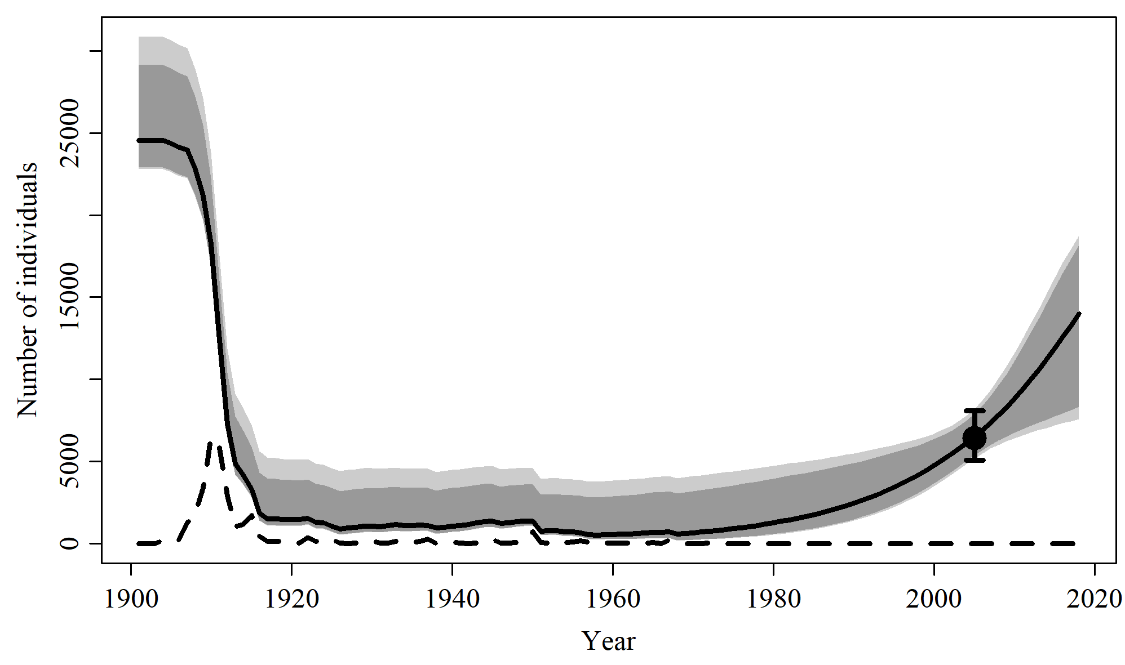

Table I. Population and parameter estimates from model fit to the absolute abundance in 2005 and core catch series of the base case from Zerbini et al (2011).

|  |  |  |  |  |  |  |
| --- | --- | --- | --- | --- | --- | --- |
|  | Mean | Median | 2.5% CI | 97.5% CI | 5% CI | 95% CI |
| *r* | 0.066 | 0.069 | 0.014 | 0.104 | 0.021 | 0.102 |
| *K* | 25,077 | 24,557 | 22,805 | 30,842 | 22,896 | 29,132 |
| Minimum *N* | 838 | 504 | 165 | 3,747 | 182 | 2,790 |
| *N* 2005 | 6,546 | 6,492 | 5,164 | 8,181 | 5,363 | 7,895 |
| *N* 2018 | 13,685 | 13,981 | 7,554 | 18,737 | 8,316 | 18,176 |

Figure 1. Population trajectory and fit of the model to the absolute abundance in 2005 of Scenario 1. The solid line corresponds to the posterior median, light grey to the 95% credible interval, grey to the 90% credible interval, error bars to the 95% confidence interval of the abundance estimate, and the dashed line to the core catch series.

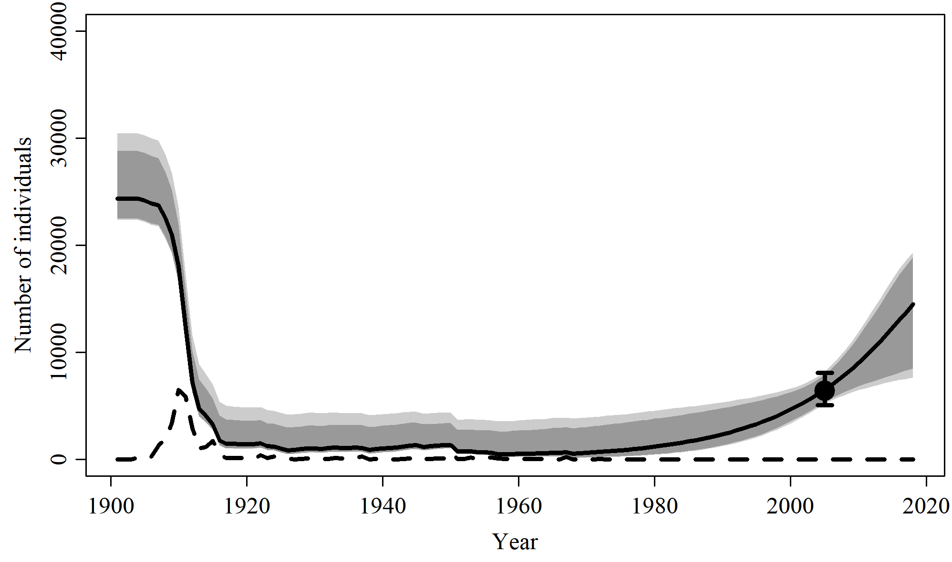

Table 1. Population and parameter estimates from model fit to the absolute abundance in 2005 and core catch series of Scenario 1.

|  |  |  |  |  |  |  |
| --- | --- | --- | --- | --- | --- | --- |
|  | Mean | Median | 2.5% CI | 97.5% CI | 5% CI | 95% CI |
| *r* | 0.071 | 0.072 | 0.015 | 0.115 | 0.023 | 0.111 |
| *K* | 24,805 | 24,343 | 22,339 | 30,466 | 22,476 | 28,811 |
| Minimum *N* | 760 | 461 | 119 | 3,508 | 134 | 2,581 |
| *N* 2005 | 6,538 | 6,488 | 5,137 | 8,220 | 5,338 | 7,904 |
| *N* 2018 | 14,167 | 14,468 | 7,638 | 19,353 | 8,487 | 18,907 |

Figure 2. Population trajectory and fit of the model to the absolute abundance in 2008 and 2012 of Scenario 2. The solid line corresponds to the posterior median, light grey to the 95% credible interval, grey to the 90% credible interval, error bars to the 95% confidence interval of the abundance estimate, and the dashed line to the core catch series.

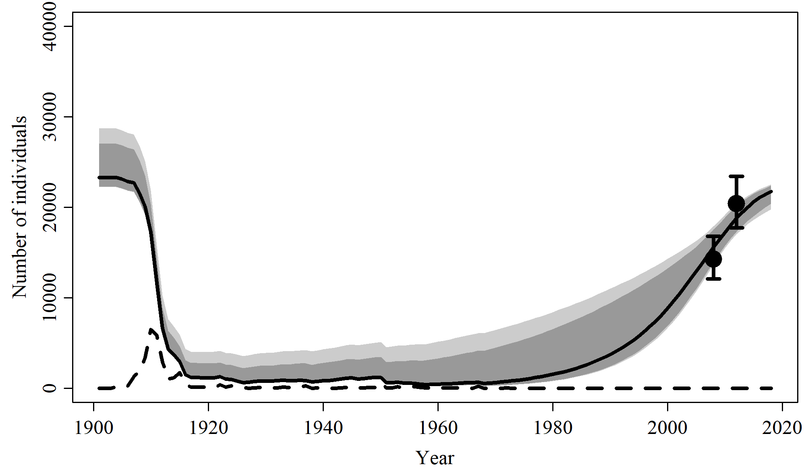

Table 2. Population and parameter estimates from model fit to the absolute abundance in 2008 and 2012 and core catch series of Scenario 2.

|  |  |  |  |  |  |  |
| --- | --- | --- | --- | --- | --- | --- |
|  | Mean | Median | 2.5% CI | 97.5% CI | 5% CI | 95% CI |
| *r* | 0.087 | 0.093 | 0.029 | 0.117 | 0.039 | 0.116 |
| *K* | 23,840 | 23,285 | 22,237 | 28,699 | 22,278 | 27,040 |
| Minimum *N* | 753 | 396 | 211 | 3,548 | 224 | 2,224 |
| *N* 2008 | 15,656 | 15,590 | 13,643 | 17,913 | 13,962 | 17,542 |
| *N* 2018 | 21,641 | 21,741 | 19,783 | 22,537 | 20,413 | 22,383 |

Figure 3. Population trajectory and fit of the model to the absolute abundance in 2008 and 2012 and growth rate observations of 1995, 1996, 1997, and 1998 of Scenario 3. The solid line corresponds to the posterior median, light grey to the 95% credible interval, grey to the 90% credible interval, error bars to the 95% confidence interval of the abundance estimate, and the dashed line to the core catch series.

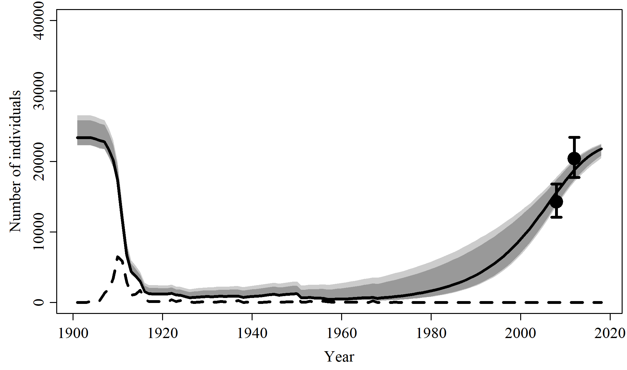

Table 3. Population and parameter estimates from model fit to the absolute abundance in 2008 and 2012; core catch series; and growth rate observations of 1995, 1996, 1997, and 1998 of Scenario 3.

|  |  |  |  |  |  |  |
| --- | --- | --- | --- | --- | --- | --- |
|  | Mean | Median | 2.5% CI | 97.5% CI | 5% CI | 95% CI |
| *r* | 0.088 | 0.091 | 0.043 | 0.117 | 0.051 | 0.115 |
| *K* | 23,658 | 23,397 | 22,260 | 26,539 | 22,321 | 25,826 |
| Minimum *N* | 604 | 425 | 216 | 1,865 | 231 | 1,449 |
| *N* 2008 | 15,628 | 15,607 | 13,683 | 17,778 | 13,962 | 17,413 |
| *N* 2018 | 21,729 | 21,780 | 20,472 | 22,543 | 20,859 | 22,408 |

Figure 4.a. Population trajectory and fit of the model to the absolute abundance in 2008 and 2012 and relative abundance data of Scenario 4. The solid line corresponds to the posterior median, light grey to the 95% credible interval, grey to the 90% credible interval, error bars to the 95% confidence interval of the abundance estimate, and the dashed line to the combined core series.

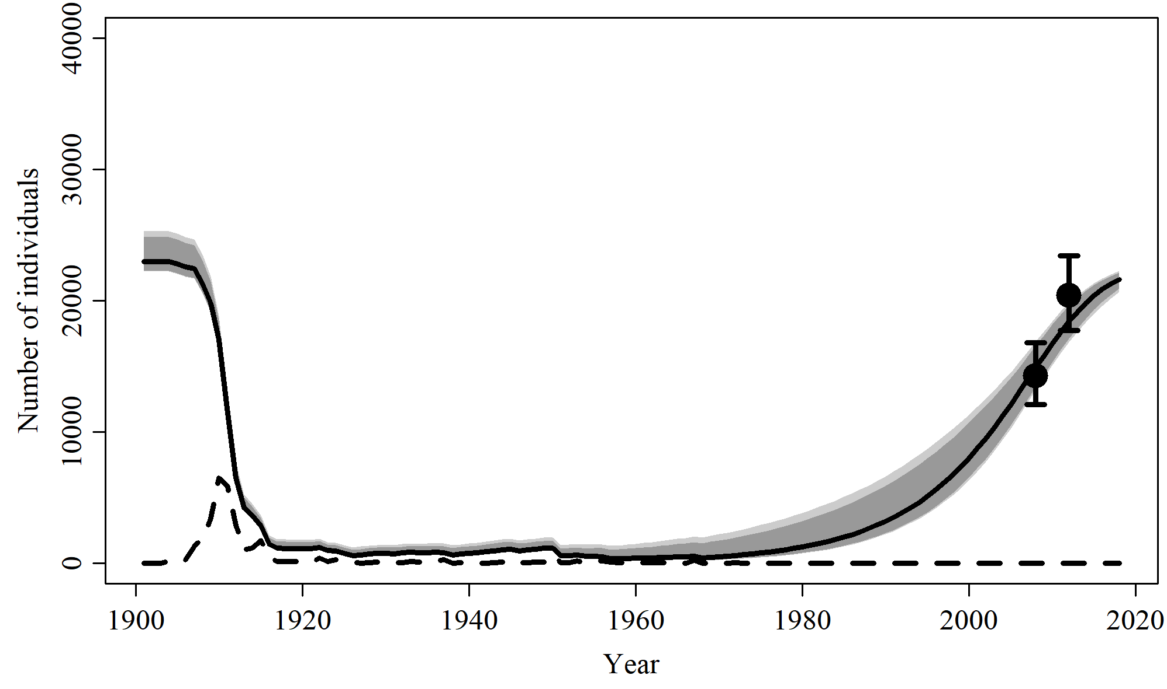

Figure 4.b. Fit of the model to index of relative abundance of Scenario 4. The solid line corresponds to the posterior median, light grey to the 95% credible interval, grey to the 90% credible interval, error bars to the 95% confidence interval of the relative abundance estimates.

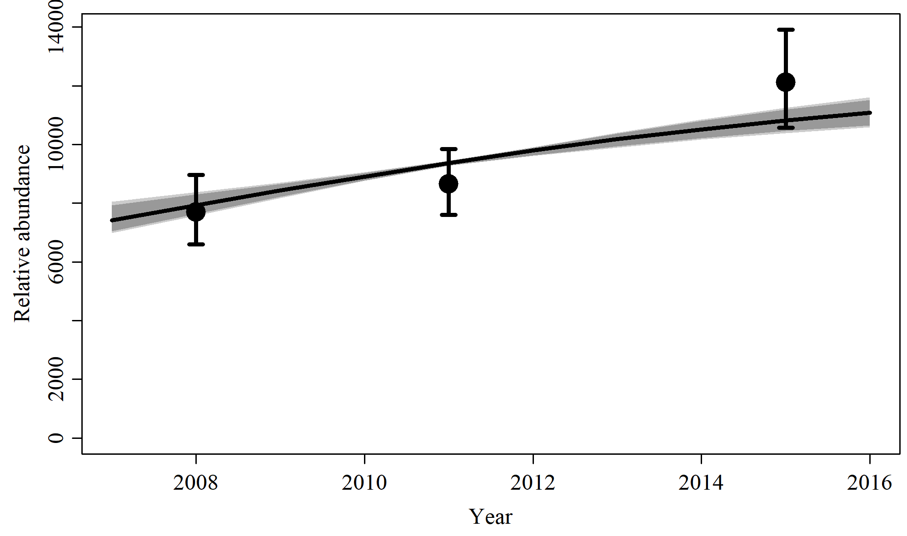

Table 4. Population and parameter estimates from model fit to the absolute abundance in 2008 and 2012 and core and historical catch series of Scenario 5.

|  |  |  |  |  |  |  |
| --- | --- | --- | --- | --- | --- | --- |
|  | Mean | Median | 2.5% CI | 97.5% CI | 5% CI | 95% CI |
| *r* | 0.096 | 0.099 | 0.057 | 0.117 | 0.064 | 0.116 |
| *K* | 23,207 | 22,996 | 22,241 | 25,307 | 22,274 | 24,846 |
| *q* | 0.533 | 0.532 | 0.49 | 0.581 | 0.496 | 0.572 |
| Minimum *N* | 424 | 328 | 198 | 1,190 | 210 | 1,001 |
| *N* 2008 | 14,947 | 14,920 | 13,179 | 16,894 | 13,425 | 16,560 |
| *N* 2018 | 21,594 | 21,621 | 20,677 | 22,266 | 20,956 | 22,136 |

Figure 5. Population trajectory and fit of the model to the absolute abundance in 2008 and 2012 of Scenario 5. The solid line corresponds to the posterior median, light grey to the 95% credible interval, grey to the 90% credible interval, error bars to the 95% confidence interval of the abundance estimate, and the dashed line to the combined core and historical catch series.

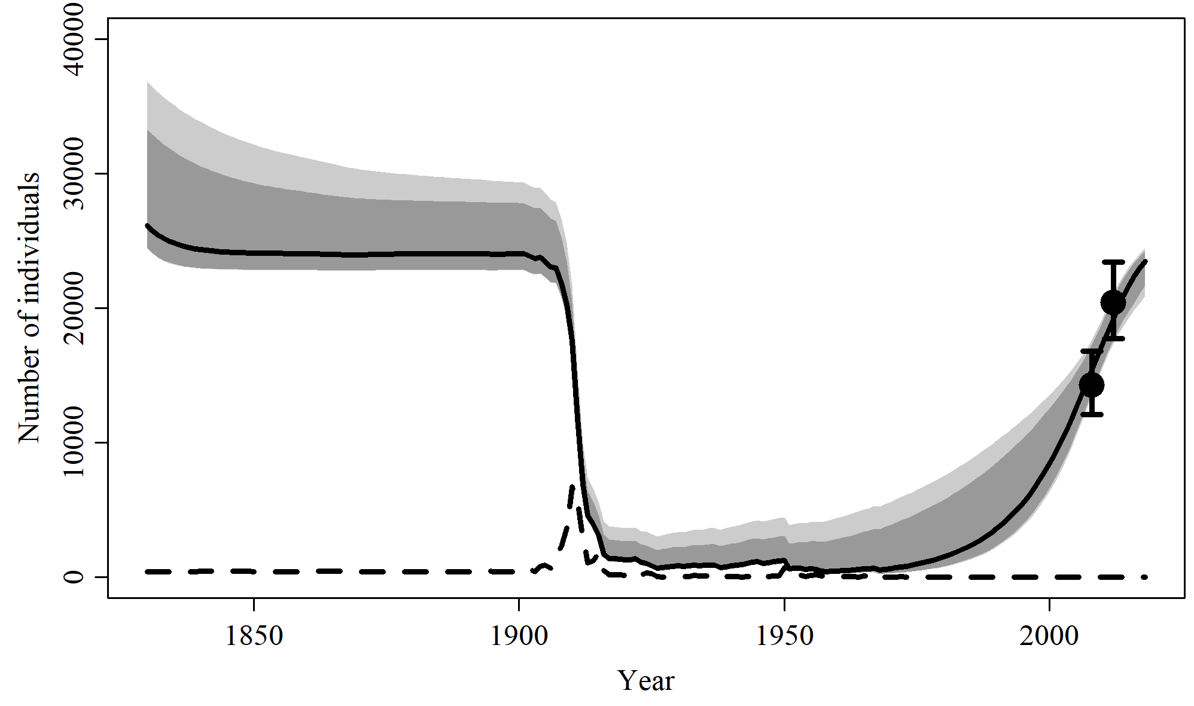

Table 5. Population and parameter estimates from model fit to the absolute abundance in 2008 and 2012 and core and historical catch series of Scenario 5.

|  |  |  |  |  |  |  |
| --- | --- | --- | --- | --- | --- | --- |
|  | Mean | Median | 2.5% CI | 97.5% CI | 5% CI | 95% CI |
| *r* | 0.087 | 0.092 | 0.031 | 0.117 | 0.041 | 0.116 |
| *K* | 27,231 | 26,160 | 24,427 | 36,841 | 24,482 | 33,300 |
| Minimum *N* | 709 | 398 | 201 | 3,015 | 211 | 1,977 |
| *N* 2008 | 15,461 | 15,422 | 13,517 | 17,644 | 13,770 | 17,289 |
| *N* 2018 | 23,310 | 23,462 | 20,881 | 24,471 | 21,672 | 24,288 |

Figure 6. Population trajectory and fit of the model to the absolute abundance in 2008 and 2012 with included catch multiplier of Scenario 6. The solid line corresponds to the posterior median, light grey to the 95% credible interval, grey to the 90% credible interval, error bars to the 95% confidence interval of the abundance estimate, and the dashed line to the combined core and historical catch series.

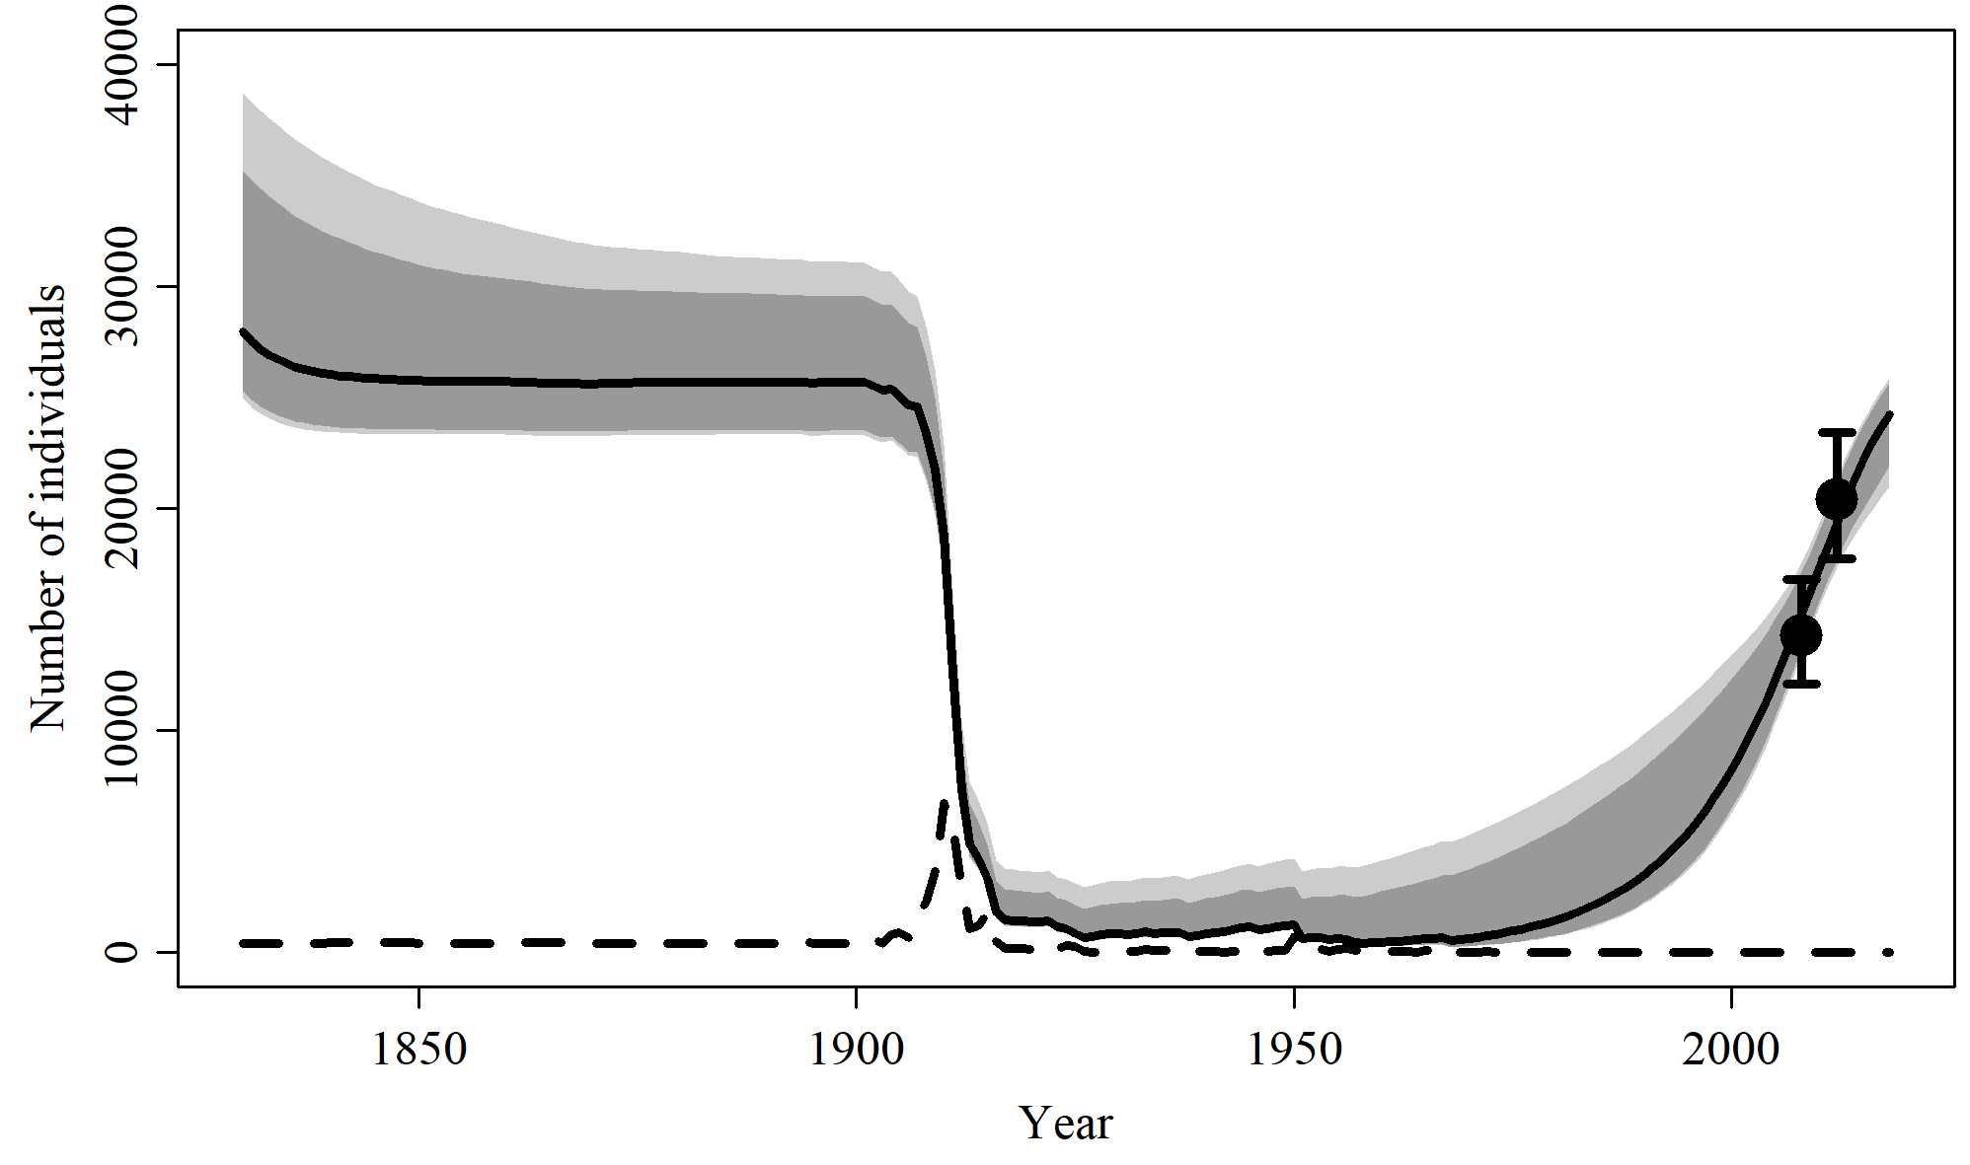

Table 6. Population and parameter estimates from model fit to the absolute abundance in 2008 and 2012 and core and historical catch series with catch multiplier of Scenario 5.

|  |  |  |  |  |  |  |
| --- | --- | --- | --- | --- | --- | --- |
|  | Mean | Median | 2.5% CI | 97.5% CI | 5% CI | 95% CI |
| *r* | 0.087 | 0.093 | 0.033 | 0.117 | 0.042 | 0.116 |
| *K* | 28,838 | 27,877 | 25,088 | 38,315 | 25,334 | 35,206 |
| Minimum *N* | 685 | 386 | 193 | 2,754 | 205 | 1,900 |
| *N* 2008 | 15,314 | 15,266 | 13,393 | 17,498 | 13,717 | 17,111 |
| *N* 2018 | 24,131 | 24,288 | 21,131 | 25,836 | 22,025 | 25,618 |