Lunar Entry and Approach

Platform for Research on Ground

(LEAPFROG)

GENERATION - 2
SPACE ENGINEERING RESEARCH CENTER
Fall 2019 – Spring 2021
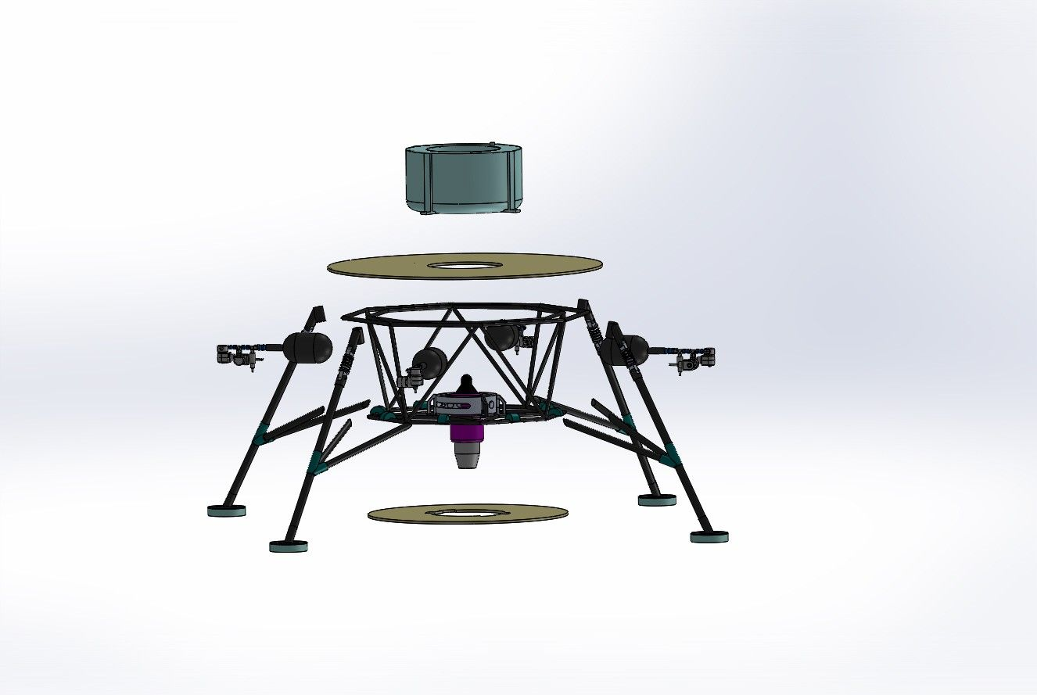
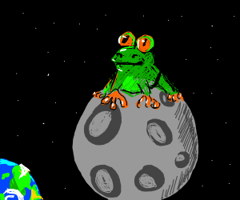

Members
Prof. David Barnhart | barnhart@isi.edu | PI
Antariksh Narain | antariks@usc.edu | Student Researcher
Michael Smat | msmat@usc.edu | Student Researcher
Isabel Yarwood Perez | yarwoodp@usc.edu | Student Researcher
Table 1: Members List

Table of Contents
Preface 6
Project Description 6
Milestones 6
Timelines 6
People Involved 6
Credits 6
Introduction 7
Overview 7
Vehicle Specification 7
Flight Information 7
System Limitations 7
Software Used 7
Structure 7
CAD 7
Vehicle Chassis 7
Vehicle Assembly 7
Test Stand 7
Electronics 7
Batteries 8
Control Boards 8
Sensors 8
Actuators 8
Engine 9
Communication 9
Software 9
Ground Station 9
Flight Software 9
Simulation 9
Validation (Testing) 10
Competition 10
Challenges 10
Website 10
Environment 10
Evaluation 10
Safety and Test Procedures 10
System Overview 11
Avionics Requirements 11
Hardware 11
Software 11
Performance Specification 12
Electronics 12
Software UML diagram 12
Timing function 12
Command Telemetry 12
Ground Control 12
Architecture 14
System 14
Vehicle 15
Ground Station 16
Simulation 17
Competition 18
Implementation – Structure 19
Implementation – Electronics 20
Implementation – Software 21
Ground Station 21
UML Diagram 21
Implementation – Simulation 22
Testing 23
ACS Test 23
Gimbal Test 23
Engine Static Hot Fire Test 23
Wireless Testing 23
Short Range 23
Long Range 23
System Analysis 24
Structures 24
Electronics 24
Software 24
Simulation 24
How to use 25
Vehicle 25
Simulation 25
Safety Procedures 26
Test Procedures 27

TODOs:
- Update Bibliographical database entry and mapping
Index of Tables
Table 1: Members List 1
Table 2: Performance Specification - Electronics 12

Table of Figures
Figure 1: System Architecture 14
Figure 2: Vehicle Overview 15

Preface

Project Description
Moon(Lunar) exploration has been generating great interest, as it provides a compelling opportunity to demonstrate new technologies that could help build self-sustaining outposts in extraterrestrial environments, particularly Mars. The key to lasting success in this challenge lies in developing sustainable and reusable architectures. Many of the diverse global lunar missions currently in development have narrowly defined purposes. These projects are and are capable of operating in limited areas on the lunar surface and while executing specific predetermined tasks. The mass sent up for the mission therefore rarely serves more than a single purpose. The project Lunar Entry and Approach Platform for Research on Ground (LEAPFROG-Gen2), aims with the primary goal of to rethink the function of reinventing a lunar lander such that it has the inherent capability to perform multiple tasks by changing the working configuration of its subsystems, maximizing the functional value of its mass. LEAPFROG is a low-cost testbed primarily for simulating lunar flight conditions on Earth.

Milestones
// talk about the goal of the project. Vehicle capabilities, performance etc.
The vehicle should,
- Flight time of 5 minutes
- Max. altitude 5 meters
- Self landing in case of emergency
- Real-time telemetry to ground station
- Control over altitude +/- 0.5 meters
- Control over tilt +/- 0.5 degree
Optional
- Flight to simulation experience
The project should,
- Analyze system in detail
- Plots related to performance analysis

Timelines
Please refer the Project Libre file Leapfrog_Plan.pod

People Involved

Credits
- Information Sciences Institute (ISI)

Introduction

Overview
The project is broken down into 5 sub divisions and this document aims to define each one of them in detail and how they connect.

Vehicle Specification

Flight Information

System Limitations

Software Used
- Visual Studio Code – software development IDE
- Gazebo – 3D simulation environment by OSRF
- GitHub – Host code for flight software and simulation
- Confluence – Store all the updates related to the project and documentations

Structure
The structure is being built using light weight materials with high tensile strength.
- Legs: CNT
- Shelves:
- Connectors
- Gimbal

CAD
Dassualt’s Solids Work software is being used to design the vehicle model. The software also analyzes how the parts of the vehicle act under different kinds of stress and strain.

Vehicle Chassis
// About vehicle chassis

Vehicle Assembly
The vehicle is being assembled in several parts. Some parts are being 3D printed and others are being manufactured from raw material at SERC.

Test Stand
Apart from the vehicle we are building test stands for different vehicle components and the whole vehicle itself. The goal of designing the stands is to validate hardware and software integration and performance, before actually being mounted on the vehicle.

Electronics
To achieve the flight time and performance mentioned above, the system needs to alive and responsive all the time. The system should be able to run without any issues, and fail safe procedures should activate and execute in case of emergency. The whole control system is divided into 2 sub-systems namely,
- Altitude Control System (ACS)
- Thrust Vectoring Control (TVC)

Batteries
Power analysis will be done to identify the C and power rating of batteries which will be mounted on the vehicle. The battery will be powering the actuators, sensors, control board and communication modules on the vehicle.

Control Boards
As the system is divided into 2 sub-systems, we have divided the control logic in to modules.
- Master Controller (Raspberry Pi 4)
  - Communication to ground station
  - Share system telemetry data
  - Control the ACS.
  - Master controller for engine
- Flight Controller (PixHawk)
  - Control the Gimbal
  - Control the Engine

Sensors
We need sensors on board which can provide information about vehicle’s position, orientation, velocity and acceleration. Also, the sensors should be able to monitor the resources on board like fuel and power status. The following sensors are being used,
- Inertial Measurement Unit (IMU)
  - Relative position, orientation, velocity and acceleration
- Global Positioning System (GPS)
- Altitude sensor
- ACS tanks pressure sensor
- Fuel tank sensor
- Battery meter

Actuators
The whole flight system is controlled by three actuation mechanism,
- Cold Gas thrusters
  - There are solenoid valves placed on the vehicle, which release cold gas at high pressure (4000psi)
  - They are used to control the principle axis of the vehicle as a whole.
- Gimbal System (Roll / Pitch)
  - Linear motion is converted to rotational motion by design to move the gimbal.
  - Linear actuator with forward/backward feedback are used to achieve this.
- Jet Engine
  - The engine should be able to lift the vehicle to desired altitude and should also be capable of providing force vector for translation.

Engine
For this generation we plan to use JetCat P300 [JCP300] engine which can generate up to 300N of thrust. The engine houses an on board Engine Control Unit (ECU) which provides an interface to communicate with the engine and also provides telemetry data.

Communication
The communication network is divided into 2 sets,
- Controller Area Network (CAN)
  - The controllers communicate using UART
  - The sensors are connected using UART, I2C and Analog input.
- Wide Area Network(WAN)
  - To provide communication between ground station and vehicle we need a communication channel which supports multiple communication channels and provides acceptable range
    - Radio Frequency (RF) – RFD900x : Long range, short bandwidth.
    - Wifi 2.4GHz : Medium range, fair bandwidth.

Software
The software developed is responsible for providing a controlled stable flight both in real world and simulation.
The project software can be broken down based on the deployed location,
- Ground Station: application to control and communicate with the vehicle
- Vehicle: flight software to manage avionics.
- Simulation: visualize the vehicle control algorithms in virtual environment.

Ground Station
The ground station software is responsible for
- Test individual components on the vehicle
- Start vehicle
- Stop vehicle
- Visualize vehicle position
- View Telemetry data

Flight Software
The flight software is designed with scalability in mind, by using object oriented paradigm. It provides interface libraries to,
- Get feedback from sensors, additional layer to filter sensor data.
- Move the vehicle in the environment using actuators.
- Closed loop control logic to act in the environment.

Simulation
The simulation environment uses the vehicle designed in CAD, which is an exact replica of actual vehicle. The world is designed to mimic the world environment on moon. The simulation uses Gazebo as a simulation environment with a combination of PX4 firmware and plugins to control the vehicle. It can be used to develop and test flight software before actually deploying on the vehicle. Actual hardware constrains can be added to the model like reaction time, sensor noise etc. to make it more realistic. Also, the simulation can be piped with actual hardware to visualize real-time movement and response.

Validation (Testing)
The testing is divided into several stages,
- Unit Testing the code: Validate if the code works properly and doesn’t throw any unexpected exception.
- Communication test: how different major system communicate
- Testing in simulation: is the flight software working
- Testing on hardware test bench: check response based on pseudo input and check for jitters
- Pseudo failure test: validate how system responds when each system fails
- Actual vehicle test: test end to end flight

Competition

Challenges
There are 3 challenges proposed for now,
- Waypoint Navigation(Simulation)
- ---(Simulation)
- Waypoint Navigation + Relative positioning (Hardware: PixHawk)

Website

Environment
We will setup GitHub classrooms for all the teams. It will allow teams to register with a unique name and create a private repository which can be viewed by the admin. Teams will be given clear instructions which section of the code they can edit.
The code can be compiled locally and when submitted, will be validated by an automated tester which will check if the code compiles and passes basic test (check terminal output with expected data).

Evaluation
The teams will be evaluated based on their performance in the first 2 competitions and accordingly will be moved to challenge 3.
// Describe a little more

Safety and Test Procedures

System Overview

Avionics Requirements

Hardware
- Sensor calibration and library
  - Stabilization: IMU
  - Attitude control: LiDAR
  - Fuel : feedback from engine to estimate fuel consumption
  - Cold gas pressure : Pressure sensor
- Controllers
  - Main Controller: Control all actuators in the system
    - ACS system: Control solenoid valves with relays
    - TVC system: validate and translate information coming from Flight Controller.
    - Communication: communicate with the ground station.
  - Flight Controller: Computation for TVC system
- Actuators
  - Linear Actuators: Move the gimbal the engine
  - Solenoid Valves : To control cold gas release
- Communication
  - Transceiver: Radio Frequency
  - Range: radial 10m
- Engine
  - Jet Engine: To control altitude of the vehicle
  - Jet Engine interface: interface to communicate with the engine.
- Power to control all electronics on-board.

Software
- Ground station
  - Sequentially start the system
  - Manual override custom operation
- Flight Information
  - Fuel, battery, cold gas pressure
  - Waypoint information
  - GPS position
  - Position, velocity and acceleration information
- Mission Mode
  - flight profile insertion: Send sequence of waypoints
  - autonomous flight
  - mission modes

Performance Specification

Electronics
Sensor | MPU6050 | Accel: ±4g | Gyro: ±500°C | Onboard DMP | 400kHz I²C
Sensor | SEN0259 | Range: 0.3-12m | Accuracy: ±4cm | Frequency: 100Hz
Sensor | PX309-5KG5V | Range: 0-5000psi | Analog voltage output
Sensor | HERE 3 | GLONASS | Accuracy: 3D FIX: 2.5 m / RTK: 0.025 m | Rate: 8Hz
Controller | Raspberry Pi | Quad Core @1.5GHz | 4GB RAM | 5V | 4A
Controller | PixCube | 32bit Cortex-M4F | 256KB RAM | 14PWM pins
Battery | LiPo 11.1V | 1800mAh | 45C | XT60 | 11.1V/3S
Battery | LiPo 22.2V | 2600mAh | 45C | XT60 | 22.2V/6S
Communication | RFD900x | 902-928MHz | 250kbps
Communication | Ground station receiv? | Should be same RFD900x?
Actuator | HDLS-4-2-12V | Stroke length: 4” | Speed(Max load): 1.37”/sec | 12V | 1A
Actuator | Solenoid Valve (Num)
Engine | JetCat P300Pro | Max Thrust: 300N | Max power(start up): 300W | Comm: UART,PWM  Integrated ECU | Engine Telemetry feedback
Others | Dbus Interface | Breakout board for DB15 connector
Others | Relay Board | 8 channel | 5V | 100mA
Others | UBEC | Input: 7.2-21.V | Output: 5V, 5A
Table 2: Performance Specification - Electronics

Software UML diagram

Timing function

Command Telemetry

Ground Control

Architecture

System
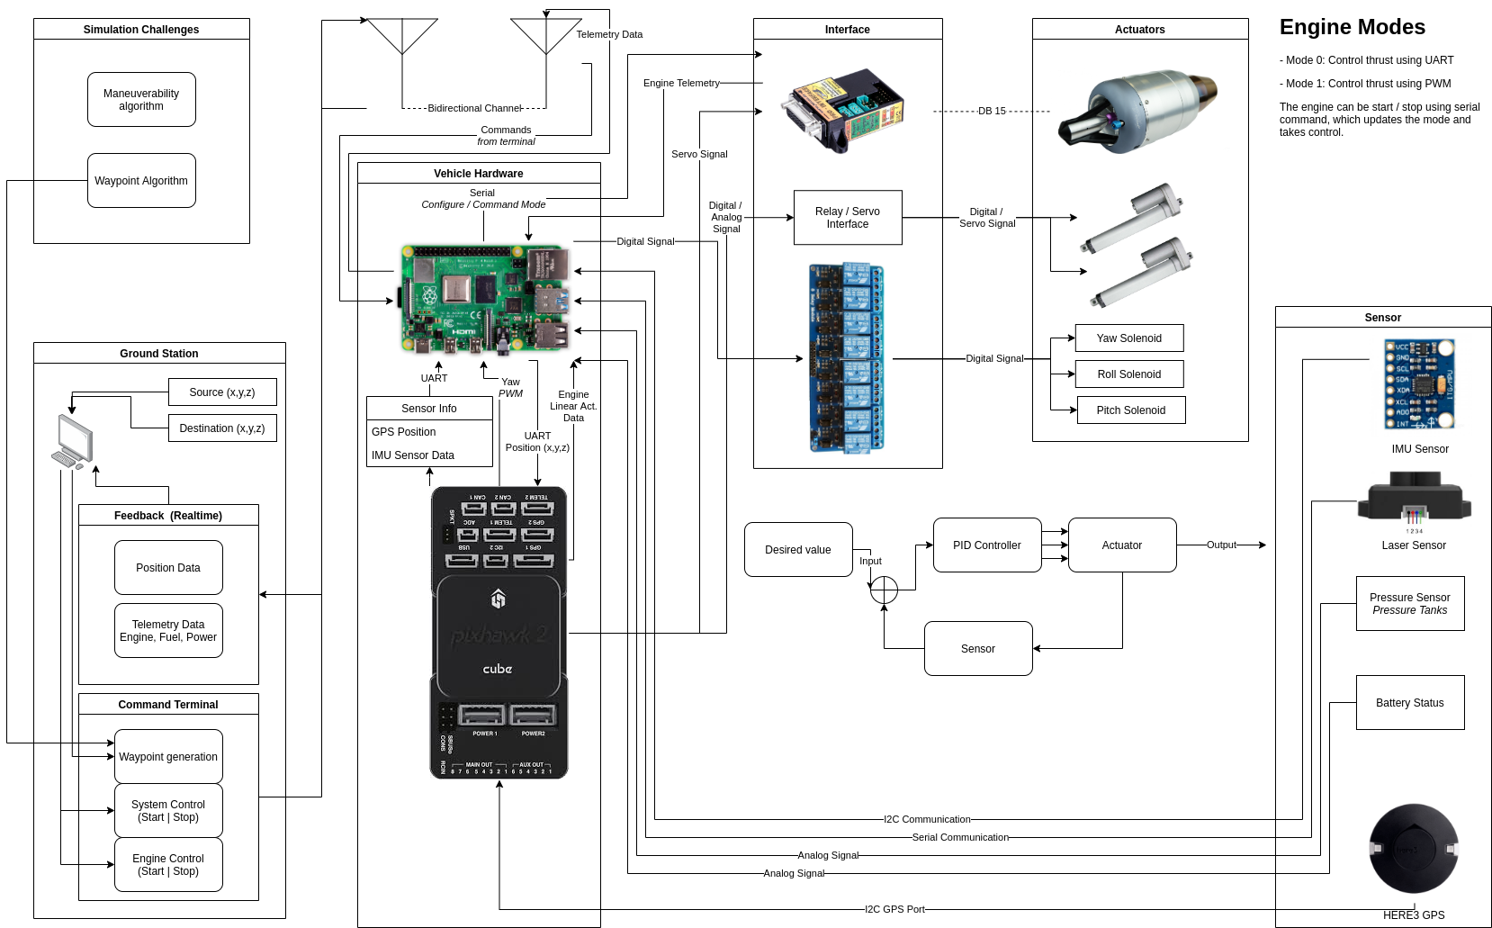Figure 1: System Architecture

Vehicle
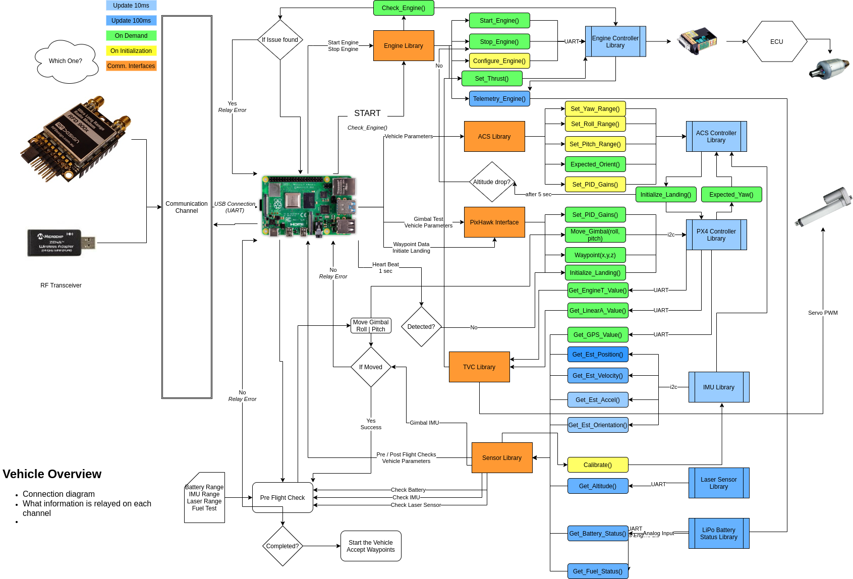Figure 2: Vehicle Overview

Ground Station

Simulation

Competition

Implementation – Structure

Implementation – Electronics

Implementation – Software

Ground Station

UML Diagram

Implementation – Simulation

Testing

ACS Test

Gimbal Test

Engine Static Hot Fire Test

Wireless Testing

Short Range

Long Range

System Analysis

Structures
// stress strain info, graphs etc.

Electronics
// datasheet info and data plots

Software
// Function analysis and execution times

Simulation
//

How to use

Vehicle
// Procedures to run the vehicle

Simulation
// Setup the environment and running/ testing the code

Safety Procedures

Test Procedures
// Each section talks about how each procedure works

Bibliography
JCP300: JetCat Company, LibreOffice Calc Functions and Formulas Tips, 2011

