Step1: Clone the repo https://github.com/sriram-R-krishnan/devops-build
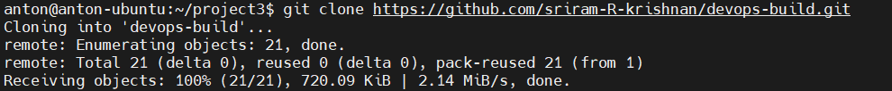
Step2: Create Dockerfile and docker-compose.yml
Dockerfile:
FROM nginx:alpine

RUN rm -rf /usr/share/nginx/html/*

COPY build/ /usr/share/nginx/html/

EXPOSE 80

CMD ["nginx", "-g", "daemon off;"]

Docker-compose.yml:
version: "3.8"

services:
devops-build-app:
build:
context: .
dockerfile: Dockerfile
container_name: devops-build-app
ports:
- "8080:80"
restart: always

Step3: Dockerize the application
Run cmd: docker compose up --build -d
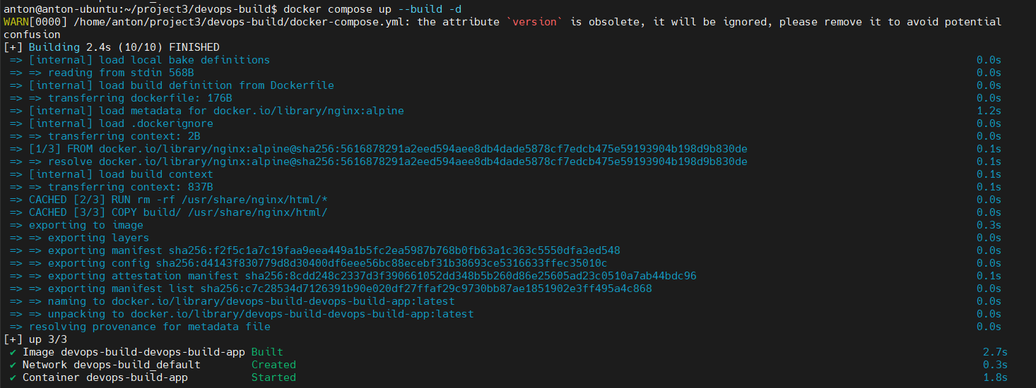
Step4: Create a public repository on github
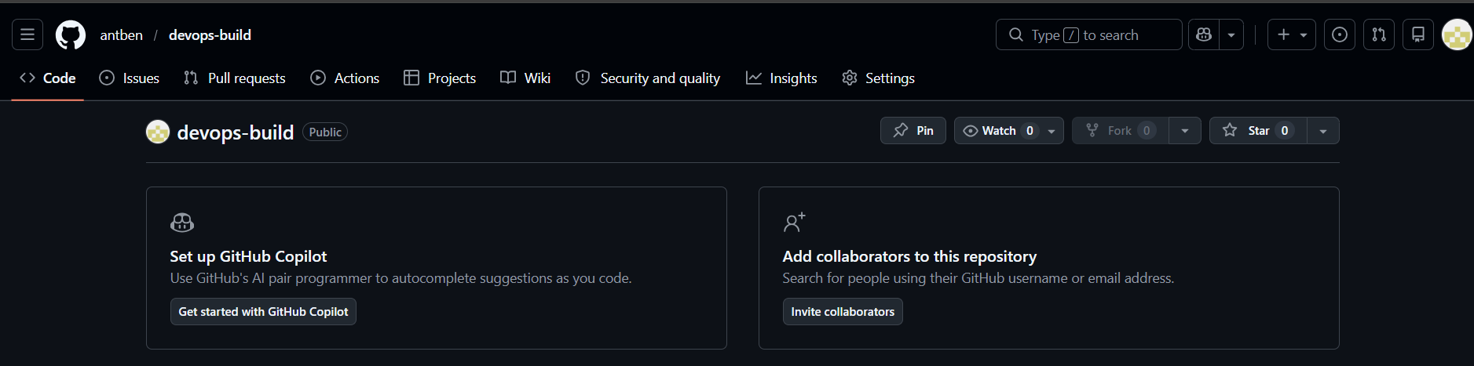

Step5: Create dev and prod branches in local git
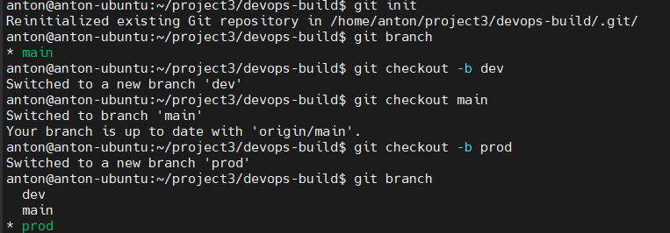
Step6: Push code to local dev branch and then from there to the github repo dev branch
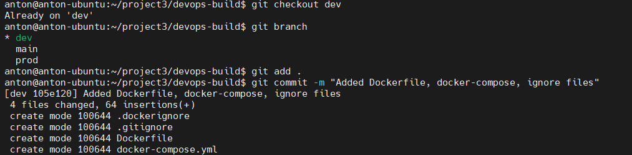
Push code to github repo dev branch
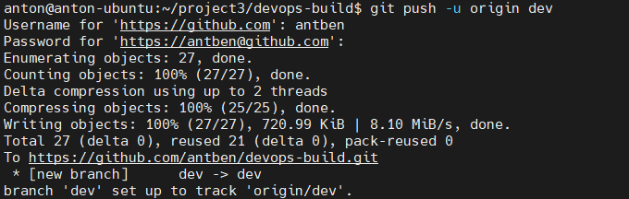
Step7: Create 2 Dockerhub repositories- “devops-build-dev” and “devops-build-prod”
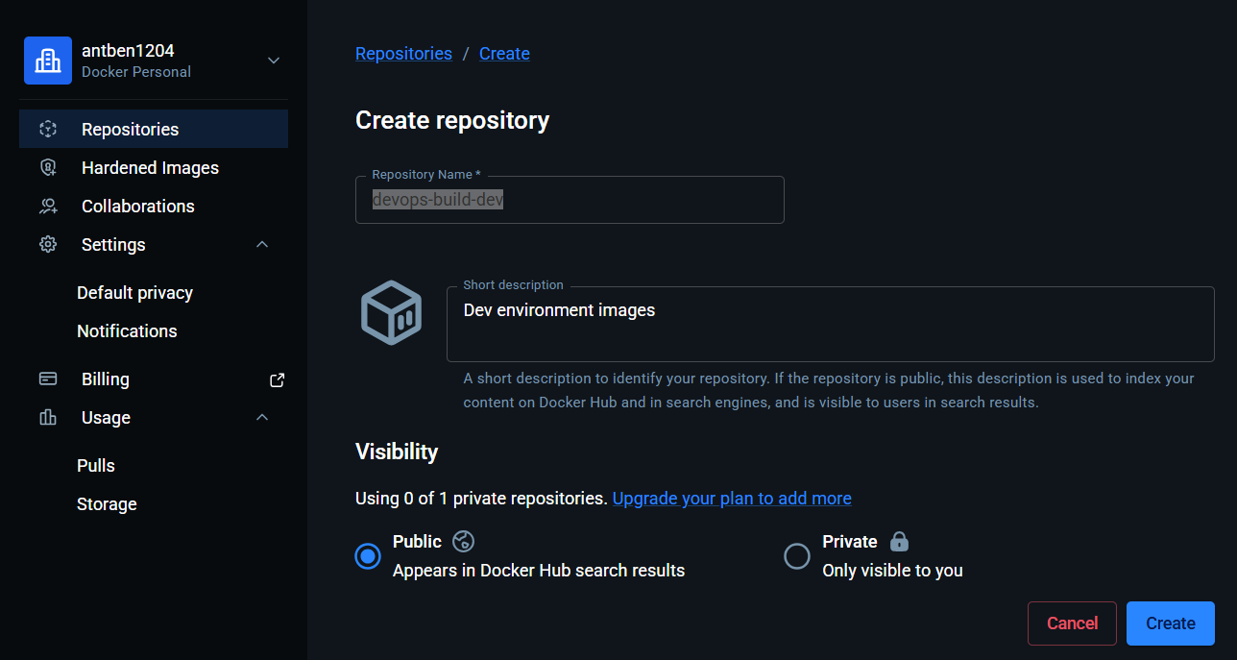
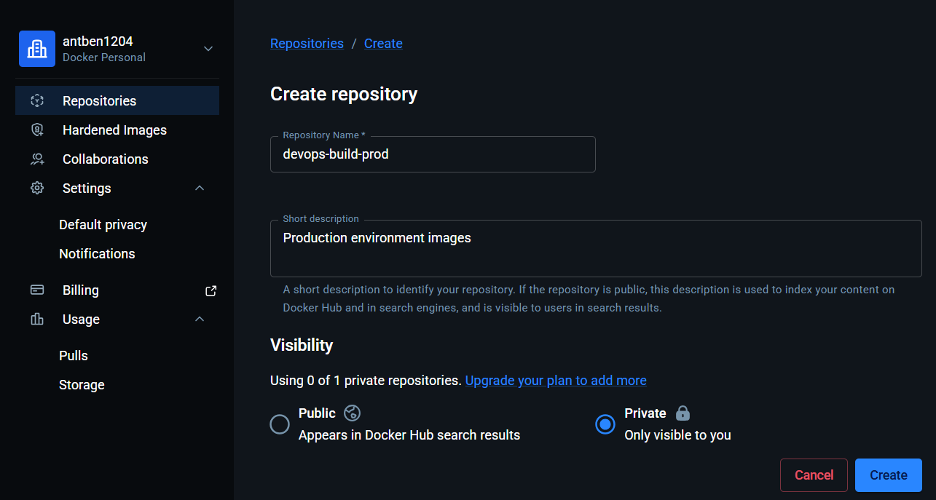
Step8: Deploy an EC2 instance and install Jenkins
sudo apt update -y
sudo apt install openjdk-17-jdk -y
java -version
curl -fsSL https://pkg.jenkins.io/debian-stable/jenkins.io-2023.key | sudo tee \
/usr/share/keyrings/jenkins-keyring.asc > /dev/null
echo deb [signed-by=/usr/share/keyrings/jenkins-keyring.asc] \
https://pkg.jenkins.io/debian-stable binary/ | sudo tee \
/etc/apt/sources.list.d/jenkins.list > /dev/null
sudo apt update -y
sudo apt install jenkins -y
sudo systemctl start jenkins
sudo systemctl enable Jenkins
sudo systemctl status Jenkins
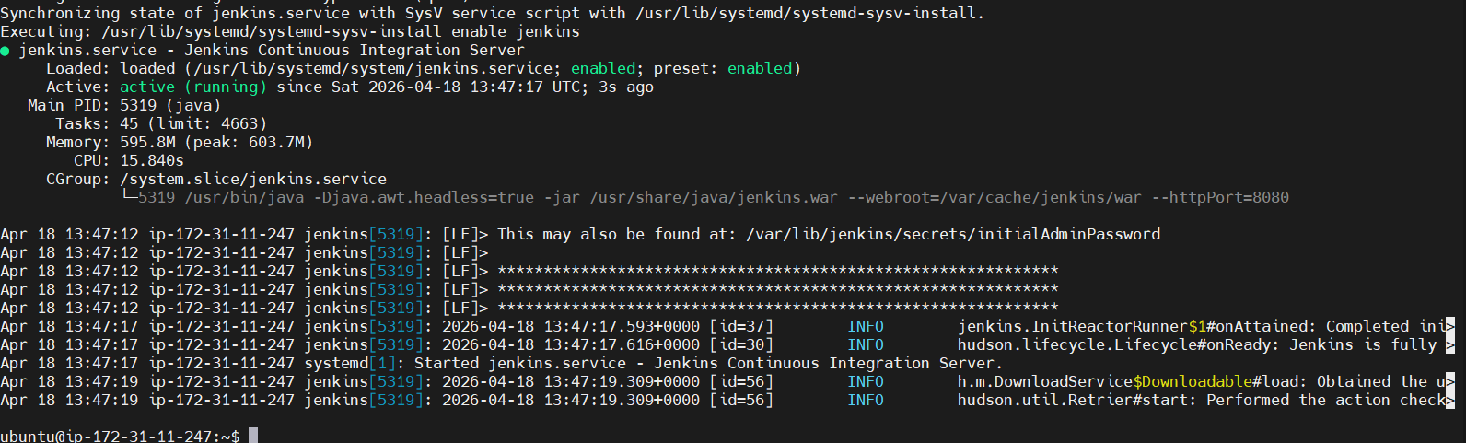
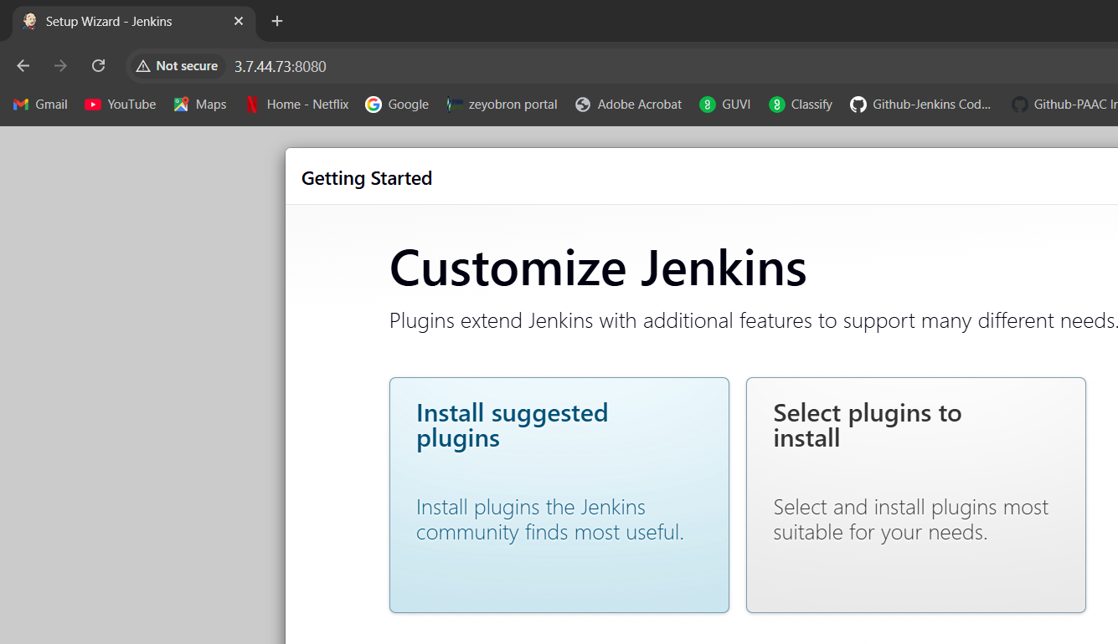
In Manage Jenkins → Plugins, make sure below plugins are installed:
Git
GitHub
GitHub Branch Source
Pipeline
Docker Pipeline
Credentials Binding
Setup GIT and Docker on the Jenkins EC2 server:
sudo apt update
sudo apt install -y git docker.io
sudo systemctl enable docker
sudo systemctl start docker
sudo usermod -aG docker jenkins
sudo systemctl restart Jenkins
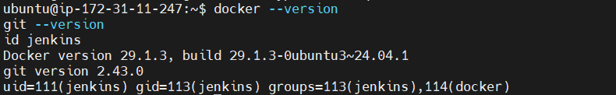
Add Github and Docker hub credentials in Jenkins
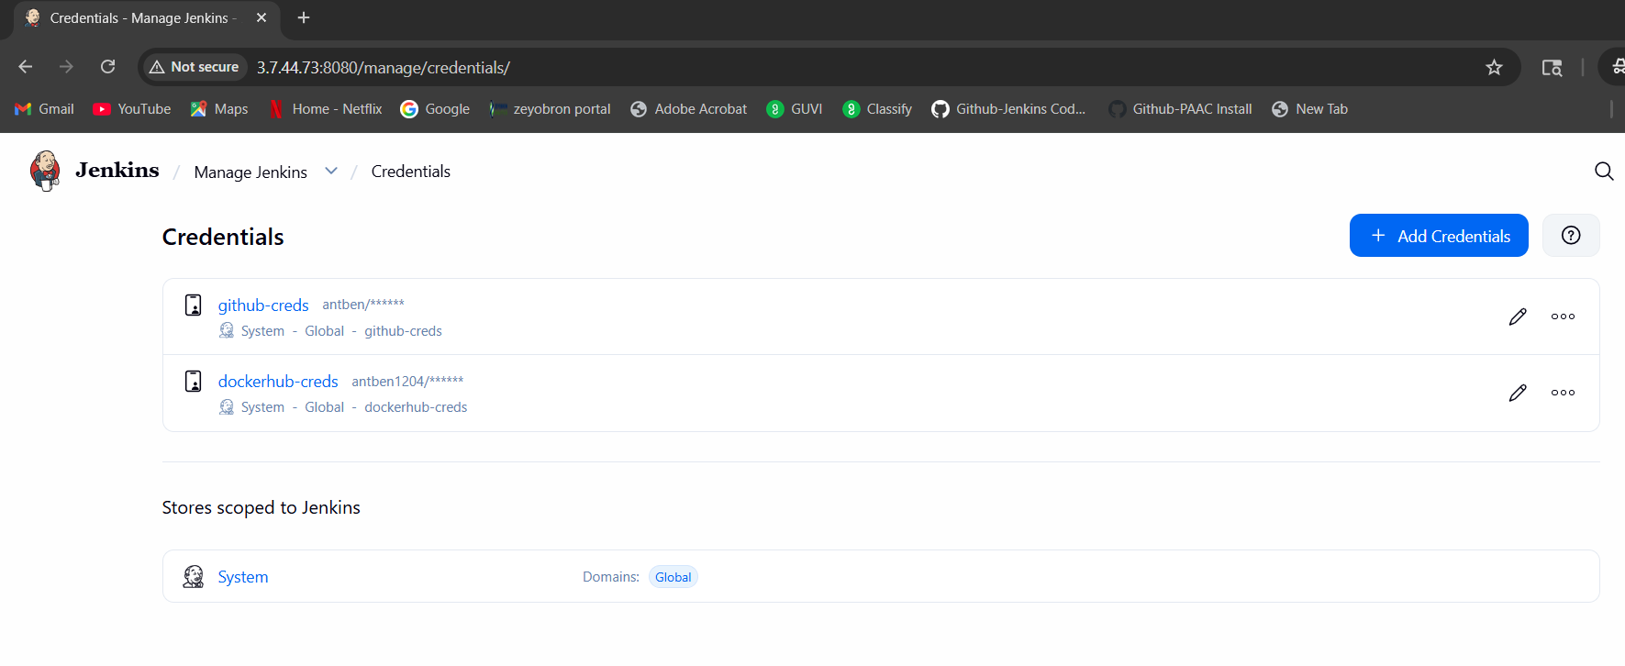

Step9: Create Jenkinsfile and place it in the root of the local repo
Jenkinsfile:
pipeline {
agent any

environment {
DOCKERHUB_CREDS = credentials('dockerhub-creds')
DOCKERHUB_USER = 'antben'
DEV_REPO = 'antben/devops-build-dev'
PROD_REPO = 'antben/devops-build-prod'
IMAGE_TAG = "${env.BUILD_NUMBER}"
}

stages {
stage('Checkout') {
steps {
checkout scm
script {
env.SHORT_COMMIT = sh(
script: "git rev-parse --short HEAD",
returnStdout: true
).trim()
}
sh 'echo Branch: ${BRANCH_NAME}'
sh 'echo Commit: ${GIT_COMMIT}'
}
}

stage('Build Image') {
steps {
script {
if (env.BRANCH_NAME == 'dev') {
env.TARGET_REPO = env.DEV_REPO
} else if (env.BRANCH_NAME == 'prod') {
env.TARGET_REPO = env.PROD_REPO
} else {
currentBuild.result = 'NOT_BUILT'
error("Branch ${env.BRANCH_NAME} is not configured for image push")
}
}

sh '''
docker build -t ${TARGET_REPO}:${IMAGE_TAG} .
docker tag ${TARGET_REPO}:${IMAGE_TAG} ${TARGET_REPO}:latest
docker tag ${TARGET_REPO}:${IMAGE_TAG} ${TARGET_REPO}:${SHORT_COMMIT}
'''
}
}

stage('Docker Login') {
when {
anyOf {
branch 'dev'
branch 'prod'
}
}
steps {
sh '''
echo "$DOCKERHUB_CREDS_PSW" | docker login -u "$DOCKERHUB_CREDS_USR" --password-stdin
'''
}
}

stage('Push Image') {
when {
anyOf {
branch 'dev'
branch 'prod'
}
}
steps {
sh '''
docker push ${TARGET_REPO}:${IMAGE_TAG}
docker push ${TARGET_REPO}:latest
docker push ${TARGET_REPO}:${SHORT_COMMIT}
'''
}
}
}

post {
always {
sh 'docker logout || true'
sh 'docker image prune -f || true'
}
success {
echo "Build and push completed for branch ${BRANCH_NAME}"
}
failure {
echo "Build failed on branch ${BRANCH_NAME}"
}
}
}
Push the file to dev and prod branches in github repository
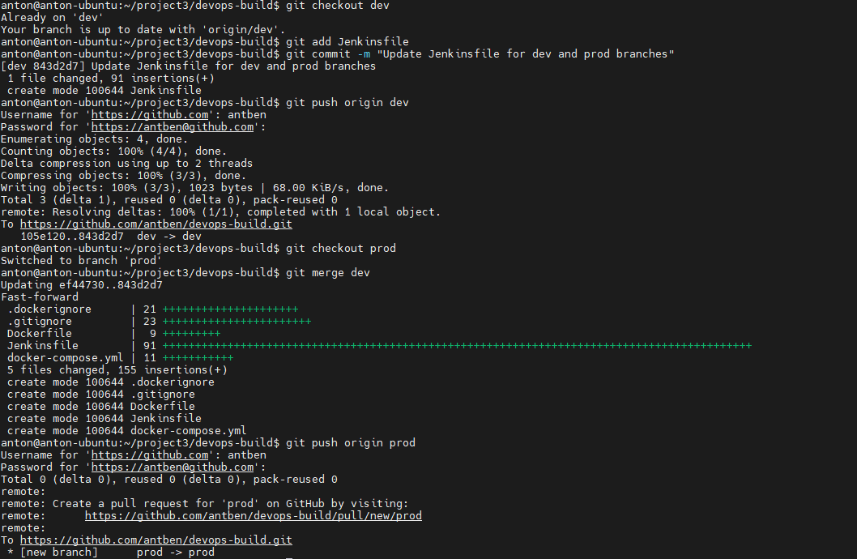
Setup a multibranch Pipeline as below:
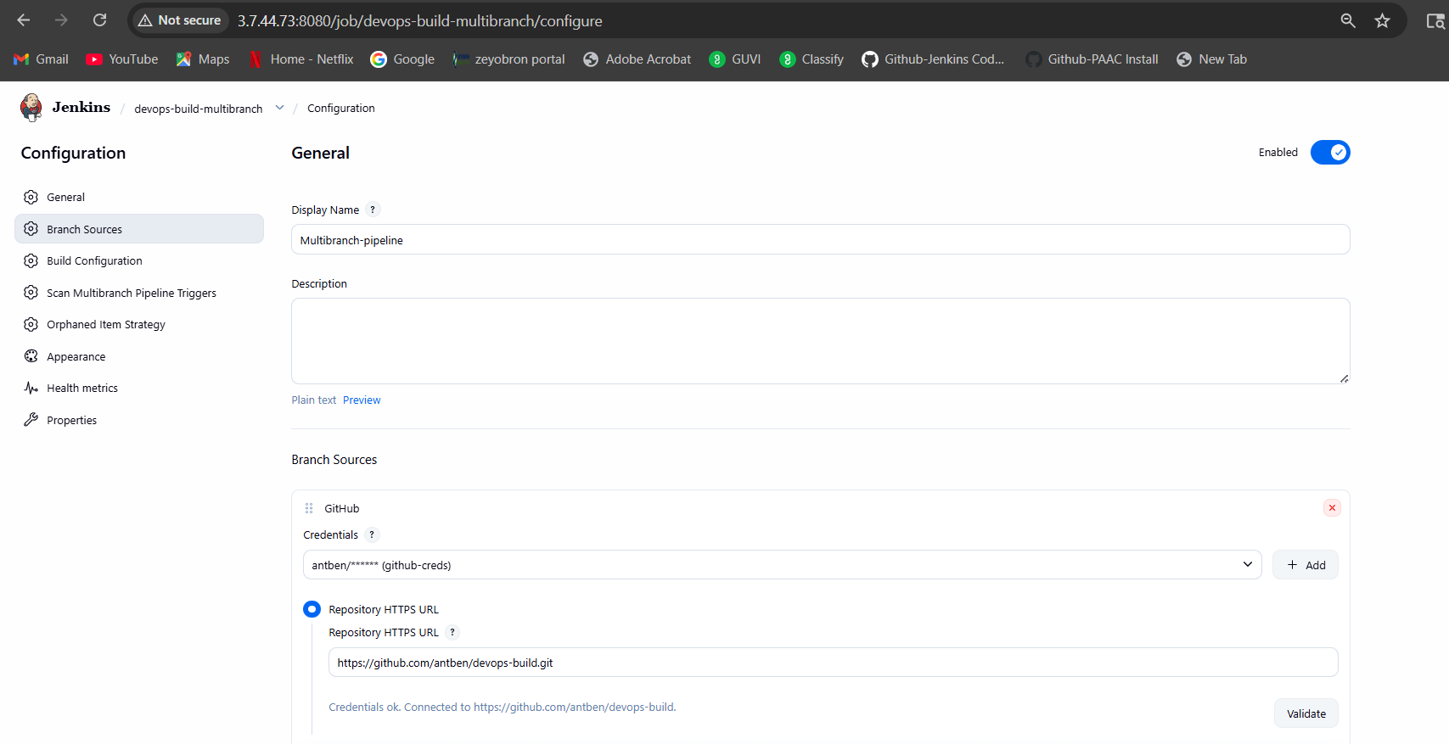
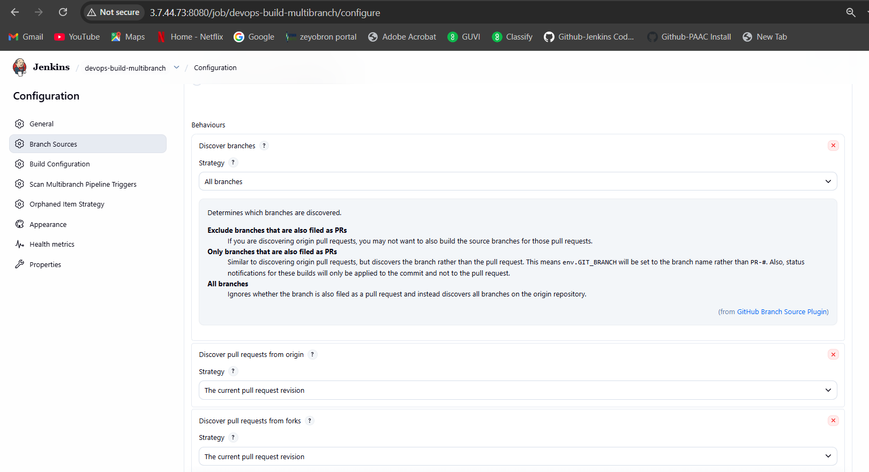
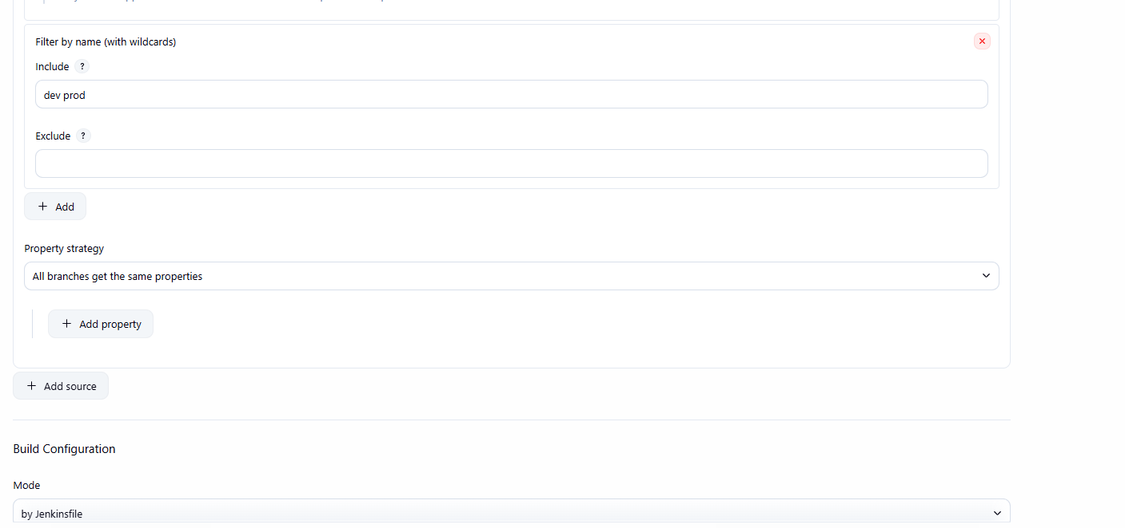

Step10: Add webhook in Github repository

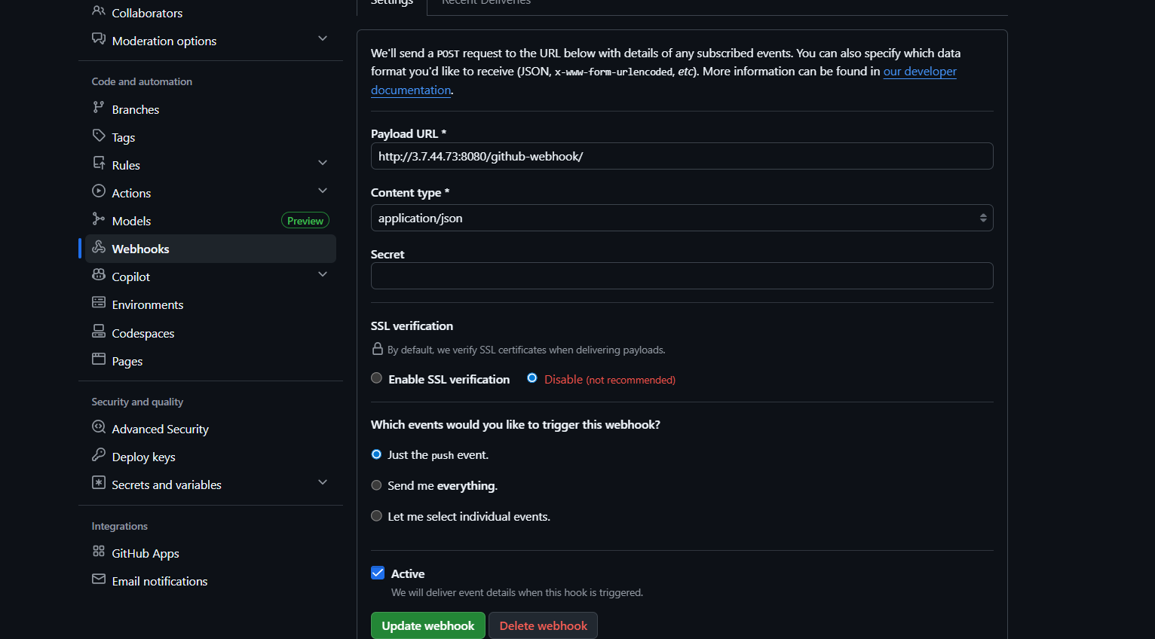
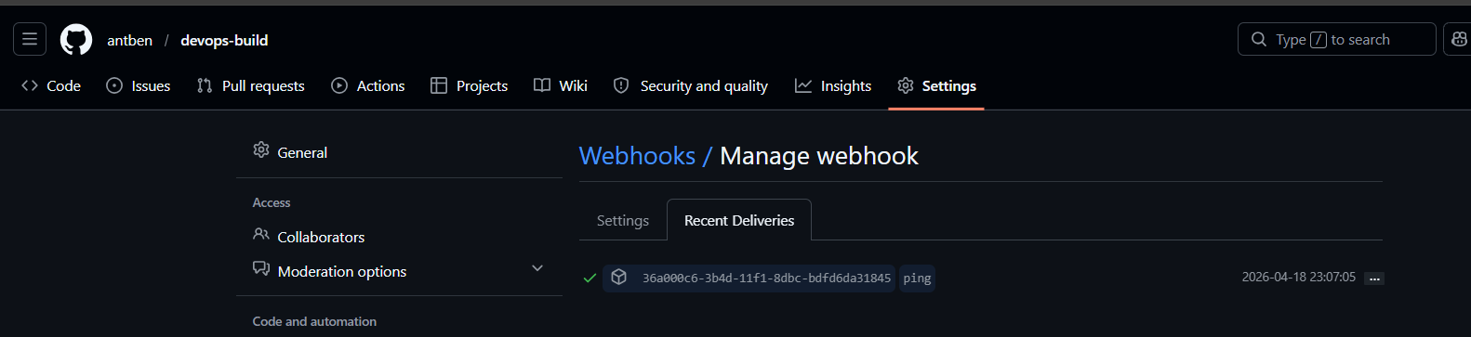

Step11: Now deploy the app-server EC2 instance:
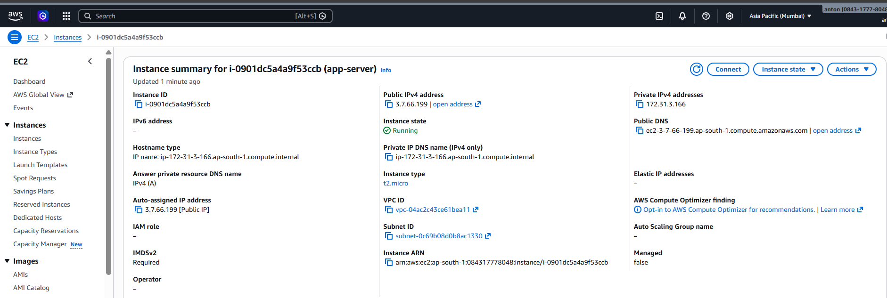

Run below cmds to install docker:
sudo apt update
sudo apt install -y docker.io
sudo systemctl enable docker
sudo systemctl start docker
sudo usermod -aG docker ubuntu
newgrp docker
docker –version
Now on the Jenkins server
Create SSh folder:
sudo mkdir -p /var/lib/jenkins/.ssh
sudo chown -R jenkins:jenkins /var/lib/jenkins/.ssh
sudo chmod 700 /var/lib/jenkins/.ssh
Generate the deploy key as the Jenkins user
sudo -u jenkins /usr/bin/ssh-keygen -t rsa -b 4096 -C "jenkins-deploy" -f /var/lib/jenkins/.ssh/jenkins_deploy_key -N ""
Show the public key
cat /var/lib/jenkins/.ssh/jenkins_deploy_key.pub
Add it to the app server
mkdir -p ~/.ssh
nano ~/.ssh/authorized_keys
chmod 700 ~/.ssh
chmod 600 ~/.ssh/authorized_keys
Test SSH from Jenkins EC2 to app EC2
Step12: Update the Jenkins file to below:
pipeline {
agent any

environment {
DOCKERHUB_CREDS = credentials('dockerhub-creds')
DEV_REPO = 'antben1204/devops-build-dev'
PROD_REPO = 'antben1204/devops-build-prod'
IMAGE_TAG = "${env.BUILD_NUMBER}"
APP_HOST = '3.7.66.199'
APP_USER = 'ubuntu'
CONTAINER_NAME = 'devops-build-app'
}

stages {
stage('Checkout') {
steps {
checkout scm
script {
env.SHORT_COMMIT = sh(
script: "git rev-parse --short HEAD",
returnStdout: true
).trim()
}
sh 'echo Branch: ${BRANCH_NAME}'
sh 'echo Commit: ${GIT_COMMIT}'
}
}

stage('Build Image') {
steps {
script {
if (env.BRANCH_NAME == 'dev') {
env.TARGET_REPO = env.DEV_REPO
} else if (env.BRANCH_NAME == 'prod') {
env.TARGET_REPO = env.PROD_REPO
} else {
currentBuild.result = 'NOT_BUILT'
error("Branch ${env.BRANCH_NAME} is not configured for image push")
}
}

sh '''
docker build -t ${TARGET_REPO}:${IMAGE_TAG} .
docker tag ${TARGET_REPO}:${IMAGE_TAG} ${TARGET_REPO}:latest
docker tag ${TARGET_REPO}:${IMAGE_TAG} ${TARGET_REPO}:${SHORT_COMMIT}
'''
}
}

stage('Docker Login') {
when {
anyOf {
branch 'dev'
branch 'prod'
}
}
steps {
sh '''
echo "$DOCKERHUB_CREDS_PSW" | docker login -u "$DOCKERHUB_CREDS_USR" --password-stdin
'''
}
}

stage('Push Image') {
when {
anyOf {
branch 'dev'
branch 'prod'
}
}
steps {
sh '''
docker push ${TARGET_REPO}:${IMAGE_TAG}
docker push ${TARGET_REPO}:latest
docker push ${TARGET_REPO}:${SHORT_COMMIT}
'''
}
}

stage('Deploy to App EC2') {
when {
branch 'prod'
}
steps {
sshagent(credentials: ['app-server-ssh']) {
sh '''
ssh -o StrictHostKeyChecking=no ${APP_USER}@${APP_HOST} "
docker login -u ${DOCKERHUB_CREDS_USR} -p ${DOCKERHUB_CREDS_PSW} &&
docker pull ${PROD_REPO}:latest &&
docker stop ${CONTAINER_NAME} || true &&
docker rm ${CONTAINER_NAME} || true &&
docker run -d --name ${CONTAINER_NAME} -p 80:80 ${PROD_REPO}:latest
"
'''
}
}
}
}

post {
always {
sh 'docker logout || true'
sh 'docker image prune -f || true'
}
success {
echo "Build, push, and optional deploy completed for branch ${BRANCH_NAME}"
}
failure {
echo "Pipeline failed on branch ${BRANCH_NAME}"
}
}
}
Step13: Now push the new Jenkins file to dev branch and then to prod to trigger the Jenkins pipeline
git checkout dev
git add Jenkinsfile
git commit -m "Add deployment stage for prod EC2"
git push origin dev
git checkout prod
git merge dev
git push origin prod
This triggers the Jenkins pipeline:
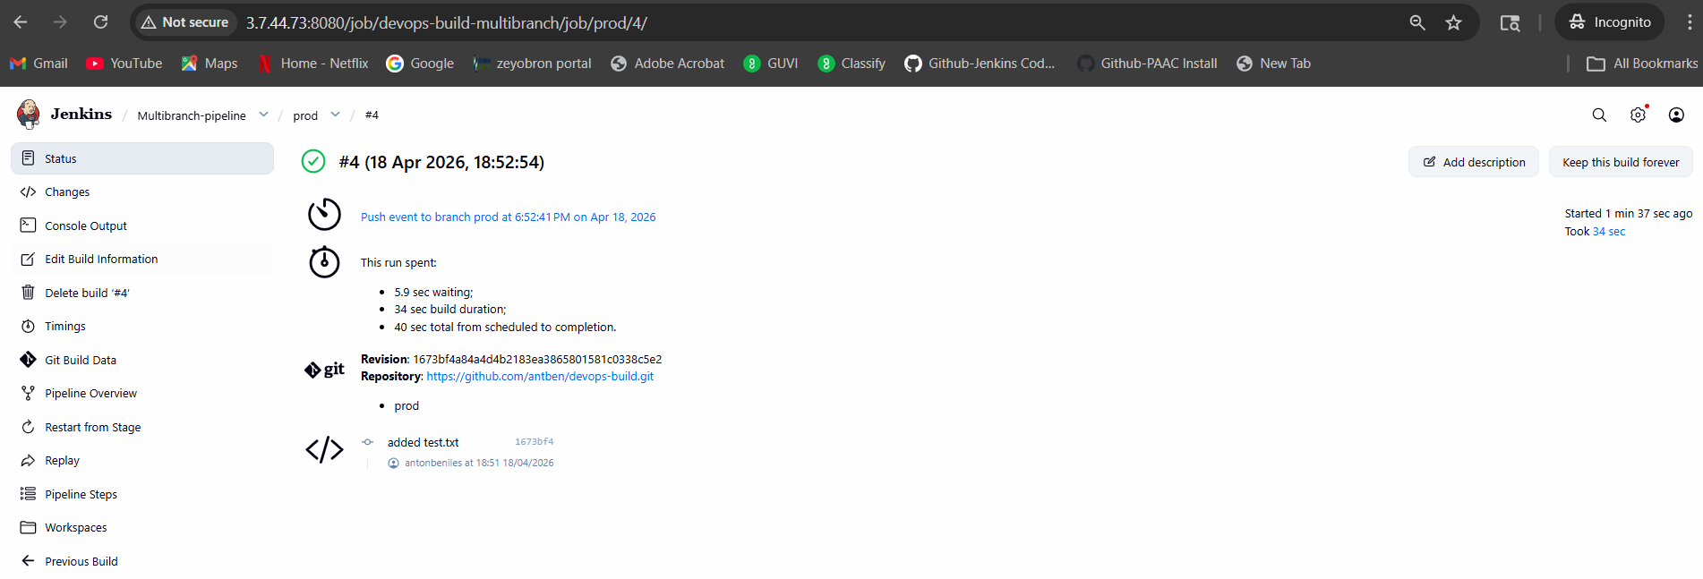

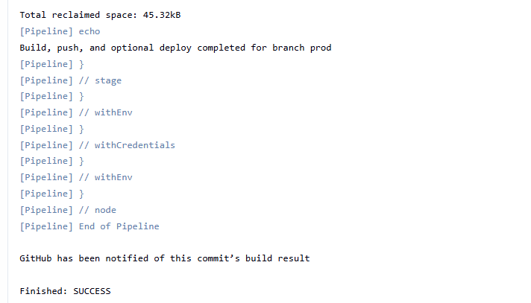

App deployed successfully
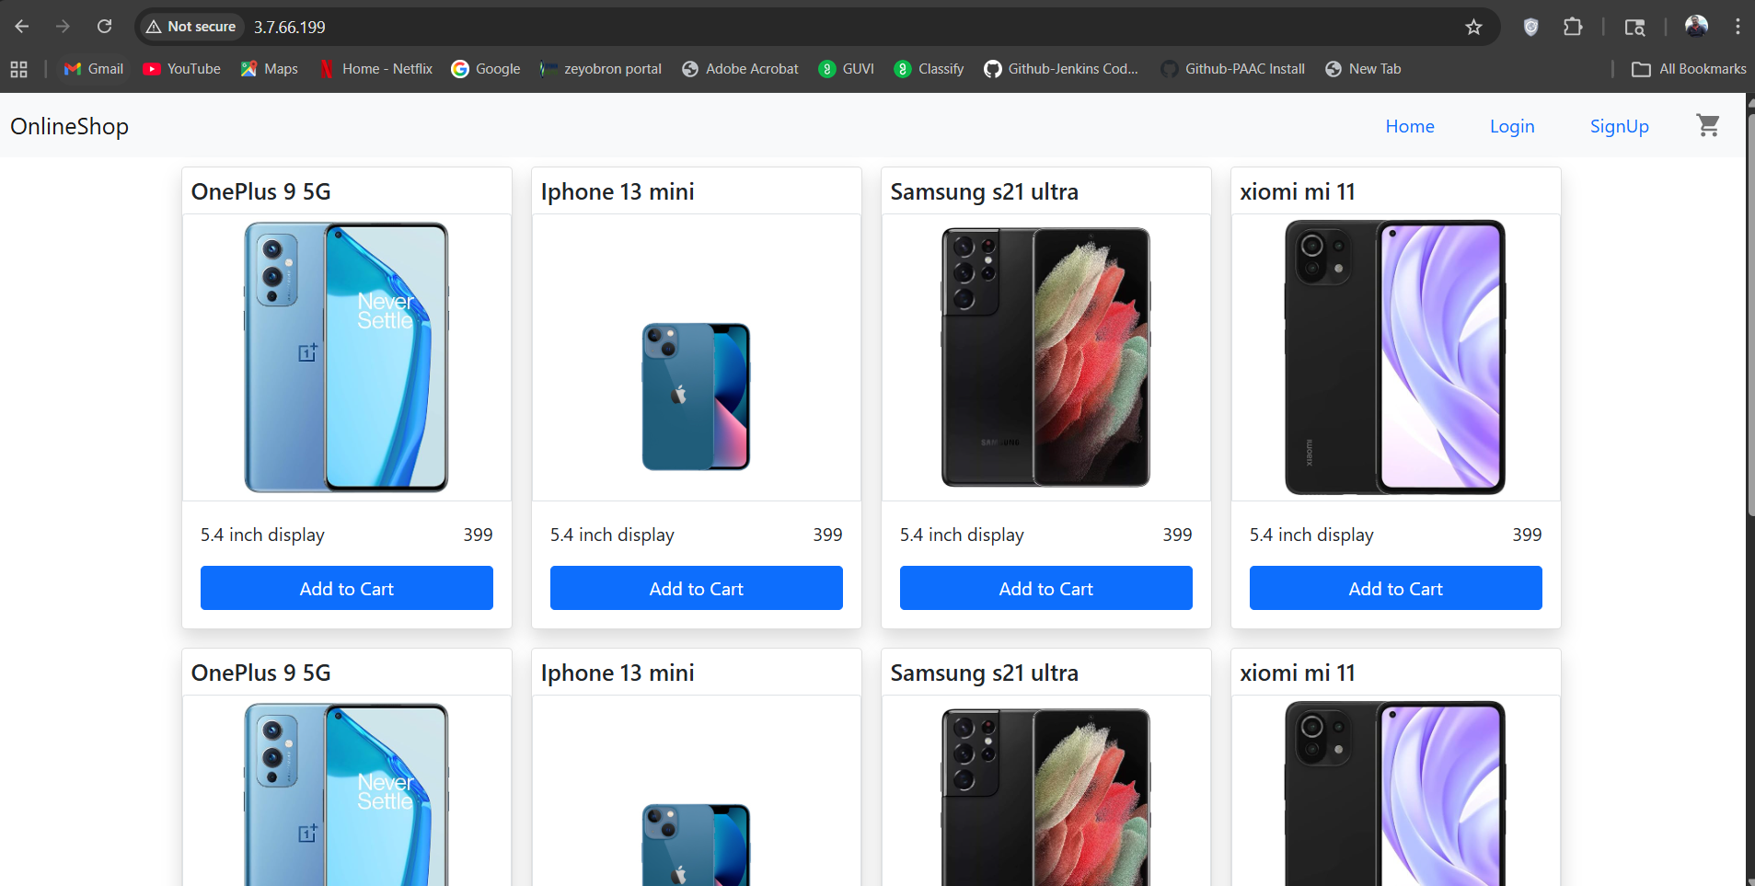

Step14: Setting up monitoring:
Create a monitoring folder on Jenkins EC2
mkdir -p ~/monitoring/prometheus
mkdir -p ~/monitoring/blackbox
mkdir -p ~/monitoring/alertmanager
cd ~/monitoring
Create docker-compose.yml at /monitoring/docker-compose.yml
Docker-compose.yml:
services:
prometheus:
image: prom/prometheus:latest
container_name: prometheus
restart: always
ports:
- "9090:9090"
volumes:
- ./prometheus/prometheus.yml:/etc/prometheus/prometheus.yml:ro
- ./prometheus/alerts.yml:/etc/prometheus/alerts.yml:ro
depends_on:
- blackbox-exporter
- alertmanager

blackbox-exporter:
image: prom/blackbox-exporter:latest
container_name: blackbox-exporter
restart: always
ports:
- "9115:9115"
volumes:
- ./blackbox/blackbox.yml:/etc/blackbox_exporter/config.yml:ro
command:
- '--config.file=/etc/blackbox_exporter/config.yml'

alertmanager:
image: prom/alertmanager:latest
container_name: alertmanager
restart: always
ports:
- "9093:9093"
volumes:
- ./alertmanager/alertmanager.yml:/etc/alertmanager/alertmanager.yml:ro

grafana:
image: grafana/grafana:latest
container_name: grafana
restart: always
ports:
- "3001:3000"

Create Blackbox Exporter config at /monitoring/blackbox/blackbox.yml
Blackbox.yml
modules:
http_2xx:
prober: http
timeout: 5s
http:
method: GET
preferred_ip_protocol: "ip4"
Create Prometheus config at /monitoring/prometheus/prometheus.yml
Prometheus.yml
global:
scrape_interval: 15s
evaluation_interval: 15s

rule_files:
- /etc/prometheus/alerts.yml

alerting:
alertmanagers:
- static_configs:
- targets:
- alertmanager:9093

scrape_configs:
- job_name: 'prometheus'
static_configs:
- targets: ['prometheus:9090']

- job_name: 'blackbox-app'
metrics_path: /probe
params:
module: [http_2xx]
static_configs:
- targets:
- http://3.7.66.199
relabel_configs:
- source_labels: [__address__]
target_label: __param_target
- source_labels: [__param_target]
target_label: instance
- target_label: __address__
replacement: blackbox-exporter:9115
Create alert rules
Create alerts.yaml at /monitoring/prometheus/alerts.yml
Alerts.yaml:
groups:
- name: app-health
rules:
- alert: ApplicationDown
expr: probe_success{job="blackbox-app"} == 0
for: 1m
labels:
severity: critical
annotations:
summary: "Application is down"
description: "The application at {{ $labels.instance }} is not reachable."
Create Alertmanager config
Create file alertmanager.yml at /monitoring/alertmanager/alertmanager.yml
alertmanager.yml:
global:
smtp_smarthost: 'smtp.gmail.com:587'
smtp_from: 'YOUR_EMAIL@gmail.com'
smtp_auth_username: 'YOUR_EMAIL@gmail.com'
smtp_auth_password: 'YOUR_APP_PASSWORD'

route:
receiver: 'email-alerts'
group_wait: 10s
group_interval: 5m
repeat_interval: 2h

receivers:
- name: 'email-alerts'
email_configs:
- to: 'YOUR_RECEIVER_EMAIL@gmail.com'
send_resolved: false
Start the monitoring stack
Run below cmd:
cd ~/monitoring
docker compose up -d
Open required ports on Jenkins EC2 security group
Add inbound rules for:

9090 → Prometheus
9093 → Alertmanager
3001 → Grafana
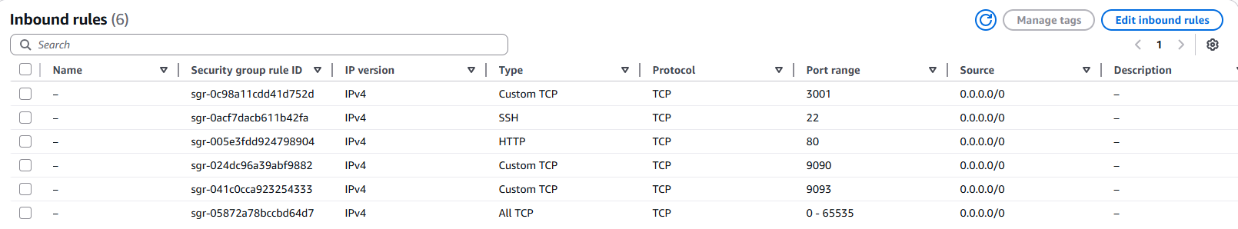
Open Grafana
http://3.7.44.73:3001/
After login ,create Dashboard
In Grafana:
Goto ->Connections
Add new connection
choose Prometheus
set URL to: http://prometheus:9090
Create a health dashboard in Grafana
App Up/Down
Add below query
probe_success{job="blackbox-app"}
When app is down , below is how the dashboard will display:
Test by running below cmd in app server EC2 instance:
docker stop devops-build-app
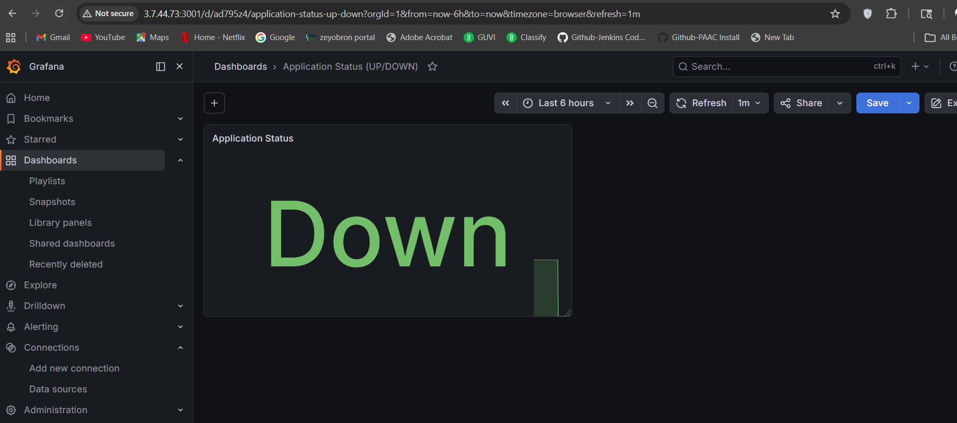
Below is screenshot of email alert received when app is down:
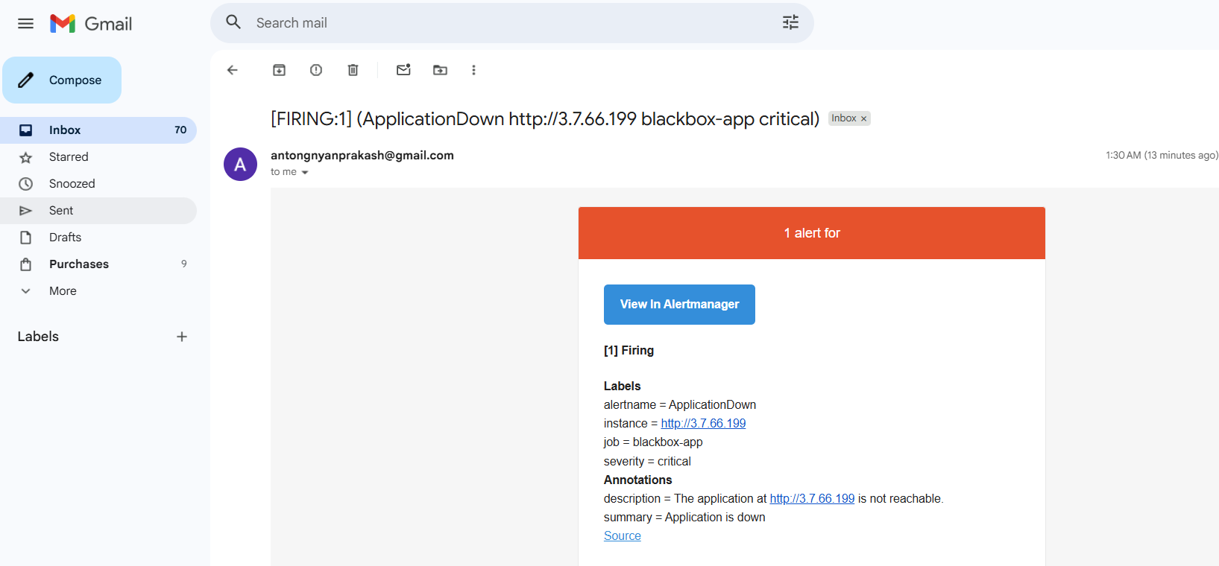

Now bring the app back up, run below cmd on app server:
docker start devops-build-app
Dashboard shows “Up”
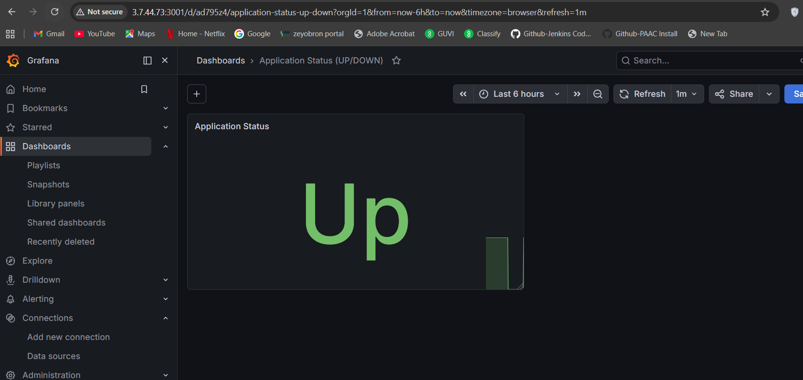
Email Notification for resolution:
