Rapport des résultats de classification

4 July 2019

Modèle : vide_pehd_petc_petf_pp-vgg16-20190628133000.hdf5

Dataset:
2728 images :
- 478 godet vide
- 630 pe-hd-opaque
- 761 pet-clair
- 595 pet-fonce
- 264 pp

Train set : 1577 images
Validation set : 394 images
Test set : 493 images
The splits keep the classes distribution.
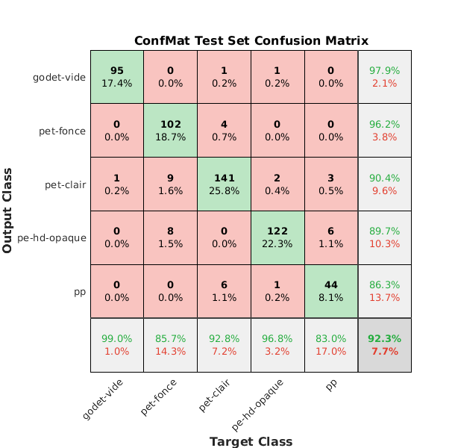
Erreurs de classification

Image : wsEN4iv2SliFUuYNXIM-5Q:IuomFzCcTZOTQ0z7xaVeQQ:320x200.png
True label: 1_pet-fonce
Has been predicted as : 2_pet-clair
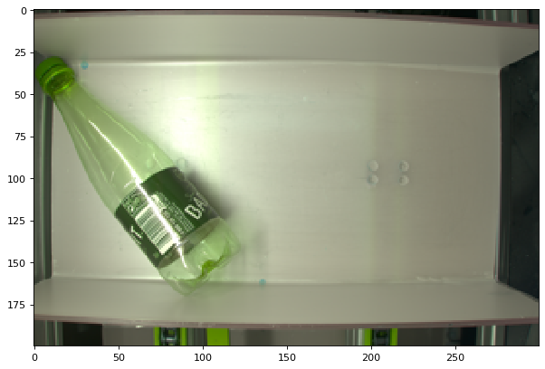
Image : wsEN4iv2SliFUuYNXIM-5Q:odt2chAGQxCwHrnY0NCYRw:320x200.png
True label: 4_pp
Has been predicted as : 2_pet-clair
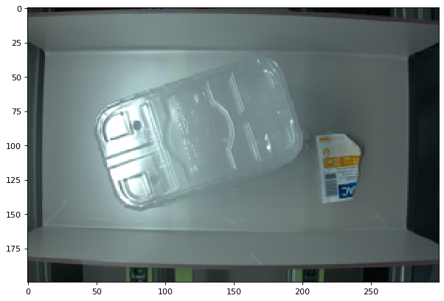
Image : wsEN4iv2SliFUuYNXIM-5Q:Iub7FwN8QYi6V4K5-a_ddA:320x200.png
True label: 2_pet-clair
Has been predicted as : 1_pet-fonce
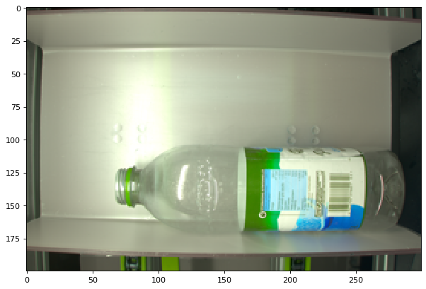
Image : wsEN4iv2SliFUuYNXIM-5Q:fNZOezKlTHORCnrCFxi3QQ:320x200.png
True label: 2_pet-clair
Has been predicted as : 4_pp
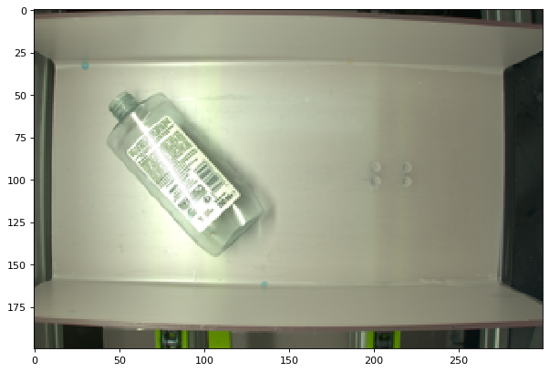

Image : wsEN4iv2SliFUuYNXIM-5Q:h8xPo5rHRxC3rVBbLL3jQA:320x200.png
True label: 4_pp
Has been predicted as : 3_pe-hd-opaque
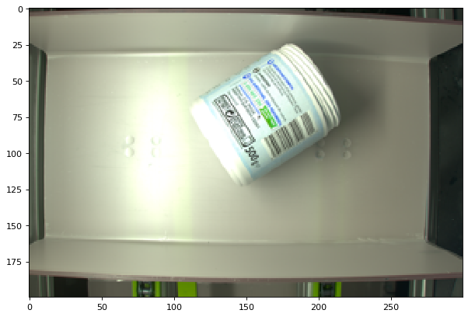

Image : wsEN4iv2SliFUuYNXIM-5Q:rnfhQ7rATcifLkxvp8ItYg:320x200.png
True label: 1_pet-fonce
Has been predicted as : 3_pe-hd-opaque
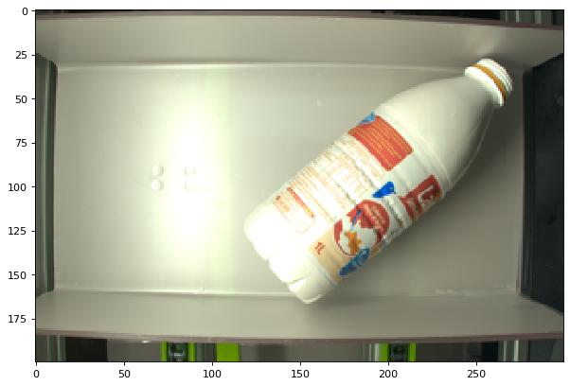
Image : wsEN4iv2SliFUuYNXIM-5Q:WIqZbLMXRjmnVj5RPgxEpA:320x200.png
True label: 1_pet-fonce
Has been predicted as : 2_pet-clair
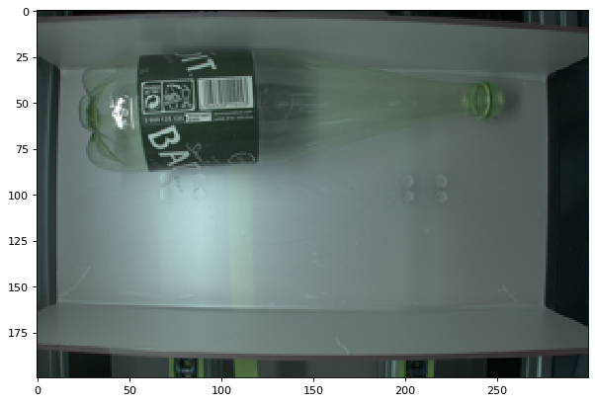

Image : wsEN4iv2SliFUuYNXIM-5Q:Uwbf_SDfTXKZg7ybK9Od3w:320x200.png
True label: 2_pet-clair
Has been predicted as : 1_pet-fonce
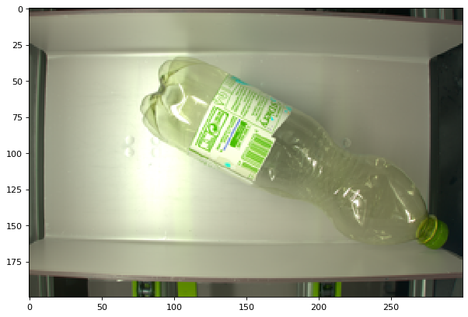
Image : wsEN4iv2SliFUuYNXIM-5Q:U-9mUgjmTL6UuU56BGrQTg:320x200.png
True label: 2_pet-clair
Has been predicted as : 4_pp
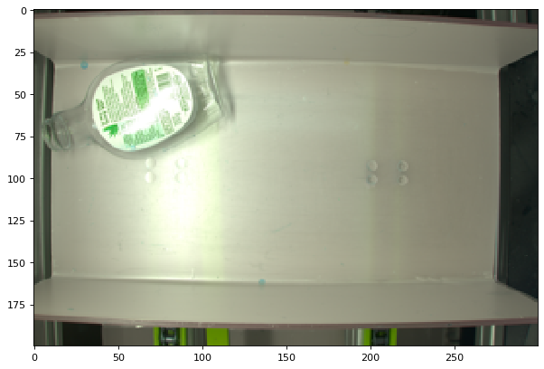

Image : wsEN4iv2SliFUuYNXIM-5Q:6mH6jtfoR3i2gyjxYi_3xg:320x200.png
True label: 2_pet-clair
Has been predicted as : 4_pp
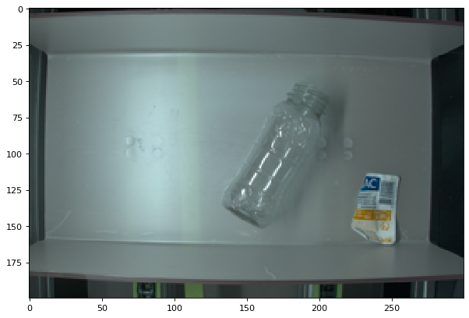
Image : wsEN4iv2SliFUuYNXIM-5Q:KAqJzhxUS065pao9EUI29g:320x200.png
True label: 2_pet-clair
Has been predicted as : 4_pp
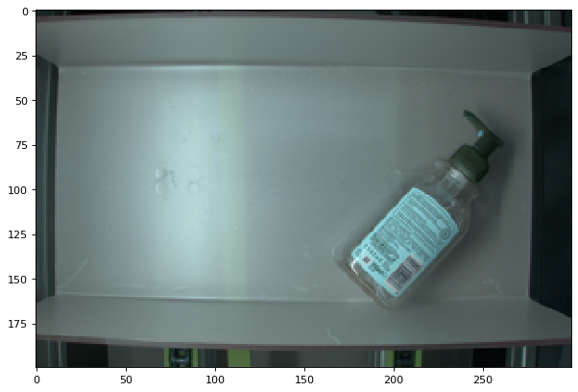

Image : wsEN4iv2SliFUuYNXIM-5Q:YSLqjWgaThamQapJxkPZDg:320x200.png
True label: 1_pet-fonce
Has been predicted as : 2_pet-clair
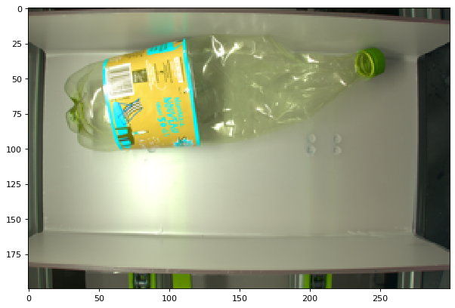
Image : wsEN4iv2SliFUuYNXIM-5Q:q996lS0kQOScPmRNWOKmPA:320x200.png
True label: 2_pet-clair
Has been predicted as : 1_pet-fonce
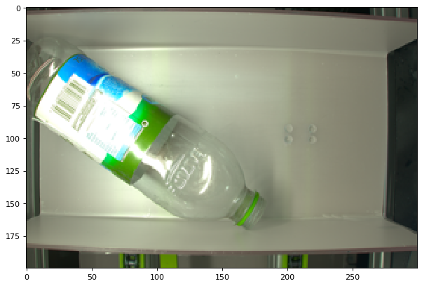

Image : wsEN4iv2SliFUuYNXIM-5Q:6eH0RvgsRVyDe_zJWbs1IA:320x200.png
True label: 0_godet-vide
Has been predicted as : 2_pet-clair
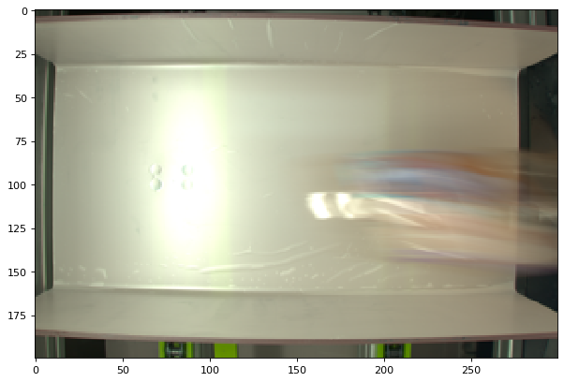
Image : wsEN4iv2SliFUuYNXIM-5Q:dIzqYl9tTVmENQgc_3KyAQ:320x200.png
True label: 1_pet-fonce
Has been predicted as : 2_pet-clair
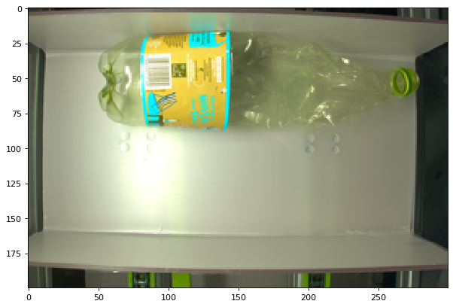

Image : wsEN4iv2SliFUuYNXIM-5Q:TRwerWDYS5WCd4qzbJXAXg:320x200.png
True label: 2_pet-clair
Has been predicted as : 4_pp
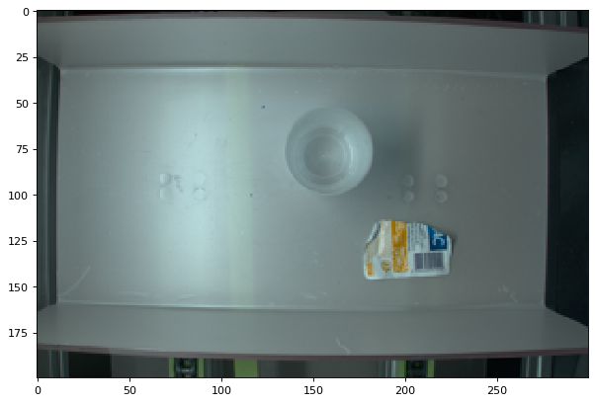
Image : wsEN4iv2SliFUuYNXIM-5Q:LSgpiwj8R--JjJuTjd0TQQ:320x200.png
True label: 4_pp
Has been predicted as : 3_pe-hd-opaque
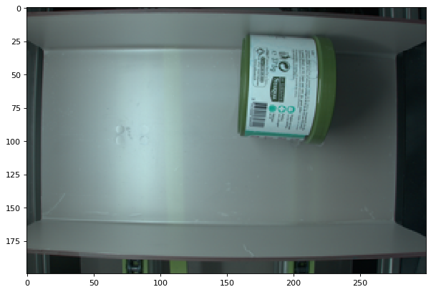

Image : wsEN4iv2SliFUuYNXIM-5Q:8FqHA2k2RMyoC9HKgsQkKA:320x200.png
True label: 3_pe-hd-opaque
Has been predicted as : 2_pet-clair
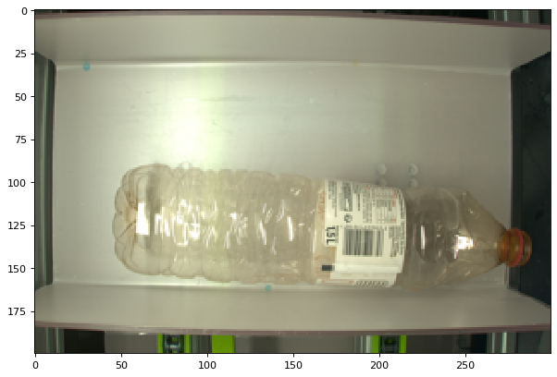
Image : wsEN4iv2SliFUuYNXIM-5Q:ugVkg94zQGmSS6m7TZenNg:320x200.png
True label: 4_pp
Has been predicted as : 2_pet-clair
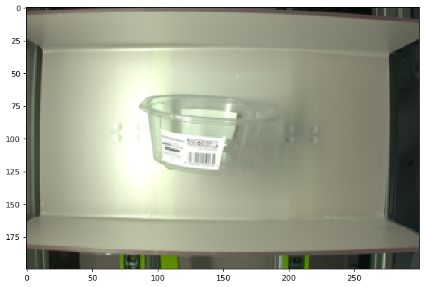

Image : wsEN4iv2SliFUuYNXIM-5Q:6P6nB2XaTuao08Rh4wnGGw:320x200.png
True label: 1_pet-fonce
Has been predicted as : 3_pe-hd-opaque
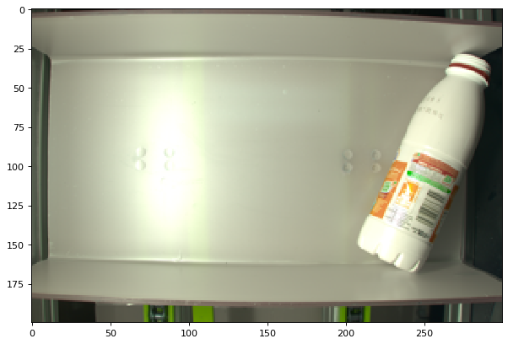
Image : wsEN4iv2SliFUuYNXIM-5Q:DSSRo2JbRzCjmkihWimMrg:320x200.png
True label: 1_pet-fonce
Has been predicted as : 2_pet-clair
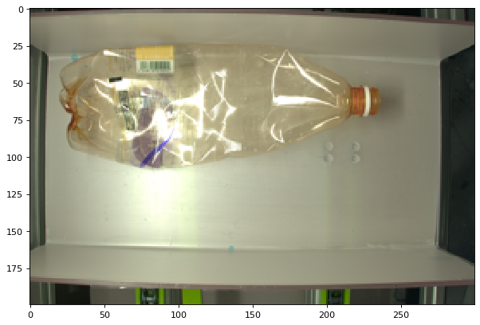

Image : wsEN4iv2SliFUuYNXIM-5Q:7CaoKkjDQXi6jlHW83sI-Q:320x200.png
True label: 1_pet-fonce
Has been predicted as : 2_pet-clair
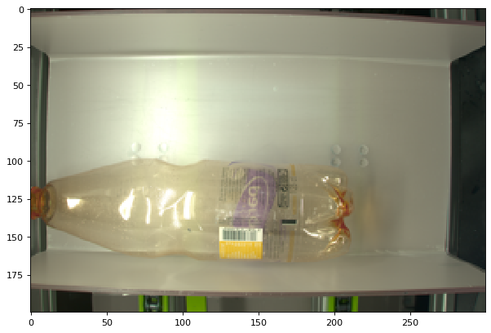
Image : wsEN4iv2SliFUuYNXIM-5Q:h7OzsrGbQrmBwlNC2_kMsQ:320x200.png
True label: 3_pe-hd-opaque
Has been predicted as : 2_pet-clair
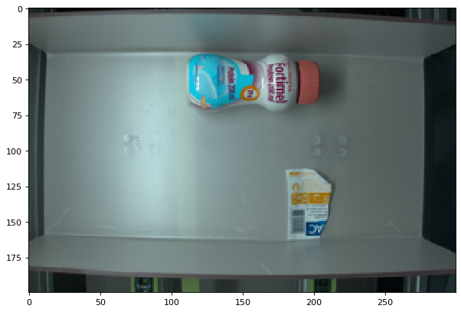

Image : wsEN4iv2SliFUuYNXIM-5Q:R19cXZwjTqi1vZvUtcdemw:320x200.png
True label: 1_pet-fonce
Has been predicted as : 2_pet-clair
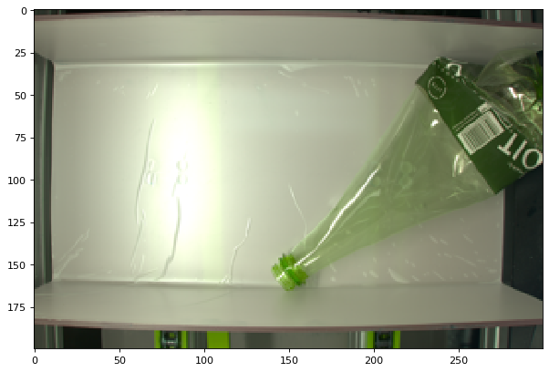
Image : wsEN4iv2SliFUuYNXIM-5Q:Pii45ok9Sc2QBJCumVNcaQ:320x200.png
True label: 2_pet-clair
Has been predicted as : 1_pet-fonce
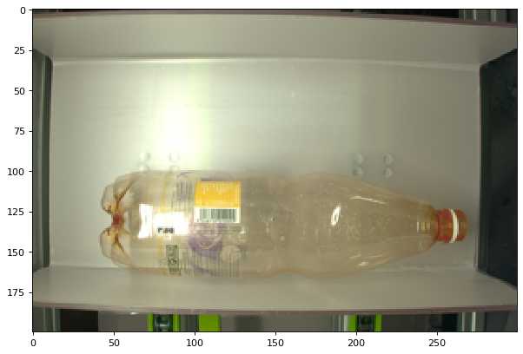

Image : wsEN4iv2SliFUuYNXIM-5Q:pQk8RL91Tnaj0_OFFjivzQ:320x200.png
True label: 2_pet-clair
Has been predicted as : 4_pp
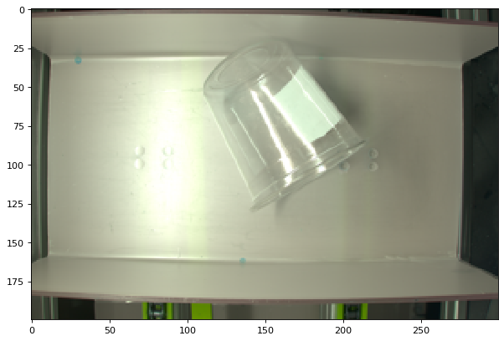
Image : wsEN4iv2SliFUuYNXIM-5Q:p4rEB8mMSamnhF-XwGnyMw:320x200.png
True label: 2_pet-clair
Has been predicted as : 0_godet-vide
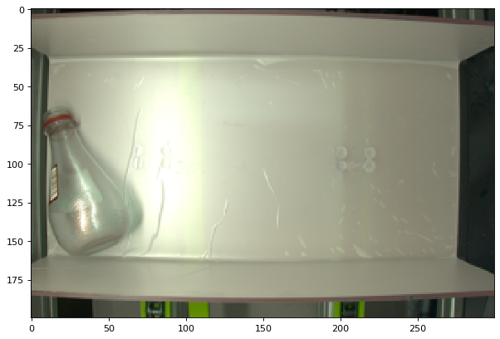

Image : wsEN4iv2SliFUuYNXIM-5Q:YbabOmqyQsKZfHC1MRMqCw:320x200.png
True label: 1_pet-fonce
Has been predicted as : 3_pe-hd-opaque
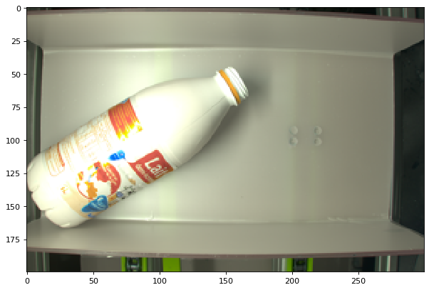
Image : wsEN4iv2SliFUuYNXIM-5Q:K7QmS0rkQWS5bKbYUlwJCw:320x200.png
True label: 1_pet-fonce
Has been predicted as : 3_pe-hd-opaque
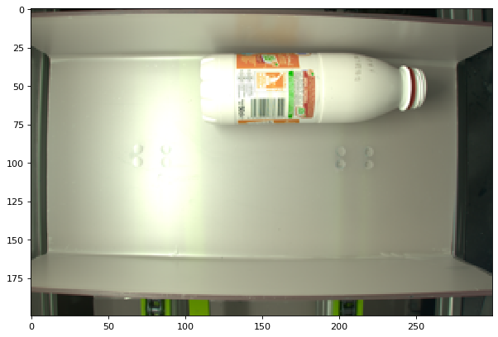

Image : wsEN4iv2SliFUuYNXIM-5Q:JDiV8EizS_2oTnnrTzzfHg:320x200.png
True label: 1_pet-fonce
Has been predicted as : 3_pe-hd-opaque
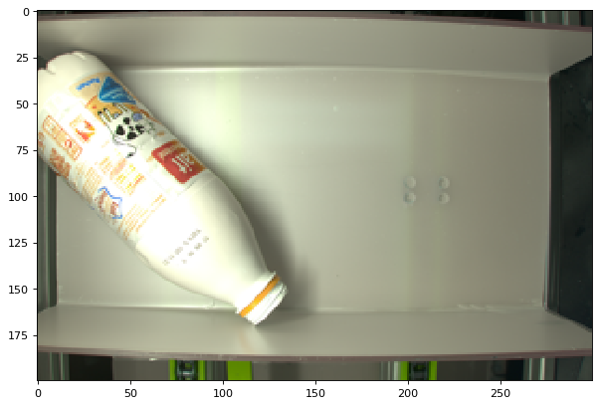
Image : wsEN4iv2SliFUuYNXIM-5Q:L9uGygOuRF64EBqLWrP44A:320x200.png
True label: 4_pp
Has been predicted as : 3_pe-hd-opaque
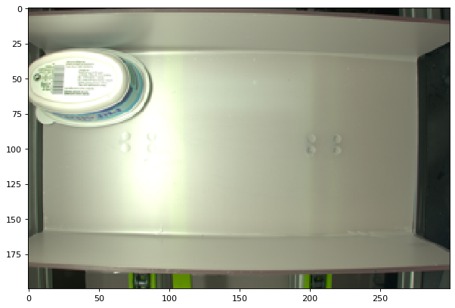

Image : wsEN4iv2SliFUuYNXIM-5Q:YVSnNcsXQwqoBPhIi6Xrlw:320x200.png
True label: 4_pp
Has been predicted as : 3_pe-hd-opaque
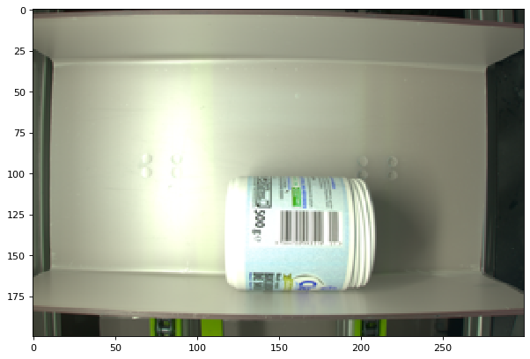
Image : wsEN4iv2SliFUuYNXIM-5Q:iuw8NZC7RP60jACHYEAsDA:320x200.png
True label: 4_pp
Has been predicted as : 3_pe-hd-opaque
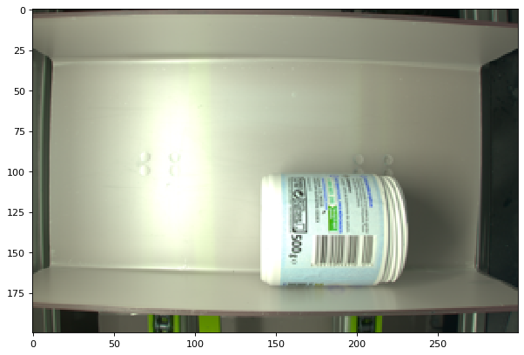

Image : wsEN4iv2SliFUuYNXIM-5Q:PLQ-iUs-SRajwpDGyplO1g:320x200.png
True label: 1_pet-fonce
Has been predicted as : 2_pet-clair
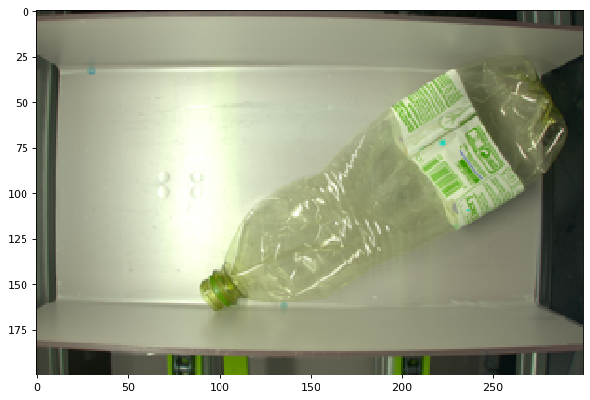
Image : wsEN4iv2SliFUuYNXIM-5Q:6ZICAmkrRtOeQyIOCN9dlg:320x200.png
True label: 1_pet-fonce
Has been predicted as : 3_pe-hd-opaque
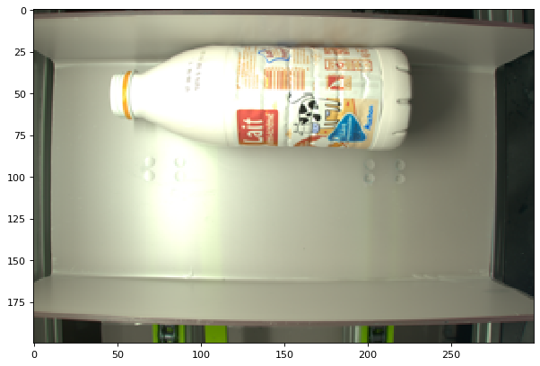

Image : wsEN4iv2SliFUuYNXIM-5Q:g-ufiVCES0KNWPME1WQVog:320x200.png
True label: 1_pet-fonce
Has been predicted as : 3_pe-hd-opaque
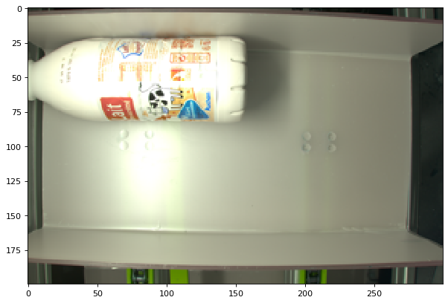
Image : wsEN4iv2SliFUuYNXIM-5Q:a7R4ar6ARlqLfqYRzeftFA:320x200.png
True label: 4_pp
Has been predicted as : 3_pe-hd-opaque
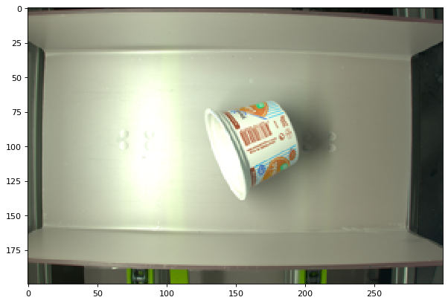

Image : wsEN4iv2SliFUuYNXIM-5Q:maIsatbWRVucJH5XIJZibA:320x200.png
True label: 3_pe-hd-opaque
Has been predicted as : 4_pp
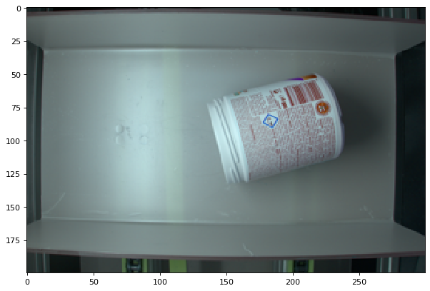
Image : wsEN4iv2SliFUuYNXIM-5Q:HRe5AjXvSO6FxhxVESyDFw:320x200.png
True label: 1_pet-fonce
Has been predicted as : 3_pe-hd-opaque
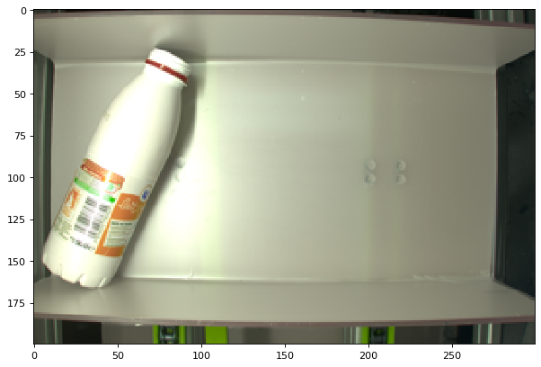

Image : wsEN4iv2SliFUuYNXIM-5Q:6g8wfCLbTd-CQ5lXgmGt6A:320x200.png
True label: 3_pe-hd-opaque
Has been predicted as : 0_godet-vide
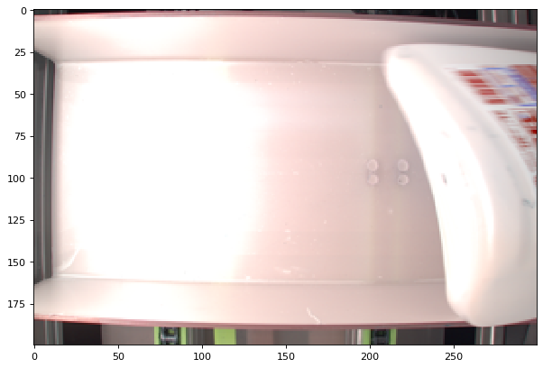
Image : wsEN4iv2SliFUuYNXIM-5Q:-4ql4x8HTYW_5tXtf4ZvOQ:320x200.png
True label: 1_pet-fonce
Has been predicted as : 2_pet-clair
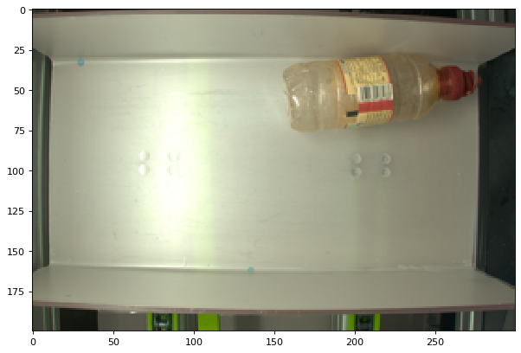

Image : wsEN4iv2SliFUuYNXIM-5Q:k3DwUUJgQR2dXAYbg8gCzA:320x200.png
True label: 4_pp
Has been predicted as : 2_pet-clair


