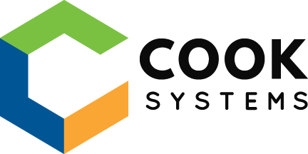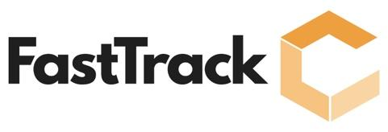

**Anthony Davis**

**PROFESSIONAL SUMMARY**

Anthony Davis is an associate software developer with a master’s degree in computer science and a background as a systems analyst. His completion of the FastTrack Java Developer program and his background has equipped him with technical proficiency and versatility, making him adept at comprehending and acquiring business needs. Anthony’s distinctive outlook towards software development allows him to communicate effectively and work collaboratively with cross-functional teams to ensure successful project completion. The combination of technical versatility and business acumen, as well as his collaborative approach, make’s Anthony an asset to any software development team.

**TECHNICAL SKILLS**

**Programming:** Java, JavaScript, HTML5, CSS3, SQL, Spring, Spring Boot, JDBC, Jackson, JPA, JQuery, Node, Webpack, Babel, Maven, NPM, React, Redux, Typescript, C#, Python, Vue

**Software:** Eclipse, VS Code, Visual Studio, Git, GitHub, Cmder, PGAdmin, SSRS

**Databases:**PostgreSQL, SQL

**Operating Systems:** Windows, MacOS, Linux

**PROFESSIONAL EXPERIENCE**

**COOK SYSTEMS – Memphis, TN                                          02/23 – Present**

***FastTrack Developer***

*Twitter-Clone API Assessment*

* Designed a RESTful Twitter API with multiple endpoints with Twitter-like features for users, tweets, and hashtag functionality via CRUD operations and other HTTP requests
* Developed a PostgreSQL database schema supported by PGAdmin for data management and storage
* Programmed controllers and services to handle HTTP requests, backend validation, and logic efficiently, resulting in a more responsive and streamlined API
* Employed a methodical and analytical approach to test, troubleshot, debug, and pair program API functionality in Postman until project requirements were achieved

*Environment: Java, Spring Boot, JPA, PostgreSQL, PGAdmin, Postman, Git, Eclipse, Maven*

*Assessment #2*

* A
* B
* C
* D

*Environment:*

*Assessment #3*

* A
* B
* C
* D

*Environment:*

**Cigna – Nashville, TN 01/16 – 10/18**

*System Analyst and Junior Developer*

* Increased team efficiency and productivity, saved costs, and improved workflow by creating an internal web portal for users to search and reuse existing reports
* Built reports using Cognos BI and SSRS by collaborating with senior developers
* Improved the team's development process and client satisfaction by co-leading the team in transitioning from a waterfall workflow to an agile workflow
* Ensured client requirements were met by liaising between business clients and developers and compiling all technical documentation needed to fulfill business needs
* Supervised successful Round 2nd Day by managing a team to coordinate all logistical requirements and itinerary necessary for 2 day in person interviews
* Coordinated on-site Code-A-Thons by organizing the itinerary, scheduling meetings with managers, setting up required technology, and all other logistical requirements
* Organized onsite recruitment at MTSU by managing a team to set up and attend on campus recruiting events and assisted with phone interviews
* Provided a welcoming experience for new hires being a mentor in the Buddy Program and providing any help, guidance, or advice needed for a successful start at Cigna

**Middle Tennessee State University – Murfreesboro, TN 08/13 – 8/15**

*Graduate Research*

Visualizing Gene Family Evolutions

* Developed a web application to visualize the evolutionary trends of gene families
* Generated a Frame file with exon locations marked from given genome sequences
* Designed and implemented a user-friendly front-end interface to display all genes to be compared with lines showing which exons were in the same locations
* Converted the SVG file into other image formats for export
* Programmed the back-end functionality of the web application to enable efficient data retrieval and processing

Environment: Python, BioPython, Pearl, PHP, HTML, CSS, JavaScript, SVG, CGI

**Willis Tower Watson – Nashville, TN 06/14 – 8/14**

*Internship*

* Resolved employee adjustment during a disaster by developing a PowerShell script to back-up and restore user profiles as part of the North American disaster recovery plan
* Created virtual servers and machines and installed the operating environment while assisting with daily tasks with the database management and SCCM/SCOM teams

**Middle Tennessee State University – Murfreesboro, TN 08/13 – 8/15**

*Graduate Teaching Assistant*

* Educated students to have a strong foundation in computer basics and web technologies by designing and delivering lectures based on Computer Orientation course criteria
* Equipped students with skills for future endeavors by providing instruction and lab exercises, reinforcing understanding of assembly and computer organization principles
* Empowered students to acquire foundational concepts of Computer Sciences I and II by facilitating practical lab settings and providing constructive feedback
* Facilitated comprehension of concepts for computer systems fundamentals through personalized attention and feedback, and aiding in overcoming academic challenges

**United States Navy 04/04 – 8/06**

* Acquired high-pressure, complex environment skills through United States Navy's nuclear power program, leading to continued utilization of skills in current pursuits
* Efficiently managed daily duties of personnel in restriction barracks, fostering personal responsibility and behavior for successful reintegration into the military community

**EDUCATION**

**Cook Systems FastTrack Java Program – Memphis, TN           02/23 – Present**

*Concentrated Java Frameworks and developer tools training*

**Middle Tennessee State University – Murfreesboro, TN          08/13 – 08/15**

*Master of Science: Computer Science*

**Middle Tennessee State University – Murfreesboro, TN          08/09 – 04/13**

*Bachelor of Science: Computer Science, Minor in Mathematics and Biology*