# UI Screenshots — GitHub Issues Mock API

# Container running (docker compose ps)



# GET /issues — 200 OK

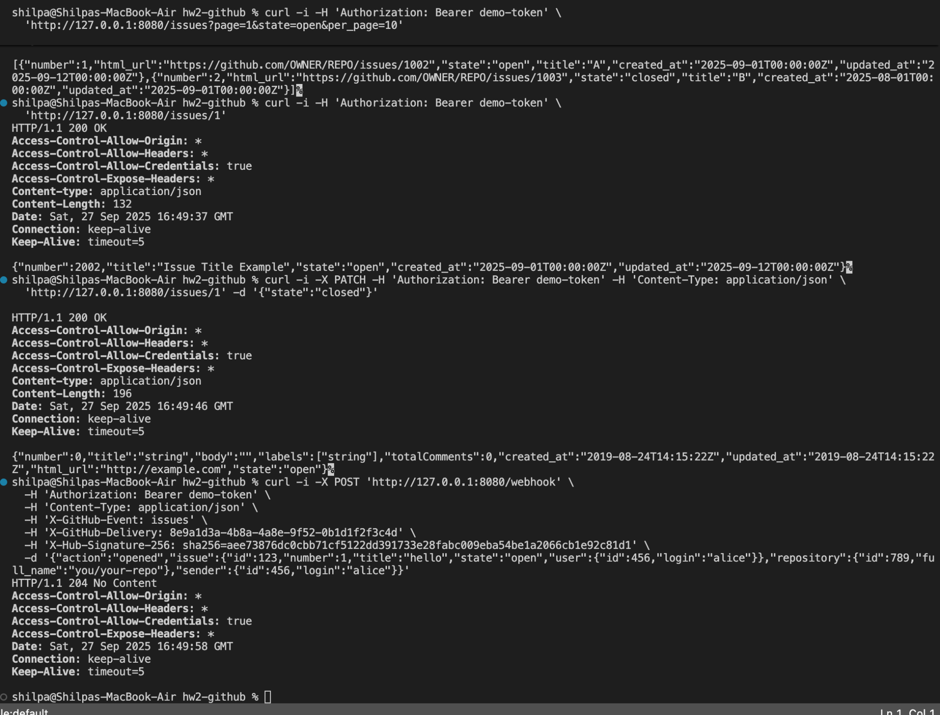

# POST /webhook — 204 No Content

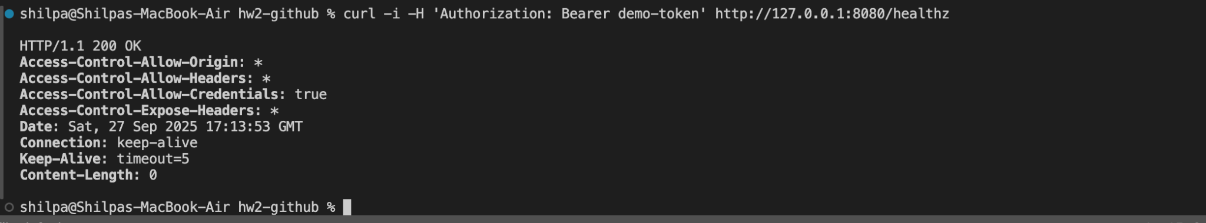

# Composite terminal output (issues, patch, webhook)



# Additional terminal snapshot

