

INTERNATIONAL UNIVERSITY
School of Computer Science & Engineering

Web Application Development
LABORATORY

Lab 02

Submitted by:
Nguyễn Hà An Thạnh – ITITWE22051

Date submits: | 18/10/2025
Date performs: | 18/10/2025
Lab section: | Lab 2
Course instructor: | Msc. N. T. Nghĩa

Exercise 1 (15 pt): Deploy the personal web pages you which do on previous lab to the github.io and submit the link via your report.
- https://anthanh2704.github.io/
Exercise 2 (30 pt):
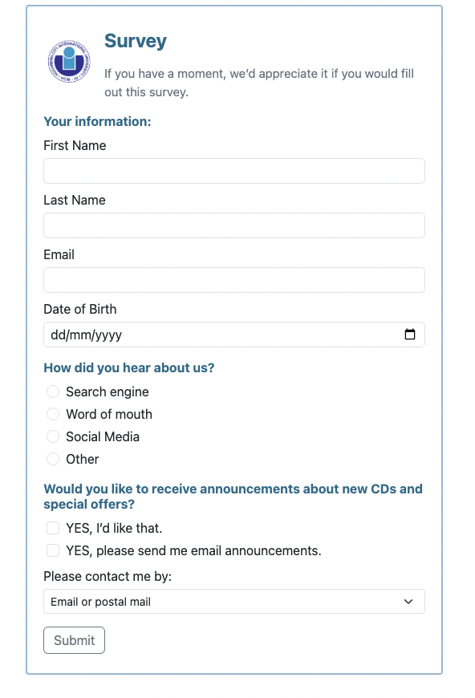

A) Functionality Requirements (12 pts)

1) Four required text inputs: First Name, Last Name, Email, Date of Birth — 3 pts
Code proof:
<input id="firstName" name="first_name" type="text" class="form-control" required>
<input id="lastName" name="last_name" type="text" class="form-control" required>
<input id="email" name="email" type="email" class="form-control" required>
<input id="dob" name="date_of_birth" type="date" class="form-control" required>

2) Radio buttons for “How did you hear about us?” — 3 pts
Code proof:
<input class="form-check-input" type="radio" name="referrer" id="ref-search" value="search" required>
<input class="form-check-input" type="radio" name="referrer" id="ref-word" value="word_of_mouth">
<input class="form-check-input" type="radio" name="referrer" id="ref-social" value="social_media">
<input class="form-check-input" type="radio" name="referrer" id="ref-other" value="other">
-All radios share the same name="referrer", so only one can be selected at a time (correct radio behavior).

3) Checkboxes for announcements preferences — 3 pts
Code proof:
<input class="form-check-input" type="checkbox" id="announcements" name="receive_announcements" value="yes">
<input class="form-check-input" type="checkbox" id="emailAnnouncements" name="email_announcements" value="yes">
Checkboxes are independent (different names).

4) Dropdown/select for contact method — 2 pts
Code proof:
<select id="contactBy" name="contact_method" class="form-select form-select-sm" required>
<option value="email_or_postal" selected>Email or postal mail</option>
<option value="email_only">Email only</option>
<option value="postal_only">Postal mail only</option>
</select>

5) Submit button present — 1 pt

Code proof:
<button type="submit" class="btn btn-outline-secondary">Submit</button>

B) HTML Structure & Semantics (8 pts)

6) Proper HTML5 document structure — 2 pts
Where: top of index.html
Code proof:
<!doctype html>
<html lang="en">
<head>
<meta charset="utf-8">
<meta name="viewport" content="width=device-width, initial-scale=1">
<title>Survey Form</title>
-Correct <!doctype html>, semantic <head> and <body>.

7) Correct use of form elements & attributes — 4 pts

Evidence:
- <form action="#" method="post" novalidate> uses semantic form container.
- All controls have name attributes (needed to submit values).
- Labels are associated via for/id (e.g., <label for="firstName"> + id="firstName").
- Group semantics: radio set shares name="referrer".

8) Appropriate input types — 2 pts
Evidence: type="text", type="email", type="date", type="radio", type="checkbox" are all used appropriately (see snippets above).

C) Visual Design & Layout (5 pts)

9) Matches example layout — 2 pts
Where: index.html + <style> block
Evidence: Framed card with blue border, headings, tight spacing similar to prompt.
.survey-frame{
max-width: 520px;
margin: 2rem auto;
border: 2px solid #94b9d1;
padding: 1.25rem 1.5rem;
border-radius: .25rem;
}
.section-title{ color:#1a6a8a; font-weight:700; }
Verify: The form appears centered with a thin blue frame; headings styled in blue.

10) Logo/header image displayed correctly — 1 pt
Code proof (final working path):
<img src="https://anthanh2704.github.io/images/logo.png" alt="School logo" style="height:64px">
How to verify: Open the page; logo appears at top-left inside the frame.

11) Proper spacing & alignment — 2 pts
Evidence: Bootstrap form classes (.form-control, .form-check, .row.g-2) ensure consistent spacing; custom CSS tightens to resemble screenshot.
<div class="row g-2 thin-input"> … </div>
.form-label{ margin-bottom:.25rem; }
.form-check{ margin-bottom:.25rem; }
Verify: Controls align vertically; labels above inputs; compact line height.

D) Bootstrap Integration (Bonus up to 5 pts)

12) Bootstrap CSS linked — 1 bonus
Where: <head> of exercise2.html
Code proof:
<link href="https://cdn.jsdelivr.net/npm/bootstrap@5.3.3/dist/css/bootstrap.min.css" rel="stylesheet">

13) Bootstrap classes applied — 3 bonus
Evidence: .container-like layout via custom frame + Bootstrap utilities; inputs use .form-control, radios/checkboxes use .form-check, select uses .form-select, button uses .btn.
<input class="form-control"> <div class="form-check"> <select class="form-select form-select-sm"> <button class="btn btn-outline-secondary">

14) Responsive behavior — 1 bonus
Evidence: Mobile-friendly meta + Bootstrap grid/utilities; frame max-width; inputs scale to 100%.
<meta name="viewport" content="width=device-width, initial-scale=1">

Exercise 3: Implement the page here using Flexbox in a 3-column, fixed-width layout (20 point)
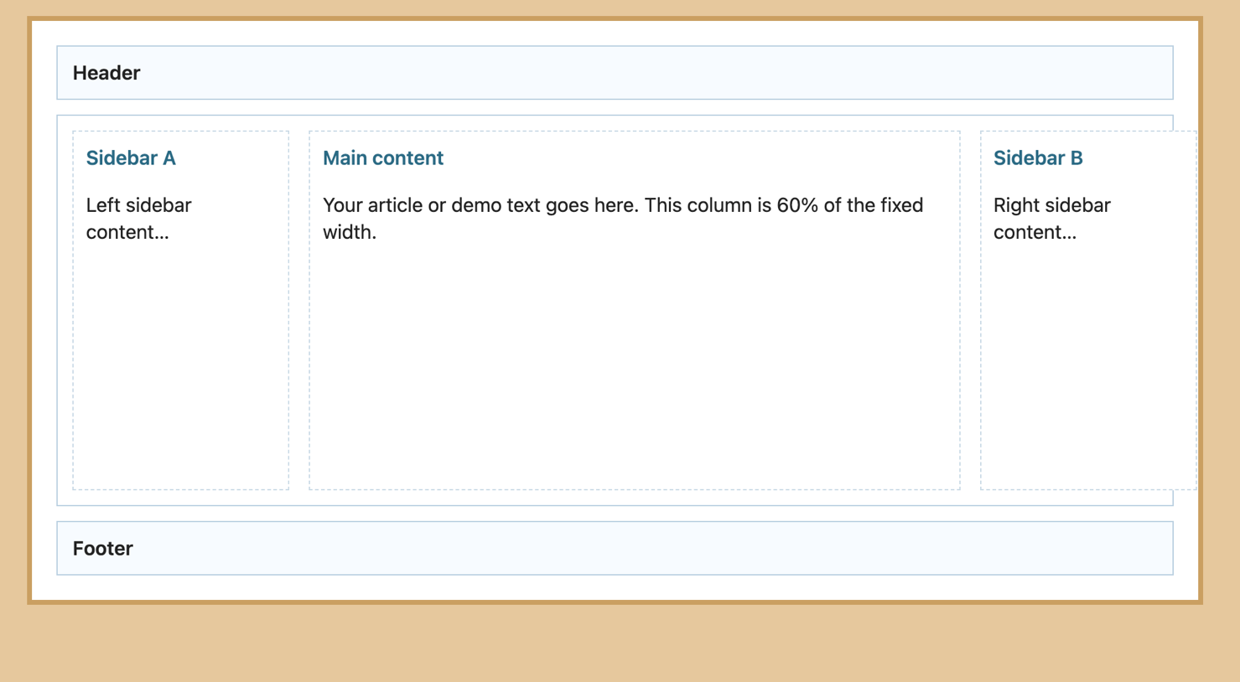

Flexbox Implementation (10 pts)

1) Flexbox container properly defined — 2 pts
Proof code
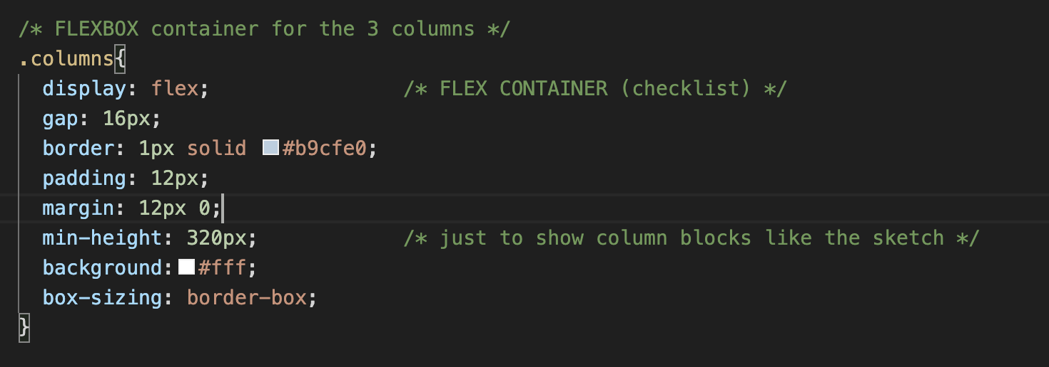
-display: flex turns .columns into a flex container; its children become flex items.

2) Three columns created using Flexbox — 4 pts
Proof code (three flex items inside .columns)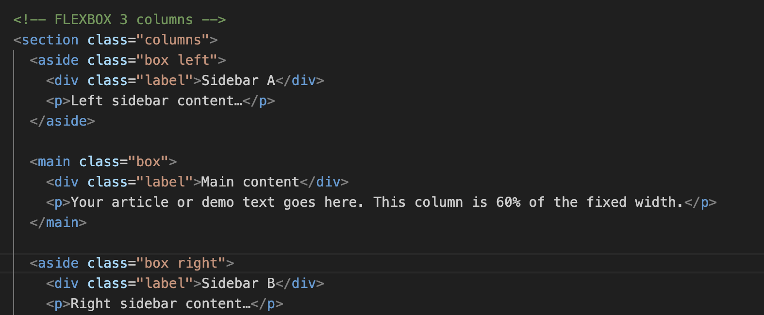
<section class="columns">
<aside class="box left">Sidebar A</aside> <!-- column 1 -->
<main class="box">Main content</main> <!-- column 2 -->
<aside class="box right">Sidebar B</aside> <!-- column 3 -->
</section>
- The two <aside> elements and the <main> are siblings inside a flex container, so they render as 3 columns by Flexbox.

3) Fixed-width layout implemented correctly — 3 pts
Proof code
<div class="frame">
...
</div>
.frame{
width: 960px; /* ← fixed width */
margin: 32px auto; /* center the fixed-width frame on the page */
padding: 20px;
border: 4px solid #caa061;
box-sizing: border-box;
}
- The whole page content lives inside .frame, which is explicitly set to a fixed width (960px), matching the assignment’s “fixed-width layout”.

4) Columns maintain proper proportions — 1 pt
Proof code
/* 20% | 60% | 20% of the frame width */
aside.left { flex: 0 0 20%; } /* fixed basis 20% */
main { flex: 0 0 60%; } /* fixed basis 60% */
aside.right { flex: 0 0 20%; } /* fixed basis 20% */
- Using flex: 0 0 X% sets a fixed flex-basis for each column, preserving their proportions regardless of content height.

Layout Structure (6 pts)

5) Header positioned and spans full width — 2 pts
Proof code
<div class="frame">
<header>Header</header>
<section class="columns">…</section>
<footer>Footer</footer>
</div>
header{
border: 1px solid #b9cfe0;
padding: 10px 12px;
background:#f7fbff;
font-weight: 600;
}
- <header> is a block-level element placed at the top of .frame, so it naturally spans the full width of the fixed container.

6) Sidebars & main correctly arranged (A–Main–B) — 3 pts
Proof code (DOM order = visual order)
<section class="columns">
<aside class="box left">Sidebar A</aside> <!-- left -->
<main class="box">Main content</main> <!-- center -->
<aside class="box right">Sidebar B</aside> <!-- right -->
</section>
- In a left-to-right flex row (the default flex-direction: row), the three items appear exactly in this order: Sidebar A → Main → Sidebar B.

7) Footer spans full width — 1 pt
Proof code
<footer>Footer</footer>
footer{
border: 1px solid #b9cfe0;
padding: 10px 12px;
background:#f7fbff;
font-weight: 600;
}
- <footer> is a block element placed after the columns, so it stretches the full width of .frame, matching the header.
Exercise 4 (35 pt): Implement following pages using CSS, HTLM and applying Flexbox to layout the pages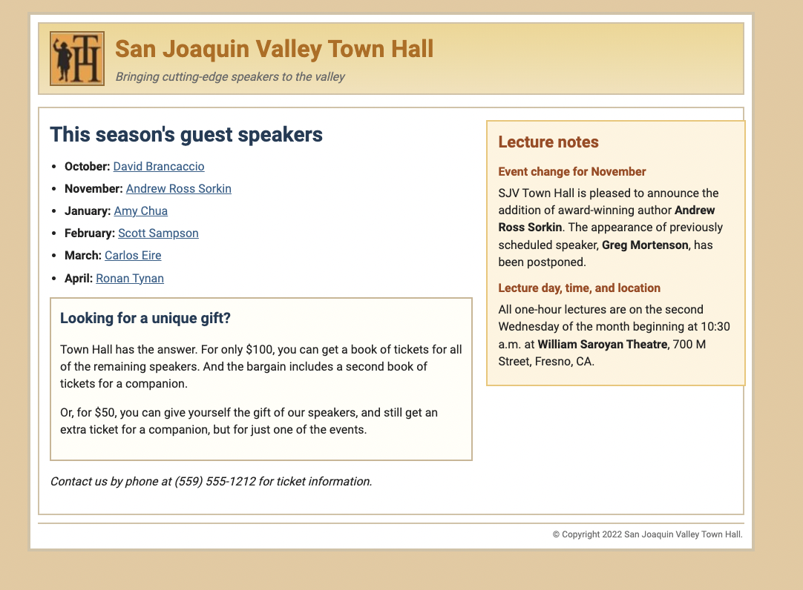

Layout Implementation (12 pts)

Flexbox used for overall page layout — 5 pts
Proof (CSS):
/* Two-column region uses Flexbox */
.cols{
display:flex; /* ← Flexbox container */
gap:18px;
border:2px solid var(--frame);
padding:16px 14px;
margin:16px 0 10px;
background:#fff;
}

/* Header also uses Flexbox for logo + title alignment */
header{
display:flex; /* ← Flexbox */
align-items:center;
gap:14px;
/* …band, padding, border… */
}
Why it counts: The page’s main areas (header, content columns) are laid out via Flexbox.

Two-column layout (main + sidebar) implemented — 4 pts
Proof (HTML):
<section class="cols">
<main> …left content… </main>
<aside> …right notes… </aside>
</section>
Proof (CSS proportions):
main { flex:0 0 62%; } /* left column */
aside{ flex:0 0 38%; } /* right column */
Why it counts: .cols is the flex container with two flex items: <main> and <aside>.

Header with logo and title — 3 pts
Proof (HTML):
<header>
<img src="./images/logo.png" alt="Town Hall logo" class="logo">
<div class="brand">
<h1>San Joaquin Valley Town Hall</h1>
<div class="tag">Bringing cutting-edge speakers to the valley</div>
</div>
</header>
Proof (CSS):
.logo{ width:70px; height:70px; border:2px solid #9b6a28; object-fit:contain; }
.brand h1{ font-size:32px; color:var(--brand); font-weight:800; }
Why it counts: Header contains a visible logo image and the site title/tagline, aligned with Flexbox.

Content & Elements (12 pts)

Logo and title displayed correctly — 2 pts
- Logo <img class="logo"> renders in header; title is <h1>San Joaquin Valley Town Hall</h1> (see header proof above).

“This season’s guest speakers” list formatted — 3 pts
Proof (HTML):
<h2>This season's guest speakers</h2>
<section class="speakers">
<ul>
<li><strong>October:</strong> <a href="#">David Brancaccio</a></li>
<li><strong>November:</strong> <a href="#">Andrew Ross Sorkin</a></li>
<li><strong>January:</strong> <a href="#">Amy Chua</a></li>
<li><strong>February:</strong> <a href="#">Scott Sampson</a></li>
<li><strong>March:</strong> <a href="#">Carlos Eire</a></li>
<li><strong>April:</strong> <a href="#">Ronan Tynan</a></li>
</ul>
</section>
Proof (CSS for link color/spacing):
.speakers ul{ margin:0 0 14px 20px; padding:0; }
.speakers li{ margin:7px 0; }
.speakers li a:link, .speakers li a:visited{ color:var(--link); text-decoration:underline; }

“Lecture notes” section included with details — 3 pts
Proof (HTML):
<aside>
<div class="notes">
<h3>Lecture notes</h3>

<h4>Event change for November</h4>
<p>…addition of … <strong>Andrew Ross Sorkin</strong> … <strong>Greg Mortenson</strong> …</p>

<h4>Lecture day, time, and location</h4>
<p>… second Wednesday … 10:30 a.m. at <strong>William Saroyan Theatre</strong>, 700 M Street, Fresno, CA.</p>
</div>
</aside>
Why it counts: Both required subsections and the location details are present.

“Looking for a unique gift?” section present — 2 pts
Proof (HTML):
<section class="gift">
<h3>Looking for a unique gift?</h3>
<p>…$100… remaining speakers… second book of tickets…</p>
<p>…$50… extra ticket for a companion… one of the events.</p>
</section>
Proof (CSS card styling):
.gift{ margin:14px 0; padding:12px; border:2px solid var(--rule); background:#fffef7; }

Contact information included — 2 pts
Proof (HTML):
<p class="contact">Contact us by phone at (559) 555-1212 for ticket information.</p>

Styling & Visual Design (8 pts)

Orange/yellow header background band — 2 pts
Proof (CSS):
header{
/* … */
background: linear-gradient(var(--band-top), var(--band-bot)); /* orange/yellow band */
}

Typography (fonts, sizes, colors) — 2 pts
Proof (CSS):
body{ font:16px/1.45 "Segoe UI", Roboto, Helvetica, Arial, sans-serif; color:var(--body); }
.brand h1{ font-size:32px; color:var(--brand); font-weight:800; }
h2{ font-size:28px; color:#1f3c57; font-weight:800; }
.notes h3{ font-size:22px; color:var(--notes-head); }
.notes h4{ font-size:16px; color:var(--notes-head); font-weight:800; }

Borders and spacing match the design — 2 pts
Proof (CSS):
.canvas{ border:4px solid var(--frame); padding:10px; }
header{ border:2px solid var(--frame); padding:10px 14px; }
.cols{ border:2px solid var(--frame); padding:16px 14px; gap:18px; }
.notes{ border:2px solid var(--notes-border); padding:12px 14px; box-shadow:0 0 0 2px var(--notes-bg) inset; }
Why it counts: Frame, inner borders, card padding, and gaps visually match the reference.

Overall color scheme matches specification — 2 pts
Proof (CSS variables):
:root{
--bg-tan:#e7c99d; --frame:#d3c2a6; --band-top:#f1d58e; --band-bot:#f3e1b7;
--brand:#b66a05; --link:#2b5f8a; --notes-bg:#fff3df; --notes-border:#efc56f; --notes-head:#a2471a;
}
Why it counts: Using tokens ensures consistent tan frame, gold header, blue links, and orange notes headings.

