SERIAL TEST TOOL PROPOSAL

REV | DESCRIPTION OF CHANGE | ECO | DATE | BY | ENG
A | INITAL |  | 12/21/2011 | K.Nguyen
B | Update for release 04 |  | 02/08/2011 | K.Nguyen
C | Update for release 05 |  | 02/09/2011 | K.Nguyen
D | Add GUI Guide Line |  | 02/09/2011 | K.Nguyen

VERIFY REVISION WITH DOCUMENTATION PRIOR TO INITIATING CHANGES

 | NAME | DATE | DESCRIPTION
COMPLIED BY
CHECKED BY
ENGINEER |  |  | SCALE: N/A | REV: D | SHT 1
MANUFACTUR'G

Contents
1. PURPOSE 3
2. SCOPE 3
3. DEFINITIONS 3
4. DESCRIPTIONS 3
5. SERIAL TEST TOOL GUIDE LINE 4
6. SYNTAX & SCRIPT KEYWORD 6
6.1. STL Resource 6
6.2. System Resource support 6
6.3. Script Keyword 6
7. BLOCK REQUIREMENT 12
8. RUN MODE: 13
9. LOG FILE FORMAT 13

- PURPOSE
Create a Tool for all test use Serial Port of PC. This is “Serial Test Tool”.
This tool is improved from “Noise Generate Tool” (in Prescan Test)

- SCOPE
Serial Test Tool is used by Developer and Tester.
Serial Test Tool support Automation Test.

- DEFINITIONS
STL: Serial Test Language
TSV: Timer Store Value
TSP: Time Span: use to compute delta time (spend time)
SSV: String Store Value
SCT: Send Counter
RCT: Receive Counter
PCT: Pass Counter
FCT: Fail Counter
RCV: Receive Data
RCT: Receive Current Time
TCT: Transmit Current Time

- DESCRIPTIONS

STL support control COMPORT send and receive data. STL also support scripting. Use script file, tester able to do:
+ Send, Receive data
+ Delay for next action
+ Check expected received data
+ Load barcode image on display
+ Print message into log file
+ All testing steps and result will be log in log file.

- SERIAL TEST TOOL GUIDE LINE

To capture and analyze data send from scanner, Tester can use Serial Test Tool (STL) application. This application provide to use script file to send, check receive data, report PASS, FAIL in test.

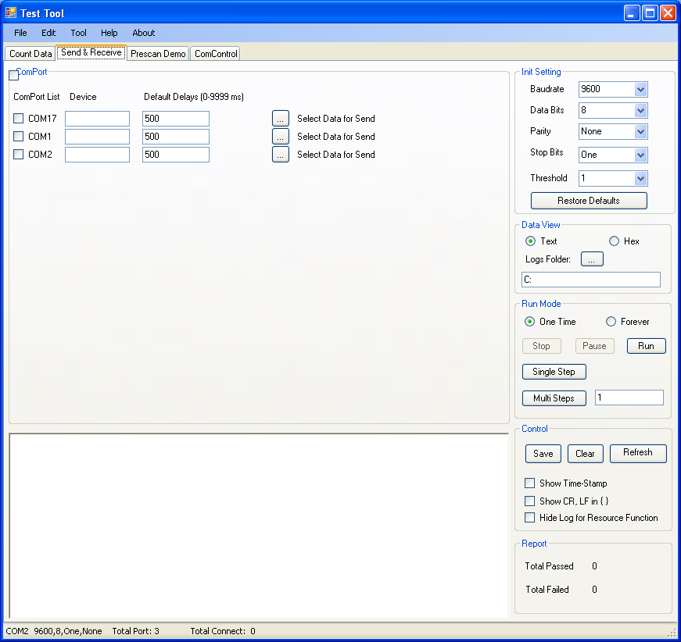
1
3
5
4
2

Details:
- Select Comport
- Put device name
- Load script file
- Select Log Folder
- Check option for Time Stamp, display Hex character (Show CR, LF in {})
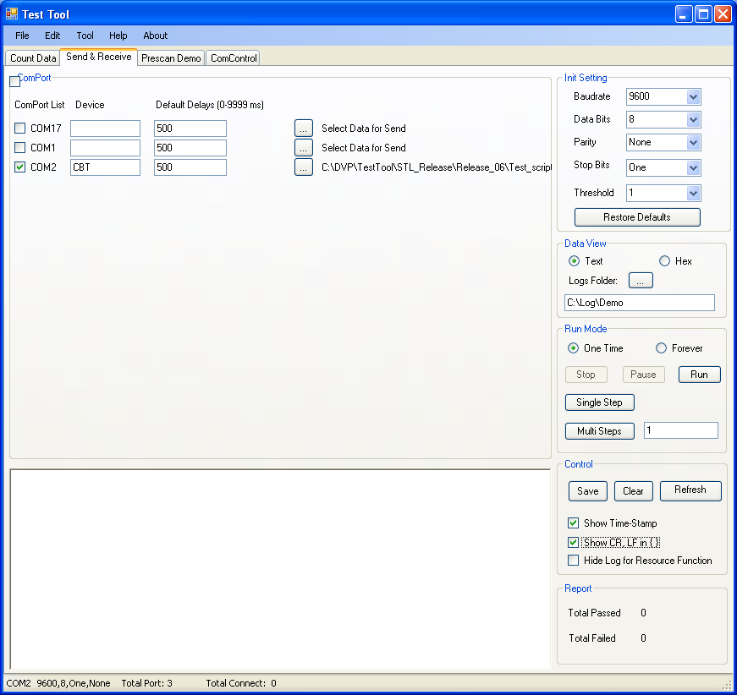
6

- Run
- Use scanner read label

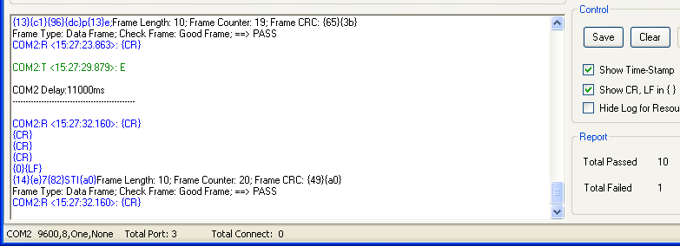
- SYNTAX & SCRIPT KEYWORD

Syntax of command:
[Prefix][Command]:[Option1]:[Option2]
We use special prefix to identify command, or resource, or data for sending:
- “$”: Resource of STL
- No Prefix: Data for sending
- “%”: Command
- “;”: Comment in script file. STL will ignore line start with “;”

  - STL Resource
For each Comport STL Support:
- Timer Store Value (TSV): STL support 6 TSVs ($T1, $T2, …, $T6). TSVs are used to store system date-time values. It useful in Measure Timing in test.
- Time Span Value (TSP): STL Support 6 TSPs ($P1, $P2, …, $P6). TSPs store spend time (delta time) when compute spend time.
- String Store Value (SSV): STL support 6 SSVs ($S1, $S2, …, $S6) . SSVs are used to store stored string data, it can be received data, message form tester.
- Send Counter: $SCT
- Receive Counter: $RCT
- Pass Counter: $PCT
- Fail Counter: $FCT

  - System Resource support
- $CST: Current system time
- $RCV: Current Receive String
- $RCT: Current Receive Time
- $TCT: Current Transmit Time

  - Script Keyword
To identify command, STL use prefix “%”

- Data for sending: No Prefix
- Use “\xHH” to send hex value
Ex:
123456 ➔ Send out data: “123456”
Abc\x30ef ➔ Send out data: “Abc0ef”
Text\x0D\x0a ➔ Send out data: “Text<CR><LF>”

- Expected Receive: %EXP:[StringExpected]
- [StringExpected]: String for expected receive
- If receive data match with expected string, report PASSED, and Pass counter increase by 1
- If receive data do not match with expected string, report FAILED, and Fail counter increase by 1.
- Special expected string character:
- “”: Expect no reply
- “R”: Use Regular Expression
- “T”: String Text

Ex:
%EXP:TDATALOGIC\x0d ➔ expect receive: “DATALOGIC<CR>”
%EXP:RA ➔ expect in receive string must have symbol : “A”
%EXP:R^a ➔ Expect start of receive string by ‘a’
%EXP: ➔ expect no Reply

- Expected Receive and Respond data: %EXP:[StringExpected]:[StringOut]
Check received before send new data.
- [StringExpected]: String for expected receive
  - If receive data match with expected string, report PASSED, Pass counter increase by 1, and send out [StringOut]
  - If receive data do not match with expected string, report FALIED, and Fail counter increase by 1.
  - [StringExpected] Prefix:
    - ‘R’: Use regular expression
    - ‘T’: Text
    - Others: Not support
- [StringOut]: Data send of if meet match with expect. I can be
  - Text
  - Action of STL:
$RTS:ON :: Force comport on RTS
$RTS:OFF :: Force comport off RTS
$DTR:ON :: Force comport on DTR
$DTR:OFF :: Force comport off DTR
$ONP :: Force COM Port
$OFF :: Force Off COM Port
$PAU :: Force Pause script
$STP :: Force Stop script
%GTO[index] :: Go to label [index]

Ex:
- %EXP:DATALOGIC:Barcode Scanner
- If receive “DATALOGIC”, Report PASSED, increase Pass Counter, and send out “Barcode Scanner” through COMPORT
- %EXP:TDatalogic:$CTS:ON
%EXP:TDATALOGIC:\x06
%EXP:R(C)$ :\x06

- If receive “Datalogic”, Report PASSED, increase Pass Counter, and turn on CTS
- If receive “DATALOGIC”, Report PASSED, increase Pass Counter, and send <ACK>
- If end of Received String is “C”, Report PASSED, increase Pass Counter, and send <ACK>
Note:
- STL only support for 6 expected receive per sending

- Wait event: %WAT:[StringWait]:[StringOut]
Check received when receiving data.
- [StringWait]: String for expected receive
  - If receive data match with expected string, report PASSED, Pass counter increase by 1, and send out [StringOut]
  - If receive data do not match with expected string, report FALIED, and Fail counter increase by 1.
  - [StringWait] Prefix:
    - ‘R’: Use regular expression
    - ‘T’: Text
    - Others: Not support
- [StringOut]: Data send of if meet match with expect. I can be
  - Text
  - Action of STL:
$RTS:ON :: Force comport on RTS
$RTS:OFF :: Force comport off RTS
$DTR:ON :: Force comport on DTR
$DTR:OFF :: Force comport off DTR
$ONP :: Force COM Port
$OFF :: Force Off COM Port
$PAU :: Force Pause script
$STP :: Force Stop script
%GTO[index] :: Go to label [index]

- Delay Command: %DLY: [xxx]:[subfix]
  - [xxx]: delay value
  - [subfix] : No subfix is delay in millisecond
“ms”: Delay in millisecond. It is default scale
“s”: Delay in second
“m”: Delay in minutes
Ex:
%DLY:100: ➔ Delay 100ms
%DLY:50:s ➔ Delay 50 second
%DLY:5:m ➔ Delay 5 minute
%DLY:100-200:s ➔ Delay with random [100:200] second
%DLY ➔ Delay with default delay (Set by GUI)
Note: Delay command do not support for zero delay. We do not support: %DLY:0
- COM PORT Change configure: %COM:[SUBCMD]:[VALUE]
When start application, All Comport will get default configuration. Default configuration can change by GUI.
In Script file, Tester can change configure of Com Port.

 | SUBCMD | VALUE
ON/OFF PORT | "ONP" | ""
ON/OFF PORT | "OFF" | ""
Baud rate | "BAD" | "9600"
Baud rate | "BAD" | "19200"
Baud rate | "BAD" | "38400"
Baud rate | "BAD" | "57600"
Baud rate | "BAD" | "115200"
Data bits | "DAT" | "5"
Data bits | "DAT" | "6"
Data bits | "DAT" | "7"
Data bits | "DAT" | "8"
Stop bit | "STP" | "One"
Stop bit | "STP" | "OnePointFive"
Stop bit | "STP" | "Two"
Parity | "PAR" | "None"
Parity | "PAR" | "Even"
Parity | "PAR" | "Odd"
Parity | "PAR" | "Mark"
Parity | "PAR" | "Space"

Ex:
%COM:OFF ➔ Close COM PORT
%COM:ONP ➔ Open COM PORT
%COM:BAD:38400 ➔ Change Baud rate of COM port to 38400
%COM: DAT:7 ➔ Change Data bit to 7

- Store Time Value: %STR:[TSV]:[Value]
[TSV]: Time Store Value ($T1, $T2, …, $T6)
[Value]: Can be
- Other TSV
- Current System Time ($CST)
- Current Receive Time ($RCT)
- Current Transmit Time ($TCT)
Ex:
%STR:$T1:$CST ➔ Store Current System Time to T1
%STR:$T2:$T3 ➔ Copy T3 → T2
%STR:$T6:$RCT ➔ Store last receive time to T6
%STR:$T4:$TCT ➔ Store last transmit time to T4
- Store String: %SST:[SSV]:[Value]
[SSV]: String Store Value ($S1, $S2, …, $S6)
[Value]: Can be
- Normal String
- Received String: $RCV
- Other SSV
Ex:
%SST: $S1:DATALOGIC ➔ Store “DATALOGIC” into S1
%SST: $S2:$RCV ➔ Store receive string into S2
%SST: $S5:$S6 ➔ Copy S6 → S5

- Concatenate String: %CAT:[SSV]:[Value]
[SSV]: String Store Value ($S1, $S2, …, $S6)
[Value]: String Concatenate can be
- Normal String
- Received String: $RCV
- Other SSV
Ex:
  - Value Stored in S1 is “DATALOGIC”
%CAT: $S1:BARCODE
➔ S1 = “DATALOGICBARCODE”
  - Value Stored in S2 is “PScan”; Received string is “ 16Key”
%CAT: $S2:$RCV
➔ S2 = “PScan 16Key”

  - Value of: S6 = “HHS”; S5 = “&FS”
%CAT: $S5:$S6
➔ S5 = “HHS&FS”

- Compute delta time: %DTA:[TSP(1)]:[TSV(1)]:[TSV(2)]
TSP(1) = TSV(1) – TSV(2)

Ex:
%DTA:$P1:$T2:$T6 ➔ TSP[1] = TSV[2] – TSV[6]

- Print String to Log File: %PRN:[Value]:[Option]
[String]: Can be
- Normal string
- SSV ($S1, $S2, …, $S6)
- Received string: $RCV
- Time Store Value: ($T1, $T2, …, $T6)
[Option]: Can be
  - “F”: Full Date and Time with format: dd/mm/yy-hh:mm:ss.ms
  - “D”: Date only with format: dd/mm/yy
  - “T”: Time only with format: hh:mm:ss.ms
- Time Span Time: ($P1, $P2, …, $P6)
Ex:
      - S1 = “Barcode”; Received String = “Label”
%PRT:DATALOGIC\x0d ➔ Print to log file: “DATALOGIC<CR>”
%PRT:$S1 ➔ Print to log file: “Barcode”
%PRT:$RCV ➔ Print to log file: “Label”

      - TSV[1] = 22/11/2011 15h30’45’’030
%PRT:$T1: F ➔ 22/11/2011-15:30:45.030
%PRT:$T1: D ➔ 22/11/2011
%PRT:$T1: T ➔ 15:30:45.030

      - TSP[1]= 3h20’15’’670
%PRT:$P1 ➔ 3:20:15.670

- Report Pass Fail: %RPT
This function will print report Total Pass & Total Fail

- Load Barcode Picture: %PIC:[Barcode]
[Barcode]: Can be
- Image file path with syntax: $[Path]
- Barcode content with syntax:
[Barcode Type]:[Resolution]:[Label Content]
-------- This feature will be descript more detail later ---------

- Goto Function: %LBL[index], and %GTO[index]
% LBL[index]: Inform Label of go to
%GTO[index]: Go to Label
STL Support 6 Label for Goto function. So index value much in range: [1:6]

- Check Frame: %ECF, %DCF, %RCN
Frame Format:
Preamble  4*<CR> | LEN  2 bytes | COUNTER  1 byte | PAY LOAD | CRC  2 bytes | EOF  <CR>

- Preamble: use for Start of Frame with 4 character <CR>
- Len: length of frame, include counter, payload, CRC.
- Counter (0→ 255): Start with 0 and increase by one for good frame. If counter lost sequence, report “Fail” for check fame
- CRC: 16 Bit CRC - The 16-bit CRC is first initialized to zero, every bytes is added to the CRC using the CCITT Standard Polynomial X**16+X**12+X**5+1, the CRC location is not included in the CRC calculation. (Use CRC on Museo Gun for CM)
- %ECF: enable Check Frame
- %DCF: Disable Check Frame
- %RCN: Reset Expect Counter

- BLOCK REQUIREMENT
STL will read and run script file block by block. Each block of STL script can be start by any command by need end by “%DLY” command.
Ex:
- Simple block

; Start of Block ➔ Comment on code, STL will ignore this line
DATALOGIC\x0d ➔ send out: “DATALOGIC<CR>”
%DLY:100: ➔ Delay 100ms
; End of block

- Full Block

; Start of Block 1 ➔ Comment on code, STL will ignore this line
%COM:BAD:38400 ➔ change configure COMPORT
DATALOGIC\x0d ➔ send out: “DATALOGIC<CR>”, expect “abc”
%DLY:100: ➔ Delay 100ms
; End of block

; Start of Block 2 ➔ Comment on code, STL will ignore this line
DATALOGIC\x0d ➔ send out: “DATALOGIC<CR>”, expect “abc”
%COM:BAD:38400 ➔ change configure COMPORT
%DLY:100: ➔ Delay 100ms
; End of block 2

Note: We not recommend Tester use syntax of block 2. Because the result of this 2 block is the same. But 2nd block make Tester confuse: “After transmit data, STL change comport.” But It not correct. STL Change comport before send out data.

- Single line block

; Start of Block 3 ➔ Comment on code, STL will ignore this line
%DLY:100: ➔ Delay 100ms
; End of block 3

Note: Block 3 mean: wait and capture all receive data in 100ms

- RUN MODE:
STL can support 2 run mode:

Manual: STL will run Block by blog with Button in GUI. In this mode, Delay command does not take affects.

Auto Run: STL will auto load and run script.
- In this mode, Tester can reset to return to the first block
- This tool also support for Pause, Step, Run, …

- LOG FILE FORMAT

File Name:
Device:
Default setting:
===========[ S E R I A L T E S T T O O L L O G ] ===========

===========[ S E R I A L T E S T T O O L R E P O R T ] ===========

Start time:
Stop Time:
Duration:
Total Pass:
Total Fail:

