CAMARINES SUR POLYTECHNIC COLLEGES
COLLEGE OF COMPUTER STUDIES
CCCS 106: Application Development and Emerging Technologies (AY 2026-2027)
--------------------------------------------------
LABORATORY TASK REPORT 01
Environment Isolation, Modern Flet GUI & Collaborative 3-Developer Git Workflow
Group Designation: | Group No. 10
Date of Submission: | September 09, 2026
Course Instructor: | Engr. Allan Ibo Jr. | CSPC College of Computer Studies

TEAM TRIAD MEMBERS & TECHNICAL ROLES
Student Full Name | Student ID | GitHub Username | Assigned Triad Role & Branch
Antoinitte E. Hernandez | 2024-2412208 | @antheaa-ipynb | Developer 1 (Lead UI)  feature/dev1-profile
Lai Pauline T. Catangui | 2024-2410990 | @lacatangui-max | Developer 2 (State Logic)  feature/dev2-state
Thea Ann S. Pacer | 2024-XXXXX | @dev3-username | Developer 3 (QA & Milestone)  feature/dev3-features

Section 1: GitHub Repository & Collaborator Proof
Public GitHub Repository URL:
https://github.com/antheaa-ipynb/cccs106-group10-showcase
Github Settings> Collaborators confirming that @antheaa-ipynb has successfully added @lacatangui and @TEAHyung as collaborators.
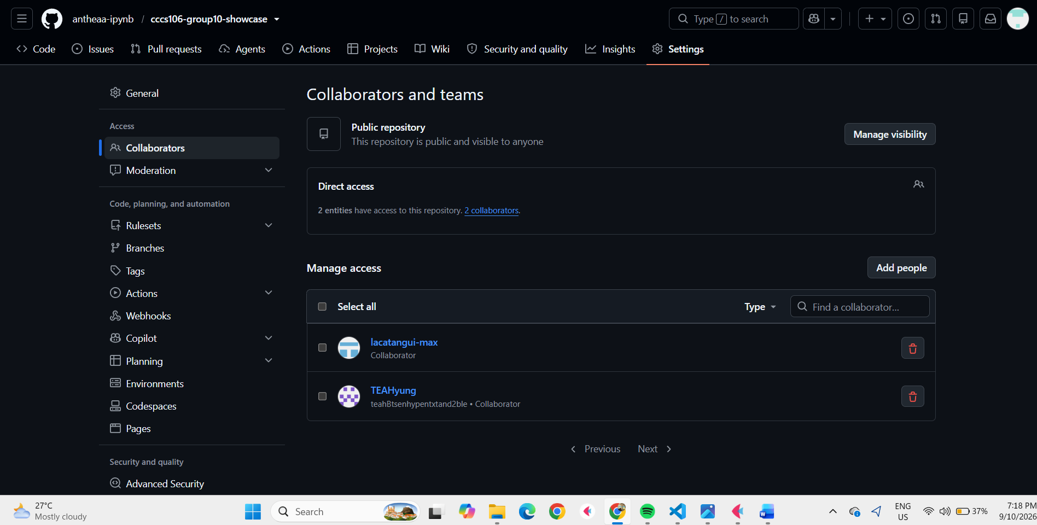
Reference: GitHub Collaborators Verification (Settings > Collaborators).
Figure 1: GitHub Collaborators Verification (Settings > Collaborators)

Section 2: Automated Pre-Flight Diagnostics Audit
Environment audit (verify_setup.py) confirming that all 6 setup checks passed in the virtual environment.

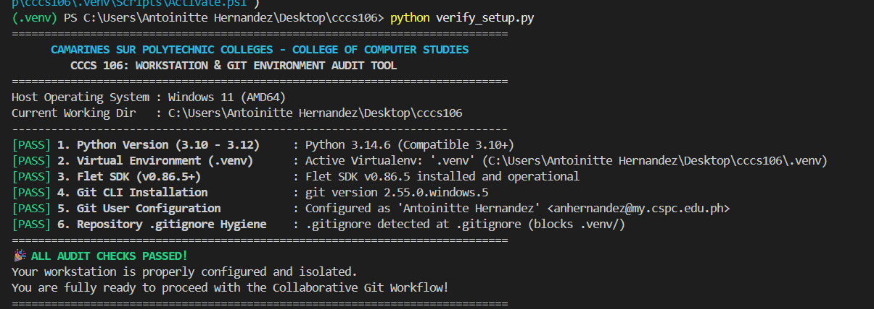
Reference: Pre-flight Environment Diagnostics Audit (verify_setup.py)
Figure 2: Pre-flight Environment Diagnostics Audit (verify_setup.py)

Section 3: Git Working Tree Cleanliness & .gitignore Audit
The Terminal output shows, verifying a clean Git status and proper exclusion of the .venv folder.
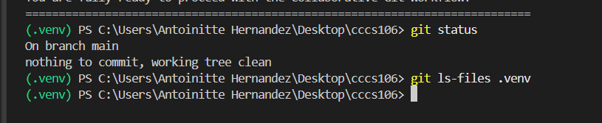Reference: Git Working Tree Cleanliness & .gitignore Hygiene Proof
Figure 3: Git Working Tree Cleanliness & .gitignore Hygiene Proof

Section 4: Running Flet v0.86.5 Application Showcase
Initial launch of the Flet desktop app showing the devs, isolated environment badge, and task counter set to 0 and the dark mode is not yet on.

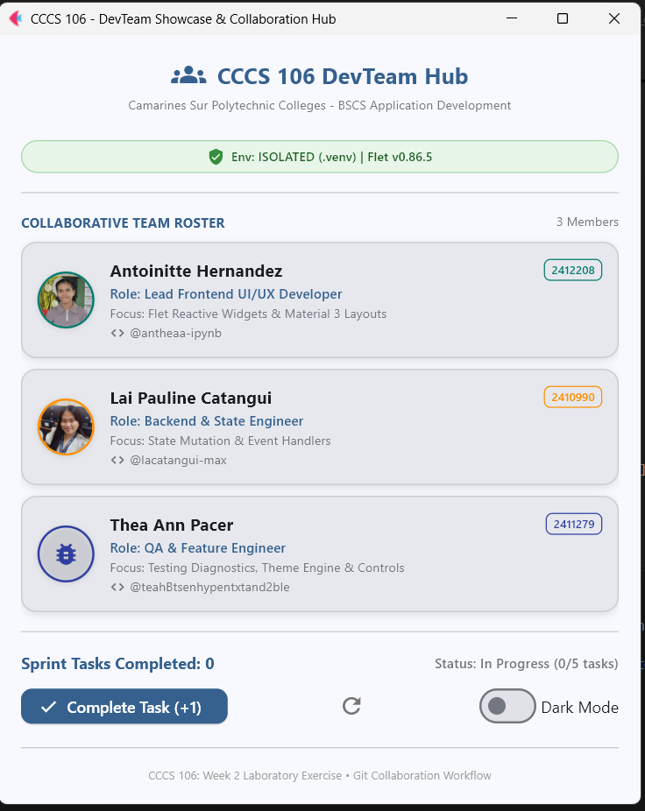
Reference: Application Initial Launch State
Figure 4: Application Initial Launch State

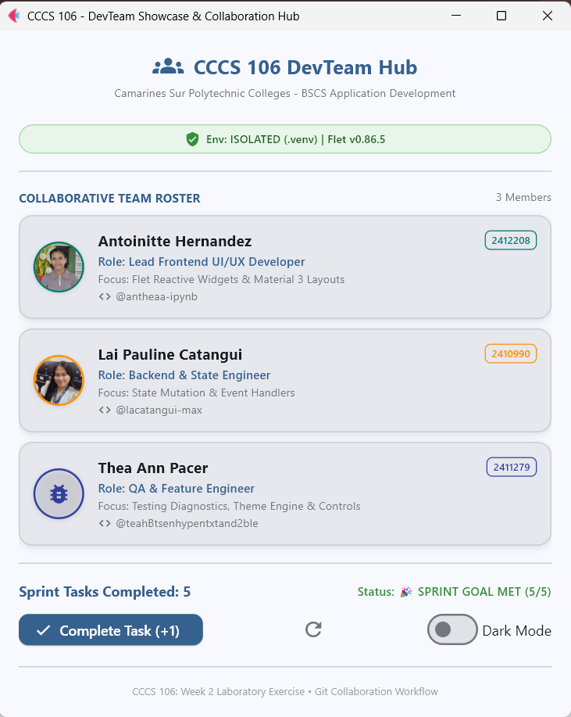
Reference: Sprint Goal Milestone Reached State
The App window showing the 5/5 sprint goal met and a complete task button disable
Figure 5: Sprint Goal Milestone Reached State
The application is running in dark theme mode.
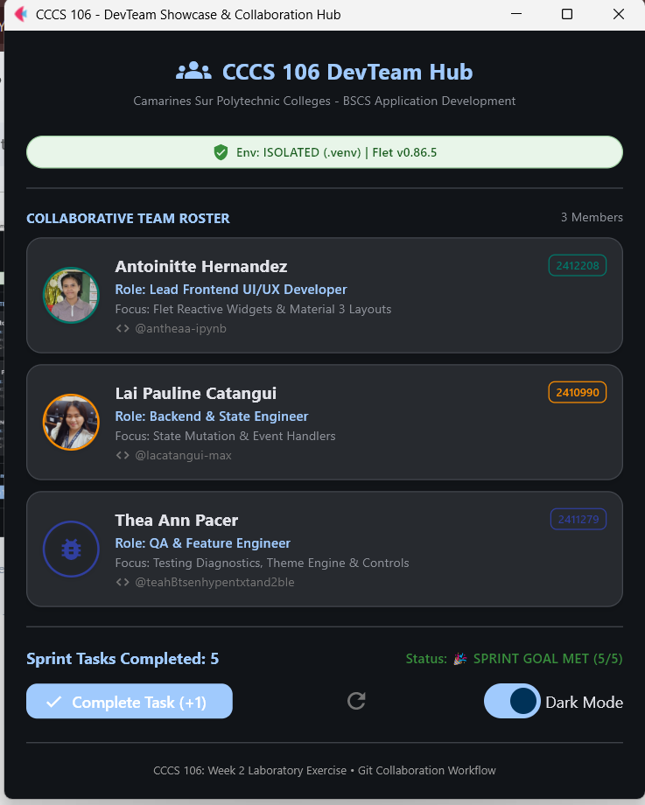
Reference: Material 3 Dark Mode Theme Toggle State
Figure 6: Material 3 Dark Mode Theme Toggle State

Section 5: Triad Contribution Matrix & Learning Reflections
Summary of individual contributions and commit accountability across all three triad developers.
Member Name | Role | Branch Name | Commit SHA | Specific Engineering Contributions
Antoinitte E. Hernandez | Developer 1  (Lead UI) | feature/dev1-profile | 64e9733 | Initialized repo, setup .gitignore, integrated card 1, configured remote repo & pushed main.
Lai Pauline T. Catangui | Developer 2  (State Logic) | feature/dev2-state | 2b43c92 | Synced main, integrated card 2, connected increment/reset event handlers, merged & pushed.
Thea Ann S. Pacer | Developer 3  (QA/Feature) | feature/dev3-features | 4df0b97 | Synced main, integrated card 3, built milestone badge logic & boundary constraints, merged & pushed.

Individual Technical Reflections
Developer 1 (Lead UI & Repo Architect):
While doing this activity I've learned many things in terms of creating repositories and using git commands. The moment I start doing the git commands specially git fetch origin to get all the updates that we do in our github repositories I feel amazed, git push to push all the changes you did in the code and git pull to pull what the other developer did. I also learned that using local . venv is important because it makes the app protected.
Developer 2 (State & Event Logic Engineer):
As the State & Event Logic Engineer, I learned how to clone and work with a remote GitHub repository while keeping my local branch updated with the latest changes from the team. I learned how to use git pull origin main to synchronize upstream changes before continuing my work, which helped prevent conflicts when integrating my changes. I also learned how to implement reactive event handlers in Flet, particularly for the increment and reset functions, so that the application responds correctly to user interactions. Through this activity, I gained a better understanding of feature branching, collaboration, and safely merging my changes into the main project.
Developer 3 (QA & Sprint Goal Feature Engineer):
As the QA & Sprint Goal Feature Engineer, I learned how feature branching allows me to work on specific features without directly affecting the main branch. I also learned the importance of enforcing state boundary constraints to make sure the application behaves correctly when the sprint goal reaches its limit. While testing the application, I gained experience in checking Material 3 controls in Flet and making sure they responded properly to user interactions. This activity helped me understand how testing, feature development, and Git collaboration work together to create a more reliable application.

Appendix: Verbatim Git Commit Tree Log
Verbatim ASCII commit history exported using 'git log --oneline --graph --all > git_log_proof.txt'. This demonstrates the complete sequential feature branching and merge timeline across all three developers.
* 4b67279 (HEAD -> main, origin/main, origin/HEAD) Merge pull request #2 from antheaa-ipynb/feature/dev3-state
|\
| * 4df0b97 (origin/feature/dev3-state) feat(state): integrate developer 3 profile
|/
* 346cc25 Merge pull request #1 from antheaa-ipynb/feature/dev2-state
|\
| * a4fb28b (origin/feature/dev2-state) merge: integrate main with dev2 state
| |\
| |/
:
* 4b67279 (HEAD -> main, origin/main, origin/HEAD) Merge pull request #2 from antheaa-ipynb/feature/dev3-state
|\
| * 4df0b97 (origin/feature/dev3-state) feat(state): integrate developer 3 profile
|/
* 346cc25 Merge pull request #1 from antheaa-ipynb/feature/dev2-state
|\
| * a4fb28b (origin/feature/dev2-state) merge: integrate main with dev2 state
| |\
| |/
|/|
* | 64e9733 feat(profile): integrate developer 1 profile card
* | c15b8b5 chore(init): baseline repository with modern flet app and verification tool
/
* 2b43c92 feat(state): integrate developer 2 profile and task counter handlers
| * ce9277e (origin/feature/dev1-profile, feature/dev1-profile) Update main.py entry point
| * c10db7e feat(profile): integrate developer 1 profile card
| * cc27caf Update main.py entry point and Dev 1 profile details
| * 93d9508 add requirements and verify setup script
| * 604aa18 chore(init): add .gitignore file
|/
* 8bbf08e add requirements and verify setup script
* d778312 chore(init): baseline repository with modern flet app and verification tool

