**TÓM TẮT CÁC BÀI TẬP ĐÃ LÀM**

Ngày: 17/08/2025

Tên: Nguyễn Thế An

MS:MSE33019

Lớp:MSE21

GIT: <https://github.com/anthenguyen9/MLOPS/tree/main/ASS>

|  |  |  |
| --- | --- | --- |
| Tên đề | Private score: | Score |
| House Prices | AECinCode | 0.19237 | 0.14389 |
| MNIST Dataset - Number Classification | 0.99128 | 0.98983 |
| NLP - Sentiment Analysis - XM | 0.97000 | 0.98500 |
| Build a Bitcoin prediction model and win a prize | 0.75418 |  |

**Bài 2:** **House Prices | AECinCode**

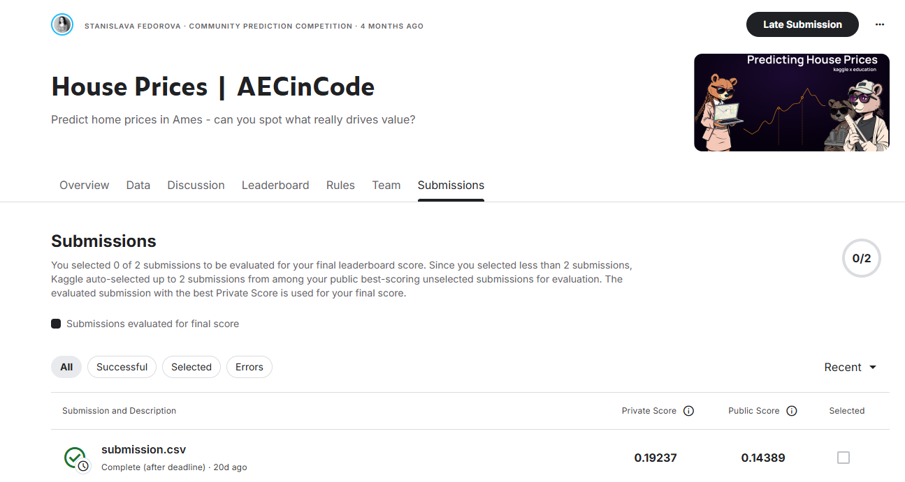

**Bài 3: MNIST Dataset - Number Classification**

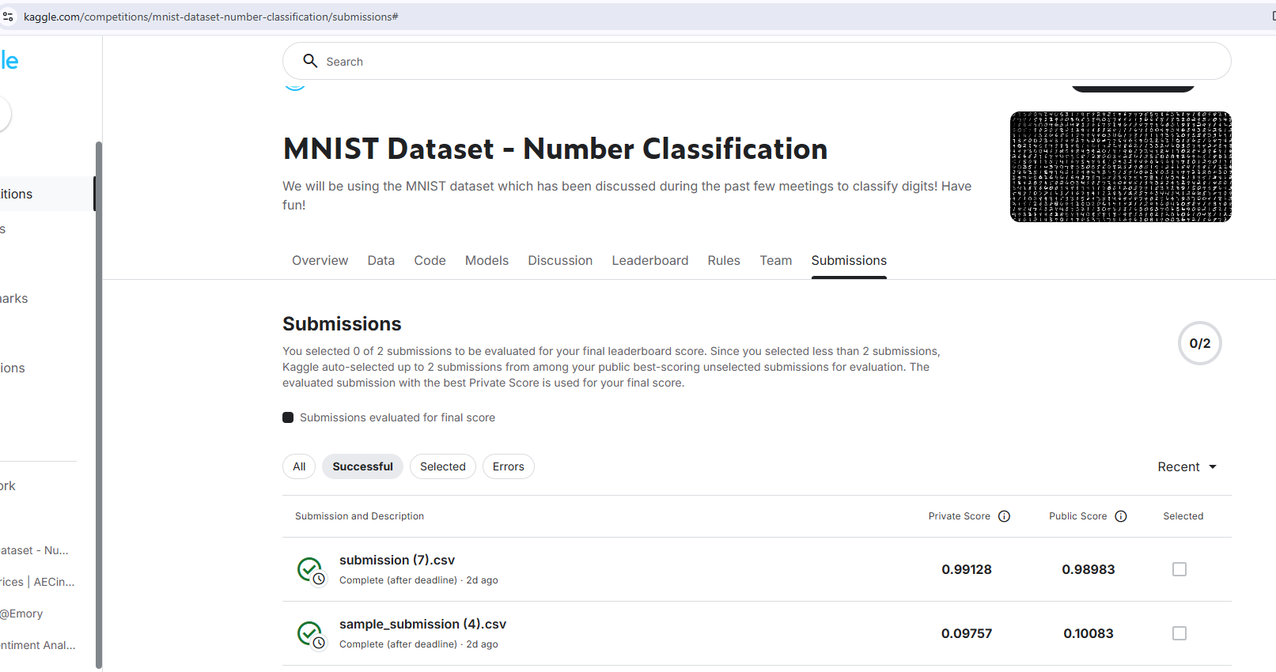

**Bài 4: NLP - Sentiment Analysis - XM**

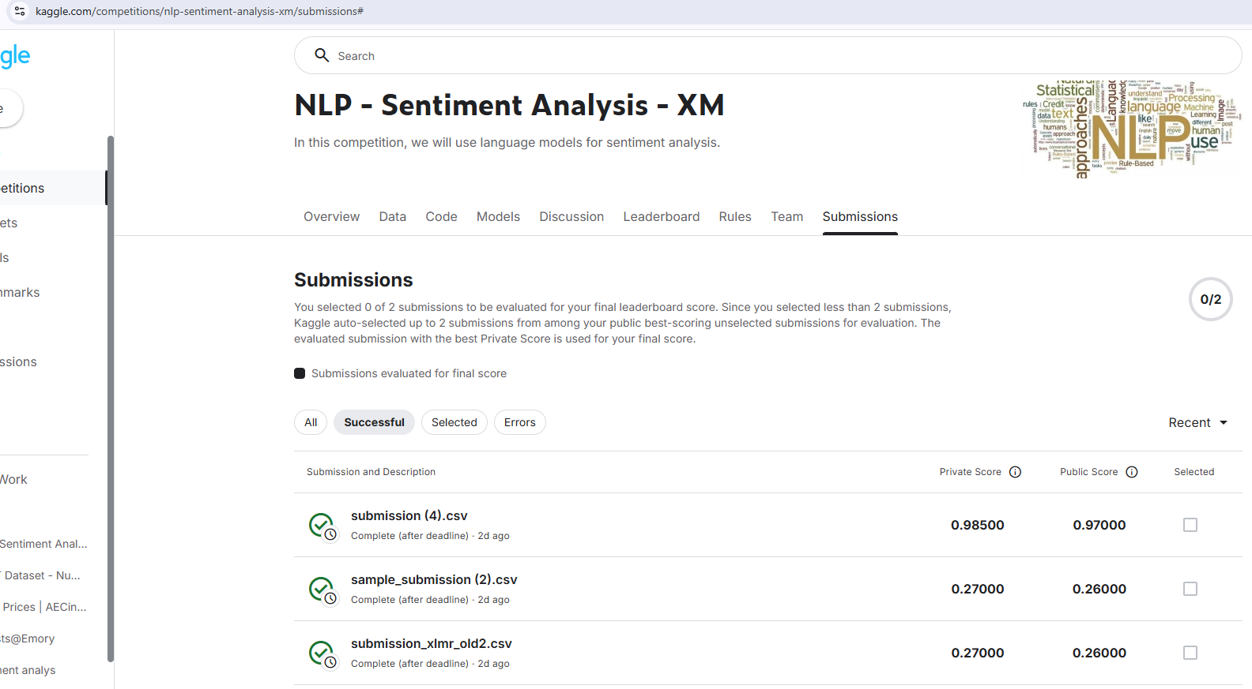

**Bài 5: Build a Bitcoin prediction model and win a prize**

