# 





**Sweet Peach Reading**

**Documentation**

|  |  |
| --- | --- |
| **Authors** | **C2109L _Group 5** |
| **Nguyen Van Hieu (Leader)**  **Le Thu Phuong**  **An Thi Chau Giang**  **Tran Duc Manh** |
| **Date** | **16/04/2024** |
| **Instructor** | **Nguyen Duc Hoang** |

Hanoi, April 2024

**Acknowledgement**

Our e-Project 4 needs assistance to be done and we, the authors, would like to give our acknowledgement to those who have supported and motivated us during the period of implementing this e-Project 4.

First and foremost, we would like to thank our instructor Mr. **Nguyen Duc Hoang** whose support and useful advices helping us to complete our e-Project 4 effectively. His encouragement and comments had dramatically enriched and improved our work.

Secondly, we would like to thank Aprotrain - Aptech Computer Education, teachers, and staffs for their support throughout our learning and completing this e-Project 4.

Thirdly, we would like to thank our families’ members including our parents, spouses and siblings for their support and care all the time, especially in the period of completing our work.

Lastly, our deep thanks come to all our classmates during studying time in Aptech. Their kind help, care, and motivation help us conquer the higher targets in the future.

**Index**

1. Problem Definition 4

1.1. Problem Abstraction 4

1.2. The Current System 4

1.3. The Proposed System 4

1.3.1. Boundaries of the System 5

1.3.2. Hardware and Software Requirements 5

2. Requirements Specification 5

2.1. Users of the System 5

2.2. System functions 5

3. System Designs 7

3.1. Entity Relationship Diagram 7

3.2. Database Design 7

4. Task sheet 23

# Problem Definition

## Problem Abstraction

When human demand is increasing, they have more and more creative ideas to meet their own needs. That is the reason why Information Technology was born and developed at such as high level. We cannot deny the enormous benefits that Information Technology has brought for our life. IT is a modern invention that reaches the top of the human world and it becomes an indispensable friend in each of us.

The story reading application is convenient, diverse in content, saves time and costs compared to paper books, creating a more flexible and interactive reading experience for users.

## The Current System

Story reading apps continue to thrive, offering diverse content, accessibility, flexible options, interactivity, and regular updates to meet the evolving needs of readers.

## The Proposed System

* System name: Sweet Peach Reading
* The status of story reading apps is characterized by:
* Diverse Content: These apps provide a wide range of genres and stories, catering to various reading preferences.
* Multi-platform Availability: They are accessible across different platforms, including mobile devices (Android, iOS), tablets, and web browsers, ensuring convenience for users.
* High Interactivity: Features such as commenting, rating stories enhance user engagement and community interaction.
* Regular Updates: Story reading apps frequently update their content to keep users engaged with fresh stories and new releases.

## Boundaries of the System

Unlimited, anyone from any age group and cultural background can use story reading apps.

## Hardware and Software Requirements

* Hardware:
* Mobile devices: Such as smartphones, tablets, e-readers like Kindle.
* Personal computers: Used to access story reading apps through web browsers or desktop applications.
* Software:
* Intellij IDEA Ultimate version 2023 or higher
* Android Studio version 2023 or higher.

# Requirements Specification

## Users of the System

Users of the system incluce:

* Readers
* Admin

## System functions

* For readers:
* 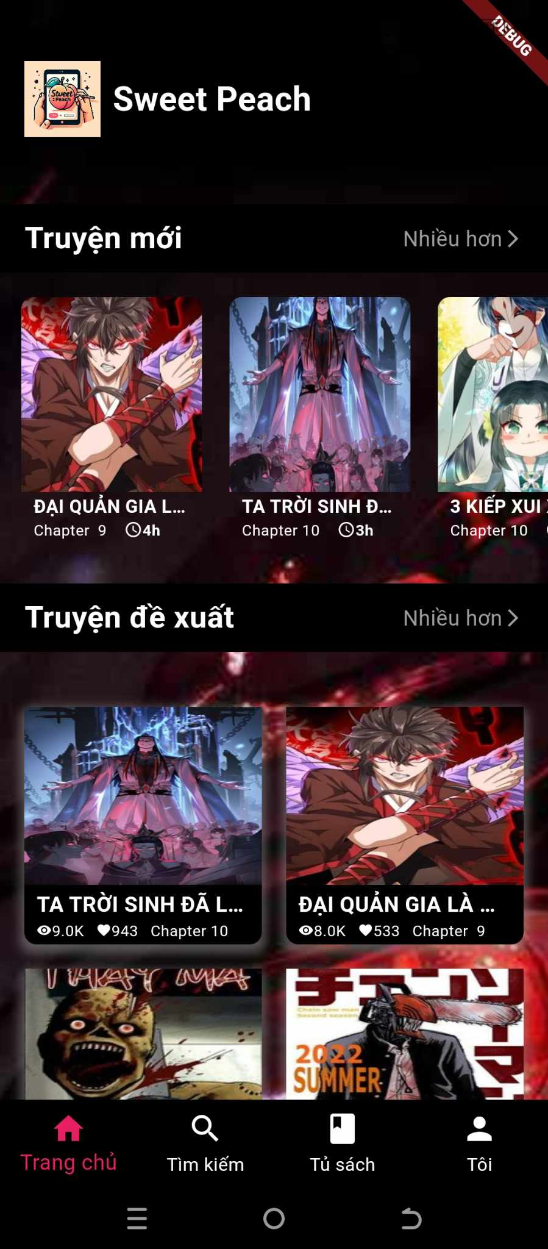When accessing the app, they don't need to log in but can still use most of the app's functions.
* At the homepage, newly updated stories will appear first.
* Next will be suggested stories, sorted based on their view and follow counts.

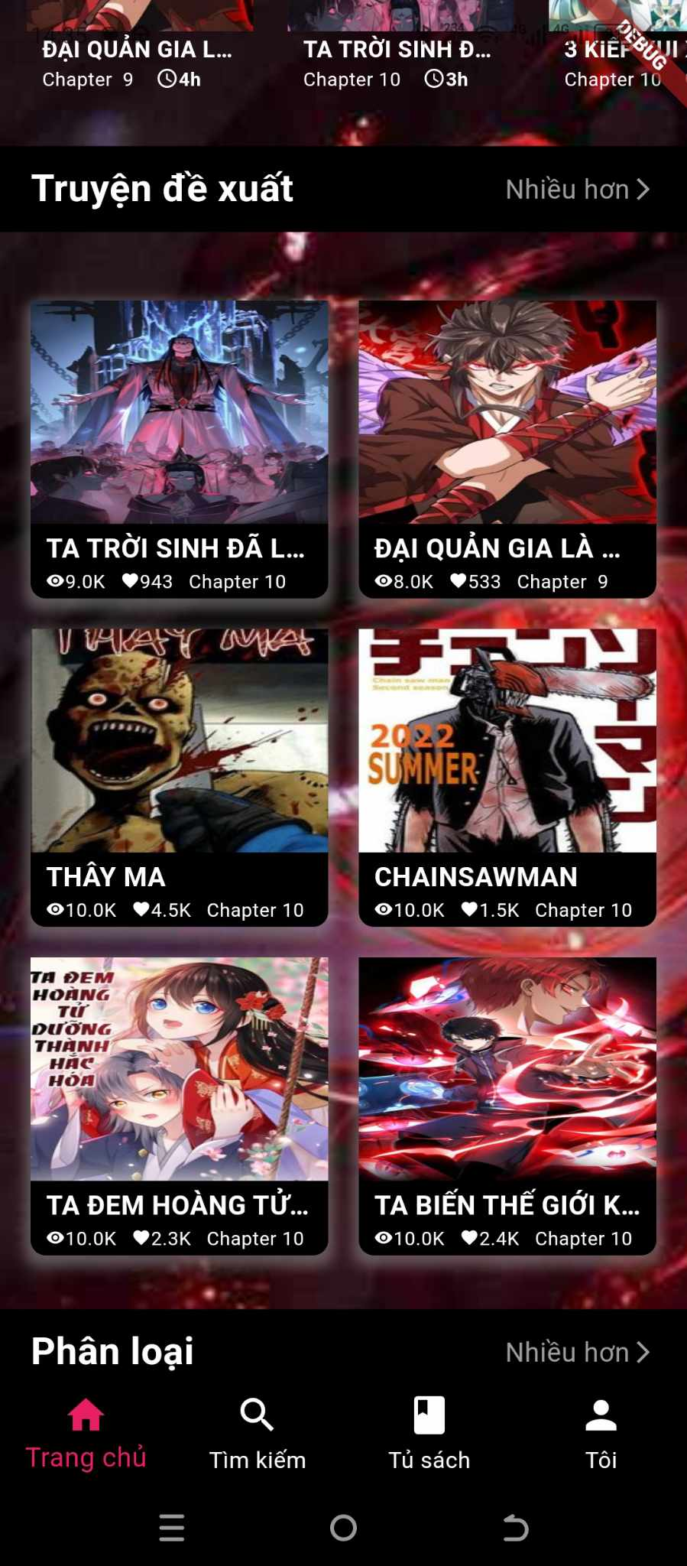

* 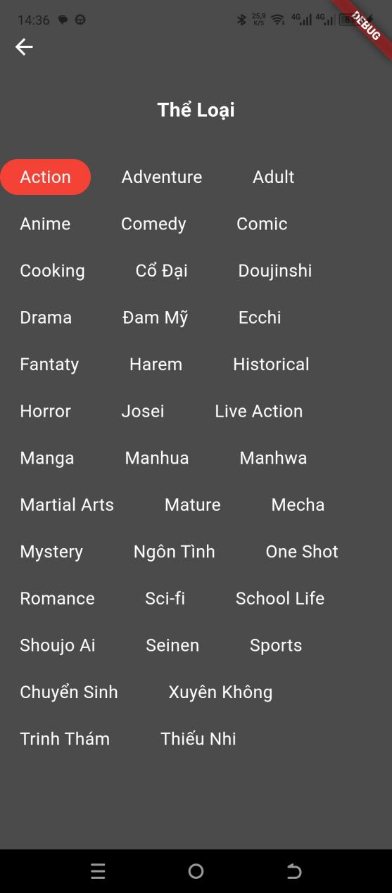Below is the section of suggested genres, where readers can click for details to reveal all genres.

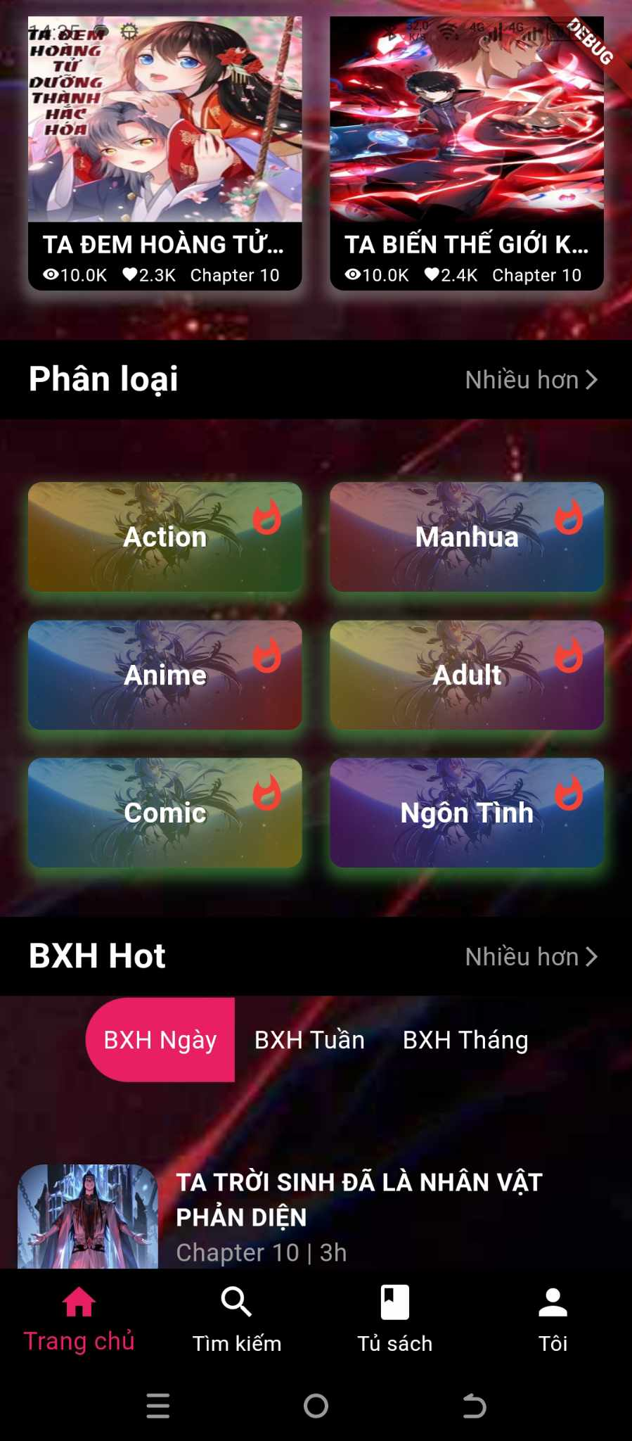

* At the bottom of the homepage is a ranking board of the most-read stories, updated daily, weekly and mothly.
* 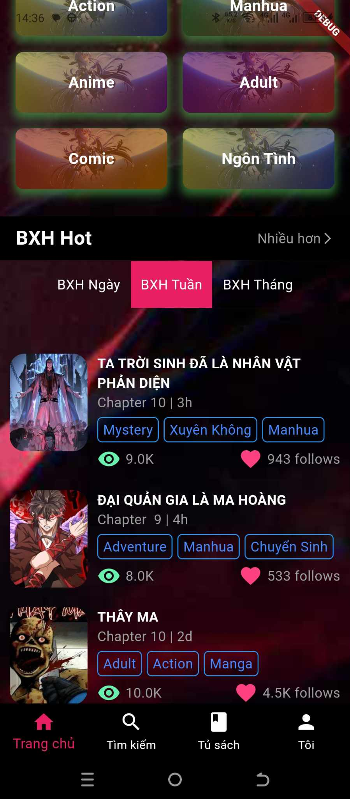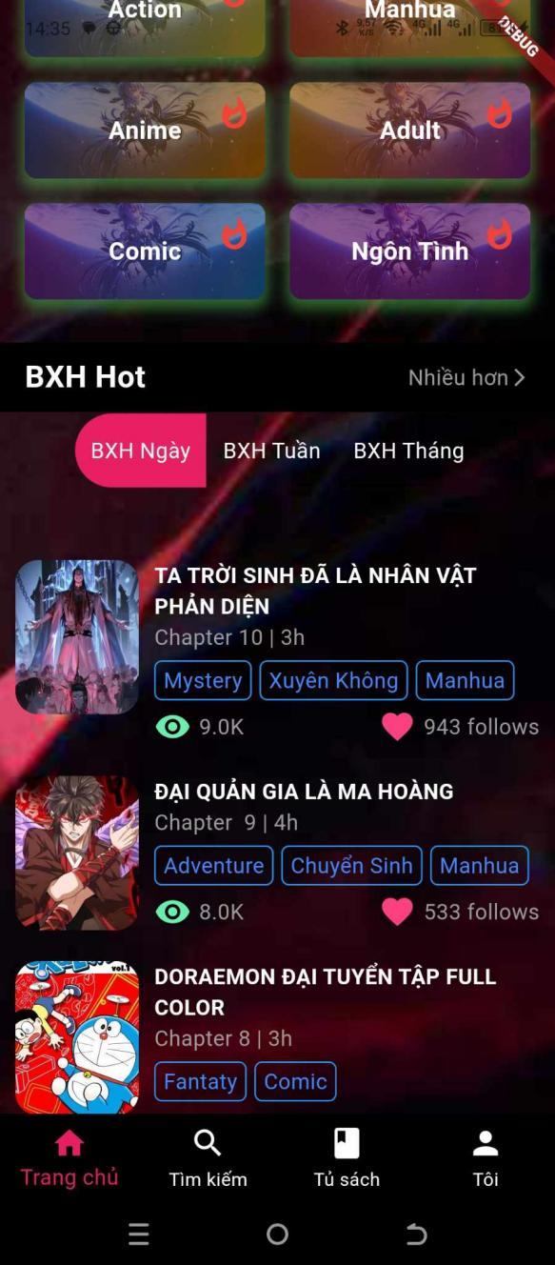With the search function, readers can search for stories based on their titles, or the app suggests searching based on the status of the story, whether it's ongoing or completed.



# 

* When clicking on a story, the story details will be displayed, allowing readers to read the story.



* However, if readers want to view their reading history, follow a favorite story or comment on a story, they need to log in to their account.



* The login/signup method is quite simple, allowing readers to easily do so.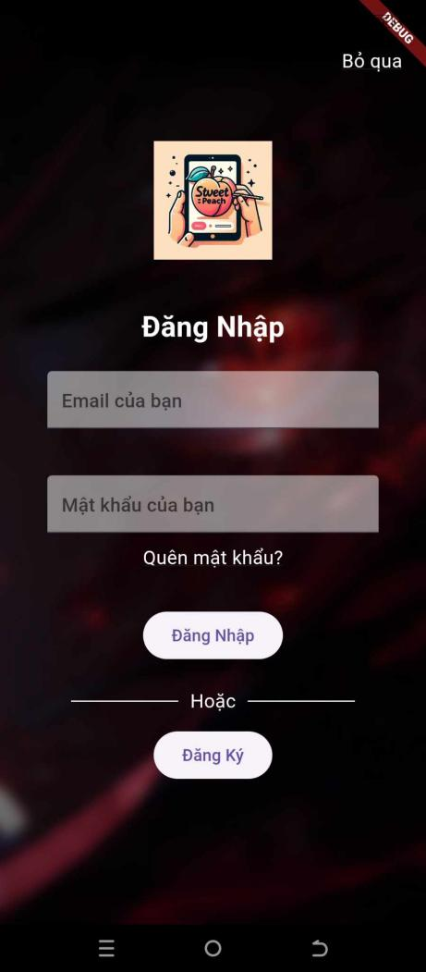
* 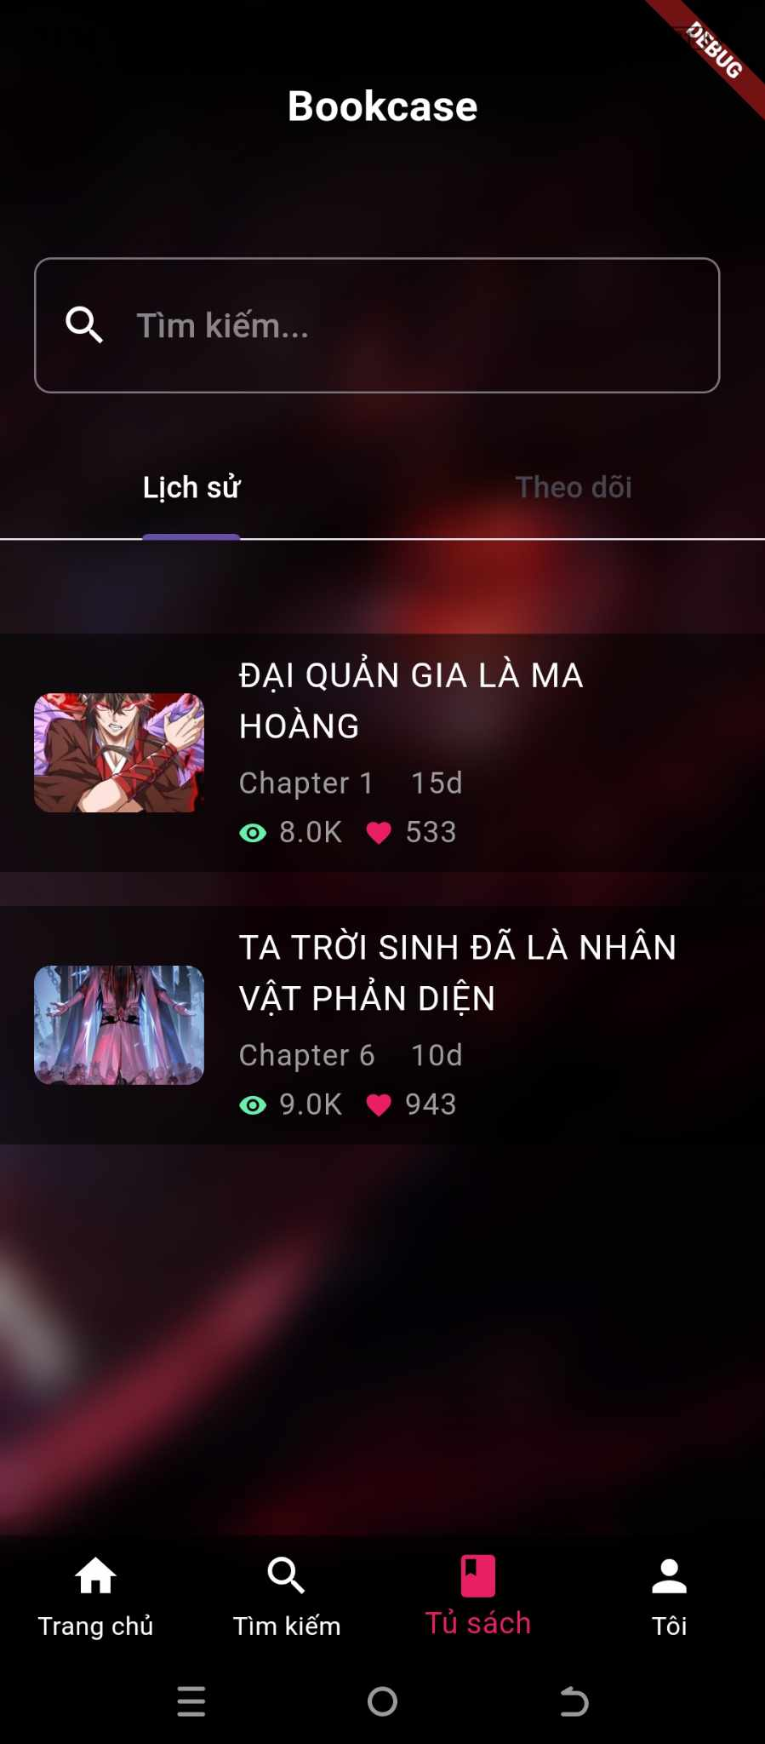After logging in, readers can view their reading history, follow stories...

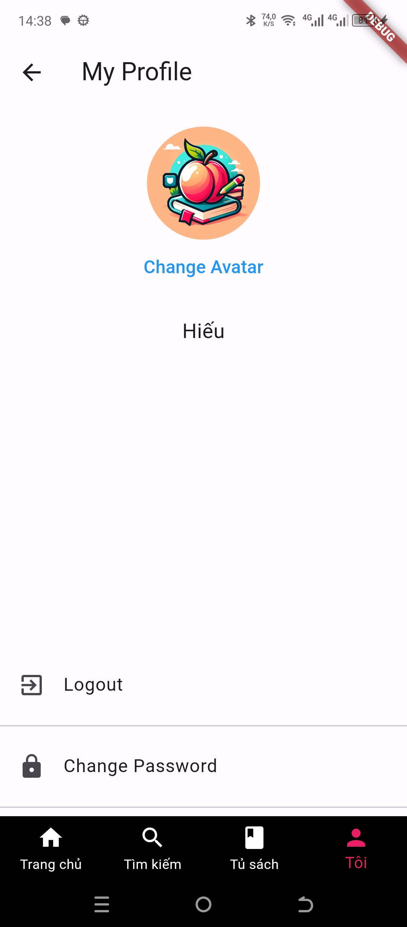

* During app usage, readers can change their profile image and password.
* For admin:
* Admin manages, adds new, and updates story collections.
* When users who haven't logged in read stories, their reading history will be saved to local storage and then sent as a request to the server. The server will respond with a corresponding display format for the reading history. If they are logged in, it will be saved directly to the database.

# System Designs

## Entity Relationship Diagram

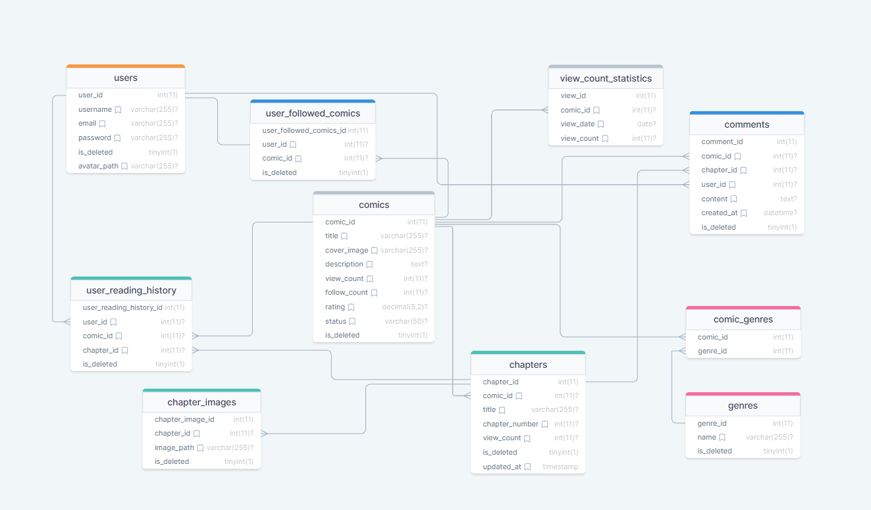

## Database Design

CHAPTERS

|  |  |  |
| --- | --- | --- |
| **Properties** | **Datatypes** | **Key** |
| chapter_id | int | Primary key |
| comic_id | int | Foreign key |
| title | varchar |  |
| chapter_number | int |  |
| view_count | int |  |
| is_deleted | tinyint |  |
| updated_at | timestamp |  |

CHAPTER_IMAGES

|  |  |  |
| --- | --- | --- |
| **Properties** | **Datatypes** | **Key** |
| chapter_image_id | int | Primary key |
| chapter_id | int | Foreign key |
| image_path | varchar |  |
| is_deleted | tinyint |  |

COMICS

|  |  |  |
| --- | --- | --- |
| **Properties** | **Datatypes** | **Key** |
| comic_id | int | Primary key |
| tiltle | varchar |  |
| cover_image | varchar |  |
| description | text |  |
| view_count | int |  |
| follow_count | int |  |
| rating | decimal |  |
| status | varchar |  |
| is_deleted | tinyint |  |

COMIC_GENRES

|  |  |  |
| --- | --- | --- |
| **Properties** | **Datatypes** | **Key** |
| comic_id | int | Foreign key |
| genre_id | int | Foreign key |

COMMENTS

|  |  |  |
| --- | --- | --- |
| **Properties** | **Datatypes** | **Key** |
| comment_id | int | Primary key |
| comic_id | int | Foreign key |
| chapter_id | int | Foreign key |
| user_id | int | Foreign key |
| content | text |  |
| created_at | timestamp |  |
| is_deleted | tinyint |  |

GENRE

|  |  |  |
| --- | --- | --- |
| **Properties** | **Datatypes** | **Key** |
| genre_id | int | Primary key |
| name | varchar |  |
| is_deleted | tinyint |  |

USERS

|  |  |  |
| --- | --- | --- |
| **Properties** | **Datatypes** | **Key** |
| user_id | int | Primary key |
| username | varchar |  |
| email | varchar |  |
| password | varchar |  |
| avatar_path | varchar |  |
| is_deleted | tinyint |  |

USER_FOLLOWED_COMICS

|  |  |  |
| --- | --- | --- |
| **Properties** | **Datatypes** | **Key** |
| user_followed_comics_id | int | Primary key |
| user_id | int | Foreign key |
| comic_id | int | Foreign key |
| is_deleted | tinyint |  |

USER_READING_HISTORY

|  |  |  |
| --- | --- | --- |
| **Properties** | **Datatypes** | **Key** |
| user_reading_history_id | int | Primary key |
| user_id | int | Foreign key |
| comic_id | int | Foreign key |
| chapter_id | int | Foreign key |
| is_deleted | tinyint |  |

VIEW_COUNT_STATISTICS

|  |  |  |
| --- | --- | --- |
| **Properties** | **Datatypes** | **Key** |
| view_id | int | Primary key |
| comic_id | int | Foreign key |
| view_date | date |  |
| view_count | int |  |

# Task sheet

|  |  |  |  |  |
| --- | --- | --- | --- | --- |
|  | **Start time** | **Finish time** | **Implemented by** | **Evaluation(%)** |
| Feasibility study phase |  |  |  | **100** |
| Written documents | 21/03/2024 | 16/04/2024 | Le Thu Phuong | 100% |
| Browse and edit content | 25/03/2024 | 16/04/2024 | Le Thu Phuong |  |
| Requirement Analysis phase |  |  |  | **100** |
| Requirement analysis | 19/03/2024 | 23/03/2024 | Nguyen Van Hieu | 60% |
| Comments | 19/03/2024 | 22/03/2024 | Le Thu Phuong | 10% |
| 19/03/2024 | 22/03/2024 | An Thi Chau Giang | 10% |
| 19/03/2024 | 22/03/2024 | Tran Duc Manh | 10% |
| Browse and edit content | 20/03/2024 | 23/03/2024 | Nguyen Van Hieu | 10% |
| Design phase |  |  |  | 100 |
| Design database | 22/03/2024 | 29/03/2024 | Nguyen Van Hieu | 20% |
| Design homepage | 21/03/2024 | 27/03/2024 | Tran Duc Manh | 20% |
| Design admin | 28/03/2024 | 09/04/2024 | Le Thu Phuong | 20% |
| Design login, account | 28/03/2024 | 04/04/2024 | An Thi Chau Giang | 20% |
| Browse and edit content | 23/03/2024 | 09/04/2024 | Nguyen Van Hieu | 20% |
| Development phase |  |  |  | **100** |
| Code models | 30/03/2024 | 01/04/2024 | Le Thu Phuong | 7% |
| Code controllers | 01/04/2024 | 09/04/2024 | Nguyen Van Hieu | 7% |
| Code dtos | 31/03/2024 | 04/04/2024 | Tran Duc Manh | 7% |
| Code exceptions | 02/04/2024 | 04/04/2024 | An Thi Chau Giang | 7% |
| Code repository | 05/04/2024 | 07/04/2024 | An Thi Chau Giang | 7% |
| Code services | 10/04/2024 | 12/04/2024 | Nguyen Van Hieu | 7% |
| Code login | 05/04/2024 | 10/04/2024 | Tran Duc Manh | 5% |
| Code register | 08/04/2024 | 10/04/2024 | An Thi Chau Giang | 5% |
| Code insert admin | 11/04/2024 | 15/04/2024 | An Thi Chau Giang | 5% |
| Code update admin | 11/04/2024 | 15/04/2024 | Tran Duc Manh | 5% |
| Code action admin | 07/04/2024 | 13/04/2024 | Le Thu Phuong | 5% |
| Code api | 07/04/2024 | 14/04/2024 | Nguyen Van Hieu | 10% |
| Code filter | 10/04/2024 | 14/04/2024 | Nguyen Van Hieu | 5% |
| Code function search | 05/04/2024 | 10/04/2024 | Tran Duc Manh | 5% |
| Connect database | 30/03/2024 | 15/04/2024 | Nguyen Van Hieu | 4% |
| Rearrange files | 09/04/2024 | 15/04/2024 | Le Thu Phuong | 4% |
| Written Document | 21/03/2024 | 16/04/2024 | Le Thu Phuong | 5% |
| Testing phase |  |  |  | **100** |
| Check Running Database | 22/03/2024 | 9/04/2024 | Nguyen Van Hieu | 10% |
| 28/03/2024 | 01/04/2024 | Le Thu Phuong | 10% |
| 23/03/2024 | 27/04/2024 | Tran Duc Manh | 10% |
| 02/04/2024 | 06/04/2024 | An Thi Chau Giang | 10% |
| Check App Status | 09/04/2024 | 16/04/2024 | Nguyen Van Hieu | 25% |
| 09/04/2024 | 11/04/2024 | Le Thu Phuong | 10% |
| 12/04/2024 | 15/04/2024 | Tran Duc Manh | 15% |
| 15/04/2024 | 16/04/2024 | An Thi Chau Giang | 10% |
| Deployment phase |  |  |  | **100** |
| Final checking | 15/04/2024 | 16/04/2024 | Nguyen Van Hieu | 25% |
| 15/04/2024 | 16/04/2024 | Le Thu Phuong | 25% |
| 15/04/2024 | 16/04/2024 | An Thi Chau Giang | 25% |
| 15/04/2024 | 16/04/2024 | Tran Duc Manh | 25% |