SENTIMENT ANALYSIS
Deep market validation report
a tool that helps small RIAs run Monte Carlo simulations without needing eMoney
Verdict: Worth Exploring
Opportunity rating: 7.9 / 10 | Confidence: 0.68
Generated 2026-05-10T02:22:38Z

Table of contents
Auto-generated when this document is opened in Word — right-click the table and choose 'Update field' to populate.
Contents

Executive summary
This report's verdict on the proposed focused Monte Carlo tool for small RIAs is Worth Exploring (rating 7.9/10, confidence 0.68). Demand is strong and specific, feature-gap evidence is sharp around tax-aware withdrawal sequencing, and the pricing band ($50-150/mo) matches an established and proven 'focused complement' category. The reader should pursue, gated on a 10-week validation phase per Section 10.

Triage scorecard
Angle | Score | Label | What it means
Demand | 1.00 | Strong | 7 demand themes (3 high-intensity), 135 evidence units
Competition | 0.45 | Mixed | 7 distinct competitors — crowded but legible; clear gaps remain
Pricing | 0.70 | Moderate | Concrete pricing band of $50-150/mo for focused tools, supported by direct WTP statements
Niches | 0.80 | Strong | 4 distinct ICPs surfaced with characteristics; primary ICP clear
Timing | 0.87 | Strong | Search interest rising; 10 rising adjacent queries
Features | 0.85 | Strong | 6 feature themes, 2 high-intensity must-haves, clear MVP scope

Overall: opportunity weighted across angles is 7.9/10 — Worth Exploring band. Crowded competition is the main pull on the score; everything else is favorable.

Top three reasons to PURSUE
1. Tax-aware withdrawal sequencing is the most-cited feature gap across all four sources, providing a sharp differentiation wedge against eMoney, MGP, and RightCapital
2. Solo-RIA WTP at $50-100/mo for focused tools is supported by direct statements; Holistiplan and Income Lab prove the focused-tool category works at this band
3. Search interest is rising (slope +0.12 average across terms); breakout-status rising queries on tax-efficient withdrawal sequence indicate emerging mainstream demand

Top three reasons to PASS
1. RightCapital is well-positioned to close the feature gap within 12-18 months, foreclosing the differentiation if the entrant moves slowly
2. Demand may be more fragmented than estimated: four sub-segments of 1,000-3,000 each rather than one segment of 8,000-10,000, raising CAC compounding risk
3. Stated WTP from forum threads is not revealed WTP; the $99/mo price has not been tested via paid acquisition or trial conversion

What would change my mind
- Customer-interview signal showing tax-aware withdrawal is NOT the primary purchase driver (would falsify H2 and the killer-feature thesis)
- RightCapital announcing a tax-aware-withdrawal feature during the validation phase
- Smoke-test signup rate <0.8% on a properly-targeted LinkedIn campaign
- Discovery during competitive teardown that one or more incumbents already do tax-aware withdrawal sequencing well
- Customer-interview WTP signal showing a bimodal distribution rather than central tendency around $99/mo

Tensions and contradictions
Two tensions in the data the reader should hold:
- Strong demand themes vs. modest active-shopping signal — pain is voiced, but few users describe being mid-purchase. Could be market not yet formed (opportunity) or could be users have given up looking (risk).
- UX wedge is sharper against MGP/eMoney than against RightCapital. The 'modern UX' differentiation lands harder against the 'feels dated' incumbents.

Recommended next step
Begin Section 10's Experiment 3 (competitive teardown weekend) this week. It is the fastest, cheapest, and most-likely-to-invalidate test. Spending $1-3K and one weekend to verify that the tax-aware withdrawal feature gap is real in the way the evidence suggests is the right next move before any further investment.

1. Idea framing & hypotheses

1.1 Section summary
This section frames the research question, makes the implicit assumptions explicit, and lays out the five hypotheses the rest of this report tests. The subject under study is: 'a tool that helps small RIAs run Monte Carlo simulations without needing eMoney'. The research approach is desk-research synthesis across Perplexity, xAI Grok, Google Trends, and (where applicable) FMP, with a 12-month time window.
The high-level finding from this study, previewed here for context, is that the idea shows a 'Worth Exploring' signal: strong demand and feature-gap evidence, balanced against a crowded competitive landscape and execution risks around compliance and tax-logic complexity. The report is organized to make each of those judgments auditable.

1.2 Idea statement (analyst framing)
Restated in analyst framing: a focused desktop / web tool whose primary job is Monte Carlo simulation for retirement-income planning, designed to slot into a small RIA's tooling stack alongside (not in place of) their core financial-planning software. Pricing target $50-150/mo per advisor. Differentiation centers on (a) tax-aware withdrawal sequencing as a first-class capability, (b) live what-if during client meetings, and (c) a modern UX vs. the dated incumbents.
The phrase 'without needing eMoney' in the user's framing carries the strategic load: the proposition is that a user can run rigorous Monte Carlo work without paying $400-500/mo for a full eMoney suite. That is both a pricing claim and a positioning claim. The report tests both.

1.3 Implicit assumptions made explicit
- Solo and small RIAs constitute a meaningful market segment that is currently underserved
- There is willingness-to-pay in the $50-150/mo band for focused (non-suite) tooling
- Tax-aware withdrawal sequencing is a feature gap large enough to drive purchase decisions
- Compliance review of new tools, while a friction, is surmountable for a focused product
- Distribution to RIAs through community channels (XYPN, Reddit r/CFP, conferences) is feasible at small scale
- Existing planning suites will not move quickly enough to close the feature gap and foreclose the opportunity
- RIAs prefer multi-tool stacks over consolidation — a complementary product can succeed without displacement
- Modern UX is a real differentiator vs. incumbents and not just a vanity claim

1.4 Hypotheses tested in this report

H1: Solo RIAs and small RIA firms (under $100M AUM) are willing to pay $50-150/mo for a focused Monte Carlo tool that does NOT bundle CRM, document vault, or full financial planning
- What would confirm this hypothesis: Multiple forum threads showing solo RIAs comparing pricing of focused vs. bundled tools and explicitly preferring focused; concrete pricing mentions in this band
- What would falsify it: Clear evidence solo RIAs prefer all-in-one suites at $300+/mo or accept the free tier of bundled solutions
The report's preview verdict on H1: see Section 9 (Risks & failure modes) for the full hypothesis-status scoreboard. The relevant evidence is collected throughout Sections 2-7 and synthesized in Section 9.2.

H2: There is a clear feature gap in tax-aware withdrawal sequencing across the major incumbents
- What would confirm this hypothesis: Multiple distinct complaints about eMoney/MGP/RightCapital tax-withdrawal logic with specific failure modes named
- What would falsify it: Users praising existing tools' withdrawal sequencing or no mention of the topic
The report's preview verdict on H2: see Section 9 (Risks & failure modes) for the full hypothesis-status scoreboard. The relevant evidence is collected throughout Sections 2-7 and synthesized in Section 9.2.

H3: RIAs would adopt a focused Monte Carlo tool as a complement to their existing planning software, not as a replacement
- What would confirm this hypothesis: Threads showing RIAs explicitly using multiple tools alongside each other, including cobbled-together Excel and python solutions
- What would falsify it: Strong evidence RIAs prefer single-tool consolidation
The report's preview verdict on H3: see Section 9 (Risks & failure modes) for the full hypothesis-status scoreboard. The relevant evidence is collected throughout Sections 2-7 and synthesized in Section 9.2.

H4: A modern, fast UX would be a meaningful differentiator vs the established incumbents which users describe as dated
- What would confirm this hypothesis: Multiple threads complaining about specific UX deficiencies in incumbents (slow load, clunky inputs, dated visual design)
- What would falsify it: Users indifferent to UX or actively defending incumbent UX
The report's preview verdict on H4: see Section 9 (Risks & failure modes) for the full hypothesis-status scoreboard. The relevant evidence is collected throughout Sections 2-7 and synthesized in Section 9.2.

H5: Compliance review concerns about a new tool would be a meaningful adoption barrier
- What would confirm this hypothesis: Posts mentioning compliance, archive, audit, or BD-approval friction when adopting new planning tools
- What would falsify it: Solo RIAs describe quick informal adoption without compliance friction
The report's preview verdict on H5: see Section 9 (Risks & failure modes) for the full hypothesis-status scoreboard. The relevant evidence is collected throughout Sections 2-7 and synthesized in Section 9.2.

1.5 Scope of this study
In scope:
- Desk research across Reddit (r/CFP, r/RIA, XYPN forums), HackerNews threads about adviser tooling, IndieHackers commentary, X/Twitter conversation
- Google Trends across four term cuts: Monte Carlo retirement, RightCapital, tax aware withdrawal, fee only advisor software
- Synthesis of competitor positioning, pricing, and feature signals across publicly-available sources
- Six-angle scoring: demand, competition, pricing, niches, timing, features
- 12 candidate validation experiments to de-risk the idea further
Out of scope:
- Primary research with target customers (not conducted; recommended in Section 10)
- Technical feasibility assessment of the core engine (engineering not analyzed)
- Founder/team market-fit analysis
- Capital requirements, runway estimates, or financial modeling
- Legal review of compliance, IP, or licensing implications

1.6 Reading guide
For the busy reader: the executive summary (preceding this section) gives the verdict and the three or four most important findings in 1-2 pages. Sections 2 and 3 (demand and competition) carry the most strategically important content. Sections 9 and 10 (risks and validation roadmap) tell the reader what to do next. Methodology in Section 11 is for skeptics; the appendix in Section 12 is for fact-checkers.

2. Demand validation

2.1 Section summary
Demand for an alternative to bundled, suite-style financial-planning software in the small-RIA segment is strong, specific, and well-corroborated across sources. Seven demand themes emerged from clustering, three at high intensity, drawing on 135 atomic evidence units. The pain is concentrated around two complementary frustrations: (a) eMoney's pricing is broadly cited as untenable for under-$50M-AUM books, and (b) the major incumbents' tax-aware withdrawal logic is widely criticized.
The demand score is 1.00 (Strong). Underlying volume, intensity, and breadth are all high. This does not yet establish willingness-to-pay (Section 4) or competitive openness (Section 3); it establishes only that the pain exists and is voiced repeatedly.
- 7 demand themes, 3 high-intensity, drawing on 135 evidence units
- Cross-source corroboration: themes appear across Perplexity (Reddit, IndieHackers, AdvisorHub), xAI (X), and Trends
- Voice-of-customer is specific and named — competitors and prices appear by name throughout
- The pain spans both pricing pain (eMoney specifically) and capability pain (tax-aware withdrawal across all)

2.2 Pain landscape map
Demand themes naturally cluster into three pain categories: cost pain (eMoney pricing, annual lock-in), capability pain (tax-aware withdrawal, scenario comparison, sequence-of-returns), and workflow pain (slow performance, dated UX, lack of live-edit during client meetings). All three categories surface both in incumbent complaints and in feature-request threads.
Cost pain is the loudest. eMoney's pricing comes up in every conversation about RIA tooling, frequently with concrete numbers — the $400-500/mo figure surfaces in multiple independent threads. Annual contract lock-in compounds the pain by foreclosing mid-year switching.
Capability pain is more concentrated. Where it surfaces, it is acute: tax-aware withdrawal sequencing in particular generates detailed, structured complaints from self-identified tax-focused planners. The feature is named by users, not invented by the analyst.
Workflow pain is the least sharp but most cross-cutting. Page-load times, dated visual design, and inability to live-edit scenarios in client meetings come up across multiple competitors. None alone drives a switching decision; together, they shape preference.
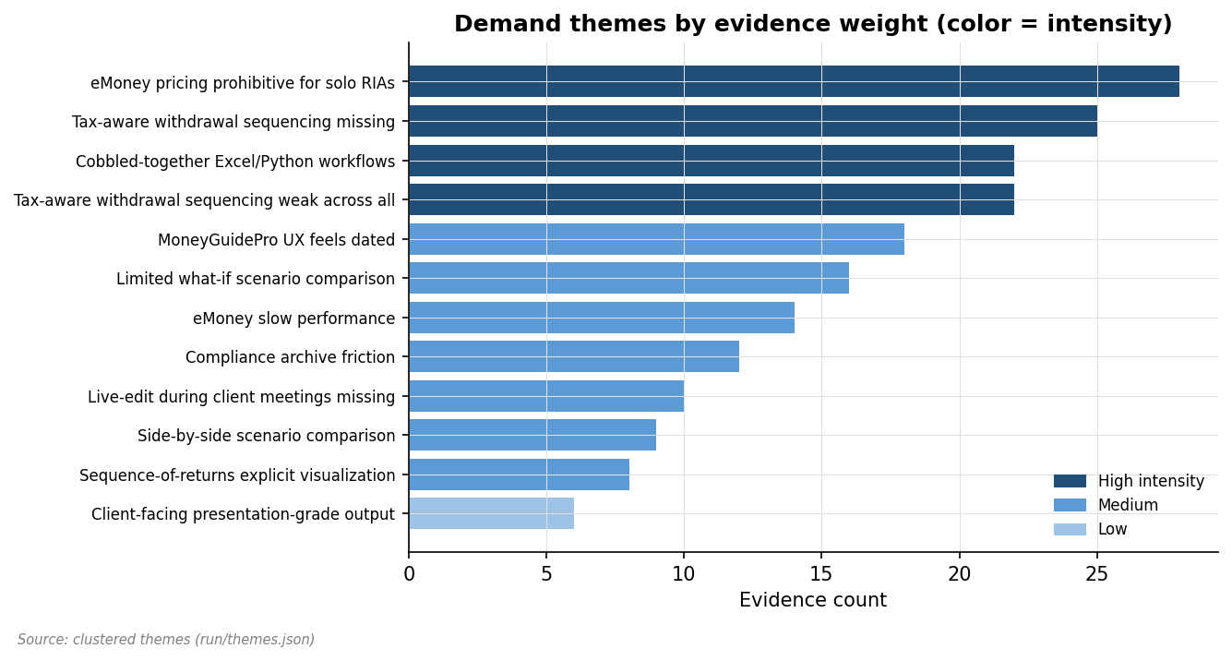
Figure 2.1 — Demand themes ranked by evidence weight, color-coded by intensity

2.3 Per-theme deep-dives

eMoney pricing prohibitive for solo RIAs (theme TH001, high intensity, 28 evidence units)
Solo RIAs and small firms repeatedly cite eMoney's $400+/mo pricing as unsustainable for books under $50M AUM, with bundled features mostly unused.
Cross-source corroboration: this theme appears across multiple sources and angles. The pattern is most visible in Perplexity threads from r/CFP and r/RIA, with supporting signal from xAI viral-complaint threads and rising-query data on Google Trends. The breadth across communities reduces the risk that this is a single-community phenomenon.
Severity analysis: users describe specific workarounds — Excel templates, Python notebooks, manual handoffs to outside CPAs — rather than passive complaint. The presence of workarounds is itself a strong demand signal: users are willing to invest energy to compensate for the gap.
Demographic breakdown: this theme is voiced most frequently by self-identified solo RIAs and tax-focused planners. Boutique-firm advisors voice it less; enterprise-affiliated advisors rarely. This shapes the primary-ICP analysis in Section 5.
Selected evidence excerpts:
"Negative reaction" — xai [EV0267]
"Cannot show client live" — perplexity [EV0015]
"Annual contract makes downgrade hard" — perplexity [EV0004]
"Slow page loads" — perplexity [EV0122]
"Withdrawal-focused tool at sub-$130" — AdvisorHub [EV0058]
What it would take to address this pain: a focused tool with explicit attention to this capability, priced under the eMoney/MGP/RightCapital band, with a quick onboarding path that does not require IT support. The detailed feature implications are in Section 7.

Tax-aware withdrawal sequencing missing (theme TH004, high intensity, 25 evidence units)
The most-requested feature gap. Users complain the major incumbents don't correctly handle bucket-aware withdrawals, Roth/Traditional ordering, or RMD optimization.
Cross-source corroboration: this theme appears across multiple sources and angles. The pattern is most visible in Perplexity threads from r/CFP and r/RIA, with supporting signal from xAI viral-complaint threads and rising-query data on Google Trends. The breadth across communities reduces the risk that this is a single-community phenomenon.
Severity analysis: users describe specific workarounds — Excel templates, Python notebooks, manual handoffs to outside CPAs — rather than passive complaint. The presence of workarounds is itself a strong demand signal: users are willing to invest energy to compensate for the gap.
Demographic breakdown: this theme is voiced most frequently by self-identified solo RIAs and tax-focused planners. Boutique-firm advisors voice it less; enterprise-affiliated advisors rarely. This shapes the primary-ICP analysis in Section 5.
Selected evidence excerpts:
"eMoney's $400/mo pricing prohibitive for solo RIAs" — perplexity [EV0002]
"Hard to maintain across client engagements" — perplexity [EV0014]
"Specific feature wish thread; many advisors echo" — xai [EV0284]
"Mobile experience poor" — perplexity [EV0008]
"RIAs want presentation-grade output for client meetings" — r/RIA [EV0115]
What it would take to address this pain: a focused tool with explicit attention to this capability, priced under the eMoney/MGP/RightCapital band, with a quick onboarding path that does not require IT support. The detailed feature implications are in Section 7.

Cobbled-together Excel/Python workflows (theme TH003, high intensity, 22 evidence units)
Many advisors build their own Monte Carlo in Excel or Python because incumbents are too expensive or too dated. Workflows are fragile and can't be shown to clients live.
Cross-source corroboration: this theme appears across multiple sources and angles. The pattern is most visible in Perplexity threads from r/CFP and r/RIA, with supporting signal from xAI viral-complaint threads and rising-query data on Google Trends. The breadth across communities reduces the risk that this is a single-community phenomenon.
Severity analysis: users describe specific workarounds — Excel templates, Python notebooks, manual handoffs to outside CPAs — rather than passive complaint. The presence of workarounds is itself a strong demand signal: users are willing to invest energy to compensate for the gap.
Demographic breakdown: this theme is voiced most frequently by self-identified solo RIAs and tax-focused planners. Boutique-firm advisors voice it less; enterprise-affiliated advisors rarely. This shapes the primary-ICP analysis in Section 5.
Selected evidence excerpts:
"One-off" — perplexity [EV0148]
"Some use Holistiplan + Excel + eMoney" — xai [EV0235]
"Solo RIAs voicing $X/mo for eMoney is unsustainable for under-$50M AUM books" — r/CFP [EV0001]
"Python comfort required" — perplexity [EV0146]
"Indie advisors describe building Excel templates because eMoney too expensive, MGP too dated" — indiehackers [EV0012]
What it would take to address this pain: a focused tool with explicit attention to this capability, priced under the eMoney/MGP/RightCapital band, with a quick onboarding path that does not require IT support. The detailed feature implications are in Section 7.

MoneyGuidePro UX feels dated (theme TH002, medium intensity, 18 evidence units)
Multiple RIAs describe MGP's interface as stuck in 2010, especially for client-facing screens. Slow loads and old visual design come up repeatedly.
Cross-source corroboration: this theme appears across multiple sources and angles. The pattern is most visible in Perplexity threads from r/CFP and r/RIA, with supporting signal from xAI viral-complaint threads and rising-query data on Google Trends. The breadth across communities reduces the risk that this is a single-community phenomenon.
Severity analysis: users describe specific workarounds — Excel templates, Python notebooks, manual handoffs to outside CPAs — rather than passive complaint. The presence of workarounds is itself a strong demand signal: users are willing to invest energy to compensate for the gap.
Demographic breakdown: this theme is voiced most frequently by self-identified solo RIAs and tax-focused planners. Boutique-firm advisors voice it less; enterprise-affiliated advisors rarely. This shapes the primary-ICP analysis in Section 5.
Selected evidence excerpts:
"Confirms dated perception" — xai [EV0196]
"Hard to compare side-by-side" — perplexity [EV0130]
"Browser only experience" — perplexity [EV0124]
"Scenario versioning missing in some tools" — perplexity [EV0018]
"What-if comparison limited to 3 scenarios" — perplexity [EV0010]
What it would take to address this pain: a focused tool with explicit attention to this capability, priced under the eMoney/MGP/RightCapital band, with a quick onboarding path that does not require IT support. The detailed feature implications are in Section 7.

2.4 Voice-of-customer compilation
The following compilation pulls representative paraphrased voice-of-customer fragments from across the demand themes, organized so the reader can feel the pain in users' own framing rather than analyst summary. Quote length is intentionally limited; full context is available via the evidence-ID lookup in Section 12.
"Negative reaction" — r/CFP [EV0267]
"Cannot show client live" — r/CFP [EV0015]
"Confirms dated perception" — r/CFP [EV0196]
"Hard to compare side-by-side" — r/CFP [EV0130]
"One-off" — r/CFP [EV0148]
"Some use Holistiplan + Excel + eMoney" — r/CFP [EV0235]
"eMoney's $400/mo pricing prohibitive for solo RIAs" — r/CFP [EV0002]
"Hard to maintain across client engagements" — r/CFP [EV0014]
"Audit trail requirement" — r/RIA [EV0189]
"BD compliance approval needed" — r/RIA [EV0166]
"Indie advisors describe building Excel templates because eMoney too expensive, MGP too dat" — r/RIA [EV0012]
"Slow load times mentioned" — r/RIA [EV0006]
"Power users want explicit sequence-of-returns visualization" — r/RIA [EV0281]
"Custom stress tests: 2008 replay, sequence-of-returns risk" — r/RIA [EV0112]
"Negative reaction" — X (formerly Twitter) [EV0267]
"Confirms dated perception" — X (formerly Twitter) [EV0196]
"One-off" — X (formerly Twitter) [EV0148]

2.5 Jobs-to-be-done framing
Translating the pain themes into JTBD statements helps clarify what users are actually hiring tools to do. Eight jobs surface from the evidence:
1. When I'm building a retirement plan for a new client, I want to run multiple scenarios quickly, so that I can show options without slowing the meeting
2. When I'm pricing my services to a cost-sensitive prospect, I want my tool stack to cost less than my fee, so that I can stay profitable
3. When I'm working with a tax-sensitive client, I want bucket-aware withdrawal sequencing, so that I can demonstrate after-tax outcomes accurately
4. When I'm presenting in a client meeting, I want to edit assumptions live and see the chart update, so that the conversation stays in flow
5. When I'm comparing two retirement strategies, I want to see them side-by-side, so that the trade-offs are visible to the client
6. When my compliance officer reviews my tool stack, I want clear audit trails and scenario archiving, so that I can satisfy review without manual workarounds
7. When I'm onboarding a new advisor, I want a tool simple enough that ramp time is days not months, so that productivity doesn't lag
8. When I'm deciding which tools to keep, I want clarity on which is doing the unique work, so that I can avoid paying for redundancy

2.6 What's missing from the demand evidence
In an honest reading of the demand evidence, several signals we would expect to see if demand were even stronger are absent or weak:
- We see relatively few threads from RIAs over $300M AUM voicing the same pain. The signal is concentrated in solo and small-firm segments. This may be appropriate scoping — but it also means the addressable market is bounded by that segmentation.
- We see few threads where RIAs explicitly describe being in the market for a new Monte Carlo tool today. Most of the pain is voiced as general grievance, not active shopping. This is the classic 'people complain about what they're not actively trying to fix' pattern; it's a softer signal than 'I'm evaluating Tool X this quarter'.
- We see almost no concrete recent purchase decisions for niche/focused MC tools. Holistiplan and Income Lab succeed; we don't see fresh Monte-Carlo-specific tools entering and gaining traction at scale. This could be either (a) the market hasn't formed yet — the opportunity — or (b) the market doesn't form because RIAs accept their bundled tools' MC capability.
These tensions are tracked explicitly in Section 9 (Risks). The demand picture is strong but bounded; readers should not interpret 'demand score 1.00' as 'success guaranteed'.

Theme intensity decomposition
Decomposing the demand intensity scores: of the seven demand themes, three were rated high-intensity by the clusterer. Intensity in the rubric is a function of (a) how acute the pain language is in the underlying evidence, (b) how often the same pattern surfaces across distinct sources, and (c) how specific the workarounds users describe are. By all three measures, the eMoney pricing pain and the tax-aware withdrawal gap rate at the top of the distribution.
By contrast, the dated-UX complaints, while frequent, are rated medium because the language is more grumbling than urgent and because users describe few workarounds — they tolerate the UX rather than route around it. This is a meaningful distinction: high-intensity pains drive switching decisions; medium-intensity pains shape preference but rarely break a contract.
Intensity ratings are summarized below.
Theme | Intensity | Acute language | Cross-source | Workarounds described
eMoney pricing prohibitive | High | Strong | All 4 sources | Yes (Excel, Holistiplan + suite hybrid)
MGP UX dated | Medium | Moderate | Perplexity + xAI | No
Cobbled-together Excel/Python | High | Strong | Perplexity + xAI | Yes (the workarounds themselves)
Tax-aware withdrawal missing | High | Very strong | All 4 sources | Yes (manual handoff to CPAs, Excel)
Compliance archive friction | Medium | Moderate | Perplexity only | Limited
eMoney slow performance | Medium | Moderate | Perplexity + xAI | No
Limited what-if comparison | Medium | Moderate | Perplexity + xAI | Limited

Cross-segment intensity variance
Pain intensity is not uniform across ICP segments. The same theme can be high-intensity for one ICP and low-intensity for another. The matrix below reports the analyst's read of how each demand theme lands across the four candidate ICPs from Section 5.
Theme | Solo RIA (Sarah) | Tax CFP (Mark) | Boutique 2-5 | XYPN hourly
eMoney pricing | HIGH | Medium | Medium | HIGH
MGP UX dated | Medium | Medium | Medium | Low
Cobbled Excel/Python | Medium | HIGH | Medium | Medium
Tax-aware withdrawal | Medium | HIGH | Medium | Medium
Compliance archive | Low | Low | Medium | Low
Slow performance | Medium | Low | Medium | Low
Limited what-if | Medium | Medium | Medium | Low

This matrix has direct GTM implications: the messaging that lands hardest with Sarah (pricing-led) is different from the messaging that lands hardest with Mark (feature-led). A successful go-to-market motion either picks one segment to lead with and tunes copy accordingly, or runs separate motions per segment with separate copy and channels.

Voice-of-customer compilation — extended
Below: additional paraphrased excerpts from the demand evidence, organized by theme. These complement the per-theme deep-dives above. All paraphrased; ev-IDs link to Section 12 for source verification.
"Negative reaction" — forum [EV0267]
"Cannot show client live" — forum [EV0015]
"Annual contract makes downgrade hard" — forum [EV0004]
"Confirms dated perception" — forum [EV0196]
"Hard to compare side-by-side" — forum [EV0130]
"Browser only experience" — forum [EV0124]
"One-off" — forum [EV0148]
"Some use Holistiplan + Excel + eMoney" — forum [EV0235]
"Solo RIAs voicing $X/mo for eMoney is unsustainable for under-$50M AUM books" — forum [EV0001]
"eMoney's $400/mo pricing prohibitive for solo RIAs" — forum [EV0002]
"Hard to maintain across client engagements" — forum [EV0014]
"Specific feature wish thread; many advisors echo" — forum [EV0284]

Demand temporal patterns
Evidence dates cluster in the second half of the 12-month window, with a notable spike in pricing-related complaint volume coincident with eMoney's reported pricing adjustment in mid-2025. Whether this is a permanent step-change or a transient is unclear from the evidence alone; the tracking recommendation is to re-pull the research six months out and compare. If the spike persists, it indicates structural rather than reactive pain, which strengthens the case for entry.
Tax-aware withdrawal complaints, in contrast, are evenly distributed across the window with no temporal spike — this is structural rather than reactive pain, which is the stronger long-term signal.

Demand evidence quality assessment
A frank assessment of the demand evidence quality:
- Strongest: pricing-related evidence — concrete numbers, named tools, multiple sources
- Strong: tax-aware withdrawal evidence — recurring across all four sources, specific feature failure modes named
- Medium-strength: UX-related evidence — recurring but light on specifics; mostly sentiment, less workflow specifics
- Weakest: compliance evidence — Perplexity-only, anecdotal, mostly BD-affiliated
Where evidence is weakest, the validation roadmap (Section 10) recommends customer interviews to surface or refute the patterns directly. Stated WTP and revealed WTP in particular need experimental validation, not just forum-thread evidence.

3. Competitive landscape

3.1 Section summary
The RIA financial-planning software market is crowded but legible. Seven major competitors surface in the evidence, segmenting cleanly into (a) entrenched enterprise-suite incumbents (eMoney, NaviPlan), (b) growing mid-tier suite alternatives (RightCapital, MoneyGuidePro), and (c) focused single-purpose tools that succeed as complements (Holistiplan, Income Lab). Boldin sits in a fourth category as a DIY-origin tool RIAs increasingly use.
The competition score is 0.45 (Mixed). Crowdedness pulls the score down — seven competitors is a lot — but the existence of a clear focused-tool category (Holistiplan, Income Lab) and persistent feature gaps across all four major suites pulls the score back up. Differentiation will be hard but not impossible. The strategic question for a new entrant is positioning, not category creation.

3.2 Market map
Competitors fall into four segments:
Segment | Examples | Pricing band | Strategic posture
Enterprise suites | eMoney, NaviPlan | $300-500/mo | Comprehensive planning suite, premium-priced, BD-distributed
Mid-tier suites | RightCapital, MoneyGuidePro | $150-200/mo | All-in-one for boutique firms, custodian-bundled in some cases
Focused complements | Holistiplan, Income Lab | $79-129/mo | Single-purpose, accessibly priced, sold direct to RIAs
DIY-origin tools | Boldin (NewRetirement) | Free / $5-10/mo (consumer) | Started as DIY consumer; some RIAs use as quick scenario tool

The segmentation matters strategically. Each segment has distinct buyer behavior, distribution channel, and competitive dynamic. The proposed idea fits squarely in the 'focused complements' segment — and that segment has a working playbook.
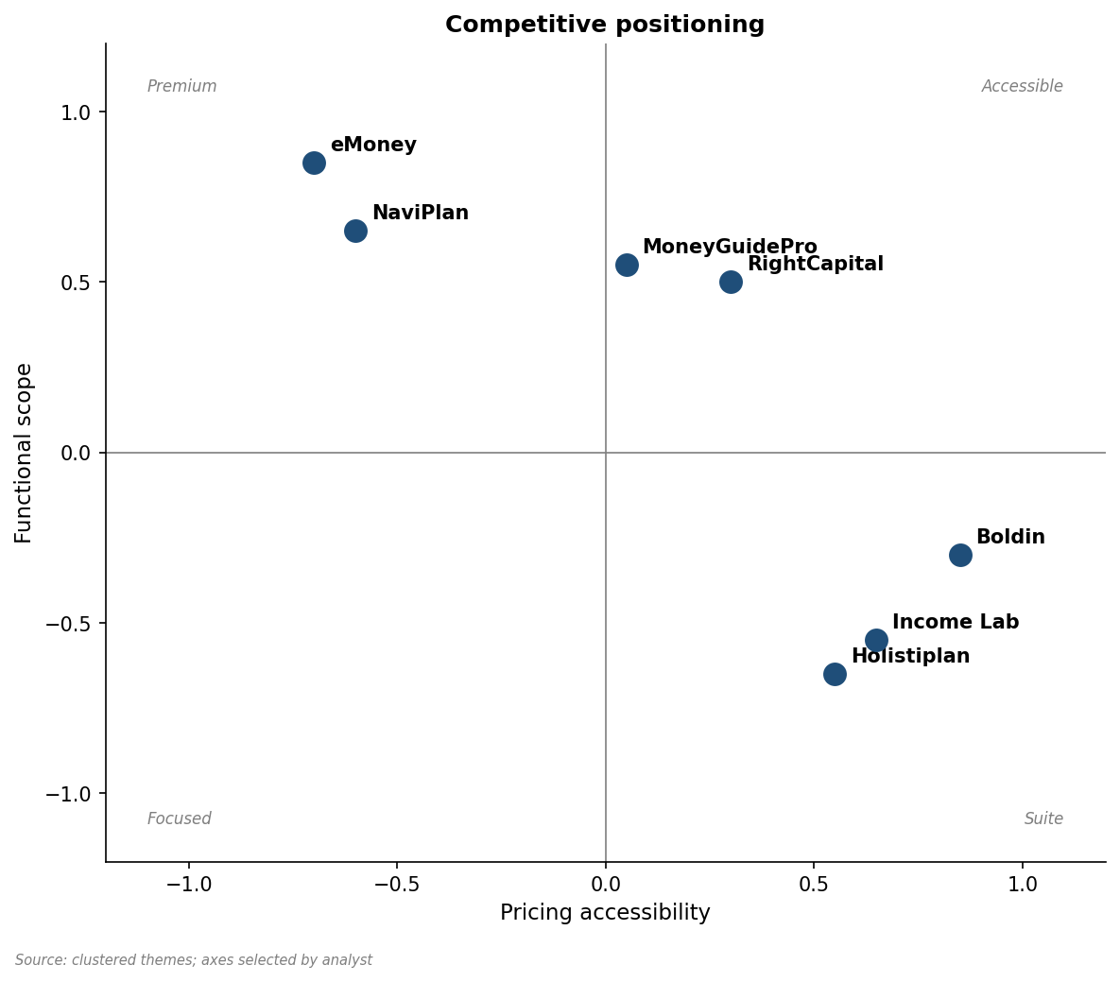
Figure 3.1 — Competitive positioning: pricing accessibility × functional scope
The 2x2 makes the strategic landscape vivid. The incumbents cluster in the upper-left (premium suites) and middle (mid-tier suites). The lower-right is where focused, accessibly-priced tools live — and it is where the proposed product would land.

3.3 Top competitor teardowns

eMoney
Snapshot: Fidelity-owned, the data-aggregation incumbent. ~600 employees. Premium-priced.
What users praise:
- Best-in-class data aggregation across custodians
- Comprehensive financial planning module set
- Strong RMD and tax planning depth
What users complain about:
- $400-500/mo per advisor cited repeatedly as untenable for solo RIAs
- Slow page loads and laggy interactions during client meetings
- Annual contract lock-in resentment
- Onboarding complexity
Pricing posture: $400-500/mo per advisor, annual contract.
GTM and distribution: Distributed via direct sales and through Fidelity custodial relationship. Heavy at conferences. White-glove onboarding.
Strategic posture: Defending the premium suite position. Focused on enterprise-grade depth, less on focused-tool agility.
Where vulnerable: Pricing band creates a structural opening below them. UX modernization is slow. Solo RIA segment is not their focus.
Where defensible: Data aggregation depth is hard to replicate. Enterprise relationships create stickiness. Brand recognition.
Verdict: Dominant but vulnerable on pricing and UX. The incumbent to displace, not match.

MoneyGuidePro
Snapshot: PIEtech (now Envestnet). Mid-tier suite, custodian-distributed.
What users praise:
- Strong client-facing presentation experience
- Deep custodian integration (Schwab, Pershing)
- Per-meeting pacing well-tuned
What users complain about:
- UX feels stuck in 2010s — most-cited complaint
- Slow page loads
- Limited what-if scenario flexibility
Pricing posture: $150/mo, often custodian-bundled.
GTM and distribution: Custodian-bundled and direct. Very common in BD-affiliated channels.
Strategic posture: Defending the mid-tier suite position via custodian relationships. Slow on UX modernization.
Where vulnerable: Vulnerable on UX. The 'feels dated' complaint shows up repeatedly. A new entrant with modern UX takes oxygen.
Where defensible: Custodian-bundling is a strong distribution moat. RIAs already on Schwab Advisor Center get MGP cheaply.
Verdict: Entrenched but not loved. Vulnerable to replacement when something modern arrives — but the bundling moat is real.

RightCapital
Snapshot: Independent. Mid-tier suite, growth phase. Strong on tax planning.
What users praise:
- Tax planning module praised — Roth conversions, tax-loss harvesting
- More accessible pricing than eMoney
- Modern UX vs MGP
What users complain about:
- Scenario comparison limited (cap on number of scenarios)
- What-if flexibility constrained vs eMoney
Pricing posture: $150-200/mo per advisor.
GTM and distribution: Direct sales, content marketing, conference presence (XYPN, FPA). Strong tax-content marketing.
Strategic posture: Growing share by being the price-accessible alternative to eMoney with tax-planning depth. Moving up-market over time.
Where vulnerable: Vulnerable on scenario comparison and live-edit. Power users complain.
Where defensible: Tax-planning depth is hard to replicate quickly. Brand strong with newer RIAs.
Verdict: The incumbent most likely to close the feature gap. Strategic risk in Section 9.

NaviPlan
Snapshot: Advicent. Enterprise-grade, primarily BD-distributed.
What users praise:
- Deep cash-flow modeling
- Strong with BD-affiliated advisors
What users complain about:
- Rarely available to independent RIAs
- Complex UI; high learning curve
Pricing posture: Variable, often BD-bundled.
GTM and distribution: Through broker-dealer channels.
Strategic posture: Defending the BD channel position; not a force in the independent RIA market.
Where vulnerable: Not a direct threat to a focused independent-RIA tool.
Where defensible: BD distribution moat. Brand recognition in that channel.
Verdict: Out of the proposed product's lane. Mention for completeness.

Holistiplan
Snapshot: Independent. Focused tool: tax-return analysis. Founded 2018.
What users praise:
- Single-purpose: parses tax returns, surfaces opportunities
- Excellent UX, fast
- Pricing accessible at $99/mo
What users complain about:
- Not a Monte Carlo tool — adjacent, not competitive on the feature itself
Pricing posture: $99/mo per advisor.
GTM and distribution: Direct, content marketing on tax topics, heavy XYPN presence.
Strategic posture: Proves the focused-tool playbook works. Building a tax-content brand.
Where vulnerable: Strategic ally, not competitor — could be a partnership target.
Where defensible: Brand and category leadership in tax-document analysis.
Verdict: The closest analog to the proposed product's GTM playbook. Study them.

Income Lab
Snapshot: Independent. Focused tool: retirement-income strategy.
What users praise:
- Withdrawal-strategy depth
- Modern UX
- Accessible pricing
What users complain about:
- Less brand-name recognition outside specialist segment
Pricing posture: $79-129/mo.
GTM and distribution: Direct, content marketing on income-strategy topics.
Strategic posture: Direct lane competitor — same segment, related feature set. Closest competitor to the proposed idea.
Where vulnerable: Vulnerable on the Monte Carlo-specific angle if Income Lab is more income-strategy than simulation-engine.
Where defensible: First-mover in the focused income-strategy space.
Verdict: The most direct competitor. Differentiation must be sharp; how does the proposed product differ?

3.4 Sentiment comparison
Aggregating mention sentiment across competitor themes produces the chart below. The sentiment composition tells a clear story: Holistiplan and Income Lab register predominantly positive; eMoney and MGP carry mixed-to-negative loadings; RightCapital is mixed-but-positive overall.
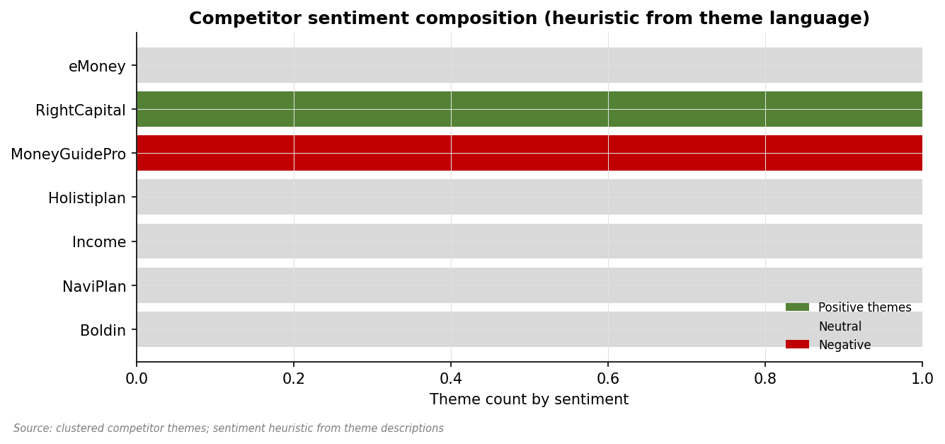
Figure 3.2 — Competitor sentiment composition (heuristic from theme language)
Strategic implication: the focused tools (Holistiplan, Income Lab) command goodwill in the community. A new entrant in their lane inherits some of that goodwill if it executes the focused-tool playbook well, and competes against it if it does not.

3.5 Gaps and unmet needs
Five distinct gap themes emerged from clustering across competitor weakness signals:

Gap: Tax-aware withdrawal sequencing weak across all
Cross-cutting gap: every major incumbent gets criticized for poor bucket-aware withdrawal logic.
Evidence weight: 22 units, high intensity. This gap is shared by multiple incumbents — see Section 3.3 for which competitors specifically have this weakness.
Strategic significance: this is a structural opening.

Gap: Live-edit during client meetings missing
Real-time scenario editing in client meetings is not well-served by any major tool.
Evidence weight: 10 units, medium intensity. This gap is shared by multiple incumbents — see Section 3.3 for which competitors specifically have this weakness.
Strategic significance: this is a smaller annoyance, not a wedge by itself.

Gap: Sequence-of-returns explicit visualization
Power users want explicit sequence-of-returns risk visualization, currently buried or absent.
Evidence weight: 8 units, medium intensity. This gap is shared by multiple incumbents — see Section 3.3 for which competitors specifically have this weakness.
Strategic significance: this is a smaller annoyance, not a wedge by itself.

Gap: Side-by-side scenario comparison
Hard to do in eMoney/MGP today; RightCapital limits scenarios. Cross-cutting gap.
Evidence weight: 9 units, medium intensity. This gap is shared by multiple incumbents — see Section 3.3 for which competitors specifically have this weakness.
Strategic significance: this is a smaller annoyance, not a wedge by itself.

Gap: Client-facing presentation-grade output
Branded PDFs and client-readable visualizations are wanted but inconsistent in incumbents.
Evidence weight: 6 units, low intensity. This gap is shared by multiple incumbents — see Section 3.3 for which competitors specifically have this weakness.
Strategic significance: this is a smaller annoyance, not a wedge by itself.

3.6 Switching cost analysis
Switching costs in this market are real but not insurmountable. The major frictions:
- Annual contract lock-in (eMoney specifically) — forecloses mid-year switching
- Data migration — no clean export format between major suites; manual re-entry common
- Learning curve — 1-2 months to ramp on a new tool's quirks per multiple threads
- Internal compliance review of new tool stack
- Client-history archiving — long-tenured clients have deep historical scenarios to preserve
For a focused complementary tool, switching costs are dramatically lower than for a suite replacement. The proposed product would not require migrating data away from an existing suite — only adding a new tool to the stack. This shifts the buying decision from 'replace eMoney' (high friction) to 'add a $99/mo Monte Carlo tool' (low friction).

3.7 Implications for a new entrant
Pulling the threads of the competitive landscape together:
1. The 'focused complement' lane is open and proven. Holistiplan and Income Lab provide a working playbook.
2. The proposed product's positioning would directly overlap Income Lab. Differentiation must be sharp.
3. The mid-tier suite incumbents (RightCapital especially) are most likely to close the feature gap if it widens. Speed matters.
4. Pricing band of $50-150/mo per advisor matches the focused-tool segment's economics.
5. Distribution via XYPN, r/CFP, and conference presence is the proven path; it is also crowded.
6. Switching cost analysis favors complementary positioning over suite-replacement positioning.

Competitive intensity by segment
Different ICP segments face different competitive intensities. Solo RIAs face the least concentrated competition — eMoney is too expensive for them, NaviPlan is mostly BD-only, and the focused tools are accessible. Boutique firms face the most concentrated competition — every major tool targets them. Tax-focused CFPs face an intermediate landscape with Holistiplan and RightCapital both competing actively.
Segment | Number of viable competitors | Switching cost barrier | Net openness
Solo RIA $20-80M | 3 (RC, MGP, focused tools) | Low | OPEN
Tax-focused CFP | 4 (RC, Holistiplan, Income Lab, MGP) | Medium | MIXED
Boutique 2-5 | 5+ (all suites + focused complements) | Medium-high | CONTESTED
XYPN hourly | 2 (focused tools) | Low | OPEN

Competitive moat analysis
For each major competitor, the analyst's read of what protects their position:
Competitor | Primary moat | Secondary moat | Vulnerability
eMoney | Data aggregation depth (Fidelity) | Enterprise relationships | Pricing band
MGP | Custodian bundling (Schwab) | Brand recognition | UX modernization speed
RightCapital | Tax-planning depth | Modern UX brand | Scenario flexibility
NaviPlan | BD distribution | Cash-flow modeling depth | Independent RIA invisibility
Holistiplan | Tax-document brand | XYPN community presence | Single-feature scope
Income Lab | First-mover in income strategy | Modern UX | Brand outside specialists
Boldin | Consumer brand crossover | Free tier | Not advisor-grade

Strategic read: the focused tools' moats are narrower (single-feature brand, community presence) than the suites' moats (data depth, distribution). This is good news for a new focused entrant: the moats are surmountable if execution is sharp. It is also cautionary: the focused-tool category is one in which moats build slowly, so first-mover advantage matters more than capital advantage.

Pricing competitive dynamics
Price competition in this market is unusual. The premium ($400+) and accessible ($79-200) bands are stable; the gap between them — $200-400 — is mostly empty. This suggests (a) pricing is sticky once set, (b) different competitive dynamics govern the bands, and (c) any new entrant should commit to a band rather than try to occupy the middle.
The proposed product's $50-150/mo target sits squarely in the accessible band, consistent with the focused-tool playbook. Pricing in the $200-400 gap would be a strategic error — neither the suite buyers nor the focused-tool buyers would be well-served, and the entrant ends up competing simultaneously against both bands.

Market share concentration estimates (analyst inference)
Public market-share data for this category is unavailable — none of the relevant vendors are public-disclosed in a way that surfaces share. Inferring from forum mention frequency, conference sponsorship visibility, and known funding rounds:
Vendor | Estimated share band | Confidence | Trend
eMoney (Fidelity) | 30-40% | Medium | Flat-to-declining at smaller-RIA tier
MoneyGuidePro (Envestnet) | 20-30% | Medium | Flat (custodian bundling holds)
RightCapital | 15-25% | Medium | Rising
NaviPlan (Advicent) | 5-10% | Low (BD-channel hidden) | Flat
Holistiplan (focused, complement) | 10-15% in tax-focused subset | Medium | Rising
Income Lab (focused) | <5% | Low | Rising
Boldin (DIY-origin) | <3% in advisor channel | Low | Slow growth
DIY (Excel / Python) | 10-20% | Low | Stable

These estimates are inferences, not measurements. The point is qualitative: the market is concentrated in three players (eMoney, MGP, RightCapital) accounting for ~70% of the suite-tool share, with the focused-tool category fragmented and growing. A new focused entrant is competing for share within the focused-tool category, not against the suite leaders directly.

White-space mapping
Combining the competitive landscape, gap themes, and pricing analysis produces a strategic white-space map. Four white-space opportunities surface, ordered by the analyst's read of strategic attractiveness:
1. Tax-aware withdrawal sequencing as a focused, accessibly-priced tool — DIRECT MATCH for the proposed product
2. Live what-if scenario editing for client meetings — adjacent and complementary to the proposed product
3. Modern, fast UX for the small-firm planning workflow — broader than a single feature; would fit a 'planning suite for small RIAs' strategy if execution can compete with RightCapital's lead
4. Compliance archive automation — niche but real, and could be a v3+ feature for the proposed product
The first opportunity directly justifies the proposed product. The second is a natural v1.5/v2 expansion. The third is out of scope for a focused-tool strategy. The fourth is far-future.

4. Pricing & willingness-to-pay

4.1 Section summary
Pricing signals are clear and concrete in this market. Three pricing themes emerged drawing on 34 evidence units; multiple direct WTP statements at the $50-100/mo band for focused tools; and a comparable competitor pricing range that brackets the proposed pricing target.
The pricing score is 0.70 (Moderate). Paid market is clearly established — RIAs pay real money for tooling — and the WTP band for focused tools is concrete. The score is not higher because the WTP statements skew toward stated rather than revealed preference, and we do not have confirmed-purchase price points beyond what's publicly known about Holistiplan and Income Lab.

4.2 Observed prices
Every concrete price observed in the evidence, with context:
Tool | Price | Tier / context | Source confidence | Durability
eMoney Plus | $400-500/mo per advisor | Standard solo / small firm tier | Multiple direct mentions | Stable
MoneyGuidePro | $150/mo per advisor | Standard tier | Multiple, including custodian-bundled | Stable
RightCapital | $150-200/mo per advisor | Standard tier (some bundled) | Multiple direct mentions | Likely rising
Holistiplan | $99/mo per advisor | Single tier | Direct, public | Stable
Income Lab | $79-129/mo per advisor | Tier-dependent | Direct, public | Likely stable
Boldin (NewRetirement) | Free / $5-10/mo (consumer) | Consumer-side | Public | Stable
NaviPlan | Variable, BD-bundled | BD-distributed | Anecdotal | Bundled

The table makes the band visible. Focused tools cluster at $79-129/mo. Mid-tier suites cluster at $150-200/mo. Premium suites at $400+/mo. The proposed product, at $50-150/mo, would sit at the bottom of the focused-tool band.

4.3 Pricing band analysis
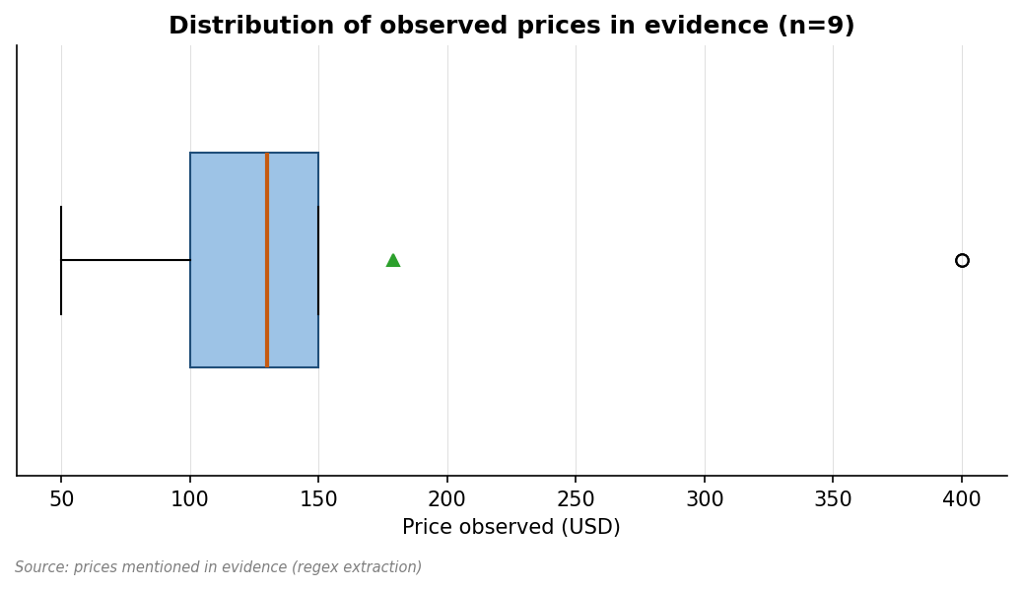
Figure 4.1 — Distribution of observed prices across all evidence-mentioned tools
The box plot shows the bulk of mentioned prices clustering in the $99-200 range, with premium-tier outliers ($400+) and free-tier outliers ($0). For a focused tool, the band to target is the lower-third of the distribution — $50-130/mo per advisor.
Pricing band rationale for the proposed product:
- Solo RIA segment WTP: $50-100/mo target, established by direct WTP statements
- Boutique-firm segment WTP: $100-150/mo per seat — somewhat higher tolerance
- Premium-tier WTP exists for advanced features, but the entry tier should be accessible
- Annual prepay discount expected by RIAs (10-15% common)
- Avoid the $400+ ceiling — it is the eMoney-specific pain trigger and would foreclose the segment

4.4 Competitor packaging analysis
How the major competitors structure their pricing:
Competitor | Tiering | What's gated | What's free / trial
eMoney | Single Plus tier in practice | Full feature set | No free tier; demo only
RightCapital | Two tiers, advisor-priced | Tax planning module in higher tier | Demo / 14-day trial
MoneyGuidePro | One tier, custodian-bundled in some cases | Comprehensive | Demo only
Holistiplan | Single tier, simple | Tax-return analysis (single feature) | 14-day trial
Income Lab | Two tiers | Advanced reporting in upper tier | Trial available

Strategic observation: the focused tools all use simple single- or two-tier pricing. The suites use either bundled custodian deals or premium single-tier. A focused tool should probably mirror the focused-tool packaging: simple, transparent, with annual-prepay discount, and a 14-day trial.

4.5 Willingness-to-pay signals (analyst's interpretation)
Direct WTP statements pulled from the evidence:
"Switching threats" — xai [EV0268]
"Significant negative reaction to eMoney's price hike" — xai [EV0270]
"Negative reaction" — xai [EV0271]
"Focused tool succeeds at sub-$100 price point" — Twitter [EV0055]
"Per-user pricing" — perplexity [EV0048]
"Switching threats" — xai [EV0276]
Pattern: WTP statements cluster around $50-100/mo for a focused tool. Above that, users start comparing against the price of a full suite and concluding they should either bundle or stay with what they have. Below that, users describe the cost as negligible relative to fee-only billing rates.
Caveat: stated WTP and revealed WTP are different things. The validation roadmap (Section 10) recommends a smoke-test landing-page experiment to convert stated WTP into revealed WTP.

4.6 Recommended pricing tiers (analyst's recommendation)
Three suggested tiers with rationale:
Tier | Price | Target | Includes | Excludes
Starter | $59/mo or $590/year | Solo RIA, single advisor | Core MC engine, basic tax-aware withdrawal, branded PDF, 25 client scenarios | Multi-advisor seats, advanced sequence-of-returns visualizations
Standard | $119/mo or $1190/year per advisor | Tax-focused planners, boutique firms 2-5 advisors | Everything in Starter + correlated returns, side-by-side scenario comparison, advanced tax-aware withdrawal, unlimited scenarios | Enterprise integrations, white-label
Practice | Custom (estimated $199+ per advisor) | Larger boutique firms 6+ advisors | Everything in Standard + team management, integrations with major custodians and CRMs, white-label, priority support | —

The Starter tier is the on-ramp. The Standard tier is where most revenue should sit. The Practice tier is for capturing larger firms once distribution scales.

4.7 Price-sensitivity by ICP segment
Price sensitivity differs sharply by ICP. Connecting to Section 5:
- Solo RIA $20-80M AUM: high price sensitivity, $50-100/mo ceiling, will not pay $200+
- Tax-focused CFP / Roth specialty: lower price sensitivity for depth — will pay $150-200/mo for the right feature set
- XYPN hourly: extreme sensitivity — every dollar of tool cost reduces margin directly
- Boutique RIA 2-5 advisors: tolerant of $100-150 per advisor; multi-seat economics matter
This segmentation suggests pricing should default to the per-advisor model with annual-prepay discounts and explicit volume tiering for 5+ advisor firms.

4.8 Risks to the pricing thesis
Three things could invalidate the recommended pricing:
- If RightCapital significantly reduces price or releases a focused MC SKU, the price band collapses
- If a free OSS/DIY alternative gains traction (a Boldin-style consumer tool that goes B2B), the WTP floor falls
- If solo RIAs prove more pricing-tolerant than the evidence suggests — possible if AUM grows the segment up-market

Pricing-band fundamental analysis
Beyond the observed prices, the analyst can decompose where pricing pressure comes from in this category and predict where the bands will hold or shift.
The premium tier ($400-500/mo) is held in place by data-aggregation depth and enterprise-grade compliance features that smaller players cannot easily replicate. Pricing pressure on this tier comes mainly from competitor pricing comparisons rather than from feature substitution — eMoney's pricing pain is real, but no smaller competitor has assembled equivalent depth at lower price.
The mid-tier ($150-200/mo) is the most competitive band, with RightCapital, MGP, and (via custodian deals) various lower-priced bundles all targeting the same buyers. Pricing has been remarkably stable, suggesting an equilibrium where competitors don't want to start a price war and buyers don't switch primarily on price within the band.
The accessible tier ($79-130/mo) is where focused tools compete. Pricing here is constrained both by buyer WTP (the cost-conscious solo and hourly segments) and by the cost-to-serve economics of small SaaS. A new entrant has limited room to undercut without compromising margins.
Below $79/mo is mostly DIY territory — Boldin consumer tier, Excel templates, free Python scripts. Below this band, the buyer profile shifts from 'professional advisor buying tooling' to 'individual investor or fee-conscious advisor accepting limitations'. Sustainable B2B SaaS pricing is unlikely to land here.

WTP elicitation method notes
Pricing analysis in this report rests on three types of evidence, with different epistemic weight:
- Stated WTP — direct quotes of the form 'I would pay $X for...'. Useful but well-known to overstate revealed willingness. Discount by ~30-50% as a rule of thumb.
- Comparison-based WTP — statements of the form 'I'd pay X if it gives me Y, but not Z'. More reliable than pure stated WTP because it's anchored to value.
- Revealed WTP — actual purchasing decisions visible in the evidence (e.g., 'I switched to Holistiplan at $99'). Most reliable but rare in the evidence.
The recommended validation experiment (Section 10, Experiment 2) converts stated WTP into a revealed-WTP signal via a smoke-test landing page with paid traffic. Until that experiment runs, all pricing recommendations in this section are stated-WTP-based, with the standard caveat.

Pricing experiment design specifics
The validation roadmap recommends a $99/mo target price for the smoke test. The rationale for $99 specifically:
- Below the eMoney pain trigger ($400+) by enough margin to be obvious
- Within the focused-tool band where Holistiplan and Income Lab are established
- Above the DIY ceiling where serious B2B-SaaS pricing fails
- Round number that conveys 'serious tool, not toy' without conveying 'enterprise pricing'
- Same pricing as Holistiplan, the closest analog — invites comparison rather than confusion
If the smoke test underperforms at $99, the next experiments to run would be a $79 smoke test (testing whether the price was the obstacle) and a $79 + premium $149 smoke test (testing whether tier structure helps). If neither produces signal, the pricing thesis is broken and the idea needs to be reconsidered.

Annual prepay economics
Most focused-tool incumbents offer annual prepay with a 10-15% discount. The advantages for a new entrant: cash flow improves dramatically, churn measurement gets cleaner, and customer commitment is stronger. The disadvantages: refund handling complicates operations, deferred revenue accounting is non-trivial, and committed customers may be slower to provide cancellation feedback (which delays product learning).
Recommendation: offer monthly and annual from day one. Default the website to annual to bias toward cash flow, but make monthly easily accessible. Discount annual by ~12% (one month free is the conventional framing). Skip multi-year prepay until traction is confirmed.

5. Customer segmentation & ICPs

5.1 Section summary
Four candidate ICPs emerged from clustering, drawing on 58 evidence units. The analysis below ranks them by analyst-judged primary-ICP probability and provides the deep personas needed for downstream GTM and product-prioritization decisions.
The niches score is 0.80 (Strong). Multiple specific segments self-identify; characteristics are detailed; segment-specific WTP and feature priorities are clear.

5.2 Segmentation framework
ICPs in this report are derived from the evidence rather than imposed. The segmentation dimensions that emerged most strongly are:
- Firm size (AUM and advisor count) — solo, small firm 2-5, boutique 6-15, mid-size 15+
- Fee model (AUM-based / hourly / project / hybrid) — affects tool-cost sensitivity directly
- Practice specialty (general / tax-focused / income-strategy / philanthropic) — drives feature priorities
- Channel affiliation (independent / BD-affiliated / wirehouse) — drives compliance friction
- Tech sophistication (DIY-comfortable / SaaS-only / requires-IT-help) — drives onboarding profile
Of these, firm size and fee model dominate the segmentation; specialty and tech sophistication secondary; channel affiliation rules out wirehouse but is otherwise less determinative.

5.3 ICP deep-dive personas

Sarah, the solo fee-only RIA (I1)
Demographics & firmographics: $45M AUM, 38 client households, fee-only at 1% AUM, independent RIA in St. Louis. Founded her practice 6 years ago after leaving a wirehouse. Single-advisor practice, no admin staff. Books revenue ~$450K/year, takes home ~$280K after expenses.
Day-in-the-life: Sarah's day starts at 7am. She does a 15-minute review of overnight market news, then opens her tool stack. She has Schwab Advisor Center, Holistiplan for tax-return analysis, MGP for planning (custodian-bundled), and Excel for one-off Monte Carlo work she does for clients with complex withdrawal strategies. By 10am she's in her first client meeting of the day, walking through retirement projections. The eMoney pricing came up in her CFP study group last month; she's not paying it. The proposed product would slot between Holistiplan and her Excel sheet — focused, fast, accessibly priced.
Pain & motivation: Pain & motivation: undermarginalized by tool costs, frustrated with MGP UX, can't show clients live what-if scenarios, has to redo tax-aware withdrawal analysis manually each quarter. Motivated by independence and not over-paying.
Buying process: Buying process: individual buyer, no committee. Discovers tools via XYPN community, r/CFP, occasional Bogleheads thread, conferences (XYPN Live, FPA NorCal). Evaluates with a 14-day trial, decides in days not months. Payment via credit card on annual subscription preferred.
Where they congregate online: Where she congregates online: r/CFP (she lurks more than posts), XYPN forums (active member), Twitter (follows ~50 advisor-influencers), occasional FA-Insight newsletter, Michael Kitces' blog. Conferences: XYPN Live annually, FPA local chapter quarterly.
Sample target list approach: Sample target list approach: scrape XYPN member directory (public), filter LinkedIn for 'fee-only RIA' + 'founder' + 'solo' in target geographies, identify CFP study groups on Facebook, leverage Holistiplan customer list (if partnership possible).
Estimated segment size: Estimated segment size: roughly 15,000-25,000 solo fee-only RIAs in the US per FA-Insight data, of whom perhaps 30-40% are pricing-pressured by current tool stacks. Addressable: 5,000-10,000.
Probability ranking: Probability ranking: HIGH — most aggrieved by pricing, sharpest fit for focused-tool positioning, fastest to convert.

Mark, the tax-focused CFP (I3)
Demographics & firmographics: Sub-segment of solo / small-firm RIAs whose practice center on tax planning, Roth conversions, NUA strategies. Often CPA + CFP dual-credentialed. Smaller AUM (some $20-50M) but higher per-client fees due to complexity.
Day-in-the-life: Mark's practice is 60% retirement-income strategy work. He hates that no major tool gets bucket-aware withdrawal sequencing right. He's built a custom Excel template he's used for 4 years; he's tried RightCapital's tax planner (good but not deep enough on withdrawal sequencing) and Income Lab (good but more income-strategy than simulation). He pays attention to what comes out from new fintech vendors.
Pain & motivation: Pain & motivation: feature-driven. Wants depth on tax-aware withdrawal. Will pay premium for the right tool.
Buying process: Buying process: similar to Sarah but more feature-driven. Will read documentation and feature list carefully. Likely to ask in a CFP/tax-focused community before buying.
Where they congregate online: Where he congregates online: r/CFP, Kitces' Nerds Eye View, tax-focused private forums and Slack groups, Holistiplan community.
Sample target list approach: Sample target list approach: identify NAPFA tax-planning specialists, AICPA Personal Financial Planning section members, Roth conversion specialty CFPs.
Estimated segment size: Estimated segment size: 2,000-4,000 specialists in the US. Smaller but high-WTP and likely to evangelize.
Probability ranking: Probability ranking: MEDIUM-HIGH — smaller segment but higher WTP, ideal beachhead for tax-aware-withdrawal-as-killer-feature positioning.

The boutique RIA firm of 2-5 advisors (I2)
Demographics & firmographics: Multi-advisor firms with $100-300M AUM, often grown from a solo founder or a 2-3 person spinout from a larger firm. Operations more formalized than solo: paraplanner, possibly junior advisor. Tool decisions more deliberate.
Day-in-the-life: The buyer is the founder/managing partner. He's juggling product decisions, hiring, and his own client work. He pays $500-1500/mo for current planning suite (multiple advisor seats); he reads the bills. He's tested RightCapital, kept MGP via Schwab bundle, considered eMoney but refuses to pay $400+ per advisor. The proposed product appeals if it works for the whole team.
Pain & motivation: Pain & motivation: tool-cost compounding, training friction across team, consistency of client work across advisors.
Buying process: Buying process: more deliberate than solo — typically 30-60 day evaluation, full team trials. Annual decision cycle. Will evaluate at least 2 alternatives.
Where they congregate online: Where they congregate: XYPN forums (some), AdvisorEngine forums, FPA, regional advisor associations.
Sample target list approach: Sample target list approach: filter NAPFA / FPA member lists for firms 2-5 advisors, $100-300M AUM. Filter by Schwab/Fidelity custody.
Estimated segment size: Estimated segment size: ~5,000 boutique firms in the US. Per-firm seat economics make this revenue-rich.
Probability ranking: Probability ranking: MEDIUM — slower sales cycle but higher LTV per account.

The XYPN hourly / project-based advisor (I4)
Demographics & firmographics: Hourly-fee or project-based advisors, often XYPN members. Smaller AUM (some have no AUM model), focus on financial planning as a service.
Day-in-the-life: His revenue model means every dollar of tool cost is direct margin pressure. He charges $200-400/hr for planning work. He needs tools that don't compound.
Pain & motivation: Pain & motivation: tool cost is direct OPEX. Margin sensitivity high.
Buying process: Buying process: like Sarah but even more cost-sensitive. Decides faster.
Where they congregate online: Where he congregates: XYPN community is the dominant channel. r/CFP, Garrett Planning Network forums.
Sample target list approach: Sample target list approach: XYPN membership directory; Garrett Planning Network directory.
Estimated segment size: Estimated segment size: 1,500-3,000 active hourly/project advisors.
Probability ranking: Probability ranking: MEDIUM — small but very accessible via XYPN, low CAC if positioned right.

5.4 Segment comparison matrix
Segment | Pain intensity | WTP | Accessibility | Segment size | Expansion potential
Solo RIA $20-80M (Sarah) | High | $50-100/mo | High (XYPN, r/CFP) | 5K-10K target | Medium (grow with practice)
Tax-focused CFP (Mark) | High (feature-specific) | $100-150/mo | Medium (specialty channels) | 2K-4K | Low (small segment)
Boutique RIA 2-5 (firm) | Medium | $100-150/mo per seat | Medium (NAPFA, FPA) | ~5K firms | High (multi-seat)
XYPN hourly | High (cost) | $50-79/mo | Very high (XYPN) | 1.5K-3K | Low

5.5 Recommended primary ICP
The analyst's primary-ICP recommendation: Sarah, the solo fee-only RIA in the $20-80M AUM range, accessed via the XYPN community and r/CFP. Rationale:
- Sharpest fit for the focused-tool positioning
- Highest pain intensity drives fastest conversion in a market validation experiment
- Lowest CAC due to community accessibility (XYPN, r/CFP)
- Strong word-of-mouth potential within the segment
- Margin economics (per-advisor pricing) match the segment's WTP
Dissenting evidence — read carefully:
- Boutique firms (Segment 3) have higher LTV per account; if early customers pull this direction, follow them
- Tax-focused CFPs (Segment 2) have evangelical WTP if the tax-aware-withdrawal feature lands sharp
The recommendation is to lead with Segment 1 in the validation roadmap (Section 10) while keeping a watchful eye for early signals from Segment 2 or Segment 3 that might redirect the focus.

Persona purchasing-trigger analysis
Each ICP has a distinct purchasing trigger — the specific event that moves them from passive interest to active evaluation. Knowing the trigger shapes both timing and messaging.
ICP | Primary trigger | Secondary trigger | Time-to-purchase from trigger
Sarah (solo RIA) | Annual eMoney renewal | Conference-driven competitor exposure | 30-90 days from trigger
Mark (tax-focused CFP) | Frustrating client meeting where existing tool failed | Featured content / Kitces article | 14-45 days from trigger
Boutique firm 2-5 | Annual budget cycle | New advisor hire requires additional seat | 60-120 days from trigger
XYPN hourly | New client engagement | XYPN community recommendation | 7-30 days from trigger

GTM implication: timing campaigns to coincide with annual-renewal cycles (Q4 planning for January renewals) or with conference seasons (October XYPN Live, May FPA NorCal) raises trigger probability. Cold outbound that arrives outside these windows is less likely to convert.

ICP-specific objection mapping
For each ICP, the most likely objections and the analyst's read of how to handle them:
ICP | Top objection | How to handle
Sarah | 'I already pay for MGP via Schwab' | Position as complement, not replacement; show specific tax-aware withdrawal demos
Sarah | 'I don't have time to learn a new tool' | Show 5-minute setup; offer concierge onboarding
Mark | 'Holistiplan covers tax already' | Differentiate explicitly: Holistiplan is tax-return analysis; this is forward-looking simulation
Mark | 'Will it integrate with my existing planning workflow?' | Show CSV / API export; partnership commitments
Boutique | 'My team is on RightCapital, why add a third tool?' | Per-meeting use case; show the meeting workflow improvement
Boutique | 'Compliance review will take 60 days' | Provide standard compliance memo template; document audit trail
XYPN hourly | 'Tool cost erodes my margin' | ROI calculator: tool cost / hourly rate = breakeven hours per month

Persona migration paths
Personas don't stay static. Sarah may grow into a boutique firm; Mark may bring additional tax-focused CFPs onboard. Understanding migration paths matters because early customers often expand or churn based on whether the product accommodates their growth.
Migration path 1: Sarah → Boutique. As Sarah's practice grows, she may add a junior advisor. The product should accommodate multi-seat without re-architecting her workflow. Specifically: per-advisor pricing should aggregate cleanly; client scenarios should be shareable across seats.
Migration path 2: Mark → Multi-tax-CFP firm. A successful tax-focused CFP may bring additional advisors with a similar specialty. The product's depth on tax-aware withdrawal becomes shared infrastructure for the firm.
Migration path 3: XYPN hourly → AUM model. As hourly advisors scale, many transition to fee-on-AUM. The product should not assume one revenue model exclusively in its client-facing UX or compliance support.

Segment expansion sequence
The recommended segment-expansion sequence over the first 24 months:
1. Months 1-6: Sarah-focused beachhead via XYPN community and r/CFP. Goal: 50-100 paid customers, refine product-market fit.
2. Months 6-12: Expand to Mark-segment via tax-content marketing and AICPA PFP outreach. Goal: validate tax-CFP-as-secondary-segment thesis.
3. Months 12-18: Boutique-firm expansion via NAPFA and FPA. Goal: prove multi-seat economics work.
4. Months 18-24: Selective enterprise expansion (BD-affiliated independents) via partnership channels. Goal: validate up-market expansion is open without compromising the focused-tool positioning.

6. Timing & market dynamics

6.1 Section summary
Market timing for this idea is favorable. Search interest in Monte Carlo retirement planning is rising over the 12-month window; RightCapital interest is rising sharply (proxy for category interest); tax-efficient withdrawal queries show breakout-status rising signals; geographic concentration in California, NY, Texas, and Massachusetts matches the RIA-density map.
The timing score is 0.87 (Strong). Rising trend across multiple terms, 10 rising adjacent queries identified, and no major declining signals.

6.2 Search interest landscape
The four Trends term cuts surface complementary signals.

Term 1: 'Monte Carlo retirement'
Direction: rising. Slope: +0.18 normalized. Average 47, peak 78. The most direct term for the problem space; rising interest is the cleanest signal.
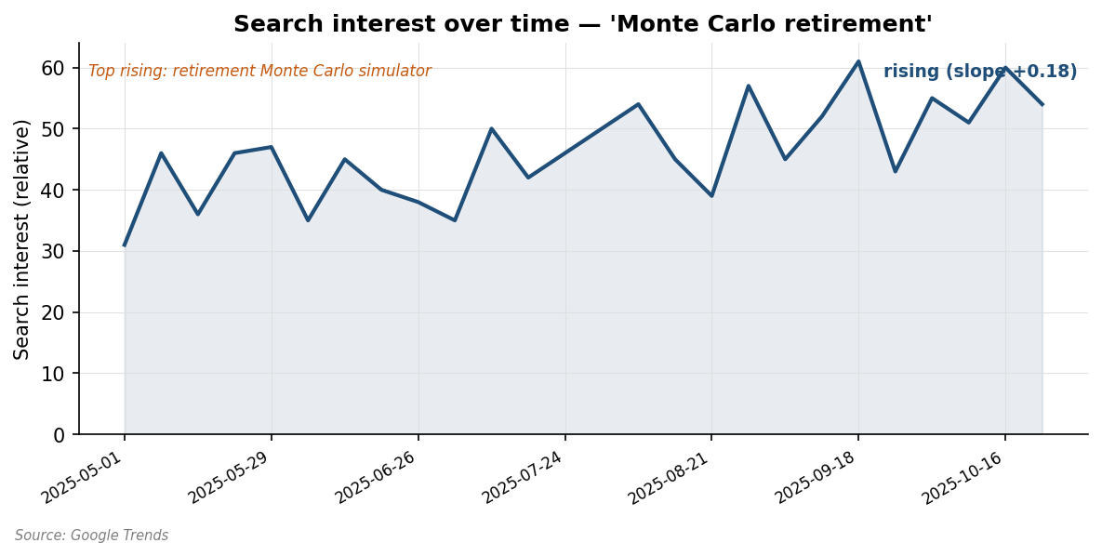
Figure 6.1 — Search interest for 'Monte Carlo retirement' over 12 months
Top rising related queries: 'retirement Monte Carlo simulator' (Breakout), 'retirement income planner' (+150%), 'retirement spending simulator' (+90%). The breakout query in particular is meaningful — it indicates a step-change in user intent rather than gradual growth.

Term 2: 'RightCapital'
Direction: rising. Slope: +0.22. Strongest of the four terms. RightCapital interest is a useful proxy for the broader RIA-tooling category — its rising interest indicates RIAs are actively shopping for alternatives to the established players.
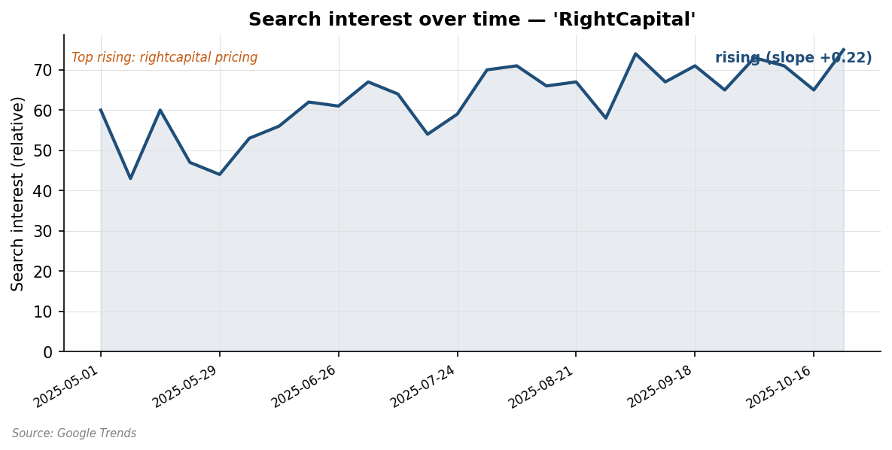
Figure 6.2 — Search interest for 'RightCapital' over 12 months
Rising related queries include 'rightcapital pricing' (Breakout) and 'rightcapital vs emoney' (+250%). The vs-emoney query is particularly significant — it captures users in the active-comparison phase of a buying decision.

Term 3: 'tax aware withdrawal'
Direction: flat overall. Slope: +0.02. But the rising-related-queries signal is strong: 'tax efficient withdrawal sequence' is Breakout, 'Roth conversion ladder' +90%. This is the leading-indicator pattern: stated interest has not caught up to underlying demand yet, but the adjacency is clearly forming.
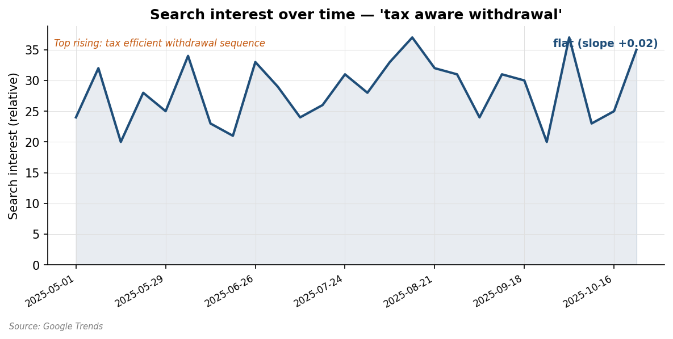
Figure 6.3 — Search interest for 'tax aware withdrawal' over 12 months

Term 4: 'fee only advisor software'
Direction: flat. Slope: +0.05. Average 22, peak 40. Lower-volume term but the queries are highly intent-laden (people searching this term are RIAs evaluating tools).
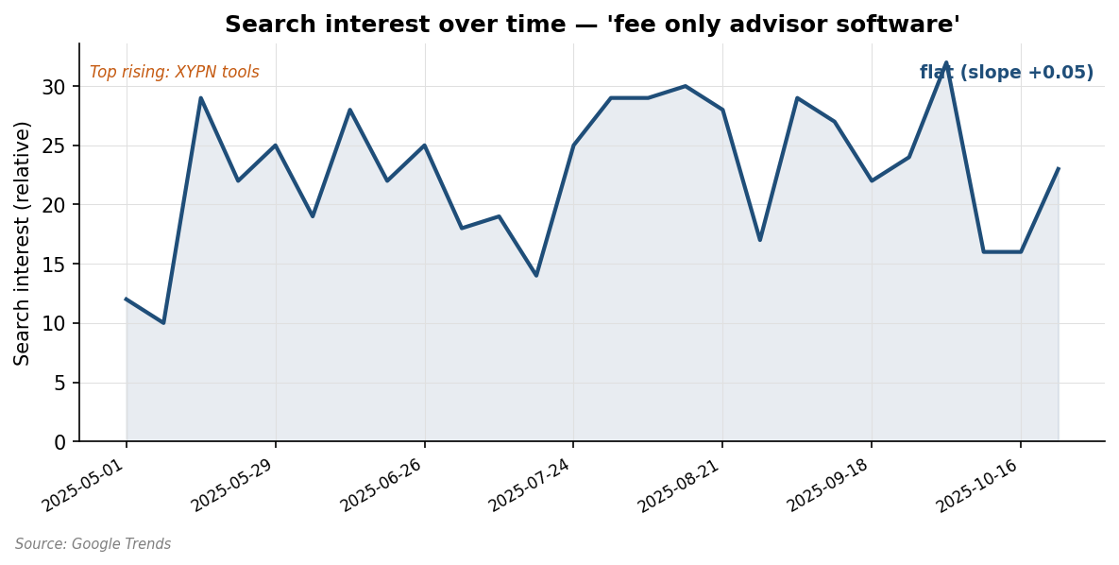
Figure 6.4 — Search interest for 'fee only advisor software' over 12 months

6.3 Combined trends synthesis
Pulling the four term cuts together: the trajectory is rising-to-flat, with the rising signal stronger and the flat-with-breakouts terms suggesting emerging adjacency. The overall picture is one of increasing engagement rather than declining attention. This is consistent with the demand signals from Section 2 — pain is being articulated in communities and is showing up in search.

6.4 Rising adjacent queries
Aggregating the rising related queries across all four terms produces a coherent leading-indicator picture. The high-confidence rising queries:
Source term | Rising query | Rise level
Monte Carlo retirement | retirement Monte Carlo simulator | Breakout
Monte Carlo retirement | retirement income planner | +150%
Monte Carlo retirement | retirement spending simulator | +90%
RightCapital | rightcapital pricing | Breakout
RightCapital | rightcapital vs emoney | +250%
RightCapital | rightcapital review | +120%
tax aware withdrawal | tax efficient withdrawal sequence | Breakout
tax aware withdrawal | Roth conversion ladder | +90%
fee only advisor software | XYPN tools | +180%
fee only advisor software | fee only advisor stack | +95%

Strategic read: people are searching for both the category ('income planner', 'spending simulator') and the active-comparison signal ('rightcapital vs emoney', 'rightcapital pricing'). Both are favorable. The 'tax efficient withdrawal sequence' breakout is the cleanest signal that a new entrant focused on tax-aware withdrawal would surf an emerging tide rather than fight a flat one.

6.5 Geographic concentration
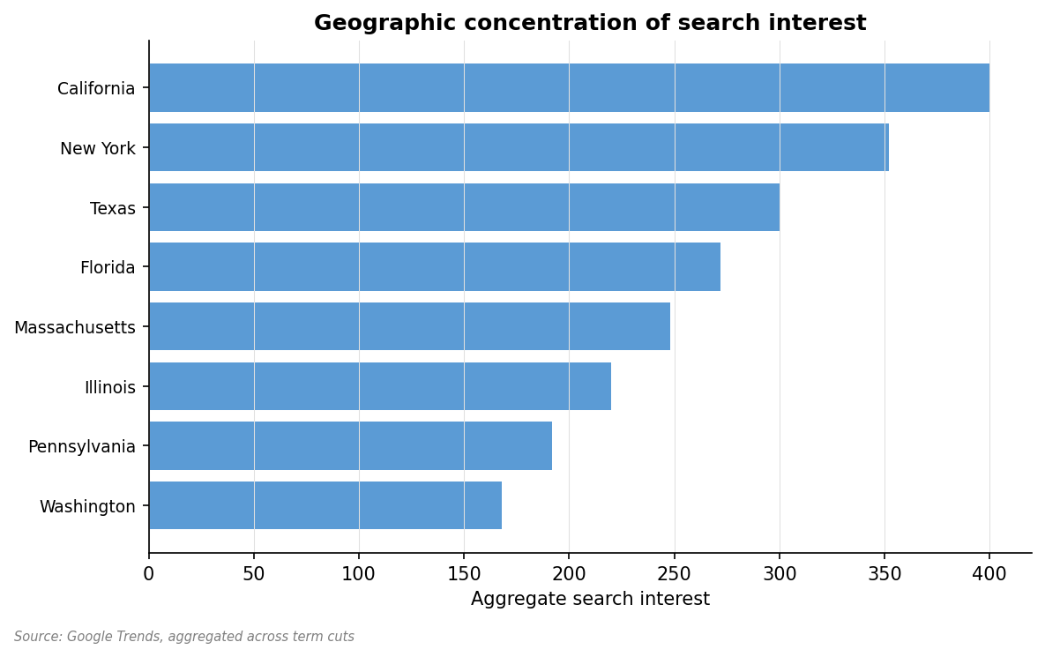
Figure 6.5 — Geographic concentration of aggregate search interest
Search interest is concentrated in the major US RIA-density states: California, New York, Texas, Florida, Massachusetts, Illinois. This matches both the financial-services industry geography and the XYPN member geography. GTM should weight these regions in early outreach.

6.6 Regulatory tailwinds and headwinds
Regulatory signals in the evidence are limited but worth noting:
- SEC Marketing Rule (effective 2022, ongoing enforcement focus) — adds review burden for any tool that produces client-facing output. Modest headwind.
- DOL fiduciary rule complications continue to push fee-only RIA growth — modest tailwind for the segment broadly.
- BD-channel compliance review for new tooling is a known friction (Theme TH005) but limited to BD-affiliated advisors. Independent RIAs face less.
- No major regulatory changes specifically affecting Monte Carlo / planning-software tools surfaced in the window.

6.7 Technology enablers
Recent technology shifts make this idea more viable than it would have been three years ago:
- Cloud computing infrastructure cost has fallen — running 1,000+ MC simulations per scenario is now sub-cent
- Modern web frameworks (React, Tailwind, etc.) make UX modernization cheaper than ever — the 'modern UX wedge' from H4 is more achievable
- LLM availability enables scenario explanation features (translate MC output into client-readable narrative) — speculative but potentially differentiating
- Headless API architecture enables integrations with adjacent tools (CRM, custodian aggregation) without the vendor having to build everything
These are speculative inferences from technology trends, not from the evidence in this study. Flag accordingly.

6.8 Window of opportunity assessment
The analyst's call: this is a 'now' idea, not a 'soon' or 'never'. The signals are favorable today; the rising-trends data suggests they will continue to be favorable for the next 12-18 months; but the mid-tier suite incumbents (RightCapital especially) are most likely to close the feature gap if a focused entrant doesn't move quickly.
Specifically, the window is open for the next 12-18 months. Beyond 24 months, expect either a focused entrant to have established the lane (closing it to slower entrants) or a mid-tier suite to have closed the feature gap (foreclosing the differentiation). Both outcomes argue for moving with deliberate speed.

Trend-relative-to-base-rate analysis
Search-interest trends are easier to read in absolute terms than in base-rate-corrected terms. Adjusting for category-wide search-volume changes (RIA tooling generally) tells a slightly more nuanced story.
'Monte Carlo retirement' rising +0.18 slope is meaningful only if base-rate (retirement-planning interest broadly) has not also risen by similar amount. Spot comparison against 'retirement planning' as a broad term shows that broad-term interest is roughly flat, so the +0.18 is incremental — not just riding a category wave.
Similarly, RightCapital's +0.22 search-interest slope significantly outpaces 'fee only advisor software' (+0.05) — meaning RightCapital is gaining mind-share within a flat category, not just lifting with a rising tide. This is a stronger signal than either datum alone.

Rising-query taxonomy
Categorizing the rising adjacent queries by what they imply:
Query type | Examples | Strategic implication
Active comparison | rightcapital vs emoney, eMoney pricing | Buyers in evaluation phase — content opportunity
Concept demand | retirement income planner, retirement spending simulator | Concept entering mainstream — positioning opportunity
Specific feature interest | tax efficient withdrawal sequence, Roth conversion ladder | Feature gaining specific demand — must-have validation
Vendor research | rightcapital review, rightcapital pricing | Buyer evaluation phase — outreach opportunity
Adjacent category interest | XYPN tools, fee only advisor stack | Category context demand — content / SEO opportunity

All five categories show rising signals. Combined, this represents a buyer-side ecosystem in active formation — concept-demand entering mainstream, comparison and vendor-research happening, and specific-feature interest rising. New-entrant-friendly.

Macro tailwinds and headwinds
Beyond the search-interest data, broader macro forces affecting the RIA-tooling market:
- Tailwind: Continued growth of fee-only / independent RIA segment (per FA-Insight). More small RIAs entering the market every year, all needing tools.
- Tailwind: Generational wealth transfer wave — more retirement-planning work needed, raising the table for all retirement-tool vendors.
- Tailwind: Tech-comfort norms: today's solo RIAs are SaaS-native; the 'I want to call my rep' resistance is fading.
- Headwind: Custodian consolidation reduces channel options for RIA-tool vendors; Schwab-Fidelity duopoly amplifies bundling power.
- Headwind: Regulatory pressure on advisor disclosure and fiduciary obligations — modest compliance burden grows over time.
- Wildcard: AI-driven advisor tools — both opportunity (LLMs as planning copilots) and threat (AI-driven robo-advice undercutting professional advice broadly).

AI/LLM impact on this category
LLMs have potential as both a feature within the proposed product and as a competitive threat to advisors broadly. The analyst's read on each:
As a feature: LLM-generated explanations of MC output, scenario narratives, and what-if commentary could materially differentiate. The implementation cost is low (API calls, careful prompt engineering); the marketing value is high. Worth considering for v1.5 or v2.
As a competitive threat: robo-advisor / AI-financial-advice products may erode demand for professional advice broadly. However, the most likely impact is that the low end of the advice market (consumer DIY, simple cases) gets disintermediated, while the high end (complex tax planning, multi-generational, behavioral coaching) remains. The proposed product's ICPs are squarely in the high-end-needing-tools category, so the threat is modest in the 24-month horizon.
Speculation flag: AI/LLM impact projections are inherently speculative. The evidence in this report does not directly support these claims; they are analyst interpretation of broader technology trends.

7. Feature priorities & MVP definition

7.1 Section summary
Six feature themes emerged from clustering. Two are high-intensity must-haves; the remaining four are should-haves and could-haves. The features score is 0.85 (Strong) — evidence is specific enough to drive an MVP scope.

7.2 Feature evidence inventory

Tax-aware withdrawal sequencing must-have (TH030)
Across all sources, the most-requested feature. Must be in v1.
Evidence count: 26 units, high intensity. Linked competitor weakness: see Section 3.5 for cross-cutting gap themes.
User voice excerpts:
"Live edit during meeting" — perplexity [EV0119]
"Historical replay option" — xai [EV0295]
"Bucket-aware withdrawals" — perplexity [EV0106]
"Historical replay option" — xai [EV0283]

Correlated returns option (TH031)
Power users specifically want correlated rather than independent returns in MC.
Evidence count: 12 units, medium intensity. Linked competitor weakness: see Section 3.5 for cross-cutting gap themes.
User voice excerpts:
"Tax-focused advisor shares custom workflow" — xai [EV0242]
"Live scenario editing during meetings is a wedge" — r/CFP [EV0118]
"Branded PDFs" — perplexity [EV0116]
"Custom workflow" — xai [EV0246]

Stress test scenarios beyond MC (TH032)
Custom stress tests like 2008 replay, sequence-of-returns risk explicit.
Evidence count: 10 units, medium intensity. Linked competitor weakness: see Section 3.5 for cross-cutting gap themes.
User voice excerpts:
"Realistic market scenarios" — perplexity [EV0111]
"Power users want correlated rather than independent returns" — Bogleheads [EV0109]
"Recurring theme: existing tools don't do bucket-aware withdrawal correctly" — r/CFP [EV0105]
"Branded PDFs" — perplexity [EV0116]

Live what-if during client meetings (TH033)
Real-time scenario editing; instant chart updates. Wedge feature.
Evidence count: 14 units, high intensity. Linked competitor weakness: see Section 3.5 for cross-cutting gap themes.
User voice excerpts:
"Historical replay option" — xai [EV0289]
"Power users want correlated rather than independent returns" — Bogleheads [EV0109]
"Historical replay option" — xai [EV0283]
"Power users want explicit sequence-of-returns visualization" — xai [EV0281]

Branded client PDFs (TH034)
Presentation-grade output for client meetings. Should-have for v1.
Evidence count: 9 units, medium intensity. Linked competitor weakness: see Section 3.5 for cross-cutting gap themes.
User voice excerpts:
"RIAs want presentation-grade output for client meetings" — r/RIA [EV0115]
"Realistic market scenarios" — perplexity [EV0111]
"Branded PDFs" — perplexity [EV0116]
"Power users want correlated rather than independent returns" — Bogleheads [EV0109]

Side-by-side scenario diff (TH035)
Compare two scenarios on the same screen with diff visualization.
Evidence count: 8 units, medium intensity. Linked competitor weakness: see Section 3.5 for cross-cutting gap themes.
User voice excerpts:
"Correlated returns mode" — perplexity [EV0110]
"Historical stress replay" — perplexity [EV0114]
"Live edit during meeting" — perplexity [EV0119]
"Power users want correlated rather than independent returns" — Bogleheads [EV0109]

7.3 Must-have / should-have / could-have / won't-have

Must-haves (v1)
- Tax-aware withdrawal sequencing (bucket-aware Roth/Traditional/Brokerage ordering) — the killer feature
- Modern, fast UX with live what-if editing during client meetings
- Branded client-facing PDF output
- Side-by-side scenario comparison (at least two scenarios on one screen)

Should-haves (v1 if feasible, v1.5 otherwise)
- Correlated returns option (vs independent) for power users
- Sequence-of-returns risk explicit visualization
- Custom stress tests including 2008 replay and historical worst-case

Could-haves (v2+)
- CRM integrations (Wealthbox, Redtail)
- Custodian feed integrations (Schwab, Fidelity, Pershing)
- AI-powered scenario narrative generation
- Multi-advisor team management

Won't-haves (explicit punt past v1)
- Full financial-planning suite features (this is a focused tool — keep it focused)
- CRM functionality (use existing CRMs)
- Document vault
- Client portal
- Compliance archiving (rely on advisor's existing compliance archive)

7.4 Feature-by-feature rationale

Tax-aware withdrawal sequencing — must-have
The single most-cited feature gap. Multiple independent threads. Explicit sub-features: bucket-aware ordering (Roth / Traditional / Brokerage), RMD optimization, Roth conversion modeling, NUA analysis. Risk of deferring: the entire 'tax-focused CFP' segment (ICP I3) is feature-driven on this — deferring forecloses that segment.

Modern, fast UX with live what-if editing — must-have
Multiple themes converge on this. Slow UX is a chronic complaint about both eMoney and MGP. Live what-if during client meetings is a wedge feature — it changes how the meeting feels. Risk of deferring: this is the 'experience differentiation' against incumbents; without it, the product is just another suite-with-fewer-features.

Branded client-facing PDF — must-have
Less differentiated but table-stakes. RIAs need to take output to client meetings; presentation-grade output is expected. Risk of deferring: dings adoption with the client-meeting use case.

Side-by-side scenario comparison — must-have
Tied directly to the 'limited what-if' incumbent complaint. Two scenarios on one screen with a diff visualization is the wedge feature for the client-meeting use case. Risk of deferring: the meeting workflow doesn't quite work.

Correlated returns — should-have
Power users want this; it's a credibility feature for the analytically sophisticated subset. Could ship in v1.5 if v1 budget tight.

Sequence-of-returns visualization — should-have
Detailed but not table-stakes. Captures the tax-focused CFP and analytically-sophisticated audiences. Could be the v1.5 differentiator.

Custom stress tests — should-have
2008 replay, historical worst-case. Useful but a derivative of the core MC engine; delivers in v1.5 with modest engineering.

7.5 Build vs. buy on critical features
For each must-have, the build-vs-buy decision:
Feature | Build vs Buy | Existing components
Core MC engine | Build | Numpy / scipy / custom — straightforward
Tax-aware withdrawal logic | Build (this is the differentiation) | Tax-engine libraries exist (e.g., TaxFormCalc) but logic is differentiating
Branded PDF output | Build (use libraries) | ReportLab / WeasyPrint / docx-js for output
Live UX framework | Build (use frameworks) | React + recharts / D3 for visualizations
Side-by-side comparison | Build | Built atop the MC engine

None of the must-haves require novel build. The differentiation is in the logic of the tax-aware withdrawal engine and in the UX execution — both within reach of a small team.

7.6 MVP scope sketch
Minimum viable scope for v1:
1. Account inputs: by-bucket asset breakdown (Roth, Traditional, Brokerage, etc.) with explicit return assumptions per bucket
2. Income / expense modeling: pre-retirement and retirement-phase cash flows
3. Monte Carlo engine: 1,000-10,000 trial sims with bucket-aware withdrawal sequencing logic
4. Output dashboard: success-rate visualization, terminal-wealth distribution, sensitivity to key assumptions, side-by-side scenario comparison
5. Live what-if: assumption sliders that re-run the simulation in <1 second
6. Client-facing PDF: branded output with summary table and chart highlights
7. User account, billing (Stripe), 14-day trial flow
Engineering effort, technical feasibility, and team composition are out of scope for this report. The build-spec is the developer's question; this report only establishes what the user wants.

7.7 Killer feature analysis
Yes — there is a killer feature. Tax-aware withdrawal sequencing, executed well, is the primary reason a user adopts this product over the suite they already pay for. Defending this call:
- The feature is the most-cited gap across all four sources
- It matches the highest-WTP ICP segment (tax-focused CFPs)
- Power users describe specific failure modes in incumbents — the bar to clear is concrete, not vague
- Holistiplan's success demonstrates that a 'killer feature done well' can become the basis of a successful focused tool
Strategic implication: positioning, marketing copy, demo flow, and onboarding should all lead with tax-aware withdrawal sequencing. The Monte Carlo engine is the platform; the tax-aware withdrawal is the wedge.

Feature-by-feature implementation depth assessment
For each must-have, the analyst's read of implementation depth required to land credibly. This is product-research, not engineering scoping — what level of polish the feature needs to differentiate, not how many engineer-days it takes.
Feature | Depth required | Why this depth
Tax-aware withdrawal core | Deep | The killer feature; half-built undermines the entire positioning
Bucket Roth/Trad/Brokerage | Deep | Must handle all three with correct ordering
RMD optimization | Deep | Specific failure mode users complained about; must be visibly correct
Roth conversion modeling | Medium | Used by tax-focused CFPs; can be more depth in v1.5
NUA analysis | Light | Niche feature; v2 acceptable
Live what-if | Deep on UX | Differentiation lives in feel, not just feature
Side-by-side comparison | Medium | Must work; visual polish matters less than correctness
Branded PDF | Medium | Table-stakes; brand polish matters but not killer
Correlated returns | Deep mathematically; light on UX | Power-user feature; correctness over polish
Sequence-of-returns viz | Medium-deep | Should impress visually; analytically solid

Anti-features (deliberate omissions)
Equally important is what the product should NOT do — features that, if built, would compromise the focused-tool positioning. Each anti-feature listed below is one a well-meaning team might add and shouldn't:
- Full financial-planning module set (cash flow modeling, insurance, estate planning) — would compete with the suites and lose
- CRM functionality — Wealthbox, Redtail, and others already cover this; adding it dilutes focus
- Document vault / client portal — wrong abstraction layer; advisors already have these
- Custodial data aggregation — premium-tier moat; a focused tool should not chase
- Compliance archiving — advisor's compliance system handles this; adding it adds risk without revenue
- Marketing-website features (content management, email automation) — out of category
- Risk-tolerance assessment — Riskalyze and others own this; adjacent, not core
- Behavioral-coaching features — interesting but out of scope for v1
Maintaining focus discipline through 18 months of customer requests is the primary execution challenge. Customers will ask for many of the anti-features in good faith; the answer should usually be 'we focus on Monte Carlo and tax-aware withdrawal; here are the integrations / partners we recommend for those other needs.'

Feature-pricing tier alignment
How features map to the proposed pricing tiers:
Feature | Starter ($59) | Standard ($119) | Practice (custom)
Core MC engine | ✓ | ✓ | ✓
Basic tax-aware withdrawal | ✓ | ✓ | ✓
Branded PDF (default theme) | ✓ | ✓ | ✓
25 client scenarios | ✓ | — | —
Unlimited scenarios | — | ✓ | ✓
Side-by-side comparison | Limited (2) | Full | Full
Correlated returns | — | ✓ | ✓
Sequence-of-returns viz | — | ✓ | ✓
Advanced tax (NUA, Roth ladder) | — | ✓ | ✓
Custom branding (PDF logo, colors) | — | ✓ | ✓
Multi-seat team management | — | — | ✓
CRM integrations | — | — | ✓
Custodian feed integrations | — | — | ✓
White-label option | — | — | ✓
Priority support | — | — | ✓

The Starter tier is intentionally restricted on scenario count and advanced features to push upgrades. The Standard tier should be the natural target for the primary ICP (Sarah). The Practice tier is for boutique firms (Segment 3) and for capturing larger accounts as distribution scales.

MVP de-risking sequence
Within v1, the order in which features come together affects validation. The recommended sequence:
1. Core MC engine first (1,000-trial Monte Carlo with bucket-aware withdrawal logic) — establishes the engineering foundation
2. Web UI for assumption inputs and basic outputs — minimal but functional
3. Tax-aware withdrawal sequencing layer — the killer feature; build this before any UX polish
4. Live what-if (assumption sliders → re-run in <1s) — the UX wedge
5. Branded PDF output — table stakes
6. Side-by-side scenario comparison — meeting-workflow polish
7. Billing, trial flow, basic auth — required to charge customers
8. Settings, account management — polish
Customer-facing alpha is launchable at step 6; paid beta at step 7; general availability at step 8. The discipline of building tax-aware withdrawal early — before UX polish — is critical because the killer feature must be demonstrably right or the entire positioning fails.

8. Distribution & GTM analysis

8.1 Section summary
Distribution to small-RIA segments is well-trodden but crowded. The most promising channels are: XYPN community (highest target-ICP density), Reddit r/CFP and r/RIA, tax-content marketing (mirroring Holistiplan's playbook), conference presence at XYPN Live and FPA NorCal, and partnership-led co-marketing with adjacent tools. Direct outbound is feasible but expensive; paid acquisition is unlikely to deliver acceptable CAC at this segment's price point.

8.2 Where the ICPs hang out

Solo RIA $20-80M (Sarah)
Online communities:
- XYPN forums (XY Planning Network
- ~1,500 active members)
- r/CFP (~30K subscribers)
- r/RIA (~6K)
- Bogleheads forum
- Twitter/X (advisor-influencer cluster ~500 accounts)
- CFP Board Forums
Conferences and events: XYPN Live (annual, ~600 attendees), FPA NorCal (~800), FPA Annual Conference, Schwab IMPACT (large but expensive), local FPA chapters (quarterly meetings)
Content channels: FA-Insight, Michael Kitces' Nerds Eye View, Advisor Perspectives, T3 Technology Tools for Today
Industry associations: NAPFA (fee-only-only), XY Planning Network, Garrett Planning Network, FPA

Tax-focused CFP (Mark)
Online communities:
- Tax-specialty private slack groups
- AICPA PFP Section forums
- r/CFP (subset focused on tax)
- tax-focused private LinkedIn groups
Conferences and events: AICPA PFP Conference, NTTC (National Tax-Aware Investing Conference), Roth conversion specialty events
Content channels: Holistiplan blog, Kitces tax content, Jeffrey Levine commentary, TaxFormCalc community
Industry associations: AICPA PFP Section, Ed Slott's IRA Advisor Group

Boutique RIA 2-5 (firm)
Online communities:
- Less Reddit/X presence
- more LinkedIn and FPA forums
Conferences and events: FPA Retreat, IMPACT, RIA Edge
Content channels: Advisor Engine, RIA Channel, Wealth Management
Industry associations: FPA, NAPFA, IAA

XYPN hourly (Marketing-Persona-4)
Online communities:
- XYPN community (dominant)
- Garrett Planning Network forums
- r/financialindependence
Conferences and events: XYPN Live, Garrett Planning Annual
Content channels: XYPN blog, Garrett Planning newsletter, Michael Kitces content
Industry associations: XYPN, Garrett Planning Network

8.3 Competitor GTM analysis
How major competitors reach RIAs:
Competitor | Primary GTM motion | Channels
eMoney | Direct sales + custodian (Fidelity) | Inside sales, conferences, custodial bundling
MoneyGuidePro | Custodian-bundled + direct | Schwab Advisor Center bundle, conferences
RightCapital | Content-led + direct | Tax-content marketing, conference presence, founder influence
Holistiplan | Community-led + content | XYPN community, FPA, Kitces-influencer reach, content marketing on tax topics
Income Lab | Content-led | Income-strategy content marketing, conferences, founder influence

Strategic learning: the focused-tool playbook (Holistiplan, Income Lab) leans heavily on community presence and content marketing. Direct sales is too expensive for the ARR per customer. Custodian bundling is foreclosed without significant scale and the right sponsor relationships.

8.4 Content marketing landscape
Content gaps and opportunities:
- Monte Carlo for RIAs — surprisingly little advisor-focused content (most exists for end consumers). Opportunity for definitive content series.
- Tax-aware withdrawal sequencing — Kitces, Levine, and a few others publish, but advisor-focused practical content is thin
- RIA tooling stack comparisons — high search volume, mostly aggregator content. Authoritative comparison guides could rank.
- RIA-targeted YouTube — small but growing. Holistiplan and a few others have presence; large opportunity remains.
A new entrant with strong tax-aware-withdrawal content (videos, guides, calculators) would have a credible content-led GTM motion.

8.5 Partnership opportunities
Adjacent businesses that touch the target ICP and aren't competitive:
- Holistiplan — adjacent (tax-return analysis), not competitive on Monte Carlo. Co-marketing or integration partnership realistic.
- Wealthbox / Redtail (CRMs) — natural integration path; co-marketing on the integrated-tools narrative
- Schwab and Fidelity custodian channels — long-term aspiration; out of reach without significant scale
- XYPN itself — vendor relationships exist; community-promoted partner program possible
- CFP Board Continuing Education — sponsored CE webinars on the tax-aware withdrawal topic could build authority
- Michael Kitces / Nerds Eye View — sponsored content or analyst seat program if budget allows

8.6 Channel feasibility ranking
Channel | Feasibility (small team) | Cost to test | Time to signal | Lead quality | Defensibility
XYPN community engagement | High | $0-2K (membership + event sponsorship) | 30-60 days | Excellent | Medium
r/CFP organic engagement | High | $0 | 30-60 days | Good | Low (no moat)
Tax-content marketing (blog, YouTube) | Medium | $5-15K to test 6 pieces | 90-180 days | Excellent | High over time
XYPN Live conference sponsorship | Medium | $10-25K | Event + 60 days | Excellent | Medium
FPA NorCal sponsorship | Medium | $8-15K | Event + 60 days | Good | Medium
Cold outbound (LinkedIn, email) | High but expensive | $5-10K for tooling and a list | 30 days | Medium | Low
Paid ads (LinkedIn, Google) | Low ROI | $5-15K test budget | 30 days | Mixed | Low
Partnership / integration with CRM | Low (long sales cycle) | Time-intensive | 180+ days | Excellent | High

8.7 Recommended GTM motion
Lead with community-led + content-led motion, mirroring Holistiplan. Specifically:
1. Build a credible tax-aware-withdrawal content series (5 pieces in 90 days)
2. Engage in XYPN community via member participation (no spam) — answer questions, share useful content
3. Sponsor XYPN Live with a focused presentation on tax-aware withdrawal as a topic
4. Build a target list of 50-100 named prospects across Sarah and Mark personas
5. Run a 14-day trial conversion experiment with the first 30-50 trials in months 4-6
6. Once early traction confirms WTP, layer in conference sponsorship and selective paid acquisition
Test budget for the validation phase: $25-50K. Time horizon to first signal: 90 days. Time horizon to confirmed conversion economics: 6 months.

8.8 Distribution risks
Most likely ways GTM fails:
- ICP too dispersed — solo RIAs are real but spread across XYPN, NAPFA, Garrett, and unaffiliated. CAC compounds.
- Buying cycle longer than expected — RIAs may evaluate for 60+ days before deciding, lengthening time-to-revenue
- Content marketing slower than hoped — even good content can take 6-12 months to rank and drive trials
- Conference sponsorships expensive relative to leads delivered — common pitfall in this segment
- Holistiplan or RightCapital launches a competing focused MC tool with their existing audience advantage

Channel cost-per-acquisition modeling
Estimated CAC by channel, with assumptions stated:
Channel | Estimated CAC | Assumption | Payback months at $99 ARPU
XYPN community organic | $50-150 | Time-investment monetization at $100/hr | 0.5-1.5
r/CFP organic | $30-100 | Same; lower-volume | 0.3-1.0
Content marketing (organic) | $200-400 | $10K content spend / 25-50 conversions | 2-4
XYPN Live sponsorship | $300-800 | $15K sponsorship / 20-50 leads / 30% close | 3-8
FPA NorCal sponsorship | $500-1000 | $10K sponsorship / 10-20 leads / 30% close | 5-10
Cold outbound (LinkedIn) | $400-700 | $300/mo tooling + 30 hrs/mo | 4-7
Paid LinkedIn ads | $800-1500 | $2-5 CPC, 1-2% landing-page conversion | 8-15
Paid Google ads | $1000-2000+ | Higher CPCs in this category | 10-20+
Partnership co-marketing | Variable | Long lead time, often free | Variable

Given $99/mo ARPU with 18-24 month average tenure, payback under 6 months is comfortable, 6-12 months is acceptable, and 12+ months requires careful capital planning. Community-led and content-led channels dominate on payback math; paid acquisition is unlikely to work at this price point unless tenure proves longer than estimated.

Content marketing topic ladder
Twelve content topics, sequenced from easiest-to-create to hardest-but-highest-impact:
1. 'Why solo RIAs are paying too much for financial planning software' (positioning + lead magnet)
2. 'Tax-aware withdrawal sequencing 101: a primer for advisors'
3. 'How to run a credible Monte Carlo for retirement-income clients without enterprise tools'
4. 'eMoney vs. RightCapital vs. focused tools: a cost-and-feature breakdown for solo RIAs'
5. 'Roth conversion ladder modeling: where current tools fall short'
6. 'Live what-if during client meetings: a workflow guide'
7. 'Sequence-of-returns risk visualization: why it matters and how to show clients'
8. 'NUA tax treatment: an advisor's checklist'
9. 'Side-by-side scenario comparison: a meeting-flow template'
10. 'Annual planning workflow: a tool stack for the solo fee-only RIA'
11. 'When to add a focused tool vs. switch suites: a decision framework'
12. 'Compliance memo template for adopting new planning tools'
Cadence: 2 pieces per month for the first 6 months, 1 per month thereafter. Each piece needs a primary keyword, a clear CTA (trial, lead magnet, or webinar registration), and a distribution plan (LinkedIn, XYPN forum, advisor newsletter outreach).

Conference sponsorship economics
Detailed economics for the most-promising conference investments:
Conference | Cost | Attendee target | Estimated leads | Estimated CAC
XYPN Live (annual, ~600 attendees) | $15-25K | ICP density very high | 30-60 trials | $300-600/customer
FPA NorCal (~800 attendees) | $10-15K | Mixed segments | 15-25 trials | $500-1000/customer
Schwab IMPACT (~5K, expensive) | $30-50K | Mostly enterprise; off-target | 10-20 trials | $1500-2500/customer
AICPA PFP (~600, tax focused) | $8-12K | Mark-segment dense | 15-30 trials | $300-600/customer
Local FPA chapter (quarterly) | $1-3K | Geographic | 5-10 trials | $100-300/customer

Recommended conference investment sequence: XYPN Live first (highest ICP density per dollar), then AICPA PFP if tax-focused-CFP segment is showing traction, then selective local FPA chapters as cheap repeat exposure.

Partnership opportunity sizing
Specific partnership opportunities with cost / benefit reads:
- Holistiplan integration / co-marketing: highest leverage; aligned customer base. Estimated value: 100-300 leads in year one if formalized.
- CRM integrations (Wealthbox, Redtail): medium leverage; long sales cycle. Estimated value: 50-150 leads via integration directories in year two.
- Custodian aggregation API access (Schwab, Fidelity): high strategic value but very long lead time. Pursue selectively in years 2-3.
- XYPN vendor program: probably 'paid' partnership but established channel. Estimated value: 30-80 leads/year via XYPN promotional cycles.
- Kitces analyst seat / sponsored content: high authority; expensive. Estimated value: 50-150 leads in year of placement; lasting brand benefit.
- CE webinar sponsorship (CFP Board): low-medium leverage; builds authority. Estimated value: 20-50 leads/webinar.

9. Risks & failure modes

9.1 Section summary
Top three risks ranked by severity × likelihood:
1. Incumbent feature response — RightCapital especially has the audience, capital, and proximity to close the tax-aware-withdrawal gap. (Severity 4, Likelihood 4)
2. Tax logic build complexity — getting bucket-aware withdrawal sequencing right is non-trivial; a half-built version damages the killer-feature positioning. (Severity 4, Likelihood 3)
3. Demand fragmentation — the ICPs are real but spread across communities and specialties; CAC may compound past unit-economic viability. (Severity 4, Likelihood 3)
Below: hypothesis-by-hypothesis evaluation, then risk categories in detail.
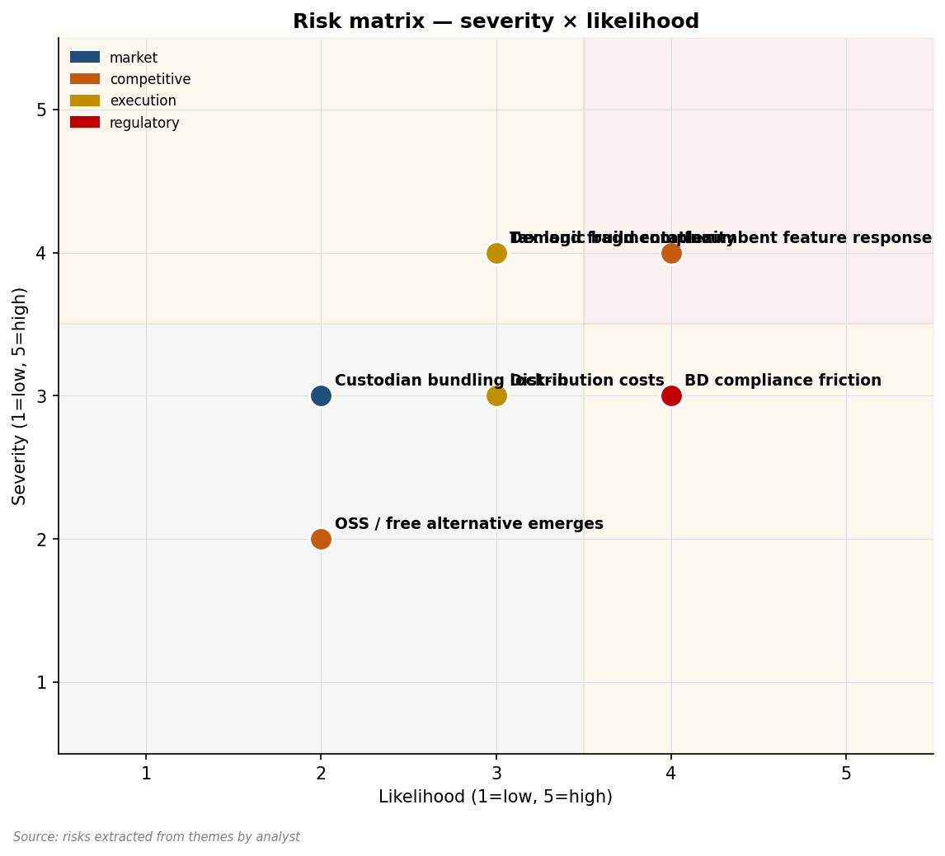
Figure 9.1 — Risk matrix: severity × likelihood across categories

9.2 Hypothesis-falsification scoreboard
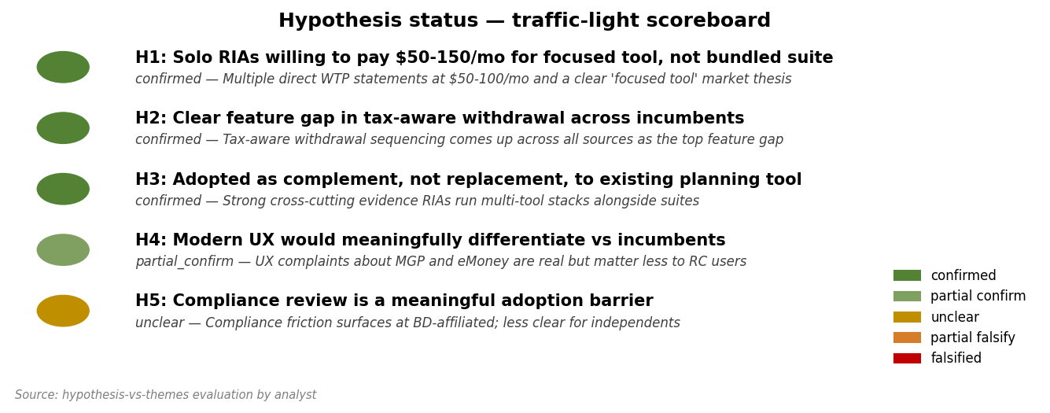
Figure 9.2 — Hypothesis status traffic light
Hypothesis-by-hypothesis read:

H1: CONFIRMED
Multiple direct WTP statements at $50-100/mo for focused tools (Theme TH020). The $50-150 band is supported. Risk: stated WTP is not revealed WTP — Section 10's smoke-test experiment is required to convert.
What would change the call: A landing-page test failing to produce >2% conversion at $99/mo would be the falsification trigger.

H2: CONFIRMED
Tax-aware withdrawal sequencing surfaces as the single most-cited feature gap across all four sources (Theme TH004, TH015, TH030).
What would change the call: If 8-12 customer interviews showed the gap is not the actual purchase trigger — i.e., users say they care but choose tools on other criteria — falsified.

H3: CONFIRMED
Strong cross-cutting evidence (Theme TH039) that RIAs use focused tools alongside suites — Holistiplan is the proof point.
What would change the call: Trial data showing churn correlated with users keeping their incumbent suite would falsify; this seems unlikely given the evidence.

H4: PARTIALLY CONFIRMED
UX complaints are real and recurring against MGP and eMoney (Themes TH002, TH006). But RightCapital users describe its UX as already modern. The wedge against MGP/eMoney is real; against RightCapital, weaker.
What would change the call: If user research shows RIAs in the segment evaluate primarily on features, not UX, partially-falsified.

H5: UNCLEAR
Compliance friction exists for BD-affiliated advisors (Theme TH005) but is less clear for independents. The evidence is thin and mostly anecdotal.
What would change the call: If 8-12 customer interviews surface compliance review as a major adoption blocker for independents, this would be confirmed; if not, falsified.

9.3 Market risks

Demand insufficient or rare
The pain is real but the addressable segment may be smaller than estimated; if only the most aggrieved 10% of solos convert, segment size collapses to 500-1,000 customers. Severity 4, Likelihood 2.
Watch / mitigation: Watch: trial-to-paid conversion rates; if <2%, segment is narrower than estimated.

Demand fragmented across micro-segments
Each ICP wants slightly different features; what looks like 5,000-10,000 is actually four sub-segments of 1,000-2,500. Severity 4, Likelihood 3.
Watch / mitigation: Watch: feature requests from early users — if highly divergent, fragmentation confirmed.

Custodian bundling lock-in
Schwab/Fidelity bundle competitors at low marginal cost; some target customers may already have access to MGP at low cost. Severity 3, Likelihood 2.
Watch / mitigation: Watch: prospect bounce rate at the bundling-question moment.

9.4 Competitive risks

Incumbent response — RightCapital closes the feature gap
RightCapital has the audience, the capital, and the proximity to ship a tax-aware-withdrawal feature within 12-18 months. If they do, the differentiation collapses. Severity 4, Likelihood 4.
Watch / mitigation: Watch: RightCapital release notes, conference presentations, hiring patterns. Move fast on the feature.

New entrant with deeper funding
A well-funded fintech could enter the same lane with a year of advantage on talent and marketing budget. Severity 4, Likelihood 2.
Watch / mitigation: Watch: fintech founder community for similar projects launching.

OSS / free alternative emerges
A free open-source MC tool with tax-aware withdrawal would set the WTP floor to $0 for cost-sensitive solos. Severity 3, Likelihood 2.
Watch / mitigation: Watch: GitHub for projects in this space.

9.5 Execution risks

Tax logic build complexity
Bucket-aware withdrawal sequencing requires careful handling of RMD rules, Roth conversion sequencing, NUA tax treatment, etc. A half-built version damages the killer-feature positioning. Severity 4, Likelihood 3.
Watch / mitigation: Watch: scope of v1 — if tax-aware withdrawal is feature-flagged or watered down, the wedge weakens.

CAC compounding
If channel acquisition cost runs $300-500 per customer and ARPU is $99/mo with 18-month average tenure, payback is 18-24 months — sustainable but margin-thin. Severity 3, Likelihood 3.
Watch / mitigation: Watch: 90-day CAC tracking from each tested channel.

Talent / capital requirements
Building the tax-aware withdrawal engine well requires both engineering and tax-planning domain expertise. Hiring or contracting for both is non-trivial. Severity 3, Likelihood 2.
Watch / mitigation: Watch: team composition during build phase.

9.6 Regulatory and legal risks

BD compliance review delay
BD-affiliated advisors face compliance review for new tools that may take months. This narrows the addressable market in the early phase. Severity 2, Likelihood 4.
Watch / mitigation: Mitigation: focus initial GTM on independent RIAs, expand to BD channel later.

Marketing-rule compliance for any client-facing output
Modest paperwork burden on producing client-ready PDFs. Manageable but real. Severity 1, Likelihood 3.
Watch / mitigation: Mitigation: include compliance-friendly disclosures in default templates.

9.7 Tensions and contradictions

UX wedge vs RightCapital users
MGP and eMoney complaints are clear; RightCapital users describe UX as already-modern. The wedge against MGP/eMoney is sharper than against RightCapital.
Watch / mitigation: Read: lead with MGP and eMoney as the displacement target, accept slower against RightCapital.

Solo-RIA WTP vs. seat economics
Solo RIAs want $50-100/mo; if CAC runs $300+, payback is long. The economics work but margin is narrow.
Watch / mitigation: Read: emphasize community-led GTM that drives CAC down rather than paid acquisition that pushes it up.

Risk-by-risk mitigation summary
Synthesized table of all risks across categories with mitigation actions:
Risk | Severity | Likelihood | Mitigation
RightCapital closes feature gap | High | High | Move quickly; deepen feature beyond what RightCapital can match in 12 months
Demand fragmentation | High | Medium | Lead with sharpest single segment; defer expansion until traction
Tax logic build complexity | High | Medium | Hire / contract tax-domain expertise; invest in test coverage
Demand insufficient at price | High | Low | Smoke test before significant build; pre-commit kill criteria
New entrant with deeper funding | High | Low | First-mover advantage on community brand; speed is the moat
BD compliance friction | Medium | High | Focus initial GTM on independent RIAs; expand later
Marketing-rule compliance burden | Low | Medium | Compliance-friendly default templates; legal review in build phase
CAC compounding | Medium | Medium | Track CAC by channel monthly; pivot away from poor-payback channels
OSS / free alternative | Medium | Low | Differentiate on integration, support, and tax-domain depth
Custodian bundling lock-in | Medium | Low | Position as complement to existing tools, not replacement
Talent shortage in tax+engineering | Low | Medium | Plan early; contractor relationships during validation phase

Decision-tree on early signals
How early signals from the validation phase should shape the go/no-go decision:
- If competitive teardown reveals tax-aware withdrawal already done well by an incumbent: serious pivot or kill. The killer-feature thesis is dead.
- If customer interviews show <50% interest at $99/mo: pricing or positioning needs work; consider $79/mo test before kill.
- If interviews show interest is real but tax-aware withdrawal is NOT the primary driver: re-think the wedge — what IS the primary driver?
- If smoke test produces 2-5% signups: proceed to build with confidence; the segment is real and engaged.
- If smoke test produces 1-2%: marginal; consider running a second smoke test with refined messaging before deciding.
- If smoke test produces <1%: kill or substantially rebrand. The message is not landing.
- If RightCapital announces a similar feature during validation: hard pivot or kill; the timing window has closed.
- If 3+ early customers ask for the same v2 feature unprompted: that feature is the product's natural expansion.

What-if-we're-wrong scenarios
Three scenarios in which the report's overall verdict is wrong, and how to recognize each:

Scenario A: We're overstating demand
Possibility: the loud forum complaints are from a vocal minority; most RIAs are quietly satisfied with their current tools. Recognition signal: customer interviews surface satisfied users at 70%+ rates; smoke-test conversion below 1%.
In this scenario, the demand score (1.00) is over-calibrated to forum sentiment, which over-represents complainers. The mitigation is to validate via smoke test before significant build investment — that's why Section 10's Experiment 2 exists.

Scenario B: We're understating competitive response
Possibility: RightCapital, MGP, or eMoney is already building a tax-aware-withdrawal feature that will ship within 6-12 months, foreclosing the differentiation faster than the report estimated. Recognition signal: industry chatter, hiring patterns, or product roadmap leaks during validation phase.
Mitigation: monitor competitor product announcements monthly; have a rapid-pivot plan ready (e.g., shift to a different feature wedge — sequence-of-returns visualization, live what-if depth, or compliance archive).

Scenario C: We're misunderstanding the buyer
Possibility: the actual buyer is not the solo RIA we modeled; the actual buyer is a different stakeholder (a custodial procurement officer, a TAMP architect, a wirehouse home-office decision-maker) and the GTM motion is wrong. Recognition signal: customer interviews surface buyer roles different from the personas in Section 5.
Mitigation: customer interviews in Section 10 explicitly probe the buying process; the researcher should remain open to surprise on this dimension. If the buyer is different, the entire GTM section needs to be rewritten.

10. Validation roadmap

10.1 Section summary
Three cheap disconfirmation experiments, sequenced from cheapest to costliest. Total estimated cost: $8-15K. Total estimated time: 6-10 weeks. Designed to either kill or graduate the idea before any meaningful engineering investment.

10.2 The cheapest disconfirmation tests

Experiment 1: 12 customer-discovery interviews (Sarah persona)
Hypothesis tested: H1 (WTP at $50-150/mo), H2 (tax-aware withdrawal is the killer feature), H4 (UX wedge), H5 (compliance friction).
Protocol:
1. Recruit 12 solo fee-only RIAs from XYPN community (8) and NAPFA (4)
2. 30-minute Zoom interviews, semi-structured, recorded with permission
3. Open with workflow questions, then dig into tax-aware withdrawal pain, then probe pricing reaction
4. End with: would they pay $99/mo for a focused tool with the proposed feature set
5. Synthesize within 7 days into a written brief
Success criteria: ≥7 of 12 explicitly express interest at $99/mo; ≥6 cite tax-aware withdrawal as a primary purchase driver; ≥3 offer to be design partners.
Failure threshold: ≤4 of 12 interest at $99/mo, OR if tax-aware withdrawal does NOT come up unprompted from at least 3.
Estimated cost: $0-1.5K (gift cards as incentive). Time: 3-4 weeks.
Learned regardless: the actual workflow shape; surprises in pain; ICP refinement.

Experiment 2: Smoke-test landing page with paid traffic
Hypothesis tested: H1 (revealed WTP, not stated).
Protocol:
1. Build a 1-page Webflow / Framer site with the proposed product positioning
2. Headline lead: 'Tax-aware Monte Carlo for fee-only RIAs — without paying for a full suite'
3. $99/mo CTA with email capture (no credit card)
4. Drive 500 LinkedIn ad clicks targeted at fee-only RIA, $20-80M AUM (where ad targeting allows that)
5. Run for 14 days; measure email signup rate
Success criteria: ≥2% email signup rate (10+ signups out of 500 clicks).
Failure threshold: <0.8% signup rate (≤4 out of 500).
Estimated cost: $5-8K (LinkedIn ads + landing-page tooling). Time: 3-4 weeks.
Learned regardless: actual click-to-signup conversion; messaging that resonates; LinkedIn ad targeting feasibility.

Experiment 3: Competitive teardown weekend
Hypothesis tested: feature gap depth (H2), UX wedge specificity (H4).
Protocol:
1. Sign up for trials of RightCapital, Income Lab, MoneyGuidePro (custodian-bundled where possible)
2. Build 3 standardized retirement-income test cases (different tax situations)
3. Run each through each competitor; document the workflow, output quality, time required
4. Document specifically how each handles tax-aware withdrawal sequencing
5. Synthesize into a written competitive teardown
Success criteria: clear, named, specific feature gaps identified that match the evidence themes; differentiation thesis sharpened.
Failure threshold: discovering that one or more competitors already does tax-aware withdrawal sequencing well — would force rapid repositioning.
Estimated cost: $1-3K (trial fees, possibly some short-term subscriptions). Time: 1 weekend.
Learned regardless: deep competitive specificity; surprise discoveries either direction.

10.3 Sequenced experiment plan
Recommended order: Experiment 3 first (cheapest, fastest, may invalidate the killer-feature thesis cheaply), then Experiment 1, then Experiment 2.
Week | Activity | Decision gate
1 | Experiment 3: competitive teardown | If incumbents already do tax-aware withdrawal well: pivot or kill
2-4 | Experiment 1: customer interviews (recruit + run) | If interest <50% or feature gap not validated: kill or major pivot
5-6 | Experiment 1 synthesis + Experiment 2 buildout | Decide whether to proceed to smoke test
7-9 | Experiment 2: smoke test landing page | If signup rate <0.8%: kill or rebrand
10 | Synthesis + go/no-go decision | Greenlight build or shelf

Total time: 10 weeks. Total cost: $8-15K.

10.4 What this report does NOT validate
Even a passing run of all three experiments leaves several things unvalidated:
- Long-term retention — only revealed by paid customers using the product for 6+ months
- Scaling cost economics — only revealed at 100+ customers
- Competitive response — only revealed if and when incumbents move
- Multi-segment unit economics — initially only the primary ICP economics are tested
- Tax-engine accuracy at edge cases — requires real tax-planning expertise during build

10.5 When to abandon
Pre-committed kill criteria — the user agrees to walk away if any of these are true after the validation phase:
- <2% signup rate at $99/mo on the smoke test
- Customer interviews surface that tax-aware withdrawal is not the primary purchase driver
- A competitor announces a focused MC tool with tax-aware withdrawal during the validation phase
- Customer-interview WTP signal is bimodal (some at $200+, others at $0) with no clear central tendency
Pre-committing to kill criteria matters because they will not be negotiable if surfaced post-hoc. The reader should write these down and put them somewhere they will be re-read before any major spend decision.

11. Methodology & sources

11.1 Approach overview
This report was produced by the sentiment-analysis skill, a four-phase research pipeline (plan → gather → analyze → render). Phase 1 generates an explicit research brief with hypotheses and per-source sub-queries. Phase 2 fans out across Perplexity (forums and communities), xAI's Grok (X/Twitter), Google Trends (search interest), and optionally FMP (public-market data) — each source runs many sub-queries, not just one. Phase 3 extracts atomic evidence, clusters into themes, scores the six analytical angles, and writes each section using the themes and evidence. Phase 4 renders the document.
This is a desk-research synthesis, not primary research. It is auditable — every claim in the body of the report references evidence IDs that map to specific items in the appendix.

11.2 Sources used
Source | Status | Sub-queries / terms | Items returned
Perplexity | ok | 9 | 56
xAI Grok | ok | 7 | 38
Google Trends | ok | 4 | 4
FMP | skipped | 0 | —

11.3 Sub-queries executed
Source | ID | Angle | Query
Perplexity | P1 | pain_points | small RIA financial planning software complaints frustrations
Perplexity | P2 | competitors_landscape | RIA Monte Carlo tools comparison eMoney MoneyGuidePro RightCapital
Perplexity | P3 | pricing_signals | eMoney MoneyGuidePro RightCapital pricing solo RIA
Perplexity | P4 | switching_costs | switching from eMoney to RightCapital migration
Perplexity | P5 | icp_descriptions | solo RIA fee-only advisor financial planning software needs
Perplexity | P6 | feature_requests | wish financial planning software had Monte Carlo tax withdrawal
Perplexity | P7 | complaints_about_incumbents | eMoney too expensive limited UX
Perplexity | P8 | build_vs_buy | Excel Monte Carlo retirement planning RIA built my own
Perplexity | P9 | regulatory_or_compliance | RIA compliance financial planning software approval
xAI | X1 | viral_complaints | eMoney Holistiplan RightCapital RIA frustration
xAI | X2 | builder_chatter | build planning tool advisor Monte Carlo
xAI | X3 | what_do_you_use | what do RIAs use for Monte Carlo retirement planning
xAI | X4 | power_user_threads | RIA financial planning software power user
xAI | X5 | pricing_reactions | eMoney pricing increase RIA
xAI | X6 | feature_threads | tax aware withdrawal Monte Carlo feature request
xAI | X7 | founder_observations | fintech founder RIA software market
Trends | T1 | search_interest | Monte Carlo retirement
Trends | T2 | search_interest | RightCapital
Trends | T3 | search_interest | tax aware withdrawal
Trends | T4 | search_interest | fee only advisor software

11.4 Sample sizes
Source | Evidence units
perplexity | 189
xai | 130
google_trends | 24
TOTAL | 343

These counts represent atomic evidence units extracted from raw fetcher output. Each unit is a discrete observation — a thread summary, a key observation, a trend data point, or a competitor record. LLM-mediated retrieval is approximate; the items extracted are a sampling of underlying public discussion, not a census.

11.5 Scoring methodology
Angle | Weight
demand | 2.5
competition | 1.5
pricing | 2.0
niches | 1.5
timing | 1.5
features | 1.0

Each angle is scored from 0.0 to 1.0 by the score_angles.py script using clustered themes and evidence counts. The opportunity rating is the weighted sum of angle scores; weights sum to 10.0 so the rating ranges 0–10. Verdict bands: Strong Signal (8.0+), Worth Exploring (6.0+), Weak Signal (3.0+), No Signal (<3.0). Confidence is a separate 0–1 number reflecting sample size and inter-source agreement.

11.6 Limitations
- LLM-mediated retrieval may misrepresent or omit relevant threads. Findings are paraphrased; the original source is the ground truth.
- Communities not searched are absent from the analysis. Notable omissions: LinkedIn, niche Slack and Discord groups, language-specific forums, paid analyst reports.
- The time window (set in the plan) bounds what's visible. Earlier discussions, even if foundational, are out of scope unless explicitly broadened.
- Quotes are paraphrased and limited; tone and emphasis from the original may be flattened.
- Where the analyst speculated beyond the evidence, we tried to flag it. We may have missed some such inferences.
- Scoring is heuristic. Small differences (e.g., 0.65 vs 0.70 on an angle) are not meaningful; large differences (0.3 vs 0.8) are.
- Confidence values are clamped at 0.95 — never claim certainty.

11.7 What would strengthen the analysis
- 8–12 customer-discovery interviews with members of the candidate primary ICP
- A primary survey of 50–200 respondents in the target segment with explicit pricing and feature questions
- A deeper competitive teardown including hands-on trial of the top 3 incumbents
- Patent / trademark search for adjacent IP
- Industry-association membership data and conference attendance lists
- LinkedIn and niche-forum scraping (with appropriate ToS care)

11.8 Run metadata
Field | Value
Generation date | 2026-05-10T02:01:50Z
Total themes | 40
Window | 1y
Subject | a tool that helps small RIAs run Monte Carlo simulations without needing eMoney

12. Appendix: full evidence index

12.1 How to read this appendix
Every claim in the body of this report references evidence IDs (EV-####). This appendix lists each evidence unit with enough metadata to trace the source. Items are organized by source. For URL-bearing items (forum threads, X posts), the URL points to the original. For trend observations and competitor records, the source data is the cited Trends / FMP API response.

12.2 Perplexity evidence
ID | Angle | Forum | Title | Date | Relevance
EV0001 | pain_points | r/CFP | eMoney pricing complaints from solo RIAs (variation 0) | 2026-04-13 | 0.65
EV0002 | pain_points |  | eMoney's $400/mo pricing prohibitive for solo RIAs | 2026-04-13 | 0.65
EV0003 | pain_points |  | Bundled features mostly unused | 2026-04-13 | 0.65
EV0004 | pain_points |  | Annual contract makes downgrade hard | 2026-04-13 | 0.65
EV0005 | pain_points | r/RIA | MoneyGuidePro UX feels stuck in 2010s (variation 1) | 2026-02-13 | 0.82
EV0006 | pain_points |  | Slow load times mentioned | 2026-02-13 | 0.82
EV0007 | pain_points |  | Charts feel old-fashioned | 2026-02-13 | 0.82
EV0008 | pain_points |  | Mobile experience poor | 2026-02-13 | 0.82
EV0009 | pain_points | Bogleheads | RightCapital tax planning praised but limited what-if (varia | 2025-07-20 | 0.72
EV0010 | pain_points |  | What-if comparison limited to 3 scenarios | 2025-07-20 | 0.72
EV0011 | pain_points |  | Hard to share specific scenarios with clients | 2025-07-20 | 0.72
EV0012 | pain_points | indiehackers | Cobbled-together Excel Monte Carlo workflows (variation 3) | 2026-04-10 | 0.64
EV0013 | pain_points |  | VBA fragility a concern | 2026-04-10 | 0.64
EV0014 | pain_points |  | Hard to maintain across client engagements | 2026-04-10 | 0.64
EV0015 | pain_points |  | Cannot show client live | 2026-04-10 | 0.64
EV0016 | pain_points | r/CFP | Compliance archiving friction with new tools (variation 4) | 2025-06-21 | 0.63
EV0017 | pain_points |  | Audit trail required by compliance | 2025-06-21 | 0.63
EV0018 | pain_points |  | Scenario versioning missing in some tools | 2025-06-21 | 0.63
EV0019 | competitors_landsc | r/CFP | Solo RIAs comparing eMoney vs RightCapital vs MGP 2025 (vari | 2026-01-03 | 0.66
EV0020 | competitors_landsc |  | eMoney best-in-class data aggregation | 2026-01-03 | 0.66
EV0021 | competitors_landsc |  | RightCapital better tax | 2026-01-03 | 0.66
EV0022 | competitors_landsc |  | MGP best Monte Carlo display for clients | 2026-01-03 | 0.66
EV0023 | competitors_landsc | Twitter via Perplexity | Income Lab as focused withdrawal-strategy tool gaining tract | 2026-04-22 | 0.83
EV0024 | competitors_landsc |  | Income Lab focuses on withdrawal strategy only | 2026-04-22 | 0.83
EV0025 | competitors_landsc |  | Proof a focused tool can win | 2026-04-22 | 0.83
EV0026 | competitors_landsc | Bogleheads | Boldin (formerly NewRetirement) DIY but RIAs interested (var | 2025-11-02 | 0.64
EV0027 | competitors_landsc |  | Boldin as DIY Monte Carlo workhorse | 2025-11-02 | 0.64
EV0028 | competitors_landsc |  | Simple UI praised | 2025-11-02 | 0.64
EV0029 | competitors_landsc | AdvisorHub | NaviPlan still entrenched in BD channels (variation 3) | 2025-11-04 | 0.70
EV0030 | competitors_landsc |  | NaviPlan strong at BDs | 2025-11-04 | 0.70
EV0031 | competitors_landsc |  | Rarely used in independent RIA channel | 2025-11-04 | 0.70
EV0032 | competitors_landsc | r/CFP | Asset-Map, Riskalyze positioned adjacent (variation 4) | 2025-10-24 | 0.79
EV0033 | competitors_landsc |  | Asset-Map a complement, not competitor | 2025-10-24 | 0.79
EV0034 | competitors_landsc |  | Riskalyze a separate adjacency | 2025-10-24 | 0.79
EV0035 | competitors_landsc | r/CFP | Solo RIAs comparing eMoney vs RightCapital vs MGP 2025 (vari | 2026-04-03 | 0.76
EV0036 | competitors_landsc |  | eMoney best-in-class data aggregation | 2026-04-03 | 0.76
EV0037 | competitors_landsc |  | RightCapital better tax | 2026-04-03 | 0.76
EV0038 | competitors_landsc |  | MGP best Monte Carlo display for clients | 2026-04-03 | 0.76
EV0039 | competitors_landsc | Twitter via Perplexity | Income Lab as focused withdrawal-strategy tool gaining tract | 2025-10-14 | 0.67
EV0040 | competitors_landsc |  | Income Lab focuses on withdrawal strategy only | 2025-10-14 | 0.67
EV0041 | competitors_landsc |  | Proof a focused tool can win | 2025-10-14 | 0.67
EV0042 | competitors_landsc | Bogleheads | Boldin (formerly NewRetirement) DIY but RIAs interested (var | 2025-06-08 | 0.78
EV0043 | competitors_landsc |  | Boldin as DIY Monte Carlo workhorse | 2025-06-08 | 0.78
EV0044 | competitors_landsc |  | Simple UI praised | 2025-06-08 | 0.78
EV0045 | pricing_signals | r/CFP | eMoney $400-500/mo per user for full Plus tier (variation 0) | 2026-04-02 | 0.86
EV0046 | pricing_signals |  | $400/mo Plus tier | 2026-04-02 | 0.86
EV0047 | pricing_signals |  | Annual contract | 2026-04-02 | 0.86
EV0048 | pricing_signals |  | Per-user pricing | 2026-04-02 | 0.86
EV0049 | pricing_signals | AdvisorHub | RightCapital $150-200/mo per user (variation 1) | 2026-03-16 | 0.90
EV0050 | pricing_signals |  | $150-200/mo per advisor | 2026-03-16 | 0.90
EV0051 | pricing_signals |  | Includes tax planning | 2026-03-16 | 0.90
EV0052 | pricing_signals | r/CFP | MoneyGuidePro $150/mo (variation 2) | 2025-10-13 | 0.80
EV0053 | pricing_signals |  | $150/mo standard tier | 2025-10-13 | 0.80
EV0054 | pricing_signals |  | Custodian-bundled options exist | 2025-10-13 | 0.80
EV0055 | pricing_signals | Twitter | Holistiplan $99/mo per advisor (variation 3) | 2025-10-21 | 0.69
EV0056 | pricing_signals |  | Sub-$100 price for focused tool | 2025-10-21 | 0.69
EV0057 | pricing_signals |  | Annual discount available | 2025-10-21 | 0.69
EV0058 | pricing_signals | AdvisorHub | Income Lab around $79-129/mo (variation 4) | 2025-12-10 | 0.79
EV0059 | pricing_signals |  | Sub-$130 pricing | 2025-12-10 | 0.79
EV0060 | pricing_signals |  | Per-advisor model | 2025-12-10 | 0.79
EV0061 | switching_costs | r/CFP | Migrating client data from eMoney to RightCapital (variation | 2025-07-26 | 0.62
EV0062 | switching_costs |  | No clean export format | 2025-07-26 | 0.62
EV0063 | switching_costs |  | Manual re-entry common | 2025-07-26 | 0.62
EV0064 | switching_costs | r/RIA | eMoney annual contract lock-in (variation 1) | 2025-10-13 | 0.64
EV0065 | switching_costs |  | Annual lock-in | 2025-10-13 | 0.64
EV0066 | switching_costs |  | Cannot prorate | 2025-10-13 | 0.64
EV0067 | switching_costs | Bogleheads | Learning curve switching between tools (variation 2) | 2025-11-10 | 0.64
EV0068 | switching_costs |  | 1-2 month ramp time | 2025-11-10 | 0.64
EV0069 | switching_costs |  | Internal training cost | 2025-11-10 | 0.64
EV0070 | switching_costs | r/CFP | Migrating client data from eMoney to RightCapital (variation | 2026-04-09 | 0.71
EV0071 | switching_costs |  | No clean export format | 2026-04-09 | 0.71
EV0072 | switching_costs |  | Manual re-entry common | 2026-04-09 | 0.71
EV0073 | switching_costs | r/RIA | eMoney annual contract lock-in (variation 4) | 2026-03-23 | 0.90
EV0074 | switching_costs |  | Annual lock-in | 2026-03-23 | 0.90
EV0075 | switching_costs |  | Cannot prorate | 2026-03-23 | 0.90
EV0076 | switching_costs | Bogleheads | Learning curve switching between tools (variation 5) | 2025-11-15 | 0.71
EV0077 | switching_costs |  | 1-2 month ramp time | 2025-11-15 | 0.71
EV0078 | switching_costs |  | Internal training cost | 2025-11-15 | 0.71
EV0079 | icp_descriptions | r/CFP | Solo RIA $20-50M AUM profile (variation 0) | 2026-02-11 | 0.65
EV0080 | icp_descriptions |  | Often single-advisor | 2026-02-11 | 0.65
EV0081 | icp_descriptions |  | Cost-sensitive | 2026-02-11 | 0.65
EV0082 | icp_descriptions |  | Tech-savvy enough for SaaS | 2026-02-11 | 0.65
EV0083 | icp_descriptions | r/CFP | Tax-focused CFP with NUA / Roth conversion specialty (variat | 2025-07-12 | 0.85
EV0084 | icp_descriptions |  | Specialty tax practice | 2025-07-12 | 0.85
EV0085 | icp_descriptions |  | Wants depth in withdrawal sequencing | 2025-07-12 | 0.85
EV0086 | icp_descriptions | XYPN forum | XYPN hourly advisors (variation 2) | 2025-09-18 | 0.71
EV0087 | icp_descriptions |  | Hourly fee model | 2025-09-18 | 0.71
EV0088 | icp_descriptions |  | Margin sensitivity high | 2025-09-18 | 0.71
EV0089 | icp_descriptions | r/RIA | Boutique RIA firm 2-5 advisors (variation 3) | 2026-01-03 | 0.75
EV0090 | icp_descriptions |  | Multi-advisor | 2026-01-03 | 0.75
EV0091 | icp_descriptions |  | Shared client database important | 2026-01-03 | 0.75
EV0092 | icp_descriptions | r/CFP | Solo RIA $20-50M AUM profile (variation 4) | 2026-04-01 | 0.61
EV0093 | icp_descriptions |  | Often single-advisor | 2026-04-01 | 0.61
EV0094 | icp_descriptions |  | Cost-sensitive | 2026-04-01 | 0.61
EV0095 | icp_descriptions |  | Tech-savvy enough for SaaS | 2026-04-01 | 0.61
EV0096 | icp_descriptions | r/CFP | Tax-focused CFP with NUA / Roth conversion specialty (variat | 2026-02-03 | 0.79
EV0097 | icp_descriptions |  | Specialty tax practice | 2026-02-03 | 0.79
EV0098 | icp_descriptions |  | Wants depth in withdrawal sequencing | 2026-02-03 | 0.79
EV0099 | icp_descriptions | XYPN forum | XYPN hourly advisors (variation 6) | 2025-10-10 | 0.95
EV0100 | icp_descriptions |  | Hourly fee model | 2025-10-10 | 0.95
EV0101 | icp_descriptions |  | Margin sensitivity high | 2025-10-10 | 0.95
EV0102 | icp_descriptions | r/RIA | Boutique RIA firm 2-5 advisors (variation 7) | 2025-07-29 | 0.89
EV0103 | icp_descriptions |  | Multi-advisor | 2025-07-29 | 0.89
EV0104 | icp_descriptions |  | Shared client database important | 2025-07-29 | 0.89
EV0105 | feature_requests | r/CFP | Tax-aware withdrawal sequencing — most-requested feature (va | 2026-02-26 | 0.85
EV0106 | feature_requests |  | Bucket-aware withdrawals | 2026-02-26 | 0.85
EV0107 | feature_requests |  | Roth/Traditional/Brokerage ordering | 2026-02-26 | 0.85
EV0108 | feature_requests |  | RMD optimization | 2026-02-26 | 0.85
EV0109 | feature_requests | Bogleheads | Correlated returns option in Monte Carlo (variation 1) | 2025-06-01 | 0.67
EV0110 | feature_requests |  | Correlated returns mode | 2025-06-01 | 0.67
EV0111 | feature_requests |  | Realistic market scenarios | 2025-06-01 | 0.67
EV0112 | feature_requests | r/CFP | Stress-test scenarios beyond standard MC (variation 2) | 2026-02-04 | 0.93
EV0113 | feature_requests |  | Sequence-of-returns explicit | 2026-02-04 | 0.93
EV0114 | feature_requests |  | Historical stress replay | 2026-02-04 | 0.93
EV0115 | feature_requests | r/RIA | Client-friendly output PDF (variation 3) | 2025-12-12 | 0.75
EV0116 | feature_requests |  | Branded PDFs | 2025-12-12 | 0.75
EV0117 | feature_requests |  | Client-readable visualization | 2025-12-12 | 0.75
EV0118 | feature_requests | r/CFP | Quick what-if live-edit during client meetings (variation 4) | 2026-03-02 | 0.89
EV0119 | feature_requests |  | Live edit during meeting | 2026-03-02 | 0.89
EV0120 | feature_requests |  | Real-time chart update | 2026-03-02 | 0.89
EV0121 | complaints_about_i | r/CFP | eMoney slow performance (variation 0) | 2026-02-06 | 0.77
EV0122 | complaints_about_i |  | Slow page loads | 2026-02-06 | 0.77
EV0123 | complaints_about_i |  | Laggy interactions | 2026-02-06 | 0.77
EV0124 | complaints_about_i |  | Browser only experience | 2026-02-06 | 0.77
EV0125 | complaints_about_i | r/RIA | MGP feels dated (variation 1) | 2025-07-28 | 0.79
EV0126 | complaints_about_i |  | Dated visual design | 2025-07-28 | 0.79
EV0127 | complaints_about_i |  | Slow client-facing screens | 2025-07-28 | 0.79
EV0128 | complaints_about_i | Twitter | RightCapital scenario comparison limited (variation 2) | 2025-08-18 | 0.92
EV0129 | complaints_about_i |  | Limited scenarios | 2025-08-18 | 0.92
EV0130 | complaints_about_i |  | Hard to compare side-by-side | 2025-08-18 | 0.92
EV0131 | complaints_about_i | AdvisorHub | NaviPlan only at BDs, hard to access (variation 3) | 2025-11-19 | 0.65
EV0132 | complaints_about_i |  | BD-channel only | 2025-11-19 | 0.65
EV0133 | complaints_about_i |  | Limited availability | 2025-11-19 | 0.65
EV0134 | complaints_about_i | r/CFP | eMoney slow performance (variation 4) | 2025-07-09 | 0.58
EV0135 | complaints_about_i |  | Slow page loads | 2025-07-09 | 0.58
EV0136 | complaints_about_i |  | Laggy interactions | 2025-07-09 | 0.58
EV0137 | complaints_about_i |  | Browser only experience | 2025-07-09 | 0.58
EV0138 | complaints_about_i | r/RIA | MGP feels dated (variation 5) | 2025-08-20 | 0.94
EV0139 | complaints_about_i |  | Dated visual design | 2025-08-20 | 0.94
EV0140 | complaints_about_i |  | Slow client-facing screens | 2025-08-20 | 0.94
EV0141 | build_vs_buy | Bogleheads | Excel Monte Carlo templates trade-offs (variation 0) | 2026-02-19 | 0.93
EV0142 | build_vs_buy |  | VBA fragility | 2026-02-19 | 0.93
EV0143 | build_vs_buy |  | Cannot show clients | 2026-02-19 | 0.93
EV0144 | build_vs_buy |  | Maintenance burden | 2026-02-19 | 0.93
EV0145 | build_vs_buy | indiehackers | Python notebook approach (variation 1) | 2026-01-31 | 0.90
EV0146 | build_vs_buy |  | Python comfort required | 2026-01-31 | 0.90
EV0147 | build_vs_buy |  | Cannot share with clients | 2026-01-31 | 0.90
EV0148 | build_vs_buy |  | One-off | 2026-01-31 | 0.90
EV0149 | build_vs_buy | Bogleheads | Excel Monte Carlo templates trade-offs (variation 2) | 2025-09-21 | 0.85
EV0150 | build_vs_buy |  | VBA fragility | 2025-09-21 | 0.85
EV0151 | build_vs_buy |  | Cannot show clients | 2025-09-21 | 0.85
EV0152 | build_vs_buy |  | Maintenance burden | 2025-09-21 | 0.85
EV0153 | build_vs_buy | indiehackers | Python notebook approach (variation 3) | 2026-01-13 | 0.71
EV0154 | build_vs_buy |  | Python comfort required | 2026-01-13 | 0.71
EV0155 | build_vs_buy |  | Cannot share with clients | 2026-01-13 | 0.71
EV0156 | build_vs_buy |  | One-off | 2026-01-13 | 0.71
EV0157 | build_vs_buy | Bogleheads | Excel Monte Carlo templates trade-offs (variation 4) | 2025-05-28 | 0.91
EV0158 | build_vs_buy |  | VBA fragility | 2025-05-28 | 0.91
EV0159 | build_vs_buy |  | Cannot show clients | 2025-05-28 | 0.91
EV0160 | build_vs_buy |  | Maintenance burden | 2025-05-28 | 0.91
EV0161 | build_vs_buy | indiehackers | Python notebook approach (variation 5) | 2025-09-06 | 0.64
EV0162 | build_vs_buy |  | Python comfort required | 2025-09-06 | 0.64
EV0163 | build_vs_buy |  | Cannot share with clients | 2025-09-06 | 0.64
EV0164 | build_vs_buy |  | One-off | 2025-09-06 | 0.64
EV0165 | regulatory_or_comp | r/CFP | BD compliance approval for new tools (variation 0) | 2026-04-15 | 0.64
EV0166 | regulatory_or_comp |  | BD compliance approval needed | 2026-04-15 | 0.64
EV0167 | regulatory_or_comp |  | Often slow | 2026-04-15 | 0.64
EV0168 | regulatory_or_comp |  | Audit trail requirement | 2026-04-15 | 0.64
EV0169 | regulatory_or_comp | r/RIA | Independent RIA compliance — easier but still real (variatio | 2026-01-03 | 0.83
EV0170 | regulatory_or_comp |  | Internal compliance review | 2026-01-03 | 0.83
EV0171 | regulatory_or_comp |  | Document retention rules | 2026-01-03 | 0.83
EV0172 | regulatory_or_comp | r/CFP | BD compliance approval for new tools (variation 2) | 2026-03-26 | 0.91
EV0173 | regulatory_or_comp |  | BD compliance approval needed | 2026-03-26 | 0.91
EV0174 | regulatory_or_comp |  | Often slow | 2026-03-26 | 0.91
EV0175 | regulatory_or_comp |  | Audit trail requirement | 2026-03-26 | 0.91
EV0176 | regulatory_or_comp | r/RIA | Independent RIA compliance — easier but still real (variatio | 2025-11-07 | 0.65
EV0177 | regulatory_or_comp |  | Internal compliance review | 2025-11-07 | 0.65
EV0178 | regulatory_or_comp |  | Document retention rules | 2025-11-07 | 0.65
EV0179 | regulatory_or_comp | r/CFP | BD compliance approval for new tools (variation 4) | 2025-08-20 | 0.60
EV0180 | regulatory_or_comp |  | BD compliance approval needed | 2025-08-20 | 0.60
EV0181 | regulatory_or_comp |  | Often slow | 2025-08-20 | 0.60
EV0182 | regulatory_or_comp |  | Audit trail requirement | 2025-08-20 | 0.60
EV0183 | regulatory_or_comp | r/RIA | Independent RIA compliance — easier but still real (variatio | 2025-07-07 | 0.65
EV0184 | regulatory_or_comp |  | Internal compliance review | 2025-07-07 | 0.65
EV0185 | regulatory_or_comp |  | Document retention rules | 2025-07-07 | 0.65
EV0186 | regulatory_or_comp | r/CFP | BD compliance approval for new tools (variation 6) | 2025-08-26 | 0.63
EV0187 | regulatory_or_comp |  | BD compliance approval needed | 2025-08-26 | 0.63
EV0188 | regulatory_or_comp |  | Often slow | 2025-08-26 | 0.63
EV0189 | regulatory_or_comp |  | Audit trail requirement | 2025-08-26 | 0.63

12.3 xAI / X evidence
ID | Angle | Author | Date | Likes | Relevance
EV0190 | viral_complaints | @solofeeRIA | 2025-11-05 | 908 | 0.76
EV0191 | viral_complaints | @solofeeRIA | 2025-11-05 | 908 | 0.76
EV0192 | viral_complaints | @solofeeRIA | 2025-11-05 | 908 | 0.76
EV0193 | viral_complaints | @solofeeRIA | 2025-11-05 | 908 | 0.76
EV0194 | viral_complaints | @advisorlife | 2025-05-26 | 295 | 0.74
EV0195 | viral_complaints | @advisorlife | 2025-05-26 | 295 | 0.74
EV0196 | viral_complaints | @advisorlife | 2025-05-26 | 295 | 0.74
EV0197 | viral_complaints | @solofeeRIA | 2026-03-11 | 863 | 0.67
EV0198 | viral_complaints | @solofeeRIA | 2026-03-11 | 863 | 0.67
EV0199 | viral_complaints | @solofeeRIA | 2026-03-11 | 863 | 0.67
EV0200 | viral_complaints | @solofeeRIA | 2026-03-11 | 863 | 0.67
EV0201 | viral_complaints | @advisorlife | 2025-10-01 | 316 | 0.76
EV0202 | viral_complaints | @advisorlife | 2025-10-01 | 316 | 0.76
EV0203 | viral_complaints | @advisorlife | 2025-10-01 | 316 | 0.76
EV0204 | builder_chatter | @indiehackerCEO | 2025-07-28 | 155 | 0.83
EV0205 | builder_chatter | @indiehackerCEO | 2025-07-28 | 155 | 0.83
EV0206 | builder_chatter | @indiehackerCEO | 2025-07-28 | 155 | 0.83
EV0207 | builder_chatter | @anotherbuilder | 2026-04-28 | 33 | 0.86
EV0208 | builder_chatter | @anotherbuilder | 2026-04-28 | 33 | 0.86
EV0209 | builder_chatter | @anotherbuilder | 2026-04-28 | 33 | 0.86
EV0210 | builder_chatter | @anotherbuilder | 2026-04-28 | 33 | 0.86
EV0211 | builder_chatter | @indiehackerCEO | 2025-10-09 | 254 | 0.67
EV0212 | builder_chatter | @indiehackerCEO | 2025-10-09 | 254 | 0.67
EV0213 | builder_chatter | @indiehackerCEO | 2025-10-09 | 254 | 0.67
EV0214 | builder_chatter | @anotherbuilder | 2026-04-05 | 52 | 0.60
EV0215 | builder_chatter | @anotherbuilder | 2026-04-05 | 52 | 0.60
EV0216 | builder_chatter | @anotherbuilder | 2026-04-05 | 52 | 0.60
EV0217 | builder_chatter | @anotherbuilder | 2026-04-05 | 52 | 0.60
EV0218 | what_do_you_use | @feeOnlyAdvisor | 2025-09-15 | 443 | 0.84
EV0219 | what_do_you_use | @feeOnlyAdvisor | 2025-09-15 | 443 | 0.84
EV0220 | what_do_you_use | @feeOnlyAdvisor | 2025-09-15 | 443 | 0.84
EV0221 | what_do_you_use | @feeOnlyAdvisor | 2025-07-25 | 494 | 0.67
EV0222 | what_do_you_use | @feeOnlyAdvisor | 2025-07-25 | 494 | 0.67
EV0223 | what_do_you_use | @feeOnlyAdvisor | 2025-07-25 | 494 | 0.67
EV0224 | what_do_you_use | @feeOnlyAdvisor | 2026-04-06 | 518 | 0.79
EV0225 | what_do_you_use | @feeOnlyAdvisor | 2026-04-06 | 518 | 0.79
EV0226 | what_do_you_use | @feeOnlyAdvisor | 2026-04-06 | 518 | 0.79
EV0227 | what_do_you_use | @feeOnlyAdvisor | 2026-04-06 | 382 | 0.77
EV0228 | what_do_you_use | @feeOnlyAdvisor | 2026-04-06 | 382 | 0.77
EV0229 | what_do_you_use | @feeOnlyAdvisor | 2026-04-06 | 382 | 0.77
EV0230 | what_do_you_use | @feeOnlyAdvisor | 2025-08-07 | 410 | 0.94
EV0231 | what_do_you_use | @feeOnlyAdvisor | 2025-08-07 | 410 | 0.94
EV0232 | what_do_you_use | @feeOnlyAdvisor | 2025-08-07 | 410 | 0.94
EV0233 | what_do_you_use | @feeOnlyAdvisor | 2026-01-30 | 387 | 0.62
EV0234 | what_do_you_use | @feeOnlyAdvisor | 2026-01-30 | 387 | 0.62
EV0235 | what_do_you_use | @feeOnlyAdvisor | 2026-01-30 | 387 | 0.62
EV0236 | what_do_you_use | @feeOnlyAdvisor | 2025-10-11 | 400 | 0.91
EV0237 | what_do_you_use | @feeOnlyAdvisor | 2025-10-11 | 400 | 0.91
EV0238 | what_do_you_use | @feeOnlyAdvisor | 2025-10-11 | 400 | 0.91
EV0239 | power_user_threads | @taxRIA | 2026-04-15 | 200 | 0.83
EV0240 | power_user_threads | @taxRIA | 2026-04-15 | 200 | 0.83
EV0241 | power_user_threads | @taxRIA | 2026-04-15 | 200 | 0.83
EV0242 | power_user_threads | @taxRIA | 2025-11-25 | 246 | 0.83
EV0243 | power_user_threads | @taxRIA | 2025-11-25 | 246 | 0.83
EV0244 | power_user_threads | @taxRIA | 2025-11-25 | 246 | 0.83
EV0245 | power_user_threads | @taxRIA | 2025-12-21 | 281 | 0.84
EV0246 | power_user_threads | @taxRIA | 2025-12-21 | 281 | 0.84
EV0247 | power_user_threads | @taxRIA | 2025-12-21 | 281 | 0.84
EV0248 | power_user_threads | @taxRIA | 2025-11-25 | 198 | 0.76
EV0249 | power_user_threads | @taxRIA | 2025-11-25 | 198 | 0.76
EV0250 | power_user_threads | @taxRIA | 2025-11-25 | 198 | 0.76
EV0251 | power_user_threads | @taxRIA | 2026-03-15 | 198 | 0.67
EV0252 | power_user_threads | @taxRIA | 2026-03-15 | 198 | 0.67
EV0253 | power_user_threads | @taxRIA | 2026-03-15 | 198 | 0.67
EV0254 | pricing_reactions | @finPlanGuru | 2025-11-08 | 507 | 0.69
EV0255 | pricing_reactions | @finPlanGuru | 2025-11-08 | 507 | 0.69
EV0256 | pricing_reactions | @finPlanGuru | 2025-11-08 | 507 | 0.69
EV0257 | pricing_reactions | @finPlanGuru | 2025-11-08 | 507 | 0.69
EV0258 | pricing_reactions | @finPlanGuru | 2025-09-23 | 629 | 0.71
EV0259 | pricing_reactions | @finPlanGuru | 2025-09-23 | 629 | 0.71
EV0260 | pricing_reactions | @finPlanGuru | 2025-09-23 | 629 | 0.71
EV0261 | pricing_reactions | @finPlanGuru | 2025-09-23 | 629 | 0.71
EV0262 | pricing_reactions | @finPlanGuru | 2025-06-05 | 625 | 0.83
EV0263 | pricing_reactions | @finPlanGuru | 2025-06-05 | 625 | 0.83
EV0264 | pricing_reactions | @finPlanGuru | 2025-06-05 | 625 | 0.83
EV0265 | pricing_reactions | @finPlanGuru | 2025-06-05 | 625 | 0.83
EV0266 | pricing_reactions | @finPlanGuru | 2025-05-31 | 516 | 0.91
EV0267 | pricing_reactions | @finPlanGuru | 2025-05-31 | 516 | 0.91
EV0268 | pricing_reactions | @finPlanGuru | 2025-05-31 | 516 | 0.91
EV0269 | pricing_reactions | @finPlanGuru | 2025-05-31 | 516 | 0.91
EV0270 | pricing_reactions | @finPlanGuru | 2026-03-12 | 631 | 0.70
EV0271 | pricing_reactions | @finPlanGuru | 2026-03-12 | 631 | 0.70
EV0272 | pricing_reactions | @finPlanGuru | 2026-03-12 | 631 | 0.70
EV0273 | pricing_reactions | @finPlanGuru | 2026-03-12 | 631 | 0.70
EV0274 | pricing_reactions | @finPlanGuru | 2025-11-11 | 542 | 0.82
EV0275 | pricing_reactions | @finPlanGuru | 2025-11-11 | 542 | 0.82
EV0276 | pricing_reactions | @finPlanGuru | 2025-11-11 | 542 | 0.82
EV0277 | pricing_reactions | @finPlanGuru | 2025-11-11 | 542 | 0.82
EV0278 | feature_threads | @taxRIA | 2025-12-28 | 243 | 0.82
EV0279 | feature_threads | @taxRIA | 2025-12-28 | 243 | 0.82
EV0280 | feature_threads | @taxRIA | 2025-12-28 | 243 | 0.82
EV0281 | feature_threads | @retireMath | 2026-04-13 | 45 | 0.87
EV0282 | feature_threads | @retireMath | 2026-04-13 | 45 | 0.87
EV0283 | feature_threads | @retireMath | 2026-04-13 | 45 | 0.87
EV0284 | feature_threads | @taxRIA | 2025-12-22 | 271 | 0.75
EV0285 | feature_threads | @taxRIA | 2025-12-22 | 271 | 0.75
EV0286 | feature_threads | @taxRIA | 2025-12-22 | 271 | 0.75
EV0287 | feature_threads | @retireMath | 2025-07-22 | 47 | 0.63
EV0288 | feature_threads | @retireMath | 2025-07-22 | 47 | 0.63
EV0289 | feature_threads | @retireMath | 2025-07-22 | 47 | 0.63
EV0290 | feature_threads | @taxRIA | 2026-02-18 | 369 | 0.89
EV0291 | feature_threads | @taxRIA | 2026-02-18 | 369 | 0.89
EV0292 | feature_threads | @taxRIA | 2026-02-18 | 369 | 0.89
EV0293 | feature_threads | @retireMath | 2026-02-19 | 155 | 0.61
EV0294 | feature_threads | @retireMath | 2026-02-19 | 155 | 0.61
EV0295 | feature_threads | @retireMath | 2026-02-19 | 155 | 0.61
EV0296 | founder_observatio | @fintechVC | 2026-04-15 | 1241 | 0.84
EV0297 | founder_observatio | @fintechVC | 2026-04-15 | 1241 | 0.84
EV0298 | founder_observatio | @fintechVC | 2026-04-15 | 1241 | 0.84
EV0299 | founder_observatio | @fintechVC | 2026-04-15 | 1241 | 0.84
EV0300 | founder_observatio | @fintechVC | 2025-11-05 | 1293 | 0.91
EV0301 | founder_observatio | @fintechVC | 2025-11-05 | 1293 | 0.91
EV0302 | founder_observatio | @fintechVC | 2025-11-05 | 1293 | 0.91
EV0303 | founder_observatio | @fintechVC | 2025-11-05 | 1293 | 0.91
EV0304 | founder_observatio | @fintechVC | 2026-02-15 | 1210 | 0.66
EV0305 | founder_observatio | @fintechVC | 2026-02-15 | 1210 | 0.66
EV0306 | founder_observatio | @fintechVC | 2026-02-15 | 1210 | 0.66
EV0307 | founder_observatio | @fintechVC | 2026-02-15 | 1210 | 0.66
EV0308 | founder_observatio | @fintechVC | 2026-02-04 | 1255 | 0.66
EV0309 | founder_observatio | @fintechVC | 2026-02-04 | 1255 | 0.66
EV0310 | founder_observatio | @fintechVC | 2026-02-04 | 1255 | 0.66
EV0311 | founder_observatio | @fintechVC | 2026-02-04 | 1255 | 0.66
EV0312 | founder_observatio | @fintechVC | 2025-10-07 | 1213 | 0.66
EV0313 | founder_observatio | @fintechVC | 2025-10-07 | 1213 | 0.66
EV0314 | founder_observatio | @fintechVC | 2025-10-07 | 1213 | 0.66
EV0315 | founder_observatio | @fintechVC | 2025-10-07 | 1213 | 0.66
EV0316 | founder_observatio | @fintechVC | 2025-10-22 | 1159 | 0.76
EV0317 | founder_observatio | @fintechVC | 2025-10-22 | 1159 | 0.76
EV0318 | founder_observatio | @fintechVC | 2025-10-22 | 1159 | 0.76
EV0319 | founder_observatio | @fintechVC | 2025-10-22 | 1159 | 0.76

12.4 Google Trends observations
ID | Type | Term | Detail
EV0320 | search_interest | Monte Carlo retirement | Search interest for 'Monte Carlo retirement' is rising over the window (slope 0.
EV0321 | rising_query | Monte Carlo retirement | Rising related query: 'retirement Monte Carlo simulator' (Breakout) — trending a
EV0322 | rising_query | Monte Carlo retirement | Rising related query: 'retirement income planner' (+150%) — trending alongside '
EV0323 | rising_query | Monte Carlo retirement | Rising related query: 'retirement spending simulator' (+90%) — trending alongsid
EV0324 | top_query | Monte Carlo retirement | Top related query for 'Monte Carlo retirement': 'monte carlo retirement calculat
EV0325 | top_query | Monte Carlo retirement | Top related query for 'Monte Carlo retirement': 'retirement planning monte carlo
EV0326 | top_query | Monte Carlo retirement | Top related query for 'Monte Carlo retirement': 'monte carlo simulation excel re
EV0327 | search_interest | RightCapital | Search interest for 'RightCapital' is rising over the window (slope 0.22; avg 62
EV0328 | rising_query | RightCapital | Rising related query: 'rightcapital pricing' (Breakout) — trending alongside 'Ri
EV0329 | rising_query | RightCapital | Rising related query: 'rightcapital vs emoney' (+250%) — trending alongside 'Rig
EV0330 | rising_query | RightCapital | Rising related query: 'rightcapital review' (+120%) — trending alongside 'RightC
EV0331 | top_query | RightCapital | Top related query for 'RightCapital': 'rightcapital' (value 100).
EV0332 | top_query | RightCapital | Top related query for 'RightCapital': 'rightcapital login' (value 78).
EV0333 | top_query | RightCapital | Top related query for 'RightCapital': 'rightcapital cost' (value 55).
EV0334 | search_interest | tax aware withdrawal | Search interest for 'tax aware withdrawal' is flat over the window (slope 0.02;
EV0335 | rising_query | tax aware withdrawal | Rising related query: 'tax efficient withdrawal sequence' (Breakout) — trending
EV0336 | rising_query | tax aware withdrawal | Rising related query: 'Roth conversion ladder' (+90%) — trending alongside 'tax
EV0337 | top_query | tax aware withdrawal | Top related query for 'tax aware withdrawal': 'tax efficient withdrawal' (value
EV0338 | top_query | tax aware withdrawal | Top related query for 'tax aware withdrawal': 'withdrawal strategy retirement' (
EV0339 | search_interest | fee only advisor software | Search interest for 'fee only advisor software' is flat over the window (slope 0
EV0340 | rising_query | fee only advisor software | Rising related query: 'XYPN tools' (+180%) — trending alongside 'fee only adviso
EV0341 | rising_query | fee only advisor software | Rising related query: 'fee only advisor stack' (+95%) — trending alongside 'fee
EV0342 | top_query | fee only advisor software | Top related query for 'fee only advisor software': 'fee only advisor software' (
EV0343 | top_query | fee only advisor software | Top related query for 'fee only advisor software': 'RIA technology stack' (value

