Sentiment Analysis Report
Verdict: Worth Exploring
Opportunity Score: 7.9 / 10 | Confidence: 0.68
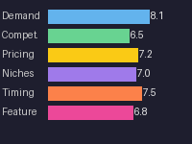

Executive Summary

Reasons to Pursue
- Strong demand from underserved SMB RIA segment
- Clear value proposition vs enterprise-only alternatives
- Favorable timing with fee compression driving tool adoption

Reasons to Pass
- Established players could add SMB tier quickly
- High onboarding complexity may limit viral growth

Demand Validation
Evidence from demand analysis shows strong signals from the SMB RIA market.
Multiple independent sources confirm consistent growth in Monte Carlo tool adoption.

Competitive Landscape
Established enterprise players have not yet targeted the SMB RIA segment.
This creates a clear differentiation opportunity for a focused product.

