CHANGES HISTORY
PIC | Date | Remarks
BJM.MR | 2018.05.03 | Created
Ghaida | 2018.05.03

TOC
- Simpi User
- Pm Visit
- Pm Visit File
- Pm Recommendation
- Parameter Analyst Quarter
- Parameter Analyst Recommendation
- Pm Model
- Pm Model Securities
- Pm Model Portfolio

Diagram ENTITY RELATIONSHIP

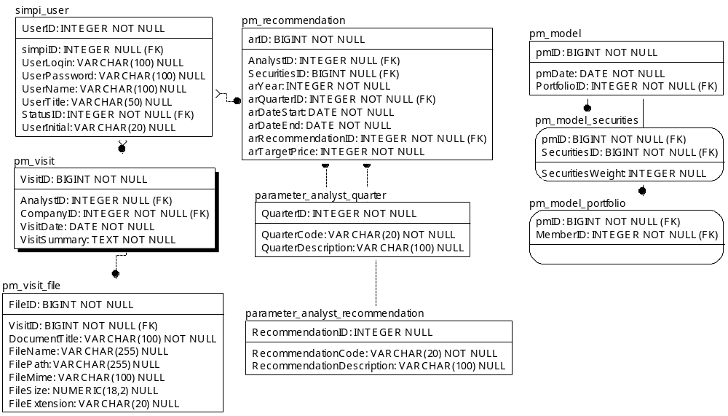

TABLE RELATIONSHIP
No | Table 1 | Table 2 | Type (1:1; 1:N; M:N) | Description
 | simpi_user | pm_visit | M:N
 | pm_visit | pm_visit_file | M:N
 | simpi_user | pm_recommendation | M:N
 | parameter_analyst_quarter | pm_recommendation | M:N
 | parameter_analyst_recommendation | pm_recommendation | M:N
 | pm_model | pm_model_securities | M:N
 | pm_model | pm_model_portfolio | M:N

Name |  | simpi_user
Objective
No | Column |  | Type | Rule  (PK, FK, Key, NN, Unik, Index) | Description
1. | UserID |  | Integer | NN
2. | UserLogin |  | Varchar(100) | Null
3. | UserPassword |  | Varchar(100) | Null
4. | UserName |  | Varchar(100) | Null
5. | UserTitle |  | Varchar(50) | Null
6. | simpiID |  | Integer | FK, Null
7. | UserInitial |  | Varchar(20) | Null
8. | StatusID |  | Integer | FK

SAMPLE DATA
No | Column | Sample 1 | Sample 2 | Sample 3 | Sample 4
1. | UserID | 1 | 2 | 49 | 50
2. | UserLogin | root | juna94@bjmanunggal.co.id | fdheapangestika@yahoo.com | mochamad.junaidi94@gmail.com
3. | UserPassword | 648e30bdee3f067646ab0536eebbbc69 | 648e30bdee3f067646ab0536eebbbc69 | b5dbdb9b59f753fabddcd8d3c54d9353 | 648e30bdee3f067646ab0536eebbbc69
4. | UserName | root | Mochamad Junaidis | Dhea Pangestika | Mochamad Junaidi
5. | UserTitle | root | Managers | Staff | Manager
6. | simpiID | 1 | 1 | 812 | 1
7. | UserInitial | root | MJs | FDP | juna94
8. | StatusID | 1 | 1 | 1 | 1

Name |  | pm_visit
Objective
No | Column |  | Type | Rule  (PK, FK, Key, NN, Unik, Index) | Description
1. | VisitID |  | BIGInteger | NN
2. | AnalystID |  | Integer | FK, Null
3. | CompanyID |  | Integer | FK
4. | VisitDate |  | Date | NN
5. | VisitSummary |  | Text | NN

SAMPLE DATA
No | Column | Sample 1 | Sample 2 | Sample 3 | Sample 4
1. | VisitID | 2
2. | AnalystID | 1
3. | CompanyID | 597
4. | VisitDate | 2016-11-10
5. | VisitSummary | Lorem ipsum dolor sit amet, consectetur adipiscing elit. Donec finibus, quam ac rhoncus sollicitudin, turpis sem accumsan mi, laoreet placerat leo lorem id velit. Nam at lacus sagittis, iaculis eros a, faucibus augue. Duis ac lacinia ex. EDIT

Name |  | pm_visit_file
Objective
No | Column |  | Type | Rule  (PK, FK, Key, NN, Unik, Index) | Description
1. | FileID |  | BIGInteger | NN
2. | VisitID |  | Integer | FK
3. | DocumentTitle |  | BIGInteger | FK
4. | FileName |  | Date | NN
5. | FilePath |  | Date | NN
6. | FileMime |  | Date | NN
7. | FileSize |  | TINYInteger | NN
8. | FileExtension |  | Numeric(30,9) | Null

SAMPLE DATA
No | Column | Sample 1 | Sample 2 | Sample 3 | Sample 4
1. | FileID | 1
2. | VisitID | 2
3. | DocumentTitle | analystmodel
4. | FileName | analystmodel.pptx
5. | FilePath | D:\OMS\APPS\oms.simpi-pro\Document\analyst model.pptx
6. | FileMime | pptx
7. | FileSize | 166
8. | FileExtension | pptx

Name |  | pm_recommendation
Objective
No | Column |  | Type | Rule  (PK, FK, Key, NN, Unik, Index) | Description
1. | arID |  | BIGInteger | NN
2. | AnanlystID |  | Integer | FK, Null
3. | SecuritiesID |  | BIGInteger | FK, Null
4. | arYear |  | Integer | NN
5. | arQuarterID |  | Integer | FK
6. | arDateStart |  | Date | NN
7. | arDateEnd |  | Date | NN
8. | arRecommendationID |  | Integer | FK
9. | arTargetPrice |  | Integer | NN

SAMPLE DATA
No | Column | Sample 1 | Sample 2 | Sample 3 | Sample 4
1. | arID | 1 | 2
2. | AnanlystID | 0
3. | SecuritiesID | 0
4. | arYear | 2016 | 2016
5. | arQuarterID | 4 | 1
6. | arDateStart | 11/8/2016 | 1/4/2017
7. | arDateEnd | 12/8/2016 | 1/21/2017
8. | arRecommendationID | 1 | 2
9. | arTargetPrice | 123 | 45

Name |  | parameter_analyst_quarter
Objective
No | Column |  | Type | Rule  (PK, FK, Key, NN, Unik, Index) | Description
1. | QuarterID |  | Integer | NN
2. | QuarterCode |  | Varchar(20) | NN
3. | QuarterDescription |  | Varchar(100) | Null

SAMPLE DATA
No | Column | Sample 1 | Sample 2 | Sample 3 | Sample 4
1. | QuarterID | 1 | 2 | 3 | 4
2. | QuarterCode | Q1 | Q2 | Q3 | Q4
3. | QuarterDescription | First Quarter | Second Quarter | Third Quarter | Fourth Quarter

Name |  | parameter_analyst_recommendation
Objective
No | Column |  | Type | Rule  (PK, FK, Key, NN, Unik, Index) | Description
1. | RecommendationID |  | Integer | Null
2. | RecommendationCode |  | Varchar(20) | NN
3. | RecommendationDescription |  | Varchar(100) | Null

SAMPLE DATA
No | Column | Sample 1 | Sample 2 | Sample 3 | Sample 4
1. | RecommendationID | 1 | 2 | 3
2. | RecommendationCode | OW | UW | N
3. | RecommendationDescription | Over weight | Under weight | Neutral

Name |  | pm_model
Objective
No | Column |  | Type | Rule  (PK, FK, Key, NN, Unik, Index) | Description
1. | pmID |  | BIGInteger | NN
2. | pmDate |  | Date | NN
3. | PortfolioID |  | Integer | FK

SAMPLE DATA
No | Column | Sample 1 | Sample 2 | Sample 3 | Sample 4
1. | pmID
2. | pmDate
3. | PortfolioID

Name |  | pm_model_securities
Objective
No | Column |  | Type | Rule  (PK, FK, Key, NN, Unik, Index) | Description
1. | pmID |  | BIGInteger | FK
2. | SecuritiesID |  | BIGInteger | FK
3. | SecuritiesWeight |  | Integer | Null

SAMPLE DATA
No | Column | Sample 1 | Sample 2 | Sample 3 | Sample 4
1. | pmID
2. | SecuritiesID
3. | SecuritiesWeight

Name |  | pm_model_portfolio
Objective
No | Column |  | Type | Rule  (PK, FK, Key, NN, Unik, Index) | Description
1. | pmID |  | BIGInteger | FK
2. | MemberID |  | Integer | FK

SAMPLE DATA
No | Column | Sample 1 | Sample 2 | Sample 3 | Sample 4
1. | pmID
2. | MemberID

