CHANGES HISTORY
PIC | Date | Remarks
BJM.MR | 2018.05.03 | Created
Ghaida | 2018.05.03

TOC
- Ots Order
- Ots Order Portfolio
- Ots Trade
- Ots Ticket
- Ots Blotter
- Ots Note
- Ots Trade Eq
- Ots Trade Detail
- Ots Blotter Portfolio
- Ots Blotter Fill
- Ots Blotter Log
- Parameter Oms
- Ots Trade Fund
- Ots Trade Fi
- Ots Omstrade

Diagram ENTITY RELATIONSHIP

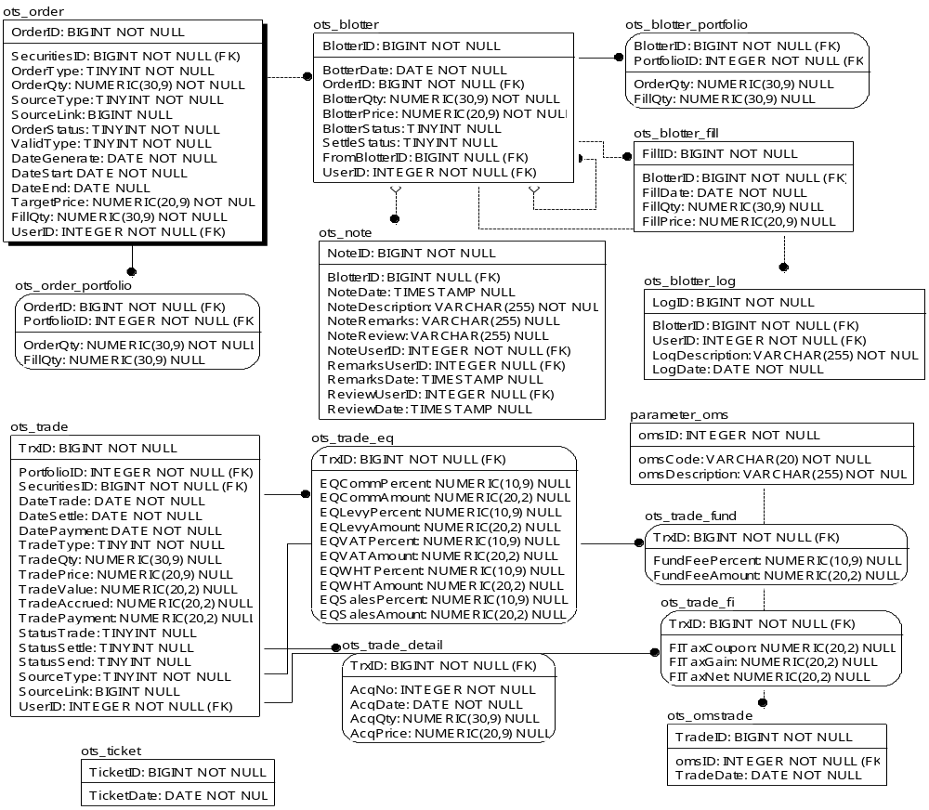
TABLE RELATIONSHIP
No | Table 1 | Table 2 | Type (1:1; 1:N; M:N) | Description
 | ots_order | ots_blotter | M:N
 | ots_order | ots_portfolio | M:N
 | ots_order | ots_trade_eq | 1:1
 | ots_trade | ots_trade_detail | 1:1
 | ots_trade | ots_trade_fund | M:N
 | ots_trade | ots_trade_fi | M:N
 | ots_blotter | ots_note | M:N
 | ots_blotter | ots_blotter_portfolio | M:N
 | ots_blotter | ots_blotter_fill | M:N
 | ots_blotter | ots_blotter | M:N
 | ots_blotter | ots_blotter_log | M:N
 | parameter_oms | ots_omstrade | M:N

Name |  | ots_order
Objective
No | Column |  | Type | Rule  (PK, FK, Key, NN, Unik, Index) | Description
1. | OrderID |  | BIGInteger | NN
2. | SecuritiesID |  | BIGInteger | FK
3. | OrderType |  | TINYInteger | NN
4. | OrderQty |  | Numeric(30,9) | NN
5. | SourceType |  | TINYInteger | NN
6. | SourceLink |  | BIGInteger | Null
7. | OrderStatus |  | TINYInteger | NN
8. | ValidType |  | TINYInteger | NN
9. | DateGenerate |  | Date | NN
10. | DateStart |  | Date | NN
11. | DateEnd |  | Date | Null
12. | TargetPrice |  | Numeric(20,9) | NN
13. | FillQty |  | Numeric(30,9) | NN
14. | UserID |  | Integer | FK

SAMPLE DATA
No | Column | Sample 1 | Sample 2 | Sample 3 | Sample 4
1. | OrderID
2. | SecuritiesID
3. | OrderType
4. | OrderQty
5. | SourceType
6. | SourceLink
7. | OrderStatus
8. | ValidType
9. | DateGenerate
10. | DateStart
11. | DateEnd
12. | TargetPrice
13. | FillQty
14. | UserID

Name |  | ots_order_portfolio
Objective
No | Column |  | Type | Rule  (PK, FK, Key, NN, Unik, Index) | Description
1. | OrderID |  | BIGInteger | FK
2. | PortfolioID |  | Integer | FK
3. | OrderQty |  | Numeric(30,9) | NN
4. | FillQty |  | Numeric(30,9) | Null

SAMPLE DATA
No | Column | Sample 1 | Sample 2 | Sample 3 | Sample 4
1. | OrderID
2. | PortfolioID
3. | OrderQty
4. | FillQty

Name |  | ots_trade
Objective
No | Column |  | Type | Rule  (PK, FK, Key, NN, Unik, Index) | Description
1. | TrxID |  | BIGInteger | NN
2. | PortfolioID |  | Integer | FK
3. | SecuritiesID |  | BIGInteger | FK
4. | DateTrade |  | Date | NN
5. | DateSettle |  | Date | NN
6. | DatePayment |  | Date | NN
7. | TradeType |  | TINYInteger | NN
8. | TradeQty |  | Numeric(30,9) | Null
9. | TradePrice |  | Numeric(20,9) | Null
10. | TradeValue |  | Numeric(20,2) | Null
11. | TradeAccrued |  | Numeric(20,2) | Null
12. | TradePayment |  | Numeric(20,2) | Null
13. | StatusTrade |  | TINYInteger | Null
14. | StatusSettle |  | TINYInteger | Null
15. | StatusSend |  | TINYInteger | Null
16. | SourceType |  | TINYInteger | NN
17. | SourceLink |  | BIGInteger | Null
18. | UserID |  | Integer | FK

SAMPLE DATA
No | Column | Sample 1 | Sample 2 | Sample 3 | Sample 4
1. | TrxID
2. | PortfolioID
3. | SecuritiesID
4. | DateTrade
5. | DateSettle
6. | DatePayment
7. | TradeType
8. | TradeQty
9. | TradePrice
10. | TradeValue
11. | TradeAccrued
12. | TradePayment
13. | StatusTrade
14. | StatusSettle
15. | StatusSend
16. | SourceType
17. | SourceLink
18. | UserID

Name |  | ots_ticket
Objective
No | Column |  | Type | Rule  (PK, FK, Key, NN, Unik, Index) | Description
1. | TIcketID |  | BIGInteger | NN
2. | TicketDate |  | Date | NN

SAMPLE DATA
No | Column | Sample 1 | Sample 2 | Sample 3 | Sample 4
1. | TIcketID
2. | TicketDate

Name |  | ots_blotter
Objective
No | Column |  | Type | Rule  (PK, FK, Key, NN, Unik, Index) | Description
1. | BlotterID |  | BIGInteger | NN
2. | BlotterDate |  | Date | NN
3. | OrderID |  | BIGInteger | FK
4. | BlotterQty |  | Numeric(30,9) | NN
5. | BlotterPrice |  | Numeric(20,9) | NN
6. | BlotterStatus |  | TINYInteger | Null
7. | SettleStatus |  | TINYInteger | Null
8. | FormBlotterID |  | BIGInteger | FK, Null
9. | UserID |  | Integer | FK

SAMPLE DATA
No | Column | Sample 1 | Sample 2 | Sample 3 | Sample 4
1. | BlotterID
2. | BlotterDate
3. | OrderID
4. | BlotterQty
5. | BlotterPrice
6. | BlotterStatus
7. | SettleStatus
8. | FormBlotterID
9. | UserID

Name |  | ots_notes
Objective
No | Column |  | Type | Rule  (PK, FK, Key, NN, Unik, Index) | Description
1. | NoteID |  | BIGInteger | NN
2. | BlotterID |  | BIGInteger | FK
3. | NoteDate |  | TimeStamp | Null
4. | NoteDescription |  | Varchar(255) | NN
5. | NoteRemarks |  | Varchar(255) | Null
6. | NoteReview |  | Varchar(255) | Null
7. | NoteUserID |  | Integer | FK
8. | RemarksUserID |  | Integer | FK, Null
9. | RemarksDate |  | TimeStamp | Null
10. | ReviewUserID |  | Integer | FK,Null
11. | ReviewDate |  | TimeStamp | Null

SAMPLE DATA
No | Column | Sample 1 | Sample 2 | Sample 3 | Sample 4
1. | NoteID
2. | BlotterID
3. | NoteDate
4. | NoteDescription
5. | NoteRemarks
6. | NoteReview
7. | NoteUserID
8. | RemarksUserID
9. | RemarksDate
10. | ReviewUserID
11. | ReviewDate

Name |  | ots_trade_eq
Objective
No | Column |  | Type | Rule  (PK, FK, Key, NN, Unik, Index) | Description
1. | TrxID |  | BIGInteger | FK
2. | EQCommPercent |  | Numeric(10,9) | Null
3. | EQCommAmount |  | Numeric(20,2) | Null
4. | EQLevyPercent |  | Numeric(10,9) | Null
5. | EQLevyAmount |  | Numeric(20,2) | Null
6. | EQVATPercent |  | Numeric(10,9) | Null
7. | EQVATAmount |  | Numeric(20,2) | Null
8. | EQWHTPercent |  | Numeric(10,9) | Null
9. | EQWHTAmount |  | Numeric(20,2) | Null
10. | EQSalesPercent |  | Numeric(10,9) | Null
11. | EQSalesAmount |  | Numeric(20,2) | Null

SAMPLE DATA
No | Column | Sample 1 | Sample 2 | Sample 3 | Sample 4
1. | TrxID
2. | EQCommPercent
3. | EQCommAmount
4. | EQLevyPercent
5. | EQLevyAmount
6. | EQVATPercent
7. | EQVATAmount
8. | EQWHTPercent
9. | EQWHTAmount
10. | EQSalesPercent
11. | EQSalesAmount

Name |  | ots_trade_detail
Objective
No | Column |  | Type | Rule  (PK, FK, Key, NN, Unik, Index) | Description
1. | TrxID |  | BIGInteger | FK
2. | AcqNo |  | Integer | NN
3. | AcqDate |  | Date | NN
4. | AcqQty |  | Numeric(30,9) | Null
5. | AcqPrice |  | Numeric(20,9) | Null

SAMPLE DATA
No | Column | Sample 1 | Sample 2 | Sample 3 | Sample 4
1. | TrxID
2. | AcqNo
3. | AcqDate
4. | AcqQty
5. | AcqPrice

Name |  | ots_blotter_portfolio
Objective
No | Column |  | Type | Rule  (PK, FK, Key, NN, Unik, Index) | Description
1. | BlotterID |  | BIGInteger | FK
2. | PortfolioID |  | Integer | FK
3. | OrderQty |  | Numeric(30,9) | Null
4. | FillQty |  | Numeric(30,9) | Null

SAMPLE DATA
No | Column | Sample 1 | Sample 2 | Sample 3 | Sample 4
1. | BlotterID
2. | PortfolioID
3. | OrderQty
4. | FillQty

Name |  | ots_blotter_fill
Objective
No | Column |  | Type | Rule  (PK, FK, Key, NN, Unik, Index) | Description
1. | FillID |  | BIGInteger | NN
2. | BlotterID |  | BIGInteger | FK
3. | FillDate |  | Date | NN
4. | FillQty |  | Numeric(30,9) | Null
5. | FillPrice |  | Numeric(20,9) | Null

SAMPLE DATA
No | Column | Sample 1 | Sample 2 | Sample 3 | Sample 4
1. | FillID
2. | BlotterID
3. | FillDate
4. | FillQty
5. | FillPrice

Name |  | ots_blotter_log
Objective
No | Column |  | Type | Rule  (PK, FK, Key, NN, Unik, Index) | Description
1. | LogID |  | BIGInteger | NN
2. | BlotterID |  | BIGInteger | FK
3. | UserID |  | Integer | FK
4. | LongDescription |  | Varchar(255) | NN
5. | LongDate |  | Date | NN

SAMPLE DATA
No | Column | Sample 1 | Sample 2 | Sample 3 | Sample 4
1. | LogID
2. | BlotterID
3. | UserID
4. | LongDescription
5. | LongDate

Name |  | parameter_oms
Objective
No | Column |  | Type | Rule  (PK, FK, Key, NN, Unik, Index) | Description
1. | omsID |  | Integer | NN
2. | omsCode |  | Varchar(20) | NN
3. | omsDescription |  | Varchar(255) | NN

SAMPLE DATA
No | Column | Sample 1 | Sample 2 | Sample 3 | Sample 4
1. | omsID | 1
2. | omsCode | oms.simpi-pro
3. | omsDescription | OMTS SIMPI PRO

Name |  | ots_trade_fund
Objective
No | Column |  | Type | Rule  (PK, FK, Key, NN, Unik, Index) | Description
1. | TrxID |  | BIGInteger | FK
2. | FundFeePercent |  | Numeric(10,9) | Null
3. | FundFeeAmount |  | Numeric(20,2) | Null

SAMPLE DATA
No | Column | Sample 1 | Sample 2 | Sample 3 | Sample 4
1. | TrxID
2. | FundFeePercent
3. | FundFeeAmount

Name |  | ots_trade_fi
Objective
No | Column |  | Type | Rule  (PK, FK, Key, NN, Unik, Index) | Description
1. | TrxID |  | BIGInteger | FK
2. | FITaxCoupon |  | Numeric(20,2) | Null
3. | FITaxGain |  | Numeric(20,2) | Null
4. | FITaxNet |  | Numeric(20,2) | Null

SAMPLE DATA
No | Column | Sample 1 | Sample 2 | Sample 3 | Sample 4
1. | TrxID
2. | FITaxCoupon
3. | FITaxGain
4. | FITaxNet

Name |  | ots_omstrade
Objective
No | Column |  | Type | Rule  (PK, FK, Key, NN, Unik, Index) | Description
1. | TradeID |  | BIGInteger | NN
2. | omsID |  | Integer | FK
3. | TradeDate |  | Date | NN

SAMPLE DATA
No | Column | Sample 1 | Sample 2 | Sample 3 | Sample 4
1. | TradeID
2. | omsID
3. | TradeDate

