# Facebook Ban On Donald Trump Will Hold, Social Network's Oversight Board Rules

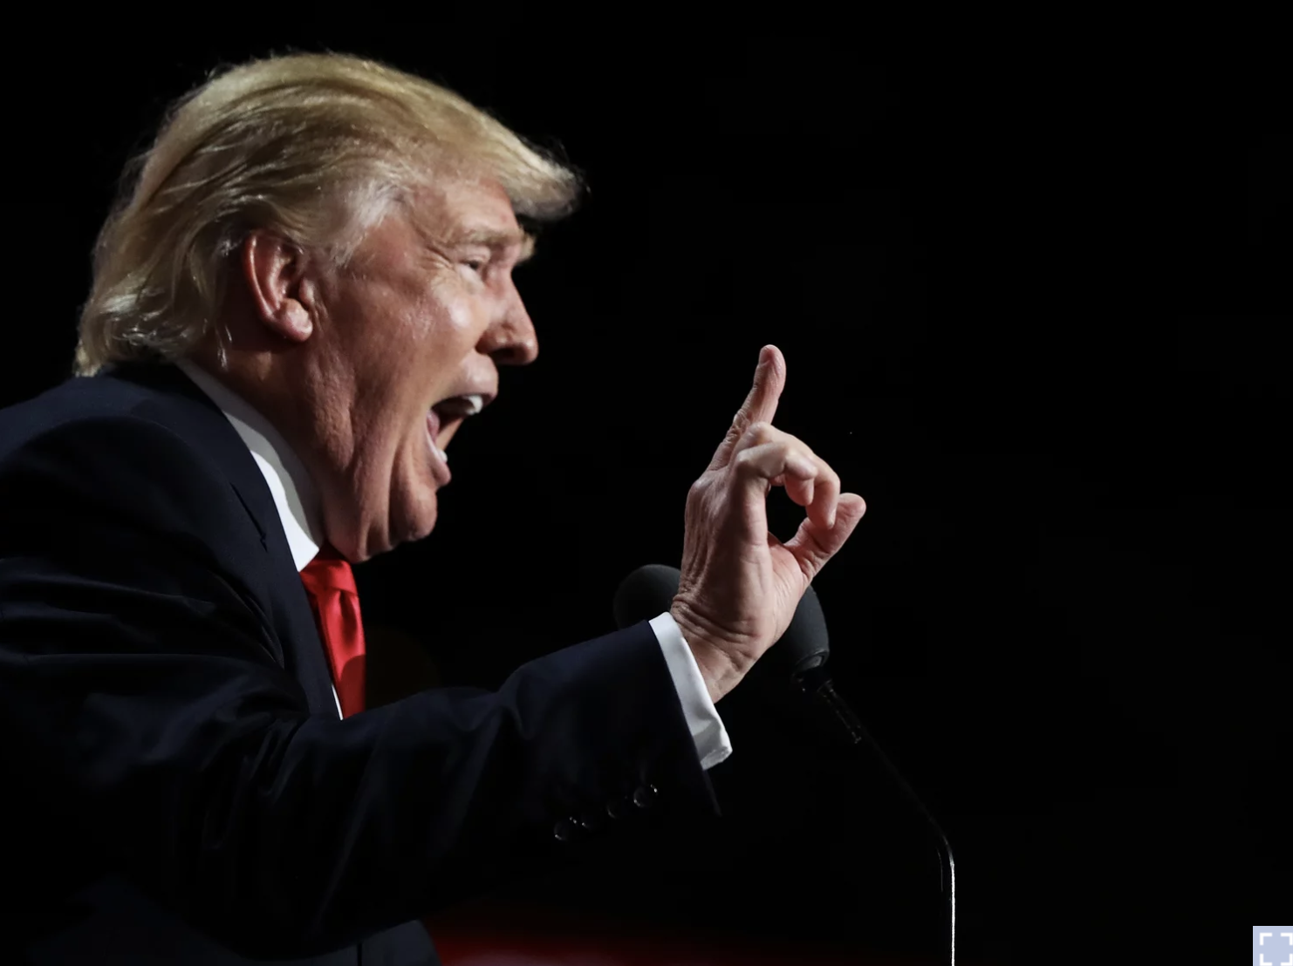

Updated May 5, 2021

But the panel said the company was wrong to impose an indefinite ban and said Facebook has six months to either restore Trump's account, make his suspension permanent, or suspend him for a specific period of time.Facebook indefinitely suspended Trump's accounts in January after a mob of his supporters stormed the U.S. Capitol, saying he used his account to "incite violent insurrection." Other social networks also kicked off the then-president, with Twitter going as far as banning Trump for good."At the time of Mr. Trump's posts, there was a clear, immediate risk of harm and his words of support for those involved in the riots legitimized their violent actions," the Oversight Board wrote in the announcement of its decision.  
"And much of the reason for demanding consistency and transparency is so that this can be revealed."While the board's policy recommendations are not binding, Clegg said the company would carefully review them.The social networks' moves to ban Trump in the wake of Jan. 6 immediately caused an uproar and added fuel to a raging debate over whether tech companies should determine who gets a voice online.Republican politicians and right-wing commentators said it was evidence of Silicon Valley's alleged anti-conservative bias.