# Facebook Ban On Donald Trump Will Hold, Social Network's Oversight Board Rules

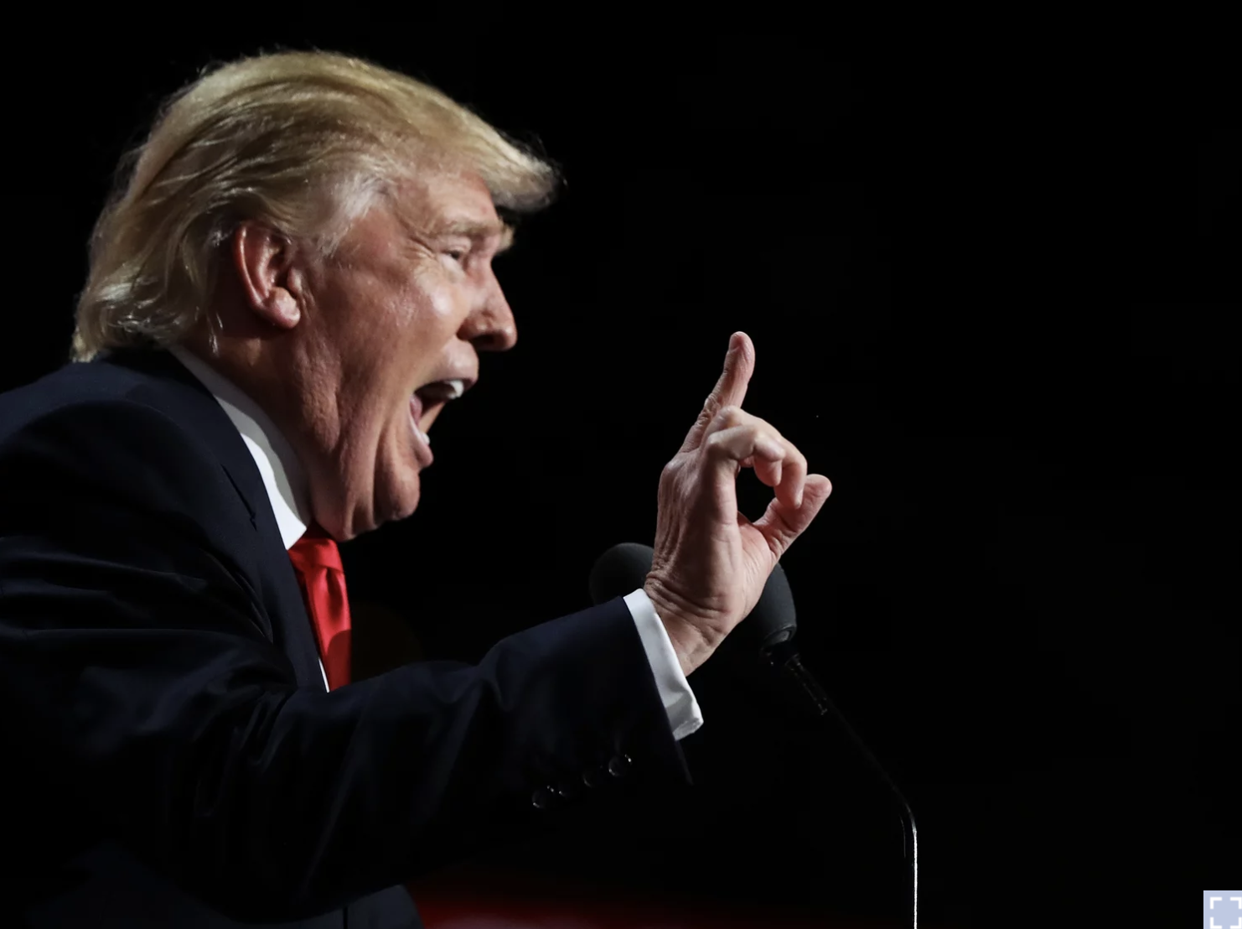

Updated May 5, 2021

Facebook indefinitely suspended then-President Donald Trump's accounts in January after a mob of his supporters stormed the U.S. Capitol.Facebook was justified in its decision to suspend then-President Donald Trump after the Jan. 6 insurrection at the U.S. Capitol, the company's Oversight Board said on Wednesday.That means the company does not have to reinstate Trump's access to Facebook and Instagram immediately.  
But the panel said the company was wrong to impose an indefinite ban and said Facebook has six months to either restore Trump's account, make his suspension permanent, or suspend him for a specific period of time.Facebook indefinitely suspended Trump's accounts in January after a mob of his supporters stormed the U.S. Capitol, saying he used his account to "incite violent insurrection." Other social networks also kicked off the then-president, with Twitter going as far as banning Trump for good."At the time of Mr. Trump's posts, there was a clear, immediate risk of harm and his words of support for those involved in the riots legitimized their violent actions," the Oversight Board wrote in the announcement of its decision.  
"Given the seriousness of the violations and the ongoing risk of violence, Facebook was justified in suspending Mr. Trump's accounts."However, it said Facebook was attempting to "avoid its responsibilities" by imposing an indefinite suspension — which the board slammed as "a vague, standardless penalty" — and then asking the board to make the final call."The Board declines Facebook's request and insists that Facebook apply and justify a defined penalty," the decision said."We're not here for Facebook just to lob politically controversial hot potatoes at us for us to decide," board co-chair Michael McConnell, a Stanford law professor, told NPR.Facebook, following the ruling, will now "determine an action that is clear and proportionate," Vice President of Global Affairs and Communications Nick Clegg said in a statement.  
Stripping Trump of the ability to reach his 35 million Facebook followers and 24 million Instagram followers has stoked criticism that the tech company is biased against conservatives — a claim many on the right have made for years without evidence.Even those who wanted to see Trump permanently banned cast doubt on the Oversight Board's legitimacy after learning of its decision."What people need to understand now is that the Oversight Board, which has still left the door open on this issue, is not the cure for what ails us on social media," said Jim Steyer of the nonprofit Common Sense, who has been a vocal critic of Facebook, in a statement.The only way to stop the spread of misinformation and disinformation on social media, he said, "is independent, democratically accountable oversight of [Facebook CEO] Mark Zuckerberg and Facebook."Zuckerberg has long said the company should not be the arbiter of truth and has argued for a hands-off approach to political speech in particular, saying it's already highly scrutinized.Yet on Wednesday, the Oversight Board suggested political leaders should not be treated differently than others with great influence online.  
It urged Facebook to be more transparent about how it applies its rules to "influential users," among other recommendations."Considerations of newsworthiness should not take priority when urgent action is needed to prevent significant harm," it wrote.The company's policies and lack of transparency have led to widespread confusion and contributed to the suspicions of bias, board co-chair McConnell said at a press conference shortly after the decision."When you do not have clarity, consistency and transparency, there's no way to know," he said.  
"And much of the reason for demanding consistency and transparency is so that this can be revealed."While the board's policy recommendations are not binding, Clegg said the company would carefully review them.The social networks' moves to ban Trump in the wake of Jan. 6 immediately caused an uproar and added fuel to a raging debate over whether tech companies should determine who gets a voice online.Republican politicians and right-wing commentators said it was evidence of Silicon Valley's alleged anti-conservative bias.  
They argued that the company had given Trump too much leeway to break its rules because of its lenient stance on political speech and posts it deemed "newsworthy" and therefore kept up, even if they violated Facebook's policies.Zuckerberg said at the time of the suspension in January that he believed the risk of allowing Trump to keep using the platform was "simply too great." When Facebook referred the decision to the Oversight Board several weeks later, the company said it believed the move "was necessary and right," given the "extraordinary circumstances."The board says it received 9,666 comments on Trump's suspension.  
A submission from Republican lawmakers accused Facebook of bias against conservatives.The board also received a "user statement" on behalf of Trump as part of its deliberations.The former president has teased that he may not return to any of the major platforms and says he's considering launching his own social media network.