# 'Frightened To Death': Cheerleader Speech Case Gives Supreme Court Pause

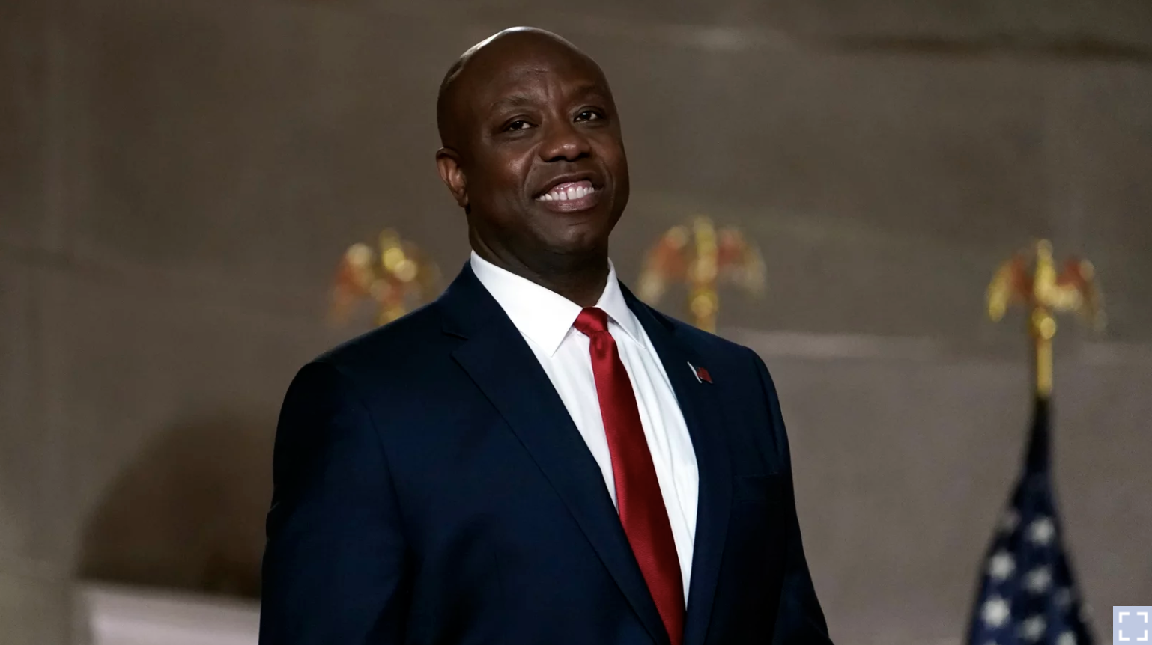

April 28, 2021

Brandi Levy wears her former cheerleading outfit as she looks at her mobile phone while sitting outside Mahanoy Area High School in Mahanoy City, Pa., on April 4.Facing its biggest student speech case in a half-century, the Supreme Court seemed to be looking for a narrow exit door on Wednesday.At issue was whether schools may punish students for speech that occurs online and off-campus but that may affect school order.The case has been billed as the most important student speech case since 1969.  
That landmark ruling came at the height of the Vietnam War. Mary Beth Tinker and four other students went to court after they were suspended for wearing black armbands to school to protest the war.By a vote of 7 to 2, the high court ruled at the time for the first time that kids do have First Amendment free speech rights at school, unless school officials reasonably forecast it will cause disruptions.Wednesday's case did not involve such serious speech.  
And on Wednesday, the Supreme Court faced a question that did not exist in 1969: Can schools punish students for their online but off-campus speech?Justice Stephen Breyer got to the heart of the matter quickly, wondering whether online swearing off-campus should even qualify for school punishment.  
In other words, all of these messages sent from off campus might well be punishable school speech.The ACLU's David Cole, representing Brandi Levy, said that once schools can discipline students for off-campus speech, that would dramatically expand the disciplinary reach of schools set out by the court in the Tinker case in 1969."Expanding Tinker would transform a limited exception into a 24/7 rule that would upend the First Amendment's bedrock principle," argued Cole, "and would require students to effectively carry the schoolhouse on their backs in terms of speech rights everywhere they go."But, the justices wanted to know, what about cases of harassment and bullying?  
All of the justices probed repeatedly for workable standard to adopt — a rule that would guide schools as to how to handle these tricky questions.Cole said student speech should be protected online.