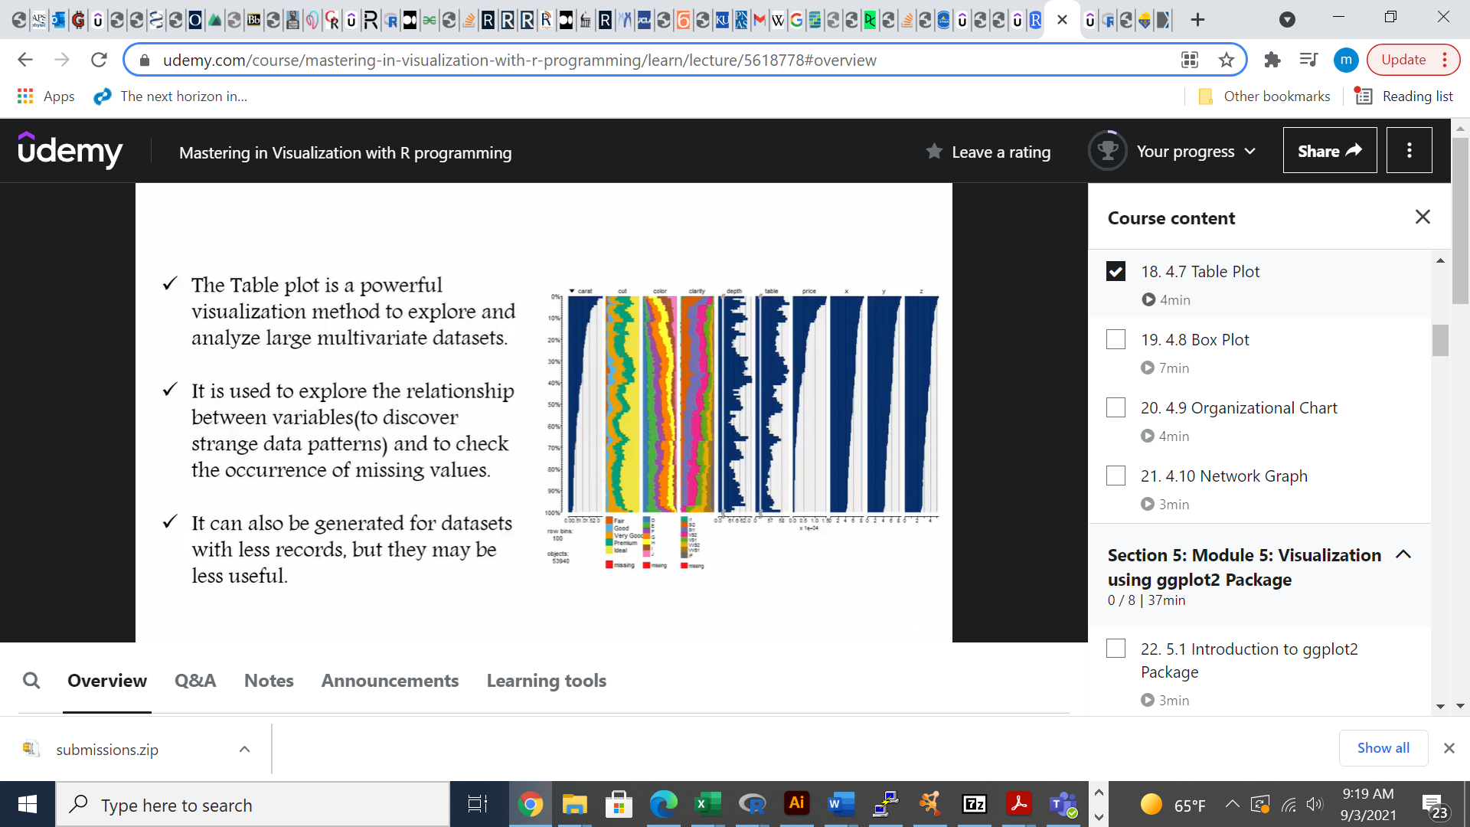

* The Table plot is a powerful visualization method to explore and analyze large multivariate Dataset.
* It is used to explore the relationship between variables (to discover strange data patterns) and to check the occurrence of missing values.
* It can also be generated for datasets with less records, but they may be less useful.