Top of Form

An Updated Secondary Lunar Meteoroid Ejecta Model for Engineering Design

Anthony M. DeStefano

NASA Marshall Space Flight Center, Natural Environments Branch, Huntsville, AL 35805



**PRESENTED AT:**

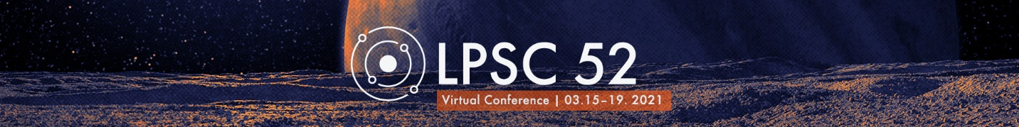

MOTIVATION

The Artemis Program is NASA's next human exploration program to send astronauts to the South Pole of the Moon and beyond to Mars. Motivated by the charge to return to the lunar surface by 2024, we seek to deepen our understanding of the lunar environment by modeling lunar meteoroid ejecta. In this work, a new lunar ejecta model is proposed, called the Meteoroid Model of Secondary Ejecta (MeMoSeE), which is to replace the Apollo-era ejecta model, NASA SP-8013. The environment definitions produced by MeMoSeE will be published in the SLS-SPEC-159 Cross-Program Design Specification for Natural Environments (DSNE). The environment definitions contained in DSNE will be used to assess impact hazards affecting lunar landers, informing shielding design.

BACKGROUND

The Moon has no atmospheric shield to mitigate meteoroid impacts. These impactors, typically ranging in size from interplanetary dust to (some other more specific term—meter size?) produce ejecta which churns and mixes the lunar regolith. This meteoroid ejecta is typically many times the mass of the primary impactor itself, though much slower than the primary impactor. The goal of MeMoSeE is to quantify the secondary ejecta environment for locations on the surface of the Moon to inform lander and habitat design.

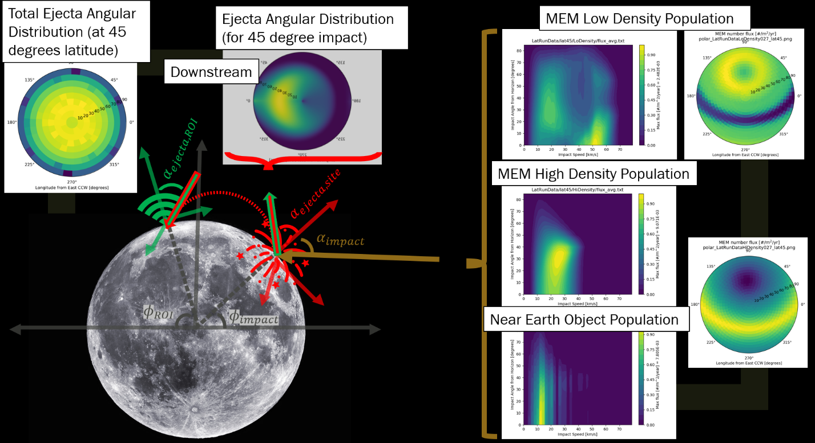

There are three driving elements to MeMoSeE: the primary impactor environment, scaling laws, and the secondary ejecta environment.

1) The first element consists of meteoroid fluxes from the Meteoroid Engineering Model (MEM3) in addition to fluxes due to near-Earth objects (NEOs). Each of these primary environments are defined in terms of impact angle, speed, and location on the lunar surface (as shown in the above figure on the right).

2) The second element is the ejecta yield, given by Housen & Holsapple’s crater scaling laws. The purpose of the scaling laws is to convert primary impacts of a given mass, velocity, and impact angle into ejected mass.

3) The third element is to sum the ejected mass that reaches a certain region-of-interest (ROI), considering impacts over the entire lunar surface. This provides the secondary ejecta environment as a function of angle, speed, and origin location on the lunar surface (see the left most plot in the figure above).

METHODS

The primary meteoroid environment used in MeMoSeE is defined by the sporadic meteoroids from MEM3 and the NEO population. The timeframe and the lunar surface location is controlled by the ephemeris chosen, e.g., a 19-year Metonic cycle with 5 degree latitude and 90 degree longitude intervals. Shown below are different impact angle-speed flux distributions of the [INSERT MODEL NAME] helion/antihelion source (top row) and apex/toroidal source (bottom row) for the lunar poles (left column), +/-45 degrees (middle column), and the lunar equator (right column).

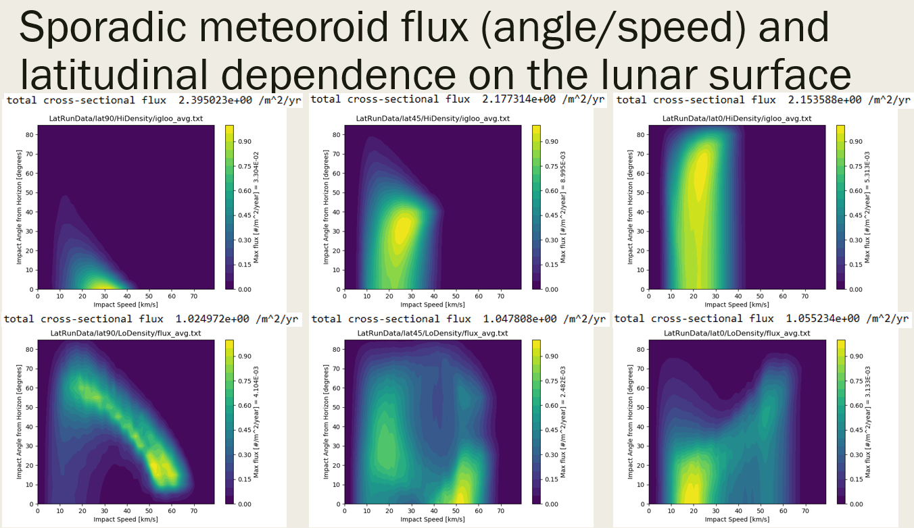

The incident impact angle of the primary environment also changes as a function of lunar impact geographic azimuth as shown in the figure below (similar to the above figure).

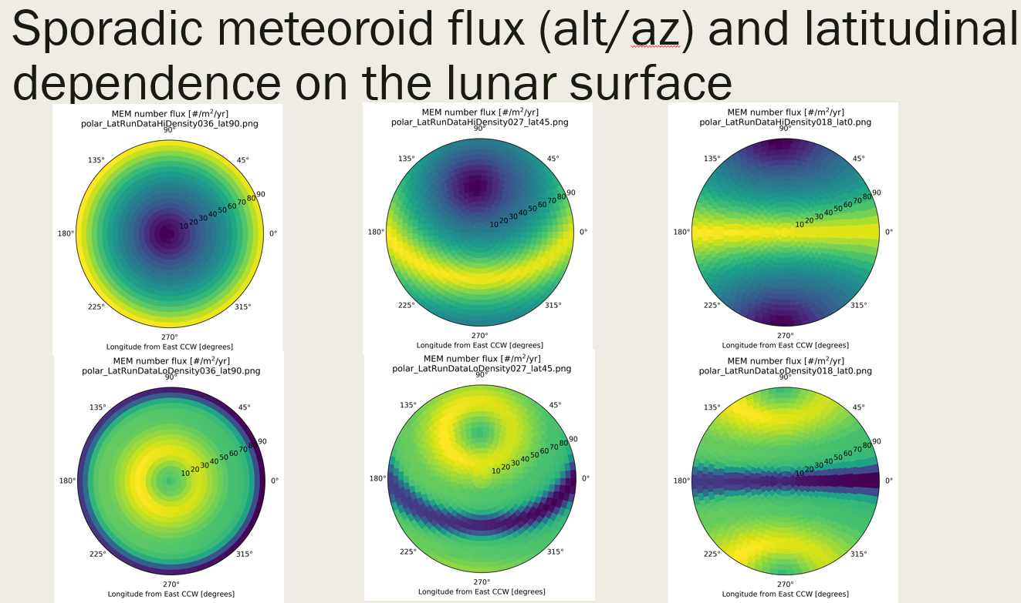

The ejecta mass can be computed from scaling laws found in Table 1 of Housen & Holsapple 2011. In order to map ejecta from an impact location to the ROI, the following equation is used (c.f., Eq (1) of Vickery 1986)

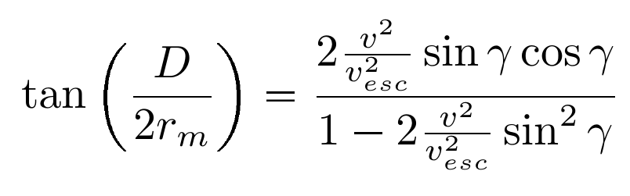

where D is the distance from the point-of-impact (POI) to the ROI, v is the ejecta speed, and gamma is the ejecta angle from zenith. This equation can also be solved for the ejecta speed or the ejecta angle, depending on what variables are known a priori.

To compare the secondary ejecta flux with the primary impact flux, a distribution of ejecta particles is needed to relate ejecta mass to number of particles ejected. In MeMoSeE, the lunar regolith particle size distribution from Carrier 2003 is employed (large ejecta fragments are ignored), which can be modeled by a log-normal distribution (weighted by mass). It can be shown that the cumulative particle size distribution weighted by number is given by



where rho is the particle density, x is the particle diameter in mm, mu = -2.649, and sigma = 1.786. This cumulative distribution is especially important in computing the PNP when using various ballistic limit equations (BLEs), which depend on particle size and speed.

The secondary ejecta environment from MeMoSeE follows the same structure as the igloo format of MEM output: The number flux is given as a function of angle (altitude & azimuth) over a sphere and speed of the ejecta less than the escape speed of the Moon. Example output is shown in the Results section.

RESULTS

Two analyses were conducted in computing the lunar secondary ejecta environment, one analytic and one numeric.

In the **analytic analysis**, we consider two cases: secondary ejecta at 45 degrees, and ejecta lofted isotopically. It was also assumed that the primary impactor environment was the same across the whole Moon. With the first case of a 45-degree ejecta angle at the POI, the analysis shows that the scaling laws that describe ejecta at a POI (i.e., M_p) are equivalent to the secondary ejecta environment at an ROI after summing up contributions of ejecta from impacts over the entire surface of the Moon (M_ROI).



This result is very useful in estimating the ejecta environment. For the second case of an isotropic ejecta distribution, it can be shown that this is also equivalent to the 45-degree case, where the error term is of order

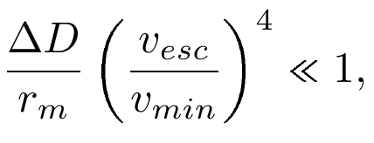

where delta D is the diameter size of the observer, r_m is the lunar radius, v_esc is the lunar escape speed, and v_min is the minimum velocity of ejecta particles the observer is interested in. If v_min = 100 m/s, then the observer size would have to be smaller than about 5 m, otherwise higher order terms would come into play.

Different locations on the Moon with respect to the ROI attribute to different speeds of the ejecta environment. Qualitatively, the contribution of ejecta for a particluar speed originates from:

* Slowest speeds ( v < 71% of v_esc): ring of locations centered on the ROI,
* Intermediate speeds ( 71% < v < 90% of v_esc): hemispherical cap of locations centered on the antipode,
* Fast speeds (90% < v < 100% of v_esc): the entire surface of the Moon.

In terms of PNP estimates, the fastest speeds tend to drive the risk, so the conclusion from the above qualitative statements is that all impact locations on the Moon are important, not only the local regions. However, when looking at the raw ejecta flux, the driver is the slowest ejecta particles, which do originate close to the ROI.

For the **numeric analysis**, the contributing flux at the ROI as a function of angle and speed is integrated over the entire surface of the Moon. Latitude and longitude dependence is included in the primary fluxes. An example of the secondary ejecta angular distribution is shown below.

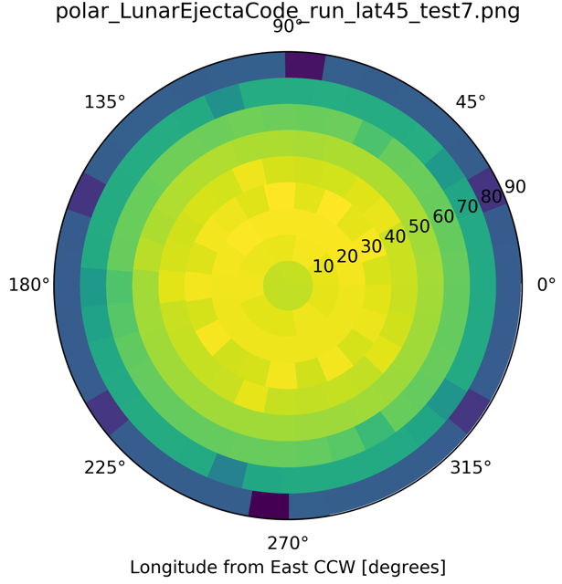

The secondary ejecta fluxes computed in MeMoSeE show to be anywhere from ~10-50 #/m^2/yr (ejecta particles > 1e-6 g), with the low-end near the poles and the high-end near the equator. Compared to the primary ejecta, the secondary ejecta is about 4-14x that of the overall primary number flux. In contrast with the SP-8013 environment, this is a factor of ~200x less, indicating a more benign environment than previously thought.

FORWARD WORK

MeMoSeE could also be used to compute the secondary ejecta due to meteor showers, if the appropriate primary fluxes are provided. Such an analysis could be done without any major modifications to the code.

Another application would be to study short term variations in the ejecta fluxes. This would be useful for short missions related to particular EVA excursions.

An extention of MeMoSeE would be to study secondary ejecta at locations above the lunar surface, such as in lunar orbit. An analysis of this type would be useful for programs like Gateway, Orion, or HLS where assets would be in cis-lunar space. Ejecta environments could be studied for EVAs that occur while in cis-lunar space as well.

DISCLOSURES

Information displayed in this work is not to be used as a design specification and is subject to change until official publication in SLS-SPEC 159.

AUTHOR INFORMATION

See my ORCID record at <https://orcid.org/0000-0001-8384-939X>

ABSTRACT

Introduction:  The surface of the Moon is constantly being bombarded by a flux of meteoroids of various sizes. Impacts due to these meteoroids produce secondary ejecta material at much lower speeds but with a total mass larger than the original impactor. Details about the secondary ejecta are important for planning missions on the lunar surface. In this work, an updated ejecta model is presented called the Meteoroid Model of Secondary Ejecta (MeMoSeE), to replace the Apollo-era ejecta model, NASA SP-8013 [1], in the SLS-SPEC 159 Design Specification for Natural Environments (DSNE) [2]. The model produces secondary ejecta flux environments for a user-specified location on the lunar surface, and sorts the incoming secondary flux by angular direction and speed.

Methods:  MeMoSeE is separated into three parts: the inputs, the conversion step, and the integration of fluxes. Inputs to the model include the primary meteoroid fluxes and the primary near-Earth object (NEO) fluxes. Meteoroid fluxes, both asteroidal and cometary, are calculated using the Meteoroid Engineering Model (MEM3) [3] for different locations on the Moon. For each surface location, an ephemeris is generated using the JPL HORIZONS System [4] that feeds into MEM3. The NEO fluxes are approximated by the high-density population of MEM3 (i.e., only the directionality), where the speed distribution of the NEO fluxes is renormalized to match observations [5]. The regolith properties are used as defined in the DSNE [2].

The conversion step utilizes scaling laws given by Housen & Holsapple 2011 [6] to convert the primary impactor flux to the total mass of secondary ejecta. The ejecta distribution, at the point-of-impact (POI), is separated into a zenith angle and azimuthal angle distribution. The zenith angle distribution follows a beta distribution where the peak depends on the impact altitude angle and the impact azimuth [7]. We employ an ejecta azimuth distribution that is based on Rival & Mandeville 1999 [8] which focuses ejecta in the downstream direction for more oblique impacts.

Finally, during the integration step, we sum secondary ejecta number fluxes at a particular region-of-interest (ROI) that originated from many POI locations over the entire surface of the Moon. We keep track of both altitude and azimuth angle bins as well as a range of speed bins, following the igloo gridding as done in MEM3 [9]. The ejecta particle size distribution and density is assumed to be the same as the lunar regolith [10, 2].

Results: The primary fluxes are computed for one Metonic cycle (19 years) for various locations over the lunar surface with a fixed orientation. Both the angular and speed distributions of the primary fluxes are dependent on the latitude and longitude. The overall primary fluxes show a roughly 13% increase from the eastern limb to the western limb.

In general, the speed distribution of the secondary fluxes span from a user-defined minimum speed to the escape speed of the Moon (2.38 km/s), roughly following a power-law relation [6]. Different parts of the speed distribution come from different primary impact locations on the Moon. The secondary ejecta is dominated by the slowest speeds, where these particles originate nearby the ROI. For speeds around 71% of the escape speed, the secondary ejecta originates from locations near the antipodal point. On the other hand, for secondary ejecta speeds that exceed roughly 90% the escape speed, the ejecta particles come from all over the lunar surface to the ROI.

Comparing the secondary ejecta fluxes from MeMoSeE with NASA SP-8013 [1], there is a reduction by about 2-3 orders of magnitude for secondary ejecta particles greater than 1 µg. These estimates agree with recent findings from Bjorkman & Christiansen 2019 [11]. The secondary ejecta fluxes are also compared with the primary fluxes, where the ejecta fluxes are roughly an order of magnitude greater than the primary fluxes.

References: [1] Cour-Palais, B. G., (1969) NASA SP-8013. [2] NASA SLS-SPEC-159 Rev. H (2020). [3] Moorhead, A. V., et al. (2019) JS&R, 1-17. [4] Giorgini, J. D., (2015) IAUGA, 29, 2256293. [5] Moorhead, A. V., (2020) Memo OSMA/MEO/Lunar-001. [6] Housen, K. R., and Holsapple, K. A., (2011) Icarus, 211(1), 856-875. [7] Gault, D. E., and Wedekind, J. A., (1978) L&PSCP, 9, 3843-3875. [8] Rival, M., and Mandeville, J., (1999) Space Debris, 1(1), 45-57. [9] Moorhead, A. V., (2019) MEM3 User Guide. [10] Carrier, W. D., (1973) The Moon, 6(3-4), 250-263. [11] Bjorkman, M. D. & Christiansen, E. L., (2019) ODC

Bottom of Form