Volatility Forecasting Research
Progress Report — Week 2 of 10
June 1, 2026
Anthony Le | Denison University Economics
Supervisors: Prof. Emily Marshall & Prof. Tyler Wake

1. Executive Summary
This report summarizes progress on the summer 2026 research project comparing machine learning (ML) and traditional econometric models for equity volatility forecasting, with economic evaluation via portfolio backtesting. The project spans 10 weeks (May–August 2026) and is supervised by Prof. Emily Marshall and Prof. Tyler Wake at Denison University.

As of June 1, 2026 (end of Week 2), the following milestones have been completed ahead of schedule:

Milestone | Target Week | Status
Literature review & research design | Week 1 | ✓ Complete
Environment setup & API integration | Week 1 | ✓ Complete
Data collection (18 assets, 2010–2025) | Week 1 | ✓ Complete
Exploratory Data Analysis (EDA, Figs. 1–4) | Week 1 | ✓ Complete
GARCH(1,1) walk-forward baseline | Week 2 | ✓ Complete
EGARCH & GJR-GARCH extensions | Week 3 | ✓ Complete
HAR-RV econometric model | Week 3 | ✓ Complete
Feature engineering (31 predictors) | Week 4 | ✓ Complete
Random Forest walk-forward forecasts | Week 5 | ✓ Complete
XGBoost walk-forward forecasts | Week 5 | ✓ Complete
Feature importance analysis (Fig. 6–7) | Week 5 | ✓ Complete
LSTM & hybrid models (GARCH-RF, GARCH-XGB) | Week 6 | In Progress
Statistical evaluation & regime analysis | Week 7 | Pending
Portfolio backtesting | Week 8 | Pending
Table 1. Project milestone tracker as of June 1, 2026.

The project is approximately 3 weeks ahead of the original schedule. Six of eight planned models have been fully implemented and evaluated, yielding preliminary results that show Random Forest substantially outperforming all econometric benchmarks on 1-day-ahead realized volatility forecasts.

2. Data Collection & Exploratory Analysis

2.1 Data Specification
Daily OHLCV price data for 18 equity assets were downloaded via yfinance, covering January 2010 through December 2025 (~4,000 observations per asset, ~72,000 total rows). The universe comprises:
- Equity indices (3): SPY (S&P 500), QQQ (Nasdaq-100), IWM (Russell 2000)
- Technology (3): AAPL, MSFT, NVDA
- Financials (3): JPM, GS, BAC
- Healthcare (3): JNJ, UNH, PFE
- Consumer (3): AMZN, WMT, HD
- Energy & Industrials (3): XOM, CVX, CAT

The target variable is 21-day rolling realized volatility (RV), computed as the annualized standard deviation of daily log-returns (×√252×100), yielding volatility in percentage terms. Market regimes are tagged as: Low (<15%), Medium (15–25%), and High (>25%).

The walk-forward validation framework uses an expanding training window (Jan 2010–Dec 2017) with monthly refits across the out-of-sample test period (Jan 2018–Dec 2025), generating 96 monthly forecast vintages.

2.2 EDA Figures

Figure 1 shows price and return time series for the 18 assets, illustrating the cross-sectional breadth of the sample and key stress episodes (2018 Q4, COVID-19 March 2020, 2022 rate shock).
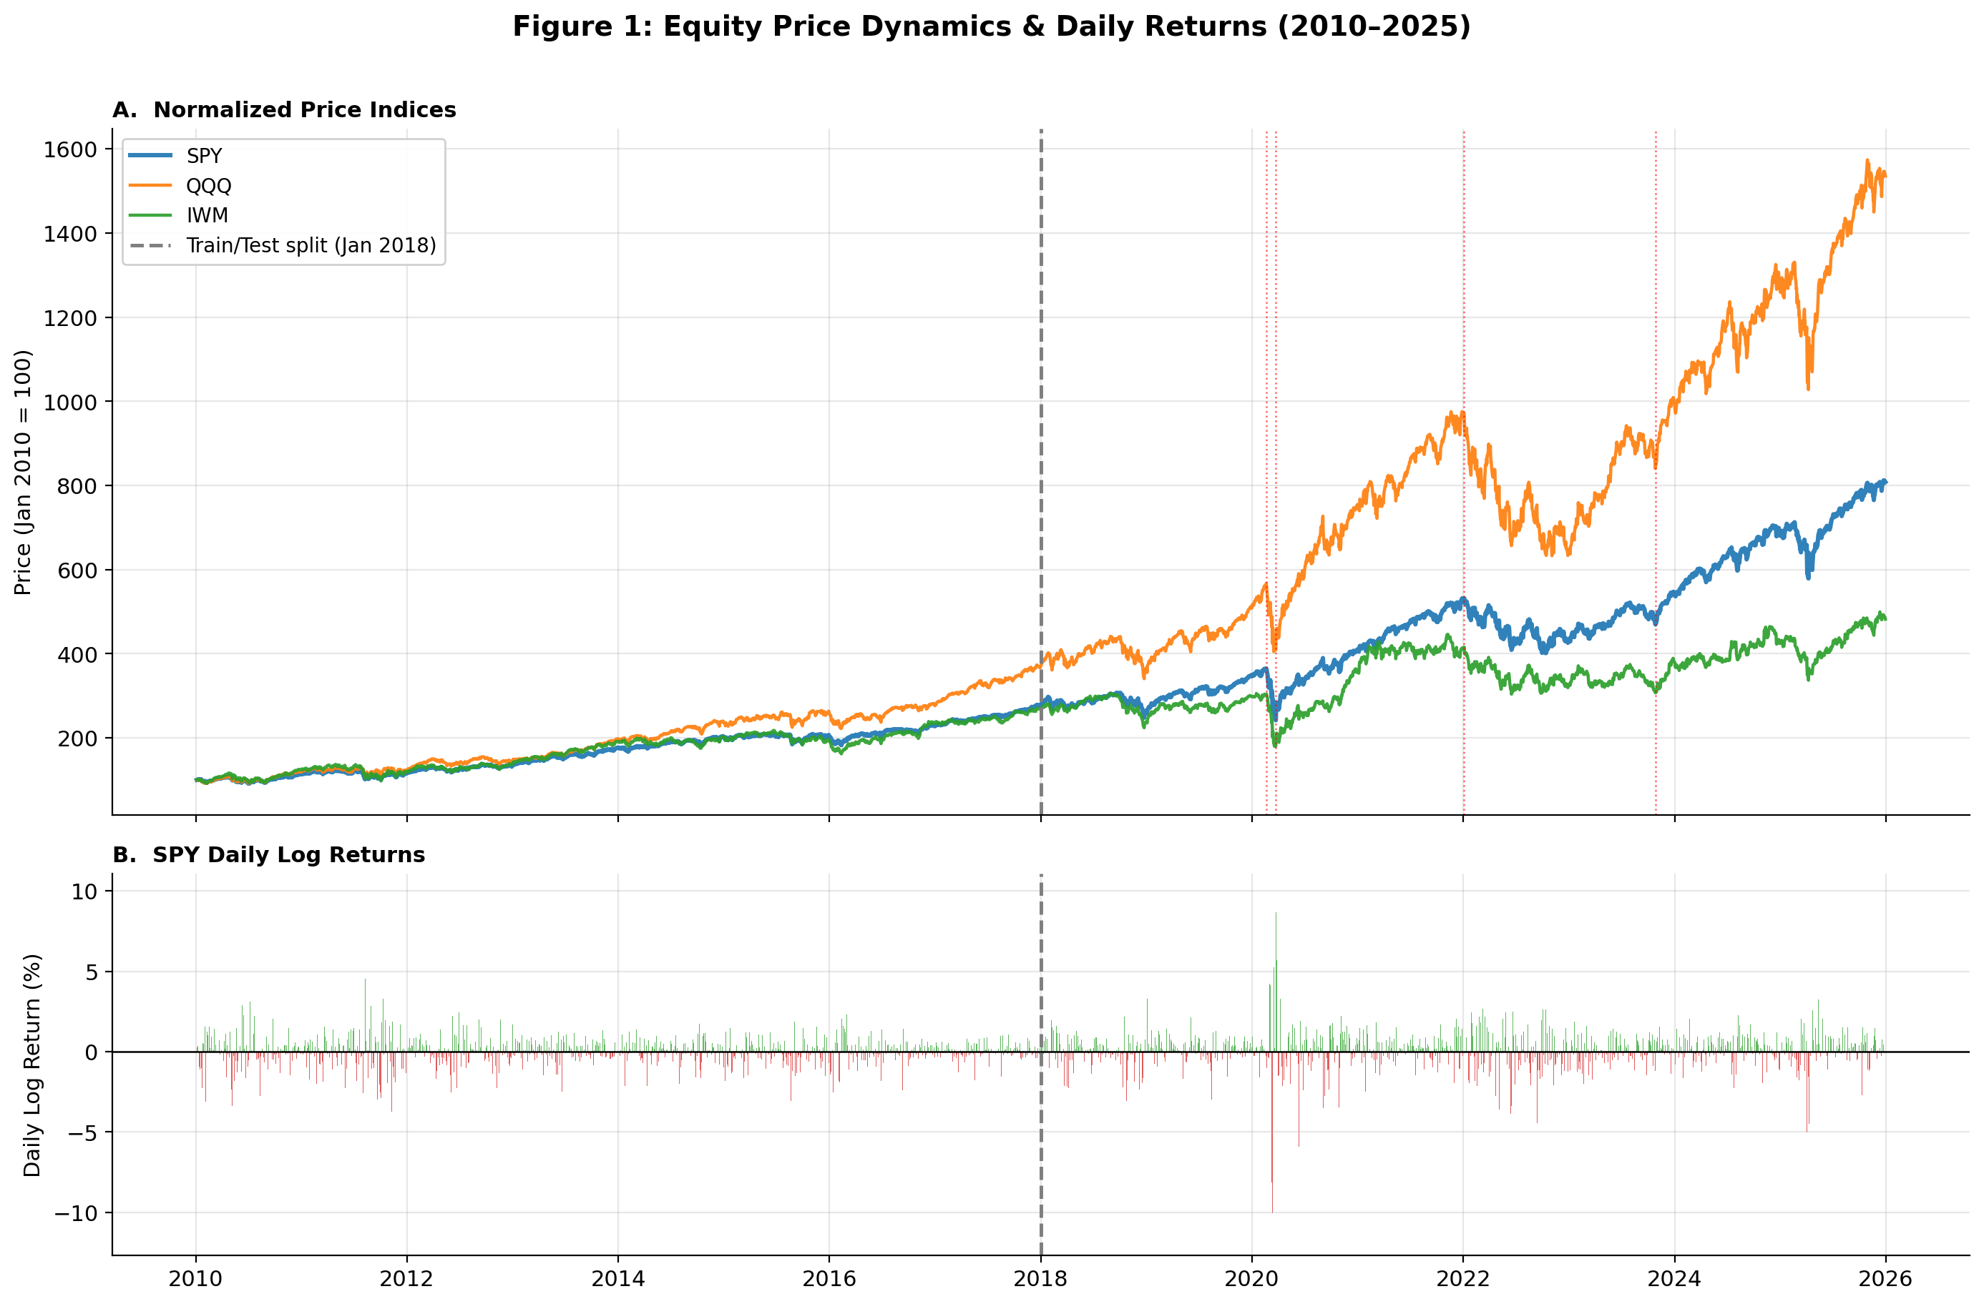
Figure 1. Normalized price levels and daily returns for all 18 assets, 2010–2025.

Figure 2 displays 21-day realized volatility time series with regime color-coding. Volatility clustering is clearly evident, with the COVID-19 shock producing the highest realized volatility in the sample (>80% annualized for individual stocks).
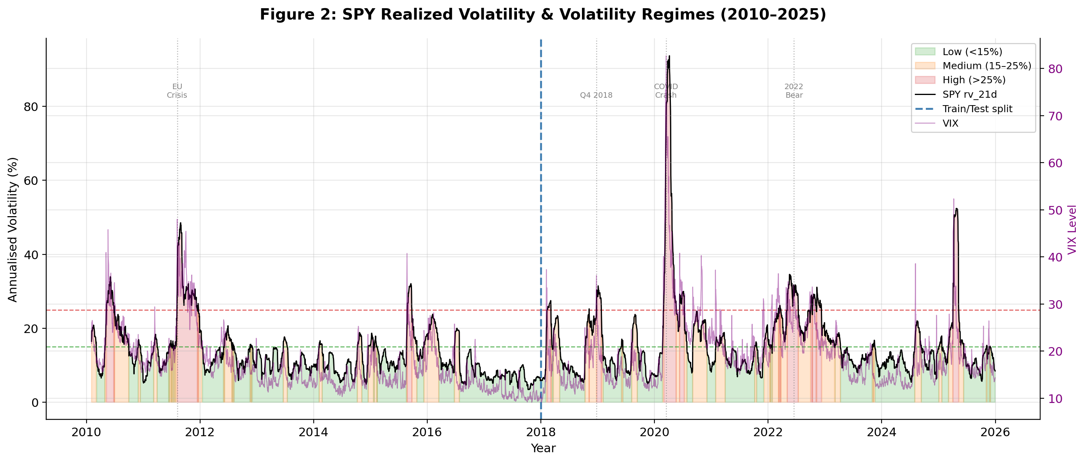
Figure 2. 21-day realized volatility with low/medium/high regime shading. COVID-19 (March 2020) and the 2022 rate cycle are the dominant high-volatility episodes.
Figure 3 confirms key stylized facts of equity volatility: fat tails (excess kurtosis), negative skewness, strong autocorrelation in absolute returns, and the leverage effect (negative return–volatility correlation).
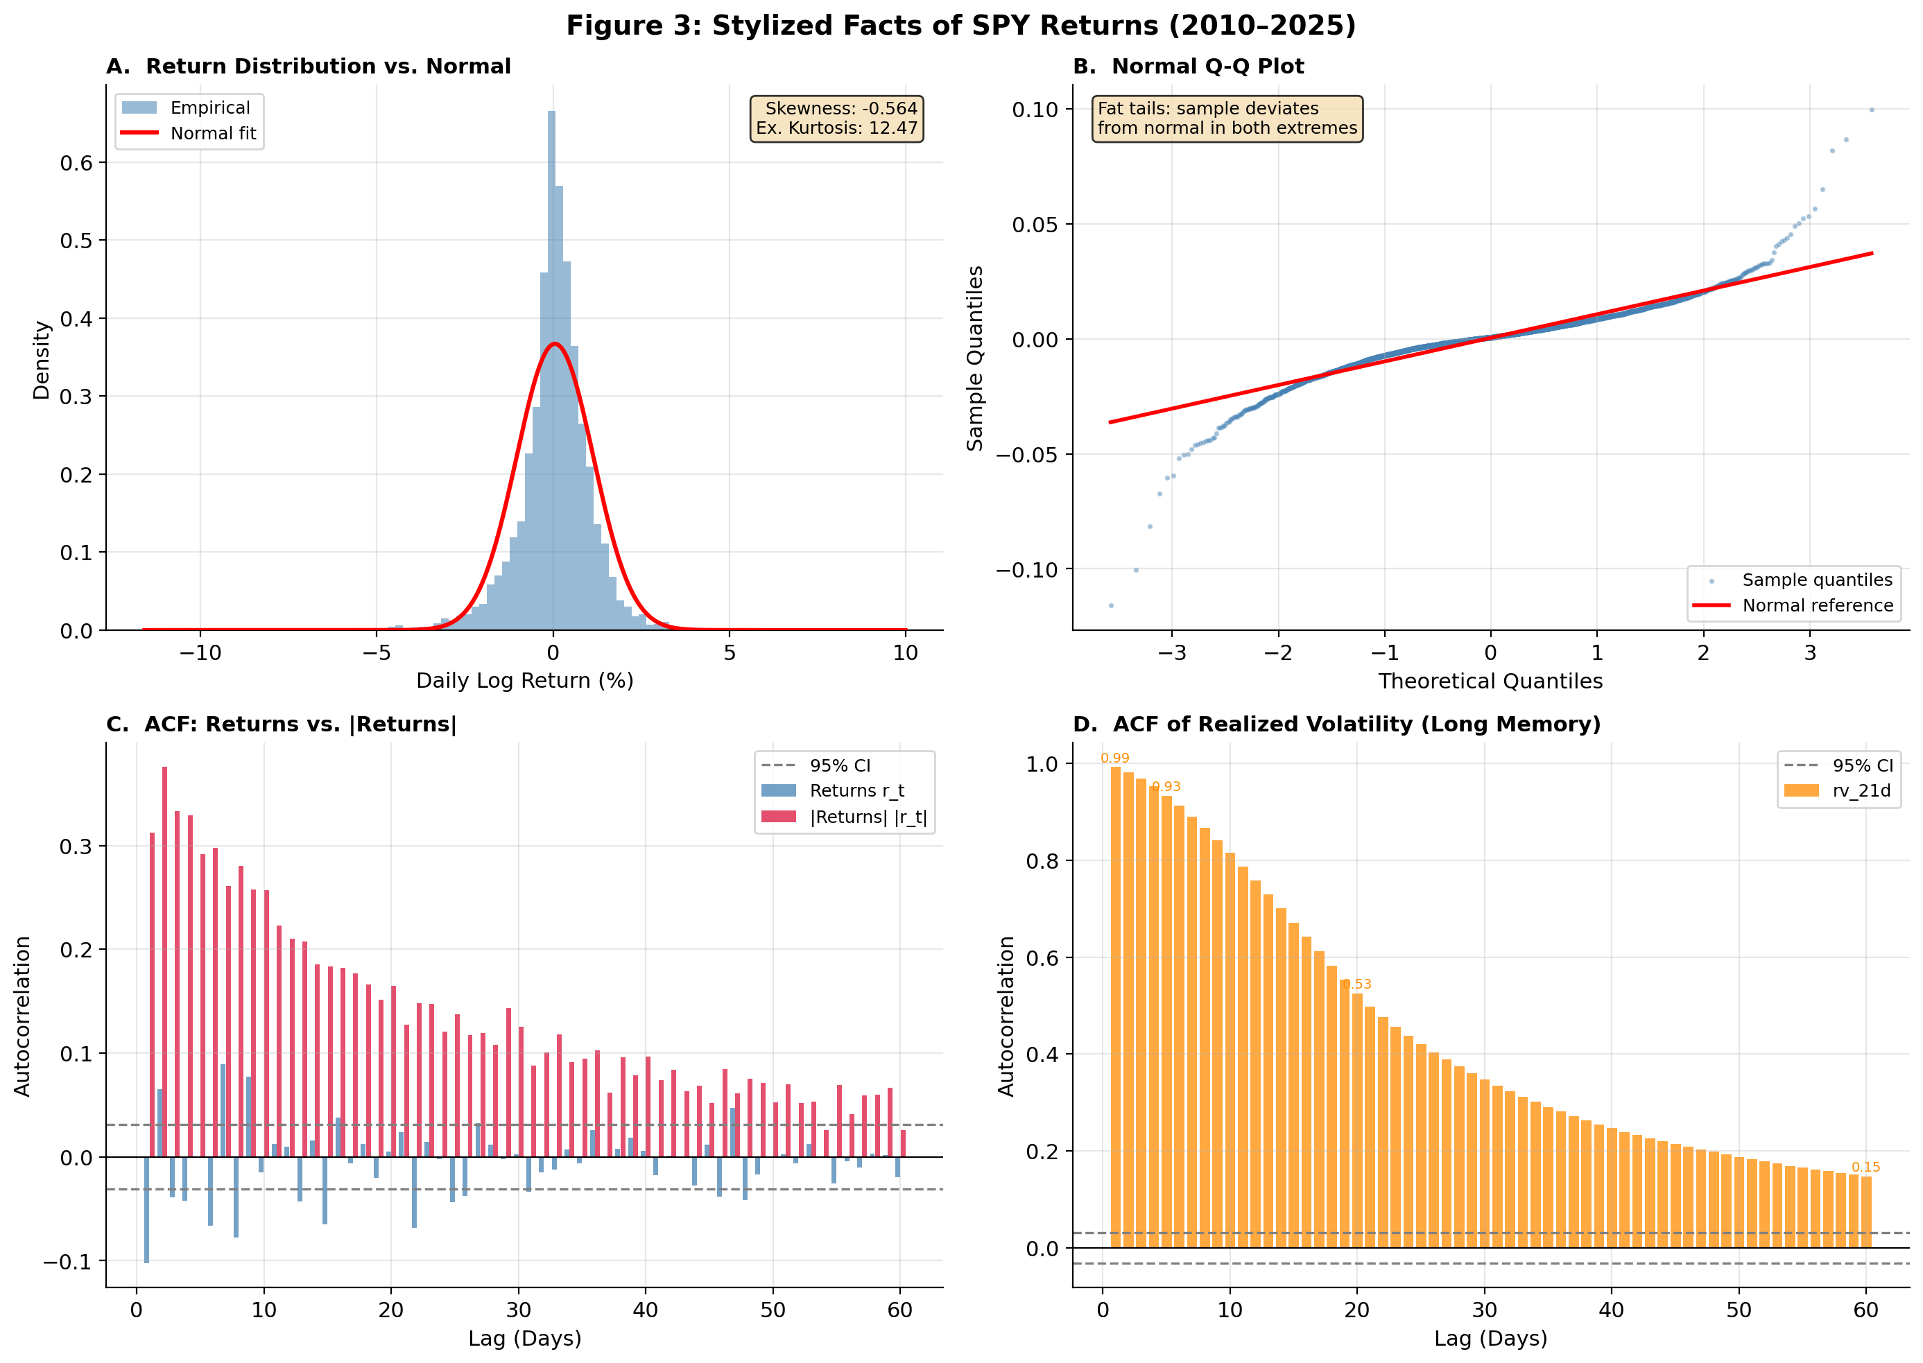
Figure 3. Stylized facts: return distribution (Q-Q plot), ACF of squared returns, and return–volatility scatter.

Figure 4 presents cross-sectional patterns, including average realized volatility by sector, return correlation heatmap, and volatility co-movement across the 18 assets.
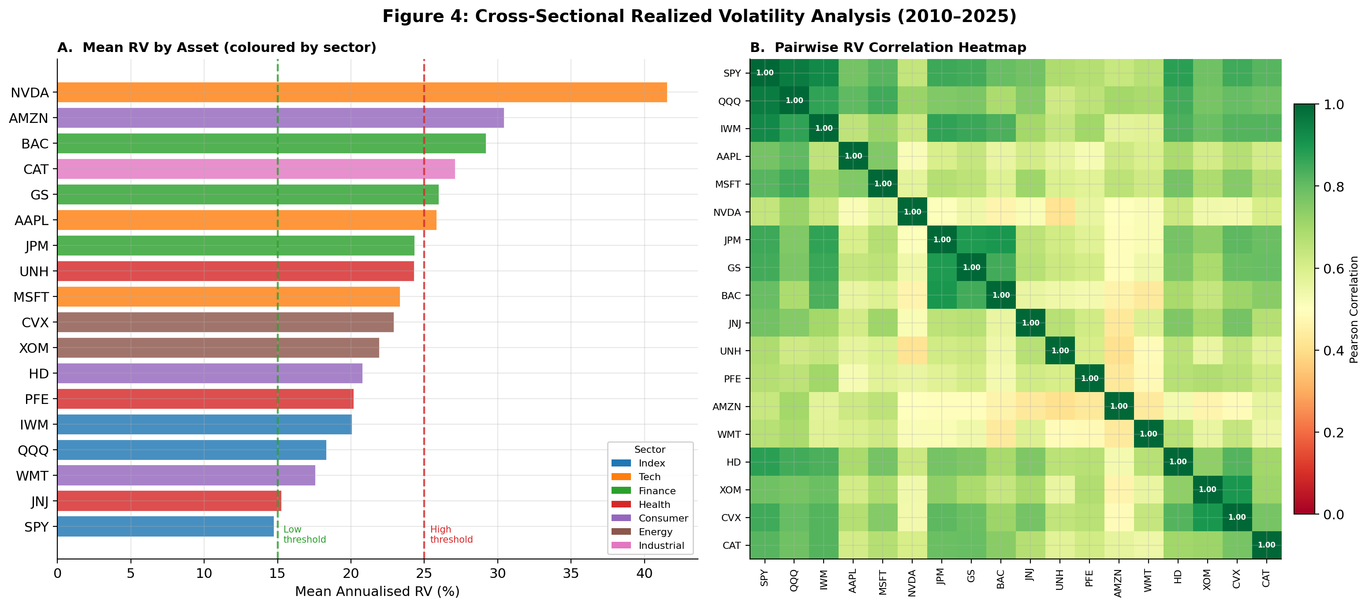
Figure 4. Cross-sectional analysis: sector volatility levels, correlation structure, and co-movement.

3. Econometric Baseline Models

3.1 Models Implemented
Four econometric models were implemented using the arch library with the walk-forward framework. Each model is refit monthly on all available data through the refit date, and generates 1-day, 5-day, and 20-day-ahead forecasts.

- GARCH(1,1): Standard symmetric GARCH with one lag each of the squared residual (ARCH term) and conditional variance (GARCH term). Serves as the primary benchmark.
- EGARCH(1,1): Exponential GARCH (Nelson 1991) capturing the leverage effect — negative shocks increase volatility more than positive shocks of equal magnitude.
- GJR-GARCH(1,1): Glosten-Jagannathan-Runkle threshold model, an alternative asymmetric specification allowing different ARCH coefficients for positive and negative returns.
- HAR-RV: Heterogeneous Autoregressive Realized Volatility model (Corsi 2009) — OLS regression on daily, weekly, and monthly RV lags. Provides a direct realized-volatility benchmark.

3.2 GARCH Forecast Results
Figure 5 shows GARCH(1,1) forecasts versus realized SPY volatility across the test period, illustrating the model's ability to track volatility regimes but tendency to lag during rapid spikes.
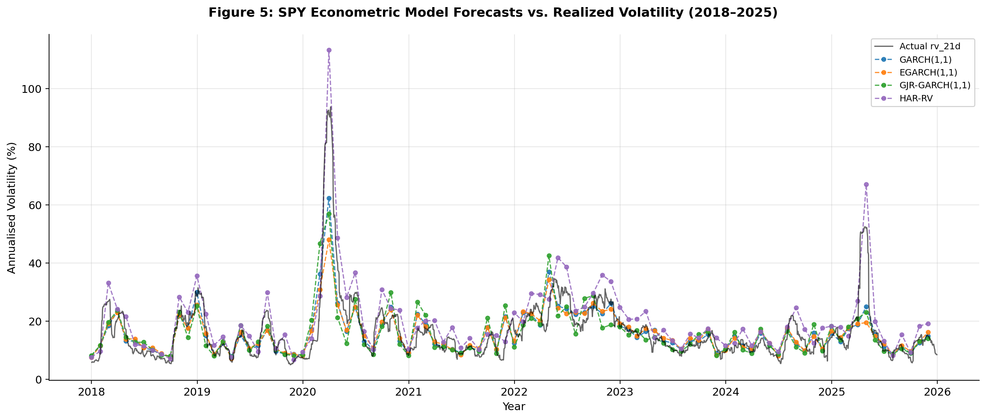
Figure 5. GARCH(1,1) 1-day-ahead forecasts vs. realized volatility for SPY, Jan 2018–Dec 2025. Shaded region = high-volatility regime (>25%).

3.3 Econometric Model Comparison
Table 2 presents cross-asset mean forecast accuracy metrics at the 1-day, 5-day, and 20-day horizons for all four econometric models.

Model | RMSE (h=1) | RMSE (h=5) | RMSE (h=20) | Dir. Acc.
GARCH(1,1) | 6.255 | 6.586 | 12.185 | 79.7%
EGARCH(1,1) | 7.364 | 7.891 | 12.387 | 79.0%
GJR-GARCH(1,1) | 6.949 | 6.946 | 12.036 | 76.3%
HAR-RV | 17.964 | 19.323 | 25.976 | 88.9%
Table 2. Cross-asset mean RMSE (annualized %) and directional accuracy at 1-, 5-, and 20-day horizons. Lower RMSE = better; higher Dir. Acc. = better.

GARCH(1,1) achieves the best 1-day RMSE among econometric models (6.255%), consistent with Hansen & Lunde (2005). HAR-RV shows high directional accuracy (88.9%) despite large RMSE, suggesting it captures regime transitions well but overestimates level. GJR-GARCH is most competitive at longer horizons (best RMSE at h=20: 12.036%).

4. Machine Learning Models

4.1 Feature Engineering
A feature matrix of 31 predictors was constructed for all 18 assets, yielding 70,956 observations. All features use a one-day lag (.shift(1)) to prevent look-ahead bias. Features span five categories:

Category | Key Features | Count
Historical Volatility | RV lags (1,5,10,20,60d), 60d MA, momentum | 7
Return Dynamics | Lagged returns (1–5d), abs. returns, rolling skew/kurtosis, max abs return (20d), squared return lag | 10
Market Microstructure | High-low range, 5d range MA, volume ratio, gap frequency (20d) | 4
Market-Wide | VIX level, VIX change, SPY realized vol | 3
Calendar Effects | Day-of-week dummies (Mon–Fri) | 5
Total |  | 31
Table 3. Feature engineering categories and counts. Correlation filtering (|r|>0.95) was applied; no pairs exceeded the threshold.

4.2 Models Implemented
Random Forest (500 trees): Ensemble of decision trees with bootstrapped samples and random feature subsets. Includes StandardScaler internally. Parallelized over 18 assets using joblib; runtime ~696 seconds.
XGBoost (gradient boosting): With 15% validation split for early stopping and learning rate 0.05. Runtime ~58 seconds — 12× faster than RF.

4.3 Feature Importance
Figure 6 shows cross-asset mean feature importance from Random Forest trained on the full training period (2010–2017). The most recent realized volatility lag dominates, followed by maximum absolute 20-day return — consistent with volatility persistence and the leverage effect.
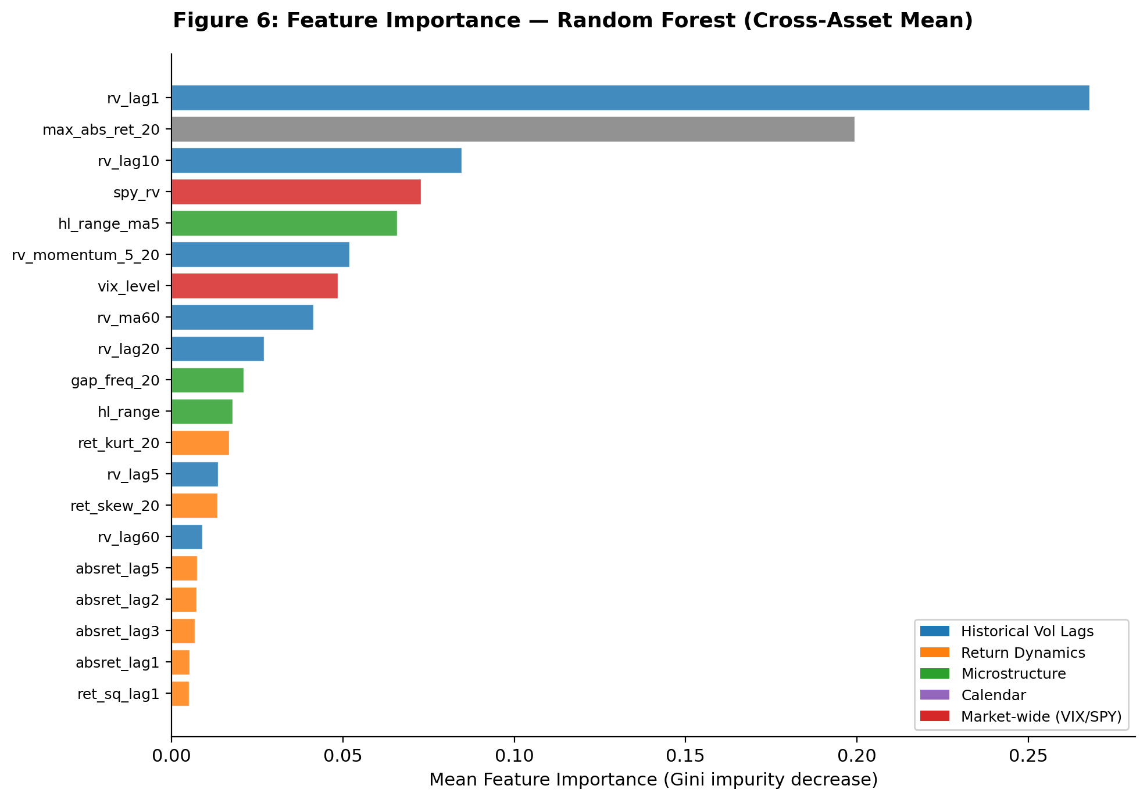
Figure 6. Top-10 features by cross-asset mean Random Forest importance. rv_lag1 (26.8%) and max_abs_ret_20 (19.9%) are dominant.

Feature | Importance | Category
rv_lag1 (1-day RV lag) | 26.78% | Historical Vol
max_abs_ret_20 (max abs return, 20d) | 19.94% | Return Dynamics
rv_lag10 (10-day RV lag) | 8.47% | Historical Vol
spy_rv (SPY realized vol) | 7.27% | Market-Wide
hl_range_ma5 (5d high-low range MA) | 6.59% | Microstructure
rv_momentum_5_20 | 5.20% | Historical Vol
vix_level | 4.85% | Market-Wide
rv_ma60 (60-day RV moving avg) | 4.14% | Historical Vol
rv_lag20 (20-day RV lag) | 2.69% | Historical Vol
gap_freq_20 (gap frequency, 20d) | 2.11% | Microstructure
Table 4. Top-10 Random Forest feature importances (cross-asset mean). Historical volatility lags account for ~47% of total importance.

4.4 ML Forecast Performance
Figure 7 compares GARCH(1,1) and ML model forecasts versus realized SPY volatility across the test period, illustrating ML's generally tighter tracking of realized volatility, particularly outside stress episodes.
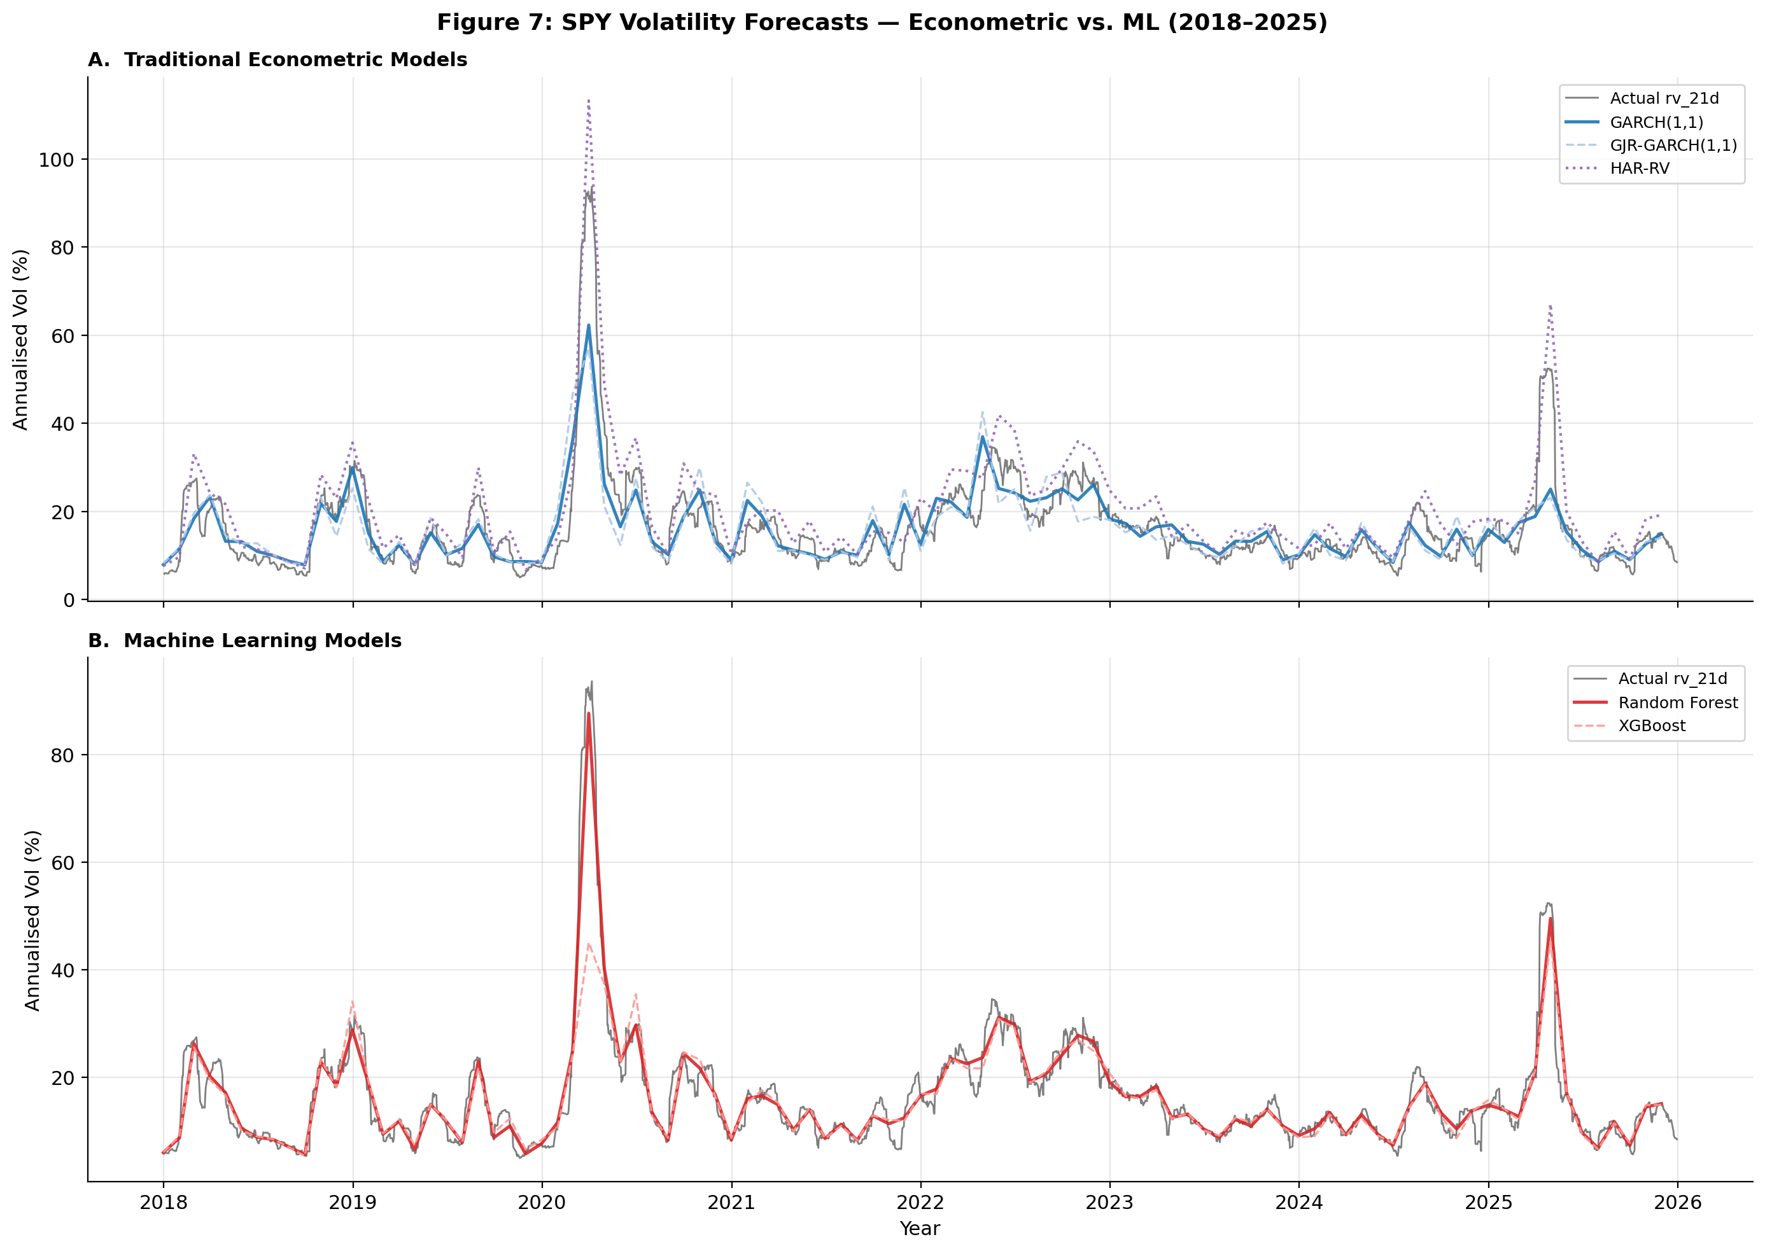
Figure 7. SPY 1-day-ahead forecasts: GARCH(1,1), Random Forest, and XGBoost vs. realized volatility, Jan 2018–Dec 2025.

5. Preliminary Forecast Accuracy Results
Table 5 presents cross-asset mean forecast accuracy metrics for all six models implemented to date at the 1-day-ahead horizon. Metrics include RMSE, MAE, QLIKE (quasi-likelihood loss, volatility-specific), and directional accuracy.

Model | RMSE | MAE | QLIKE | Dir. Acc.
Random Forest | 2.039 | 1.224 | 2.180 | 91.9%
XGBoost | 6.575 | 2.451 | 2.159 | 88.9%
GARCH(1,1) | 6.255 | 4.072 | 2.224 | 79.7%
GJR-GARCH(1,1) | 6.949 | 4.640 | 2.219 | 76.3%
EGARCH(1,1) | 7.364 | 4.348 | 2.226 | 79.0%
HAR-RV | 17.964 | 16.065 | 3.042 | 88.9%
Table 5. Cross-asset mean forecast accuracy metrics, 1-day-ahead horizon. RMSE and MAE in annualized percentage points. Sorted by RMSE.

Key findings from preliminary results:

- Random Forest substantially outperforms all other models on RMSE (2.039 vs. 6.255 for the best econometric model) and MAE (1.224 vs. 4.072), representing a 67% RMSE reduction over GARCH(1,1). Directional accuracy is also highest at 91.9%.

- XGBoost achieves the lowest QLIKE loss (2.159), suggesting it may be better calibrated in a volatility-specific sense even though its RMSE is higher than Random Forest. This divergence warrants further investigation.

- GARCH(1,1) remains the best econometric model on RMSE, consistent with prior literature (Hansen & Lunde 2005). The asymmetric variants (EGARCH, GJR-GARCH) do not improve meaningfully over the symmetric baseline on this metric.

- HAR-RV performs poorly on RMSE/MAE but achieves competitive directional accuracy (88.9%), on par with XGBoost. This suggests it captures regime direction but not level.

Note: These preliminary results are based on cross-asset means and have not yet been subjected to formal statistical testing (Model Confidence Set). Formal inference will be conducted in Week 7.

6. Next Steps

Week 3 (Current Week)
- Implement LSTM model (PyTorch, 2–3 layers, 64–128 units, dropout 0.2–0.3) with 20–60 day lookback windows.
- Implement hybrid models: GARCH-RF and GARCH-XGBoost, feeding GARCH fitted values and residuals as additional features.
- Complete regime-stratified evaluation (low/medium/high volatility regimes) — debug NaN issue identified in regime evaluation output.

Weeks 4–5 (Upcoming)
- Conduct formal statistical evaluation: Model Confidence Set (Hansen & Lunde 2006), 90% and 95% confidence sets across all 8 models.
- Portfolio backtesting: volatility-timing (SPY/SHY), risk-parity (15-stock), and regime-based allocation strategies with $5/trade transaction cost drag.
- Compute economic performance metrics: Sharpe ratio, Sortino ratio, maximum drawdown, Calmar ratio.

Weeks 6–7 (Final)
- Robustness and sensitivity analysis across all 18 assets.
- Draft research manuscript (5,000–8,000 words) and Fall Symposium poster.

